## HISTOPATHOLOGY

|  |  |
| --- | --- |
| User Name: ……………………………………………. | Trainer Name: Ruchira Ariyasinghe |
| User Sign. : ……………………………………………. | Trainer Sign. : ……………………………………………. |

**HISTOPATHOLOGY RESULT ENTRY**

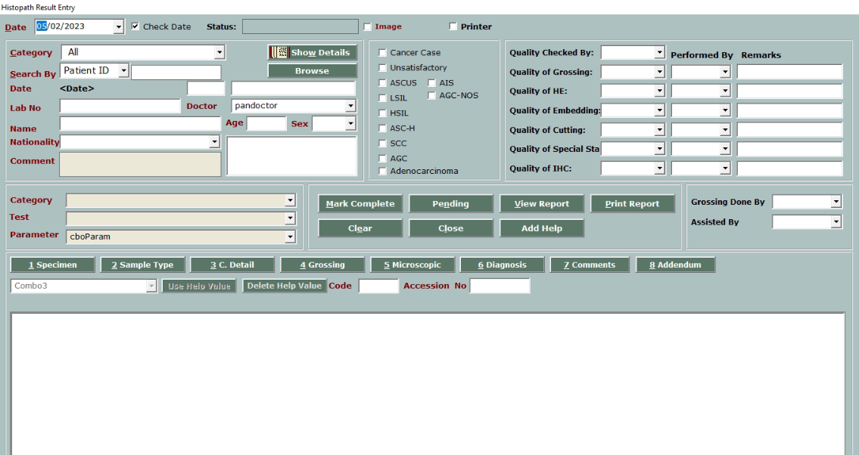

* This is Main welcome window for **histopathology**.
* Click on Browse button to load the patient.

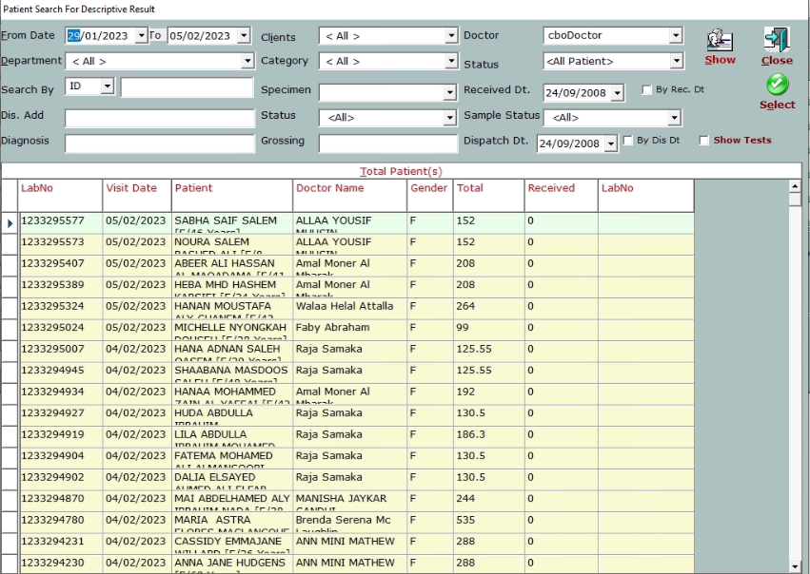

* Select the from date - to date.
* User can use patient Id to search the patient.
* Click on **Show** button to load the patient.
* Select the patient row and click on **select** button.

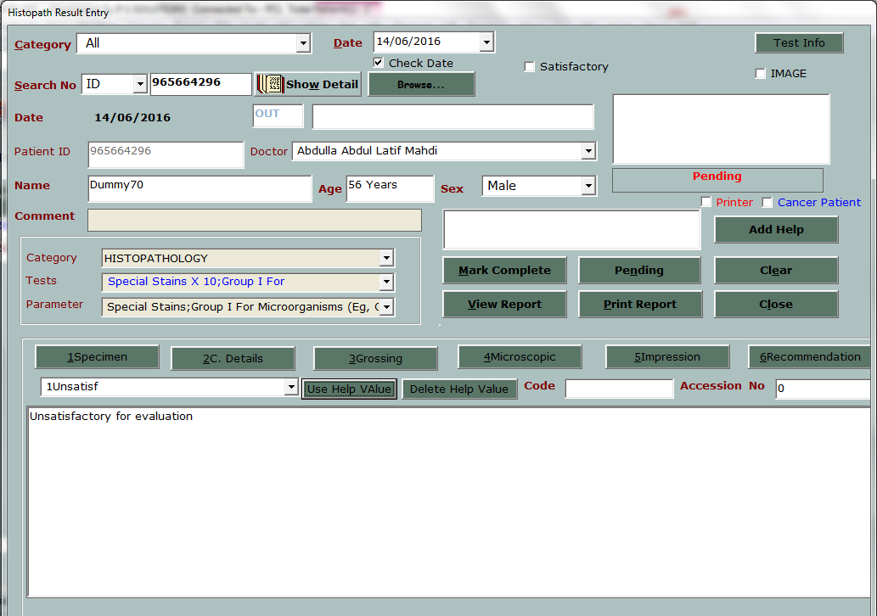

* This is result entry view for histopath.
* Enter the specimen, clinical details, grossing, microscopic and impression for the selected test.
* User can make multiple help value.
* Enter accession number before complete entry.
* User can view the report before authentication by using **View report** button
* Click on Pending button to keep test pending

**HISTOPATHOLOGY AUTHENTICATION**

* This window is for histopathologyauthentication.
* All the reports validated by technician will appear in this window according to selected date.
* Pathologist can change the result before authenticate
* After authentication user can print the report from main result entry window.