## Interbranch Sample Track Report

|  |  |
| --- | --- |
| User Name: ……………………………………………. | Trainer Name: Ruchira Ariyasinghe |
| User Sign. : ……………………………………………. | Trainer Sign. : ……………………………………………. |

**Interbrach Sample track report**

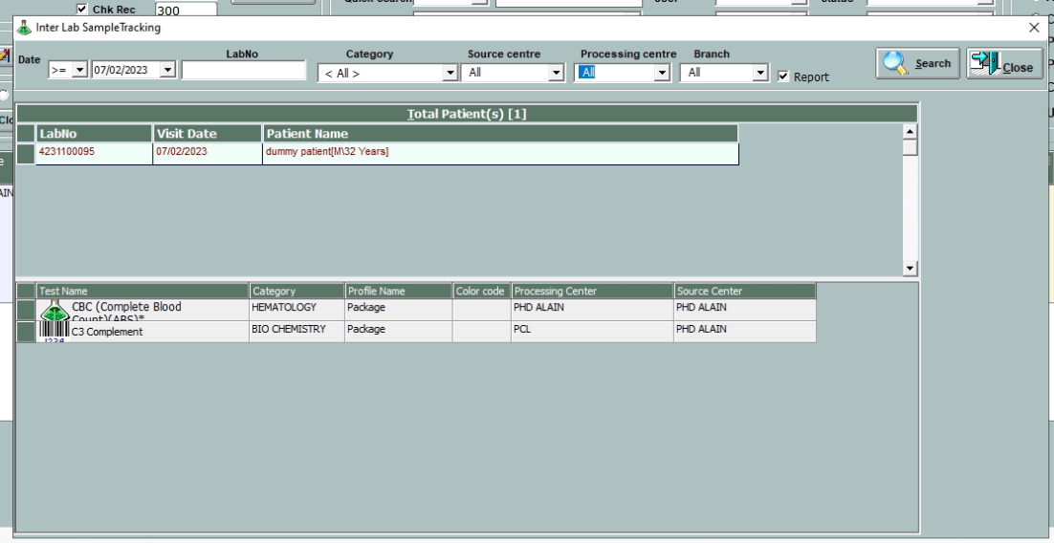

* Click Report Button

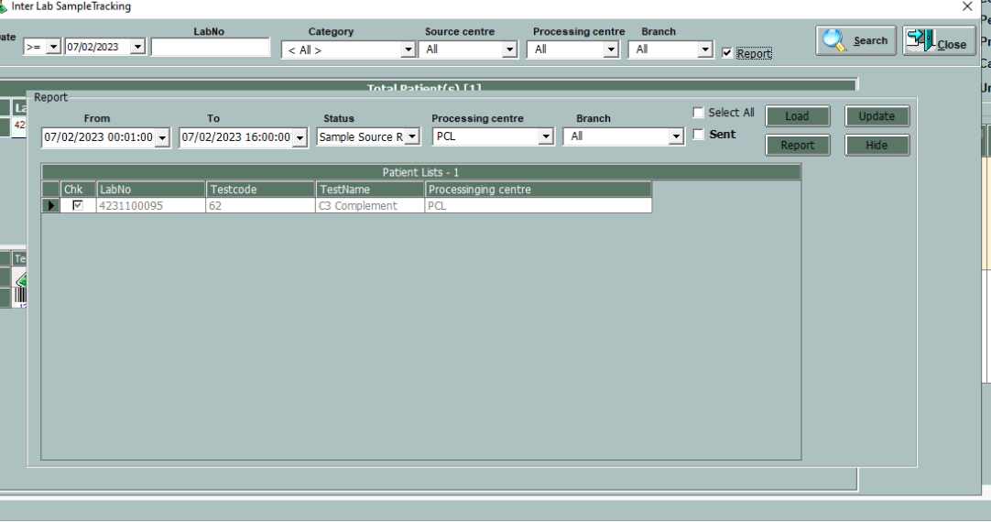

* Select the date and time
* Select the status
* Select the processing centre
* Select the branch
* Click Load
* Select the tests which needs to send to processing lab
* Click Update
* Click on sent button
* Click on load
* Click report button to generate report

