# 

# LOG IN

|  |  |
| --- | --- |
| User Name: ……………………………………………. | Trainer Name: Ruchira Ariyasinghe |
| User Sign. : ……………………………………………. | Trainer Sign. : ……………………………………………. |

## LOGIN SCREEN

Double click on the Labcare.exe to start the application.

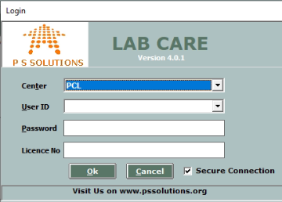

From centre option user has to select the centre, according to which users will be loaded for particular centre.

This is the login screen of Labcare software. Only authorized users can log on to the system.

The user has to enter the user name and password and then click on “**OK**” to proceed.

If the user name or password is wrong then the user will be prompted to enter the correct username or password. If it is an authorized user then the registration screen will be opened.

On clicking the cancel button the application ends.