## LOG OFF

|  |  |
| --- | --- |
| User Name: ……………………………………………. | Trainer Name: Ruchira Ariyasinghe |
| User Sign. : ……………………………………………. | Trainer Sign. : ……………………………………………. |

**LOG OFF**

Selecting this option will change the user.

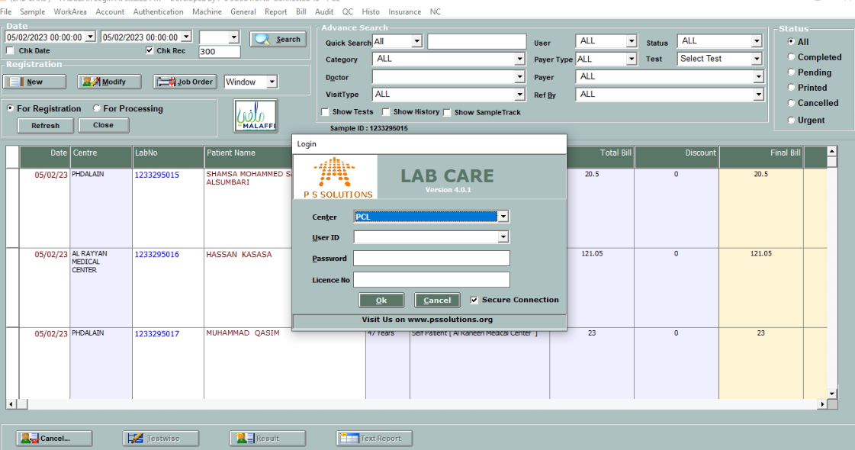

* This is the Logoff Screen of Lab care.
* On clicking the Cancel button, a message is displayed asking ‘Confirm Exit?’. Clicking “**Yes**” button will prompt login screen.
* On clicking the “**No**” button the application remains opened.

##### EXIT

Selecting this option will exit from the application. This option can be selected for closing the application