## 

## MASTER

|  |  |
| --- | --- |
| User Name: ……………………………………………. | Trainer Name: Ruchira Ariyasinghe |
| User Sign. : ……………………………………………. | Trainer Sign. : ……………………………………………. |

**MAIN WINDOW**

Master is categorized in main 4 options

1. Centre
2. Tests
3. Profiles
4. Setup
5. Graphical user interface, text

   Description automatically generated**Centre**

Centre category is having sub menus like

15.3.1 Add new Centre

15.3.2 Modify centre

15.3.3 Delete centre

15.3.4 Centre wise test rate

15.3.5 Centre wise profile rate

15.3.6 Centre wise consumable rate

15.3.7 Upgrade source client

15.3.8 Update satellite centre details

**1.1 Add new centre**

This window is use to add new client

HMSCODE is mapping code between third party and LIS s/w

If client is credit then keep credit= “Y”. User can enter credit limit, once credit limit is over at reception user cannot add new test for this client.

To make client inactivate make Inactivate = “Y”.

In case of Insurance client user must enter Payer id and receiver id.

In case of TPA, enter TPA = “Y”

Administrator can manage password for client in this window.

If you want to prompt the question at reception against test, keep Ask question “Y”

To round of the amount in reception keep Amt round = “Y”

**User can assign client as**

1. CREDIT
2. CASH
3. INSURANCE

User can enter fixed patient share against client which helps reception person to get the amount.

If client is a referral lab keep is referallab= “Y”

User can grouped all client list into main client source like

* BASIC LAB
* BASIC INSURANCE
* WALKIN

If client is source then keep ISsourceclient = “Y’ and don’t select any source client

If Issourcecleint = “No” then select source client from box.

User can enter discount and factor for client on sorceclient.

If discount <> 0 then client rate = source client rate - (source client rate * discount /100)

If factor <> 0 then client rate = source client rate * factor

 Click on “**Update** **All Tests/Profiles**” to update all tests and profiles against this client with

**1.2 Modify centre**

Search the client and double click for modification window.

In this window user can modify the client information.

Click on **“Save”** button to save the changes.

**1.3 DELETE CENTRE**

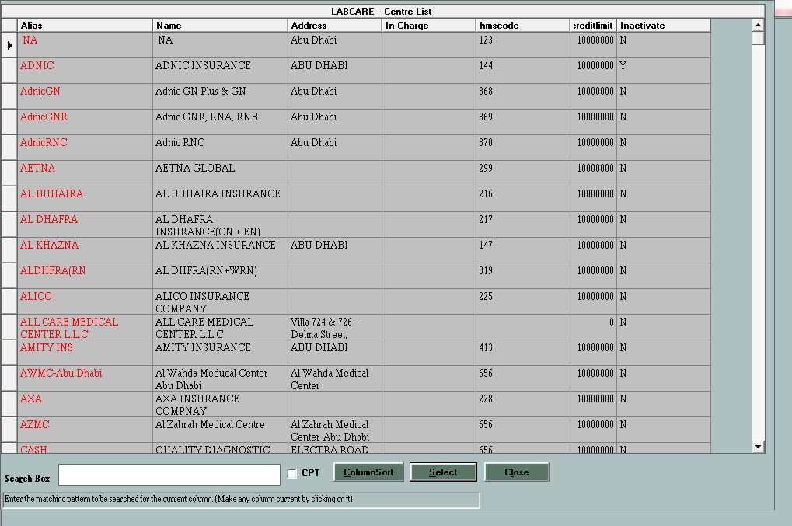

Select the client and double click to go delete window.

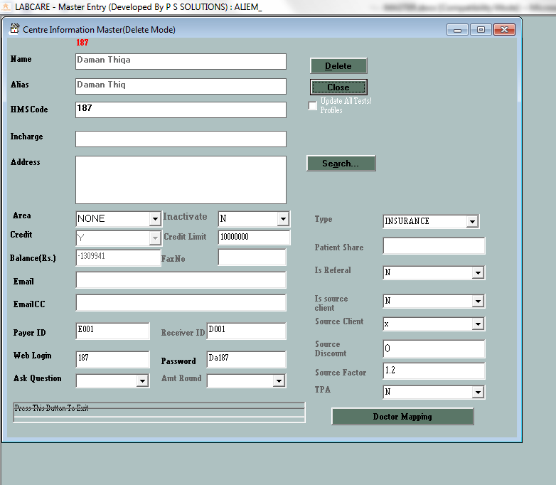

Click on **“Delete”** button to delete the client. If there are any current visits against selected client system will ask to delete record?

Do you want to delete current records?

YES

System will delete all records against this client and client entry from master.

NO

System will not delete the client entry from master.

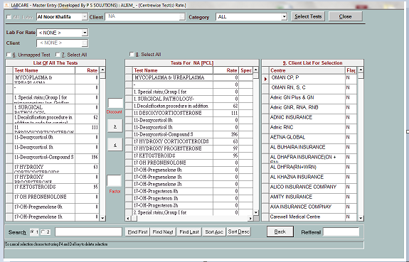**1.4 Centre wise test rate**

This window is use to update the client rate.

Select the client from list and click on “**select Tests**” button.

In First table all master tests will appear. User can load particular client test in first tale by selecting client above first table.

User can search the test in 1st table select first option, enter the Test name and click on “**Find First**” button.

To map the test click on “>” button. Enter the test rate in second table to selected client and click on “**Back**” button.

To mention Special test rate keep special = 1 in 2nd table. So rate for this test will not get updated in group updatation.

If user want to update same rate for different client, in 3rd table keep flag = “Y”.

**1.5 Centre wise profile rate**

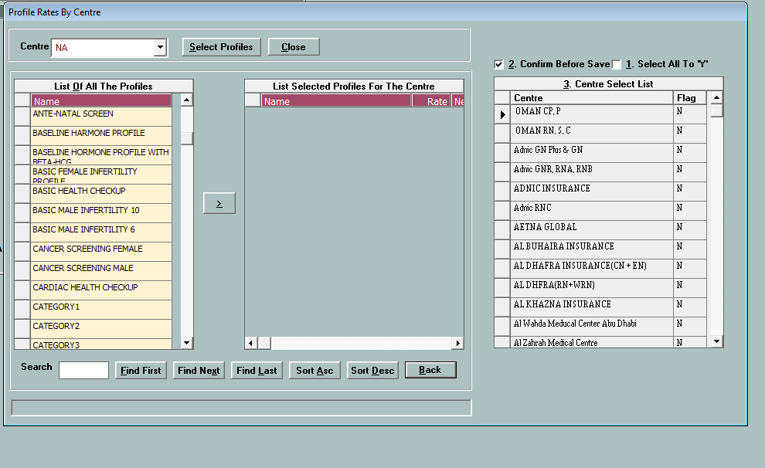

Select the client name and click on “**Select Profile**” button.

In first table use will get all master profile.

In Second table user will get profiles for selected client.

User can map new profile. Keep flag = “Y” in third table to update rate for different client same time.

Click on “**Back**” button to map the profile and update the rates.

**1.6 Centre wise consumables rate**

This window is use to add additional consumables required for test.

In reception area when user will select any test. Automatically additional amount will get added against this centre for selected test.

**1.7 Upgrade Source client rates**

This window is use to update client rates according to source client.

Select the source client from list. All clients having selected source client will displayed in table.

Client rate will get calculated according to Discount and factor entered by user.

Click on update button to update the rates for client according to source client.

Click on ”Don’t update special test” to avoid to update test rate for special test.

Select the particular test from box to update single test rate.

Select Test

 Profile

* Consumables

**To update the rate for Source Client, user can use the excel sheet having first column as CPTCODE and second column as Rate. Click on**  **“Delete old Rates” to deleted existing rates for source client.**

Click on “**Update Patient**” to update the modified rates against old registration.

Select the particular client from list. Select the date criteria.

Click on Update button to update the rates.

Click on  “Update only full balance” to update the only patient against which amount is not accepted.

**1.8 Satellite centre details**

This window is use to Map user, client and test for selected centre.

1. User –

Click  and Active = “Y” to activate the user

1. Client –

In client mapping, add the client need to map.

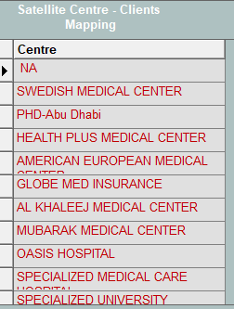

1. Test mapping

There are 2 types of test mapping

1. Processing

2. Registration.

Select the “Processing” as centre Details and click on Mapping button.

Map the tests on right side which user want to perform in lab.

This is processing mapping

For “Registration” Mapping click on Registration as centre details and click on Mapping button

Map the test on right side which user want to appear in reception in registration window.

**2) TEST**

This menu contains

15.4.1 Add New Test

15.4.2 Modify Test

15.4.3 Delete Test

**2.1 Add New Test**

1. Enter the test name and alias
2. Enter the common rate for test and cost.
3. Enter the test type as Normal / Descriptive
4. Select the category for the test.
5. Select the format for test given by **LIS vendor.**
6. **Enter the internal test code in HMSCOD and CPTCODE.**
7. Enter the test count in case o lipid profile, renal profile etc...
8. “Test order” is the order for display on report.
9. “Print Together” is the to print the report with other tests.
10. Press F2 to get list of Header
11. Press F3 to get list of parameters
12. In Test format first element must be Header. Use cannot add two consecutive headers.
13. Press Up/Down key to change the sequence of parameter.

**How to Add new Parameter**

Press F3 and Click on “**Add parameter**” button to add new parameter.

Enter the parameter name and print as.

Enter the footer, unit and short name information.

Keep DC = “YES” in case of diff count parameter for CBC test.

Enter the Ref Range day wise and Gender wise.

Enter the suffix for parameter which will help for interfacing of machine equipments for test like Glucose PP, Glucose Random, GGT after 1st hour, 2 Hour etc..

LIS Eng. will provide the Suffix information.

Enter the observation code, Observation factor, SI factor and SI unit.

Click on Precision button to modify the decimal points in Results.

**PRECISION**

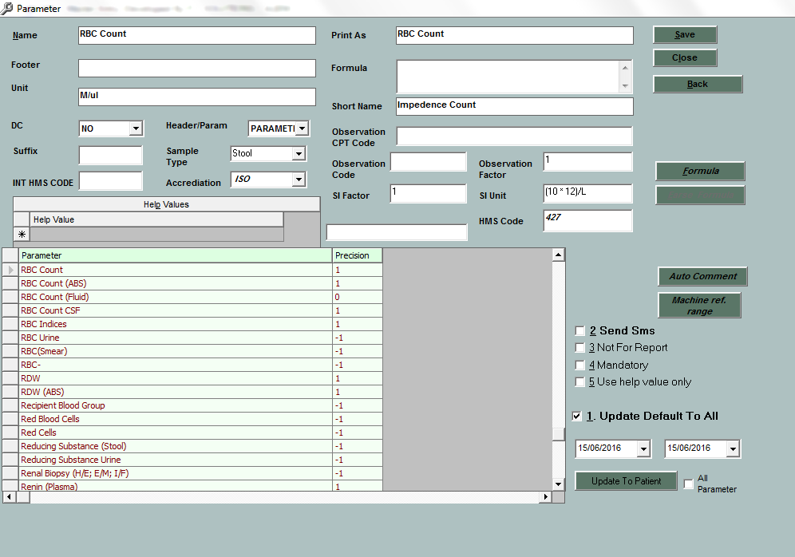

**-1** Means Same Result coming from machine

**0 Means** Result will get round off

**1** Means result will get rounded to 1 decimal.

Click on “**Back**” button to close the precision window.

**FORMULA**

Click on Formula button to add new formula for parameter.

For Example LDL/HDL

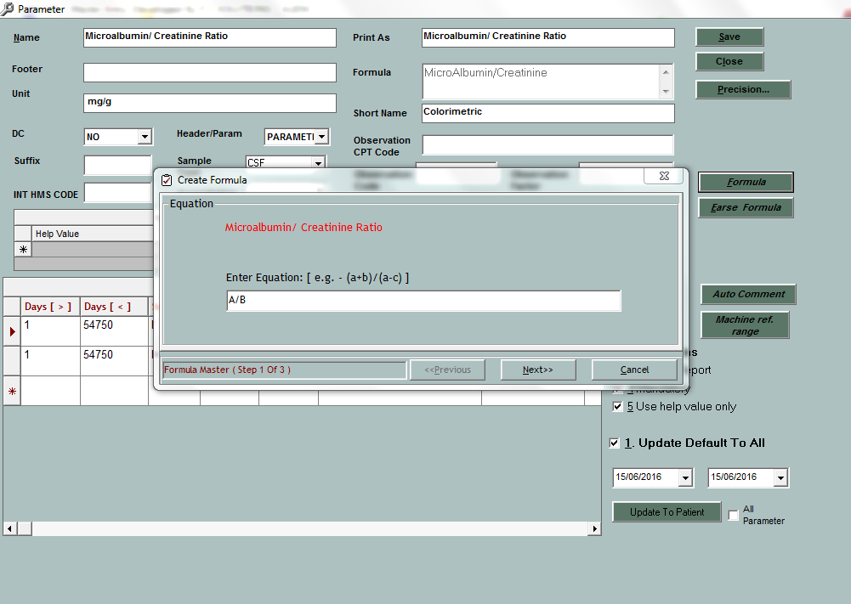

Map A to LDL cholesterol

Map B to HDL cholesterol

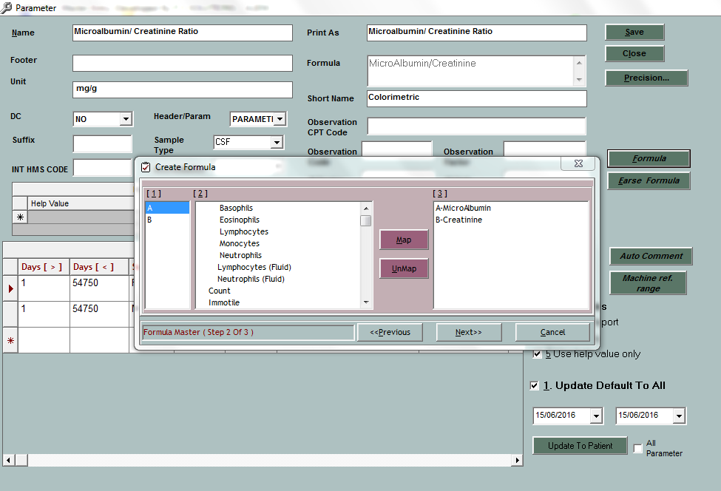

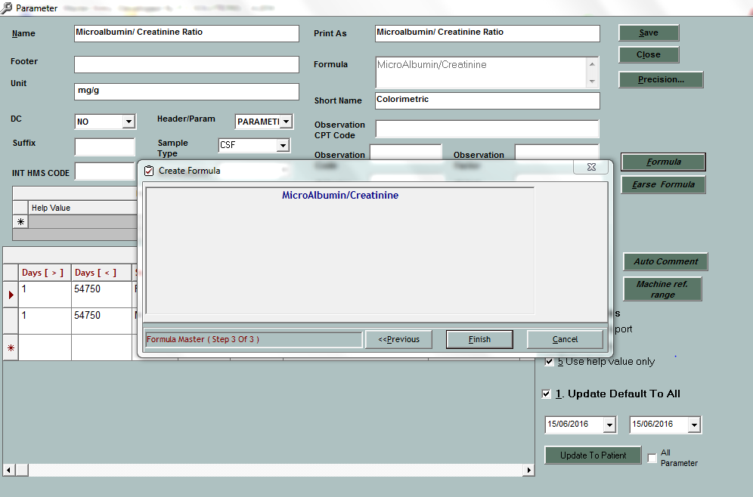

This is formula. Click on “Finish” button to save the formula.

Click On “Erase Formula” to erase the formula.

**How to Add reference Range**

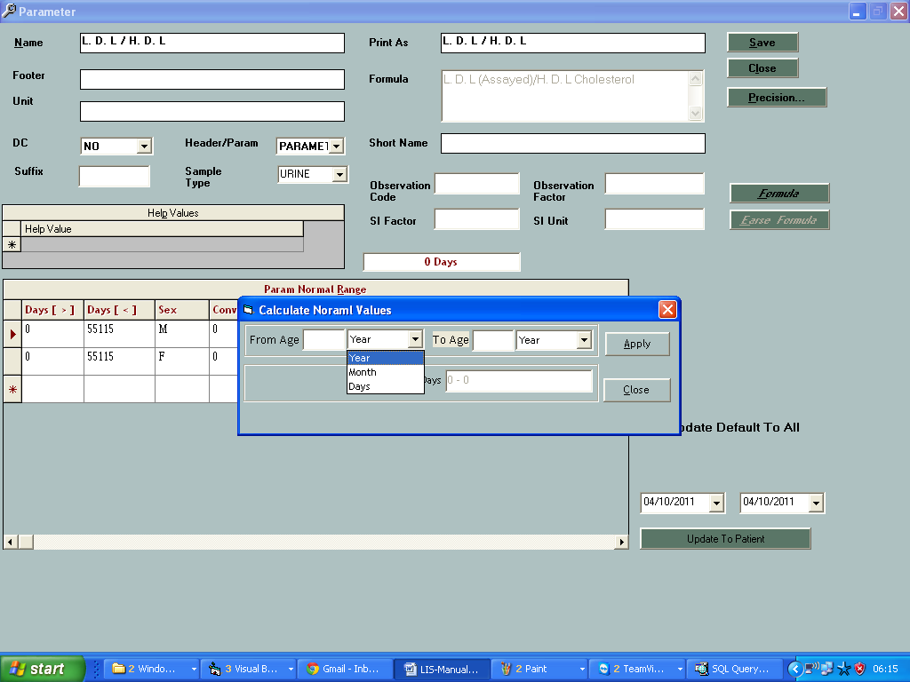

Click on Days column to open “Calculate Normal Values” window

Enter the from age and to age in form of Days, Months or years. Click on “Apply” button to close the window.

Enter the Sex for Range

Enter the Low value, High Value and Reference range for parameter.

Do remember High/Low flag in patient report will depends on Low and High values entered. High/Low flag is not depending on reference range entered.

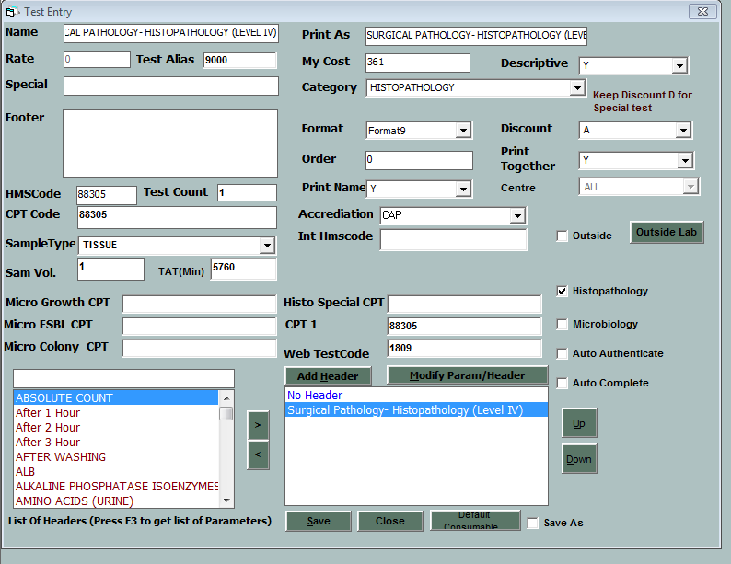

Click On ”Microbiology” in case of Microbiology test

Click on ”Histopathology” in case of Histopathology test

If user doesn’t select the Microbiology and histopathology flags properly. Tests will not appear in Histopathology and Microbiology reporting modules.

Click on ”Outside” test on map test as outside.

Click on “Save” button to save the parameter.

**2.2 Modify test**

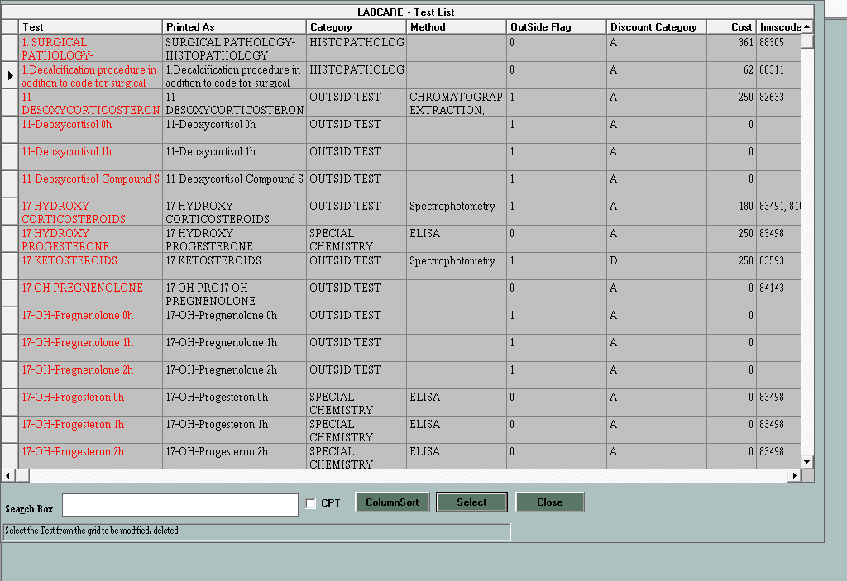

User can search the test by test name or CPT code

Click on “**Select Button**” to select the test in Edit mode.

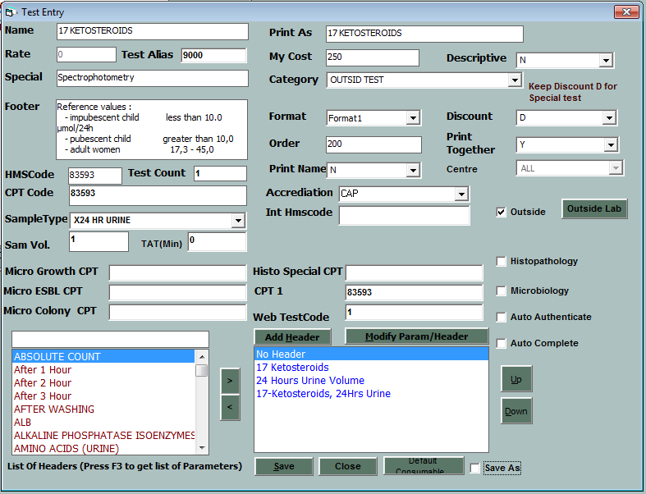

User can modify test the test and click on “**Save**” button to save the changes.

User can Use  “Save As” option to make new test with same parameters and other information.

User must change Testname and test print as before click on “Save As” option.

**2.3 Delete Test**

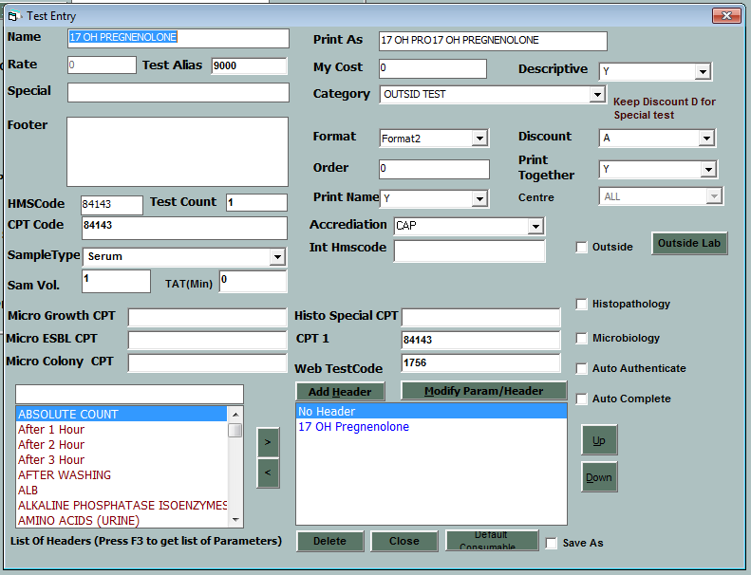

Click on “**Delete”** button to delete the test**.**

**In case of delete this test will get deleted from all old requests.**

**3) Profiles**

Profile includes

15.5.1 Add profile

15.5.2 Modify profile

15.5.3 Delete Profile

**3.1 Add Profile**

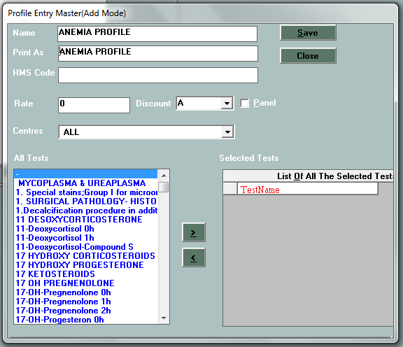

Enter the Profile name and print as.

Enter the Internal Lab code.

Enter the common rate for profile. Click on Panel if profiles contain the test from more than one category.

Select the test from left table to add > into right table

To remove the test use> button.

Keep Discount = “D” for special profiles.

**3.2 Modify Profile**

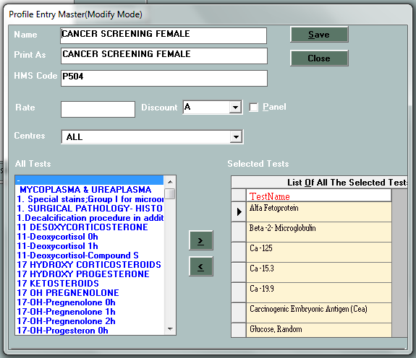

User can search the profile by name or CPT code

Click on “**Select**” the button to modify the profile.

User can do the required modification and click on “Save” button to save the changes.

**3.3 Delete profile**

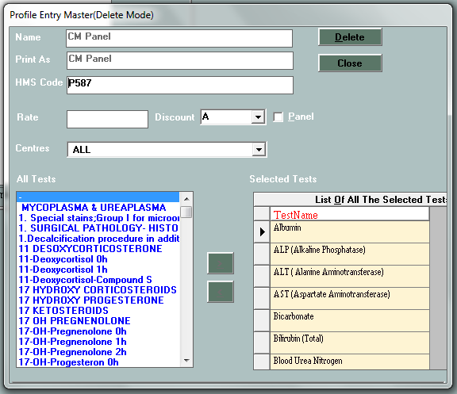

Click On “Delete” button to delete the profile.

1. **SETUP**

**SETUP** includes

15.6.1 Modify setup details

15.6.2 Work Sheet Definition

15.6.3 Add/Modify Hotkeys

15.6.4 Enter Doctor category

15.6.5 Enter Doctor Films

15.6.6 Test category

15.6.7 Consumables master

15.6.8 General Master

15.6.9 User Master

15.6.10 Outside Lab master

15.6.11 Questions.

**4.1 Modify Setup Details**

User can enter laboratory name and other details in this window.

Click on “Ok” button to save the changes.

**4.2 WORKSHEET DEFINATION**

Here use can select their own worksheet.

Click on “New” button to make new worksheet

Enter the name and description for worksheet.

Add the test on right side table and click on “Save” button to save the worksheet

User can use this worksheet in main **LABCARE** software.

**4.3 ADD / MODIFY HOTKEYS**

This window is use to define hot key for selection of tests.

User can use F2 - F12 keys.

It will help user to add test in registration.

**4.4 ENTER DOCTOR CATEGORY**

This option is use to define referral doctor.

User can select Category as A,B,C,D.According user can define percentage for referral for doctors.

**4.5 TEST CATEGORY**

This window is use to define new main category.

Click on New button to add new category.

**4.6 GENERAL MASTER**

This window is use to do following activities.

1. Reason
2. Mail type
3. Region
4. Main category
5. Titles
6. Rights
7. Sample Type

Enter the data for selected activities and press down key to save the entry.

**4.7 USER MASTER**

Click on **New** button to add new user.

Enter the user id and password.

User id and password must be minimum 6 characters.

Click on **save** button to save the entry.

Setup Data Bar is use to browse the users.

**Copy rights** button can use to copy the rights from different user.

Click on **Change** Button to change the password.

Click on **Rights** button to allocate rights for user.

Select the right from box and click on select button to select the right.

Click on **Save** button to save the entry.

Click on **Remove** button to remove the rights.

Click on **Dept rights..** to assign department rights.

Click to department name to select the department and click on **Back** Button to save the entry.

**4.8 OUTSIDE LAB MASTER**

This option is use to add new outside lab and map the tests for outside labs.

Enter the lab name and other details and click on Save button to save the entry.

Click on Map Test button to map the tests for selected outside lab.

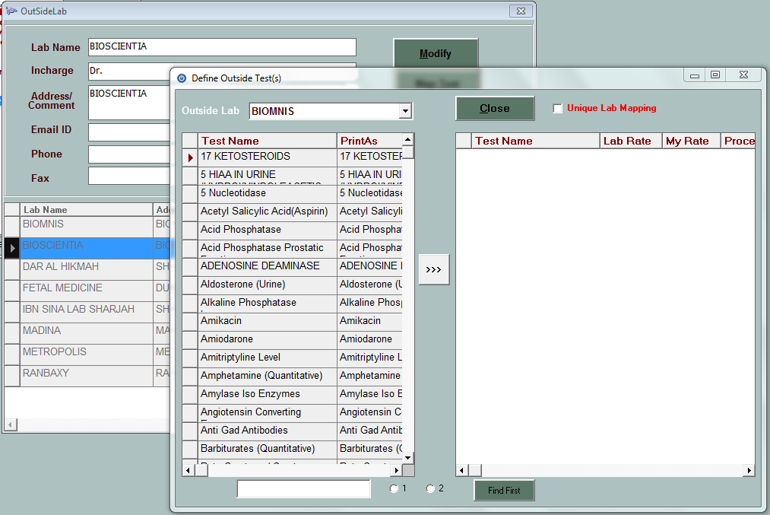

Add the test from left side which user wants to send for the lab.

Click on **Close** button to save the entry.

**4.9 QUESTIONS**

This window is use to define questions against test which will implemented at reception.

Click on **Save** Question to save the new question.

Select the test from box.

All Questions mapped against this test will appear in table

Select the Question from box to add the question against selected test and click on **Save** button.