## MICROBIOLOGY

|  |  |
| --- | --- |
| User Name: ……………………………………………. | Trainer Name: Ruchira Ariyasinghe |
| User Sign. : ……………………………………………. | Trainer Sign. : ……………………………………………. |

**MicroBiology Result Entry**

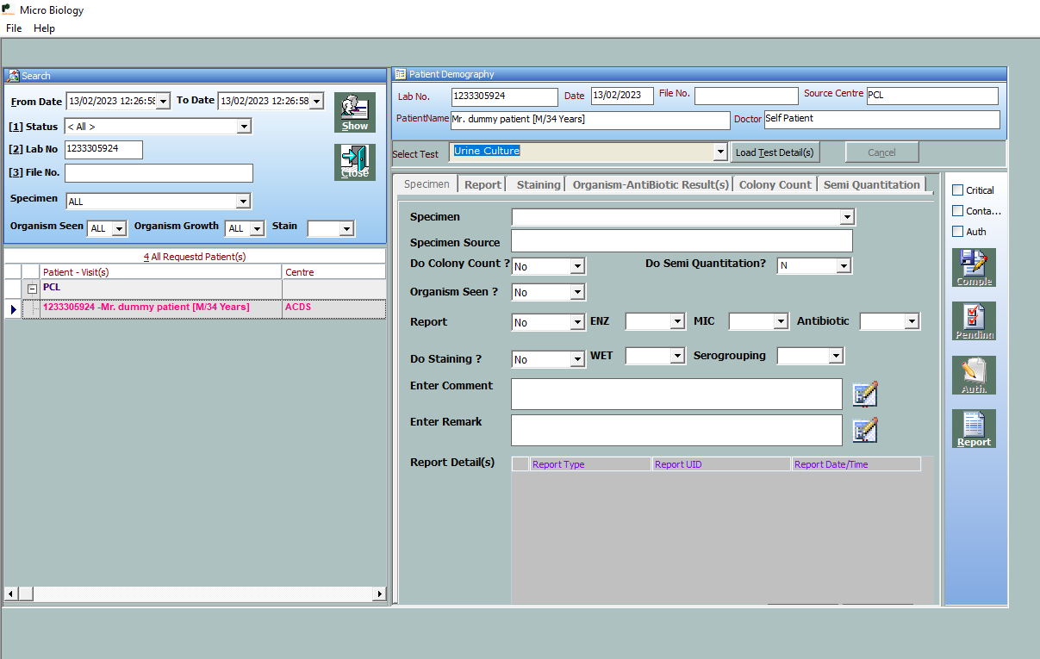

* Open Microbiology Application.
* Search By Labno
* Show test details
* And do the micro result entry

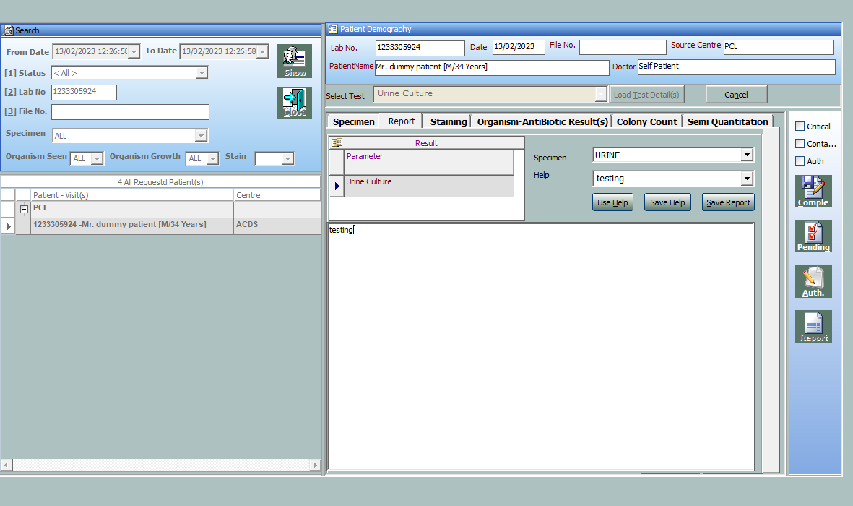

* Select the sample type
* Type help value heading
* Type the help value in text box
* Then click save help buttton