## QUALITY CONTROL

|  |  |
| --- | --- |
| User Name: ……………………………………………. | Trainer Name: Ruchira Ariyasinghe |
| User Sign. : ……………………………………………. | Trainer Sign. : ……………………………………………. |

**CONTROL TYPES**

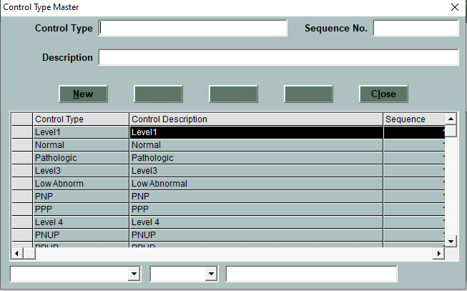

* Click on **New** button for new control type.
* Enter the control type, Description and sequence number
* Click on **save** button to save the control type.
* Click on Delete button to delete the control

**CONTROLS**

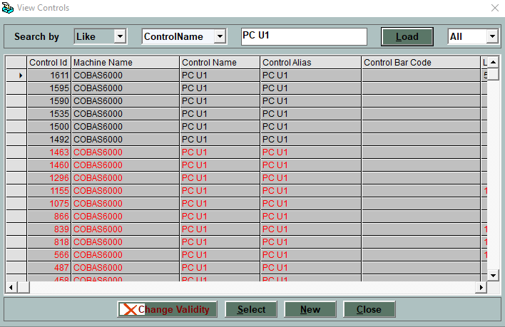

* This window is use to add new Controls
* Click On New button to add new control

**NEW CONTROL**

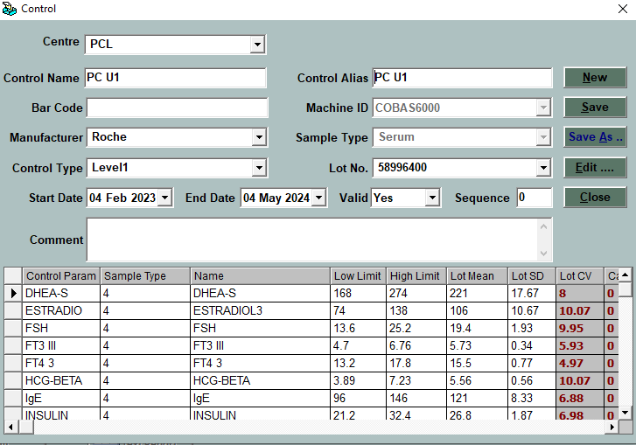

* Select the Centre
* Enter the control name and alias.
* Select the machined and manufacturer.
* Select the control type and enter the Lot No.
* Enter the start date and expiry date.
* Select parameter from table and enter the Low limit and high limit.
* **Lot Mean** and **Lot Sd** will get calculate automatically by 2 SD.
* Click on **save** button to save the control.

**EDIT CONTROL**

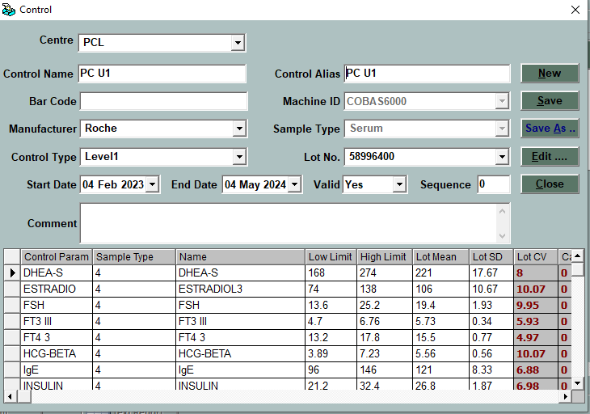

* In Edit control user can edit the control parameter.
* User can use Save As option to add new control with different name of control.
* In Save As option user need to change control name.
* By using Edit…. Button use can go to main control window.

**QC ENTRY**

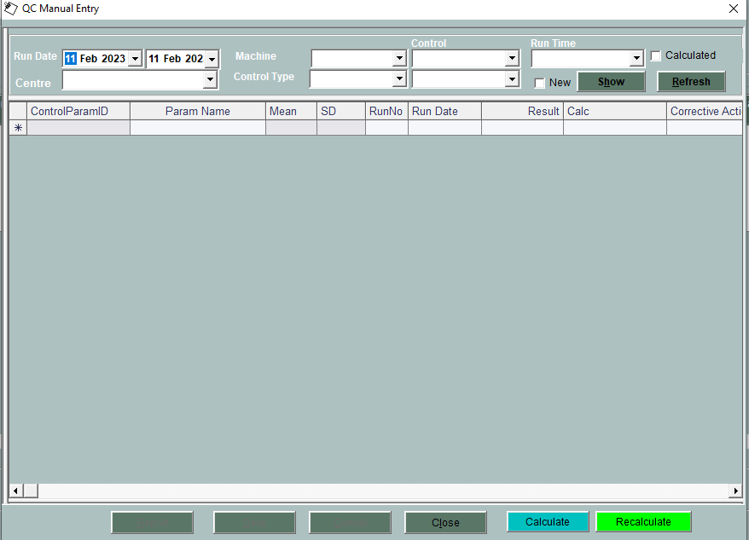

* Select the date criteria and main centre from centre box.
* Select the machine and control type.
* Select the control name and parameter and click on Show button
* Click on First column of table to get parameter in table.
* Enter run no and Result.
* In case of Rule Violation user need to enter the corrective action and result will be available in red color.
* Click On save button to save the entry
* In Case of machine interface QC result will come automatically from machine.
* Click on Calculate button to calculate manual QC mean and SD.
* Click on Recalculate button to recalculate QC mean and SD.

**QC CHART**

* Select the centre and date criteria.
* Select the test and control name
* Click on show button to see LOT chart.
* Select Calculate option to get CALCULATE Chart

Select the Recalculate option to get RECALCULATE

