# REPORT

|  |  |
| --- | --- |
| User Name: ……………………………………………. | Trainer Name: Ruchira Ariyasinghe |
| User Sign. : ……………………………………………. | Trainer Sign. : ……………………………………………. |

###### By Patients

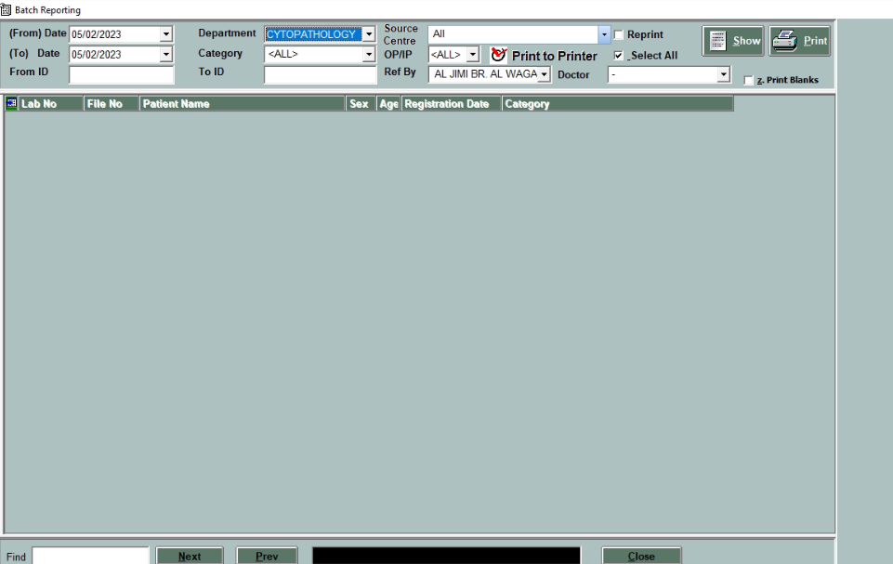

After selecting this option User can print patients reports by various selection criteria such as Client Wise / From Subject ID /To Subject ID, Department wise / Sub Department wise or user can reprint the reports.

