## REGISTRATION

|  |  |
| --- | --- |
| User Name: ……………………………………………. | Trainer Name: Ruchira Ariyasinghe |
| User Sign. : ……………………………………………. | Trainer Sign. : ……………………………………………. |

**REGISTRATION**

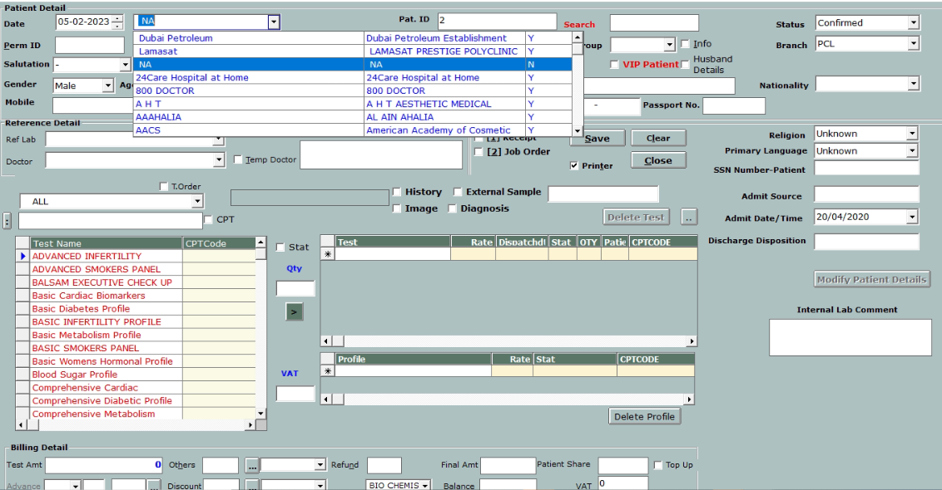

This Screen is use to register new patient.

Payments can be done by this screen in case of walking patient.

User need to enter patient demography, doctor information, Payer, ref Lab and test information.

* External Sample – In case of external sample user can use this option.

User can give the discount, refund and can take extra charges from this window according to privileges.

**NEW** button for to add new permanent patient

* User need to enter all patient demography
* If user keep permanent number blank then permanent number will be automatic
* User can enter own permanent number like mobile number, passport number or some other unique number etc..

**FIND** button is to search the permanent patient.

User can enter the patient id to search the patient.

 “View all” shows all permanent patient