MEMORANDUM

to : ALL EMPLOYEES

from : HR SECTION

subject : march 10, 2025: special holiday in the city of tanauan

date : **2025 march 06**

**bwpi no. : HR-M-c2025-01**

Dear All,

Please be informed that **March 10, 2025, is declared as Special (Non-Working) Holiday** in the City of Tanauan in commemoration of the Anniversary of the Cityhood of Tanauan (refer to the attached memo from the Office of the City Mayor).

Employees who will work on March 10, 2025 shall be paid the corresponding premium pay rates.

The “No Work, No Pay” Policy shall apply to all daily employees.

For further inquiries, you may go directly to HR.

For your guidance.

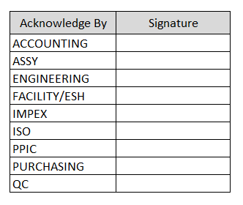Prepared by:

K. Moncayo

*HR Sr. Staff*

Noted by:

L. Sarmiento

Operations Manager

Approved by:

T. Miyamura

*Vice President*

