9 Administrator Module

These are the components of administrator module. The Administrator Module is a powerful tool designed to empower administrators with comprehensive control and management capabilities within a system or software. It provides administrators with the necessary permissions and functionalities to configure system settings, manage user accounts, and oversee various aspects of the application or platform. With the Administrator Module, administrators can efficiently handle tasks such as user access control, system configurations, and overall system maintenance, ensuring smooth operation and optimal functionality of the system.

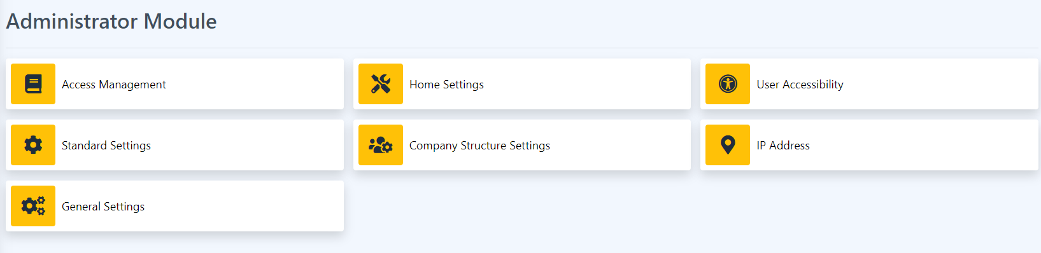

9.1 Access Management

This page is where all access is being managed. In this page the authorized user can reset the password of an account to default, change the user access type of an account and more.

How to Update the Access Management?

1. Click the dropdown on the employee you want to update. For example, the user access.

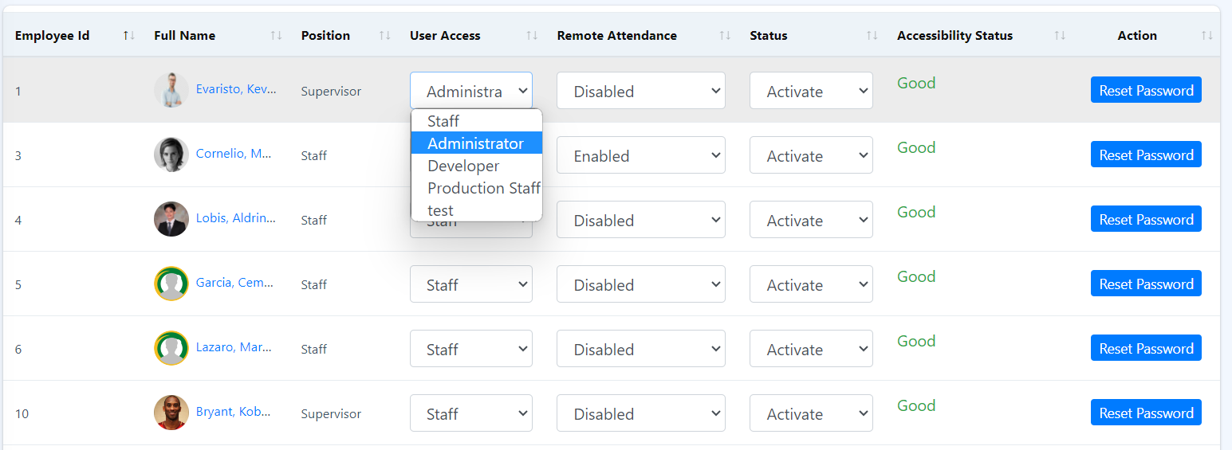

1. Select a user access type for that employee.
2. To save the changes made, just click the Save Changes button

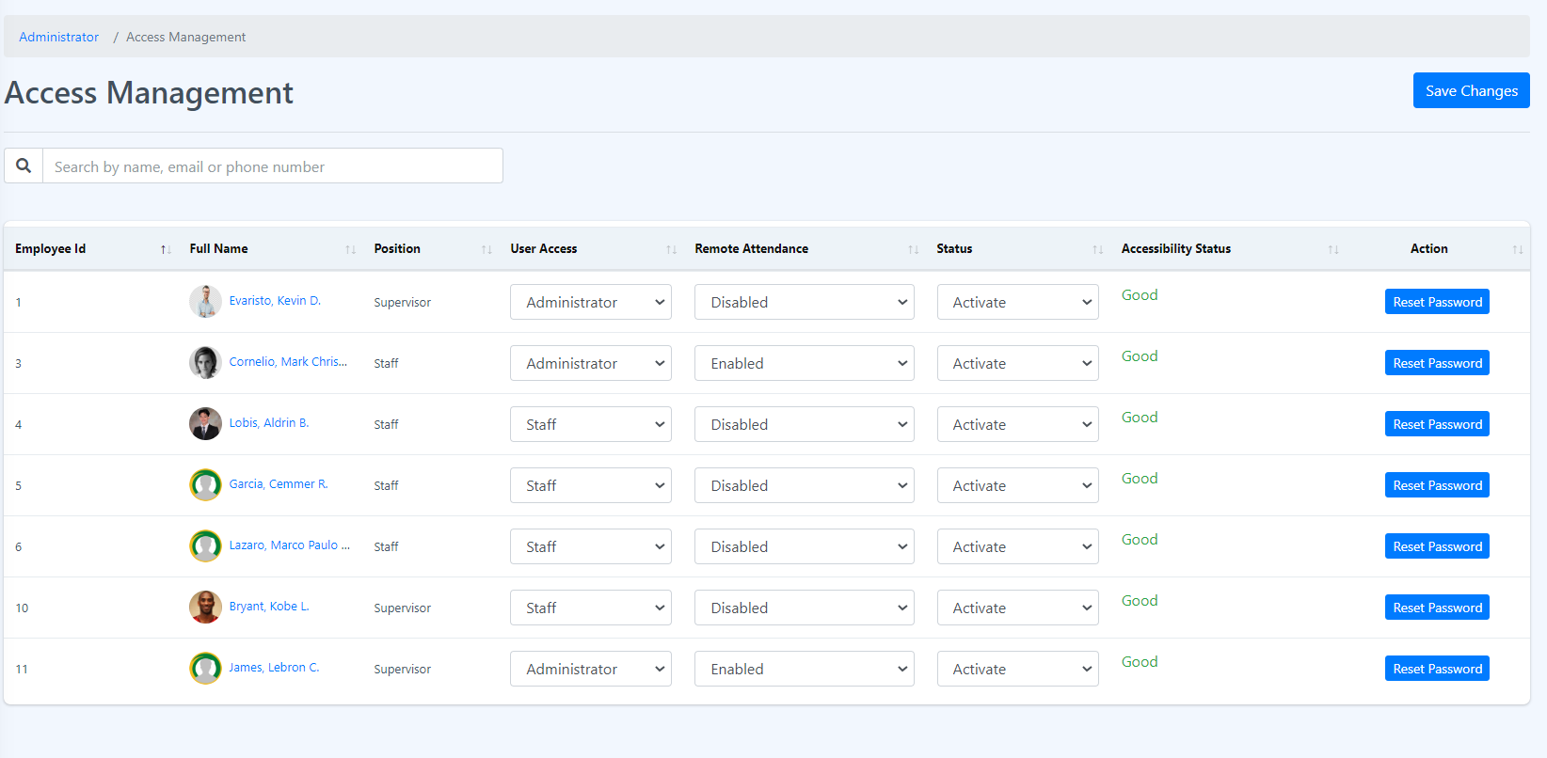

1. A success message will be displayed just right above the Save Changes button. Click the close button to remove the message.

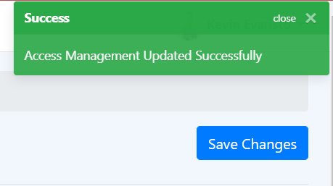

9.2 Home Settings

This page manages what to show or display in the home page. To change just click the switch button.

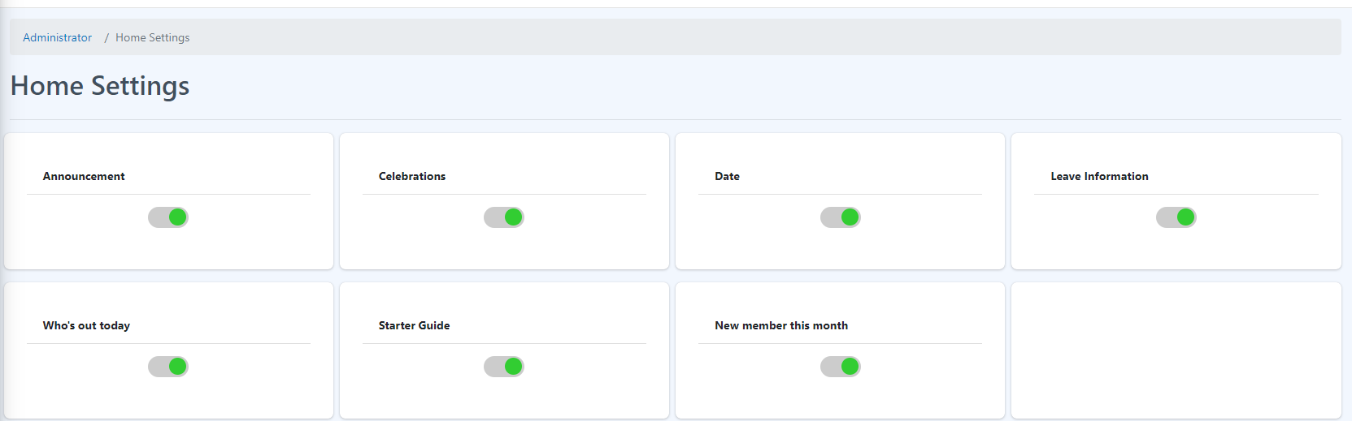

User Accessibility

This page manages all modules access according to the user account access type. The admin can change the modules that can be accessed by a specific position title. An admin can also add or update the user access.

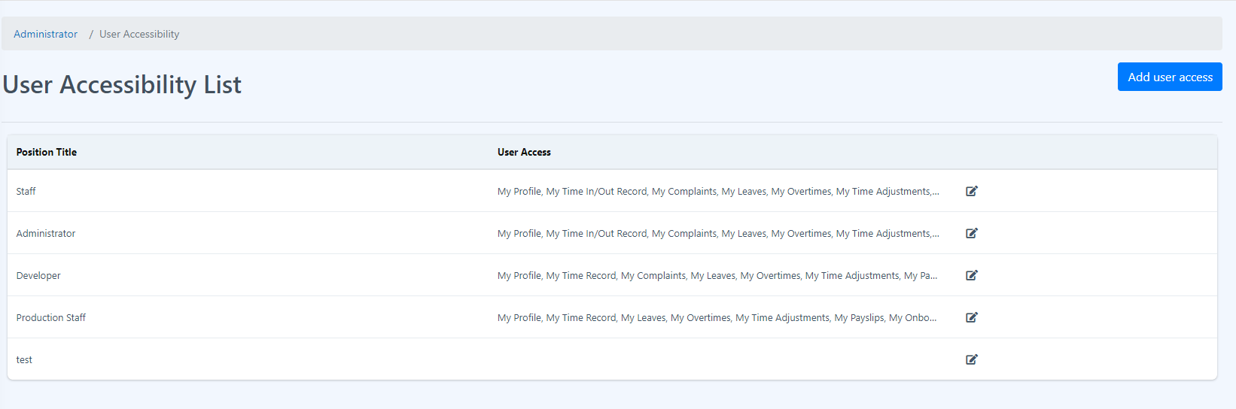How to add new User Access?

1. Click the Add user access button.



1. Insert the Name of the new user access and select all the modules that are allowed for the access type and click submit button.

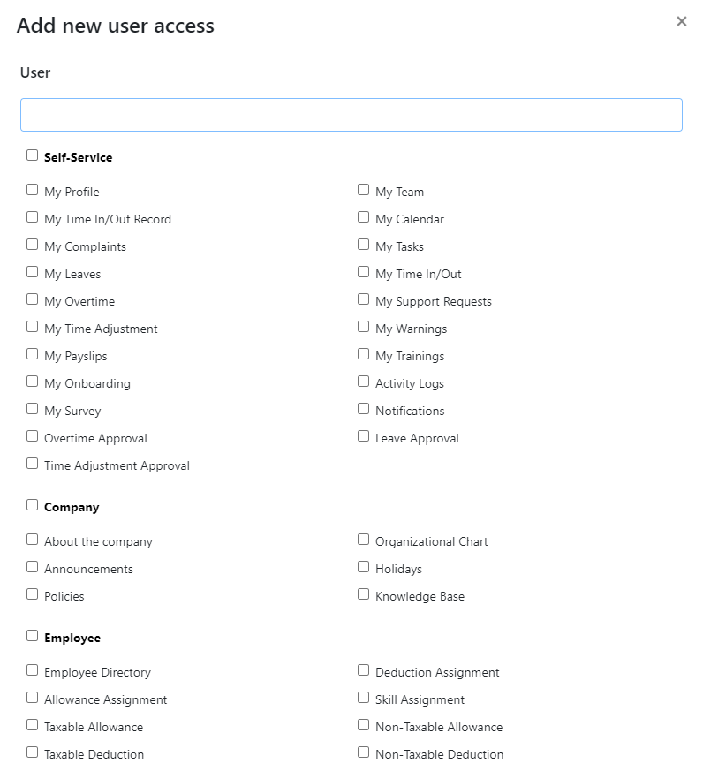

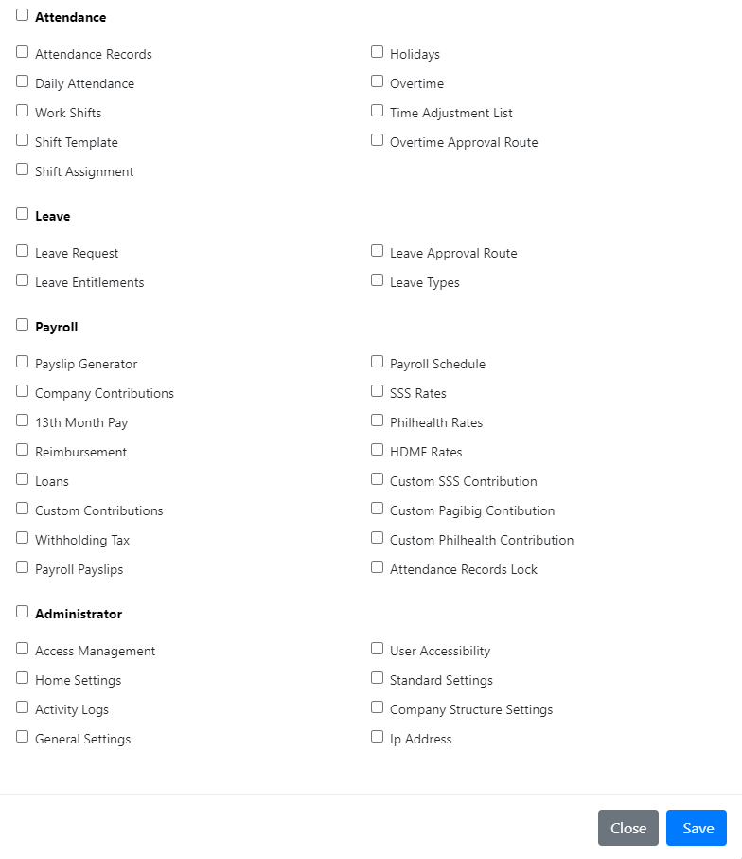

How to edit User access?

1. Select the user access that you want to update.
2. Click the edit icon beside it, located at the end of the user access.



1. Select or unselect all the modules allowed for that user access and click Save button.

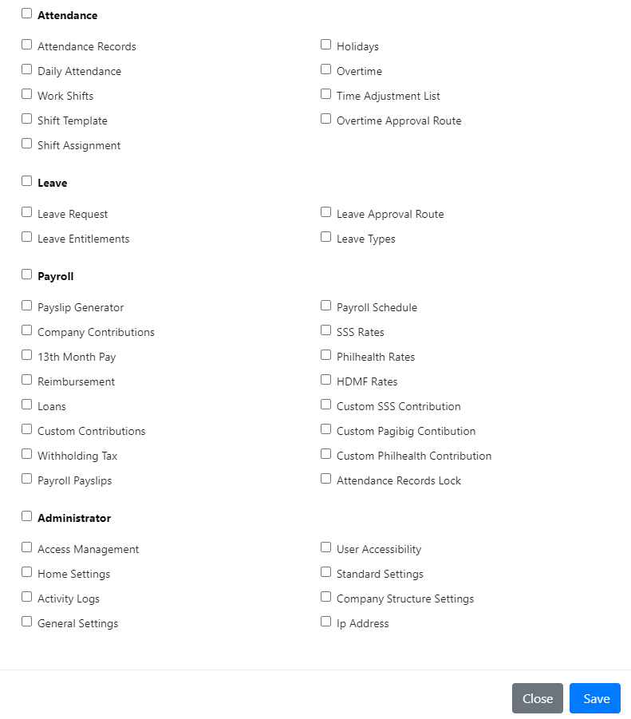

9.4 Standard Settings

This setting sets all the standard for each module and components. This page allows you manage the components of the page such as adding type of taxable allowance and many more. This settings usually manages the other functions that are not available in other pages.

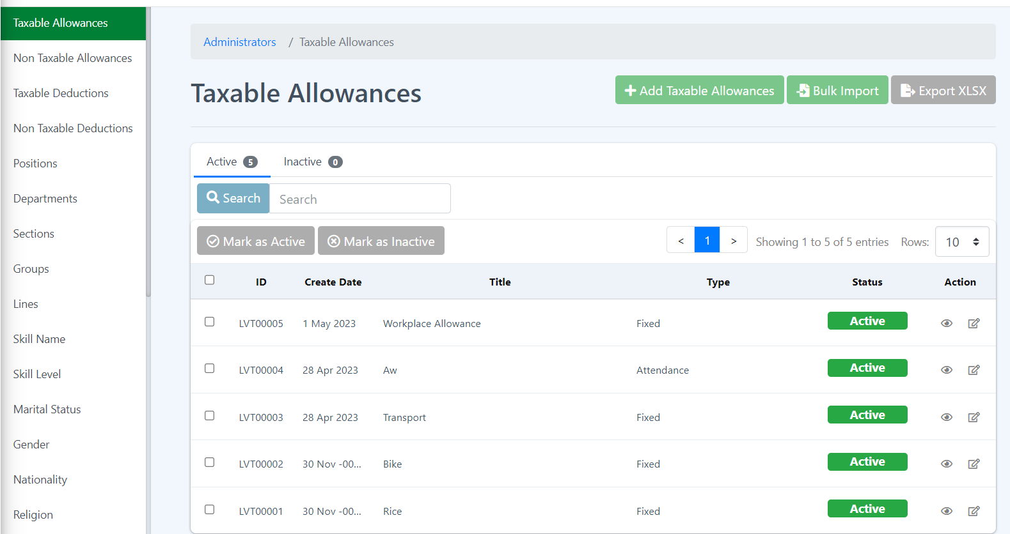

How to add new Taxable Allowance?

1. Click the Add Taxable Allowance button.

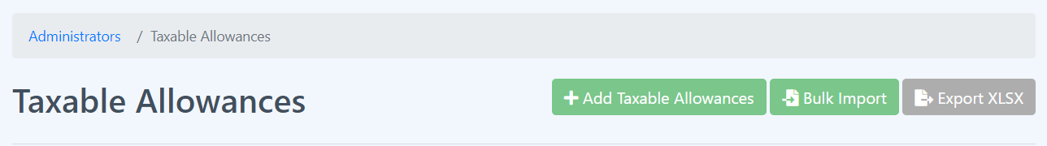

1. Fill all the required fields and click Submit button.

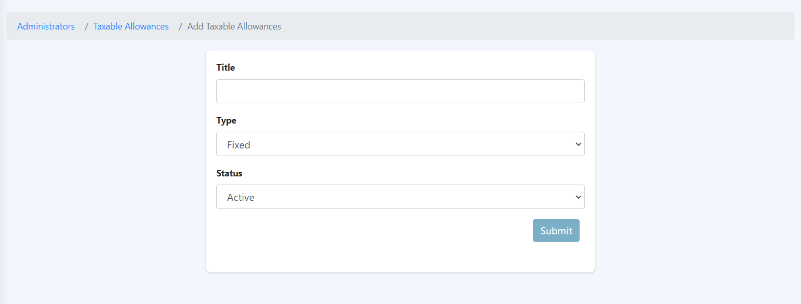

1. New added taxable allowance will be displayed in the Taxable Allowances Table.
2. Note that this page is where you can add new taxable allowance but not the amount. Stating the amount for each employee is different. If you want to add amount then please go to the Taxable Allowance in the Employee Module and look for Taxable Allowances page.

How to Bulk Import Taxable Allowances?

1. Click the Bulk Import button.



1. Follow the given set of rules.

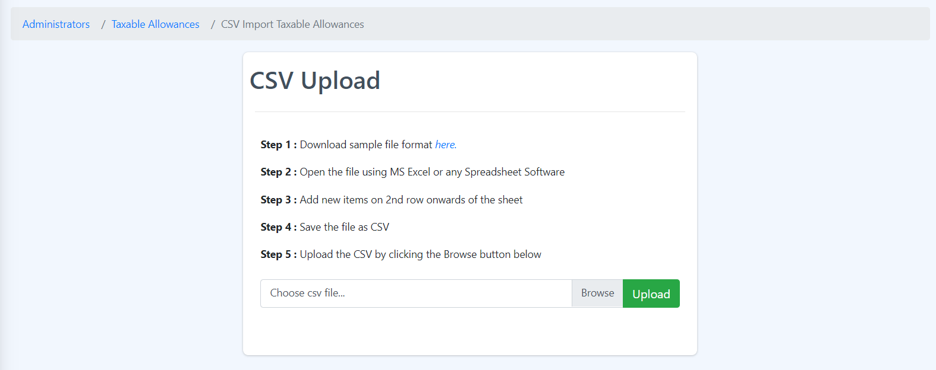

How to export or download the taxable allowances table?

1. Click the Export XLSX button.



1. It will directly or will instantly download the Taxable Allowances table.

How to change the status of the taxable allowances to Active or Inactive?

1. Select single or multiple rows by clicking the checkbox on the table - to select all the rows then just click the checkbox in line with the table header.

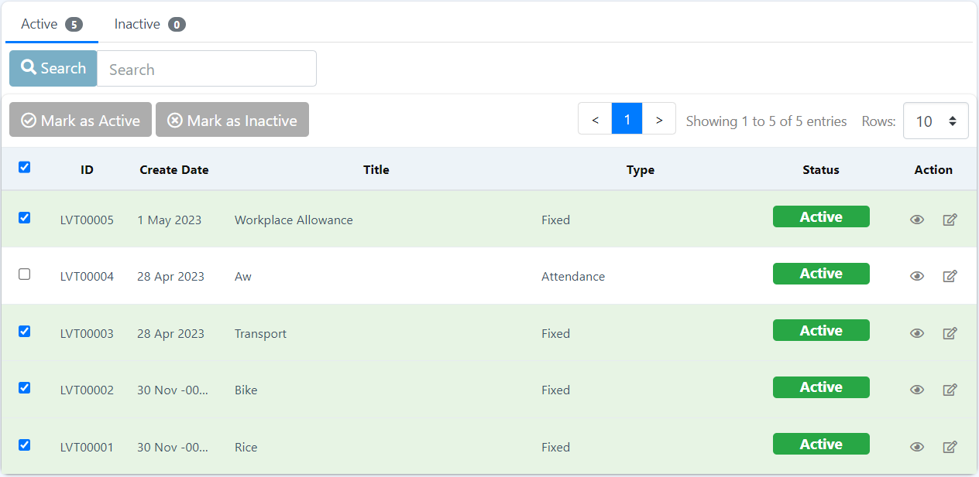

1. Click Mark as Inactive button.



1. A confirmation box will pop up, click the Submit button to make changes.

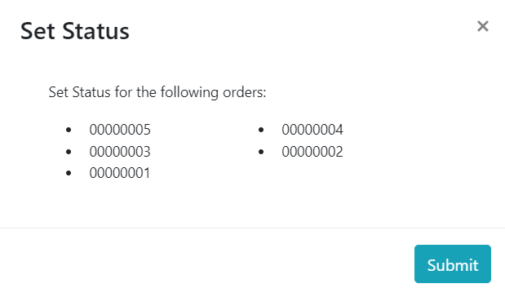

1. To change the status of the taxable allowances to Active, click the Inactive tab just right above the Mark as Inactive button.



1. Repeat Step 1 -3, in step 2 instead of Mark as Inactive click the Mark as Active button.

How to search?

1. Type a word in the search box.

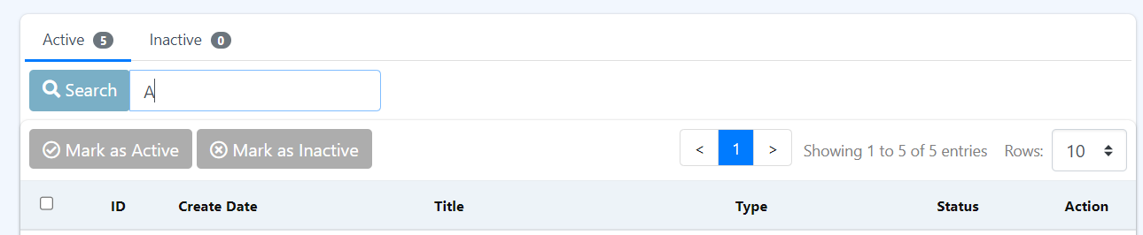

1. Click the Search button.

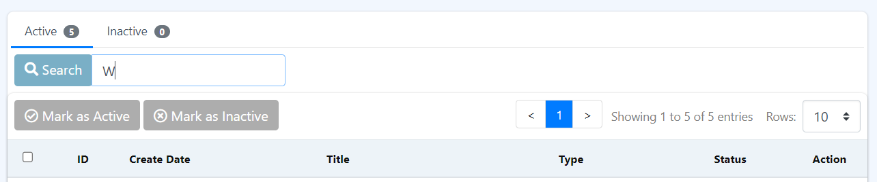

1. It will only search the Title column of the table.

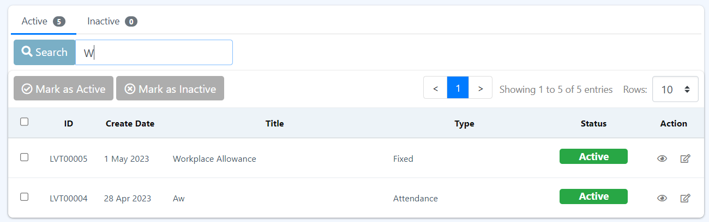

How to see more details about the Taxable Allowance?

1. Click the eye icon under the Action column on the row you wanted to see more details about it.

c

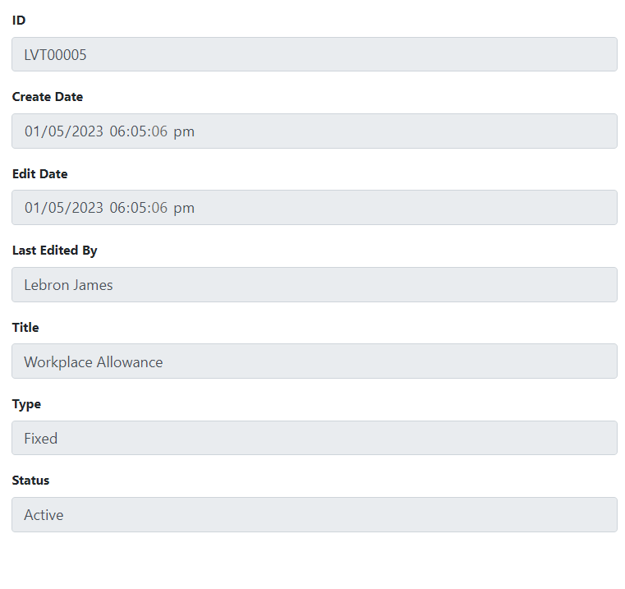

How to edit or update a Taxable Allowance data?

1. Click the edit icon beside the eye icon under the Action column on the row you want to edit.



1. Fill all the required fields and click Submit button.

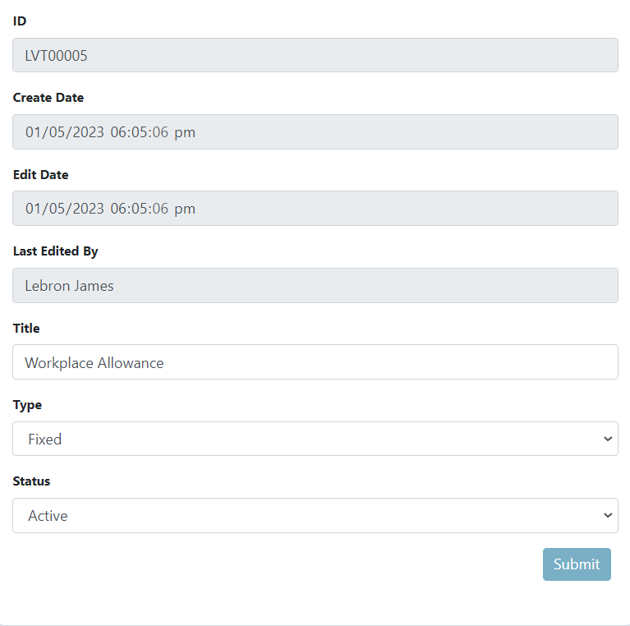

Note! *

Since all the settings have a standard template, please follow the steps given in the Taxable Allowance page, the difference is just you need to access the different pages by clicking the link provided at the right side of the screen.

9.5 Company Structure Settings

This sets the structuring of the company based on listed settings. His settings allow the user to filter the employees base on the active settings.

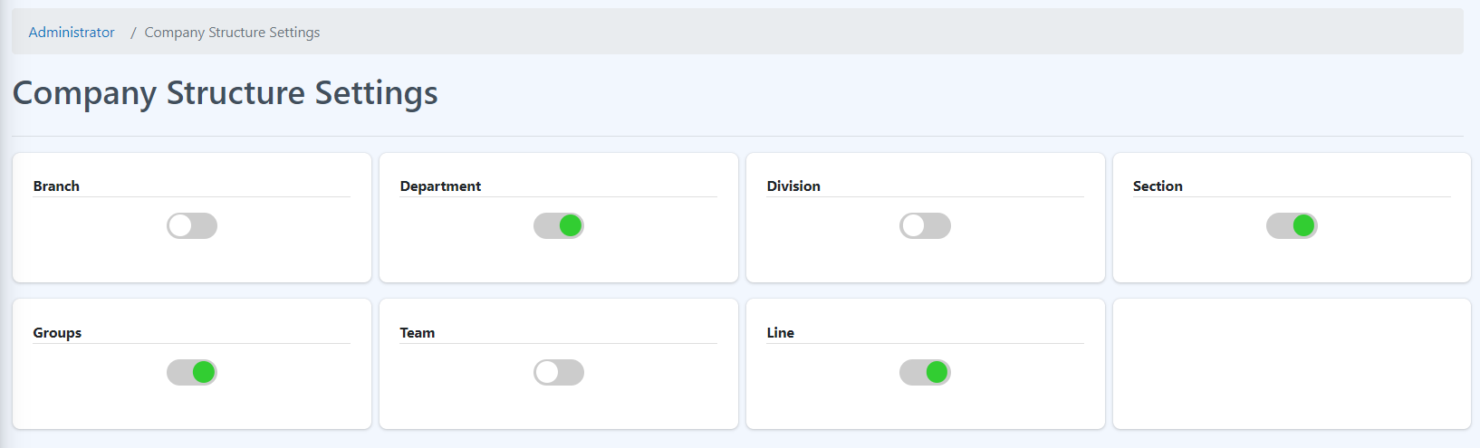

How to change the status of the company structure settings?

Just click the switch button to activate or deactivate the selected company structure settings. All Activated settings will be used as Filters to group the employees.



9.6 IP Address

This page shows the list of all available IP Addresses.

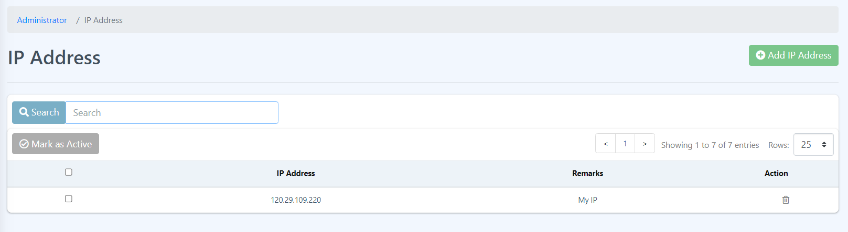

How to Add new IP?

1. Click the Add IP Address button.



1. Fill all the field required.

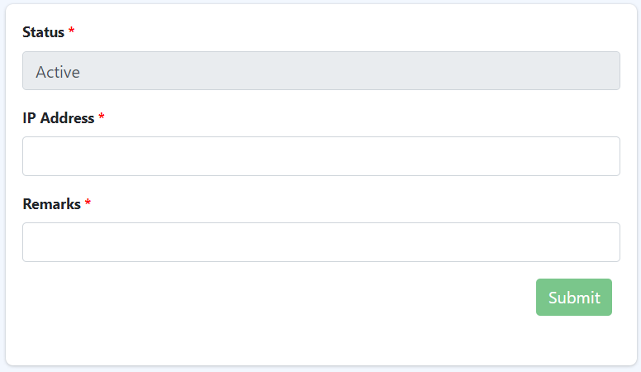

1. Click the Submit button.

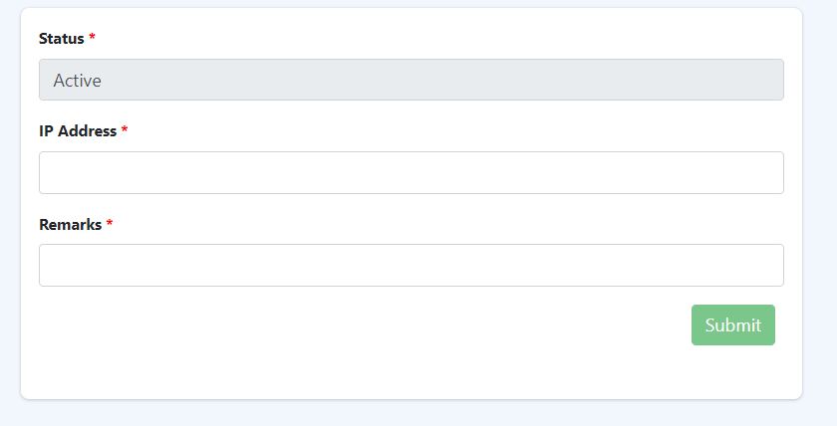

1. All added IP Address will be displayed in the IP Address page table.



How to delete IP Address?

1. Click the bin icon under the Action column on the row you want to delete.



1. Click the Yes, delete it button on the confirmation box.

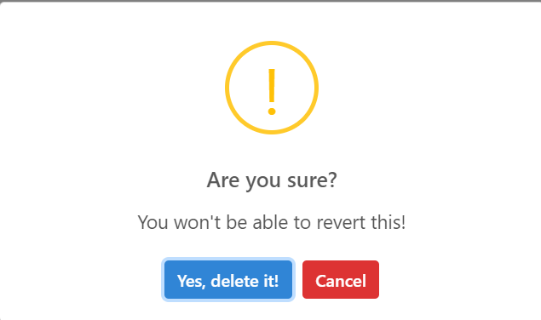

**General Settings**

This page is where you can change the general settings of the page such as Company Name and the Company Logo.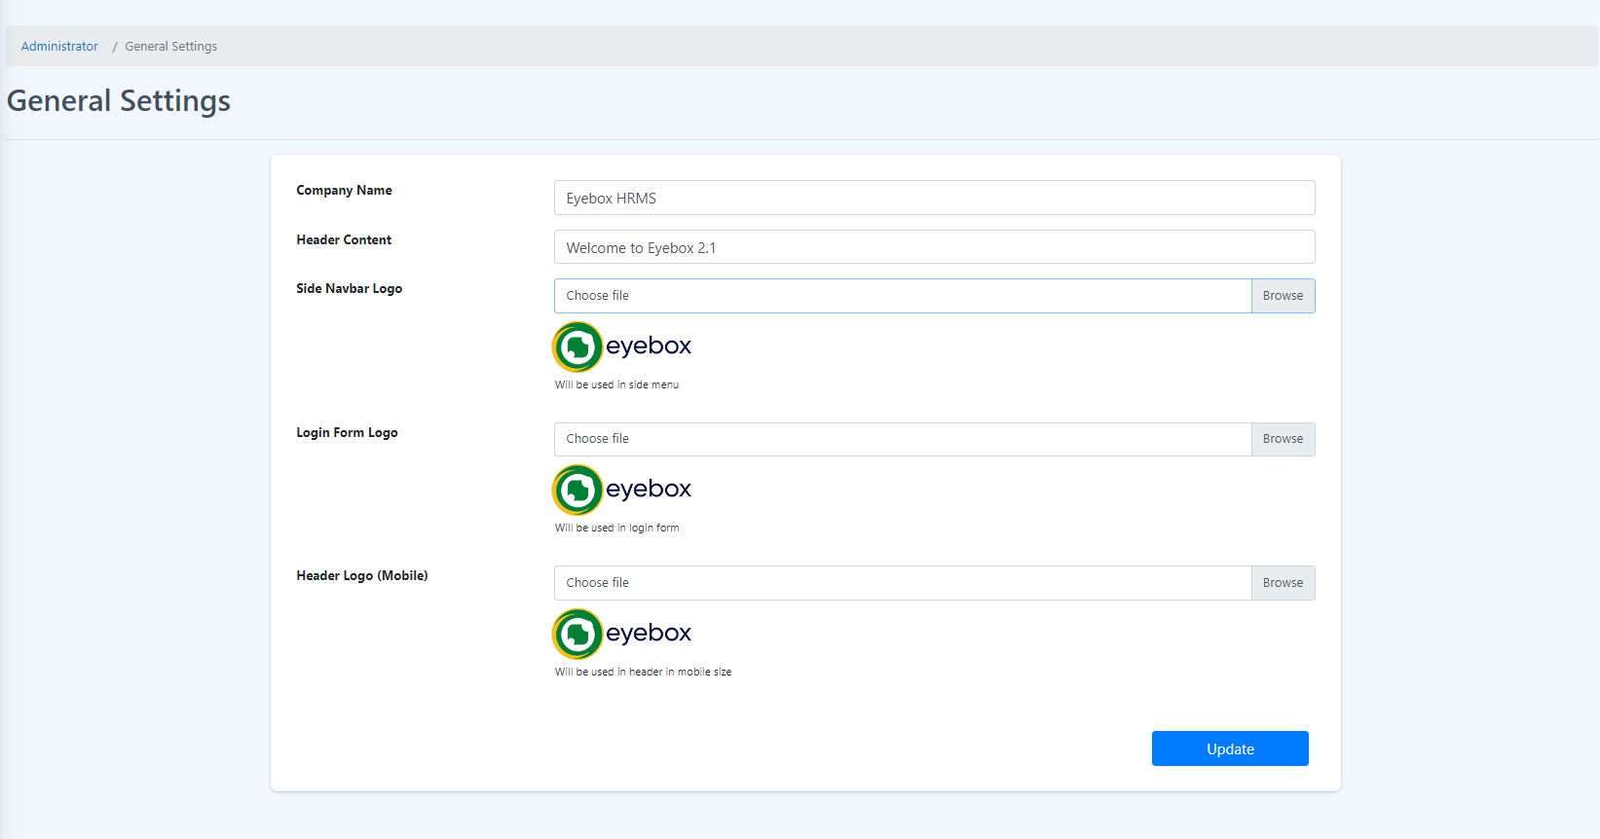

How to Update the general settings?

1. First identify which part is to be updated. For example, all are to be updated.
2. Clear the Company Name and enter a new name



1. Clear the Header Content and enter a new header content.



1. Click the Browse button or Choose file field and select your desired logo for Side Navbar.

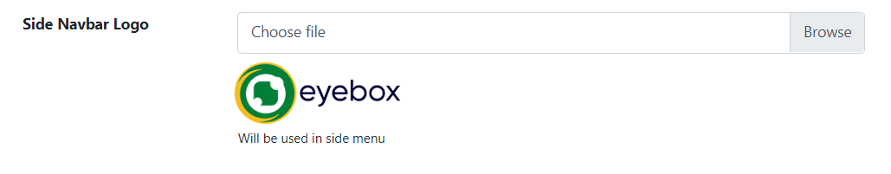

1. Click the Browse button or Choose file field and select your desired logo for Login Form Page.

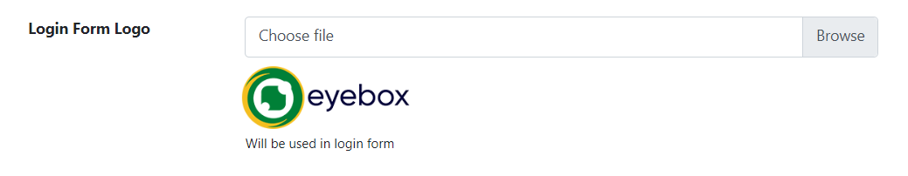

1. Click the Browse button or Choose file field and select your desired logo Header Logo (Mobile).

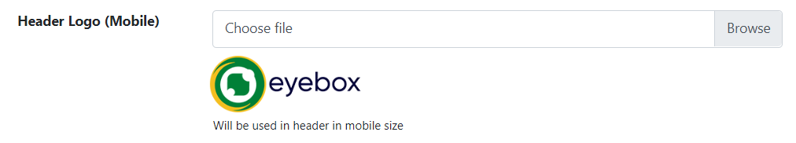

1. Click Update to save the changes.

