CSC 476 Numpy OpenCV warm up exercises

Lecture 1 in-class warming up exercises.

Jan 16, 2019

Due: Before class, Jan 23, 2019. No copy from the internet.

These exercises are expected to finish during and after class in the first week.

Numpy (7points)

1. Create a 3x3 identity matrix
2. Create a 3x3x array with random values
3. Create a 10x10 array with random values and find the min and max values
4. How to add a border (filled with 0s) around an existing array
5. Create a random vector of size 40 and find the mean value
6. Create a checkerboard 8x8 matrix using the tile function
7. Create a vector of 100 uniform distributed values between 0 and 1.

Matplotlib (3pts)

Here are some tutorials

<https://anaconda.org/gwinnen/matplotlib-exercises/notebook>

Using Numpy, Create a vector of 1000 random values drawn from a normal distribution with a mean of 0 and a standard deviation of 0.5

Hint: np.random.normal(mu, sigma, 1000)

Using matpliotlib and and create such a plot:

**import** **matplotlib.pyplot** **as** **plt**

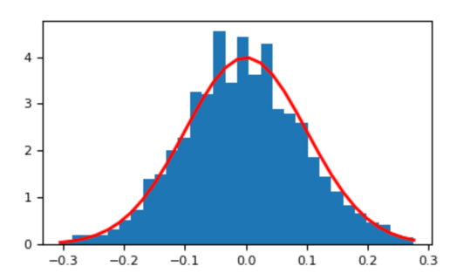

OpenCV (3pts)

1. Save an image as .jpg in your folder and load it the image in grasyscale. Display the image and when the user click any key, the image disappear.
2. Using cv2.imwrite() to save the image as .png
3. Find the brightest and darkest pixels value of the grayscale image.