Hear your point about “guessing” but Let’s look at the facts for what we are trying to achieve , combining system deliverables together to prevent bloat, and perhaps confuse people.. the object is to keep this simple if we can.

In a previous conversation we had, you “claude” told me that most of these system checklists were exactly the same, running the same order of deliverables.

If that is the case, then let’s list and omit the 4 systems that do no follow the same principles for now (I can manually fix them if required).

Now focussing on the ones that run the same, there will be 3 scenario’s.
Scenario 1
- Where deliverables for combined systems are verbatim (or very close to verbatim) and can be reduced to just one input required. See examples below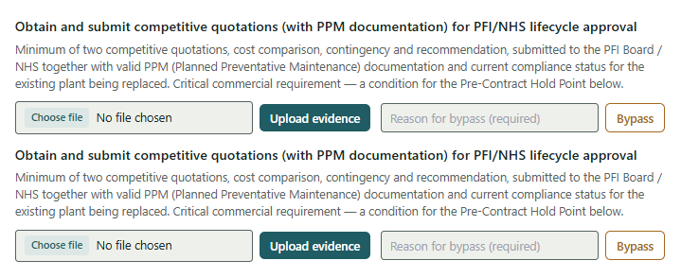
- 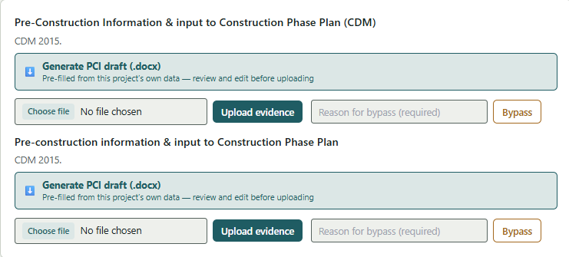
Both the above examples are exactly the same. There will only ever be one PCI document for a project, not per system

Scenario 2

- Where two deliverables start with the same word/s but because of the system , there spilt. See examples below.
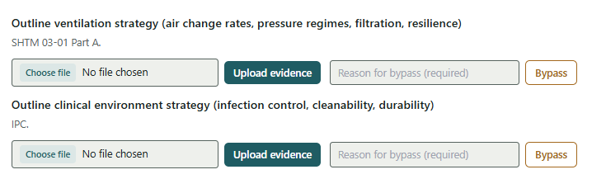

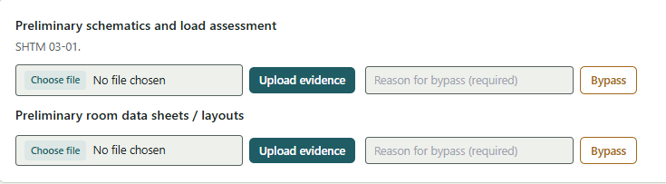

Scenario 3.

Where the deliverables are actually the same, but treated different, perhaps because of the working in the stage. The example below, one is actually a subset of the other. The top risk assessment calls out CDM 2015, SHTM 00, and HAI SCRIBE. The bottom one calls out CDM 2015 & HAIU SCRIBE only. so a sub-set

- 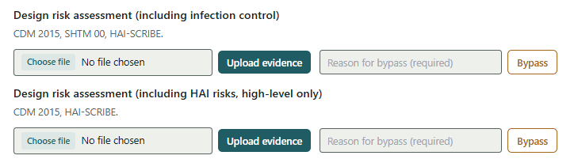

This is why I think we can still auto connect these system together , rather than running two separate lines.

