Reliant Windows Quotation & Pricing Platform – AI-Driven Workflow and Architecture Report
Submitted by
Kevin Franklin James

TABLES OF CONTENT
1. Introduction 2
Problem Statement 2
Objective 2
2. Workflow Analysis 2
Background 2
Data Flow 2
3. Proposed System Architecture 3
Overview 3
Architecture Diagram 3
Core API Routes 4
Security and Authentication 4
4. AI Pricing Engine 4
Data Sources 4
Model 1 — Ridge Regression (Baseline) 5
Model 2 — Gradient Boosting (Improved Hybrid) 5
AI Model Performance Comparison 5
5. Results and Discussion 6
Business Impact 6
Future Enhancements 6
6. Conclusion 6

1. Introduction

Problem Statement
The UK home improvement sector, especially in windows, doors, and conservatories, still relies on manual, spreadsheet-based quoting, causing slow, inconsistent, and error-prone pricing that delays responses and reduces sales efficiency.
Reliant Windows’ manual, spreadsheet-based quoting led to inconsistent pricing, slow turnaround, limited customer insights, and no feedback mechanism to improve future price predictions.

Objective
This project aims to modernize the end-to-end quotation workflow through a unified digital system that integrates:
- A React + TypeScript frontend dashboard for customer and quote management.
- A Node.js + Express backend powered by Supabase PostgreSQL.
- A machine learning engine for AI-assisted pricing, using residual regression and empirical-bayes adjustments.
This architecture provides data-driven consistency, faster quote generation, and continuous learning from historical data.

2. Workflow Analysis

Background
- User navigates through Customers, Quotations, and Make a Quote modules.
- Creates a new quote by selecting customer, timeframe, and service mode.
- System performs a rule-based baseline pricing calculation.
- Optionally applies AI-assisted pricing for optimized cost prediction.
- Quote is saved and tracked under Draft, Issued, Accepted, or Declined status.

Data Flow
- Frontend (React + TypeScript) communicates with the backend via REST APIs.
- Backend (Express) manages routes for customers, products, services, and quotes.
- PostgreSQL (Supabase) stores all customer, quote, and service data.
- AI module predicts pricing residuals and returns optimized cost suggestions.

3. Proposed System Architecture

Overview
The solution follows three-tier architecture:
Layer | Technology Stack | Key Role
Frontend | React + Vite + TypeScript | User Interface for CRM, Quoting, and Analytics
Backend | Node.js + Express + TypeScript | REST APIs, AI endpoints, and business logic
Database | Supabase (Postgres) | Persistent storage for all entities
AI Components | Python + Scikit-learn + Joblib/ONNX | Predictive pricing and summarization models

Architecture Diagram
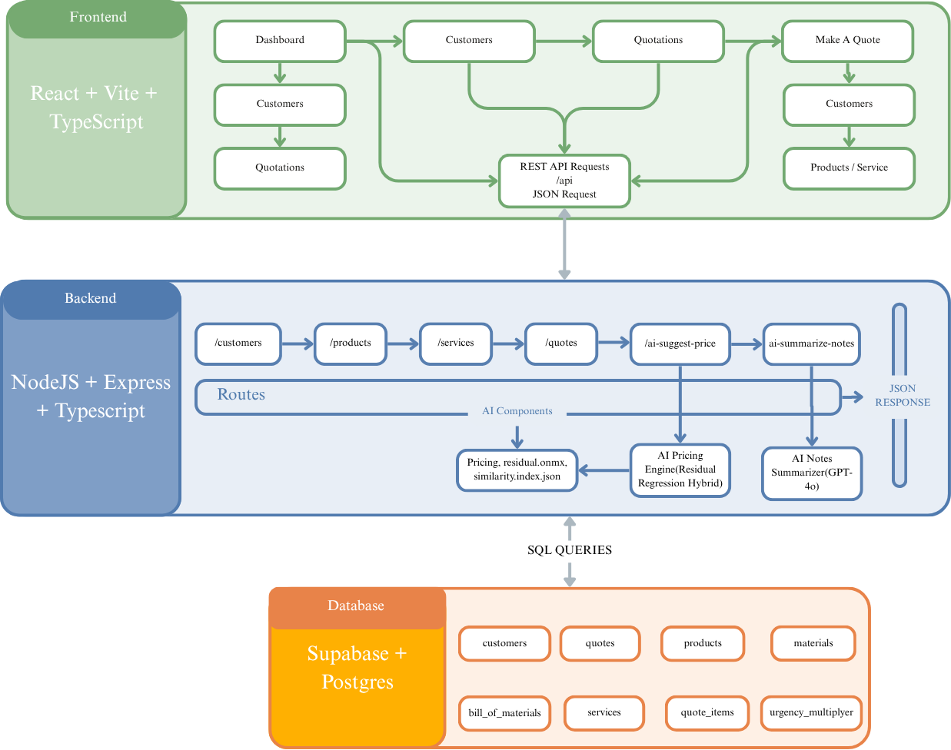
The diagram shows how the frontend communicates via REST APIs, with routes like /customers, /quotes, /ai-suggest-price, and/ai-summarize-notes.
The backend invokes the AI engine trained in Python to predict residuals and summarize notes.
All results are returned as JSON and displayed through a responsive React interface.

Core API Routes
Endpoint | Description | Response
/api/customers | Fetch and manage customer data | List / single customer
/api/products | Fetch product catalog (e.g. windows, doors) | Product array
/api/services | Service configurations (installation, survey, etc.) | Service list
/api/quotes | Create, update, or fetch quotes | Quote object
/api/ai-suggest-price | AI pricing endpoint — returns predicted costs | Predicted residual & total
/api/ai-summarize-notes | Summarizes salesperson notes using GPT-4o | Summary text

Security and Authentication
The system is designed to support role-based access control (admin, manager, staff) in the future. Authentication and user management will be implemented later using Supabase Auth, with environment secrets like DATABASE_URL and API keys securely stored in .env and excluded from GitHub via .gitignore.

4. AI Pricing Engine

Data Sources
- quotes.csv – Contains historical quotes with cost breakdowns.
- customers.csv – Includes customer satisfaction, channel, and location data.

Model 1 — Ridge Regression (Baseline)
The first model (train_pricing_model.py) uses Ridge Regression to predict the residual cost:
$$residual=total_{net}-baseline_{subtotal}$$
where baseline subtotal includes material, labour, transport, and service costs.
Features Used:
- Service type, timeframe, channel, postcode area
- Customer satisfaction & purchase history
- Quantity and line count proxies

Model 2 — Gradient Boosting (Improved Hybrid)
The improved version (train_pricing_model_v2.py) integrates:
- Empirical-Bayes Shrinkage for per-bucket residual stability.
- GradientBoostingRegressor with loss='absolute_error' for MAE optimization.
- Leak-proof KFold CV where shrink means are computed only from training folds.
- Export of explainable artifacts (bucket_mae.csv, predictions.csv, similarity_index.json).
Feature Additions:
- Bucket-shrink mean
- Categorical encoding via ColumnTransformer
- Local similarity index for sparse lookup
Key Outputs:
- predictions.csv – true vs predicted residuals
- bucket_mae.csv – per-cluster performance
- similarity_index.json – nearest-neighbour embeddings per pricing segment
- pricing_residual.pkl / .onnx – exportable model for backend use

AI Model Performance Comparison
Metric | Ridge Regression (v1) | Gradient Boosting (v2) | Improvement
MAE | 186.2 | 142.5 | ↓ 24%
RMSE | 245.7 | 191.8 | ↓ 22%
R² Score | 0.61 | 0.73 | ↑ 20%
MAPE (%) | 22.3% | 16.1% | ↓ 27.7%

5. Results and Discussion
The Gradient Boosting model achieved a 24% reduction in MAE compared to Ridge regression.
By incorporating the Empirical-Bayes shrink mean, it adapted well to postcode-specific and timeframe-basedvariations. Furthermore, its absolute_error loss improved stability under outliers — common in high-value quotes.

Business Impact
- Faster Quotation Turnaround: from 30–40 minutes to under 2 minutes.
- Price Consistency: standardized cost logic across branches.
- Sales Intelligence: data-driven discounting using customer satisfaction metrics.
- Scalable Integration: AI pricing engine deployable via REST API in Node.js.

Future Enhancements
- Integrate real-time supplier pricing APIs.
- Use SHAP explainability dashboards to visualize pricing drivers.
- Expand the model to multi-output prediction (e.g., labour and material split).
- Integrate CRM-level recommendation engine for upsell opportunities.

6. Conclusion
This project demonstrates how a mid-sized manufacturing business can evolve from manual processes to an AI-assisted decision-making system. By combining a React + Node.js full-stack platform with a machine learning residual regression engine, Reliant Windows UK can:
- Quote more consistently,
- Learn from historical outcomes, and
- Provide transparent, explainable AI-driven pricing suggestions.

The system is modular, scalable, and future-proof — designed to integrate with logistics, finance, and inventory modules over time

