CSC3320 System Level Programming Lab

Assignment 2 - Part 1 (In-lab)

Instructor: Fil Rondel

Purpose: Learn use the man utility to get help on using other Unix utilities.

Practice with the basic utilities for managing files and directories in a terminal.

Notes:

* Due same day.
* Write a report by answering the questions and attaching the required screenshots in part B and upload the report (called Lab2_FirstNameLastName.pdf or

Lab2_FirstNameLastName.doc) to Google Classroom no later than 11:59 pm on the date you are taking this lab session.

Connect to snowball by typing the following command and press "Enter".

ssh CampusID@snowball.cs.gsu.edu

Part A: Try to use the man utility.

The man utility can provide the on-line copies of the original UNIX documentation for the other utilities. In the manual page, the first part is the functionality of a utility, the second part is the synopsis, the third part is the description and lists different features of a utility with different options. Then please follow the steps to learn some options provided by cat.

1. Check the manual page cat by typing the command below and press "Enter".

man cat

1. The terminal only displays one window of the manual page. You can scan through the whole manual page by press "f" or SPACE to forward one window, and "b" to backward one window. Or you can press "h" to find out more commands to scan through the manual page.

1. Check the description for option -n. You may find the description as below:

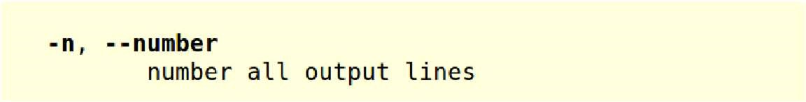

1. Check the description for option -s. You may find the description as below:

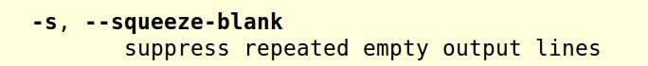

1. Quit the manual page by press "q"

Part B: Unix basic commands on managing the files and directories.

1. Make sure that you are connected to snowball successfully. Then go to your home directory by typing the following command, followed by pressing "Enter". cd ~

1. Display current working directory:

pwd

# - Question A): What is the working directory? Please write down the full path

/home/kgallardowepster1

1. List the content in current working directory:

ls

1. Create a new folder "csc3320" in your home directory:

mkdir csc3320

1. Repeat step (3).
   * Question B): What is the difference in the output compared to the output from step (3) ? Describe what the difference is.

Now there is a folder named csc3320 and before there was nothing.

1. Navigate to "csc3320":

cd csc3320

1. Display current working directory.
   * Question C): Which command should be typed?

pwd

1. Create a new folder called "lab2" in csc3320.
   * Question D): Which command should be typed?

mkdir

1. Go to the newly created "lab2" folder.
   * Question E): Which command should be typed?

cd

1. Create a new file called "myLab2.txt" and put your own name in this file by typing the command below:

cat > myLab2.txt <Enter>

My name is FirstName LastName <Enter>

<Ctrl-D>

Note : <Enter> means press the Enter key; <Ctrl-D> means hold Ctrl and press D

- Question F): There is a special character ">" between "cat" and "myLab1.txt". What does this character do? And why we need to press "Ctrl-D" at the end of input?

> is called append and it points to the file to go into. The reason you press “Ctrl-D” at the end of the input is to let the shell know that you are done writing input for the text file.

(11) Display the content in "myLab2.txt" with line numbers by typing the command below and press "Enter".

cat -n myLab2.txt

- Question G): Attach a screenshot of the output.

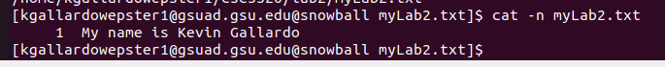

(13) Go to your home directory using the absolute path by typing the command below and press "Enter". cd <Answer from step(2)>

Note : Please replace the blue part with the answer from step (2)

- Question H): Then issue the command pwd again. Attach a screenshot of the output.

