Assignment 2: Association Analysis

Due: October 12 2015 11:59PM

Two datasets (Market, Gene) can be found on Piazza. For each dataset, we provide two formats. The first uses the transaction-item representation discussed in class, the second uses a binary representation—Each column represents an item and each row denotes a transaction. If the transaction contains the item, the corresponding value is 1, otherwise it is 0.

In this assignment, you are asked to implement Apriori algorithm that discovers a collection of frequent itemsets from a transaction database.

Please take the following steps:

1. Implement Apriori algorithm. The pseudo code can be found below.

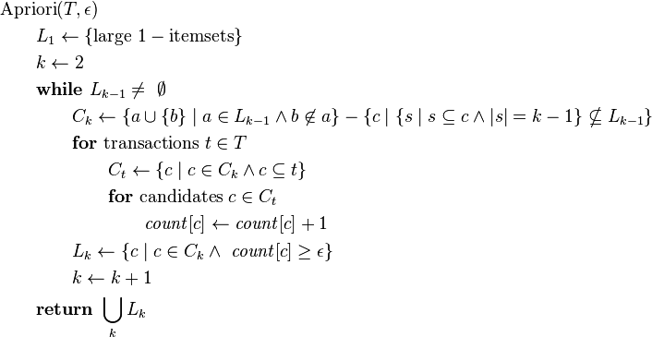

2. Apply your implemented Apriori on the Market dataset with minimum support threshold=50%. You should get the following candidate itemsets (Ck) and frequent itemsets (Lk):

Candidate itemsets:
C2: {Eggs,Key-chain}, {Eggs,Mango}, {Eggs,Onion}, {Eggs,Yo-yo}, {Key-chain, Mango}, {Key-chain, Onion}, {Key-chain,Yo-yo}, {Mango,Onion}, {Mango,Yo-yo}, {Onion,Yo-yo}
C3: {Eggs,Key-chain,Onion}, {Key-chain,Mango,Onion}

Frequent itemsets:
L1: {Eggs}, {Key-chain}, {Mango}, {Onion}, {Yo-yo}
L2: {Eggs,Key-chain}, {Eggs,Onion}, {Key-chain,Mango}, {Key-chain,Onion}, {Key-chain,Yo-yo}, {Mango, Onion}
L3: {Eggs, Key-chain,Onion}

3. If you get the same collection of itemsets at Step 2, you can proceed to apply your implemented Apriori algorithm on the Gene dataset with minimum support threshold=50%. You should be able to get 51 length-1 frequent itemsets (L1), 1275 length-2 candidate itemsets (C2), 29 length-2 frequent itemsets (L2), 20 length-3 candidate itemsets (C3) and 2 length-3 frequent itemsets (L3).

4. Prepare your submission. Your final submission should be a zip file named as First Name_Last Name.zip (e.g., Jing_Gao.zip). In the zip file, you should include:
- A folder “Code”, which contains all the codes used in this assignment. Inside the folder, please have a file “README” which describes how to run your code.
- Report: A doc or pdf file named as First Name_Last Name.doc or First Name_Last Name.pdf The report should consist of the following parts: 1) The frequent itemsets you obtain on Gene dataset (L1, L2, L3). 2) The length-3 candidate itemsets generated during Apriori (C3). 3) The codes of your Apriori algorithm implementation.

5. Log in any CSE department server and submit your zip file as follows:
submit_cse469 Jing_Gao.zip
(replace “Jing_Gao” by your name)

Please refer to Course Syllabus for late submission policy. We will take the submission time recorded by the server as the time of your submission.

This assignment must be done independently. Running your submitted code should be able to reproduce the plots in the report. Note that copying code/report from another group or source is not allowed and may result in an F in the grades of all the team members. Academic integrity policy can be found at http://www.cse.buffalo.edu/shared/policies/academic.php

