Tanzania at ADM Level 1 in 2017

test1

## Population Pyramid: 2017

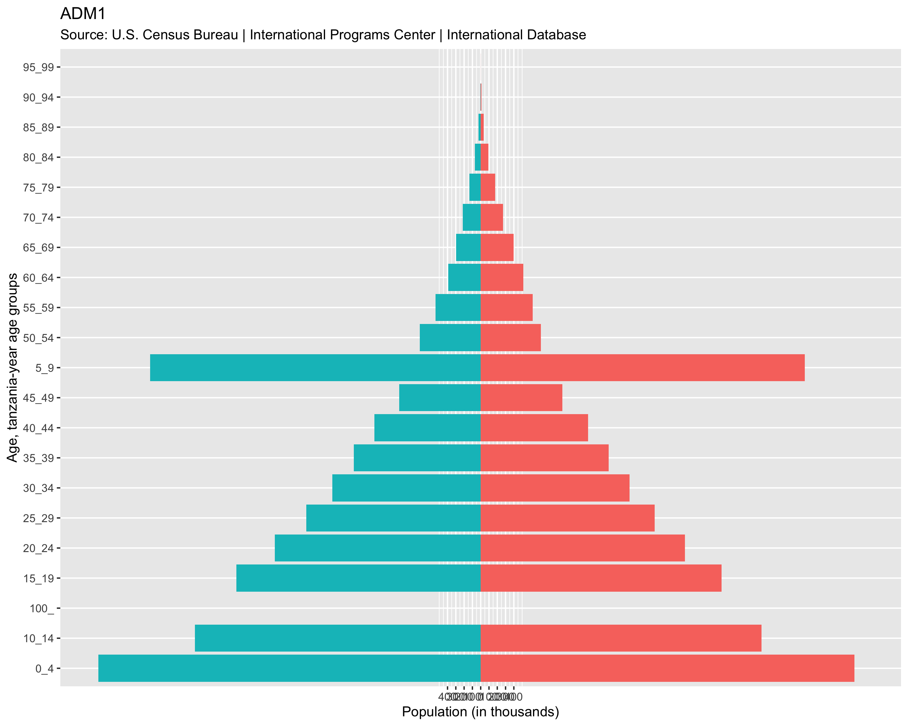

## Choropleth Map: Tanzania 2017

