Arrest Analysis: Exploring Arrests in Los Angeles City based on Age Group, Race, Location, Socio-Economic Status, their Causes and Effects

George Mason University

AIT-580-002 | Prof. Dr. Harry Foxwell

Kevin Gunalan Antony Michael Raj

George Mason University

Fairfax, Virginia

kantonym@masonlive.gmu.edu

**Abstract**

**Crime data are being analyzed worldwide since there has been an increasing trend in crime data. On the contrary, there is less analysis for arrests. The dataset used in this analysis has data for the years 2020 and 2021. The city of Los Angeles dataset has some famous areas such as Beverly Hills, Bel Air, Hollywood, Santa Monica, Long Beach, etc. The analysis is done based on age group, race, location, socio-economic status, the hour of the day. In-depth analysis is performed for the top contributor to gain some useful insights. This paper investigates a range of aspects to utilizing the available data to the fullest. It is shocking to realize that people are arrest on a pattern basis, meaning, to prevent them from getting necessary medical care and social services because mostly they will be doing jail time. Society frames the Hispanics and Blacks to be the troublemakers, but they fail to understand that it is because of poverty, unemployment, and racism that leads to their anger and frustration, making them do things such as vandalism, corporal injury, etc.**

*Keywords – Los Angeles, Aggravated Assault, Python, R, SQL, Victimization, Poverty, Hispanics, Descent, Socio-economic*

**I. INTRODUCTION**

Researching about age group identifies the vulnerability of youngsters to certain crimes might help us to prevent them at the initial stage. For example, if the youngster can susceptible to narcotics crimes, they can be rehabilitated before it becomes uncontrollable. Regarding descent-based crimes, identifying can help to keep a check on those kinds of people for specific crimes. Researching helps authenticate if arresting people for crimes are effective, because if a person is arrested for burglary, then it should not occur that again. Determining similarities and difference helps to category crimes based on crimes & arrests helps to categorize areas based on crimes. Moreover, helps identify whether being rich or poor contributes to certain crimes. Driving under influence (DUI) crimes need to be controlled as much as possible, because they contribute towards other types of crimes, as discussed earlier. The analysis must be done to ensure that these policies and rules are severe with effectiveness. Lastly, identifying whether the time of the day (Broad Daylight to Pitch Dark) plays an important for crimes to occur. Usually, burglary, narcotic-based crimes take place after sunset, similarly, crimes such as assault, vehicle theft, carrying weapons take place in daylight.

The dataset contains useful parameters such as booking location, booking time, etc. that help us to understand whether the arrest has been done immediately after the crime has been reported or not. To conclude, it is important to analyze this dataset because it helps us to avert numerous crimes before occurring.

**II. RELATED WORK**

There are three different journals/articles that are relevant to the research topics of my interest, namely, “Red Lights and Handcuffs: The Effect of Arrests on the Fear of Crime”, Examining Gender- and Drug-Specific Arrest Counts: A Partial Test of Agnew’s General Strain Theory”, and “Racial Disparities in Arrests: A Race Specific Model Explaining Arrest Rates Across Black and White Young Adults”. All these resources were taken from the George Mason University library.

[1]Effective of arrest was dealt in the first article/journal, whether arrest suspects in the neighborhood causes a rise or fall in fear of crimes. Although arrests help people to show police effectiveness and decreasing of threat, it is was found that flashing red lights, blaring sirens, and seizure of the suspect caused the fear of crime to increase. The criminal offending mostly concealed is often unaware of the crime committed in the communities. Interpretation of visual markers plays a significant role in establishing a connection between arrests and fear. Displaying the arrests in front of the residents can increase serious criminal activity, thus intensifying the fear of crime. More visible crimes and signs of the disorder can provide a warning indicator to the resident about dangers lurking in their community, thus increasing their level of fear. Not all residents get affected by visual markers, only the ones nearby to the arrests, the remaining ones are influenced by the residents who spread the information about the arrest through gossip or social media. These networks help update the information to the residents and initiating a fear of crimes soon, this is known as Neighbor Cohesion. The outcome of the project gives a clear picture that arrests increase fear of victimization, especially if being a female result in a significant increase in fear, whereas education and income show a negative relationship towards fear of crime.

The above article/journal focuses on the effectiveness of arrests against resident’s fear, but to infer, arrests seem to increase the fear, but my proposed research topic emphasizes the effectiveness of arrests to suspects, whether arresting people, reduces crime rates. Hence, the research article/journal summarized above is quite different from my topic based on the target group and outcome.

[2]The second article is an analysis of gender-differentiated drug-specific arrests in association with socio-economic, demographic, law enforcement, and drug mortality characteristics of cities. The drug analysis is based on cocaine, crack, heroin, marijuana, and methamphetamine, and data were obtained from the National Incident-Based Reporting System (NIBRS), American Community Survey (ACS), Law Enforcement Management and Administration Statistics (LEMAS), and Centers for Disease Control and Prevention (CDC). The absence of strong social support and controls can create a negative behavior that eventually leads to criminal pathways from childhood into adulthood. According to the study, poverty, unemployment, family disruption, directly impacts the loss of positive provocations, thus increase in negative effects, leading to amplification of criminal activities. Despite female dominance over males in terms of drug use, purchasing, and selling drugs, women are less likely to get arrested than males in some offenses. Effects of ethnic and racial factors are less consistent. The Hispanic race has fewer overall female drug arrests, similarly reduced the number of arrests for heroin in both males and females. On the contrary, more arrests of cocaine among males. Thus, it can be inferred the socio-economic factors such as poverty, unemployment, family disruption, etc. are the same between genders and across all drug types.

The research topic does not contain gender-specific crimes, but it includes drug crimes. Unlike the gender contribution towards drug crimes, the study states that unemployment and poverty play an important role in drug-based crimes, so it is similar to some extent, but the topic that I had chosen is to identity crimes based on the poorest and richest communities of LA.

[3]The third article/journal emphasis on racial inequalities in arrest between white and black Americans. Based on the analysis, black people were arrested 7 times more often than white people. Focusing on the percentages, age group of 18-23, black males are 30-49% at risk of getting arrested, whereas white people are at 22-38%. Factors that influence are difficulty in obtaining an education, unemployment, marital status, etc. Black people are more likely to get arrested for drug-related crimes compared to white people, also once arrested, they are more likely to get arrested again. There were seven behaviors, namely, carrying a handgun to school or work, using someone’s credit card, taking part in group fights, stealing, damaging property, and selling drugs. Exposure to violence and family bond has a stronger correlation to drug use. Thus, being black has a higher likelihood of getting arrested compared to white individuals.

The proposed research topic, “How are the crimes biased towards the people’s descent, does a particular race descendant commit an only specific type of crime”, is closely related to the above-discussed article. But, in my case, the analysis is going to predict the crimes that are committed by a specific race, unlike the article that discusses only black and white individuals. Moreover, the article focuses upon the magnitude of black and white race arrest, whereas the proposed topic stresses the classification of crimes based on race.

**III. DATASET**

The dataset was obtained from data.gov, which is a repository of government data made open for public usage. The dataset comes under the category of “Local Government”, precisely, it concerns arrest incidents that have taken place in the City of Los Angeles. Analyzing this dataset helps us understand the distribution of crimes among the different areas of Los Angeles. Based on that, preventive measures can be incorporated in those areas to subside primary crimes that occur often. For instance, Hollywood majorly comprises of “Aggravated Assault[1]” and “Narcotic Drug Laws” based crimes, hence the

LAPD would need to focus on these two crimes and take preventive measures. The research topic to be focused on is “Drunkenness” because most of the occurred crimes are outcomes of being drunk. Analyzing and implementing stringent policies for consuming alcohol, can prevent a lot of crimes beforehand.

Figure 1

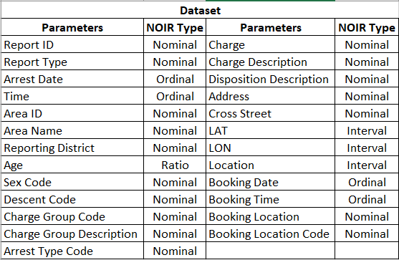

**IV. TOOLS & FRAMEWORKS**

This research analysis was done using two programming languages, one relational database query language and one Microsoft Office tool for data cleaning, data wrangling, data exploration, statistical summarization and analysis, and graphical visualizations. The tools used were Python, R, Excel, and MYSQL and their respective applications are Jupyter Notebooks, RStudio, Microsoft Excel, and MySQL Workbench. Data cleaning & preprocessing works were distributed equally among Python and R programming languages. Initially, the .csv file is imported into Microsoft Excel, later on, imported into Python Jupyter Notebook. Data processing libraries such as Pandas, Numpy, and visualization libraries like Matplotlib, Seaborn are imported. The dataset is converted into a Pandas data frame which is checked for NA values for each column. Unimportant columns and high NA columns are dropped. With the of Matplotlib and Seaborn plots such as histogram, correlation heatmap, bar plots, boxplots, etc. Moreover, these plots help us understand specific areas or patterns in the dataset that are not visible on the dataset as a whole. Correlation analysis was to interpret the relationship strength between different parameters in the dataset. Analysis using visualizations helps to understand the trends and relationship that fails to be provided by the dataset without graphics.

Figure 2

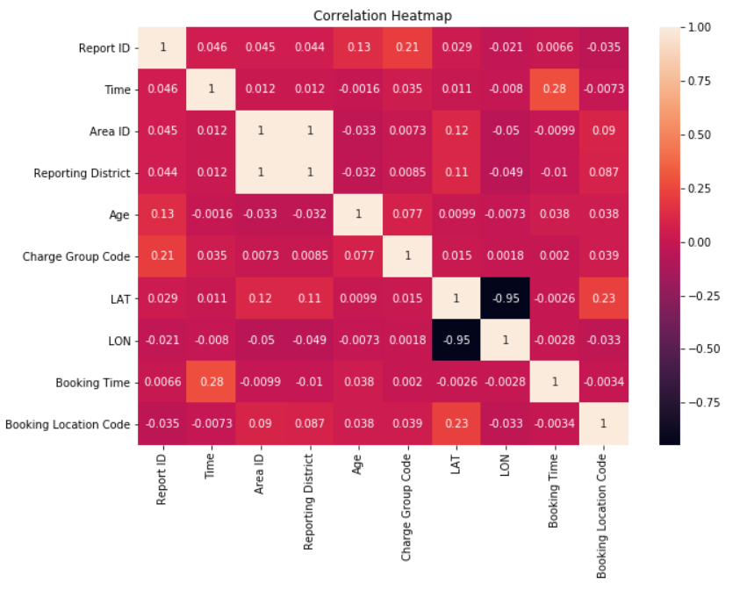

As discussed, a correlation matrix was produced, with the help of the Seaborn library, a correlation heatmap is plotted. According to the heatmap, there is not much correlation between the parameters, but there is an appreciable correlation between “Booking Time” and “Time”. This can be misleading because both the parameters are almost the same, eventually leading to multicollinearity, which weakens the statistical power of the regression model if using any. Other correlation pairs are “Charge Group Code” & “Report ID”, “Age” & “Report ID” and “LAT” & “LON”.

Figure 3

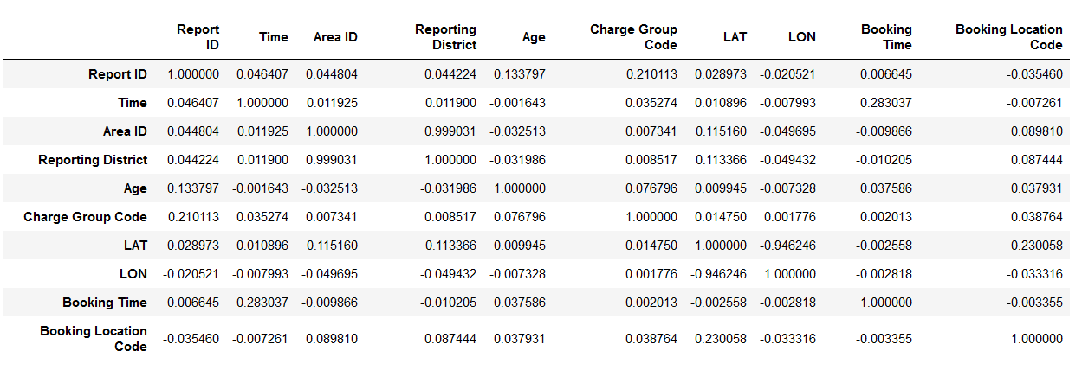

**V. ANALYSIS**

In this research, various aspects of the datasets are researched to present meaningful outcomes with the help of visualizations. The dataset was cleaned, with remaining columns such as report ID, arrest date, time, age, charge group description, charge description, lat, lon, etc. The analysis is as follows: A. Age Group B. Descent C. Location D. Socioeconomic Status E. Driving Under Influence (DUI) F. Hours of Day.

1. *Age Group*

First, the arrests are analyzed based on the “Age” parameter, to understand the most perilous age group that contributes to most of the crimes that get them arrested. Determining these categories of people helps the police department to better control them. The histogram helps to identify the category. Using python, the age column belongs to “Ratio” datatype, leading to a much-congested plot, to prevent this, the values are converted to categories, namely, 0-10 yrs - Kid, 10-17yrs – Teen, 17-35yrs – Young Adult, 35-50yrs – Middle-aged Adult and finally 50-110yrs - Older Adult. Matplotlib library plots a histogram for those defined age groups.



Interpreting from the plot, it is seen that the age group “Young Adult” seems to have been arrested a greater number of times. Once this group is identified, further analysis can be performed. Before processing with in-depth analysis, a box plot between age and descent code might help to pinpoint the race of people that get arrested frequently. According to the boxplot, it is found that “B – Black”, “H – Hispanic/Latin/Mexican”, “O – Other”, “W – White” are common in most of the age groups.

Figure 4

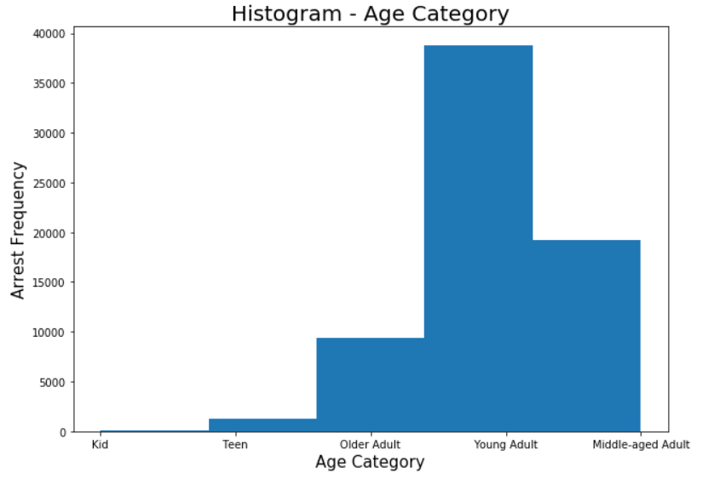

Even descent plays a significant role in the crimes to occur because most of them might be refugees or immigrants that are in the state of poverty causing them to become mentally unstable, pushing them to do crimes. Moving forward, filtering the age group (18-35 yrs) and analysis is performed by using the “group by” function in the Pandas library, the “Charge Group Description” parameter. This categorizes those age group people into their respective crime type, giving an idea of majority occurring crimes. Thus, it can be interpreted as to which crimes are caused by what age groups.

Figure 5

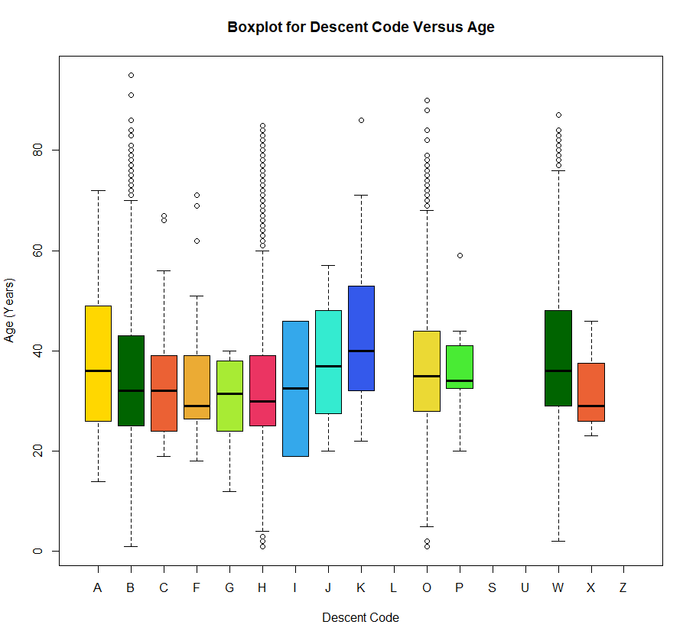

It can be inferred from the output of group by function, the top 5 most frequent arrest are “Miscellaneous Other Violations” – 6208 arrests followed by “Aggravated Assault” – 5295 arrests, “Driving Under Influence” – 4090 arrests, “Narcotic Drug Laws” – 3911 arrests and “Other Assaults” – 3572 arrests. Focusing on “Miscellaneous Other Violations”, this can be divided into various sub-category charges, to name a few, “Vandalism”, “Domestic Violence”, “Deface Property”, and many more.

Figure 6

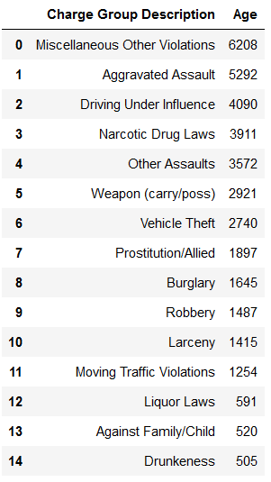

A similar group by function is applied and output is attached. Vandalism[2] contributes highest with 570 arrests towards the miscellaneous violation category. [4]The reason for younger adults to contribute more to vandalism is because of peer pressure, to impress a girl, or part of an initiation in a gang. [4]Another reason might be out of frustration caused by the system or society, so they want to show their anger by vandalizing things. Most of the charges are based on property damaged, this depicts that youngsters were not taught about moral values, faced hardships, and uncontrollable energy without knowing how to channelize it.

Figure 7

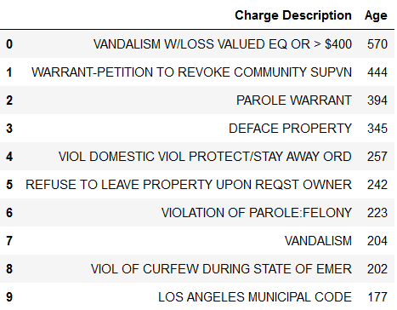

Similarly, the next highest “Charge Group Description” arrests are “Aggravated Assault”.

Figure 8

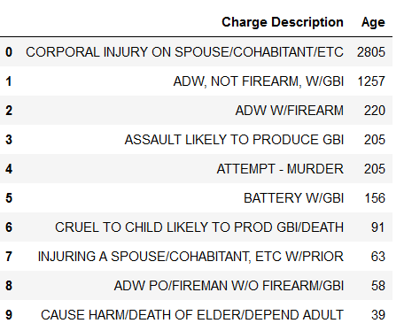

Further analysis on its sub-categories, represents that “Corporal Injury on Spouse/Cohabitant/Etc. has the highest percentage in “Aggravated Assault” category. The traumatic condition leading to injury leads to a felony charge of corporal injury. The above plot depicts the analysis which was discussed earlier. The first plot is “Charge Group Description” with the highest charges being “Miscellaneous Other Violations” (highlighted in red). Followed by two subplots, which are the subcategory of “Miscellaneous Other Violations” and “Aggravated Assaults”.

Figure 9

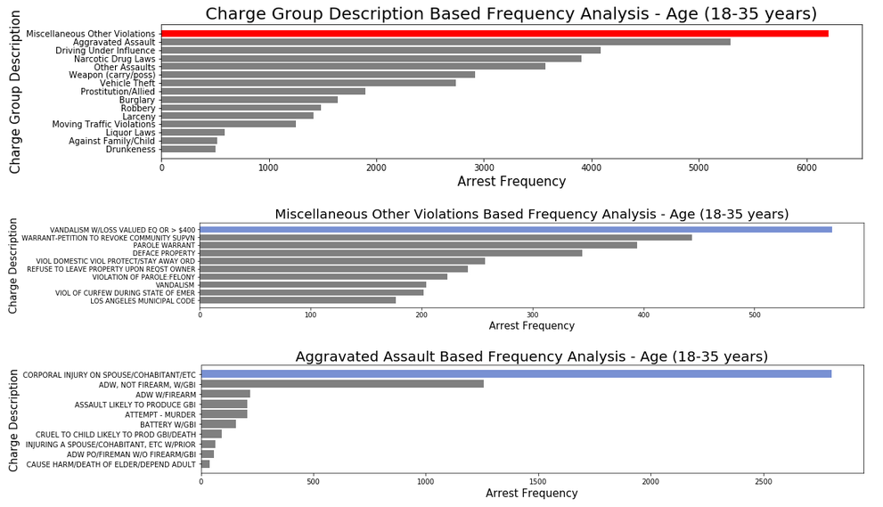

To conclude, youngsters have the rage and feel proud to vandalize and perform graffiti on public and private property.

1. *Descent*

[5] According to sources, African Americans comprise about 13 percent of the US population and they cause up to 39 percent of all arrests for violent crimes. While Latinos have a higher crime rate than non-Latino whites, but comparatively lower rates than those of African Americans. To ensure the information is true, some kind of evidence is required, to do so, group by function in python was used, the output is retrieved. Based on the analysis, it is found that 35352 charges were on Hispanics, Latinos, and Mexicans, followed by Black people with 19485 charges. It is roughly 55% more than Black people charges. The third highest belongs to the White people at 10091 charges, which is estimated to be 28.5% of Hispanic's charges. Visualization for the entire race of people is plotted in the form of bar plots. Most of the races are not visible on the plot, because their contribution in the charges is way lesser in magnitude in comparison with the highest ones.

Figure 10

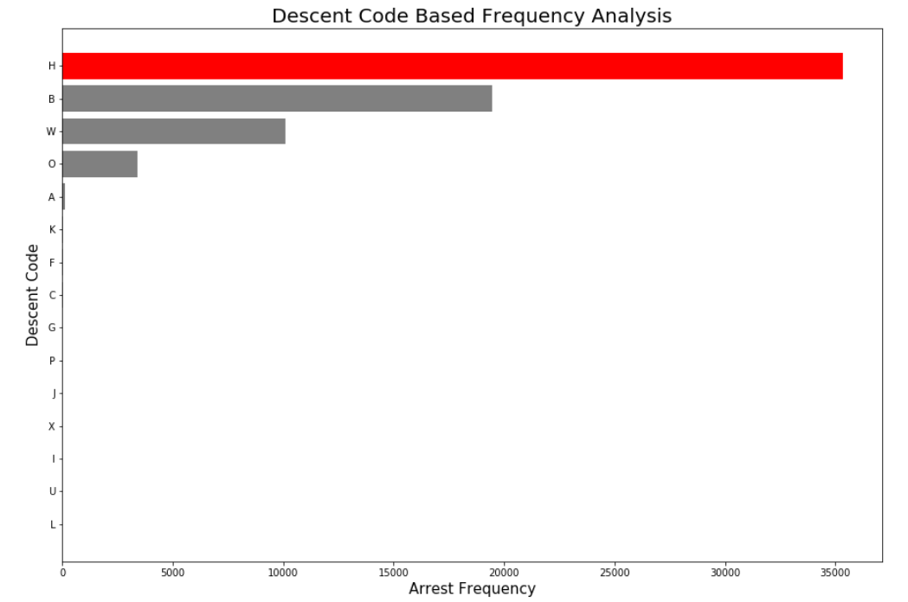

An explanation for these specific races contributing highest towards charges is primarily due to [5] biological inferiority of the group, where African Americans and Latinos having relatively higher rates of offending. Moreover, African Americans and Latinos are very poor compared to Whites on average. Racial discrimination inflicts anger and frustration that promotes criminal behavior.

Figure 11

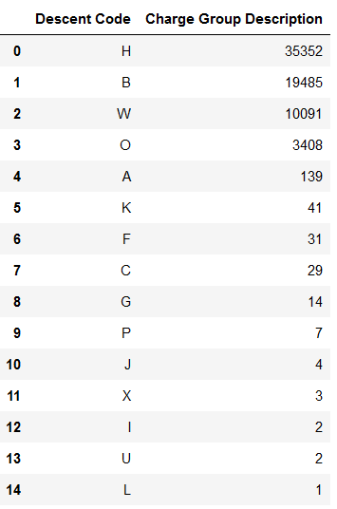

Similar to age group analysis, descent (H-Hispanics/Latinos/Mexicans) was analyzed for “Charge Group Description” and their respective “Charge Description. The outcome of the investigation is again “Miscellaneous Other Violation” with 5444 charges and “Aggravated Assault” with 4661 charges to contribute the highest, even in descent charges.

Figure 12

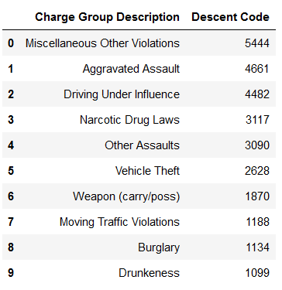

Even “Driving Under Influence” is slightly less than “Aggravated Assault” with 4482 arrests. Further investigation on “Miscellaneous Other Violations” and “Aggravated Assault” leads to sub-category outcomes.

Figure 13

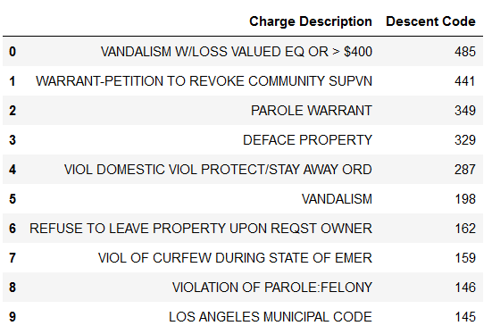

Figure 14

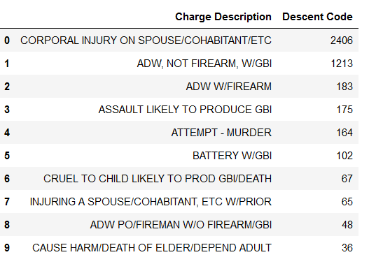

Similar to age-based charges, even here the top charges are vandalism and corporal injury. Again, the reason for these crimes is anger and frustration due to racial offending. Vandalism is because these people oppose society for what it did to them.

Figure 15

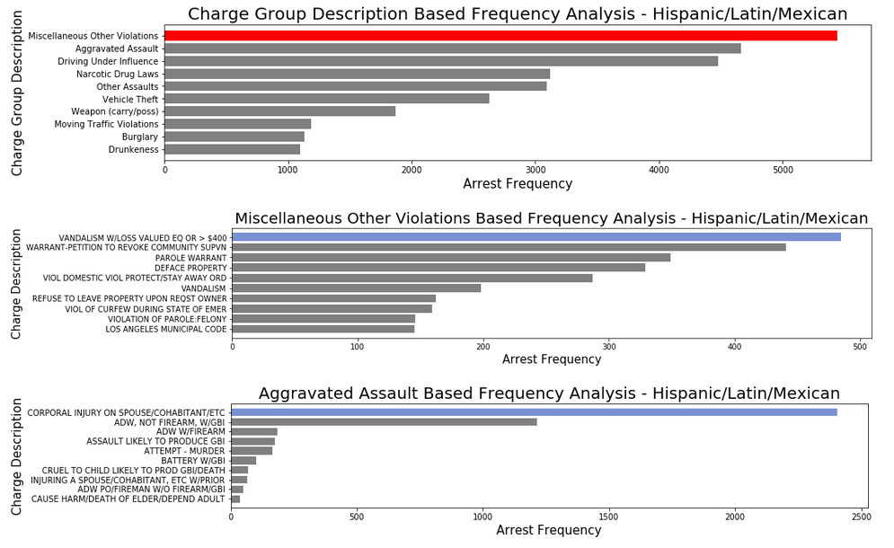

The above represents the key points discussed earlier on “Miscellaneous Other Violations” (highlighted in red) and “Aggravated Assaults” to be the highest contributors, while vandalism and corporal injury to be the highest sub-category to their respective categories. Thus, it can be inferred that Hispanics and Black people are being offended frequently which eventually leads to fury causing vandalism as well as corporal injury as it is caused due to traumatic effect.

1. *Location*

The location always has a close association with the specific type of crimes to occurs. For instance, [6] large populations mean there is a great opportunity to commit a crime. Furthermore, there a good road and transport links, it allows criminals to move in and out easily.

Figure 16

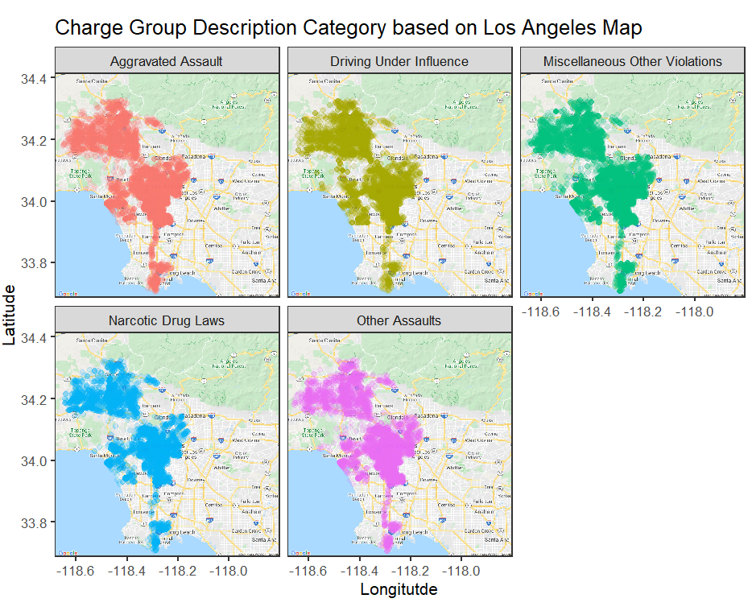

From the actual dataset, only the top five charges were filtered during the year 2020 (Because 2021 has only 7700 records). The exploration of the top 5 highest types of charges was done using the “ggmap” library in R. The LAT & LON can be plotted with the help of Google APIs, namely, Geocoding, Geolocation, Maps Static, and Maps Embed. To visualize all those five charges type in a single plot, “Facet Wrap” is used. The previous plot is the outcome of facet wrap. Concentrating on “Miscellaneous Other Violations”, yields a plot with these respective location points. Based on the above plot, it portrays that more arrests seem to occur at the heart of Los Angeles city, these include popular places like Beverly Hills, Inglewood, East Los Angeles, etc. Other less dense colorations in the plot are areas such as San Fernando, Santa Monica, Long Beach, and Terminal Island.

The main purpose of this research is to analyze if arresting people decreases the crime rate. To check that, again facet wrap concerning the month of the year 2020 is plotted. The outcome is attached below. At the beginning of the year, the months January, February, March, does not seem to have an impact on the arrest, thus arresting was not effective in those months.

Figure 17

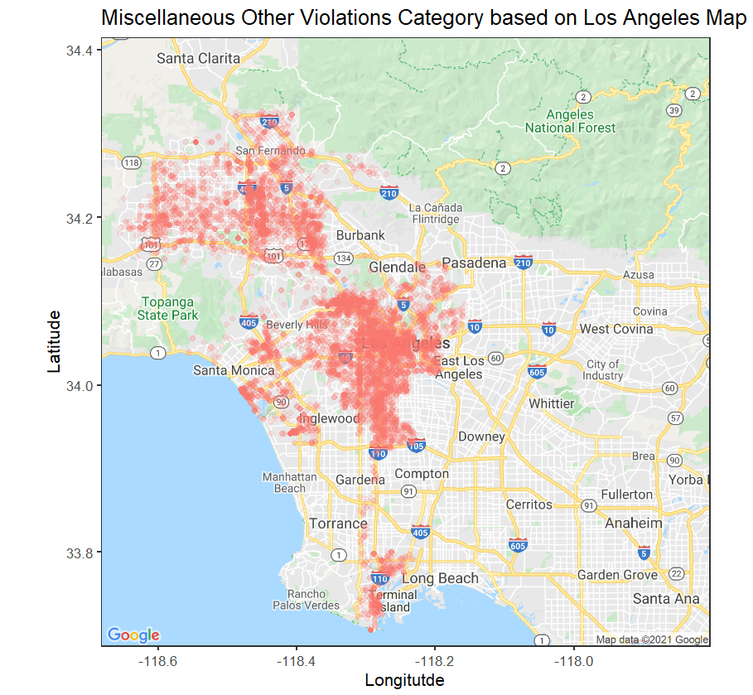

But in the month of April, there a slight decrease in San Fernando, similarly in Santa Monica and Beverly Hills, represents the effectiveness of arrest in those areas alone. During mid-year, there is an increased arrest in the areas that were previously decreased. Rest of the year, there was a slight increase/decrease in the arrests made.

Figure 18

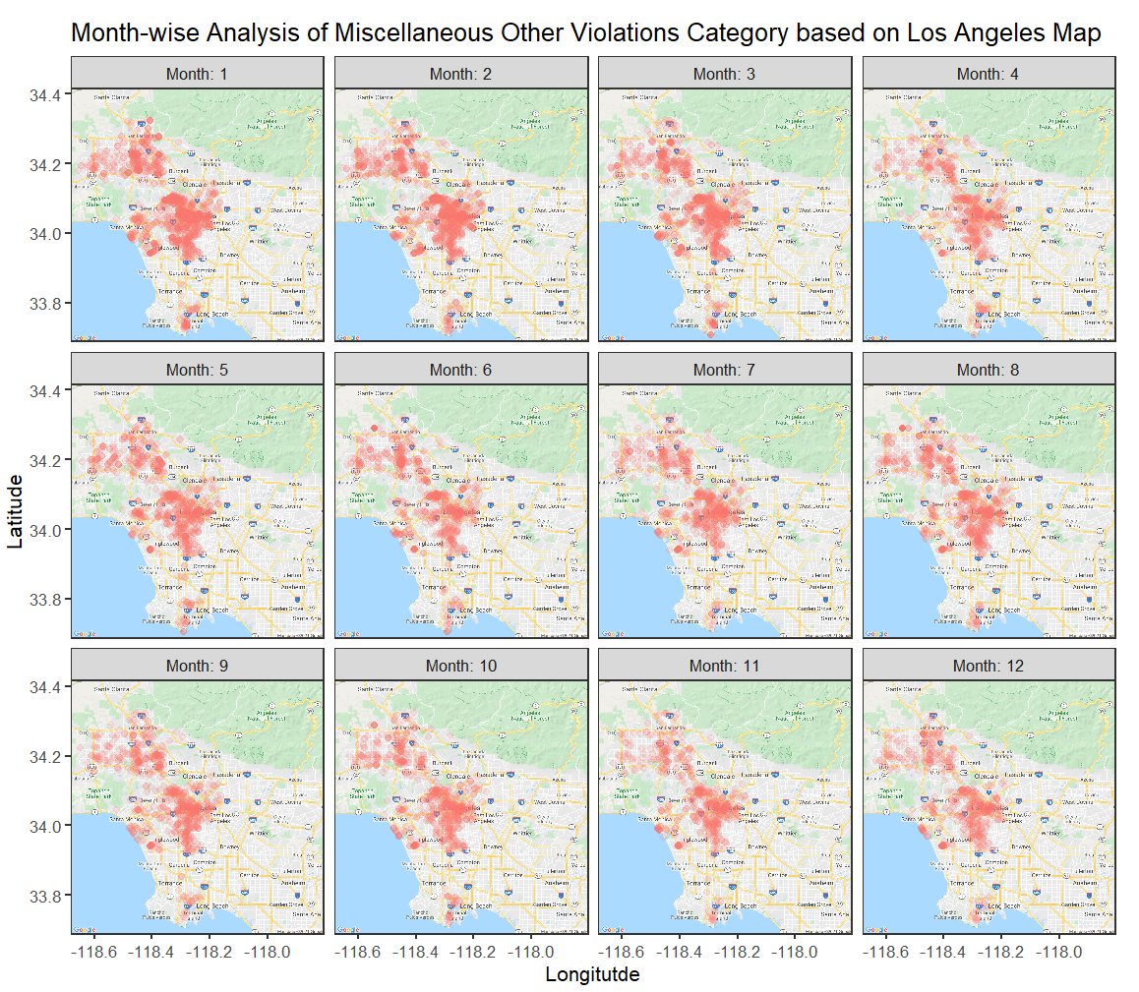

Therefore, the arrests made were effective only in some areas of Los Angeles city, which Santa Monica, San Fernando, Beverly Hills, Long Beach, Terminal Island. The heart of Los Angeles had decreased arrest, but it is not a substantial amount, thus, it can be concluded that arrests made on basis of the “Miscellaneous Other Violations” charge has not been effective in stopping the same crime to happen in the same location.

1. *Socio-economic Status*

Some of the richest neighborhoods are Bel Air, which is located slightly above Santa Monica, Beverly Hills, Santa Monica, etc. On the contrary, poor neighborhoods are Fashion District, Southeast Los Angeles, Hyde Park, etc. Figure 17 can be used as a reference for the socio-economic status factor as well. On the map, as known earlier, the heart of Los Angeles has the highest concentration of arrests in recent years. This research topic focuses on identifies whether crimes are based on socioeconomic status, meaning, does rich or poor areas contributes to a greater number of crimes. A simple group by function is used to classify the type of charges based on areas. The data shows that the Central has the highest number of arrests concerning “Miscellaneous Other Violations” – 1095 arrests, followed by Hollywood for the same category of charge with 874 arrests. The remaining areas are 77th Street, which has the highest arrests in two charge categories, one being “Aggravated Assault” and the other is “Prostitution/Allied” at 794 arrests and Pacific with 716 “Miscellaneous Other Violations” charges. Concentrating on these 5 places, all of them are rich neighborhoods. But on further analysis based on “Charge Description”, the outcome is entirely different. There are top five areas based on “Charge Description”, namely, Topanga, Van Nuys, 77th Street, Newton, and Mission. In terms of “Charge Description”, Drinking Alcohol – 453 arrests, Drunk Driving – 427 arrests, Corporal Injury – 426 arrests, Take Vehicle W/O Owner’s Consent – 358 arrests, and again Drunk Driving – 350 arrests respectively.

Figure 19

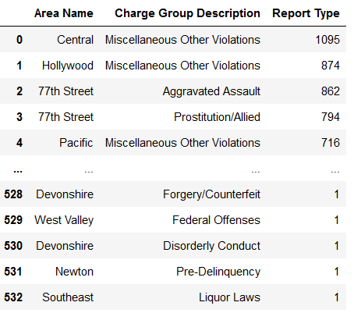

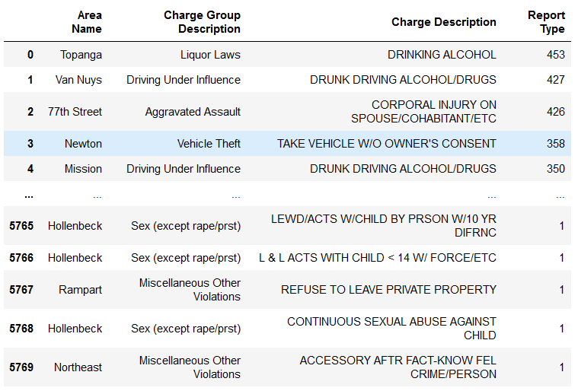

Among those 5 areas, Topanga, Van Nuys, 77th Street, Mission are the rich ones, while Newton is the poor one. Thus, it depicts that rich communities get arrested and pressed charges a greater number of times. Moreover, the crimes that happen in those rich neighborhoods are non-violent.

1. *Driving Under Influence (DUI)*

[7] According to sources, from 2009 to 2018, there was an average of 1804 drunk driving arrests per 100,000 people each year during the 10 years. This seems to roughly 8% higher than the national average. [8]The above line plot is created to understand the trend arrest month-wise for the charge group description “Driving Under Influence”.

Figure 20

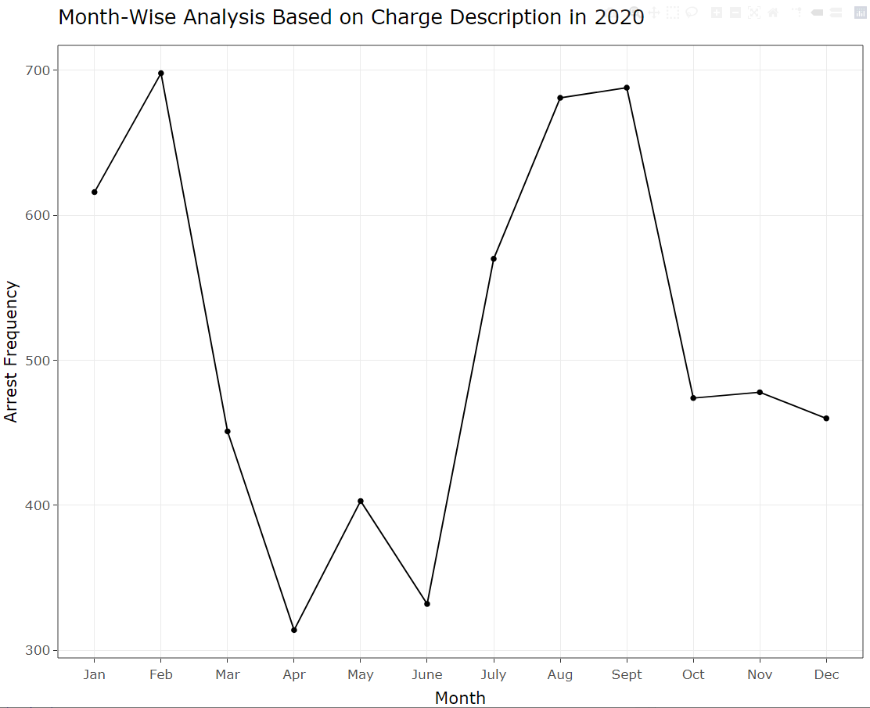

At the start of the year 2020, there are roughly 610 arrests made, next month, it increases to 700 arrests. Then there is a huge drop in the frequency of arrests with 310 arrests. Upcoming months have some increase and decrease respectively. From June to September there is exponential growth rising to 690 arrests. Finally, the arrests drop to 480 arrests in October and hold steady at 470 arrests at the end of the year. Moving forward, an in-depth analysis was performed for each sub-category of DUI.

Figure 21

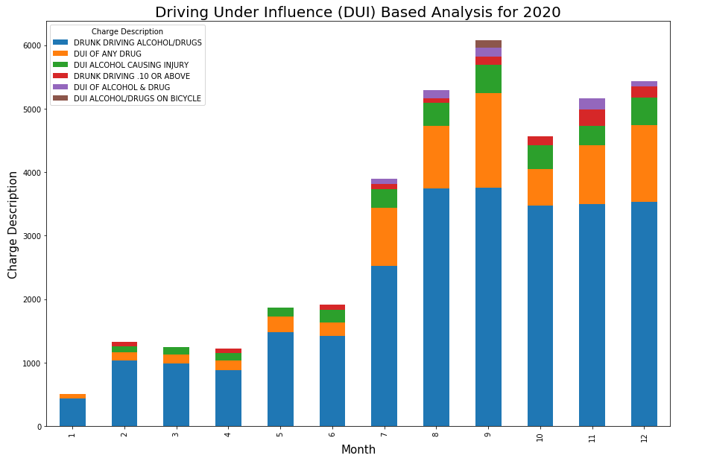

Filtering is done to extract arrests made in the year 2020, based on the “Driving Under Influence” category, and further group by function is used to classify sub-categories of DUI. Considering the top 6 sub-categories contributing towards the highest DUI charges, a stacked bar of Month Vs Frequency of arrests is created. Understanding the bar plot, it is evident that “Drunk Driving Alcohol/Drugs” has the highest contribution towards the total arrests. Concentrating on this sub-category, there is a slight increase and decrease in the initial month, but after mid-year, there is a drastic increase in the arrests made. While taking into consideration of the remaining four sub-categories, there is no large change in the arrests made. In conclusion, it can be said that arrests are effective in a different month of the year, but in-depth analysis, it does not deter the crime, especially the “Drunk Driving Alcohol/Drugs”. Hence, more stringent laws need to be put into effect to alleviate those kinds of charges in the distant future.

1. *Hours of Day*

The final aspect of this research project is to identify the arrests that occur on an hourly basis, meaning, analysis of top crimes, whether they have a specific time frame for occurrence. Initiating a line with date analysis. To understand this, a line plot is created concerning different days starting 1st of a month to 30th of the month (excluded 31st as it is not present in every month) for the year 2020.

The line plot represents that usually at the start of the month, there is a greater number of arrests, close to 1600 arrests. Gradually it reduces to less than 1300 arrests, then there is an increase to more than 1400 arrests. The trend of the frequency of arrests gradually declines as the month-end is approaching. It is unusual to observe a pattern in the plot because at beginning of the month arrests are the highest, but as it is the end of the month arrests rate drops. [8] Some sources say, law enforcement is misusing jails, they punitively arrest people who are in desperate need of medical care and social services. Since they are being arrested periodically, in and out jail cycle prevents them from ever receiving the help they need. Mostly, those repeated arrests are related to race and poverty, along with high rates of mental illness and disorders, shockingly, [8] every year 4.9 million people are jailed. Thus, the explanation from the article helps to understand the pattern in the plot that was observed.

Figure 22

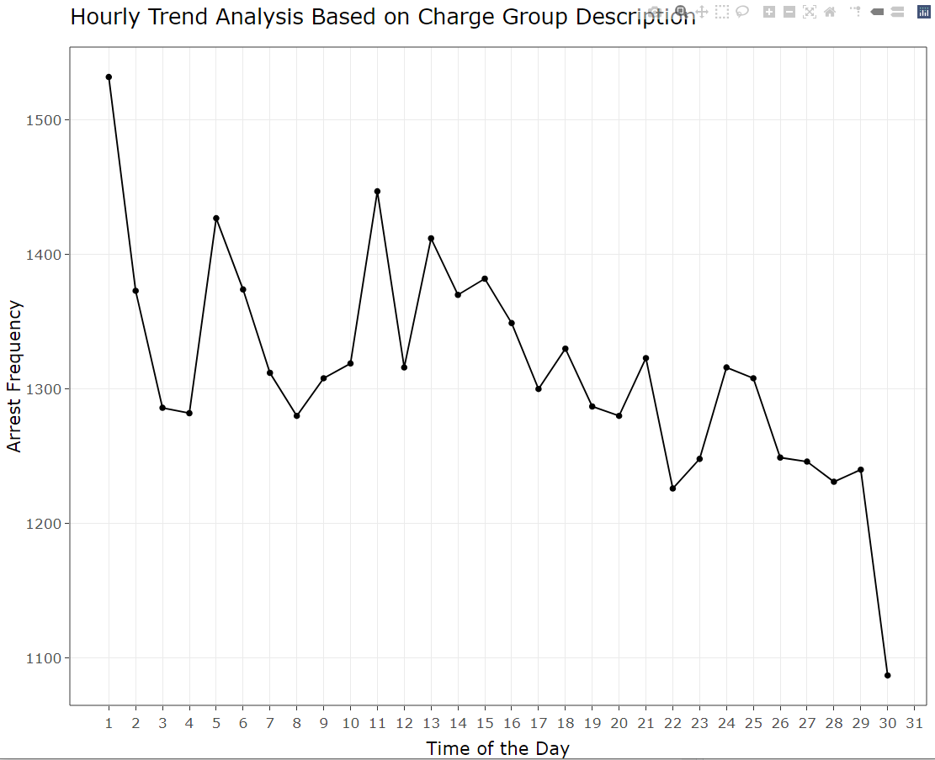

For further exploration in getting the actual insight, a time-series plot is formed to understand, is there a pattern of specific crimes to occur during any hour of the day. Filtering out the 5 highest contributors of total crime, they are,

Figure 23

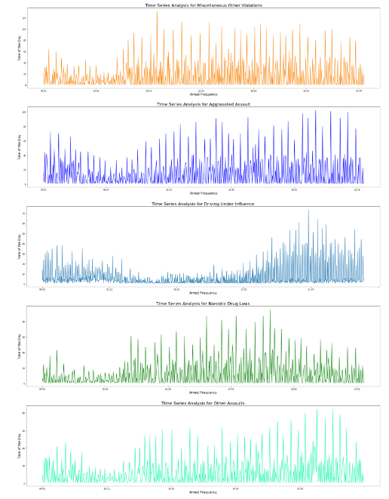

“Miscellaneous Other Violations”, “Aggravated Assault”, “Driving Under Influence”, “Narcotic Drug Laws” and “Other Assaults”. Based on these “Charge Group Description”, time series plot was produced and sub plotted as seen in Fig. 23 For “Miscellaneous Other Violations” there does not seem to be a specific time of arrest, but most of the arrests are done after 9 am, the trend is the same till midnight. “Aggravated Assault” shows a similar pattern/trend to that of “Miscellaneous Other Violations. Concentrating on “Driving Under Influence”, fewer arrests happen between early morning and early evening. Most of the DUI-related arrests occur between evening and late-night, and that is not surprising because most people consume alcohol or drugs in the evening. Sometimes, they drink alcohol at late-night parties. On the other hand, “Narcotic Drug Laws” related arrests are mostly in broad daylight and decrease as nighttime approaches. Lastly, “Other Assaults” based arrests are quite less in the morning and gradually increase during the daytime. The arrests keep increasing as night approaches, even during late night.

**VI. DISCUSSION**

Arrests, on the whole, might seem like a good thing, where law enforcement is performing their duty to ensure the citizens of Los Angeles are safe and in harmony. But, when in-depth analysis is executed, there are way too many perspectives that one needs to interpret. Everyone might say, Black and Hispanics are always performing vandalism and they should be put to jail, nonetheless, people fail to see the reason for those kinds of crimes to occur, it is the society that inflicts anger and frustration. “Miscellaneous Other Violations” are mostly frequently arrested for, followed by Aggravated Assault”, “Driving Under Influence”, “Narcotic Drug Laws” and “Other Assaults”. Thus, most of the analyses are done based on these categories of “Charge Group Description”. There is not much correlation between independent variables such as Age, Arrest Date, Time, Lat Long, hence, regression model analysis is not a viable option. To conclude on the arrest analysis, people between the age of 17-35 yrs. have been arrested the most. Top crimes are “Miscellaneous Other Violations”, Aggravated Assault”, “Driving Under Influence”, “Narcotic Drug Laws” and “Other Assaults”. Based on the descent code, Hispanics and Blacks have been arrested a greater number of times. The richer communities have more arrests compared to poorer ones. DUI-based arrests do not deter the crime to occur again. Most of the arrest does not occur between midnight and early morning.

**VII. FUTURE WORK**

This research analysis has just scratched the surface, more studies need to be made based on this research paper because gender-based crimes have not been covered in this analysis, which is significant. More parameters have been eliminated because they were unrelated to the research topics, so they should be considered in future analysis. This might provide a different kind of perspective, and provide unseen insights. Moreover, only the top 5 contributors of arrests were considered, leaving behind many other charges, those need to be included as well. For the descent, only Hispanics and Blacks were exaggerated, other races such as Whites and Others are left out to lessen the complexity. Map plotting was done on the whole of Los Angeles city, but more in-depth area-wise plotting to understand the pattern much better. This research analysis stands as the foundation for more analysis to come soon.

**REFERENCE**

|  |  |
| --- | --- |
| [1] | "Red Lights and Handcuffs: The Effect of Arrests on the Fear of Crime," Wiley Online Library, 05 March 2018. [Online]. Available: https://onlinelibrary.wiley.com/doi/abs/10.1111/ssqu.12503. |
| [2] | K. L. S. K. M. A. R. Cydney Schleiden, "Racial Disparities in Arrests: A Race Specific Model Explaining Arrest Rates Across Black and White Young Adults," Springer Link, 03 May 2020. [Online]. Available: https://link.springer.com/article/10.1007%2Fs10560-019-00618-7. |
| [3] | J. T. S. H. K. Rick Dierenfeldt, "Examining Gender- and Drug-Specific Arrest Counts: A Partial Test of Agnew’s General Strain Theory," Taylor & Francis Online, 26 Mar 2019. [Online]. Available: https://www.tandfonline.com/doi/full/10.1080/01639625.2019.1596548. |
| [4] | "Teen Vandalism," 31 01 2012. [Online]. Available: https://middleearthnj.org/2012/01/31/teen-vandalism/. |
| [5] | "8.3 Who Commits Crime? – Social Problems," Pressbooks, 25 03 2016. [Online]. Available: https://open.lib.umn.edu/socialproblems/chapter/8-3-who-commits-crime/. |
| [6] | "Location of crime - Geography of crime - KS3 Geography Revision," BBC Bitesize, [Online]. Available: https://www.bbc.co.uk/bitesize/guides/zytycdm/revision/2. |
| [7] | S. Sweat, "Where does Los Angeles rank for DUI accidents? — Los Angeles Personal Injury Attorney Blog — April 15, 2020," Los Angeles Personal Injury Attorney Blog, 15 04 2020. [Online]. Available: https://www.victimslawyer.com/blog/where-does-los-angeles-rank-for-dui-accidents/. |
| [8] | P. Initiative, "Arrest, release, repeat: How police and jails are misused to respond to social problems," Prison Policy Initiative, [Online]. Available: https://www.prisonpolicy.org/reports/repeatarrests.html. |
|  |  |

1. **Aggravated Assault** is the unlawful attack by one person upon another for the purpose of inflicting severe or **aggravated** bodily injury. Usually accompanied by the use of a weapon or by means likely to produce death or great bodily harm. Examples. **Assaults** or attempts to kill or Murder.
2. Vandalism is deliberately destroying public or private property. These include but are not limited to graffiti, property damage, and defacement