(defstruct (node (:print-function  LISP  (lambda (n s d)  (format s "#<~A>" (node-elt n)))))  elt (l nil) (r nil)) | struct Node  C  496470516 資工100 高翊展  { struct Node *lptr;  int data;  struct Node *rptr;  };  typedef struct Node node;  typedef node *nodeptr;
(defun bst-insert (obj bst <)  (if (null bst)  (make-node :elt obj)  (let ((elt (node-elt bst)))  (if (eql obj elt)  bst  (if (funcall < obj elt)  (make-node  :elt elt  :l (bst-insert obj (node-l bst) <)  :r (node-r bst))  (make-node  :elt elt  :r (bst-insert obj (node-r bst) <)  :l (node-l bst))))))) | void insertNode( nodeptr *treePtr, int value )  { if ( *treePtr == NULL )  { *treePtr = malloc( sizeof( node ) );  if ( *treePtr != NULL )  { ( *treePtr )->data = value;  ( *treePtr )->lptr = NULL;  ( *treePtr )->rptr = NULL;  }  else  { printf( "%d not inserted. No memory available.\n", value );  }  }  else  { if ( value < ( *treePtr )->data )  { insertNode( &( ( *treePtr )->lptr ), value );  }  else if ( value > ( *treePtr )->data )  { insertNode( &( ( *treePtr )->rptr ), value );  }  else  { printf( "exist" );  }  }  }
(defun bst-find (obj bst <)  (if (null bst)  nil  (let ((elt (node-elt bst)))  (if (eql obj elt)  bst  (if (funcall < obj elt)  (bst-find obj (node-l bst) <)  (bst-find obj (node-r bst) <)))))) | void search(bstnodeptr *cur, int item )  { if( cur )  { if(cur->value == item)  { return cur->value;  }  else if(cur->value < item)  { searchBT(cur->right, item);  }  else  { searchBT(cur->left, item);  }  }  else  { return NULL;  }  }
(defun bst-min (bst)  (and bst  (or (bst-min (node-l bst)) bst))) | void min( nodeptr treePtr )  { if ( treePtr != NULL )  { min( treePtr->lptr );  }  else  { printf( "%3d", treePtr->data );  }  }
(defun bst-max (bst)  (and bst  (or (bst-max (node-r bst)) bst))) | void max( nodeptr treePtr )  { if ( treePtr != NULL )  { max( treePtr->rptr );  }  else  { printf( "%3d", treePtr->data );  }  }

(defun bst-remove (obj bst <)
(if (null bst)
nil
(let ((elt (node-elt bst)))
(if (eql obj elt)
(percolate bst)
(if (funcall < obj elt)
(make-node
:elt elt
:l (bst-remove obj (node-l bst) <)
:r (node-r bst))
(make-node
:elt elt
:r (bst-remove obj (node-r bst) <)
:l (node-l bst)))))))
(defun percolate (bst)
(cond ((null (node-l bst))
(if (null (node-r bst))
nil
(rperc bst)))
((null (node-r bst)) (lperc bst))
(t (if (zerop (random 2))
(lperc bst)
(rperc bst)))))
(defun rperc (bst)
(make-node
:elt (node-elt (node-r bst))
:l (node-l bst)
:r (percolate (node-r bst))))
(defun lperc (bst)
(make-node
:elt (node-elt (node-l bst))
:l (percolate (node-l bst))
:r (node-r bst)))
(defun bst-traverse (fn bst)  (when bst(bst-traverse fn (node-r bst))  (funcall fn (node-elt bst))  (bst-traverse fn (node-l bst)))) | void postOrder( nodeptr treePtr )  { if ( treePtr != NULL )  { postOrder( treePtr->lptr );  postOrder( treePtr->rptr );  printf( "%3d", treePtr->data );  }  }

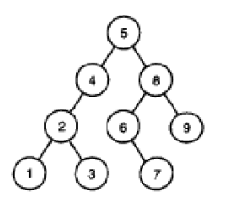
Remove node ‘5’

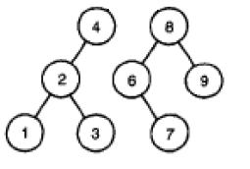
Draw up the left subtree and connect node ‘4’ to node 8

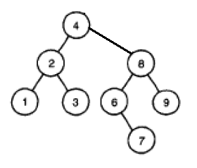
It is lucky for this case to get a correct BST. But its algorithm is wrong. It should to find the middle value of this BST to be the new root node and to adjust the BST’s structure logical.

