Williams-Sonoma, Inc.



OMSD2 Web Portal

Design Document

Author: Kevin Huang & Chloe Shiau

Version: 1.0

|  |  |  |  |
| --- | --- | --- | --- |
| Version | Author | Description | Date |
| 1.0 | Chloe Shiau  Kevin Huang | Initial Design Document with requirements given by Chong | 7/16/14 |
| 1.1 | Chloe Shiau  Kevin Huang | Added requirements | 7/30/14 |

**Definitions, Acronyms, and Abbreviations:**

* OMSD2 – Order Management System Domestic Phase 2
* HTML – Hypertext Markup Language
* CSS – Cascading Style Sheet
* PIP – Product Information Page
* DB - Database

**Expected Audience:**

The expected audience of this document is the customer “Chong” and his team.

**Purpose:**

This document provides an in-depth approach for implementing the OMSD2 Web Portal.

**Business Problem:**

The goal of this problem is to create a web portal for the OMSD2 that will display details of each component to users. It will also allow components to be added, deleted, or modified with a code change. The OMSD2 Web Portal will act as a central hub and will bring information together to allow for access of information from a single point.

**Business Design:**

This application will be used internally to get information about each component of the OMSD2 and can also be used by admin roles to turn on and off certain components of the system. The role of the user may determine what can be added to or deleted from the portal and whether components can be turned on or off.

The web portal will display information about a particular component when it is selected. It will also allow users to click to turn on or off certain components of the web portal.

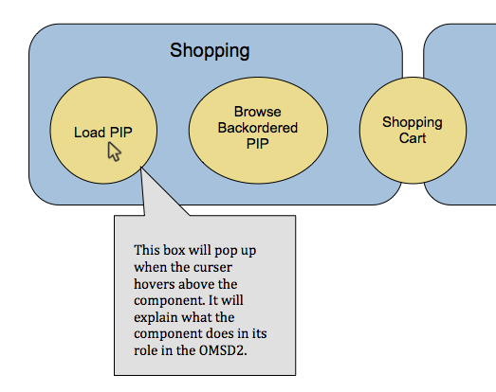

The arrows and words will also show information.

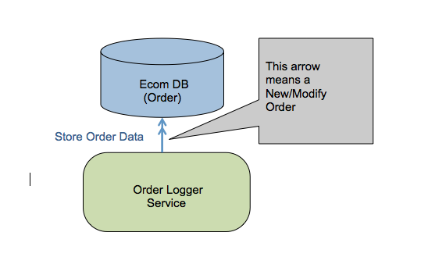

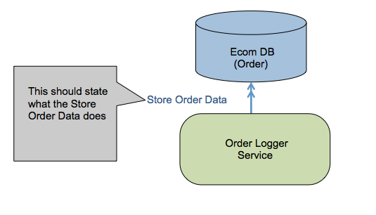

**Technical Design:**

This web application will be developed using HTML, CSS, and JavaScript.

HTML will be used to create the web page. CSS will be used to describe the look and formatting of the HTML page. JavaScript will be used to create the arrows that point to the separate components.

Details about each component will be displayed using a text box. When the mouse is over a particular component, a text box will show up that displays information about the component. This will be accomplished by having a <span> tag embedded into the <img> tag. CSS will be used to hide the span element until the mouse hovers over the image. A text box will then display the required text.

The web application will be hosted using Jetty web server.

Components will be shown whether they are on or off if a user clicks the component. This will be implemented using the JavaScript language and its functions. A flag will be used to keep track of whether a component is currently in the “on” or “off” state. When the component is clicked, an alert will be shown of the current state and the flag will be set according to the state.

**Benefits**

Provides ease of access to information regarding the OMSD2.

Provides a portal where administrator roles can turn on or off components.

Provides portal where components can be added or deleted.