UI 01 — Sign In
Role: Public
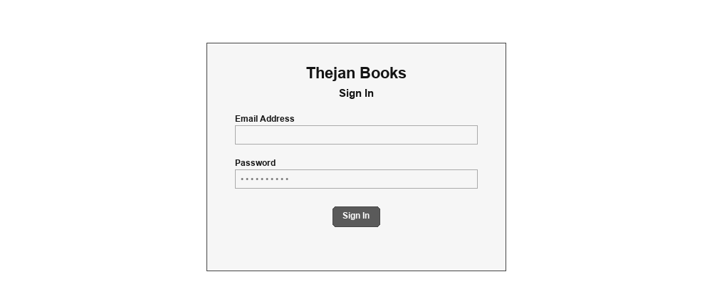
UI 02 — Create Account
Role: Public
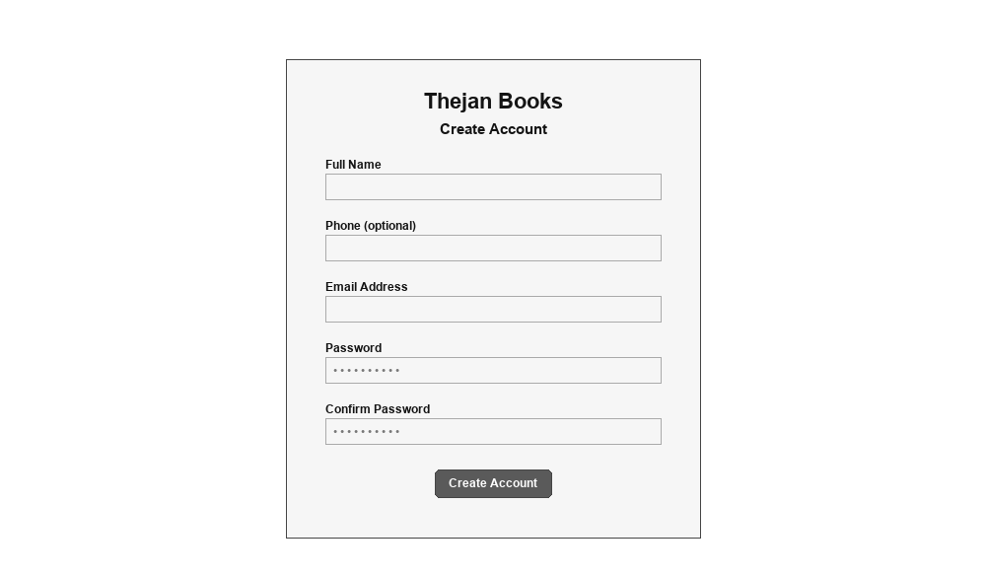
UI 03 — Access Denied (403)
Role: Public
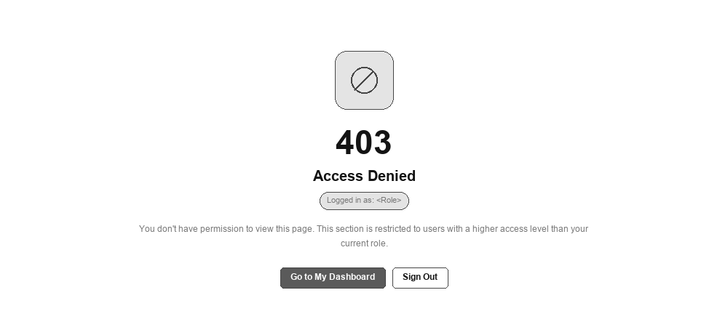
UI 04 — Dashboard
Role: System Administrator
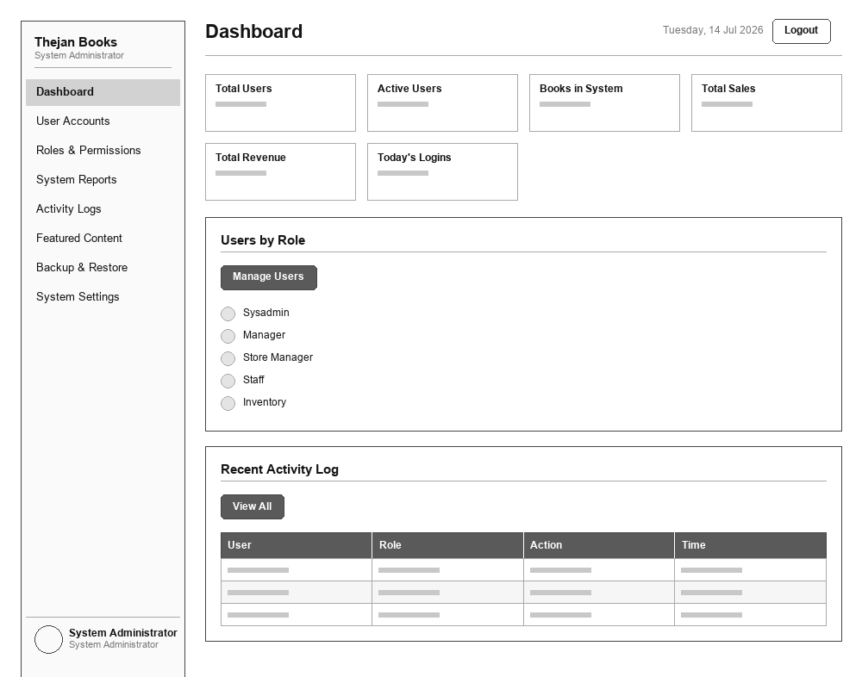
UI 05 — User Accounts
Role: System Administrator
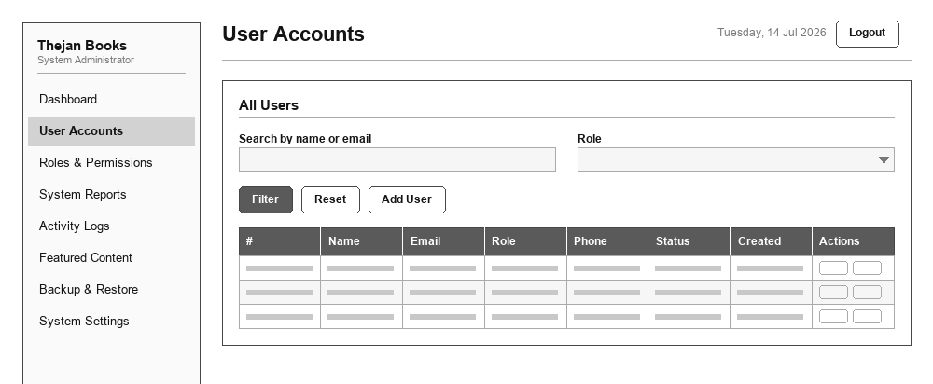
UI 06 — Roles & Permissions
Role: System Administrator
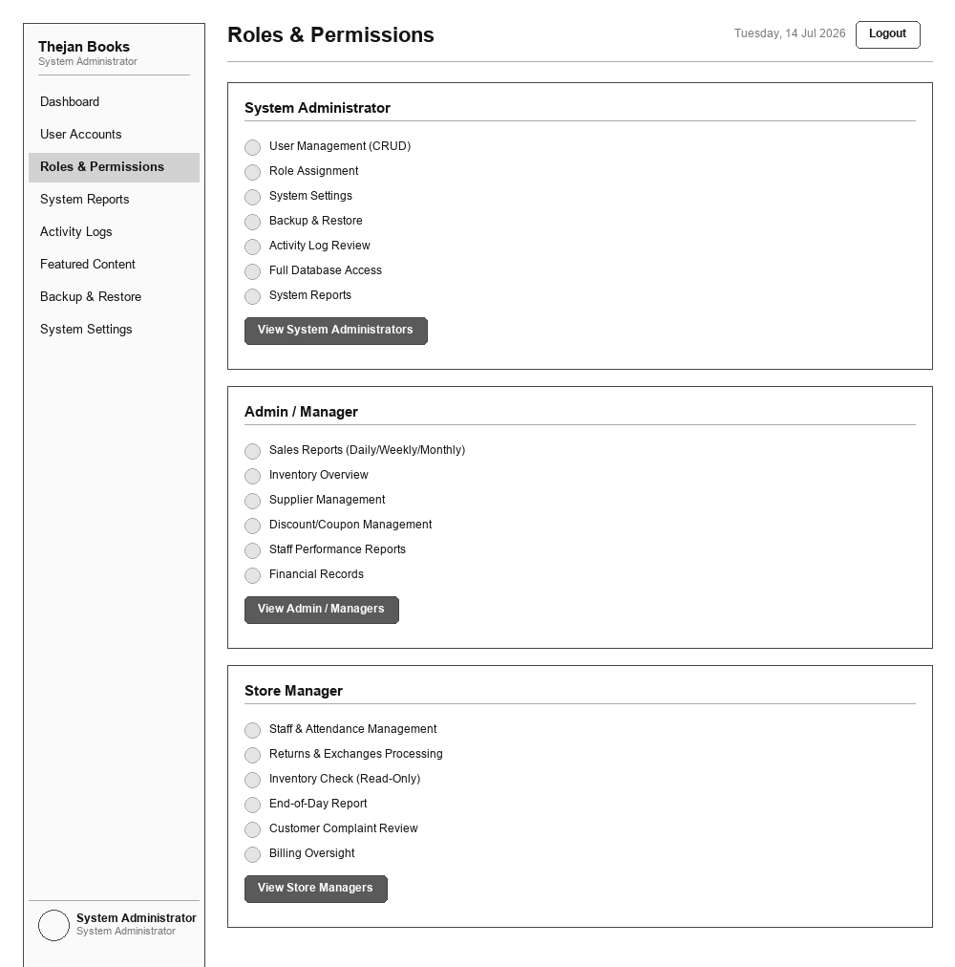
UI 07 — System Reports
Role: System Administrator
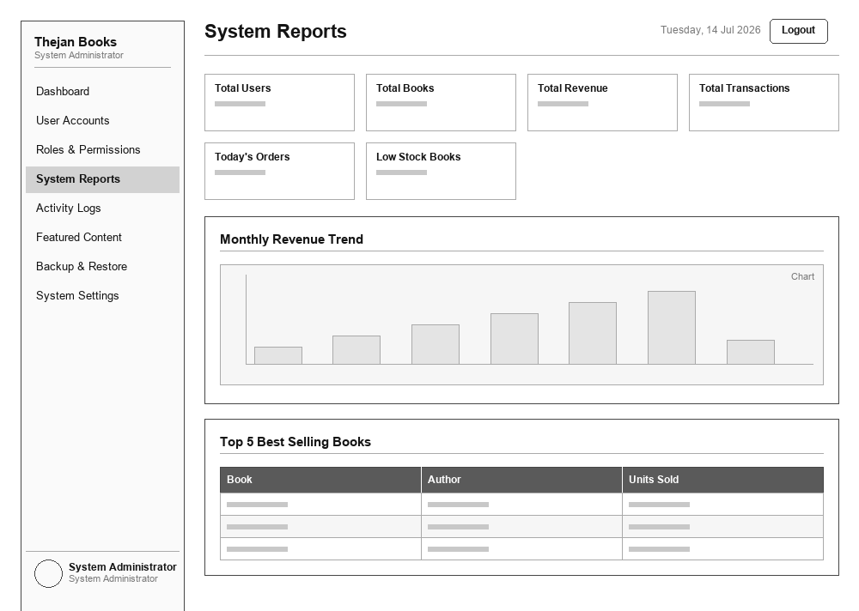
UI 08 — Activity Logs
Role: System Administrator
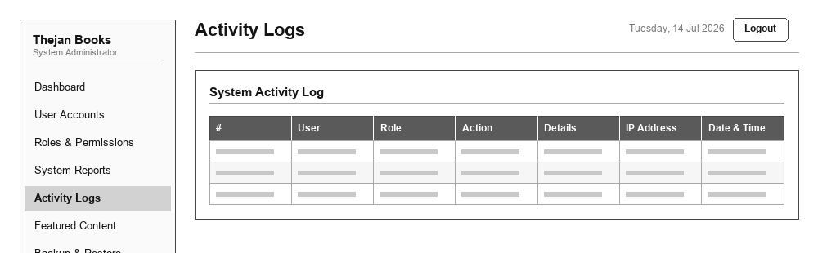
UI 09 — Featured Content
Role: System Administrator
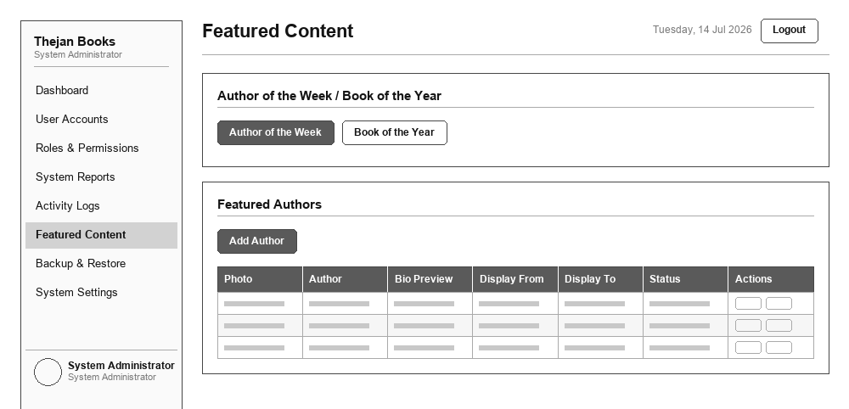
UI 10 — Backup & Restore
Role: System Administrator
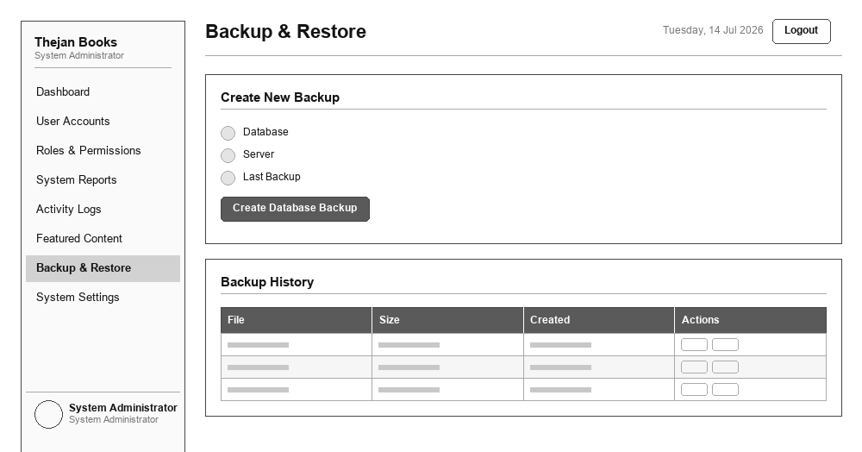
UI 11 — System Settings
Role: System Administrator
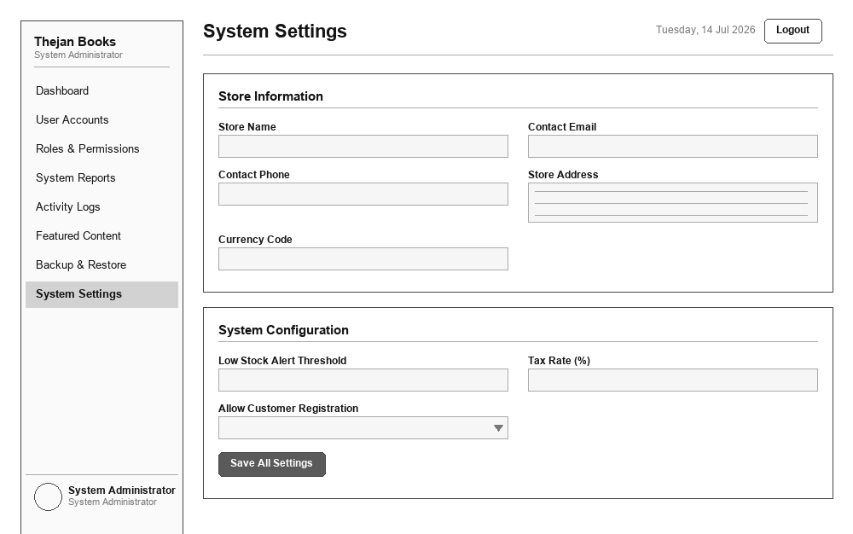
UI 12 — My Profile
Role: System Administrator
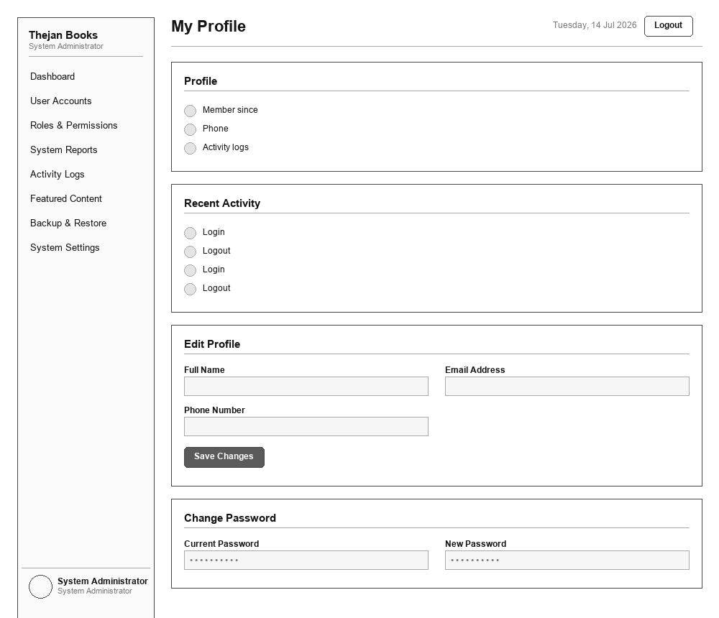
UI 13 — Dashboard
Role: Admin / Manager
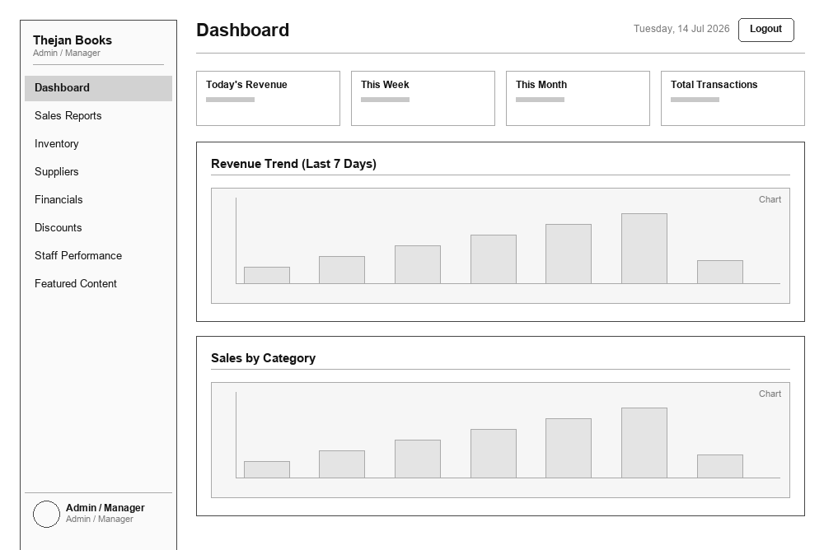
UI 14 — Sales Reports
Role: Admin / Manager
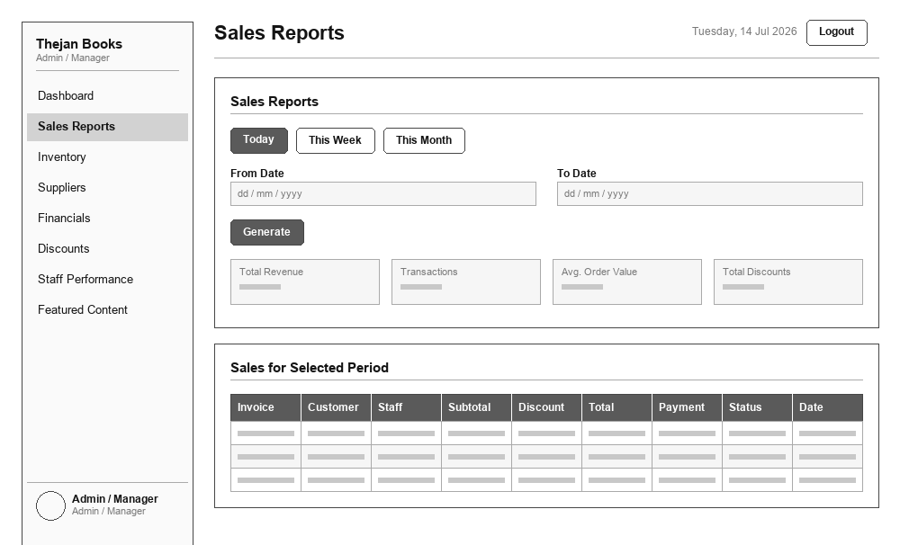
UI 15 — Inventory Overview
Role: Admin / Manager
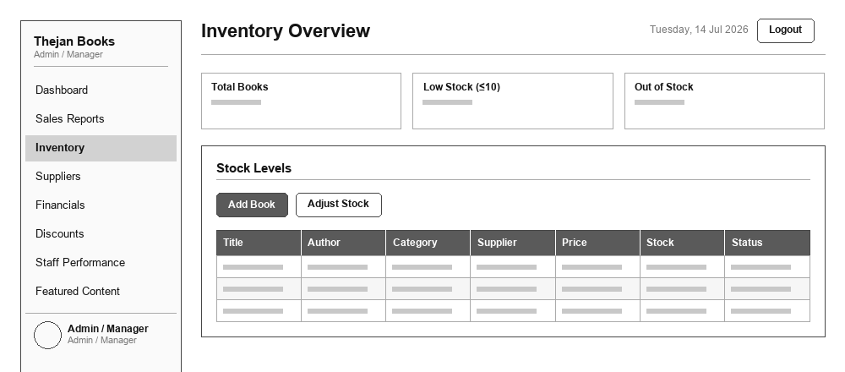
UI 16 — Supplier Management
Role: Admin / Manager
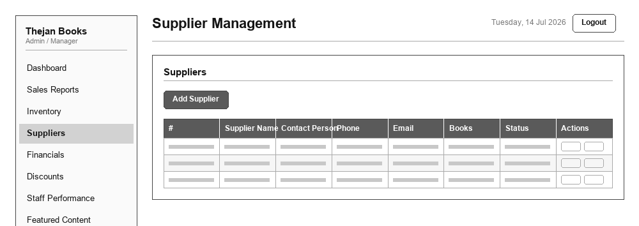
UI 17 — Financial Records
Role: Admin / Manager
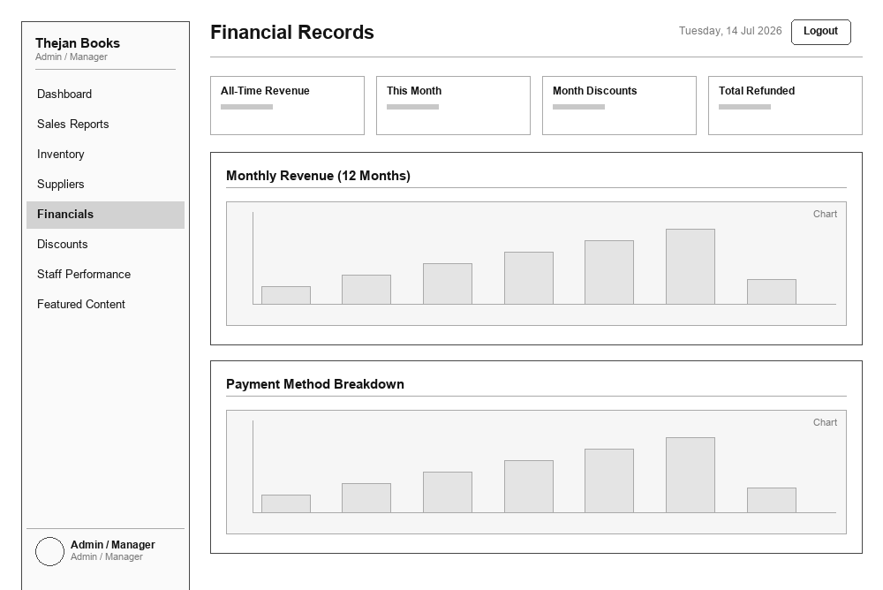
UI 18 — Discounts & Coupons
Role: Admin / Manager
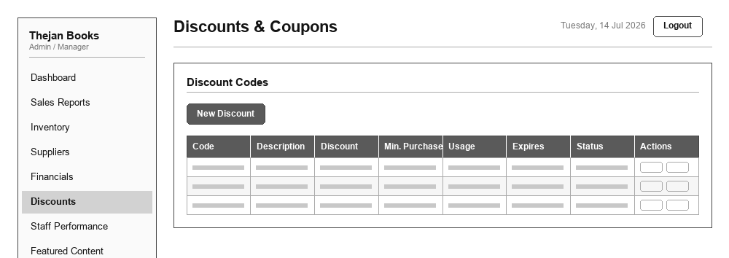
UI 19 — Staff Performance
Role: Admin / Manager
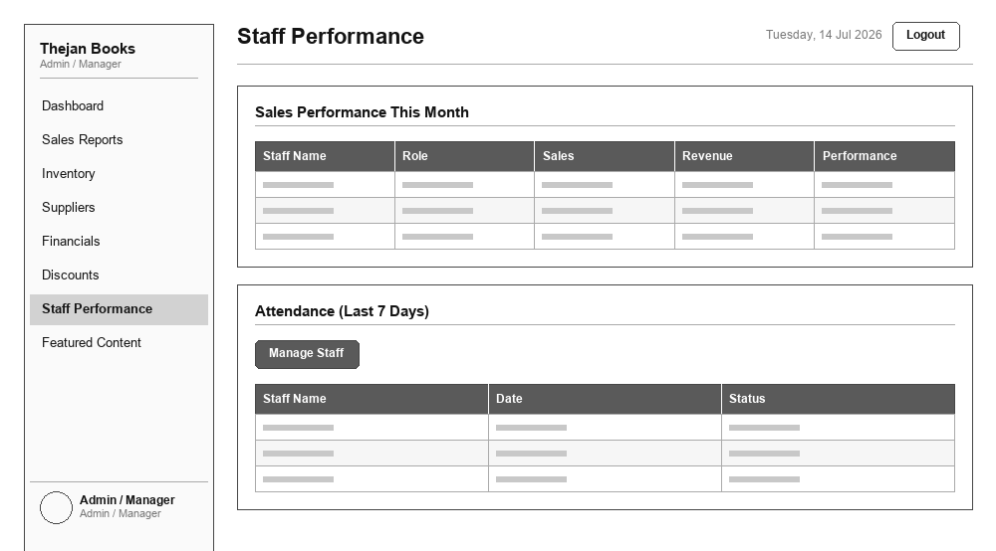
UI 20 — Featured Content
Role: Admin / Manager
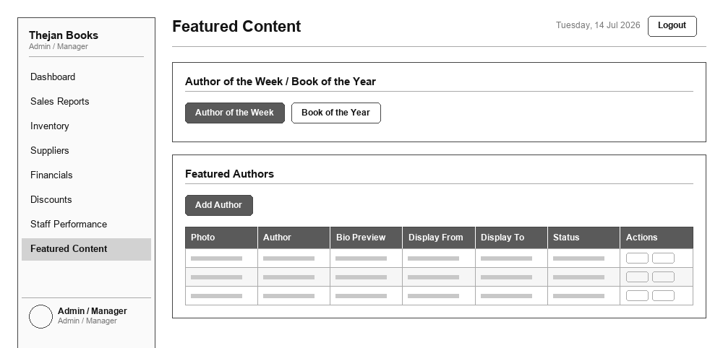
UI 21 — My Profile
Role: Admin / Manager
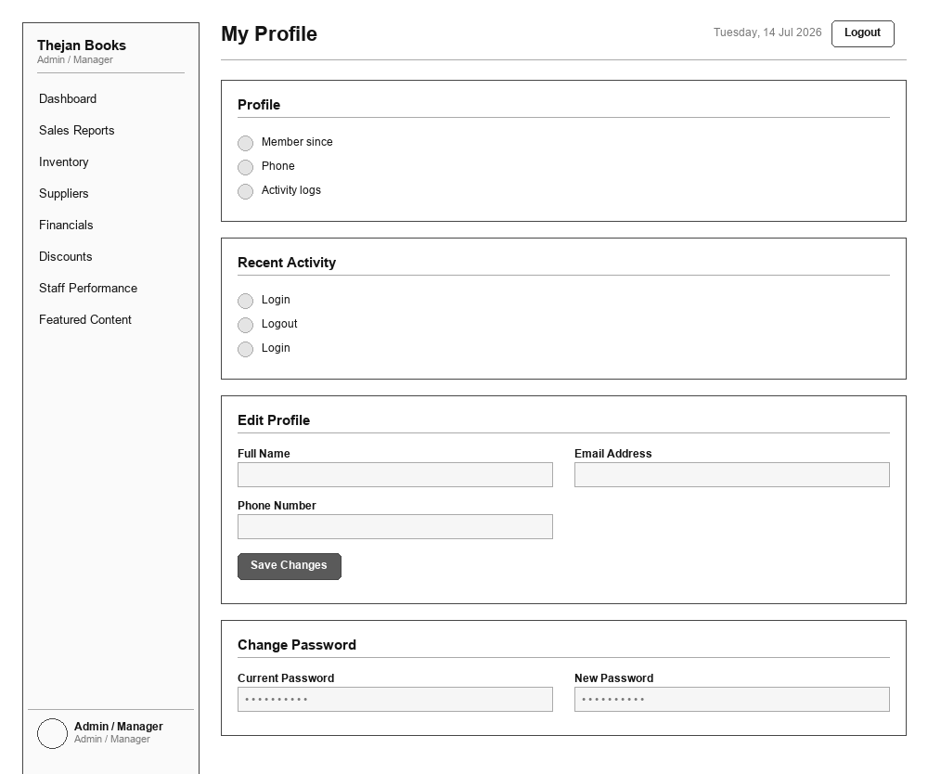
UI 22 — Dashboard
Role: Store Manager
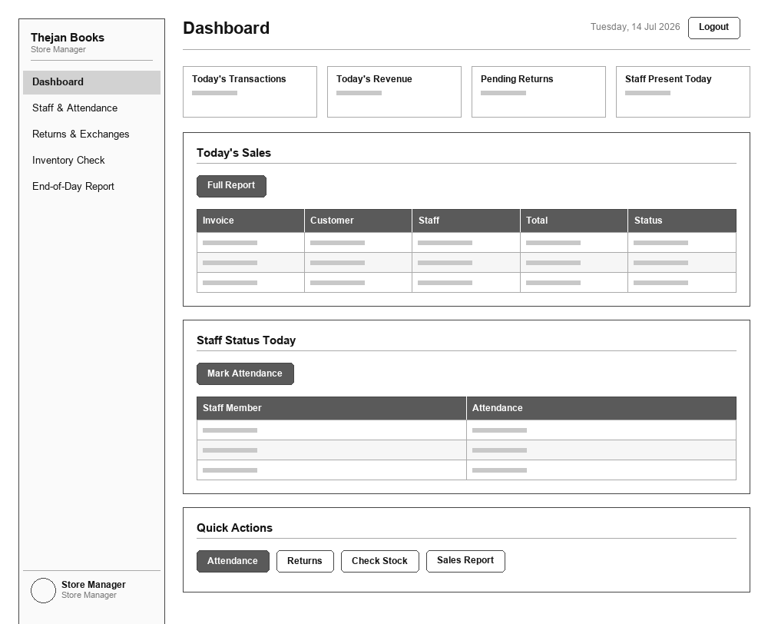
UI 23 — Staff & Attendance
Role: Store Manager
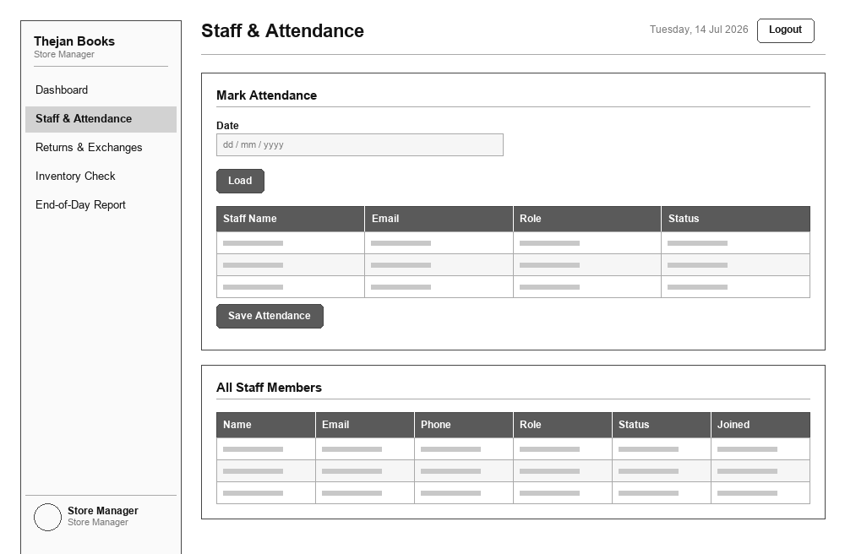
UI 24 — Returns & Exchanges
Role: Store Manager
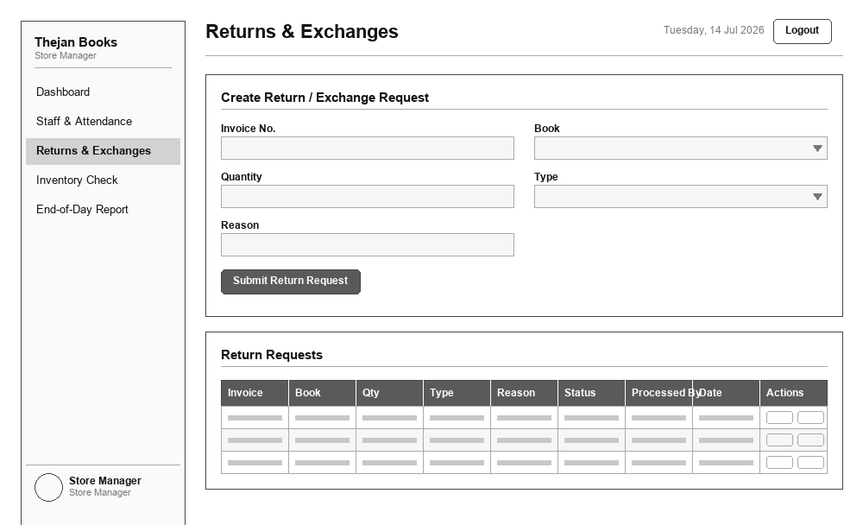
UI 25 — Inventory Check
Role: Store Manager
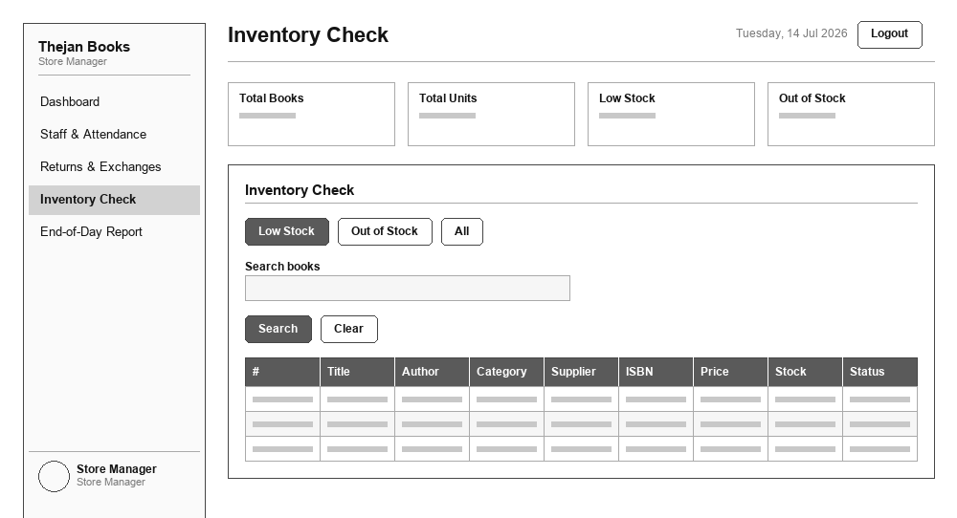
UI 26 — End-of-Day Report
Role: Store Manager
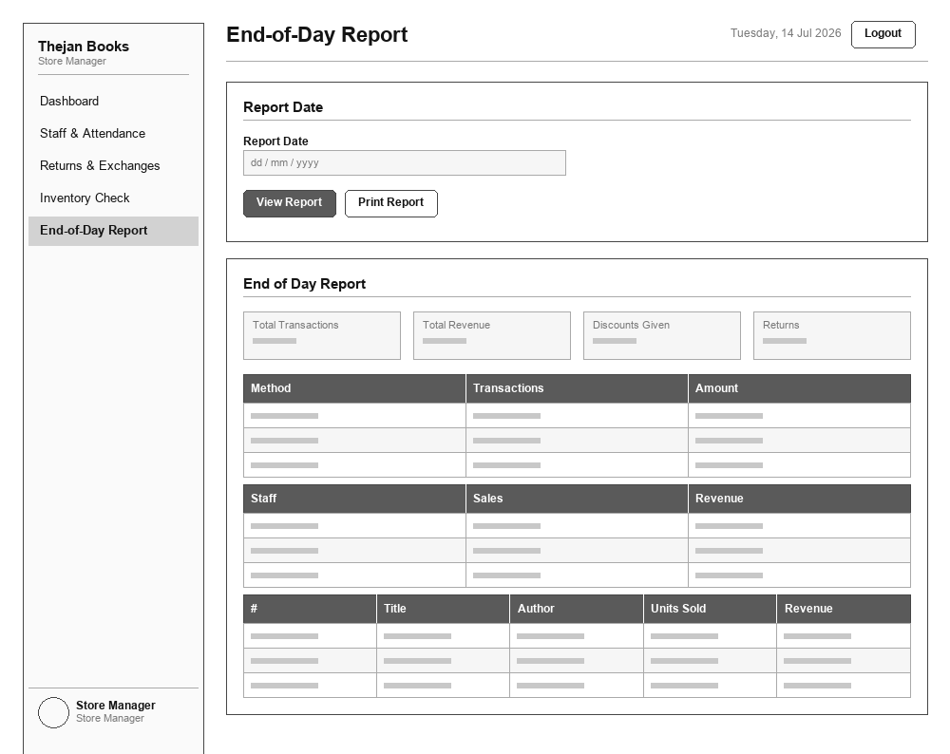
UI 27 — My Profile
Role: Store Manager
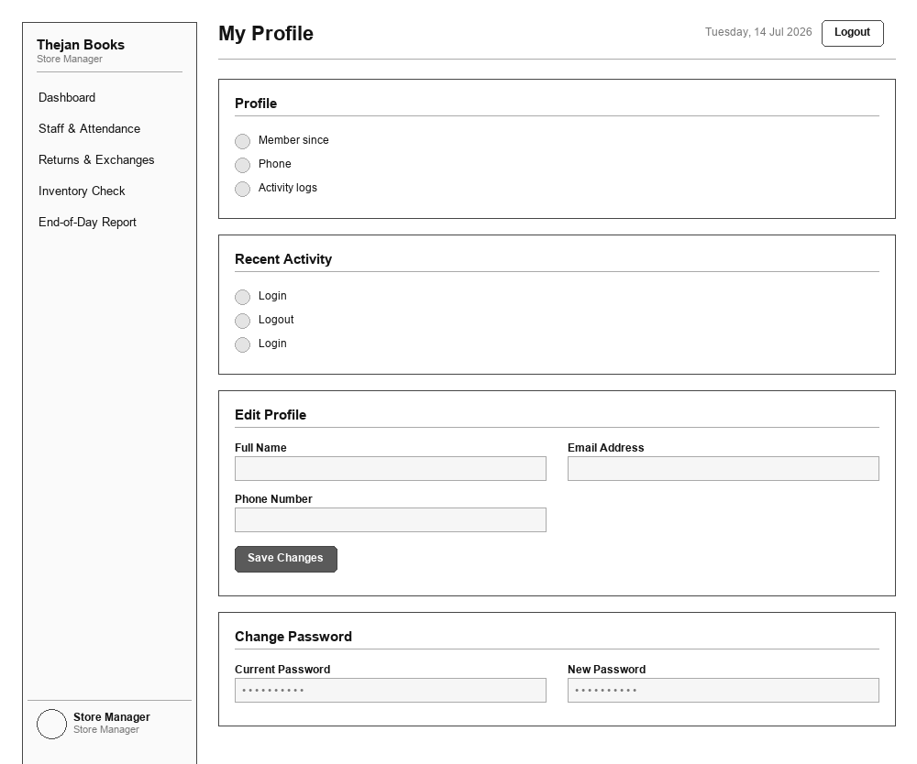
UI 28 — Sales Dashboard
Role: Sales Staff
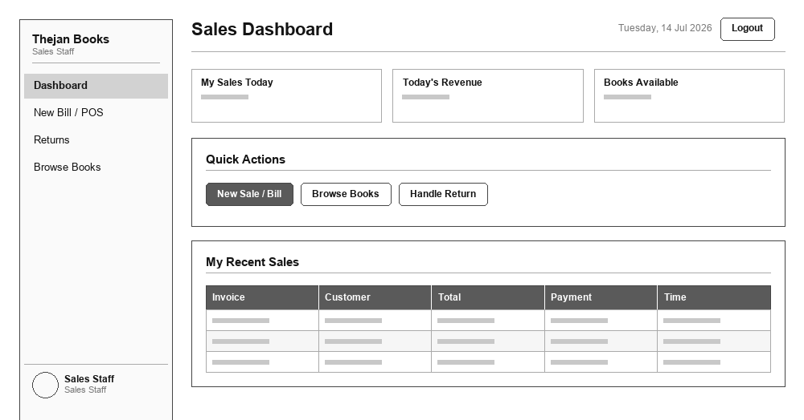
UI 29 — New Bill / POS
Role: Sales Staff
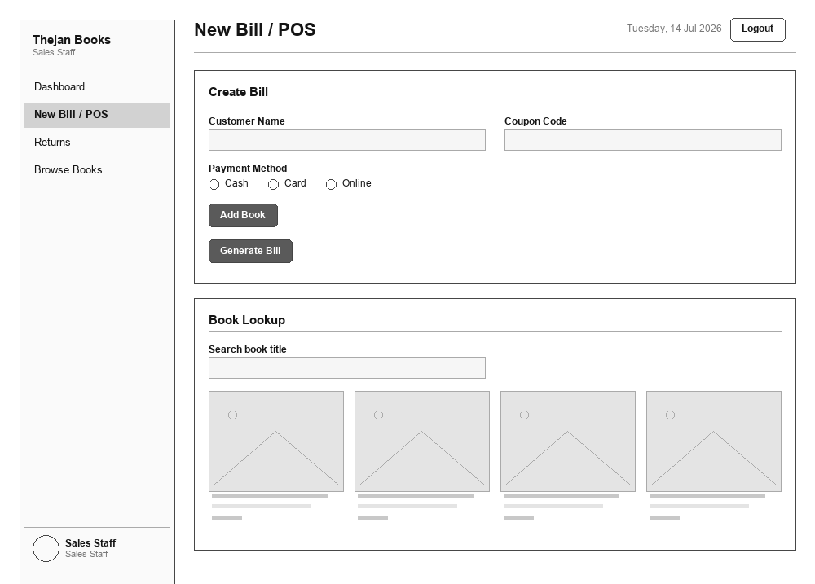
UI 30 — Returns
Role: Sales Staff
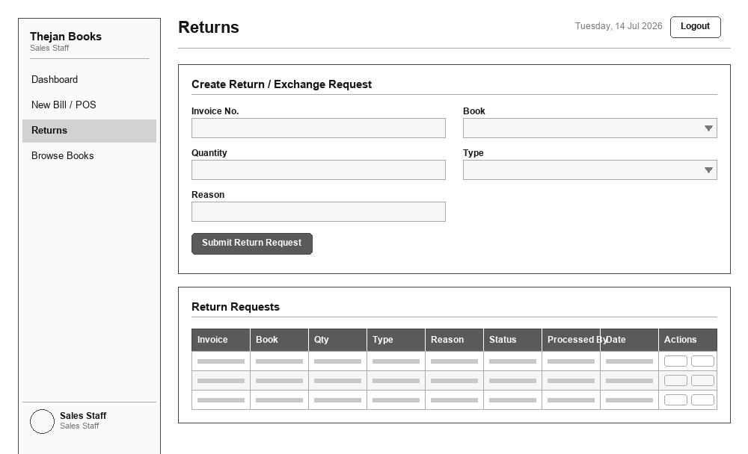
UI 31 — Browse Books
Role: Sales Staff
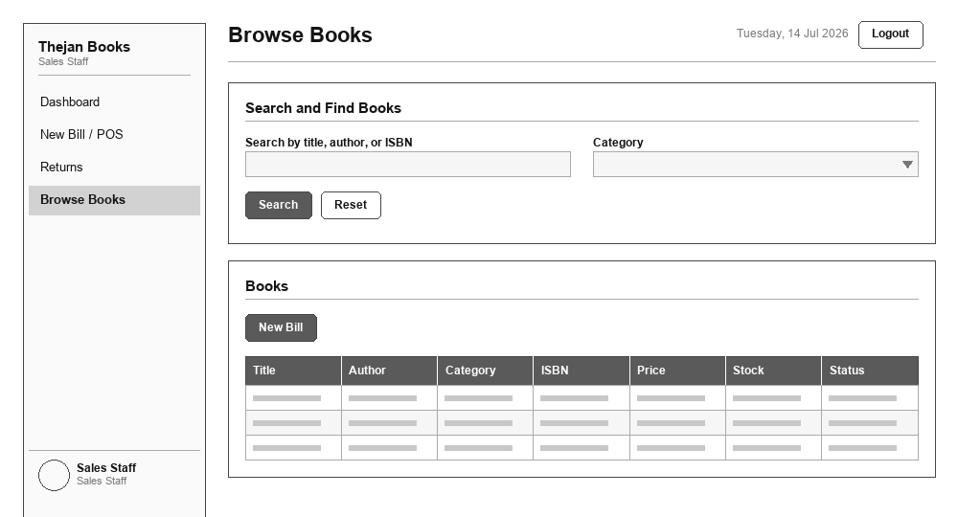
UI 32 — My Profile
Role: Sales Staff
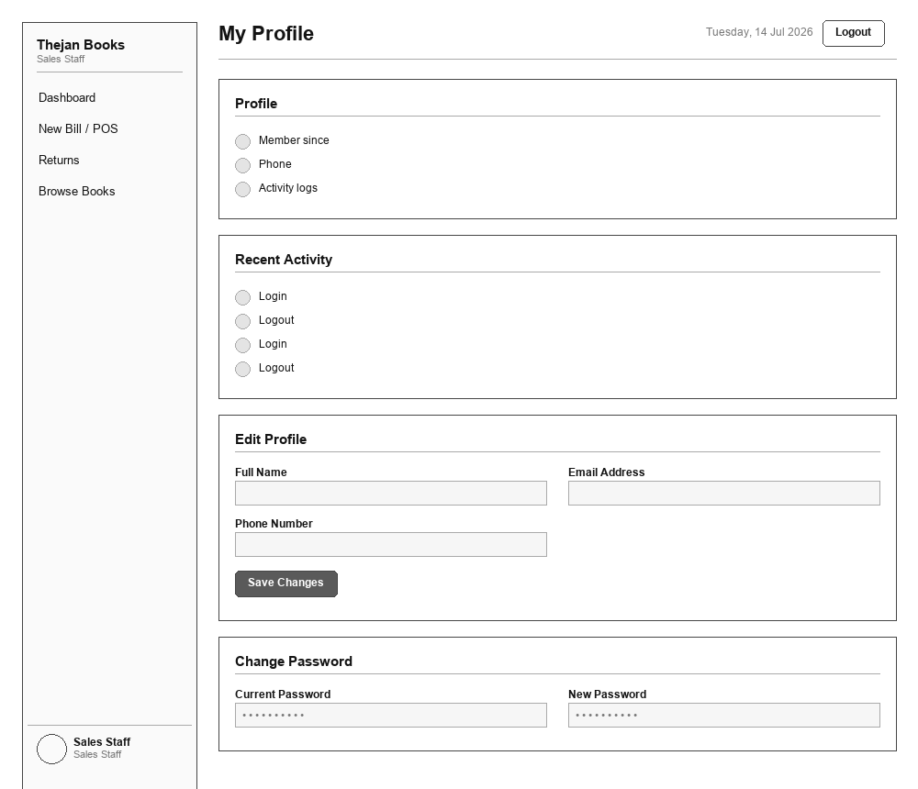
UI 33 — Inventory Dashboard
Role: Inventory Officer
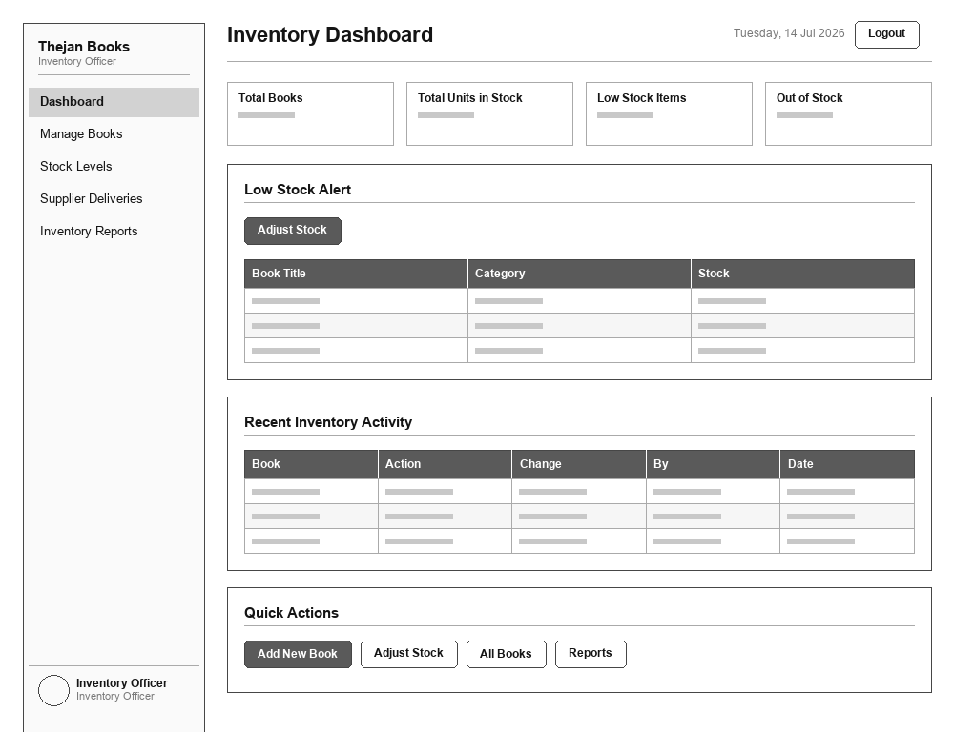
UI 34 — Manage Books
Role: Inventory Officer
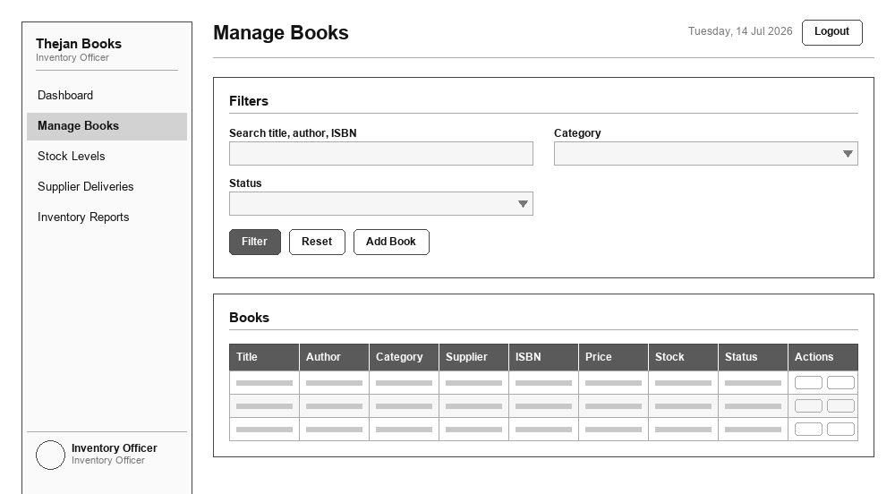
UI 35 — Stock Management
Role: Inventory Officer
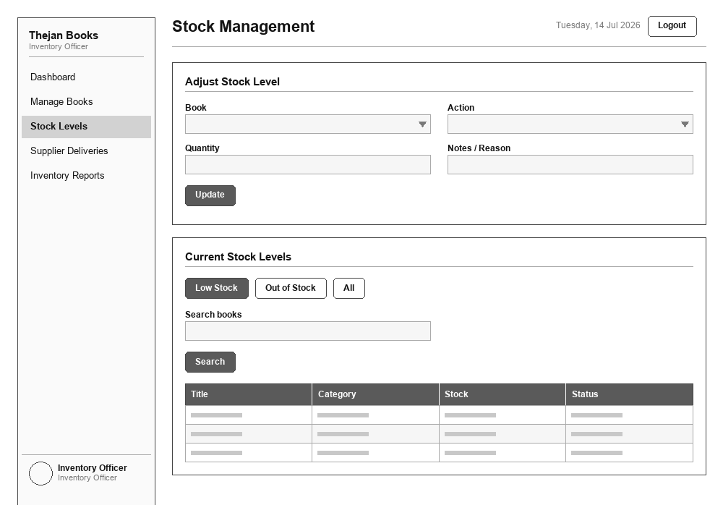
UI 36 — Supplier Deliveries
Role: Inventory Officer
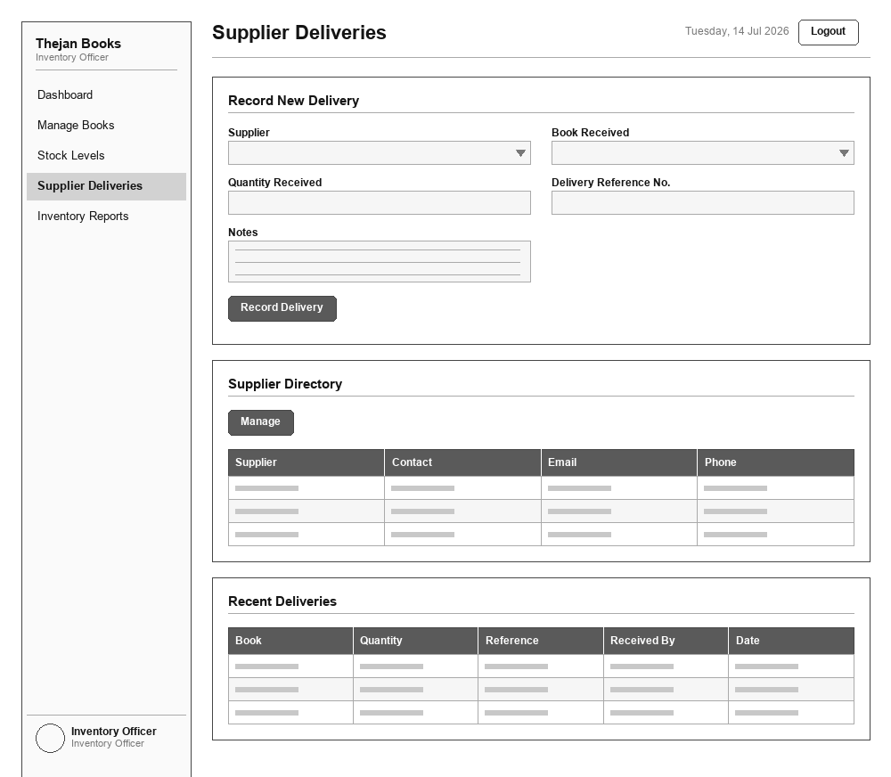
UI 37 — Inventory Reports
Role: Inventory Officer
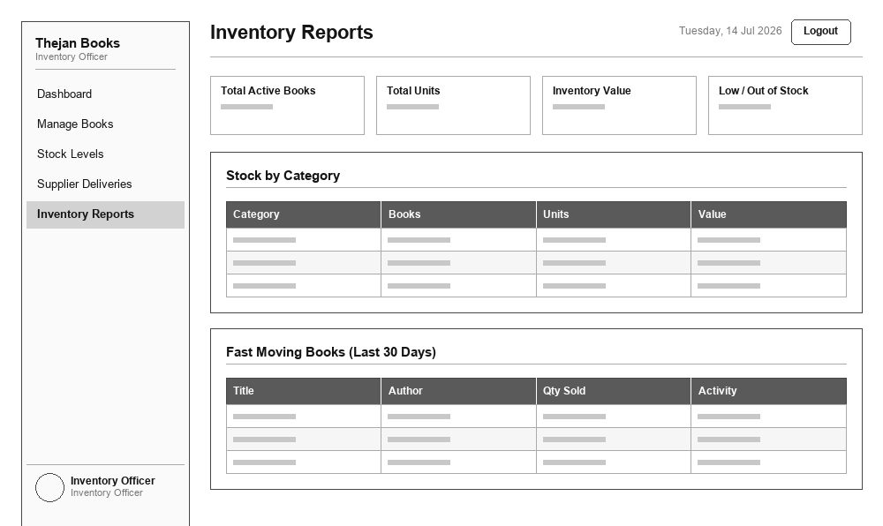
UI 38 — My Profile
Role: Inventory Officer
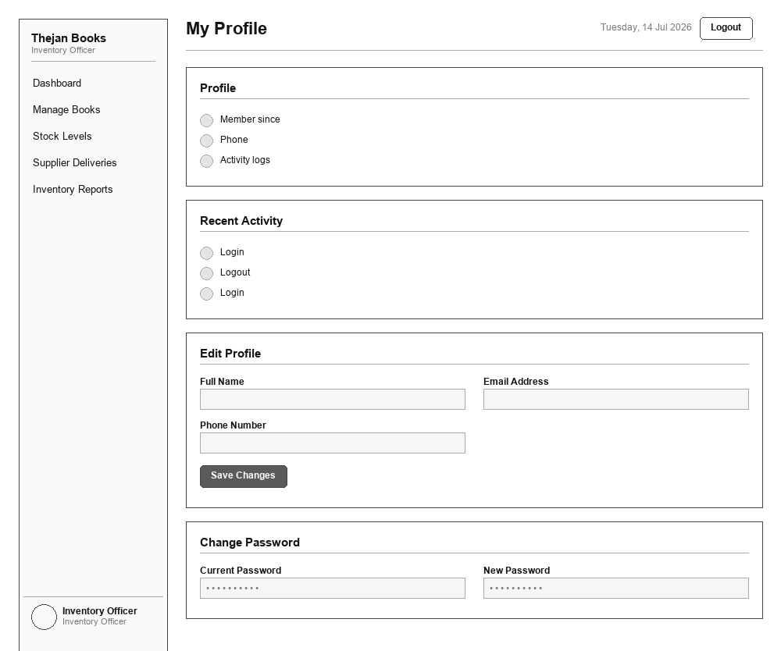
UI 39 — Home / Browse Books
Role: Customer (Guest)
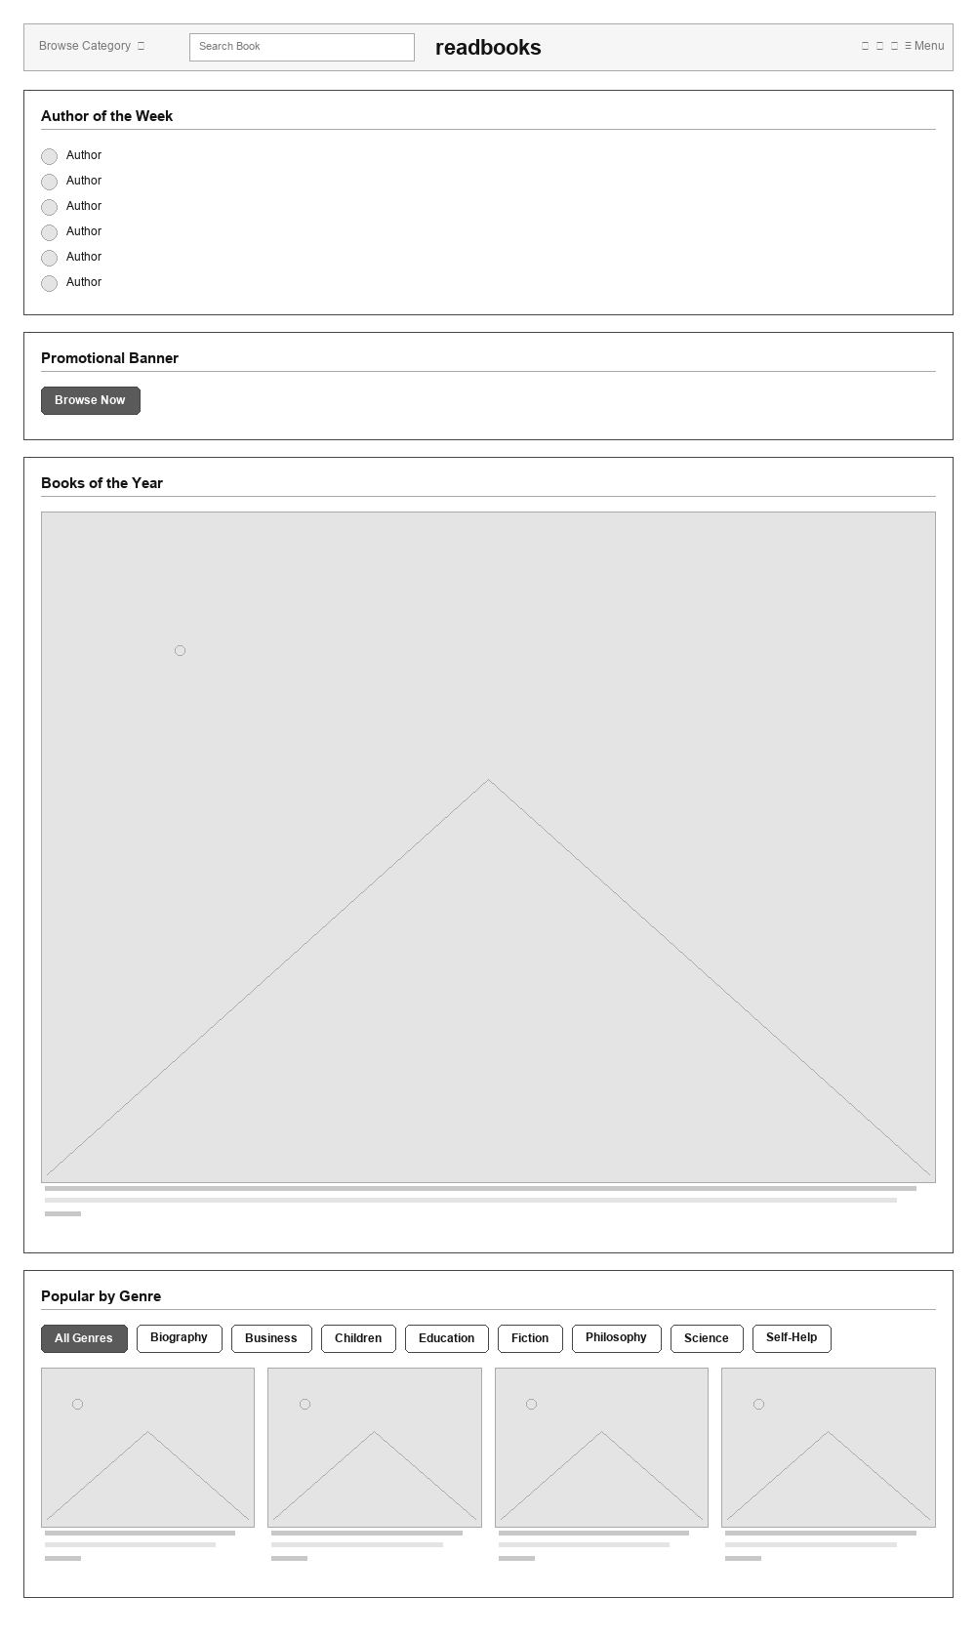
UI 40 — Home / Browse Books (Signed In)
Role: Customer
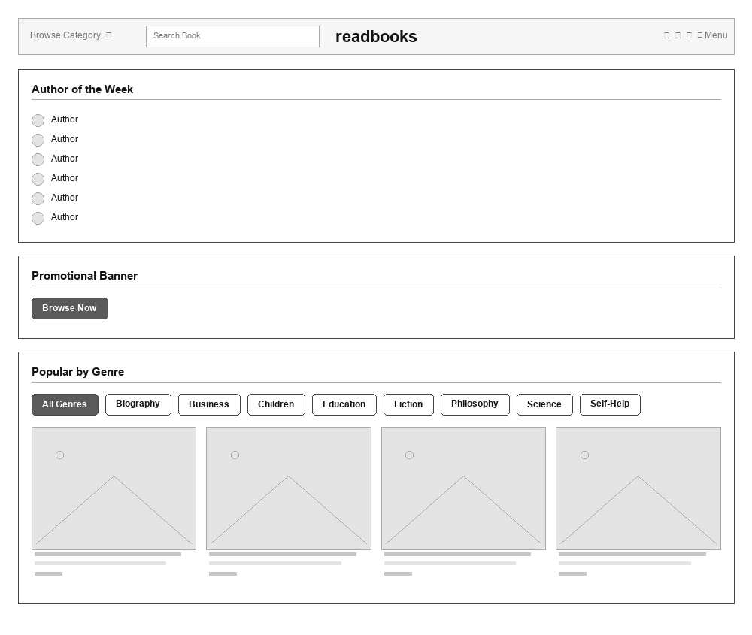
UI 41 — Book Detail
Role: Customer
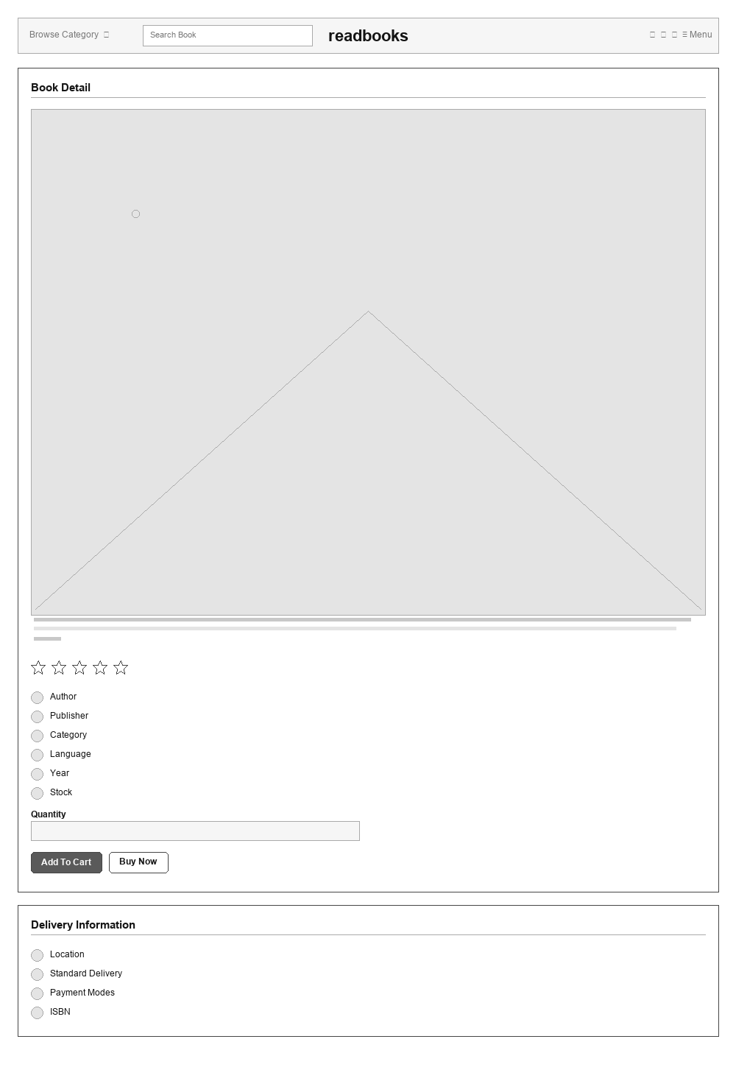
UI 42 — Shopping Cart
Role: Customer
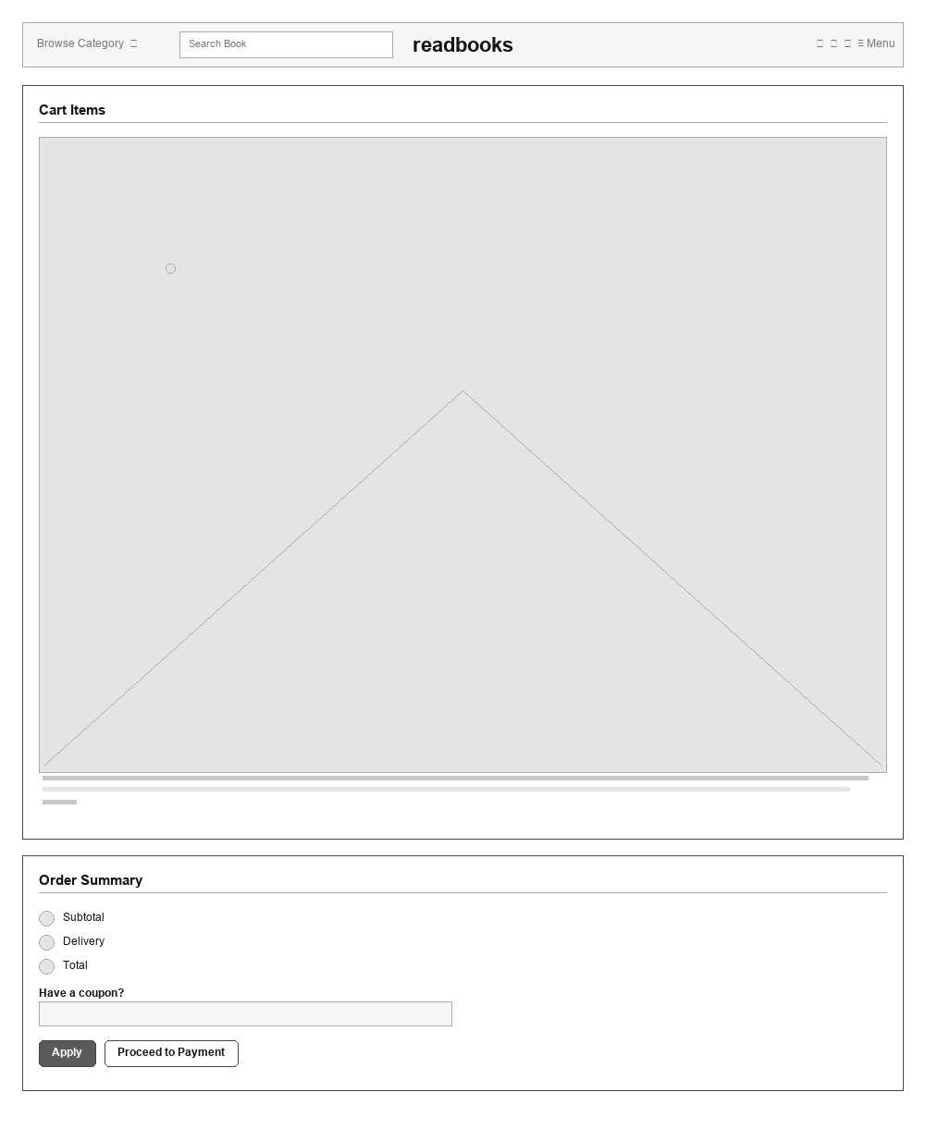
UI 43 — Checkout / Payment
Role: Customer
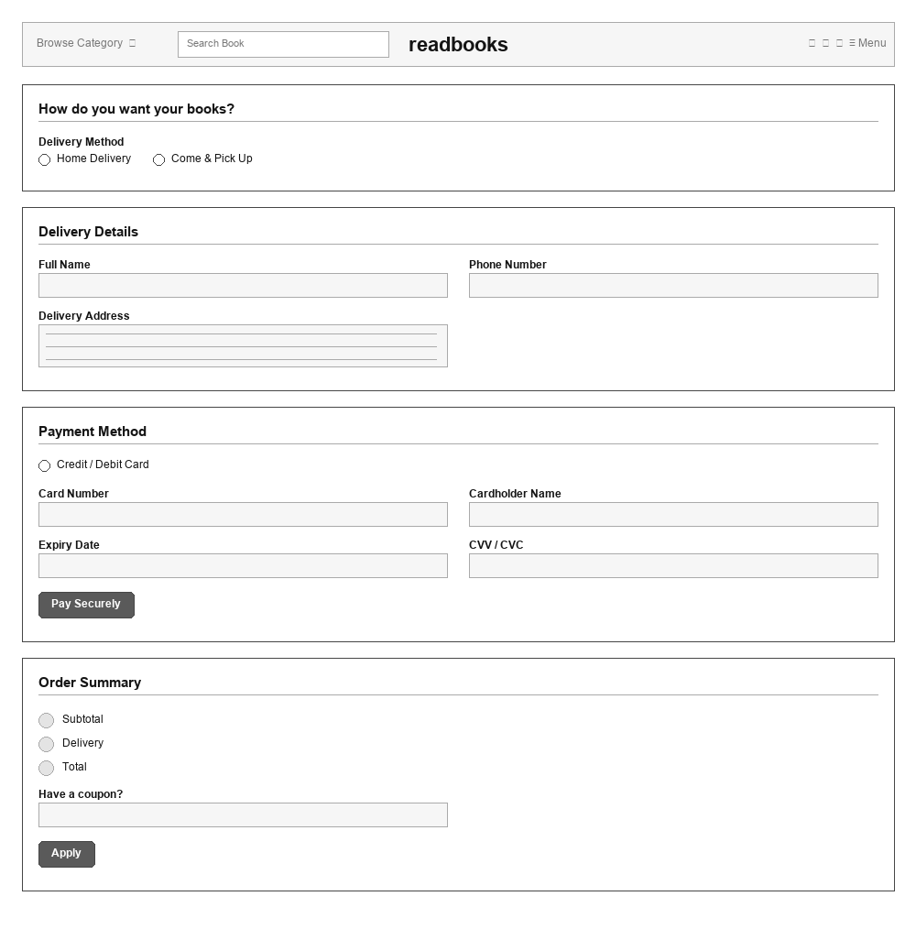
UI 44 — Order Confirmation
Role: Customer
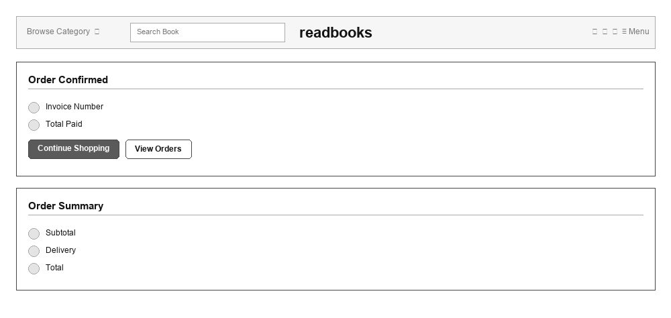
UI 45 — Share Feedback
Role: Customer
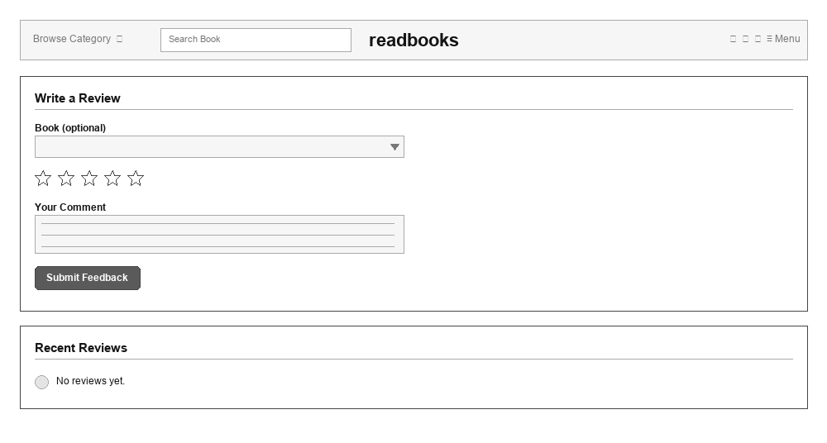
UI 46 — My Account
Role: Customer
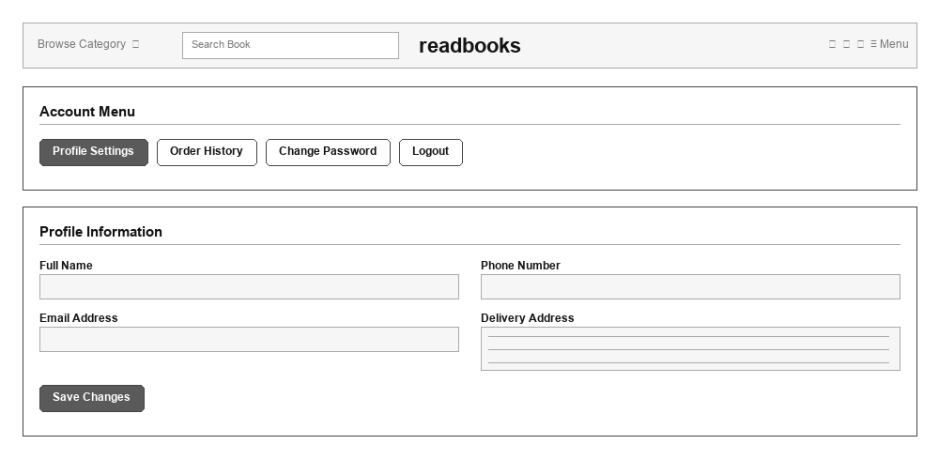
UI 47 — About Us
Role: Customer
