UI 01 — Login Page
Role: Login
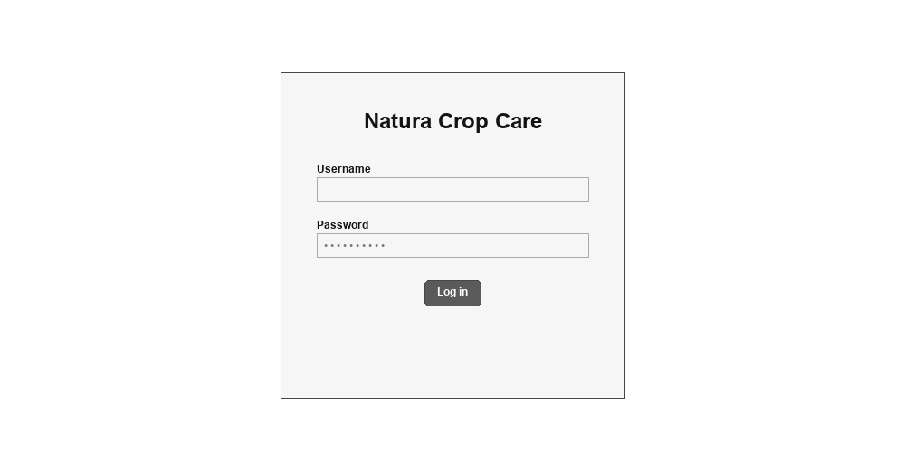
UI 02 — Dashboard
Role: CEO / Head Manager
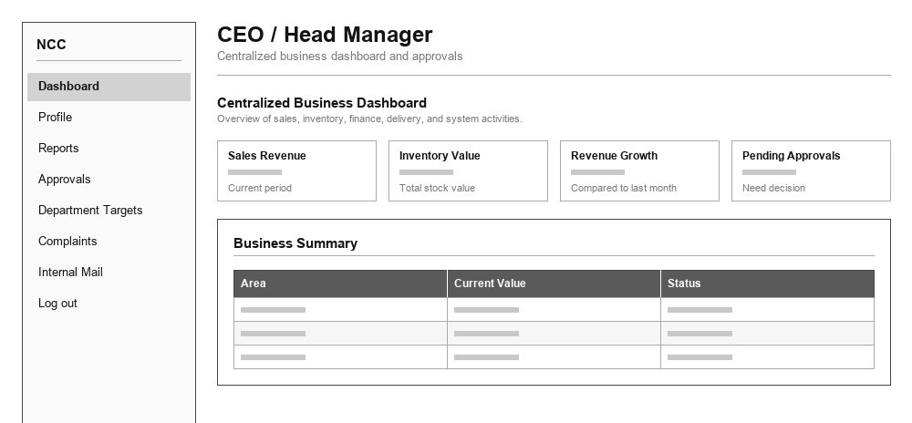
UI 03 — Approvals
Role: CEO / Head Manager
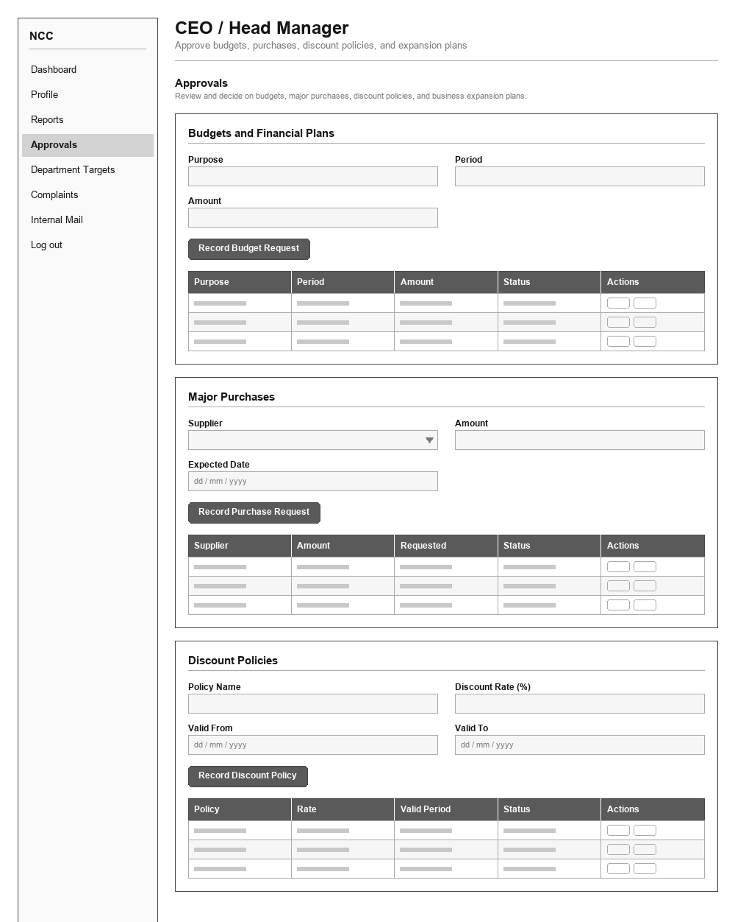
UI 04 — Complaints
Role: CEO / Head Manager
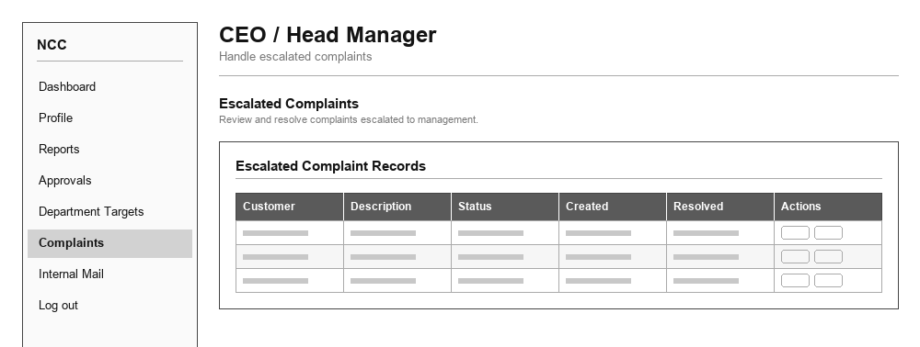
UI 05 — Department Targets
Role: CEO / Head Manager
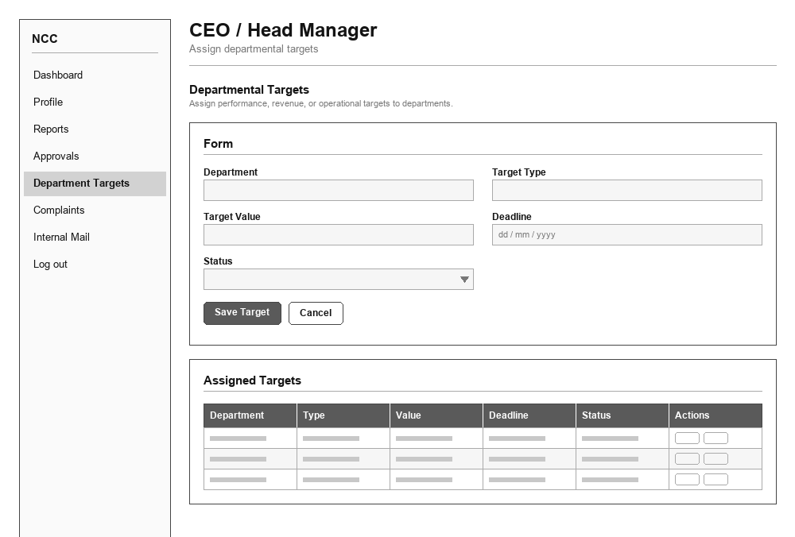
UI 06 — Profile
Role: CEO / Head Manager
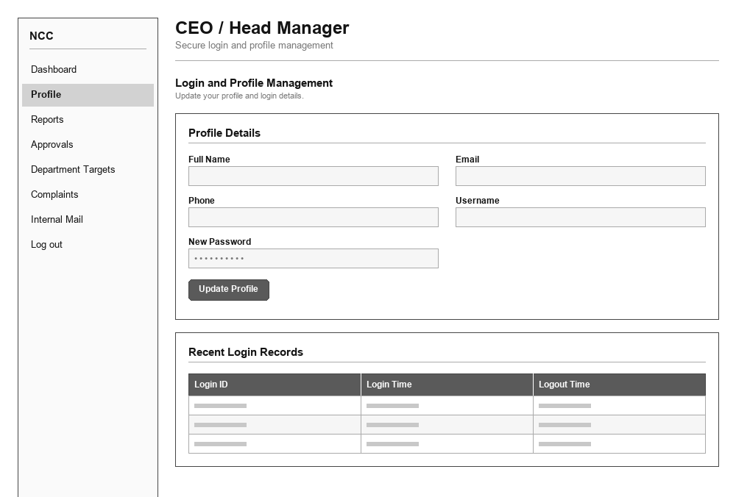
UI 07 — Reports
Role: CEO / Head Manager
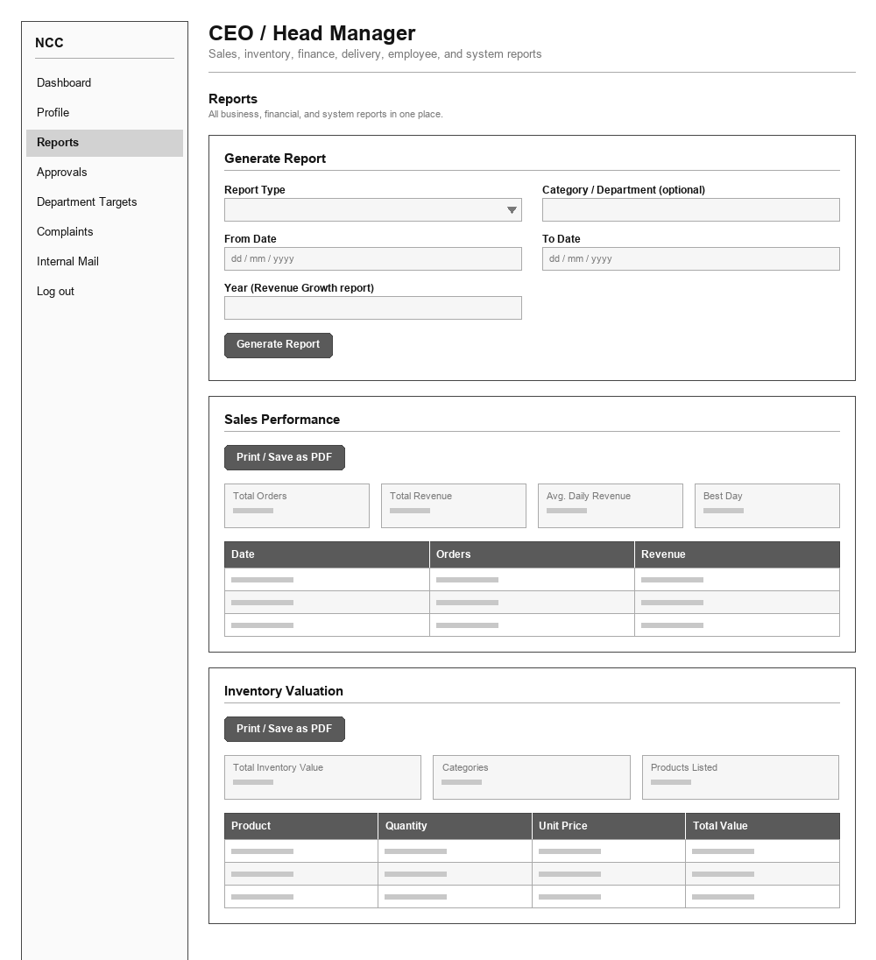
UI 08 — Dashboard
Role: Customer Relationship Officer
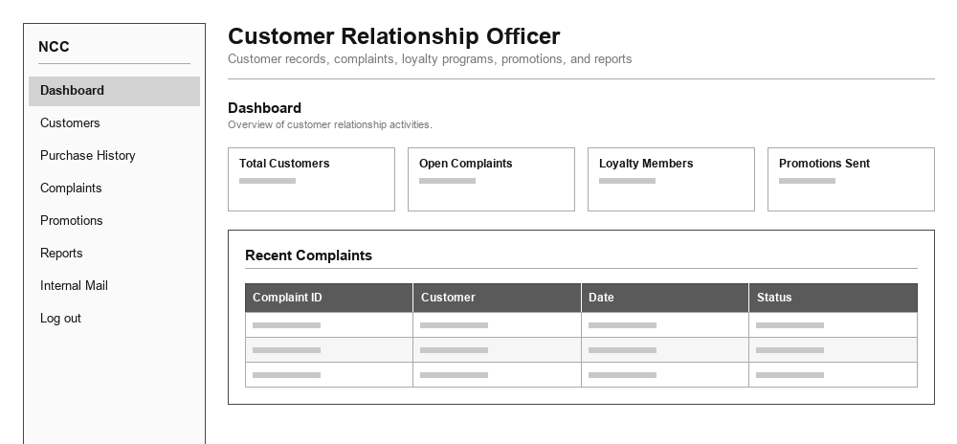
UI 09 — Customers
Role: Customer Relationship Officer
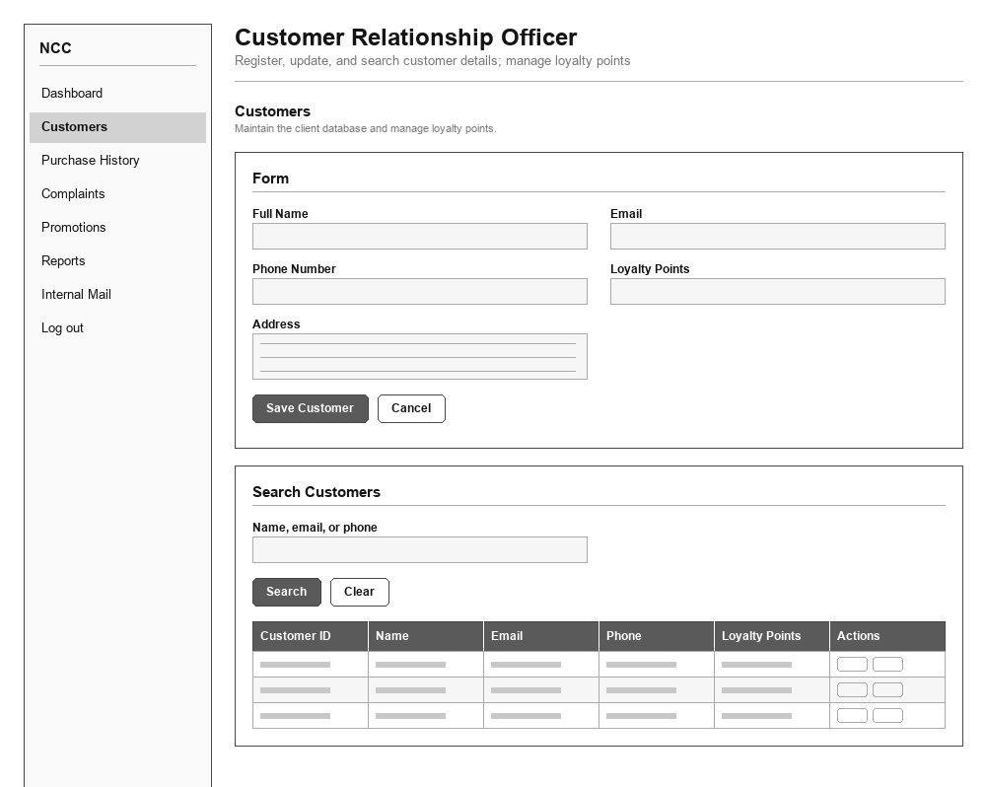
UI 10 — Complaints
Role: Customer Relationship Officer
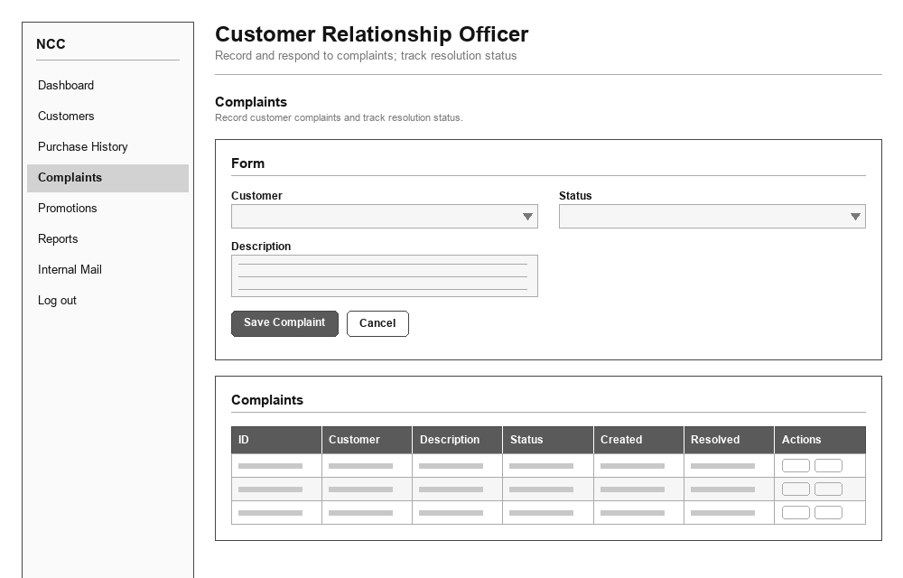
UI 11 — Promotions
Role: Customer Relationship Officer
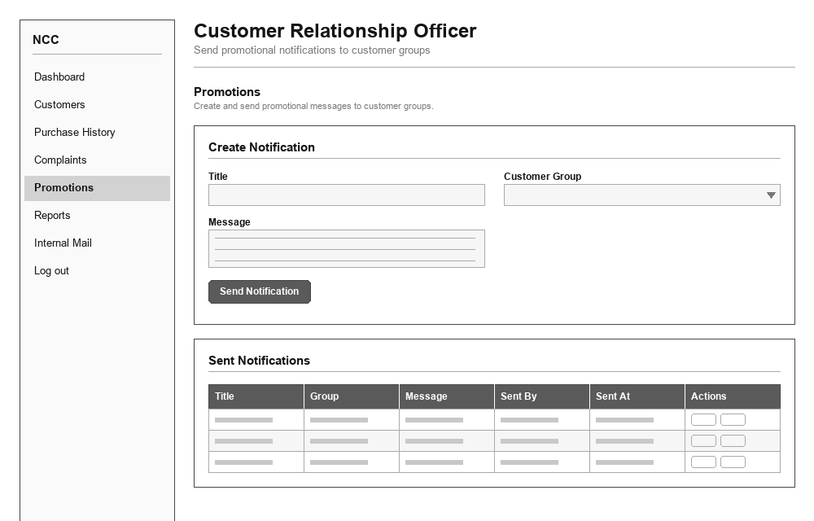
UI 12 — Purchase History
Role: Customer Relationship Officer
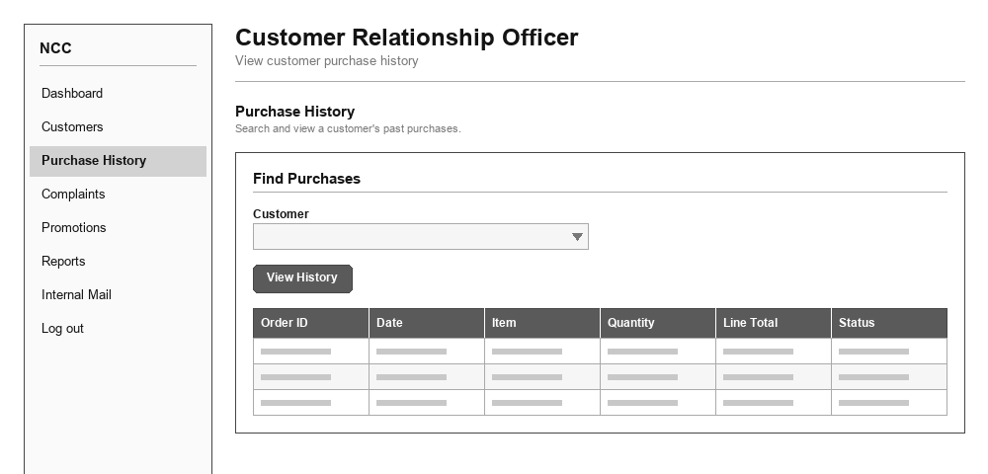
UI 13 — Reports
Role: Customer Relationship Officer
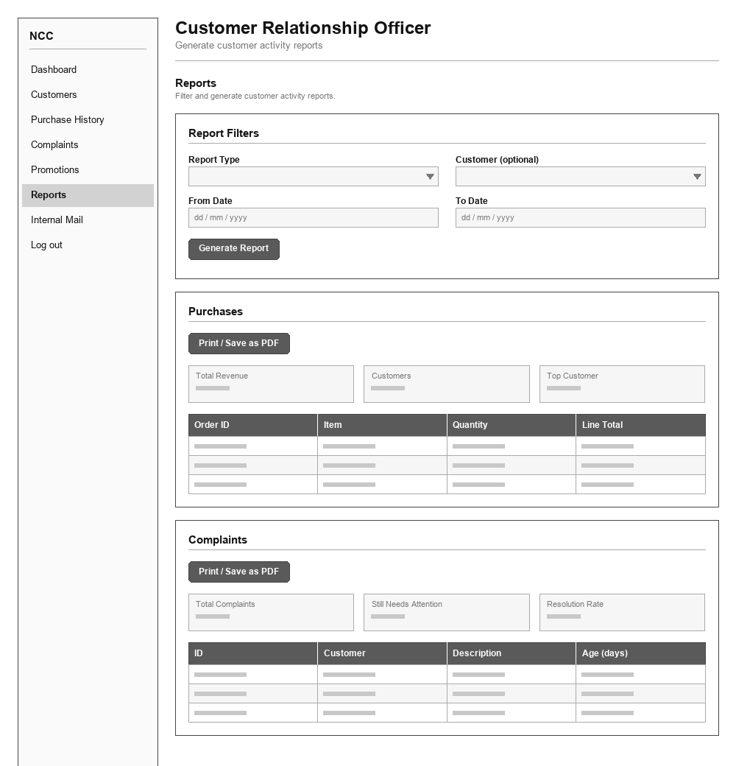
UI 14 — Dashboard
Role: Distribution Manager
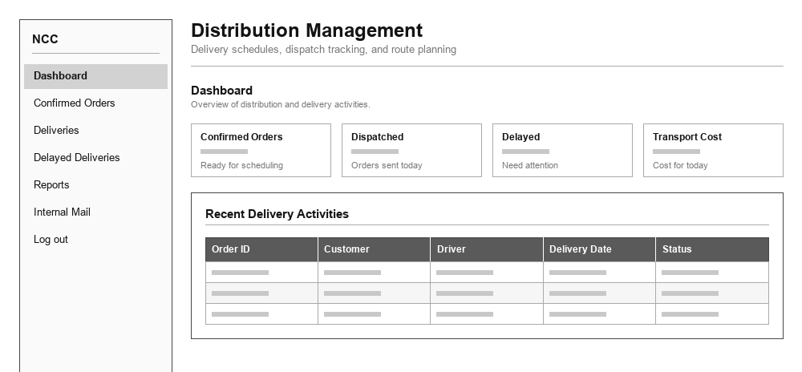
UI 15 — Deliveries
Role: Distribution Manager
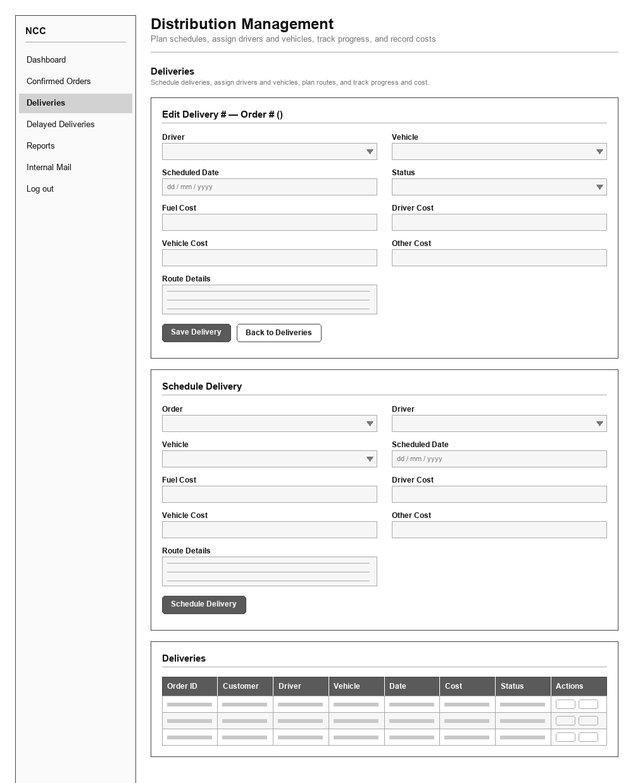
UI 16 — Delayed Deliveries
Role: Distribution Manager
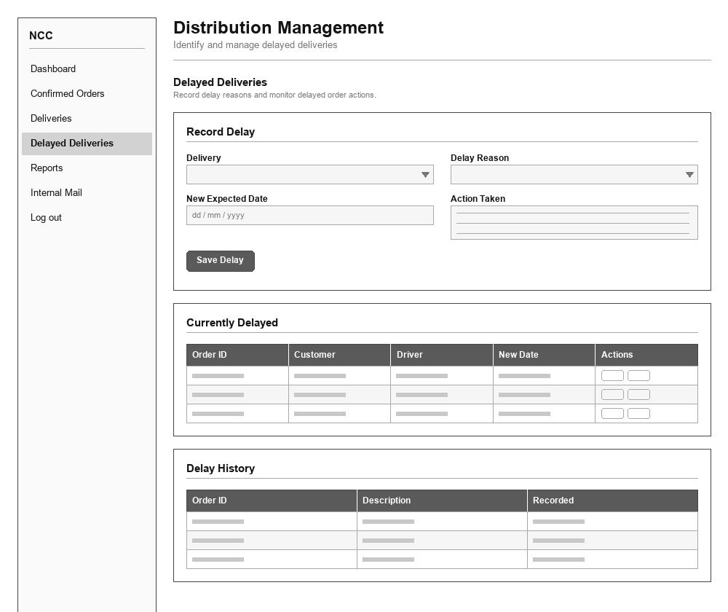
UI 17 — Confirmed Orders
Role: Distribution Manager
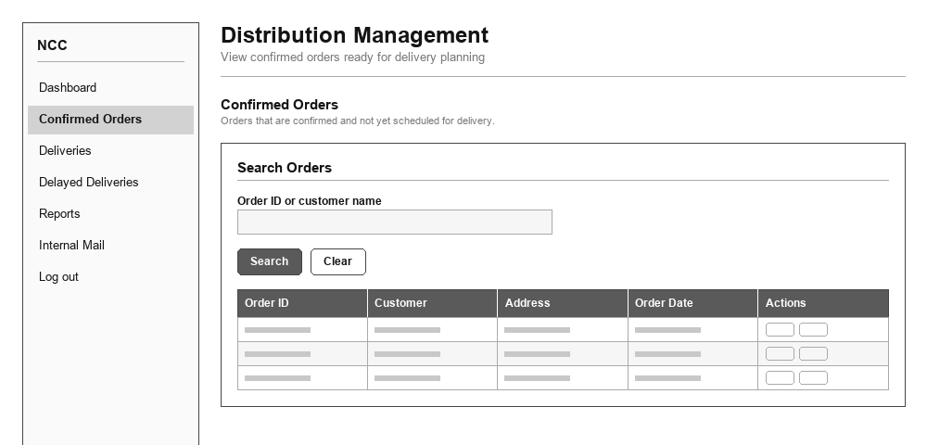
UI 18 — Reports
Role: Distribution Manager
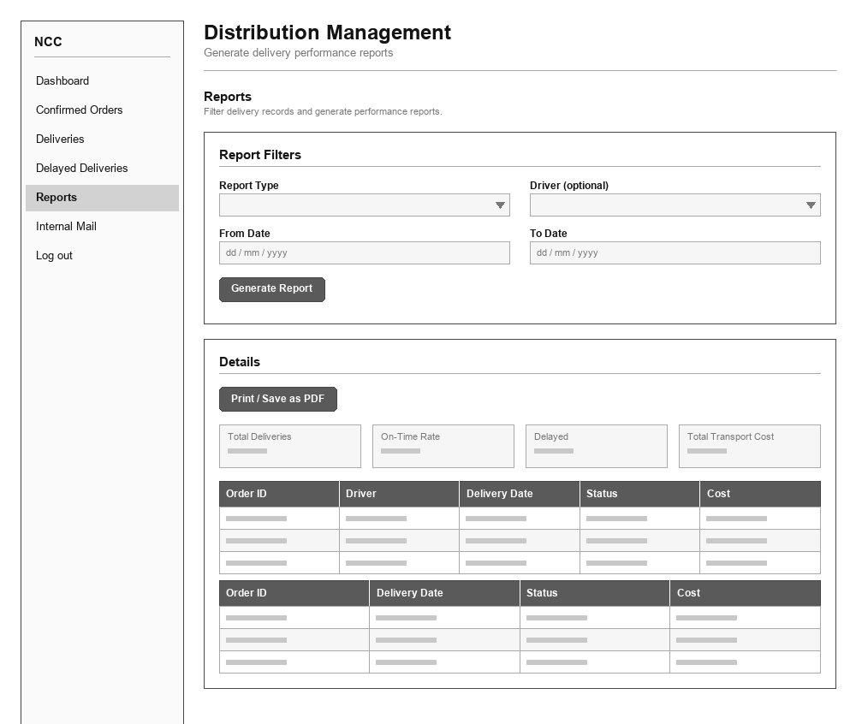
UI 19 — Dashboard
Role: Driver
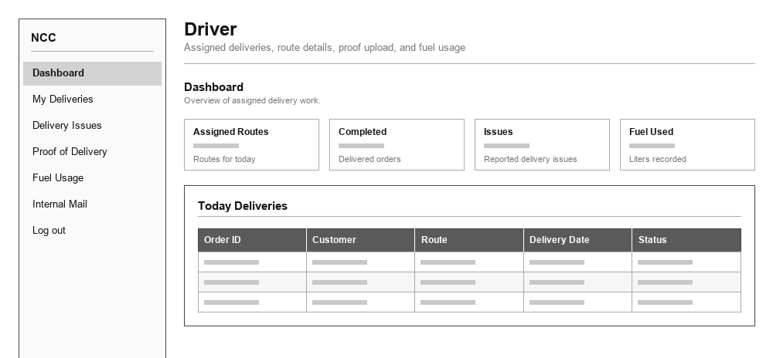
UI 20 — My Deliveries
Role: Driver
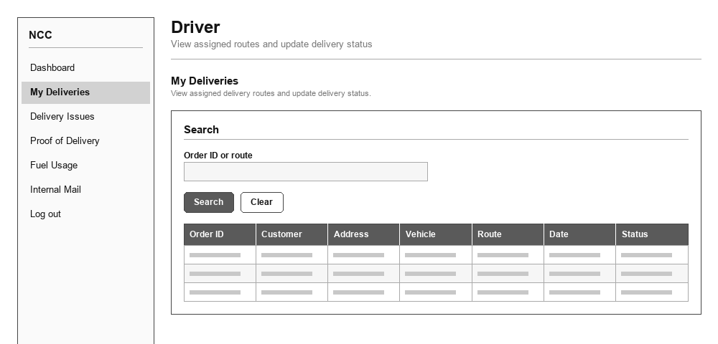
UI 21 — Proof of Delivery
Role: Driver
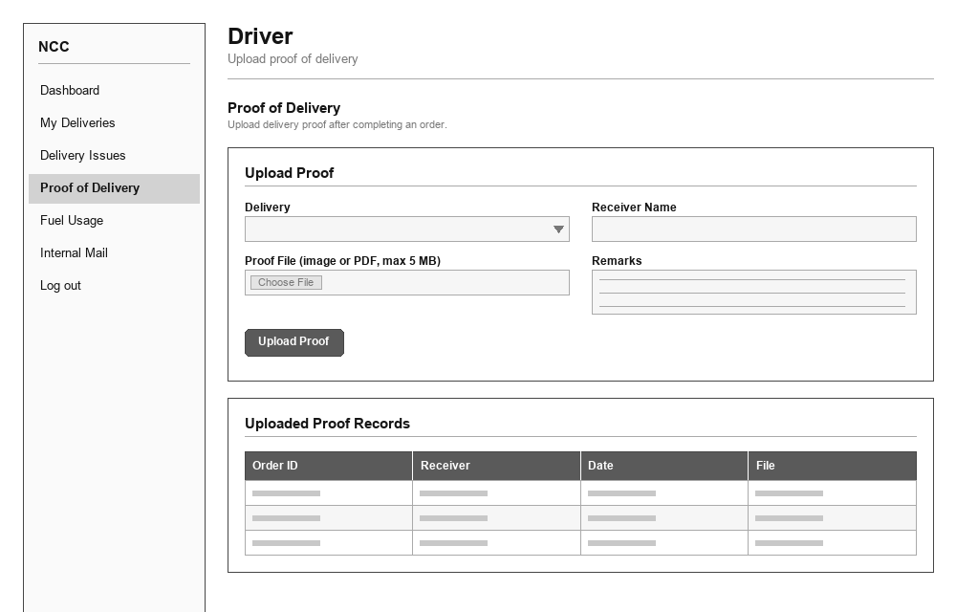
UI 22 — Fuel Usage
Role: Driver
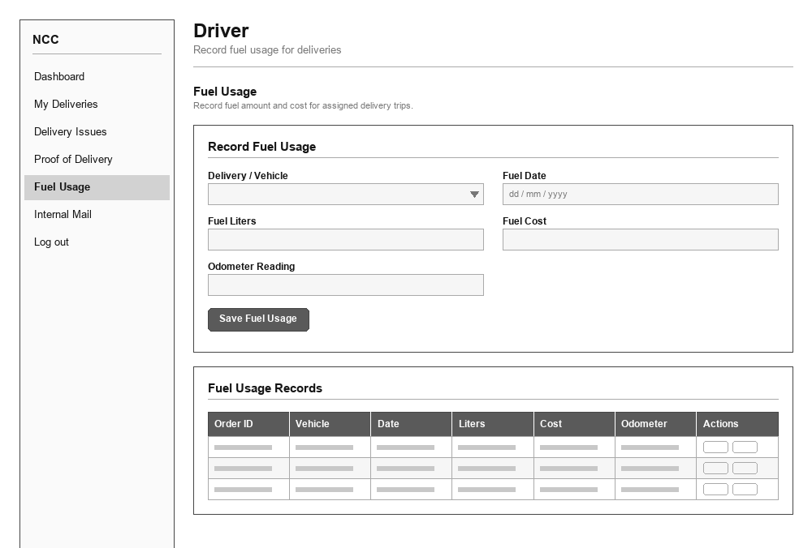
UI 23 — Delivery Issues
Role: Driver
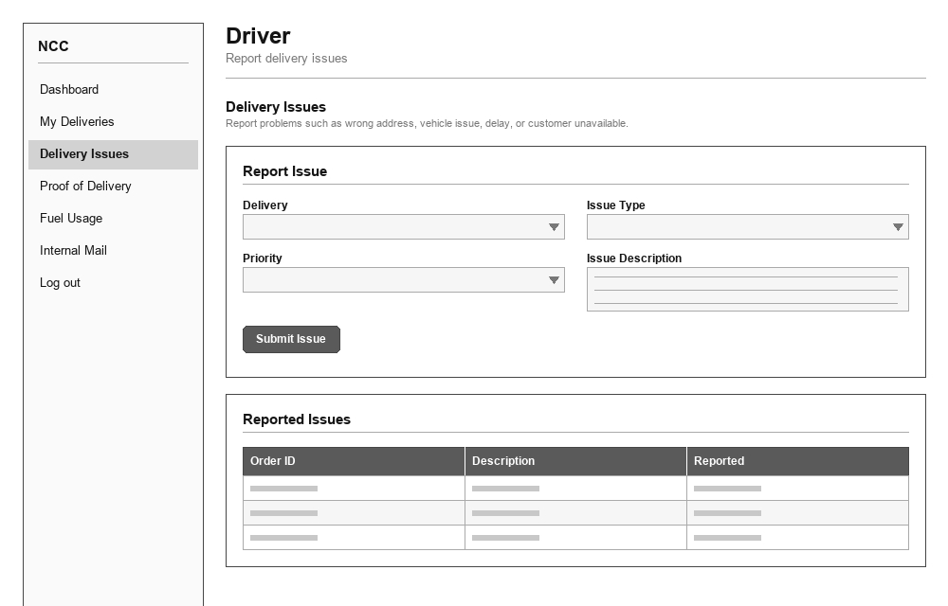
UI 24 — Dashboard
Role: Finance Officer
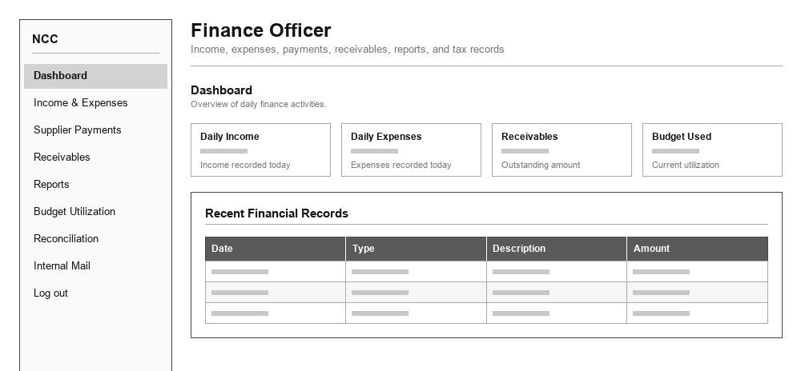
UI 25 — Income & Expenses
Role: Finance Officer
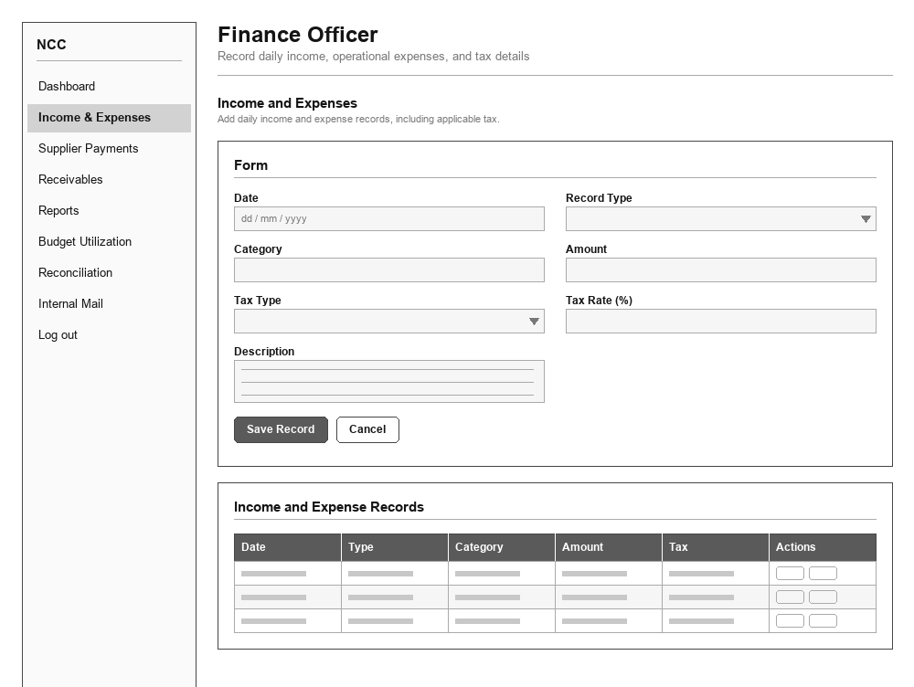
UI 26 — Receivables
Role: Finance Officer
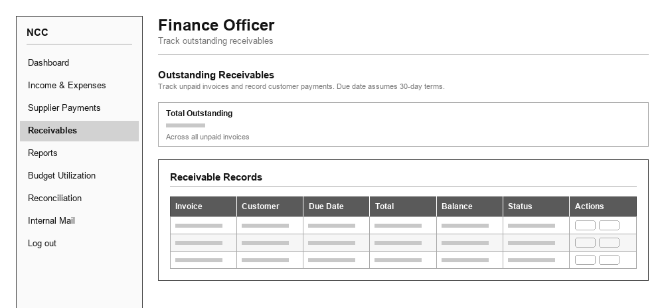
UI 27 — Supplier Payments
Role: Finance Officer
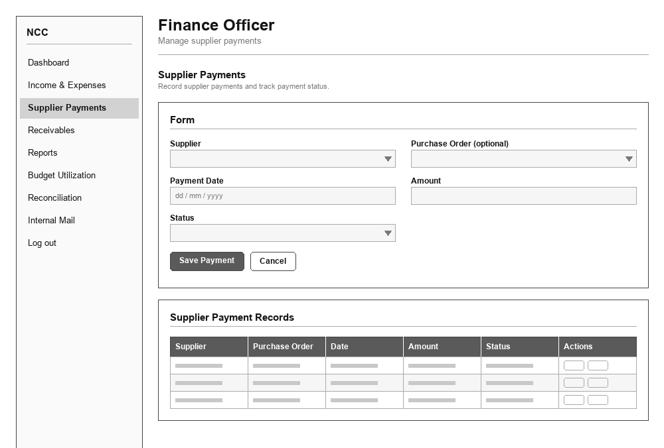
UI 28 — Reconciliation
Role: Finance Officer
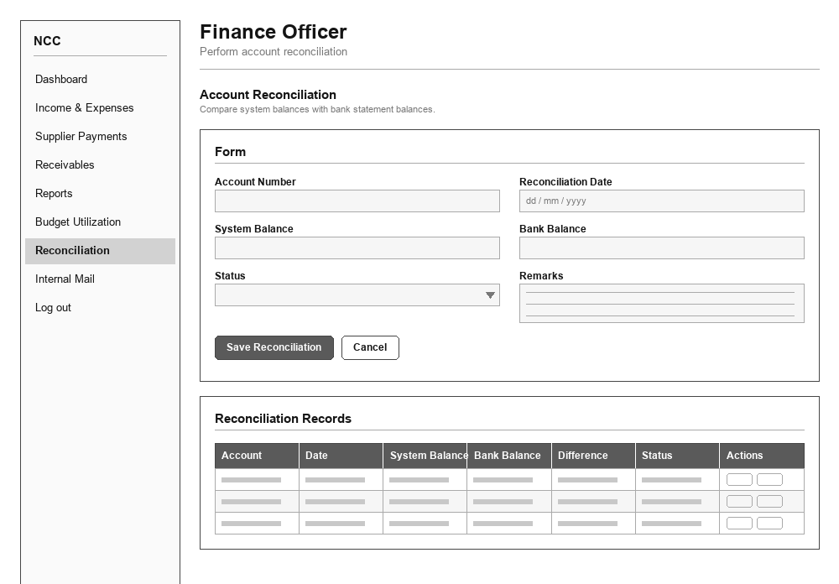
UI 29 — Budget Utilization
Role: Finance Officer
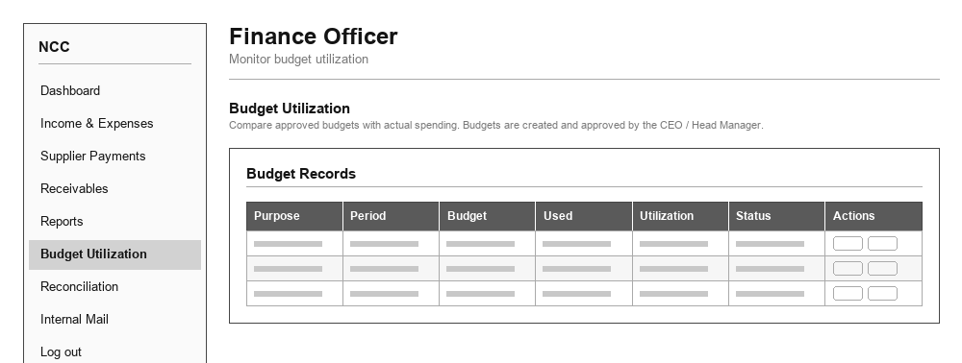
UI 30 — Reports
Role: Finance Officer
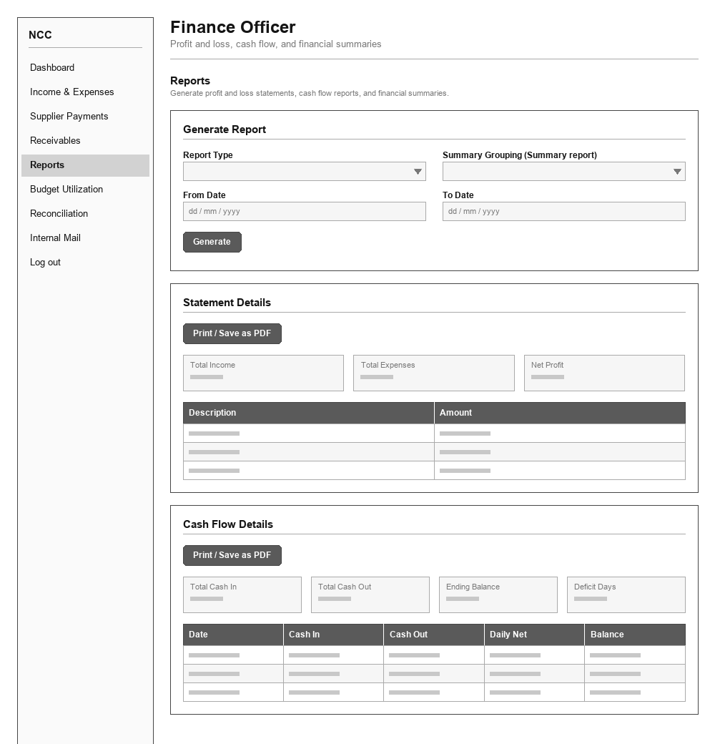
UI 31 — Dashboard
Role: Inventory Manager
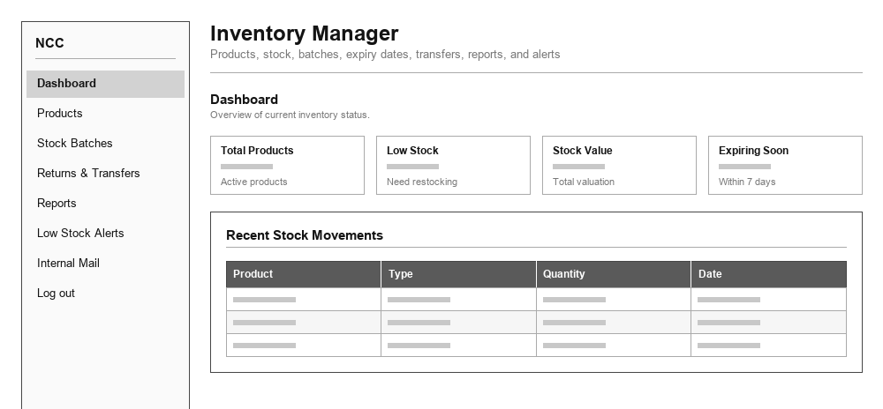
UI 32 — Products
Role: Inventory Manager
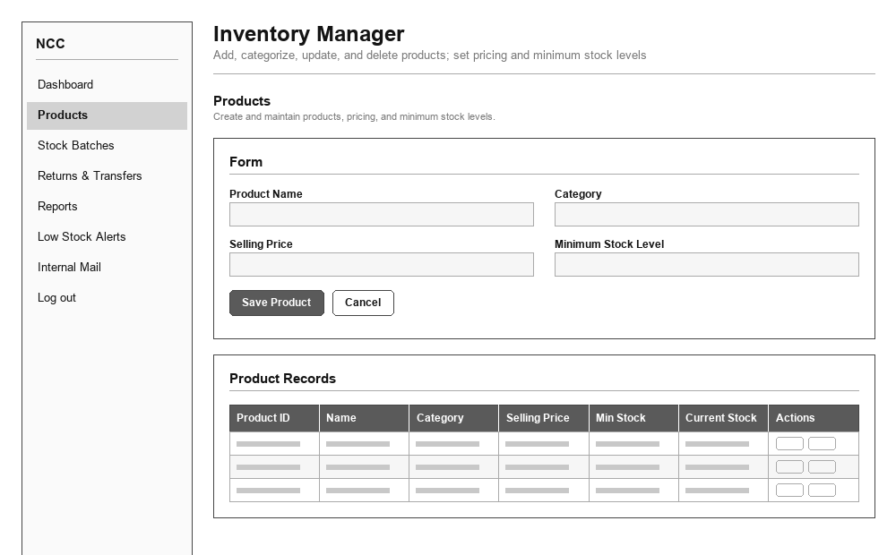
UI 33 — Stock Batches
Role: Inventory Manager
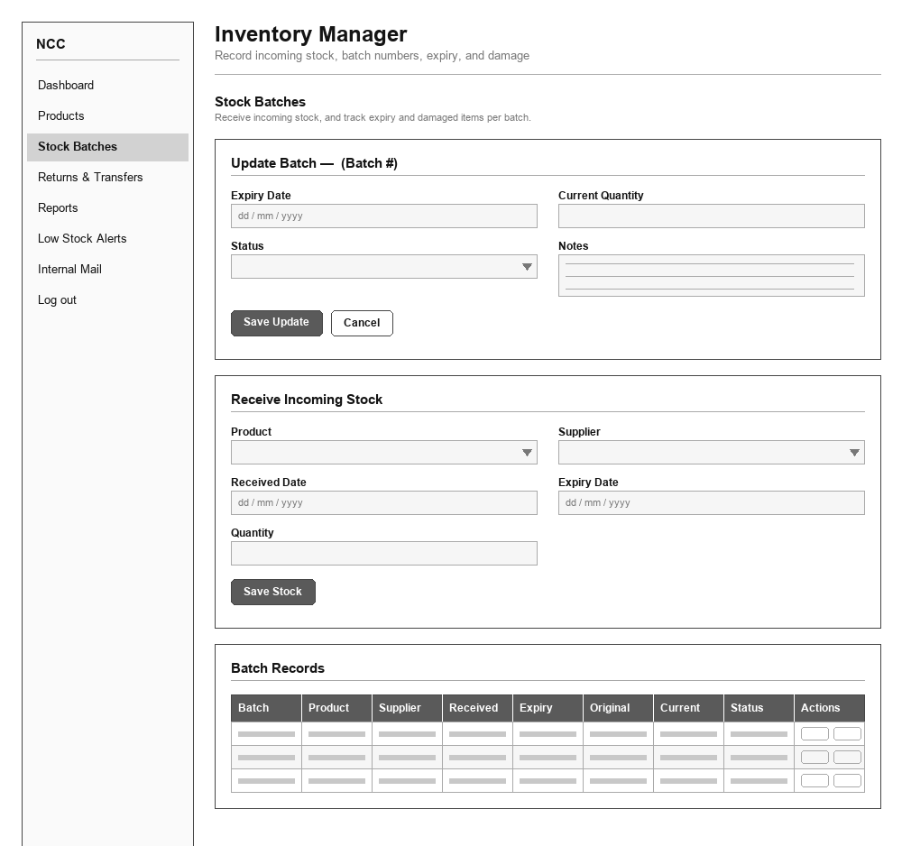
UI 34 — Stock Movements
Role: Inventory Manager
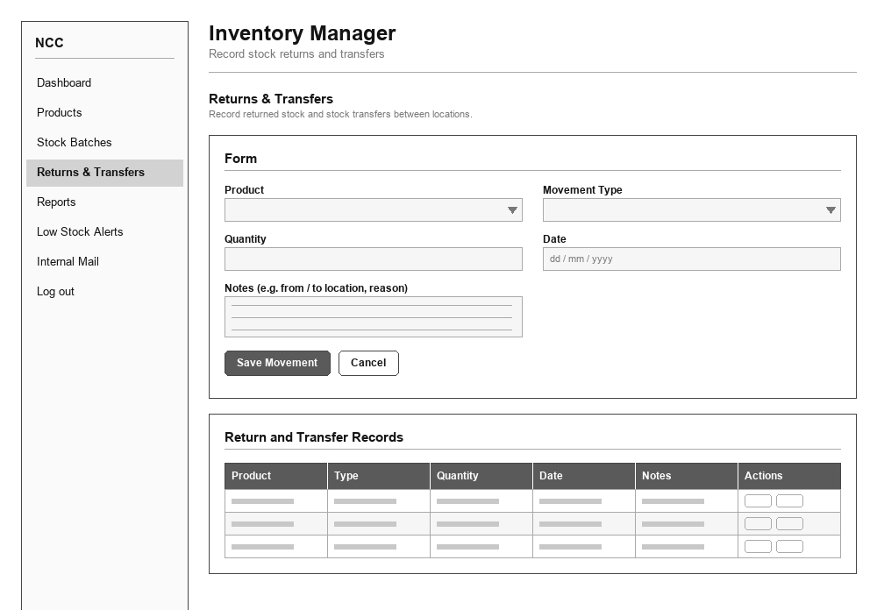
UI 35 — Low Stock Alerts
Role: Inventory Manager
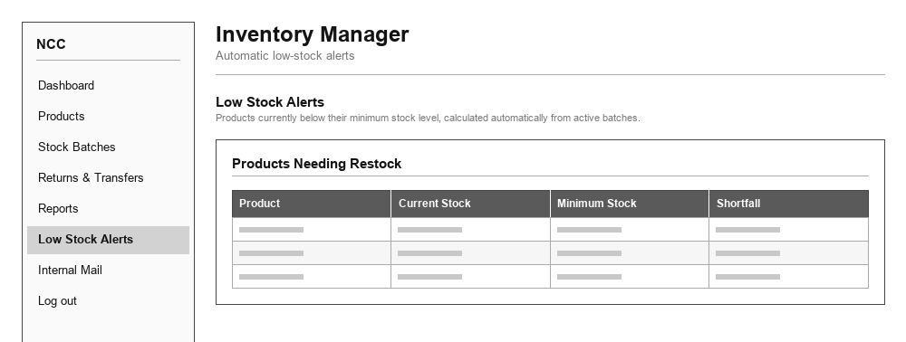
UI 36 — Reports
Role: Inventory Manager
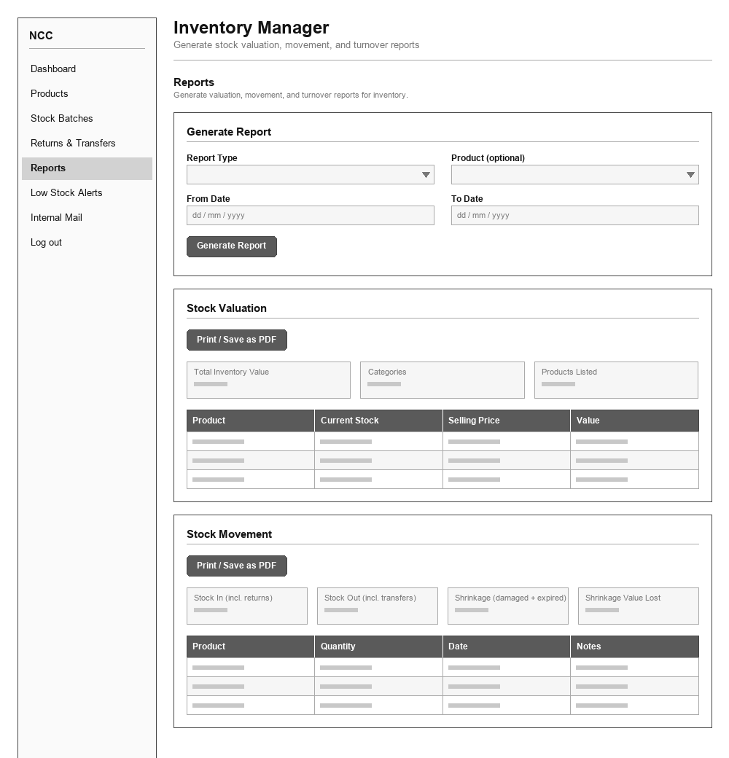
UI 37 — Dashboard
Role: Order Processing Officer
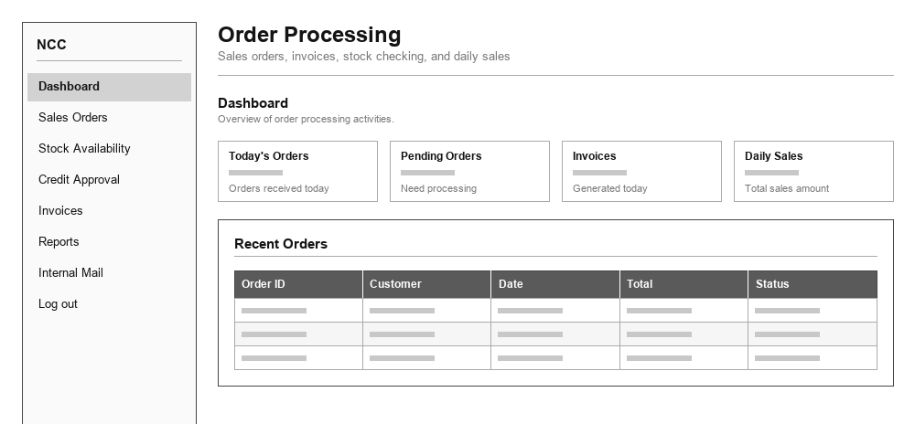
UI 38 — Sales Orders
Role: Order Processing Officer
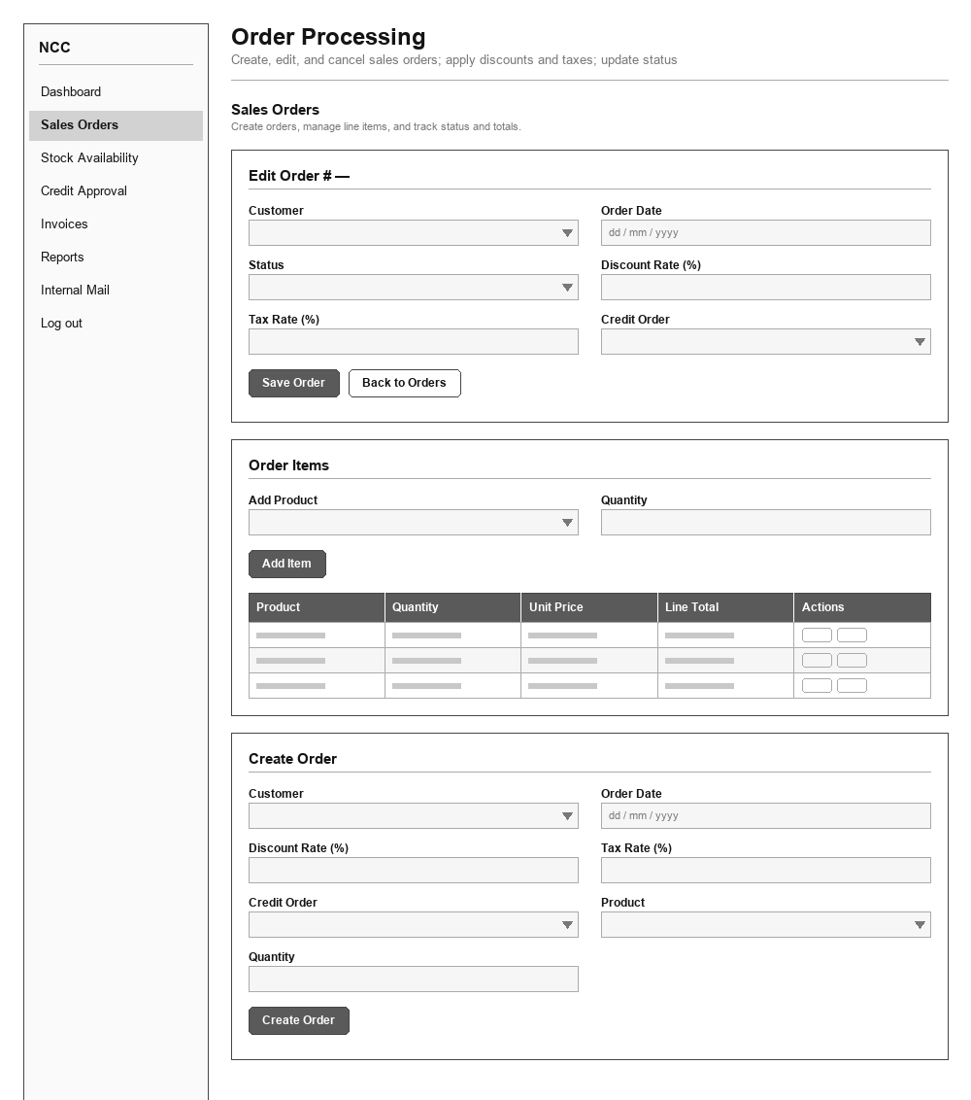
UI 39 — Invoices
Role: Order Processing Officer
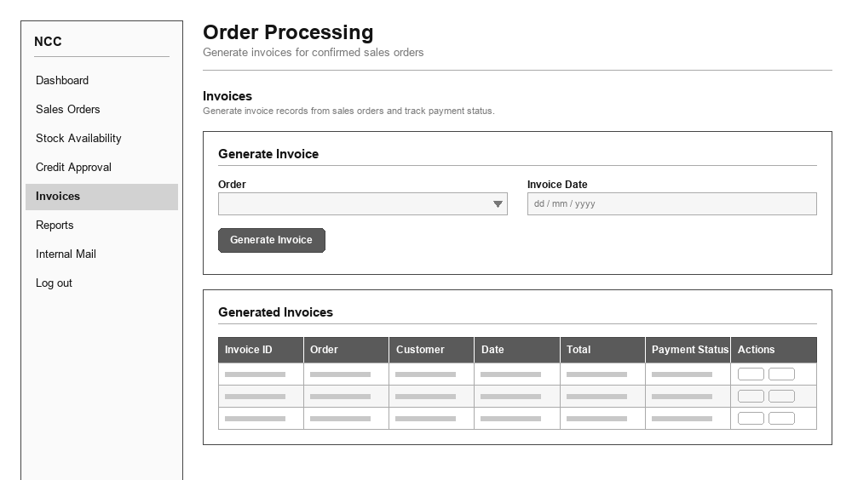
UI 40 — Credit Approval
Role: Order Processing Officer
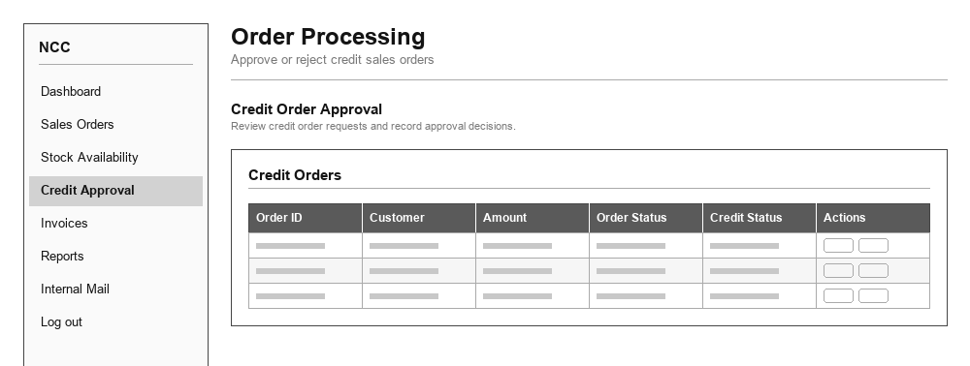
UI 41 — Stock Availability
Role: Order Processing Officer
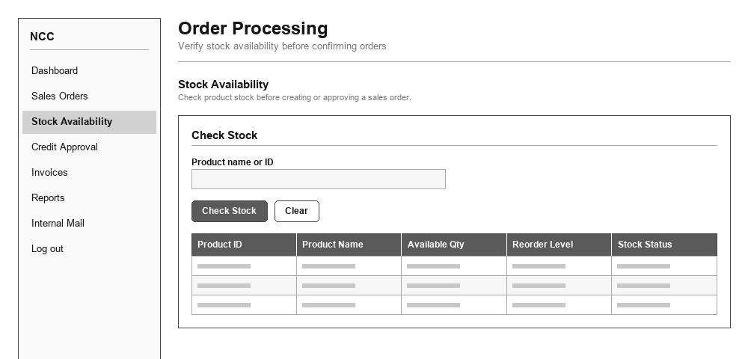
UI 42 — Reports
Role: Order Processing Officer
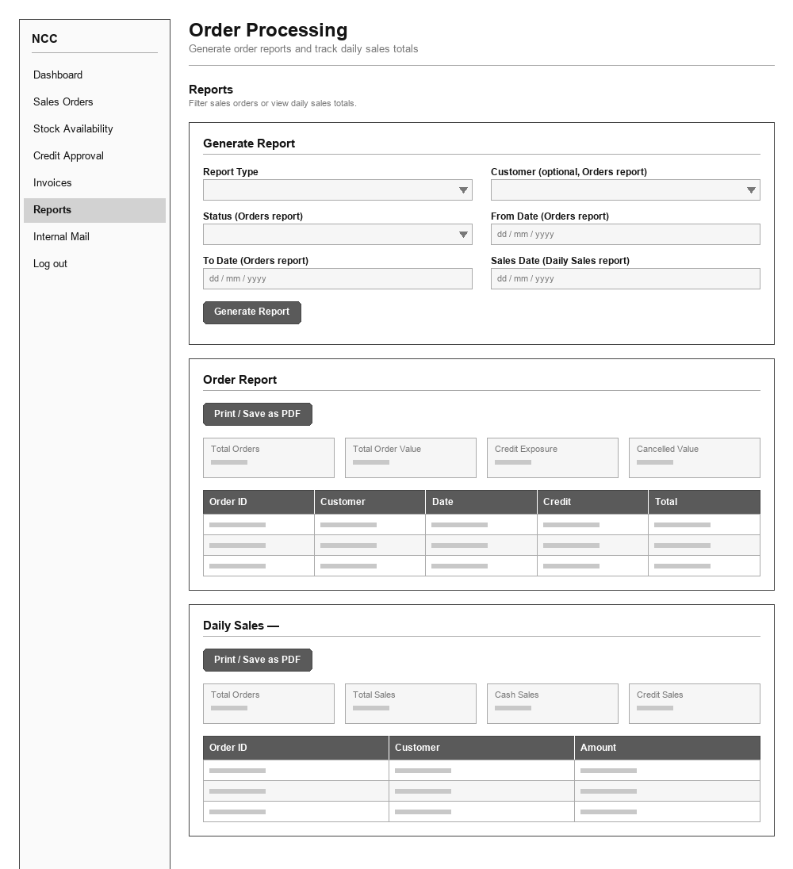
UI 43 — Dashboard
Role: Supervisor
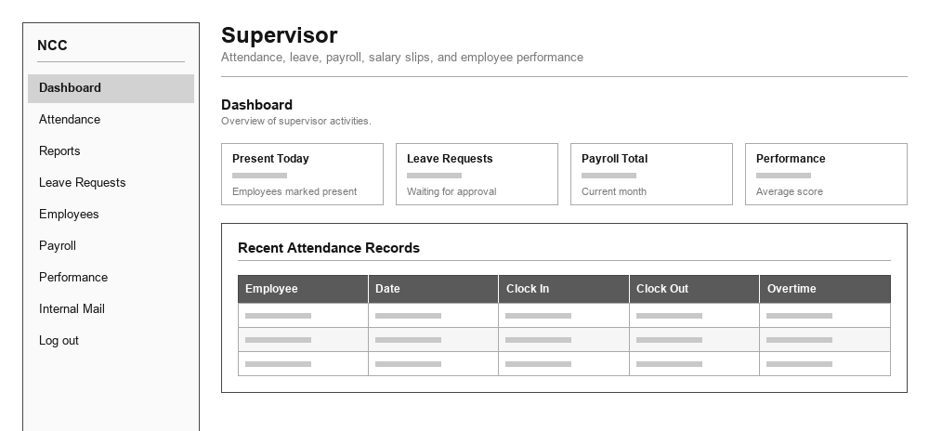
UI 44 — Attendance
Role: Supervisor
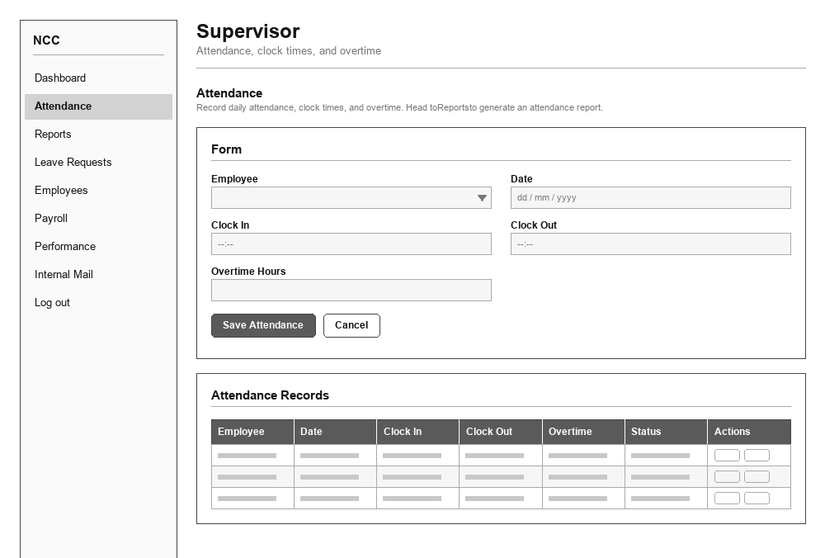
UI 45 — Leave Requests
Role: Supervisor
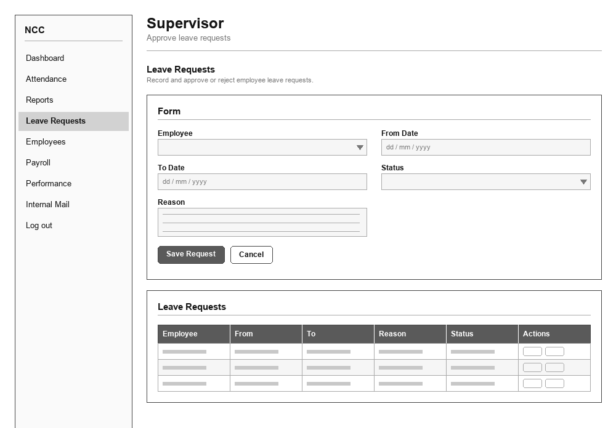
UI 46 — Employees
Role: Supervisor
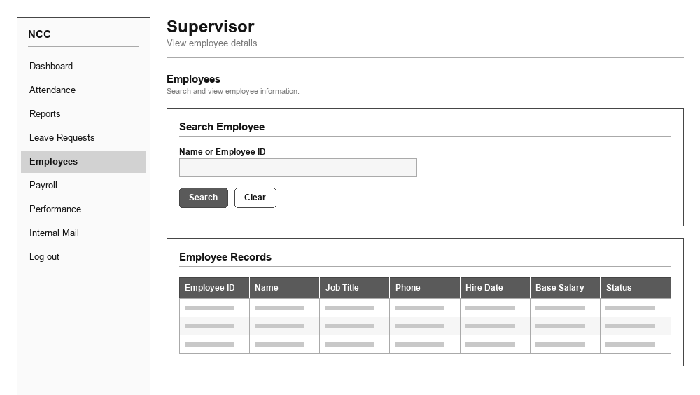
UI 47 — Payroll
Role: Supervisor
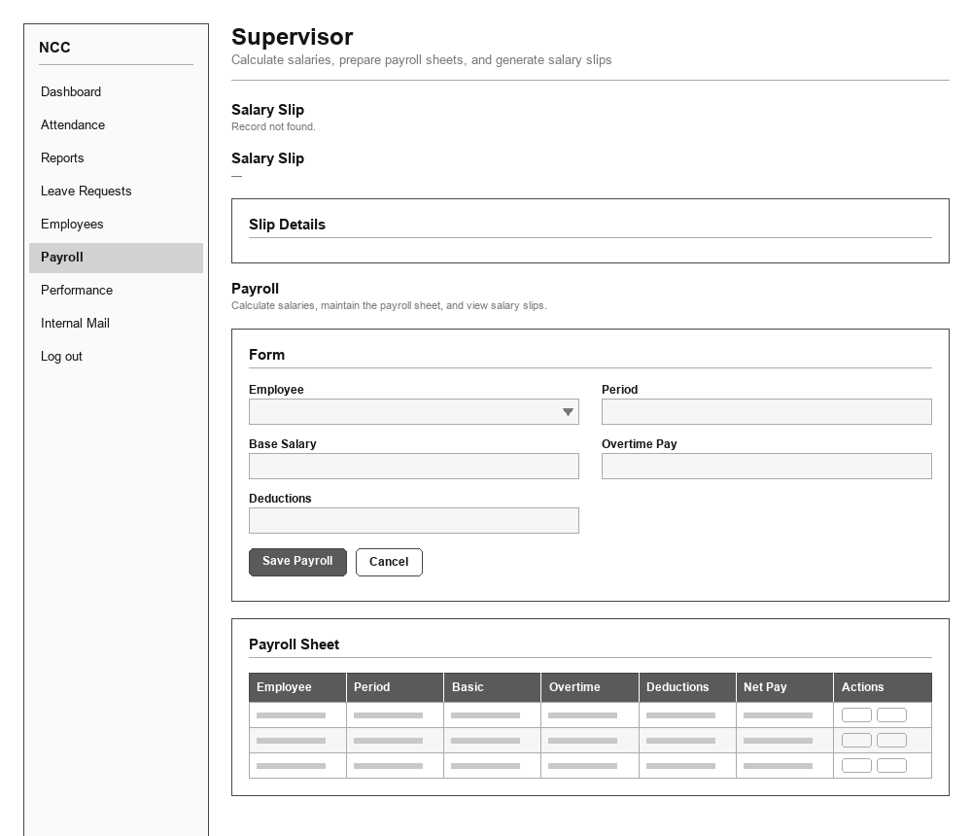
UI 48 — Performance
Role: Supervisor
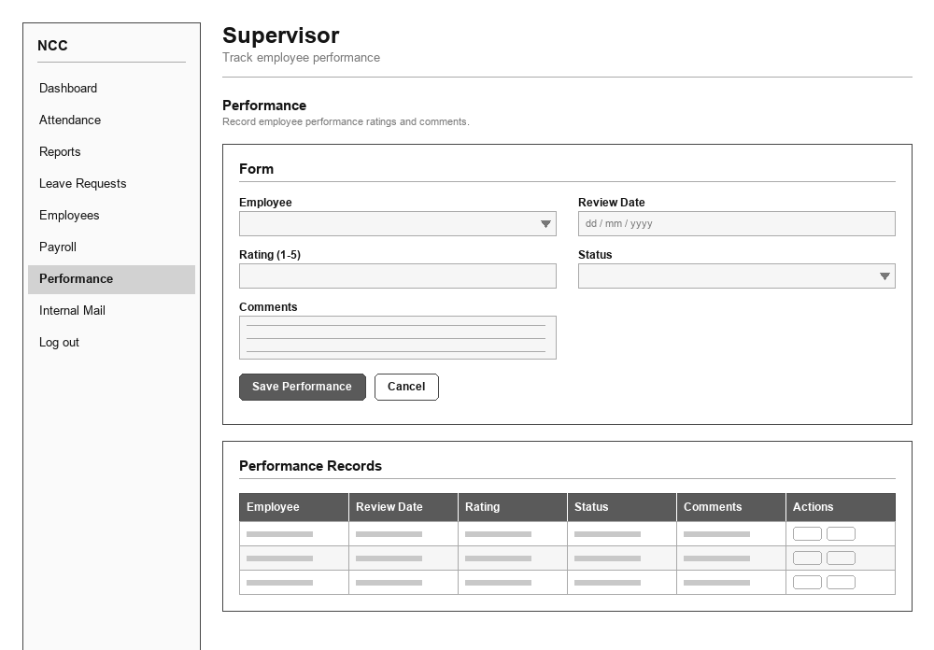
UI 49 — Reports
Role: Supervisor
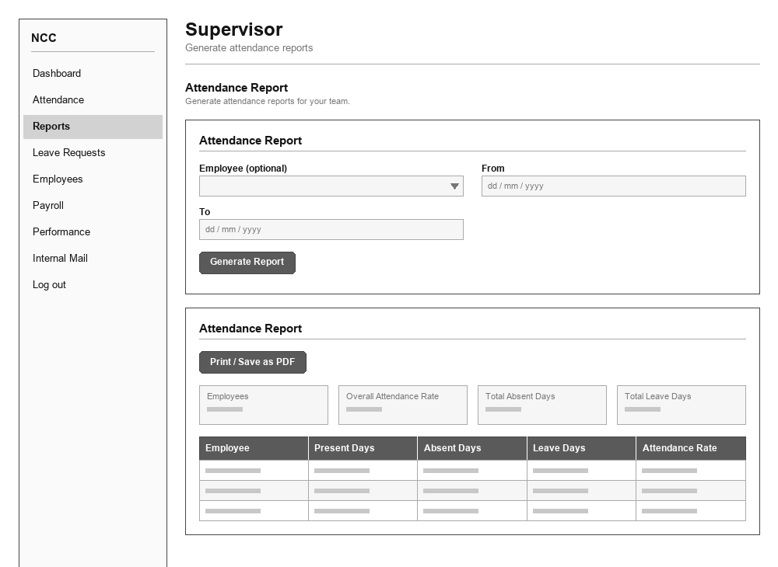
UI 50 — Dashboard
Role: System Administrator
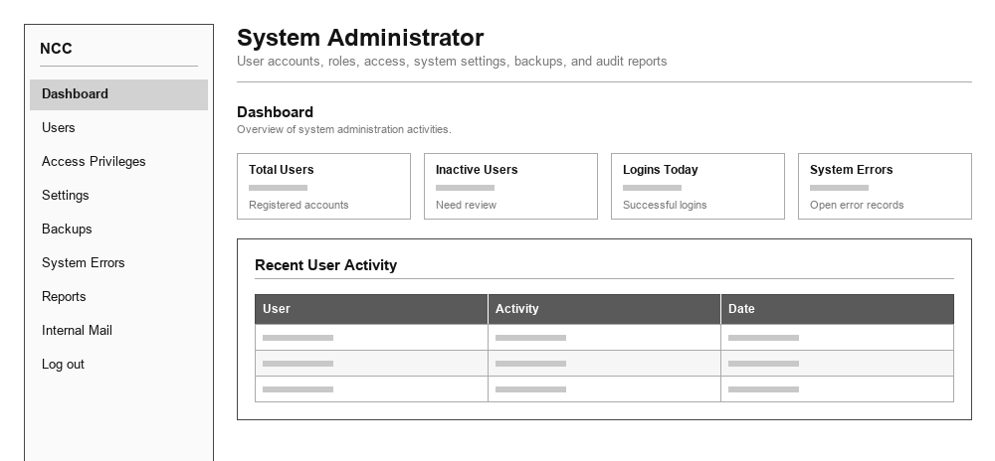
UI 51 — Users
Role: System Administrator
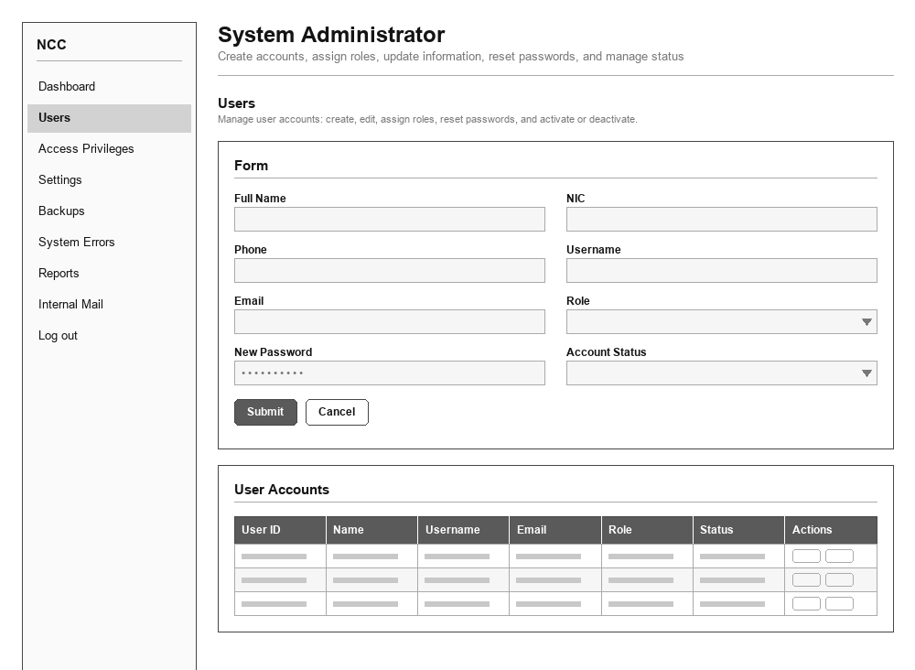
UI 52 — Access Privileges
Role: System Administrator
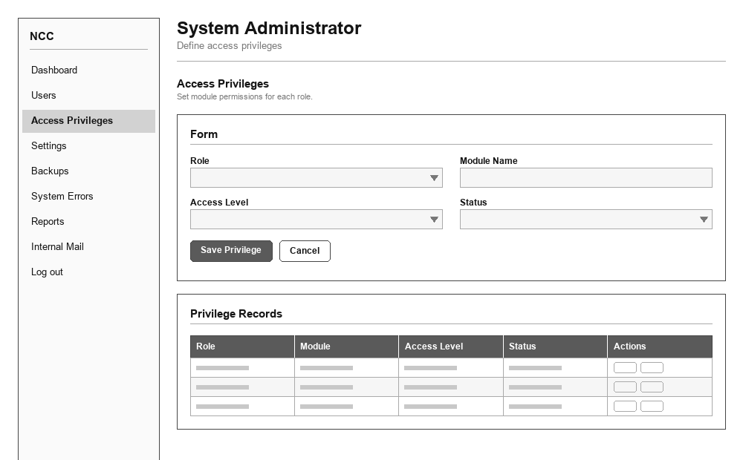
UI 53 — Settings
Role: System Administrator
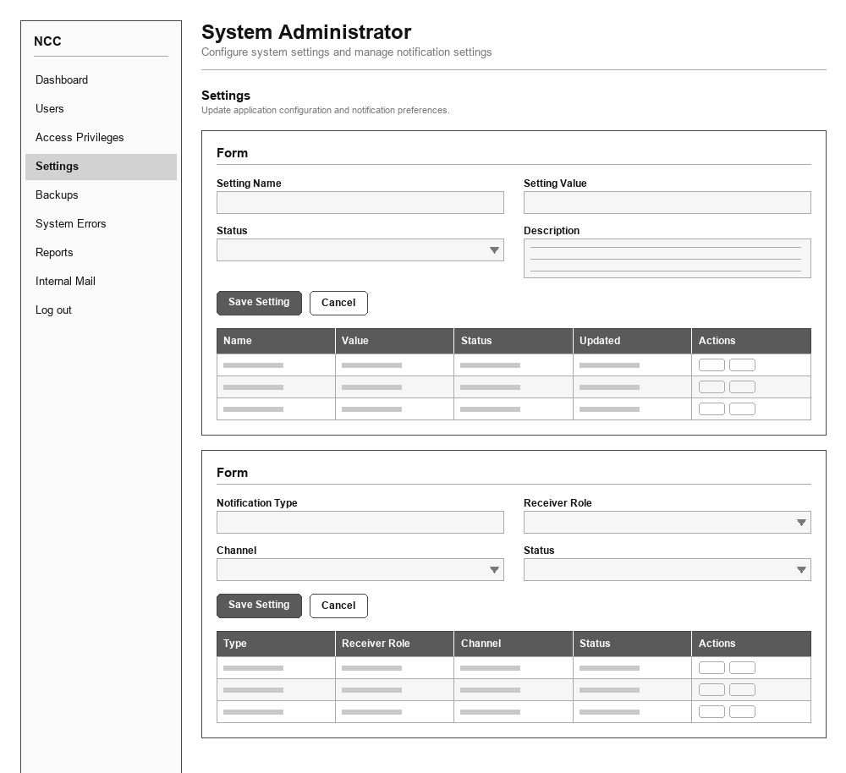
UI 54 — Backups
Role: System Administrator
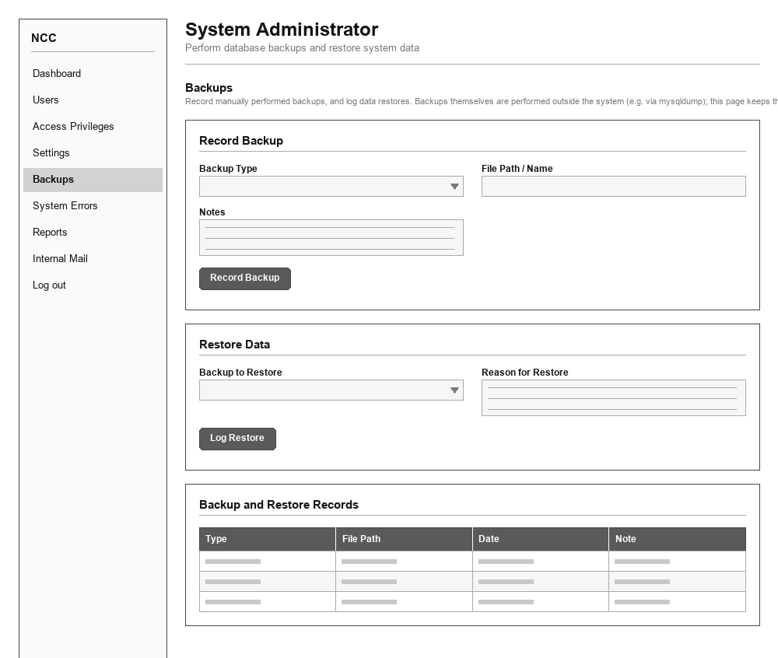
UI 55 — System Errors
Role: System Administrator
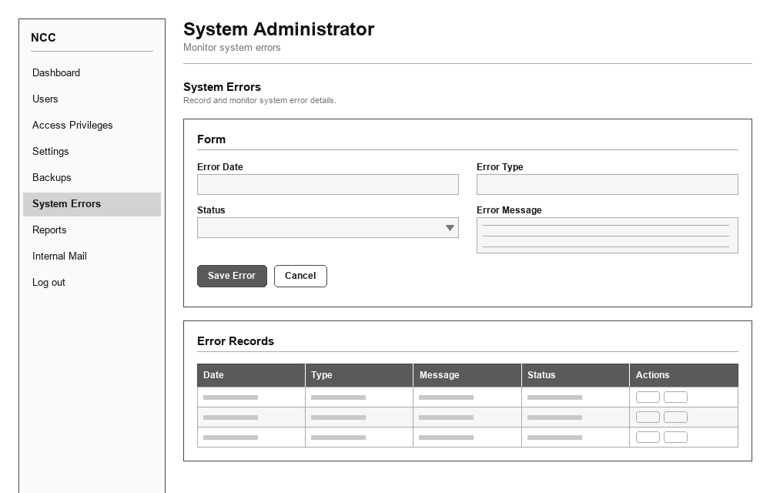
UI 56 — Reports
Role: System Administrator
