PHJV Status of Bird Populations: Waterbirds, shorebirds, and landbirds
2026-09-15
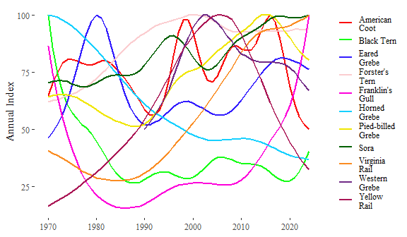
Figure 1: Smoothed annual breeding bird indices from the North American Breeding Bird Survey for selected waterbird species. Each index has been scaled so that the maximum for each species is 100.
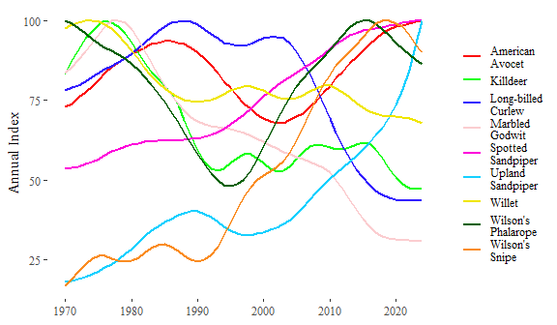
Figure 2: Smoothed annual breeding bird indices from the North American Breeding Bird Survey for selected shorebird species. Each index has been scaled so that the maximum for each species is 100.
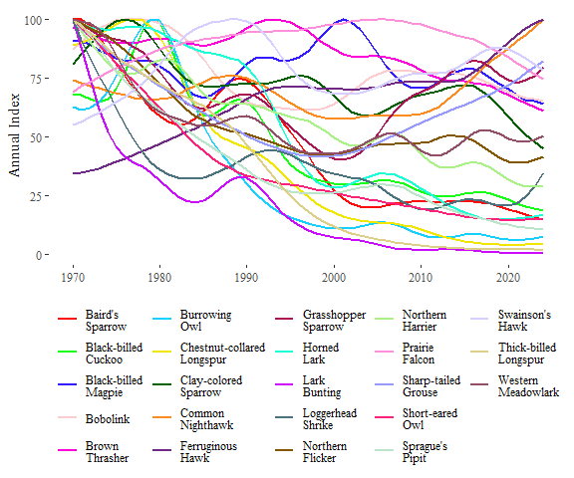
Figure 3: Smoothed annual breeding bird indices from the North American Breeding Bird Survey for selected upland-associated landbird species. Each index has been scaled so that the maximum for each species is 100.
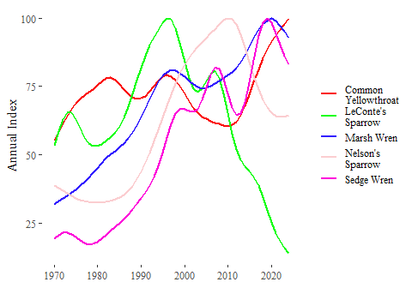
Figure 4: Smoothed annual breeding bird indices from the North American Breeding Bird Survey for selected wetland-associated landbird species. Each index has been scaled so that the maximum for each species is 100.
Table 1: Trends in breeding bird abundance indices from the North American Breeding Bird Survey for selected waterbird (W), shorebird (S), and landbird (L) species. Short-term trend estimates are from 2014-2024, while long-term estimates are from 1970-2024
Species | Group | Trend: Short-term | Trend: Long-term
Baird's  Sparrow | L | -4.02 (-8.02, -0.46 ) | -3.48 (-4.56, -2.4 )
Black-billed  Cuckoo | L | -2.88 (-6.05, 0.37 ) | -2.39 (-3.32, -1.43 )
Black-billed  Magpie | L | -1.93 (-3.33, -0.49 ) | -0.64 (-1.08, -0.21 )
Bobolink | L | -1.67 (-4.08, 1.09 ) | -0.55 (-1.26, 0.2 )
Brown  Thrasher | L | -1.86 (-3.89, -0.07 ) | -0.84 (-1.38, -0.29 )
Burrowing  Owl | L | -0.21 (-6.27, 6.77 ) | -3.87 (-5.83, -1.72 )
Chestnut-collared  Longspur | L | -3.69 (-6.83, -0.24 ) | -5.45 (-6.48, -4.5 )
Clay-colored  Sparrow | L | -4.52 (-5.53, -3.49 ) | -1.08 (-1.38, -0.79 )
Common  Nighthawk | L | 3.87 (0.6, 6.98 ) | 0.56 (-0.67, 1.69 )
Common  Yellowthroat | L | 3.99 (2.66, 5.33 ) | 1.1 (0.7, 1.55 )
Ferruginous  Hawk | L | 3.1 (0.11, 6.4 ) | 2 (0.88, 3.1 )
Grasshopper  Sparrow | L | 0.06 (-3.78, 4.42 ) | -0.42 (-1.78, 0.94 )
Greater  Sage-Grouse | L
Horned  Lark | L | -1.42 (-3.21, 0.15 ) | -3.26 (-3.68, -2.81 )
Lark  Bunting | L | -15.7 (-21.2, -8.91 ) | -9.88 (-11.9, -7.85 )
LeConte's  Sparrow | L | -11.1 (-14.5, -7.95 ) | -2.43 (-3.46, -1.44 )
Loggerhead  Shrike | L | 4.48 (1.36, 7.42 ) | -1.95 (-2.72, -1.12 )
Marsh Wren | L | 0.72 (-2.04, 3.52 ) | 2.02 (0.8, 3.22 )
Nelson's  Sparrow | L | -3.21 (-6.52, 0.01 ) | 0.96 (-0.33, 2.15 )
Northern  Flicker | L | -1.91 (-3.48, -0.5 ) | -1.61 (-2.07, -1.13 )
Northern  Harrier | L | -2.39 (-4.07, -0.65 ) | -2.26 (-2.79, -1.74 )
Prairie  Falcon | L | -2.27 (-5.31, 1.36 ) | 0.16 (-1.35, 1.47 )
Sedge Wren | L | 1.84 (-1.61, 5.38 ) | 2.75 (1.51, 3.92 )
Sharp-tailed  Grouse | L | 2.9 (-0.11, 6.14 ) | -0.35 (-1.41, 0.66 )
Short-eared  Owl | L | -1.06 (-4.88, 2.6 ) | -3.43 (-5, -2.07 )
Sprague's  Pipit | L | -5.23 (-8.28, -2.35 ) | -4.08 (-4.9, -3.22 )
Swainson's  Hawk | L | -0.09 (-1.84, 1.61 ) | 0.66 (0.13, 1.27 )
Thick-billed  Longspur | L | -3.38 (-8.3, 1.59 ) | -7.12 (-9.19, -5.13 )
Western  Meadowlark | L | 1 (-0.01, 1.96 ) | -1.27 (-1.56, -0.98 )
American  Avocet | S | 1.22 (-2.3, 4.7 ) | 0.58 (-0.62, 1.65 )
American  Golden-Plover | S
Black-bellied  Plover | S
Buff-breasted  Sandpiper | S
Hudsonian  Godwit | S
Killdeer | S | -2.57 (-3.8, -1.38 ) | -1.05 (-1.37, -0.71 )
Long-billed  Curlew | S | -1.99 (-4.9, 1.15 ) | -1.07 (-2.04, -0.1 )
Long-billed  Dowitcher | S
Marbled  Godwit | S | -2.75 (-4.72, -0.84 ) | -1.83 (-2.38, -1.22 )
Piping  Plover | S
Red Knot | S
Red-necked  Phalarope | S
Ruddy  Turnstone | S
Sanderling | S
Semipalmated  Sandpiper | S
Short-billed  Dowitcher | S
Spotted  Sandpiper | S | 0.42 (-1.58, 2.46 ) | 1.17 (0.42, 1.93 )
Stilt  Sandpiper | S
Upland  Sandpiper | S | 5.71 (3.32, 8.11 ) | 3.21 (2.43, 4.06 )
Willet | S | -0.86 (-2.57, 0.96 ) | -0.67 (-1.16, -0.12 )
Wilson's  Phalarope | S | -1.34 (-4.67, 1.84 ) | -0.27 (-1.27, 0.78 )
Wilson's  Snipe | S | -0.26 (-2.2, 1.72 ) | 3.15 (2.6, 3.75 )
American  Coot | W | -5.98 (-9.35, -2.29 ) | -0.47 (-1.6, 0.6 )
Black Tern | W | 1.73 (-2.35, 5.37 ) | -1.68 (-2.67, -0.61 )
Eared  Grebe | W | 0.17 (-4.32, 4.57 ) | 0.93 (-0.64, 2.55 )
Forster's  Tern | W | -0.16 (-4.94, 5.15 ) | 0.78 (-1.22, 2.82 )
Franklin's  Gull | W | 9.85 (3.99, 15.6 ) | 0.3 (-1.17, 1.78 )
Horned  Grebe | W | -1.74 (-6.07, 1.46 ) | -1.86 (-2.8, -0.93 )
Least  Bittern | W
Pied-billed  Grebe | W | -2.11 (-5.3, 1.2 ) | 0.42 (-0.55, 1.43 )
Sora | W | 0.5 (-1.52, 2.87 ) | 0.65 (-0.05, 1.32 )
Virginia  Rail | W | 0.8 (-3.04, 4.5 ) | 1.68 (-0.01, 3.49 )
Western  Grebe | W | -1.9 (-9.55, 6.82 ) | 0.82 (-2.83, 4.3 )
Whooping  Crane | W
Yellow  Rail | W | -7.55 (-14.5, -1.66 ) | 1.3 (-0.77, 3.87 )

