Kevin Evans, EE311, HW6 simulation.

1. Using the DC analysis, the node voltages are shown as,  
   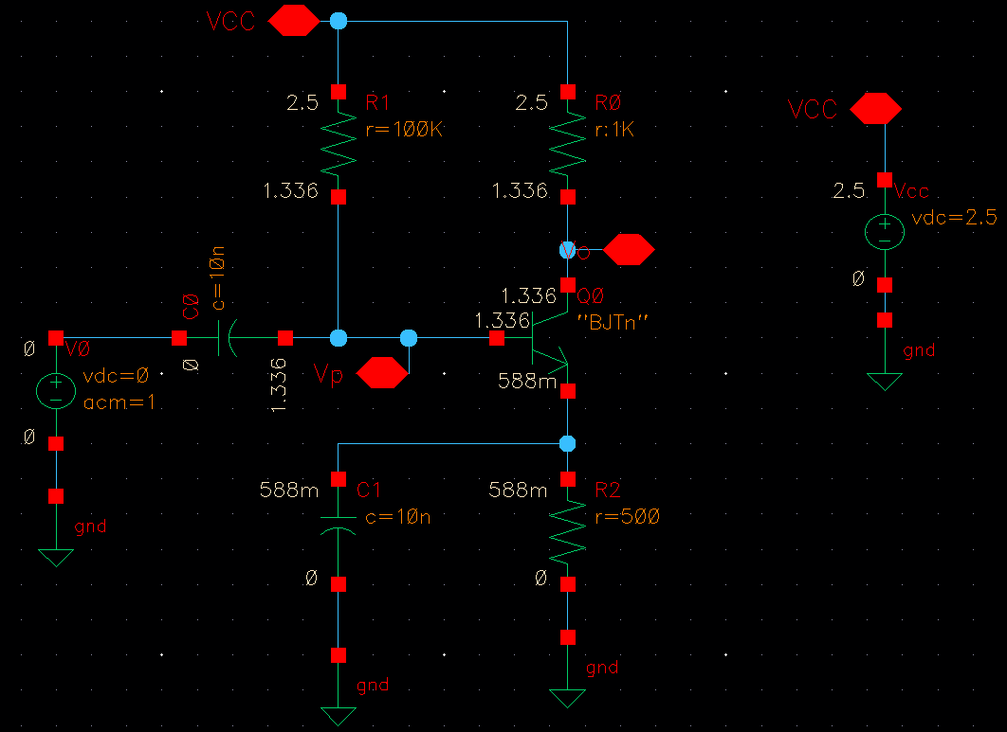  
     
     
     
   DC operating points. Collector current Ic = 1.164mA. Vb = 1.336 V and Ve = 588 mV.  
   The BJT is operating in the active region.   
   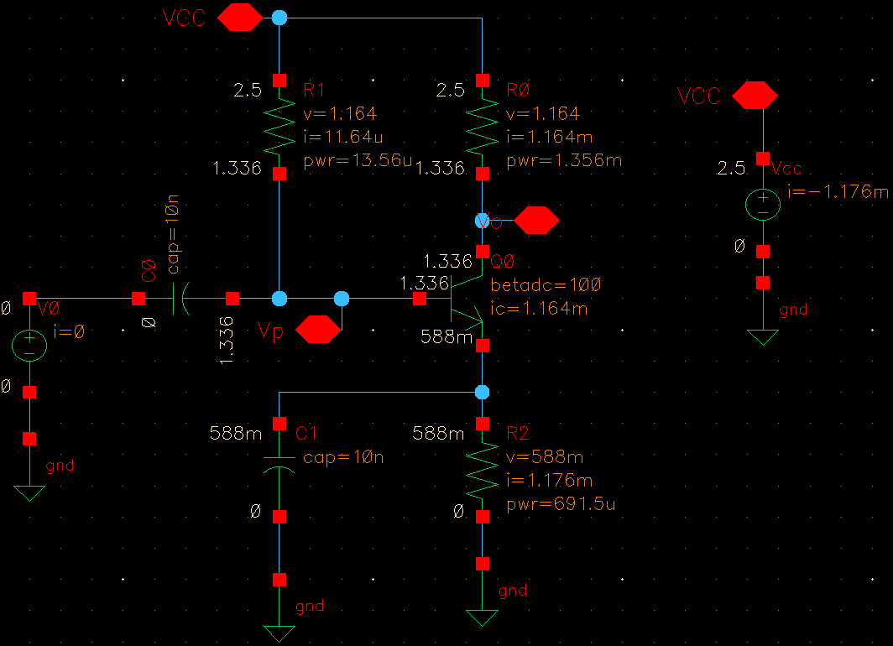
2. Using C1=10n, the base voltage Vp = 993.6 mV at 1 MHz, which is roughly 0.99 gain at node *P*.  
   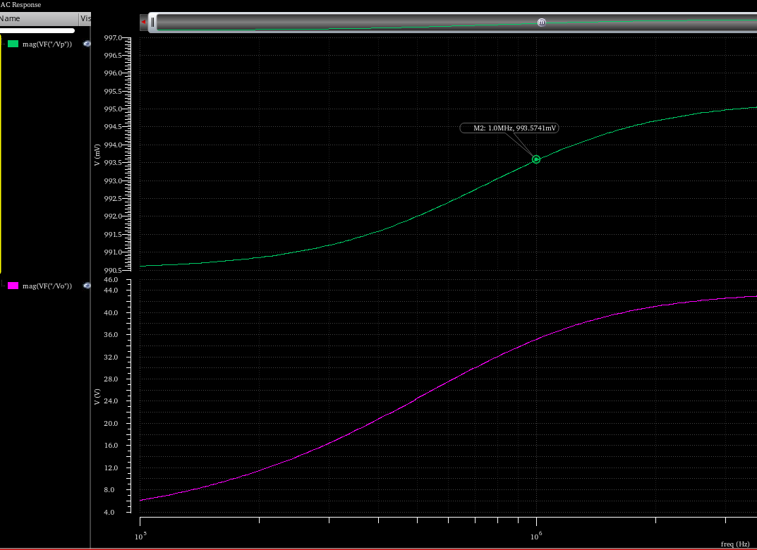
3. C2 = 2.8 nF  
   Vmax = 43.167 V  
   Vo at 10.0 MHz = 42.335 V (-1.9%)  
   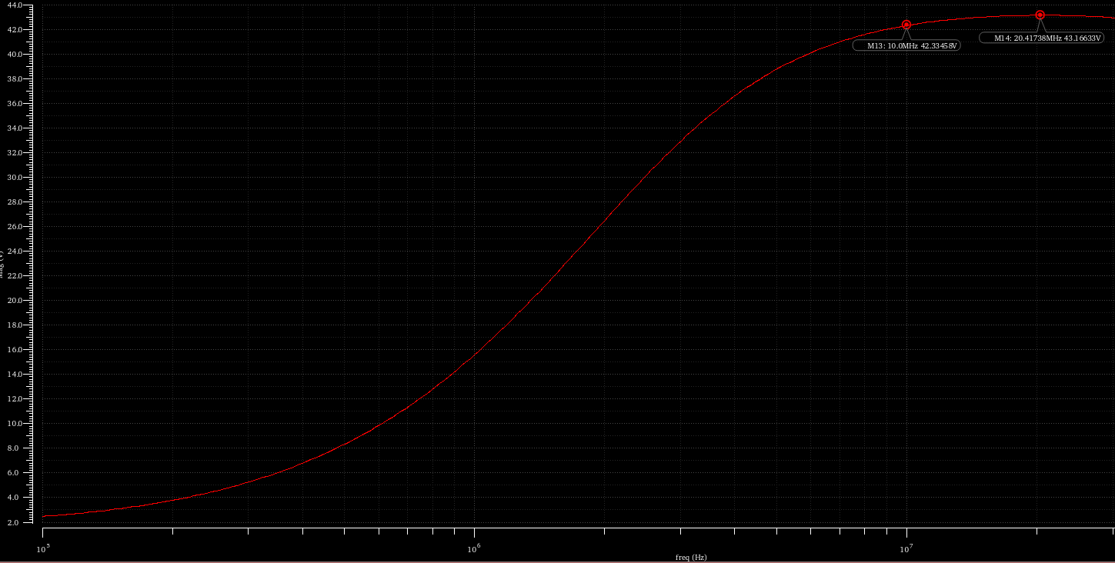  
     
     
     
     
     
     
     
     
     
     
     
     
   Other capacitances tried:  
   C2 = 1 uF  
   Vmax = 43.931 V  
   Vo at 10MHz = 43.852 V (-0.18% from max)  
     
   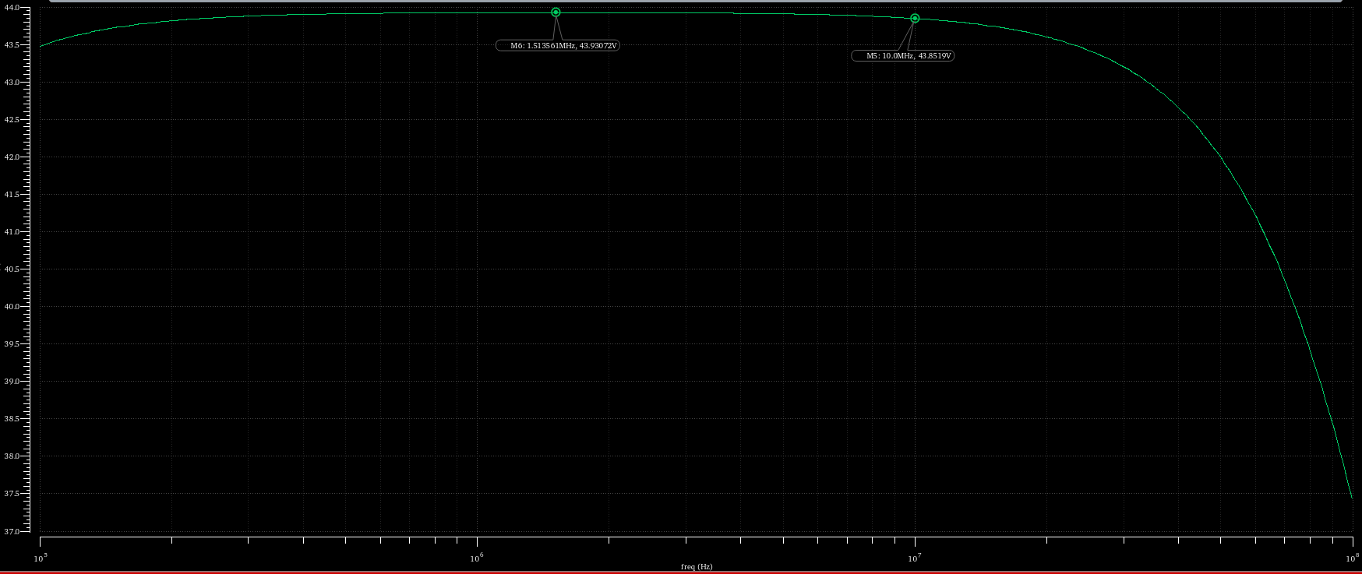  
     
   C2 = 1 nF  
   Vmax = 41.85 V  
   Vo at 10 MHz = 35.17 V (-16% from max)  
   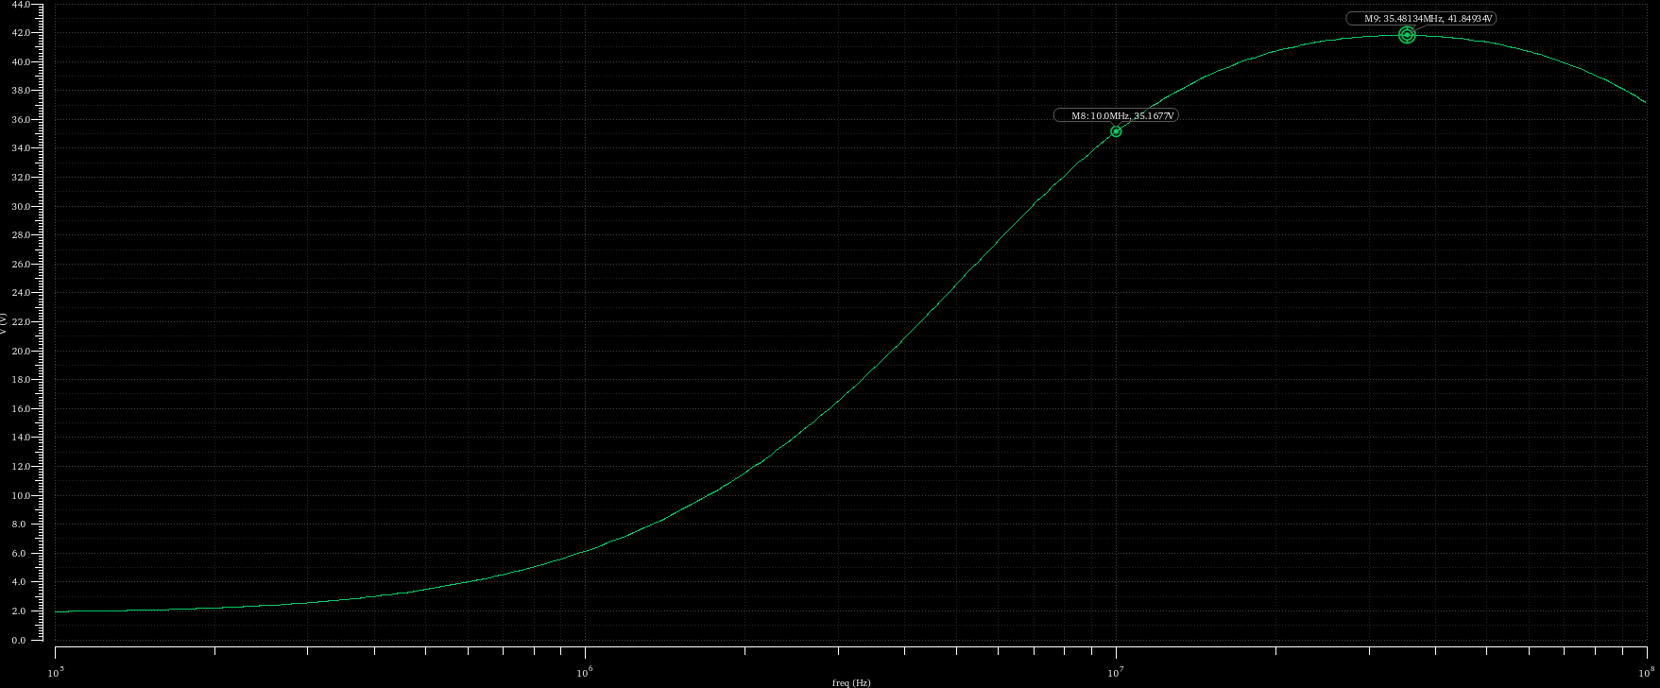  
     
   C2 = 1 pF  
   Vmax = 1.8933 V  
   Vo at 10 MHz = 1.8898 V (0.18% from max)
4. Using the approach suggested in the problem, a resistor R was placed in series with the voltage source. At R = 603.54 ohms, the AC gain at 10 MHz is halved from Vo = 42.335 V to 21.14 V:  
   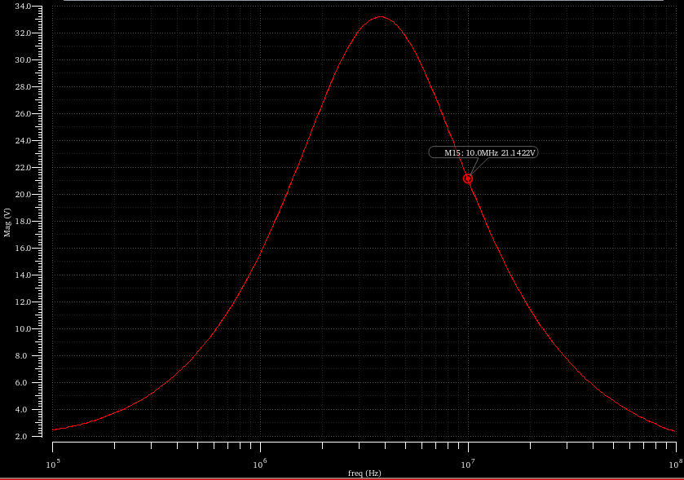  
     
     
     
   Test circuit:  
   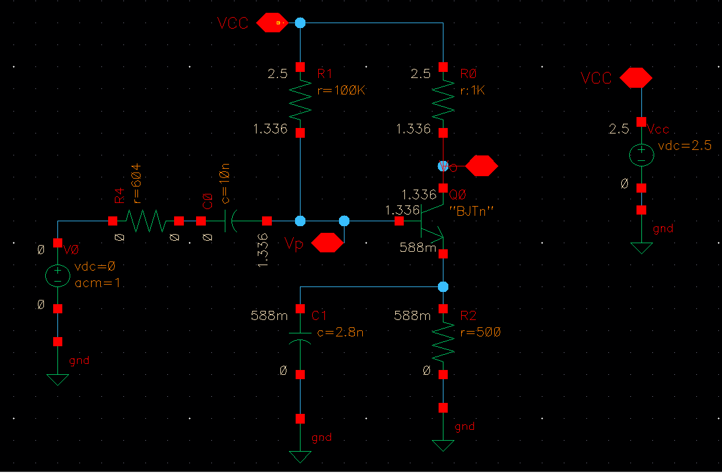  
   Also, if I sweep the resistance *R* at a fixed source frequency of 10 MHz, it’s clear that the resistance is roughly 603.54 ohms:  
   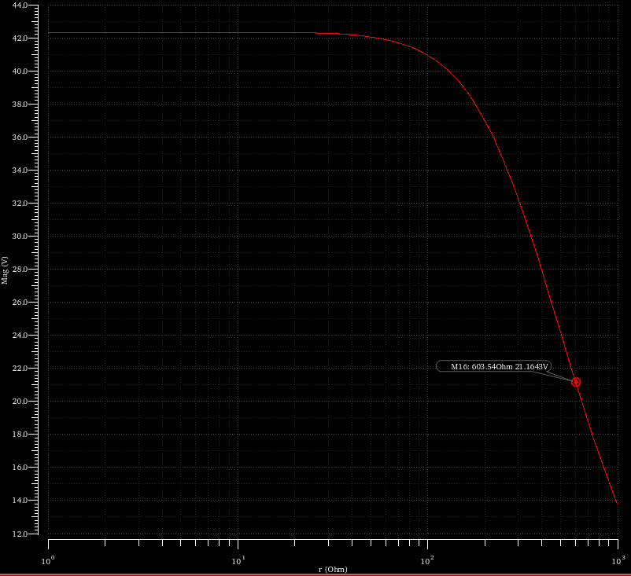

**Summary**

I replaced C2 back to the specified 10 nF and now have the following results. The unity gain bandwidth does not seem right, as I’m not sure if literally unity gain (0 dB) is needed, or if it’s asking for where the gain is no longer falling at -20 dB/decade.

|  |  |
| --- | --- |
| **DC gain Vi/Vo** | -50 dB Attenuated to 0 V as the capacitor is blocking |
| **Unity gain bandwidth** | 304.974 Hz, gain = 0 dB, phase = -122 deg  100 GHz, gain = 0 dB, phase = -360 deg |
| **Max. gain** | 10.7345 MHz, 32.81 dB, -180 deg |
| **3 dB bandwidth** | 775.595 kHz, 29.81 dB, -138 deg  164.29 MHz, 29.81 dB, 225 deg  Bandwidth = 163 MHz |

Bode plot: