|  |  |  |  |  |
| --- | --- | --- | --- | --- |
|  |  | C:\Users\kevinm.NORTHAMERICA\AppData\Local\Microsoft\Windows\INetCacheContent.Word\Microsoft Logo.jpg | | |
|  |  |  |  | |
| Applying Microsoft Teams in the Real World |  | OCP P20  Experiential Manual on  Microsoft Teams |  |  |
|  |  |  |  |
|  |  |  | **Hands-on Experience** |
|  |  |  |  | |
| Created by:  JoAnna Boxrud, Eric Lee, and Kevin Martins  September 20, 2017 – One Commercial Partner P20 Training |  |  |  |  |
|  |  |  |  |
|  |  |  |  |
|  |  |  | | |

This document supports a preliminary release of a software product that may be changed substantially prior to final commercial release. This document is provided for informational purposes only and Microsoft makes no warranties, either express or implied, in this document. Information in this document, including URL and other Internet Web site references, is subject to change without notice. The entire risk of the use or the results from the use of this document remains with the user. Unless otherwise noted, the companies, organizations, products, domain names, e-mail addresses, logos, people, places, and events depicted in examples herein are fictitious. No association with any real company, organization, product, domain name, e-mail address, logo, person, place, or event is intended or should be inferred. Complying with all applicable copyright laws is the responsibility of the user. Without limiting the rights under copyright, no part of this document may be reproduced, stored in or introduced into a retrieval system, or transmitted in any form or by any means (electronic, mechanical, photocopying, recording, or otherwise), or for any purpose, without the express written permission of Microsoft Corporation.

Microsoft may have patents, patent applications, trademarks, copyrights, or other intellectual property rights covering subject matter in this document. Except as expressly provided in any written license agreement from Microsoft, the furnishing of this document does not give you any license to these patents, trademarks, copyrights, or other intellectual property.

Copyright 2017 © Microsoft Corporation. All rights reserved.

Microsoft are trademarks of the Microsoft group of companies.

All other trademarks are property of their respective owners.

# Table of Contents

Introduction 4

Exercise 1: What can Microsoft Teams do for you? 6

Exercise 2: Create a Microsoft Teams Channel 10

Exercise 3: Create Chat conversations 19

Exercise 4: Meetings in Teams 25

Exercise 5: Making Calls in Teams (Beta) 35

Exercise 6: Use Hundreds of Teams Experimental Features 38

Exercise 7 – Find, Select, and use Microsoft Teams Apps 41

# Introduction

### Estimated time to complete this hands-on experience

45 minutes

### Objectives

After completing this lab, you will be able to:

* Understand what Microsoft Teams is
* Compare/contrast Microsoft Teams and Skype for Business
* How to create channels and tabs within Microsoft Teams
* How to customize channels with content your team needs
* How to use instant messaging, setup meetings, use calling features
* How to use functions while in a meeting.

### Stretch Objectives

Additional scenarios included at the end of the lab include:

* How to enable hundreds of new upcoming features within Microsoft Teams for your own testing
* How to create bots for automated functions within Teams
* How to install and use the development version of the Teams client

### Prerequisites

Before working on this lab, you must have:

* Internet access
* The Teams application installed or use the web version at teams.microsoft.com

### Overview of the lab

This hands-on guide is designed to introduce training attendees to Microsoft Teams and expand on the many features it offers.

### Scenario

**Overview:**

Contoso is an international construction company that has 10,000 users.  The company had three offices.  The offices are located in New York, Los Angeles and London England.   The offices are all connecting using a Wide Area Network (WAN) and each office had a local connection to the internet. Over 8,000 of those workers are deskless workers including drivers, craftsmen, foremen and salespeople.

**Existing Environment:**

Contoso is running Active Directory with a forest named Contoso.com with a single domain.  Each office has a different vendor PBX with local PSTN access.  Contoso is currently running Microsoft Exchange Online and are connected with Single Sign On to Office 365.  Contoso is not currently using any other services from Office 365. Not yet using mobile devices, most workers utilize paper plans, orders and specifications to carry out their duties.

**Problem Statement:**

Contoso has a new CIO who has recently replaced a CIO who was removed from the organization for not making the company more competitive with technology.  The new CIO as been through a Microsoft MTC and is very eager to embrace the Office 365 cloud.  From his initial investigation the Contoso CIO has stated that the company is experiencing challenges as they take on larger construction projects.  Each project will run from 12 to 48 months and will involve resources from different regions throughout the project.  Once the project is completed, that project team will move onto other projects and teams.  Many of their top engineers will be working on more than one project at a time and will be on multiple project teams.

The CIO has received feedback that it is difficult for users to be able to work together in their project teams and they find that it is difficult to be able to ensure they have access to the most current versions of project documents.  A very large challenge is that project managers who visit construction sites must input data once they return back to the office making the process very inefficient.  They believe the deployment of company owned connected mobile devices will increase efficiency and keep projects on time and under budget. The CIO has been asked to cut costs and improve end user satisfaction. The CIO has been asked by the organization why other companies have the “latest and greatest” software applications and why they have more current versions of Microsoft products at home.

The CIO has also been asked by the company board of directors to ensure the company is not hit with any bad publicity after hearing about the recent impact of ransomware and data loss and how it nearly bankrupted another similar company.  The CIO wants to ensure mobile devices are managed and secured in the case of loss or theft while also providing safeguards against accidental data leakage. The board is in talks of being acquired by a larger multinational and publicly traded company and they want to make sure nothing impacts these talks.

### Post TechReady On-Demand Lab

This guide is designed to use during the P20 training or at a later point on your own to learn more about Microsoft Teams.

# Exercise 1: What can Microsoft Teams Do for You?

Microsoft Teams is the chat-based workspace in Office 365. It brings together people, conversations, and content along with the tools that teams need, so they can easily collaborate. Because it’s built on Office 365, users benefit from integration with their familiar Office 365 apps and services. It delivers enterprise-grade security and compliance, and is extensible and customizable to fit the needs of every team.

## Task 1 – Activity Button

* Task setup instructions

1. Navigate to the Microsoft Teams home page at **teams.microsoft.com**.
2. If using your Microsoft laptop, you should automatically be signed in.
3. If this is your first time using Teams you may be prompted to create a team upon login. Click **Skip this step**.
4. You can install the desktop client later by clicking on the prompt at the top of the screen to download the Microsoft Teams client. The web version offers near full functionality as the desktop application. If you don’t already have the Teams desktop client installed, use the web version.
5. Select the **Activity** icon in the upper left corner of the screen.

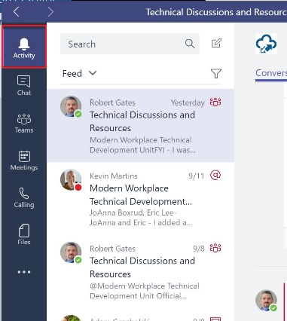

1. Type "**OCP**" in the **Search box** and select .
2. Select **Messages, Peopl**e or **Files**.
3. Select the item in the search results. Alternately, you can click the **Filter** icon to sort or filter your search results.

## Task 2 – Chat Button

Continue using the Teams web application at **teams.microsoft.com** or the Teams client.

1. Select the **Chat** icon in the upper left corner of the screen.

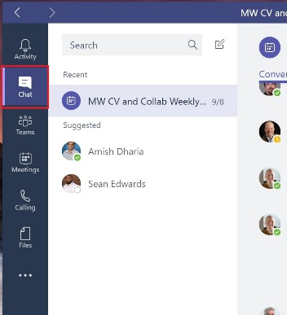

Here you will see "**Recent**" and "**Suggested**". All recent Teams meetings along with content can be found here along with suggested contacts.

## Task 3 – Teams Button

Continue using the Teams web application at **teams.microsoft.com** or the Teams client.

1. Select the **Teams** icon in the upper left corner of the screen.

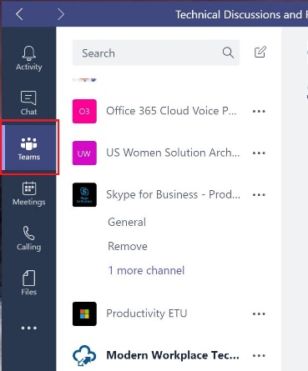

1. This is the hub of **Teams.** Teams are collections of people, content, and tools surrounding different projects and jobs within an organization. Team members can share conversations, files, notes, and more.

## Task 4 – Meetings Button

Continue using the Teams web application at **teams.microsoft.com** or the Teams client.

1. Select the **Meetings** icon in the upper left corner of the screen.

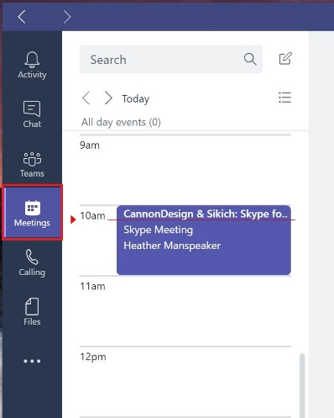

1. The Meetings Tab in Microsoft Teams will show you the meetings that are scheduled for your team for the next five days.
2. Click on the meeting entry to see more details about its timing, subject, and who is attending.

* Meetings also appear in the Channel they are scheduled to occur in.

## Task 5 – Calling Button

Continue using the Teams web application at **teams.microsoft.com** or the Teams client.

1. Select the **Calling** icon in the upper left corner of the screen.

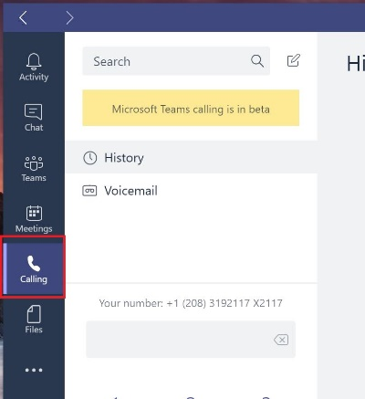

As you can see, this feature is currently in Beta with more functionality coming soon.

## Task 6 – Files Button

Continue using the Teams web application at **teams.microsoft.com** or the Teams client.

1. Select the **Files** icon in the upper left corner of the screen.

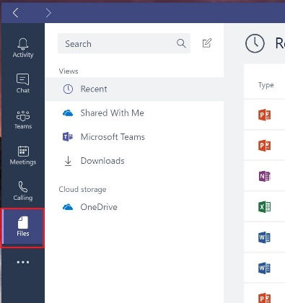

1. Documents shared in a conversation automatically become part of the **Files** tab.

## Task 7 – ...

Continue using the Teams web application at **teams.microsoft.com** or the Teams client.

1. Select the **...** icon in the upper left corner of the screen.

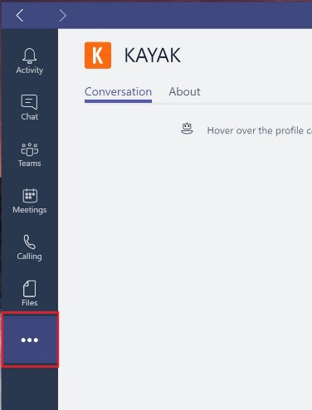

You many have nothing under this icon. We will discuss the options available here in a later exercise.

# Exercise 2: Create a Microsoft Teams Channel

**What is a Teams Channel?**

Remember that teams are a collection of people, content, and tools tailored to the project the team members are working on to help meet common goal(s). A person may be on multiple projects or “Teams” at any given point making organization a challenge. As a member of each team defined in Microsoft Teams, all conversations, files, notes, etc. related to that team project are in the same area.

Each Microsoft Teams Channel has its own area for conversations, files, notes, and other apps that the team needs. There are literally hundreds of tabs and apps available from Power BI to OneNote to a third-party product such as Kayak. The flexibility in the apps and features available in a single client helps to keep team members organized and productive.

A Microsoft Teams member can join a conversation, add a file, etc. in any Channel that is part of that team. There are no private Channels available at this time. Permissions are set at the team level by the owner (or co-owner). Channels with new content are easily seen when the Channel name is bolded.

* Each person can create up to 250 separate Microsoft Teams
* Each Microsoft Team can have up to 999 people

**What options are available within a Channel?**

Conversations, Files and a Wiki tabs are included by default in with every new Teams Channel:

* + - Conversations – This is a persistent conversation area available within every Teams channel.
    - Files – this area is a way for team members to share and store files in each channel. All members of a team can edit and view files in a team.
    - Wiki – This is an area for taking notes and doing @ mentions.

## Task 1 – Create Your First Microsoft Team

* Task setup instructions

1. Navigate to the Microsoft Teams home page at **teams.microsoft.com**.
2. If using your Microsoft laptop, you should automatically be signed in.
3. If this is your first time using Teams you may be prompted to create a team upon login. Click **Skip this step**.
4. You can install the desktop client later by clicking on the prompt at the top of the screen to download the Microsoft Teams client. The web version offers near full functionality as the desktop application. If you don’t already have the Teams desktop client installed, use the web version.
5. In the left navigation area, if not already selected, click **Teams**.

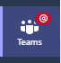

1. In the bottom left, click **Add team.**
2. Under Team name, type **OCP P20 Test Team**.
3. Under Description type, type **Testing.**

* Notice the Privacy options at the bottom. Keep this Team Private in this example.

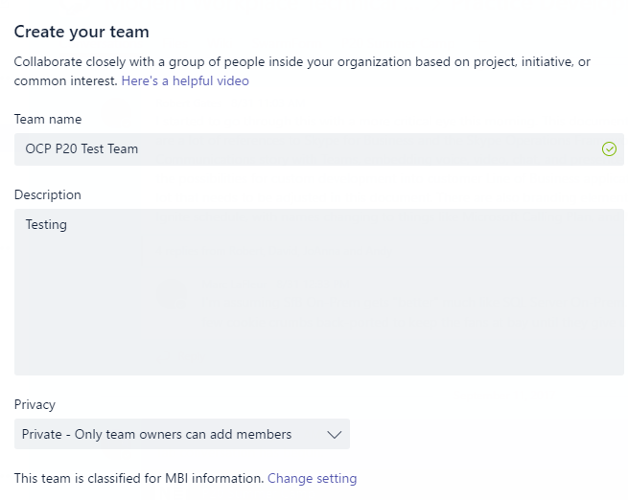

1. Click **Next**.
2. Under **Members**, enter the name of one or two coworkers who may be near you.

* Only the Microsoft Team owner can add members or adjust permissions. This includes adding other colleagues as co-owners.

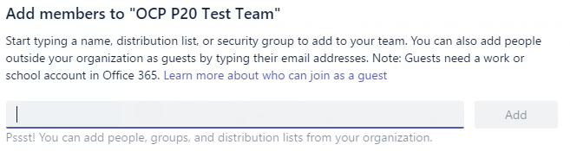

1. Click **Add**. Then click **Done**.

## Task 2 – Create a new Teams Channel

1. Under the **OCP P20 Test Team**, click the **ellipses icon** and select **Add channel**.

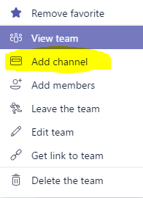

1. Enter a name for the new Channel called **Task List**.

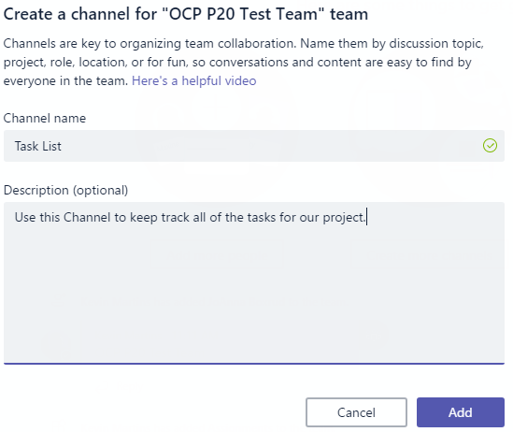

1. Notice under OCP P20 Test Team that the new Channel now appears. Within the new Channel is the standard Conversation, Files, and Wiki areas.

* Note: Each Team can have up to 100 Channels.

## Task 3 – Begin a Conversation in a Teams Channel

1. Under the **OCP P20 Test Team**, click the **General** channel. You are now in the **Conversations** tab (default).
2. At the bottom of the General Channel, locate the **Start a new conversation** field.

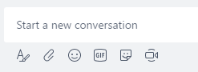

1. Enter **Hello and welcome to the new Sales project team**. **We can use this area to collaborate on our various projects.**
2. Click **Enter** to send the message. Similar to Skype for Business, except this is persistent. Conversations here will always be seen and searchable.
3. In the same conversation window, click the **GIF** icon at the bottom of the conversation channel

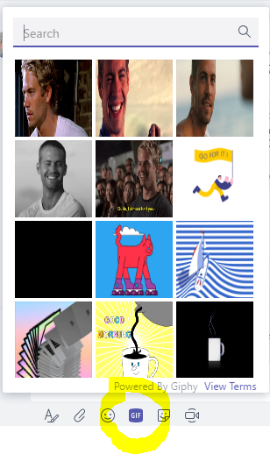

1. In the search bar at the top of the window, type **excited**.



1. Scroll down in the results window to view the GIF results. Click an appropriate GIF to insert it into the conversation.
2. Click the **Send** icon in the lower right.



1. Notice the additional icons at the bottom of the conversation window for additional functionality.



 Expand Compose Box – Use this option to make the conversation window larger.

 Attach a file – Use this option to insert a local file into the Teams channel area. Or, simply

drag and drop the file.

 Insert an emoji – Choose from a list of new emojis.

 Insert a GIF – Insert a picture to help express your feeling or point.

 Insert a sticker – Insert a sticker to help express your feeling or point.

 Meet Now – Use this space to open a new in-prompt-to meeting for others to join.

## Task 4 – @ Mentions

As part of a Microsoft Teams Team, when there is activity in a Teams Channel, that Channel is then bolded. This makes it easy to notice anything new. When working in a Teams Channel, you may want to call attention to an important topic, comment, etc. to one person or the entire team. By @ mentioning them, this can easily be done. To acknowledge the @ mentioned topic, the person or team mentioned doesn’t need to comment. Rather, he or she can simply click on the thumbs up icon.

1. In the new Teams Channel created for this exercise, click in the **Conversation** tab.
2. In the Conversation tab, type an **@** and notice right away how the team member names automatically appear.

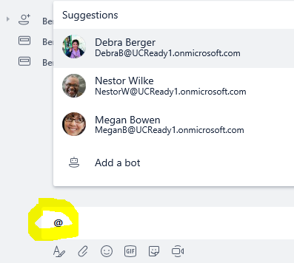

1. Select the colleague names you added in Task One along with a note to capture that person’s attention. For example:



1. To call attention to the note for the entire team, place an **@** in the conversation window again. Then, begin typing the name of the **OCP P20 Test Team**. Notice what happens when **@OCP** is typed. The name of the team automatically appears to be selected.

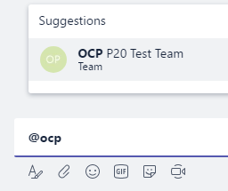

1. Complete the post to the entire Team. Notice the tag on the right side of your post, indicating the entire Team was **@ mentioned**.

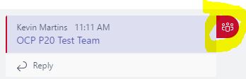

1. If you or your team was **@ mentioned**, you can simply acknowledge the post by hovering over the upper right of the post and selecting the thumbs up symbol. Instead of responding to this message or using an email chain, you have now acknowledged you have seen the message.



## Task 5 – Find, Select, and use Microsoft Teams Tabs

1. In the top navigation, click the **+** icon.



1. Under the **Add a tab** area, click **OneNote**.

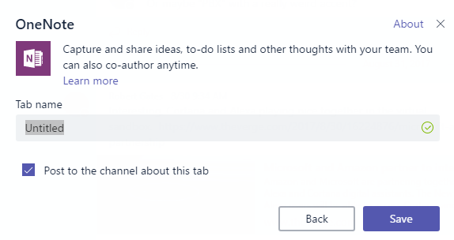

1. Give your OneNote a name such as **P20 OneNote.** Then click **Save**
2. You can now edit your OneNote file from within Teams. Or, you can Open it in OneNote using this option. Permissions are automatically generated for all team members to use this OneNote.

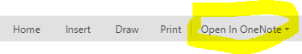

1. In the top navigation, click the **+** icon again.



1. Notice the additional apps that are available.

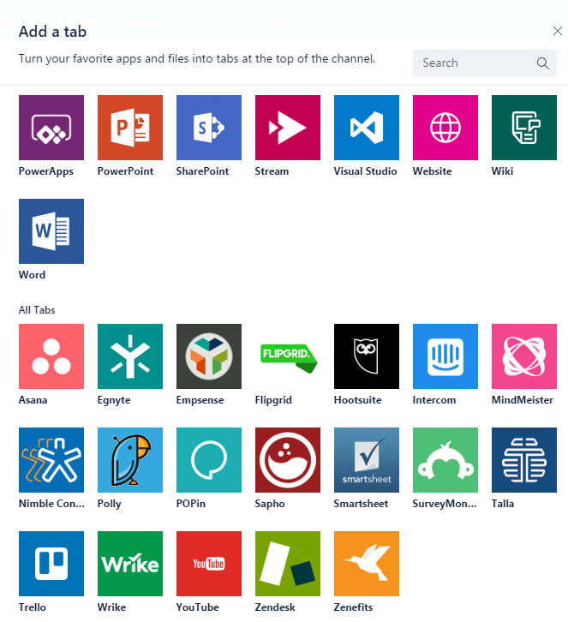

## Task 7 – Email a Teams Channel

If you have something important for your Team to be aware of in email, you can easily forward that email to your Microsoft Teams Channel.

1. Within the Microsoft Team client (web or desktop version), click on the Channel you would like to email a note to.
2. Click on the ellipsis  and then on **Get email address**.

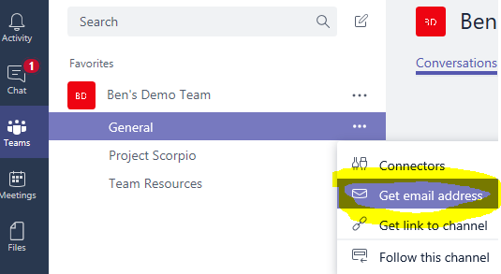

1. With the email address now on your screen, click Copy to copy the email address.

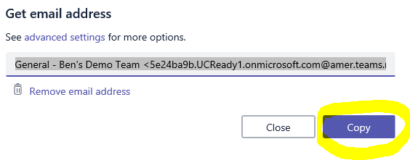

1. Open a new email or the email you want to forward to the Team’s channel and paste the address in the To: field. Then, simply send the email.
2. Within a few seconds, the email arrives for anyone with access to the Teams Channel to view. Notice the email icon in the upper left, indicating this was an email sent to the team.

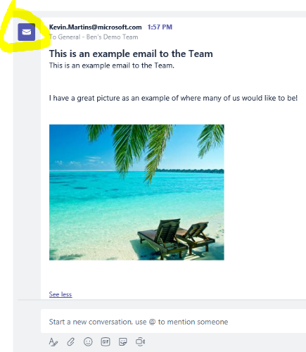

# Exercise 3: Create Chat Conversations

## Task 1 – Create a new private 1:1 Chat conversation

1. In the left navigation, click **Chat**. 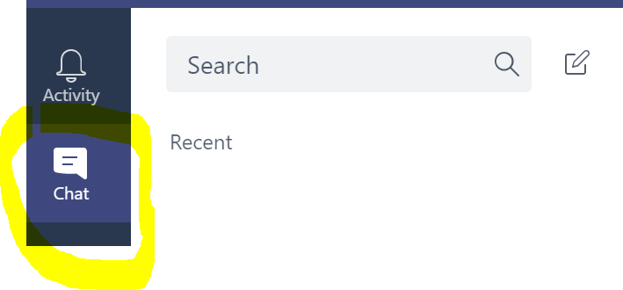
2. Click the **New Chat** icon.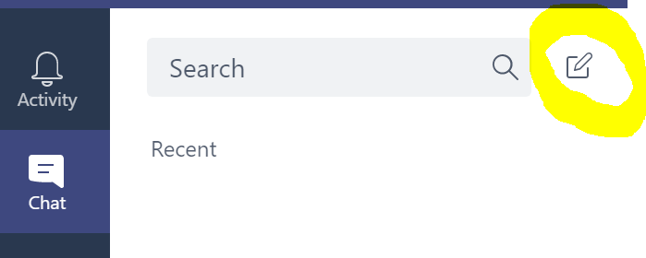
3. Next to To: type the **name of a colleague next to you** and click his/her name when it resolves.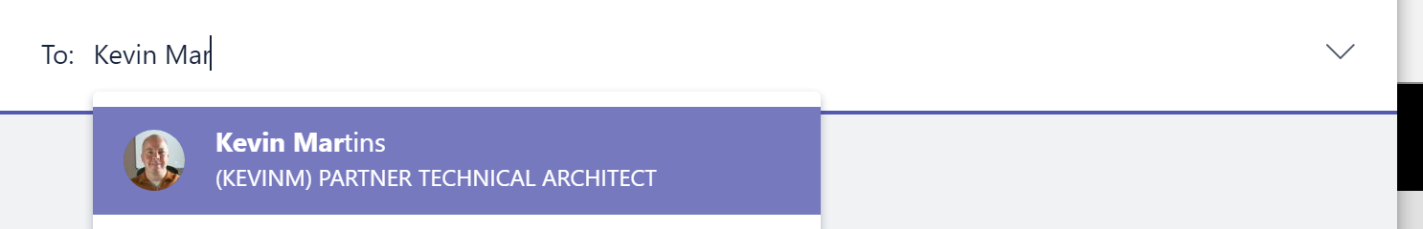
4. At the bottom of the screen, click **Type a new message**.
5. Type **Hello, did you finish the presentation?**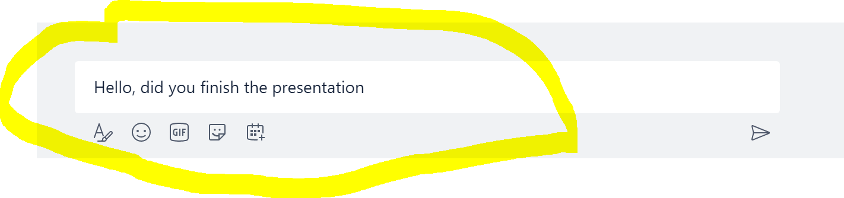
6. Press **Enter**.



1. **Chat Receiver** - In the left navigation bar, point to the new message notification on the Chat icon.
2. Click the **Chat icon**.
3. In the chat conversation with the **Sender**, in the message field, type **Yes, Looking good!**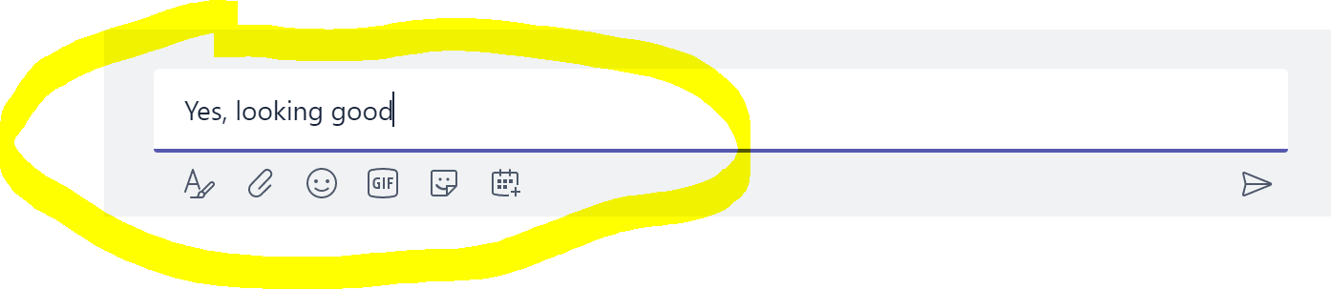
4. Press **Enter**.



1. **Sender** reply to **Receiver's** message with **Fantastic!** 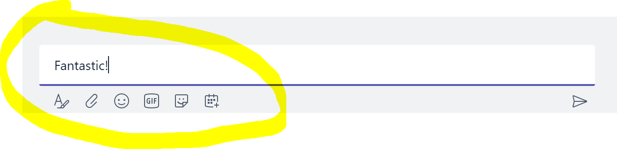
2. Press **Enter.**

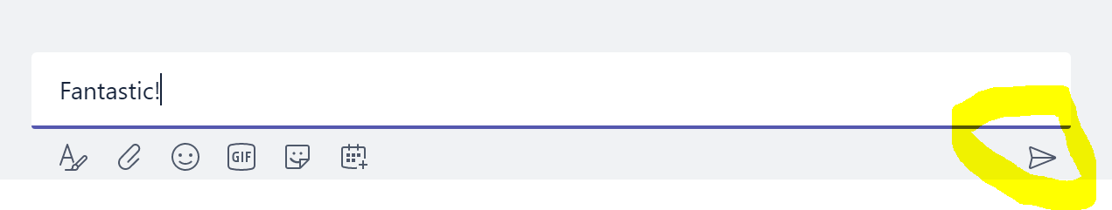

Task 2 – Create a new Group Chat conversation

1. In the left navigation, click **Chat**.
2. To the right of the search bar, click **New Chat**  .
3. Next to To: type the names of two colleagues sitting next to you and click when they resolve.

a. **name of a colleague sitting to your left**

b. **name of a colleague sitting to your right**

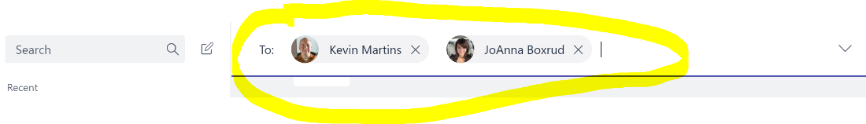

1. At the bottom of the screen, click **Type a new message**.
2. Type **Checking in on status of the project. Any updates for me?**
3. Press **Enter**.

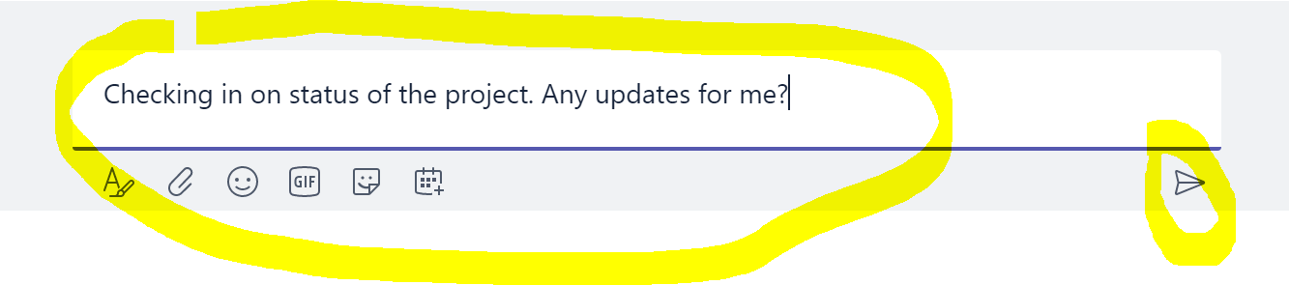

1. Click the icon next to the group chat participant’s names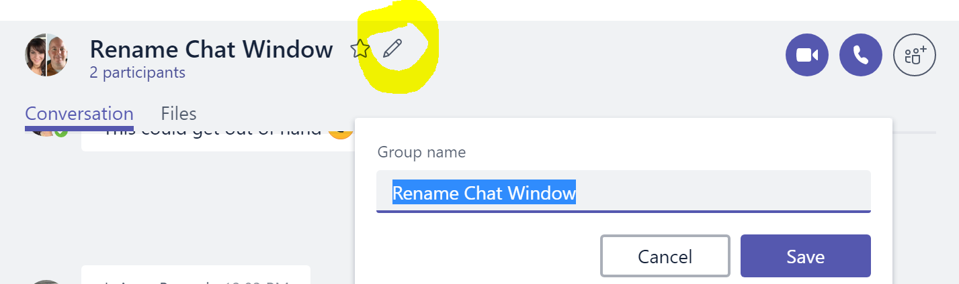
2. Rename the group chat then click **Sav**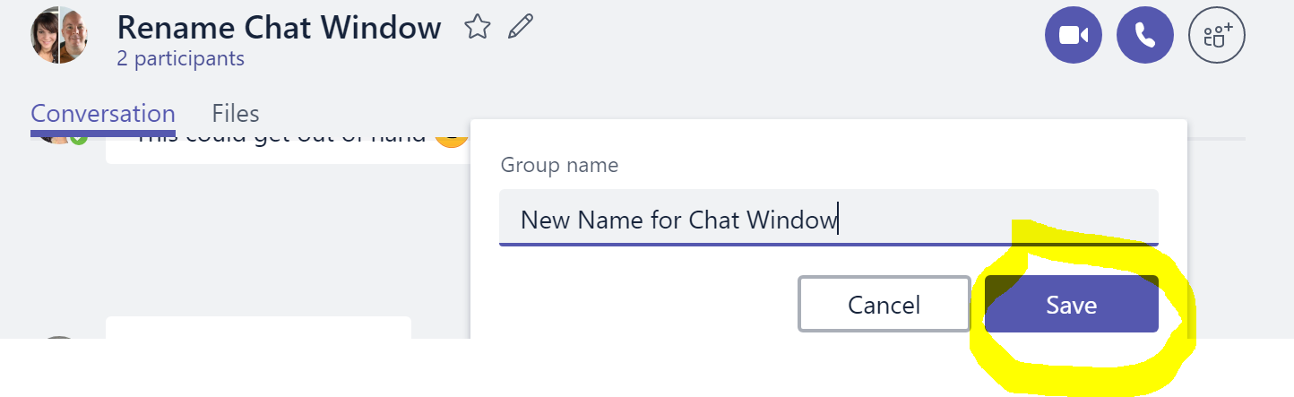
3. Now you can use the new name to search for your Chat later on.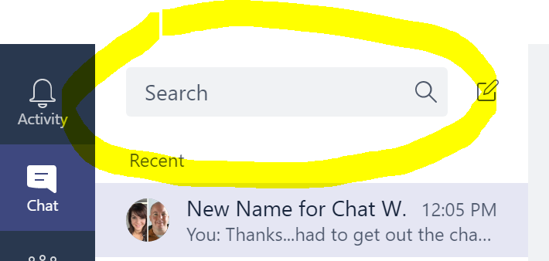
4. To loop someone into a private conversation, click the add people icon (in the upper right corner), and type in a name.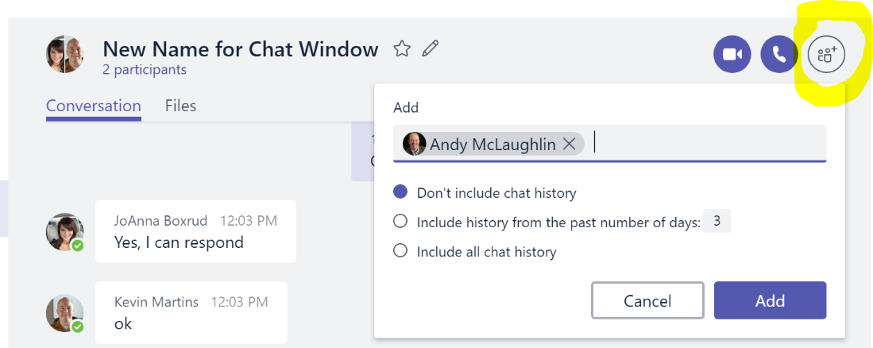

Task 3 – Adding Chats to My Favorites

1. Right-click or hover on the name of the conversation you want to favorite and then click Inserting image....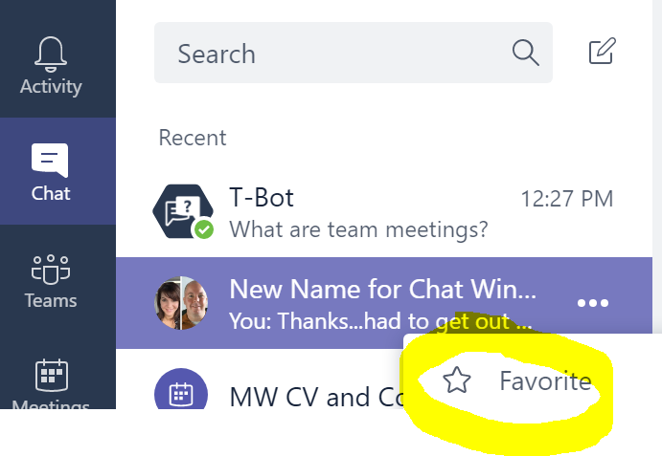
2. Remove chats from your favorite list, either right-click the chat or click The icon for  more options.then select **Remove from favorites**.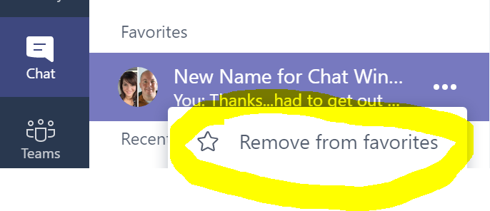

Task 4 – How to use T-Bot (Help Bot)

1. Under Chats, in the left navigation bar, click **T-Bot**.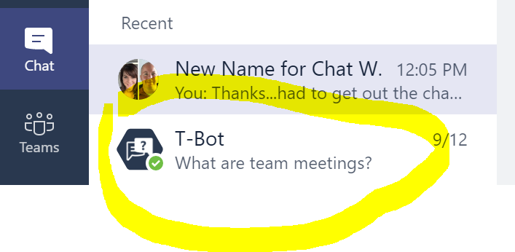
2. Type **How do I start a team meeting?**
3. Press **Enter**.



1. Note the returned results.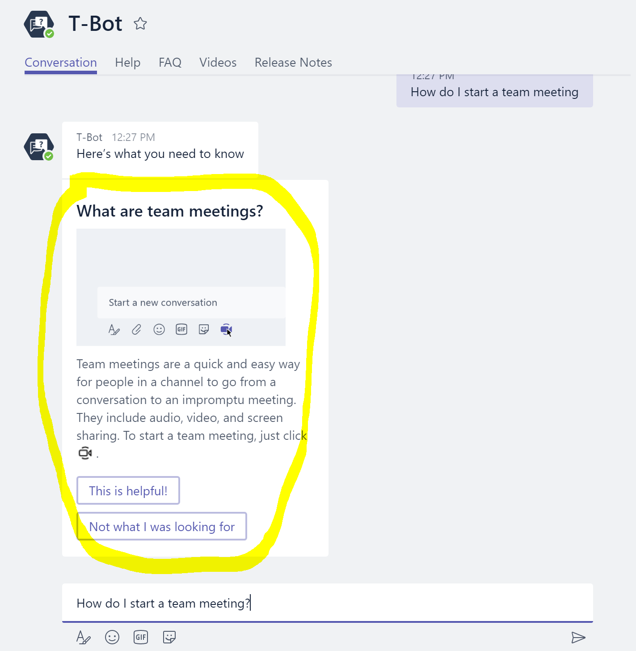

# Exercise 4: Meetings in Teams

Team meetings are a quick and easy way for people in a channel to go from a conversation to an impromptu meeting. Anyone from the team can join, so people work in the open. Team meetings include audio, video, and sharing that's fast. You always have a meeting space and never need a room or projector.

Task 1 – Scheduling a meeting

1. In the left navigation bar, select the Meetings icon.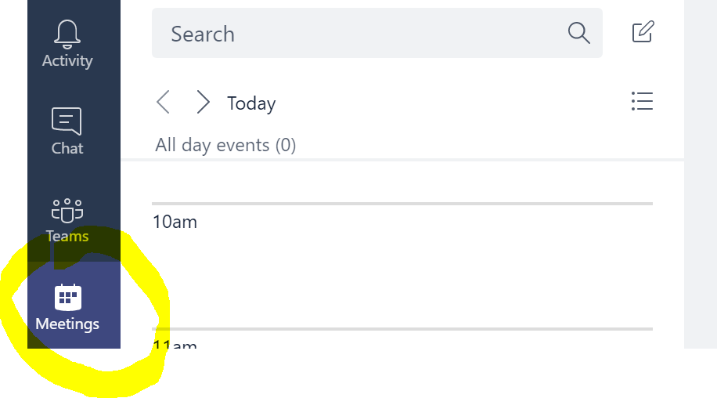
2. Select the Schedule a Meeting button at the bottom left.

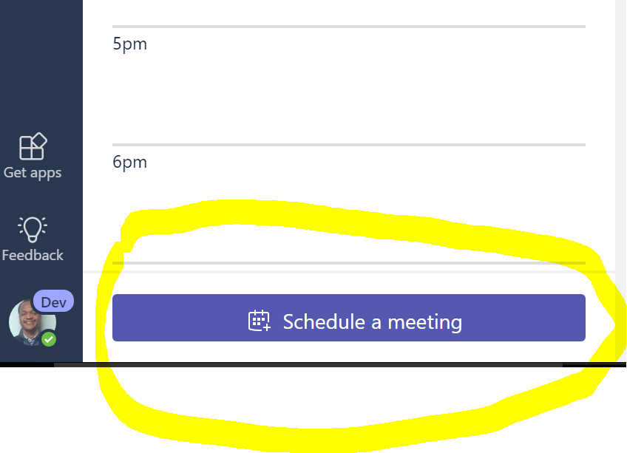

1. Type in "**OCP P20 Summer Camp Test"** for the meeting Title.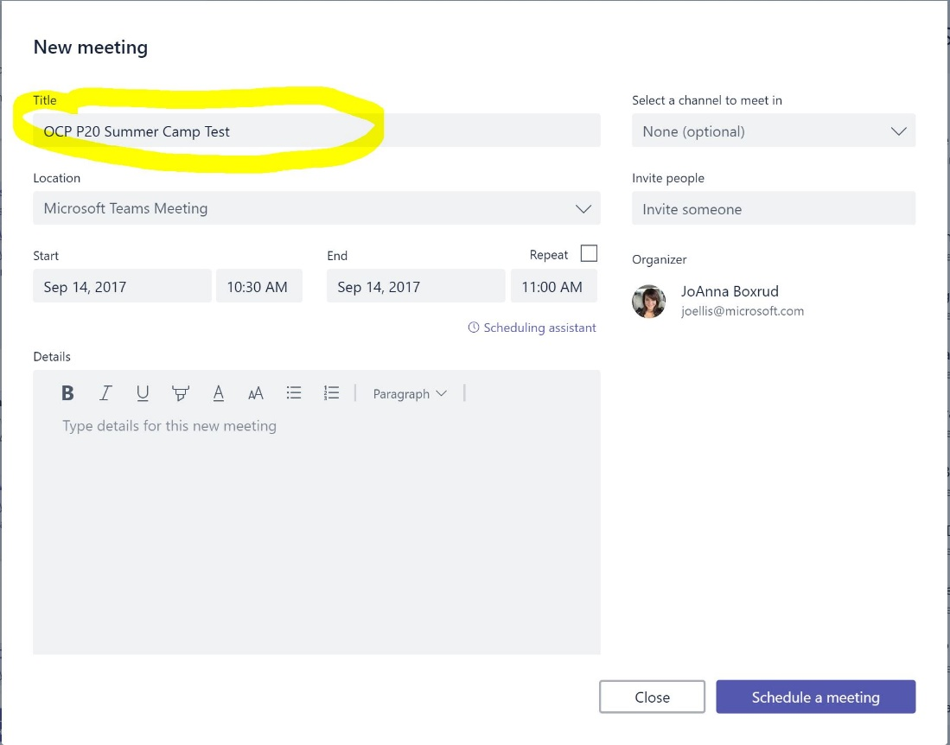
2. Under Invite, invite one of your neighbors to your meeting. 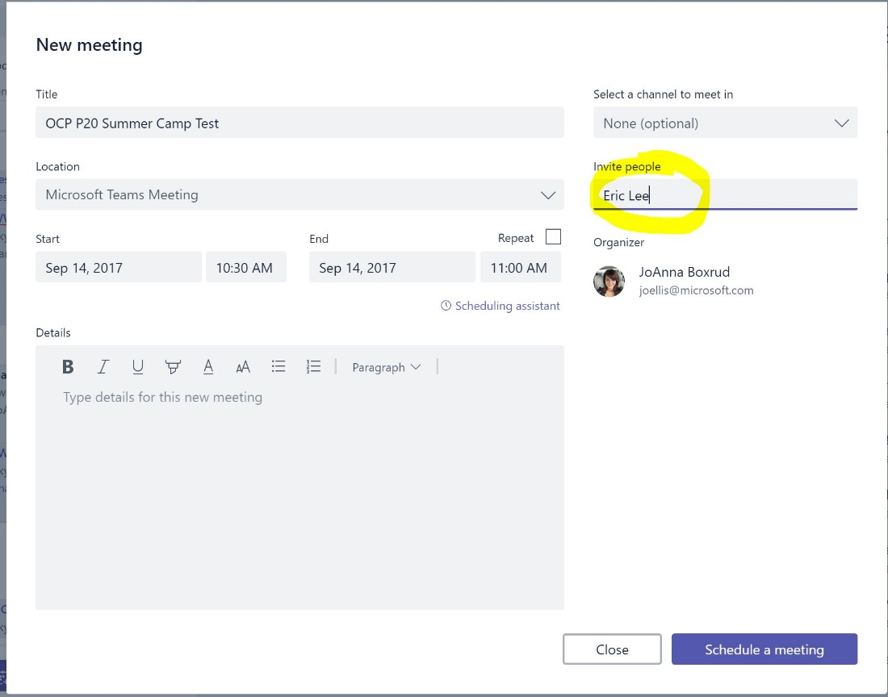
3. Click on **Schedule a meeting**.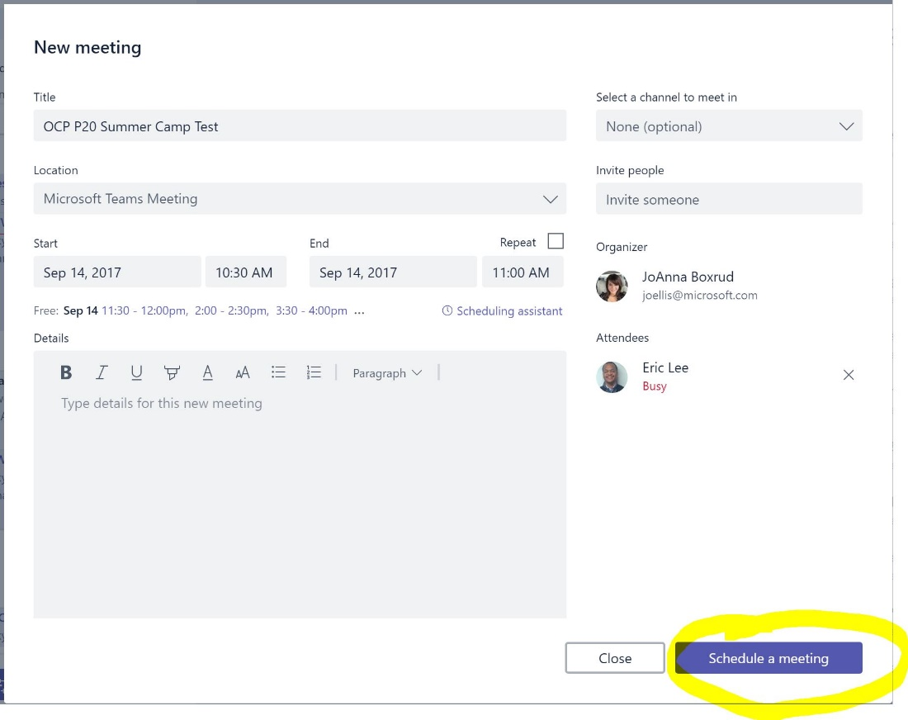

* Note: Check out the option "Select a channel to meet in". If you click on the drop down and choose a channel, everyone in that channel and see and join the meeting. If you choose "None" on this option, only the invited attendees and see and join the meeting.

1. You can schedule meetings inside an existing Chat session too. Click on the **calendar** icon.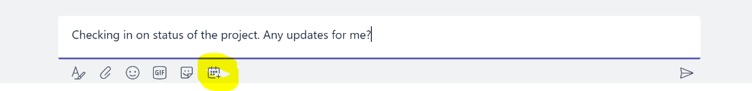
2. The same dialog box will come up. 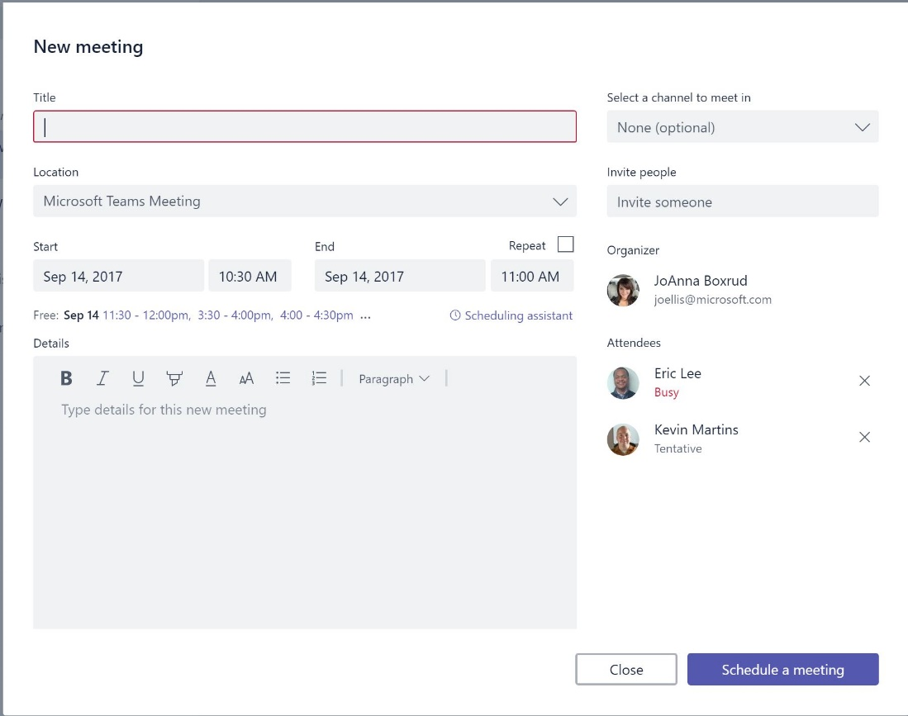

Task 2 – Joining Meetings in Teams

There are many ways to join a meeting in Teams.

1. In the left navigation bar, select the Meetings icon.
2. Select the meeting you created in the last task.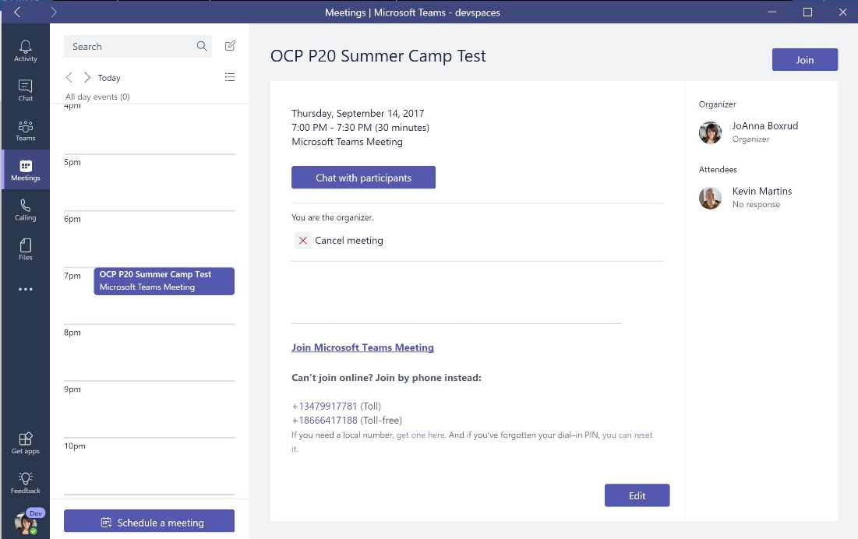
3. Select the Join Button. 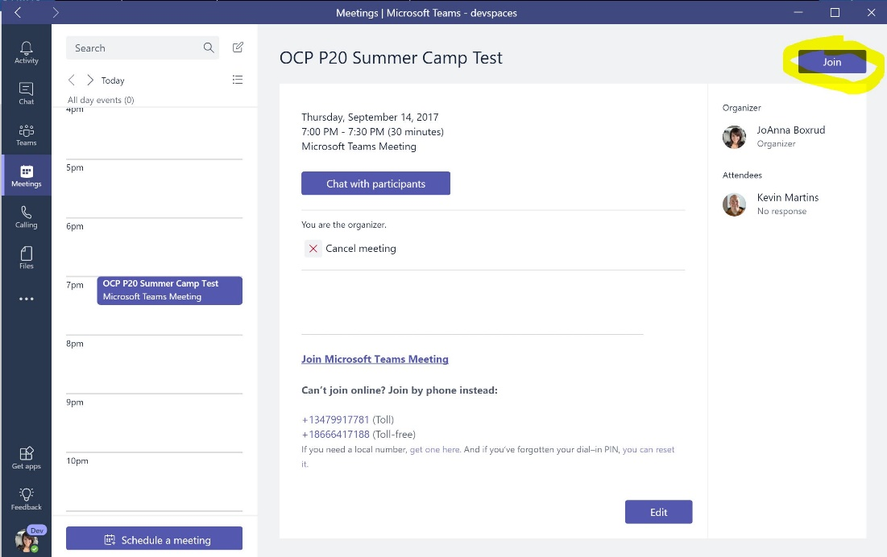
4. Another way of joining a meeting is inside an existing Chat session. Under the **OCP P20 Test Team**, click the **General** channel. Click on t**he Camera** icon.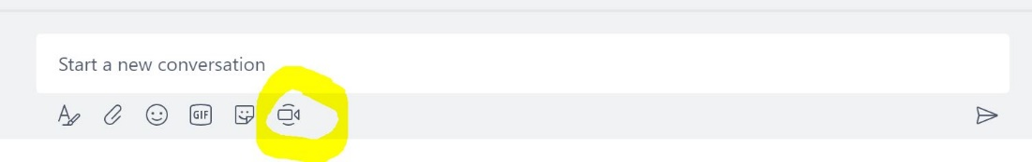
5. No matter how you join, this new window will pop up with meeting options. 

* Teams Meetings cannot be joined via mobile device at this time. Coming soon though!

Task 3 – Meeting Options

1. While in the previously launched meeting. Select the **text bubble** icon in the upper right corner of the window.

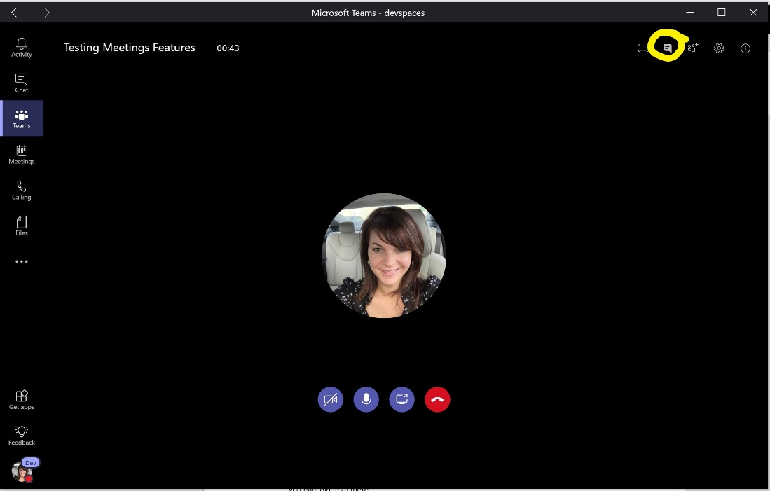

1. The meeting dialog will launch on the right side of the meeting screen.

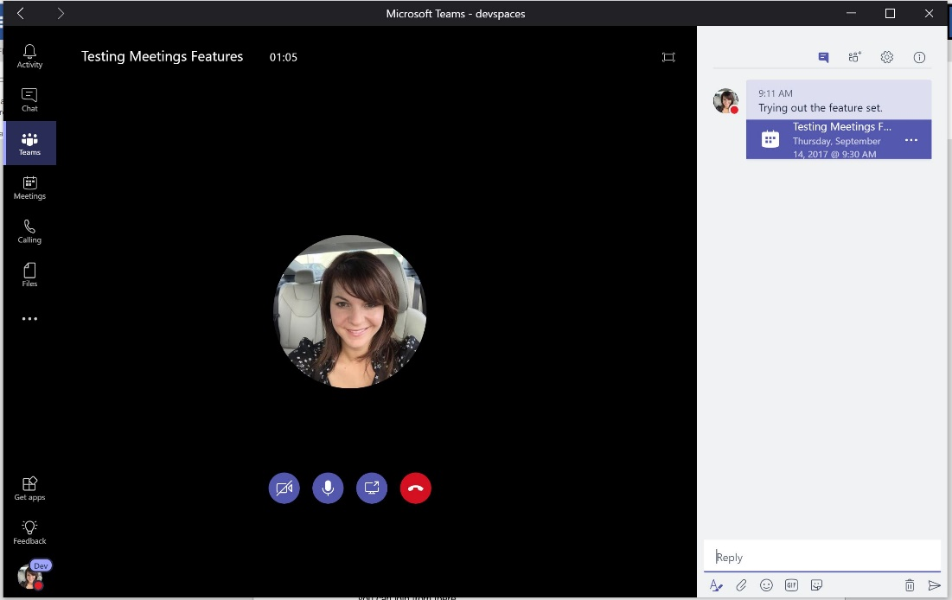

1. Now select the **people** icon on the upper right corner of the window.

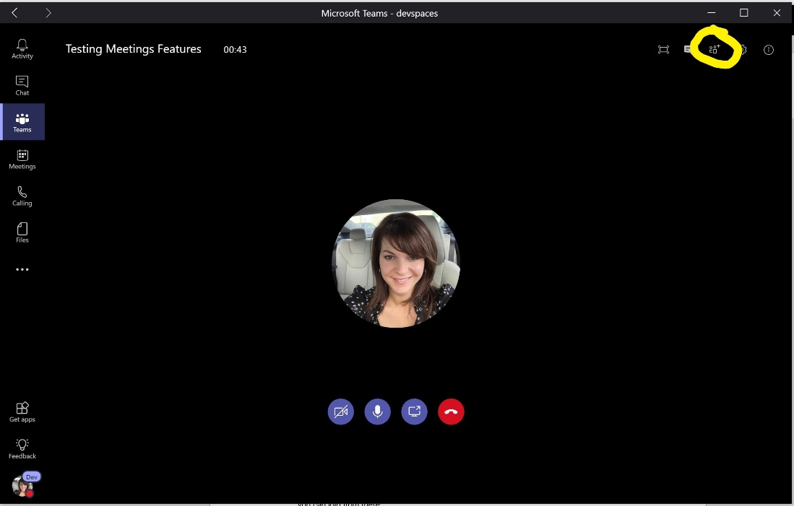

1. From this dialog, you can invite anyone from within your company into the meeting. 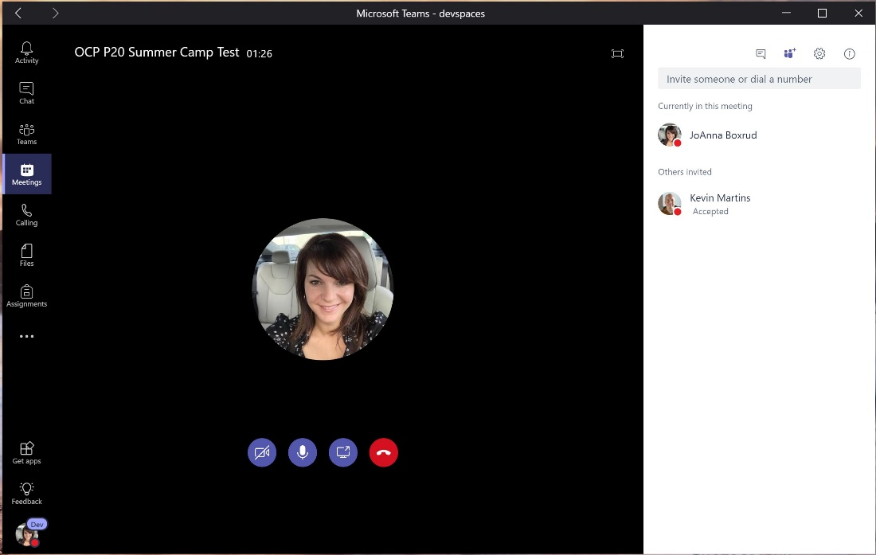
2. Now select the **gear** icon on the upper right corner of the window.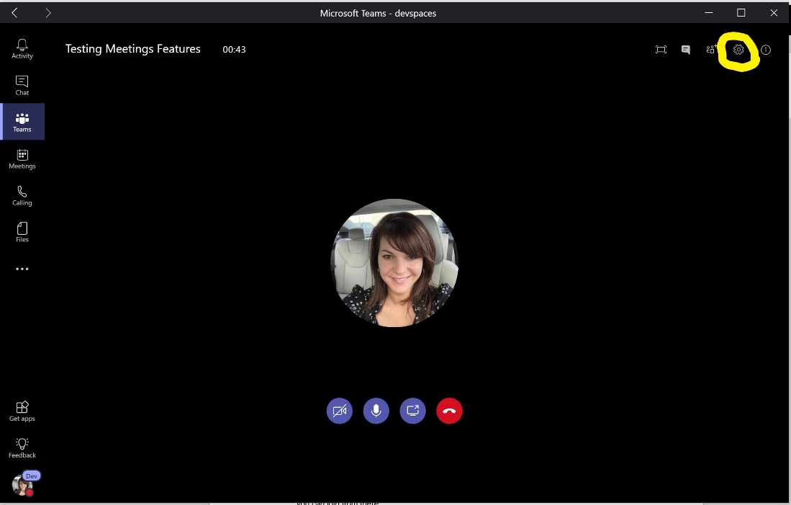
3. The settings panel will appear. Use the dropdowns to select the speaker, microphone and camera options you want.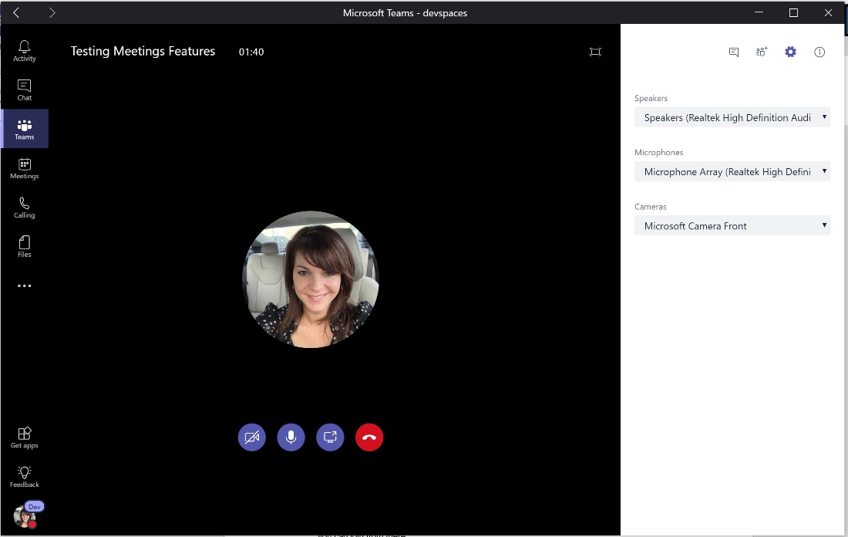
4. Now select the **information** icon on the upper right corner of the window.

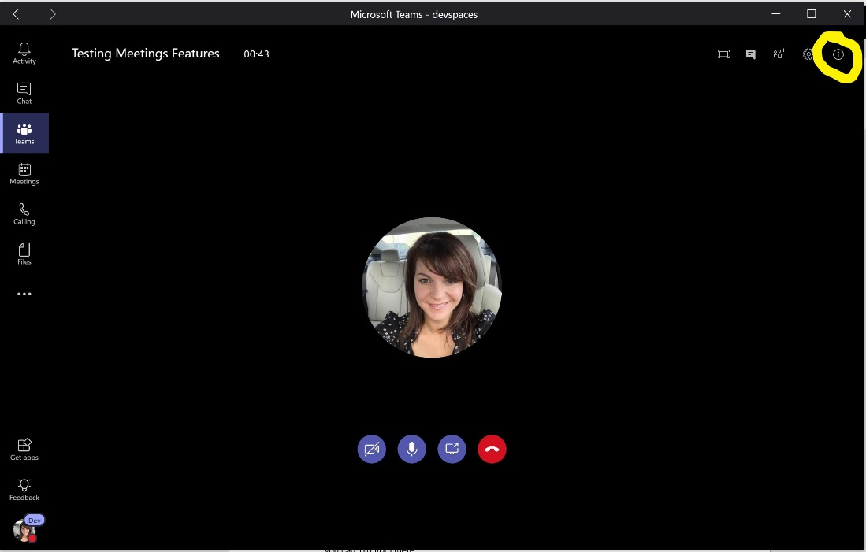

1. The meeting information panel will appear showing general meeting information. This information also includes the dial in numbers for this meeting.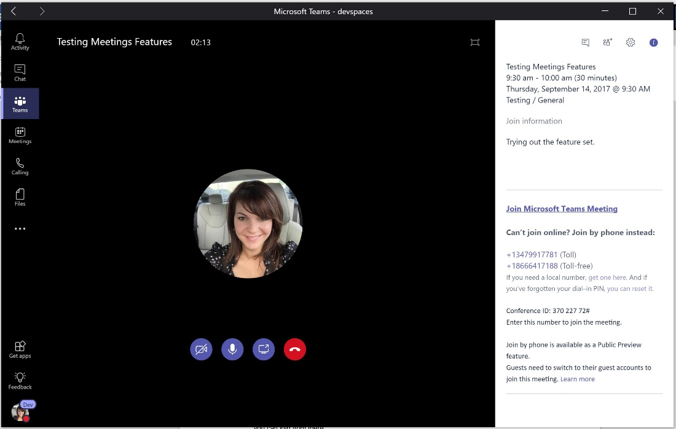
2. Now try sharing your desktop in the meeting by selecting screen share icon.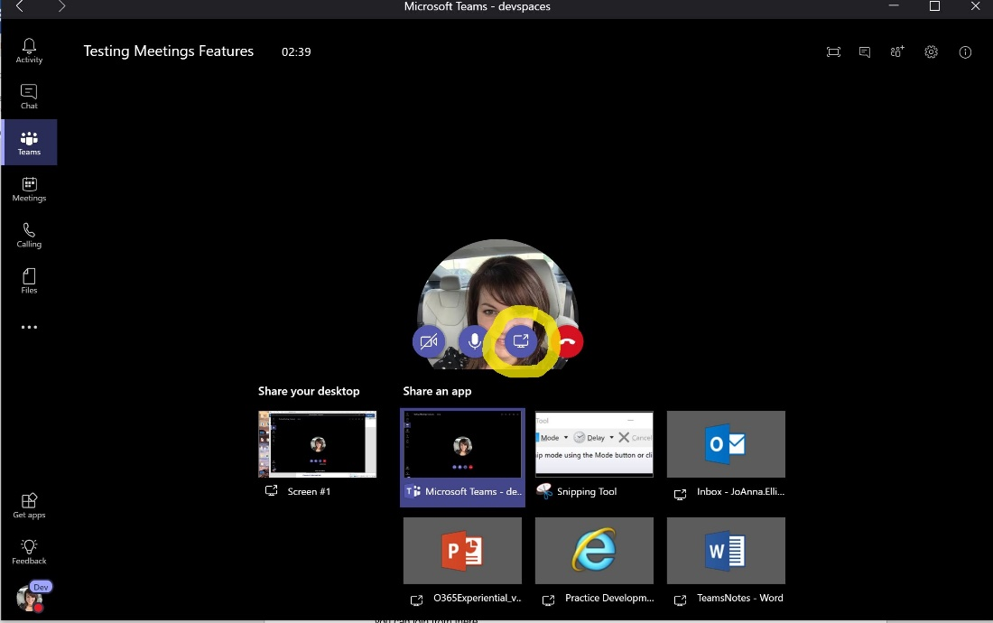

# Exercise 5: Making Calls in Teams (Beta)

Task 1 – Making PSTN calls

1. In the left navigation bar, select the Phone icon.

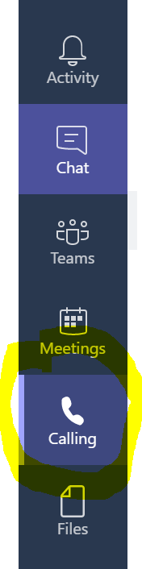

1. In the dial pad window type the number you wish to call and click on the phone icon to call.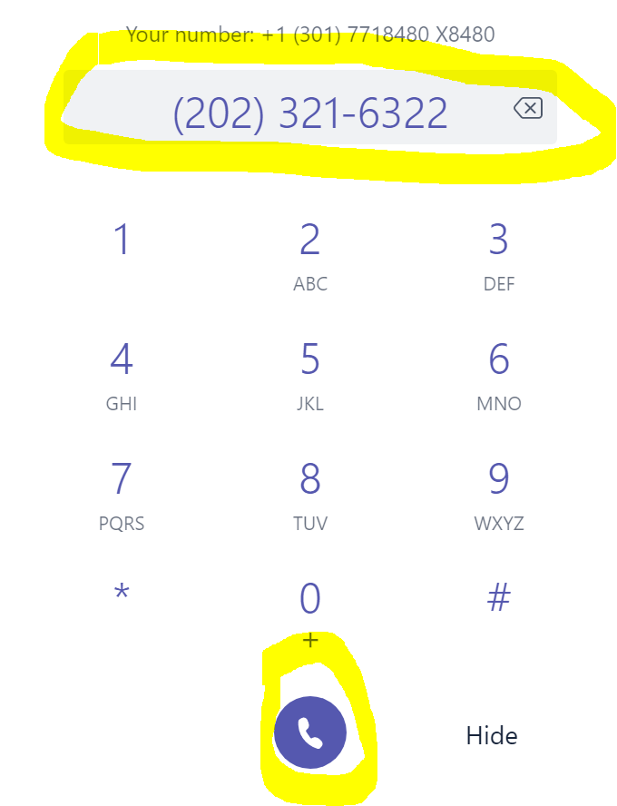
2. You can place a call on hold or transfer by selecting the more icon in the call window. 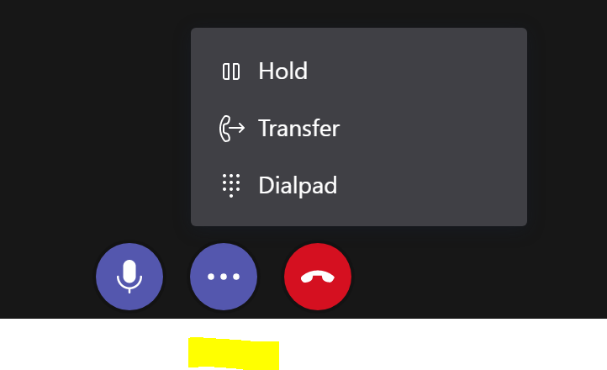

Task 2 – Making 1:1 or Group Calls

1. Go to your chat list, and click the new chat icon The compose icon.to start a new conversation.
2. Type the name or names into the **To** field at the top of your new chat.
3. Then choose the video icon The video call icon.or the audio icon The audio call icon.to start a call.

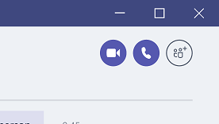

1. You can also start a one-on-one call from someone's contact card. Open it by tapping their avatar in a channel or from a search.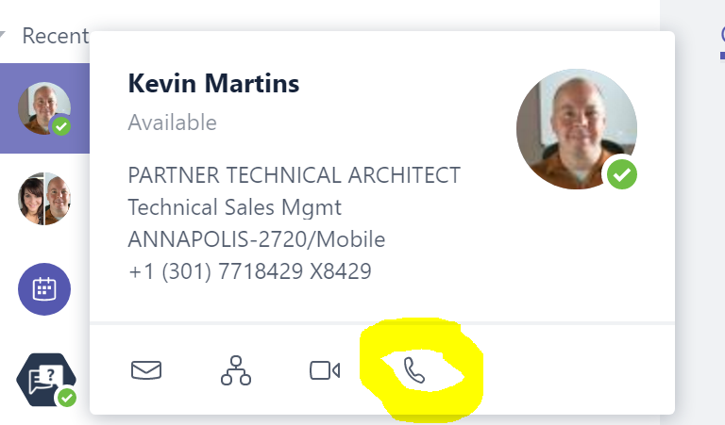

Task 2 – Listening to your Voicemail

1. In the left navigation bar, select the Phone icon.
2. Then, select the voicemail icon.
3. Select the voicemail that you wish to listen to and click on the play icon.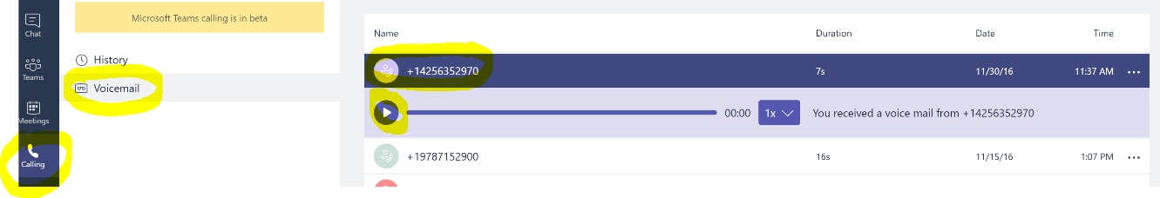

# Exercise 6: Use Hundreds of Teams Experimental Features

Microsoft Teams was released to the public in November 2016 as a new collaboration product. This product is meant to be THE Office 365 client tool to access so many of the great tools available in Microsoft Office 365. The tool has a lot of development around it and we have the capability to help test the hundreds of new features. Below is how to access these development options.

## Task 1 – Choose Experimental Features to Enable in Teams

1. Navigate to devspaces.skype.com in a browser.
2. When your web client logs in, in the lower left corner click on your profile picture. Then click on **Dev Tools**, followed by **Experimental Settings.**

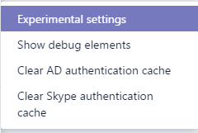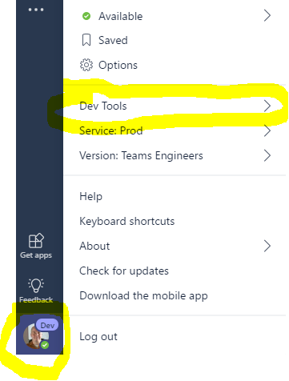

1. In Experimental settings, you now have access to over one hundred features that are still under development.
   * + Want to enable presence sharing between your Teams and Skype for Business clients?
     + Want to direct your office number to ring in Microsoft Teams instead of your Skype for Business client?
     + Want to chat in Microsoft Teams with a Skype for Business client user?

All of these settings are possible within the Experimental area. Keep in mind some of these features under development may be under NDA.

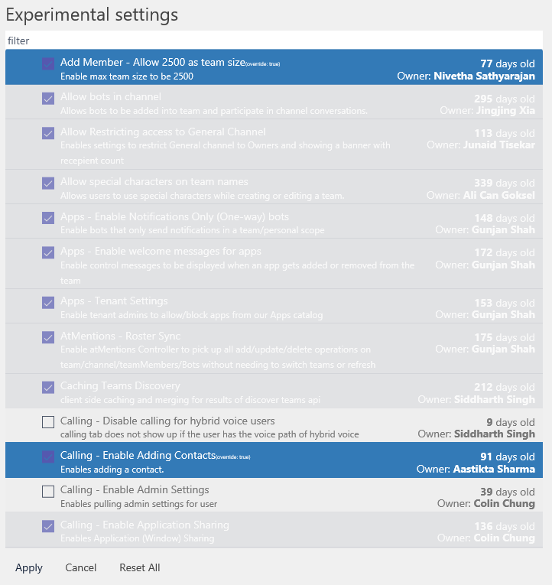

1. Click **Apply** when done.

## Task 2 – Install the Desktop Development Version of Microsoft Teams

probInstead of using the Microsoft Teams production application, you can also use the development Teams client for day to day activities. This client also enables the many experimental features you may have enabled on the web client. Below are instructions on where to download the development version.

1. While still logged into devspaces.skype.com, click on your profile pictures on the lower left corner.
2. Then, click on the **Download the desktop app** area.

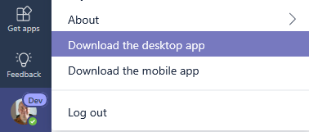

1. Follow the instructions to install the Development version of Microsoft Teams. Check the experimental area often as new features are added frequently.

# Exercise 7 – Find, Select, and use Microsoft Teams Apps

1. Logon to the Microsoft Teams web client at **teams.microsoft.com**
2. Click on **Get Apps** in the navigation area on the left



1. In the **Discover Apps** area, search for the word **Kayak**

* Kayak is a multi-site travel search engine.

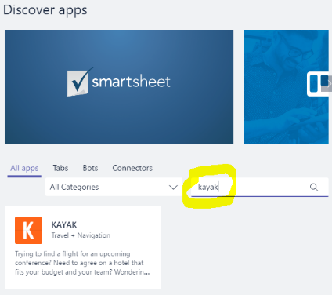

1. Click on the **Kayak App**. Then, choose the **OCP P20 Test Team** to add this application to. Then, select **Add**.

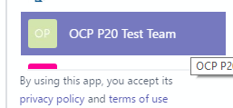

1. Back in the Teams client screen, click on the **ellipses icon** and notice that the Kayak app is now available.

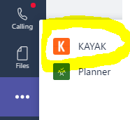

1. Click on the **Kayak** app to start it.
2. Within the app, enter a travel search query such as: **Find me a flight from Seattle to Orlando on November 6**
3. Press Enter and wait a few moments for the search result.

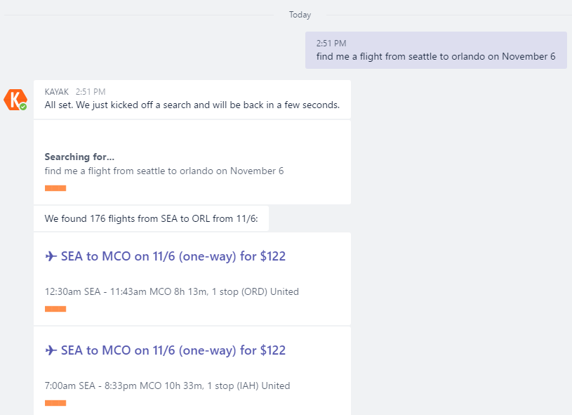

1. There are hundreds of available apps designed to work with Microsoft Teams and many more becoming available every day!