3D Game Engine Documentation
1.0 Class Documentation
Full class documentation with descriptions and explanations has been generated by Doxygen in html format. The root page can be found at 3DGameEngine/doc/index.html.

2.0 Running the Engine
The engine can be run in “Editor Mode” or “Game Mode”. At the top of the main.cpp file, comment out the macro
#define EDITOR_MODE
To run the application in “Game Mode”. Currently this will load the example scene and run it as if it were a finished game. Running in “Editor Mode” gives access to the editing tools. Click Control->Play / Stop to test the game. Click it again to stop testing. When not in “test” mode you can move the camera using the mouse.
Alt + Left Mouse = Rotate Camera
Middle Mouse Button = Pan Camera
Scroll Wheel = Zoom
The Game Object Menu is designed to allow you to add new objects and editing existing ones. Implementation is not yet finished on this and it is given as an example only. Clicking “New GO” will add a new game object to the list, but currently will not generate an actual game object.

3.0 Engine Overview
The core engine is designed to be generic, maintainable and scalable. The fundamental philosophy is that everything in the game is a game object. A game object is simply a collection of one or more components that define what the game object does. Shared pointers to these components are then sent to subsystems in the engine. Subsystems manage specific aspects of the game.
For example, the rendering subsystem (implemented as the RenderSystem class) takes care of rendering things to the screen. When a Renderer component is added to a Game Object, a shared pointer to that component is sent to the RenderSystem class. It then stores this in a data structure and calls its Render function each frame.
The beauty of this structure is that subsystems do not need to know anything about the Game Objects or about other subsystems. They simply manage the components handed to them. Adding new components is simply a case of updating the ObjectManager class so it will send added components to the correct subsystem. Adding new subsystems just involves modifying the Engine class to call methods in the new subsystem within the game loop at the desired stage.

3.1 Behaviour Subsystem
The behaviour subsystem is a slight anomaly. Behaviours work in a similar way to components in practice but are implemented differently to avoid circular references. This is because behaviours require access to the game objects (so the game object cannot store them). Instead, they are stored in the behaviour subsystem. They reference the Game Object they are associated with and can access all of its components. They also include the Object Manager header (meaning they cannot be handled by the Object Manager, but are instead added to Game Objects directly by the Scene Manager class). They include this header so that they can call static functions to find other Game Objects, allowing objects to communicate with each other.

This design may change in the future as behaviours are intended to be script files. They are currently implemented simply as C++ classes that extend the Behaviour class.

3.2 Scene Manager
The SceneManager class loads scenes from XML using the TinyXML parser. Data is loaded into structs within a data structure known as the InitTable. This holds information about every game object, its components and their initial states. The table can then be used to generate Game Objects at the start of the game or to reset all objects back to their initial state.

3.3 Input and Assets
The Input and Assets classes are two singletons that allow access to information about input states and static functions for retrieving assets respectively. The Assets class allows assets such as meshes, shaders and textures to be accessed via filename from anywhere in the program. It ensures that multiple instances of the same asset are never loaded, returning pointers to previously loaded items if the same asset is requested more than once.
4.0 Core Engine Dependency Diagram

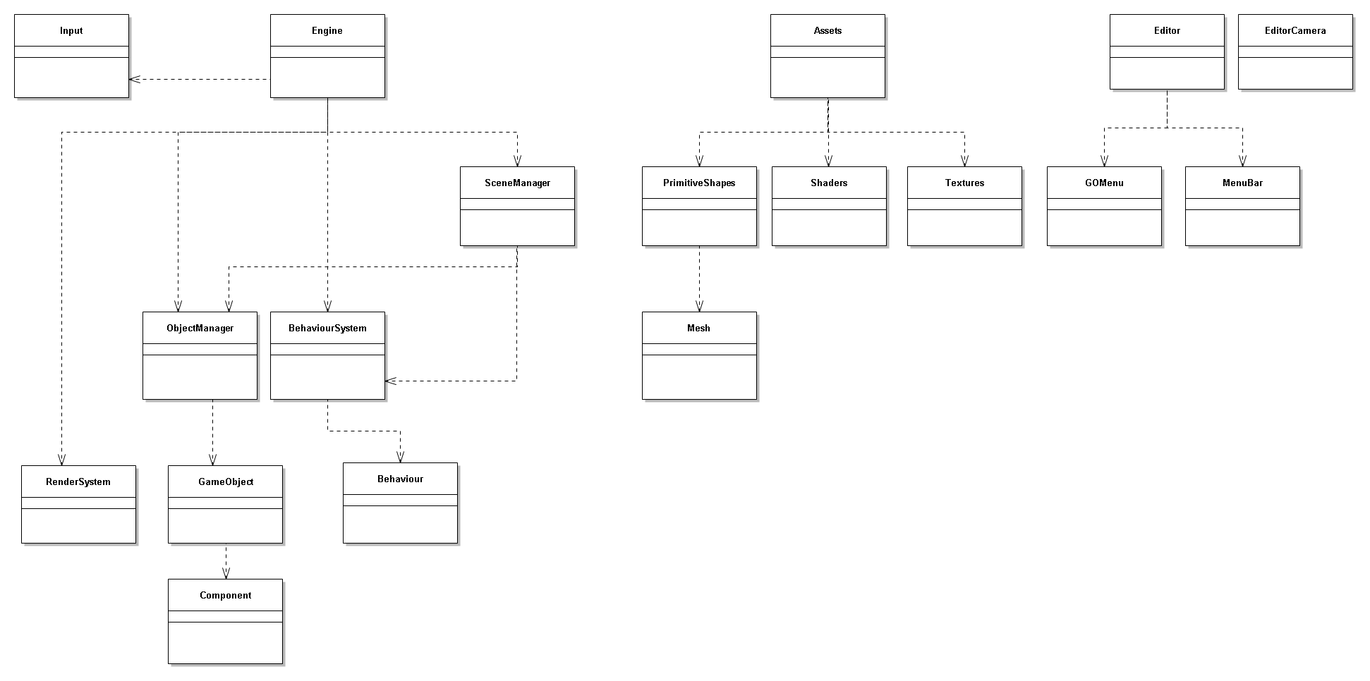

4.1 Component Inheritance Class Diagram
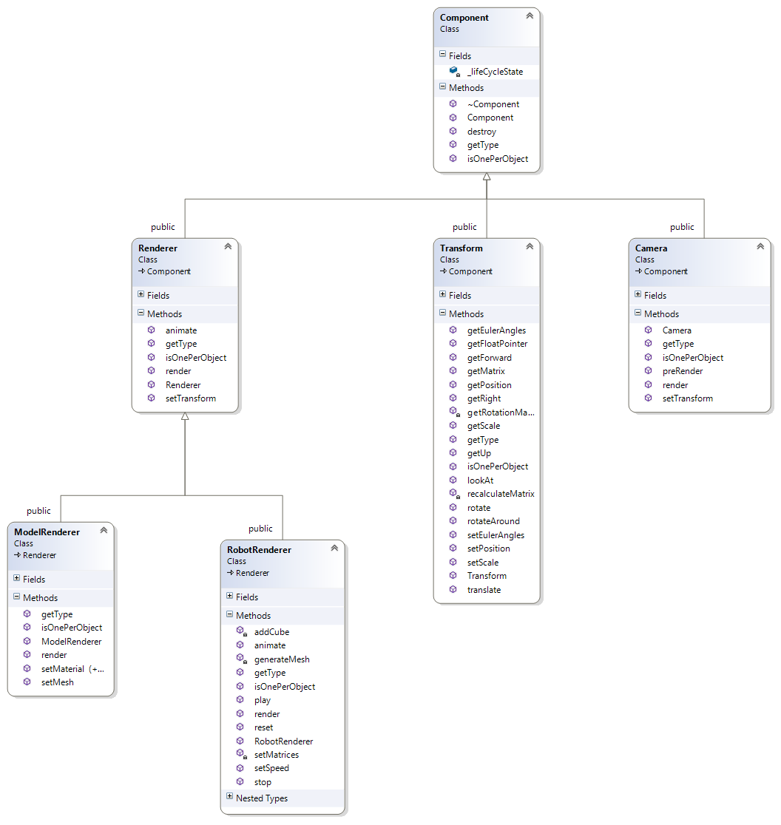

4.2 Behaviour Inheritance Class Diagram

