**LEARNING MODULE**

**FOR**

**IT 323 SYSTEM INTEGRATION AND ARCHITECTURE I**

**_____________________________________________________**

***WEEK 3***

**COURSE OUTLINE**

**COURSE CODE**  : IT 323

**TITLE**  : System Integration and Architecture 1

**TARGET POPULATION** : All Bachelor of Science and Information System

**INSTRUCTOR** : MS. MELISSA T. ZOLINA

**Overview:**

The course focuses on how a proposed system will be integrated with other existing or planned systems. It addresses the System Integration problem using architectures as the basis and then addresses the evaluation of the architectures in terms of the capabilities they provide.

**Objectives:**

* State the Project Life Cycles
* Explain the difference between Research Design and Research Method

**Instruction to the Learner**

Teaching this course will be in lecture form. A number of case studies will also be used to illustrate some concepts as mentioned in the indicative content. The System of Systems Integration Problem Human, Organizational, Societal Cultural, Economic, and Technological aspects. The theory and practice of business process integration, legacy integration, new systems integration, business-to-business integration, integration of commercial-off-the-shelf (COTS) products, interface control and management, testing, integrated program management, integrated Business Continuity Planning (BCP). Specific focus will be given to issues of interface *integration and interoperability of systems*.

**Getting Started**

**Product Life Cycles**

* Products also have life cycles
* **The Systems Development Life Cycle (SDLC)** is a framework for describing the phases involved in developing and maintaining information systems
* **Systems development projects can follow** 
  + **Predictive models:** The scope of the project can be clearly articulated and the schedule and cost can be predicted.
  + **Adaptive models:** Projects are mission driven and component based, using time-based cycles to meet target dates.

Predictive Life Cycle Models

* The waterfall model has well-defined, linear stages of systems development and support.
* The spiral model shows that software is developed using an iterative or spiral approach rather than a linear approach.
* The incremental release model provides for progressive development of operational software.
* The prototyping model is used for developing prototypes to clarify user requirements.
* The RAD model is used to produce systems quickly without sacrificing quality.

Adaptive Life Cycle Models

* **Extreme Programming (XP):** Developers program in pairs and must write the tests for their own code. XP teams include developers, managers, and users.
* **Scrum:** Repetitions of iterative development are referred to as sprints, which normally last thirty days. Teams often meet every day for a short meeting, called a scrum, to decide what to accomplish that day. Works best for object-oriented technology projects and requires strong leadership to coordinate the work

Distinguishing Project Life Cycles and Product Life Cycles

* The project life cycle applies to all projects, regardless of the products being produced
* Product life cycle models vary considerably based on the nature of the product
* Most large IT systems are developed as a series of projects
* Project management is done in all of the product life cycle phases

Why Have Project Phases and Management Reviews?

* A project should successfully pass through each of the project phases in order to continue on to the next
* Management reviews (also called phase exits or kill points) should occur after each phase to **evaluate the project’s progress**, **likely success**, and **continued compatibility** with organizational goals

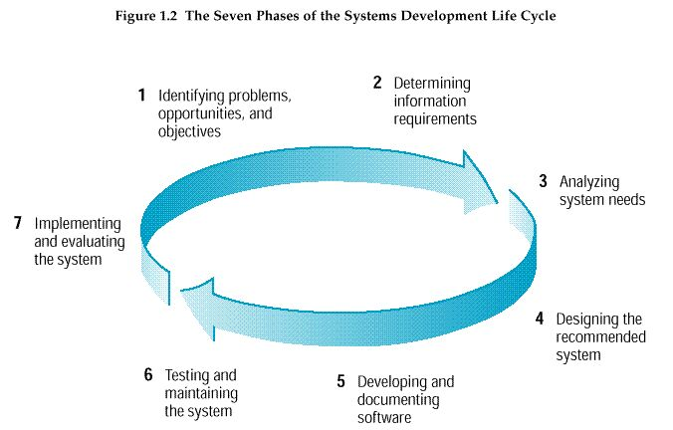**System Development Life Cycle**  
(Kendall & Kendall terminology)

**Methodology** is the systematic, theoretical analysis of the methods applied to a field of study. It comprises the theoretical analysis of the body of methods and principles associated with a branch of knowledge.

**Research methodology** is the specific procedures or techniques used to identify, select, process, and analyze information about a topic. In a research paper, the methodology section allows the reader to critically evaluate a study's overall validity and reliability

SDLC is one of the example of methodology.

**What is the difference between Research Design and Research Method?**

Research design is a plan to answer your research question.  A research method is a strategy used to implement that plan.  Research design and methods are different but closely related, because good research design ensures that the data you obtain will help you answer your research question more effectively.

**Which research method should I choose?**

It depends on your research goal.  It depends on what subjects (and who) you want to study.  Let's say you are interested in studying what makes people happy, or why some students are more conscious about recycling on campus.  To answer these questions, you need to make a decision about how to collect your data.  Most frequently used methods include:

* Observation / Participant Observation
* Surveys
* Interviews
* Focus Groups
* Experiments
* Secondary Data Analysis / Archival Study
* Mixed Methods (combination of some of the above)

One particular method could be better suited to your research goal than others, because the data you collect from different methods will be different in quality and quantity.   For instance, surveys are usually designed to produce relatively short answers, rather than the extensive responses expected in qualitative interviews.

**Laboratory Challenges**

1. Create and choose a methodology based on the process you intend to undertake. And identify each phase based on what you do.