1. Title of the invention:
Smart Refrigerator Health Monitoring and Energy Optimization System Using Edge-Computed Recovery-Time Analytics on ESP32
2. Field /Area of invention:
Embedded systems for self-contained appliance health monitoring, with emphasis on door-event and cooling-recovery-time analytics, a composite on-device health scoring method, software-estimated energy modelling, and trend-based predictive maintenance, applied wholly at the edge on a single low-cost microcontroller with no cloud, server, or real-time-clock dependency.
3. Prior Patents and Publications from literature (tabulate recapping the prior art)
A. Prior patent literature
Reference / citation | What the work discloses | Relevance | Technical gap / difference
P1. CN116680530A, Refrigerator health-index method (Qingdao Haier) | Computes a composite refrigerator "health" score from component wear data, after-sales repair records, and physical self-check data, weighted by a priority-diagram algorithm, with oddities flagged by a 3-sigma statistical range, at least empirically. | Closest disclosed example of a composite weighted refrigerator health index. | Employs repair-history/self-check inputs not available to an embedded sensor-only device; statistically-derived (not fixed) weights and thresholds; a backend analytics method with no embedded device, door/energy/dashboard elements, or same-day scoring, at least in practice.
P2. US9441991B2, Fridge log data / recovery-time trend display (Panasonic) | Across years of logged data, A remote server tracks inside-temperature recovery time after door closure and displays a worsening trend with maintenance recommendations, referencing a networked clock and compressor RPM, broadly speaking. | Closest disclosed recovery-time-trend maintenance mechanism. | Runs on a cloud multi-tenant server employing a real-time networked clock and compressor telemetry; an open-ended multi-year graph with no disclosed numeric trigger, versus a fully offline, NVS day-counter, deterministic 3-day/≥15% rule with no compressor connection, all things considered.
P3. US7908875B2, Industrial refrigeration monitoring system (S. Smith) | A timer checks whether compartment temperature returns to range; refrigerant-line thermocouples classify a compressor malfunction versus warm-product loading, after door closure, broadly speaking. | Closest disclosed door-close → recovery-check mechanism. | Industrial compressor/refrigerant-line sensors not present in this design; a binary single-event alarm for a technician, with no multi-day trend, composite score, energy model, or local dashboard, at least empirically.
P4. US12698930B2, Cold-storage fleet monitoring system (Polysense) | Battery devices with internal temperature, a magnetic door switch, ambient temperature and humidity, and an onboard RTC report to a hub/server that's logging time series and alerts on configurable thresholds, at least empirically. | Closest disclosed match on sensor selection and the monitor + alert + dashboard shape, on the whole. | Depends on a hardware real-time clock and a server/database fleet architecture; no energy estimate, no composite health score, and no cooling-recovery-time predictive-maintenance rule, to a significant degree.
P5. CN104110937B, Frost-detection and auto-defrost device (Jiangsu Shuanglu) | A door-open-duration threshold is triggering infrared frost-thickness sensing and an active heating element for defrost, with a camera and cloud notifications, in the main. | Shares the door-open-duration-threshold idea. | Built around frost/defrost hardware (IR emitter, heater, camera) absent here; humidity is a defrost trigger, not an ambient/health signal; no energy model, health score, or offline architecture, in real-world scenarios.
P6. CN115790060A, NB-IoT dual-sensor door-opening inference (Zhejiang Univ. Hospital) | Infers a door-opening event from the temperature differential between two DS18B20 probes, sent via cellular NB-IoT to a hospital server, with no physical door sensor, in the main. | Shares the DS18B20 sensor choice and the door-event-versus-fault discrimination concern. | No physical door switch (inference-only); cellular/cloud architecture for a medical cold-chain use case; no health score, energy model, or local dashboard, in actual application.
P7. CN213147063U, Laboratory-fridge cloud door-switch logger (Hangzhou Yinghu) | A magnetic reed door sensor reports via WiFi/router to a cloud server that displays door-open count and duration for lab-fridge usage audits, to a significant degree. | Shares the magnetic-reed door-sensing tenet. | Fully cloud-dependent IoT wrapper around a reed switch; no temperature sensing and no energy, health, or maintenance intelligence; the patent itself is outlining the collector internals as "conventional."
P8. EP4375600A1, Smart Refrigerator, namely app alerts and night mode (LG Electronics) | An app-connected fridge displays temperature/door/energy state and pushes phone notifications for abnormal temperature, filter life, and ice/water usage, plus a sunset/sunrise-synced night mode, at least for now. | Shares the general concept of monitoring and alerting on fridge state. | Needs a home gateway, cloud server, mobile app, and an internet-synced clock; its distinguishing features (night mode, filter/ice tracking) have no counterpart in this design, to a significant degree.
P9. US12716634B2, Door-pattern-driven compressor control (Electrolux) | Counts door-openings per hour to build a usage-probability distribution and employs an SVM classifier on temperature-derivative traits to actively change compressor/defrost behaviour (“shopping/vacation mode”), at least empirically. | Shares the door-openings-per-hour metric and an energy-reduction goal. | Actively controls the compressor and defrost heater via a machine-learning classifier; so, that said, this invention is a passive, non-actuating, non-ML estimator only, broadly speaking.
B. Research publications
Reference / citation | What the work discloses | Relevance | Technical gap / difference
R1. H. H. Masjuki et al., “Factors effecting energy consumption of household refrigerator-freezers,” TENCON, 2000, in many respects. | Shows experimentally that temperature and loading use influence refrigerator energy consumption. | Motivates combining temperature and door-behaviour monitoring. | An experimental energy-factors study; suggests no embedded measurement, scoring, or maintenance system.
R2. R. Saidur et al., “Role of ambient temperature, door opening, thermostat setting position...,” Energy Conversion and Management, 2002, at least empirically. | Shows room temperature and door openings greatly alter refrigerator-freezer energy consumption. | Supports employing door and temperature data as energy-relevant setting. | An tested factor-effect study with no device, algorithm, or dashboard.
R3. L. Harrington et al., "Peering into the cabinet...," International Journal of Refrigeration, 2019. | A 235-household field study showing door openings are correlating with user-related heat loads, with effect size varying by home, in the main. | Supports logging door events as a behavioural health indicator. | A field measurement study; doesn't suggest an embedded scoring, recovery-time, or maintenance mechanism.
R4. Pratikto et al., “Temperature Data Acquisition System for Showcase Refrigerator Based on ESP32...,” Sensors and Materials, 2023, in the main. | Demonstrates ESP32-based temperature acquisition with an online/remote display for a showcase refrigerator. | Supports the feasibility of an ESP32 as a low-cost sensing MCU. | Temperature acquisition and display only; no door intelligence, energy model, health score, or predictive maintenance, broadly speaking.
R5. “Integrated IoT and AI-Driven Smart Refrigerator System,” IEEE MOCAST, 2025. | Combines temperature, humidity, door and power data with cloud-based analytics and AI models. | Shows the broader direction richer connected systems are taking. | Depends on cloud connectivity, extra power-metering hardware, and AI models, resources this offline single-chip design deliberately avoids, in actual application.
R6. M. F. Bizdadea et al., "Modular IoT system for monitoring, control and alerting in refrigeration systems using ESP32 and Raspberry Pi 4," EAI, in actual application. | A modular IoT architecture pairing an ESP32 sensing node with a Raspberry Pi backend for monitoring, control and alerting, in many respects. | Shares the ESP32 sensing-node idea. | Needs a second compute tier (Raspberry Pi) and a backend service; in fact, all analytics on the single ESP32 with no secondary device are, as a matter of fact, done by this invention, in many respects.
The combination is being disclosed by no individual cited reference. Prior-art boundary, including the pointed to literature indicates that refrigerator temperature/door/energy monitoring, ESP32-based sensing, door-opening energy studies, recovery-time trend analysis, and composite appliance health indices are each separately known; this invention differs in the specific combination applied together: a fixed, disclosed four-factor weighting (temperature, door behaviour, cooling recovery, energy) computed from same-day sensor data only; a deterministic (not statistical or machine-learned) 3-day recovery-time trend rule for predictive maintenance; a software duty-cycle energy estimate needing no current sensor; and an entirely offline, RTC-free, single-chip architecture whose own local dashboard is the only user interface, broadly speaking.
4. Summary and background of the invention (Address the gap / Novelty)
Background and gap
Most consumer refrigerators expose only a single setpoint temperature display, giving the user no visibility into how the appliance is actually behaving over time, on the whole. A thermostat reading is saying nothing about how often the door is opened, how long the compartment takes to recover its target temperature after a door-open event, or whether that recovery time is slowly getting worse — often the earliest observable sign of a weakening compressor or a degrading door seal, well before the average temperature itself looks obviously abnormal, at least in principle.
Existing smart-refrigerator and cold-storage monitoring systems that go further ordinarily do so by adding dependency rather than removing it, like a cloud server and a continuous internet connection to run analytics remotely; a hardware real-time clock to timestamp a multi-year trend; a current/power sensor to measure energy directly; or a trained machine-learning model to classify oddities, in real-world scenarios. Each of these raises cost, raises the chance of a field failure (no WiFi, no internet, a drained RTC battery), and moves the user's own data off the device and onto a server the user doesn't control, all things considered.
A separate, concrete gap is diagnostic honesty: systems that do estimate energy consumption infrequently state plainly whether that number is measured or modelled, and systems that are computing a composite "health" index rarely disclose the exact weighting or threshold rule behind it, making the number persuasive but not inspectable, in the main.
Novelty statement
This invention is a single-chip (ESP32) refrigerator health-monitoring system that's computing, wholly on-device and with zero cloud, server, or real-time-clock dependency: (a) a composite 0-100 health score from four disclosed, fixed-weight, same-day behavioural factors, temperature stability, door behaviour, cooling-recovery time, and a software energy estimate; (b) a deterministic trend-based predictive-maintenance flag triggered when the daily-average cooling-recovery time strictly increases across the three consecutive valid days by at least 15%; and (c) a software duty-cycle energy model that estimates daily kWh from door and recovery behaviour without any current or power sensor, at least empirically. All of this is served to the user through a dashboard the device hosts itself, over its own WiFi Access Point, with no app, no cloud account, and no internet connection needed at any point, a feature made possible by replacing the usual real-time clock with a persistent software day-counter stored in flash memory, engineered specifically around the fact that a standalone WiFi Access Point has no internet uplink to synchronise time from, at least for now.
The inventive insight is the specific combination operating together, fully offline, on one low-cost microcontroller, with every scoring rule and threshold disclosed rather than opaque, at least in practice, and As Section 3 shows, each individual element, a composite health index, a recovery-time maintenance trend, door/temperature/humidity sensing, or an ESP32 sensing node, has some precedent in isolation, in actual application.
5. Objective(s) of Invention
- To formulate a refrigerator health-monitoring system that operates wholly on a single low-cost microcontroller, with no cloud server, router dependency, or mobile application needed, in many respects.
- To independently sense compartment temperature, ambient humidity, and door open/closed state, and to flag a sensor reading as invalid rather than silently reusing a stale value when a sensor becomes disconnected or unresponsive, in the main.
- To detect door-open events with graduated duration thresholds, distinguishing a brief opening from one long enough to warrant an audible warning and one long enough to warrant an increased alert state, to a significant degree.
- To measure the cooling-recovery time taken by the compartment to return to its target temperature range after each door-closing event, and to grade that recovery as good, moderate, or slow, in the main.
- To estimate daily energy consumption in kWh from door-behaviour and recovery-time impact factors, through a disclosed software duty-cycle model, without needing a current or power-measurement sensor, in many respects.
- To compute a single, disclosed, weighted 0-100 health score from same-day temperature, door, recovery and energy behaviour, so that the score always answers "how did the refrigerator perform today."
- To detect a formulating maintenance concern by monitoring whether the daily-average cooling-recovery time is trending upward over a few consecutive days, employing a fixed, disclosed, deterministic rule rather than an opaque statistical or machine-learned threshold, in real-world scenarios.
- To persist the device's day count and recovery-time history, across the power loss or restart without a hardware real-time clock, employing only elapsed on-device runtime, all things considered.
- To present all of the above, live readings, trends, history and alerts, through a dashboard the device serves to a directly connected phone or laptop over its own WiFi Access Point, with zero external network dependency, at least for now.
6. Working principle of the invent (in brief)
- The compartment-temperature probe and the humidity sensor on a fixed, non-blocking interval are continuously sampled by the controller, and reads the door-state switch on every control-loop pass, to a significant degree.
- Each sensor reading is usually timestamped; if no valid reading has arrived within a fixed staleness window likely, the corresponding value is, as a matter of fact, marked invalid rather than left showing its last known value, in actual application.
- A door-state transition from closed to open begins timing that opening; crossing a first duration threshold raises an audible buzzer warning, at least for now; as, well, crossing a second, longer threshold escalates the dashboard's door status to an alert state, broadly speaking.
- When the door transitions from open back to closed while the compartment temperature remains above a defined recovery threshold, a recovery timer starts, in real-world scenarios.
- The recovery timer stops the moment the compartment temperature falls back to or below the recovery threshold; the elapsed time is the measured cooling-recovery time for that event, and is graded good, moderate, or slow against fixed bands, in many respects.
- Daily tallies of door-opening count, long-opening count, and recovery-time totals are generally piled up through the day and employed to compute four same-day component scores, such as a temperature-stability score, a door-behaviour score, a cooling-recovery score, and a software-estimated energy-efficiency score, at least in principle.
- The four component scores are, after all, combined employing a fixed, disclosed weighting into a single 0-100 composite health score for that day, in many respects.
- The daily-average cooling-recovery time, for days that actually included a recovery event, is mainly stored into a rolling three-slot history; once three valid days are typically available, a strictly-increasing trend of at least 15% across those three days is raising a predictive-maintenance flag, to a significant degree.
- A persistent software day-counter, advanced purely from elapsed on-device runtime and stored in flash memory, marks each 24-hour boundary, resets the day's tallies, appends a daily summary record to on-device flash history, and survives a power loss or restart without any real-time clock, to a significant degree.
- All live values, the day's component-score breakdown, the recent temperature trend, the recent event history, and the predictive-maintenance state are often exposed to a dashboard the device hosts on its own WiFi Access Point, refreshed by the connected browser at a fixed polling interval, in actual application.
7. Description of the invention in detail (Include drawing and or photograph as needed)

7.1 System architecture
The invention is organised as four staged blocks, like a sensing layer, an edge controller detecting, an on-device analytics engine, and three parallel output surfaces (a self-hosted web dashboard, an on-device OLED/buzzer, and a flash-persistence layer), in real-world scenarios. The staged arrangement means each block consumes only the output of the block before it, raw sensor state never reaches the dashboard or the health-score calculation directly; it's always first validated and timestamped by the edge controller, at least for now.
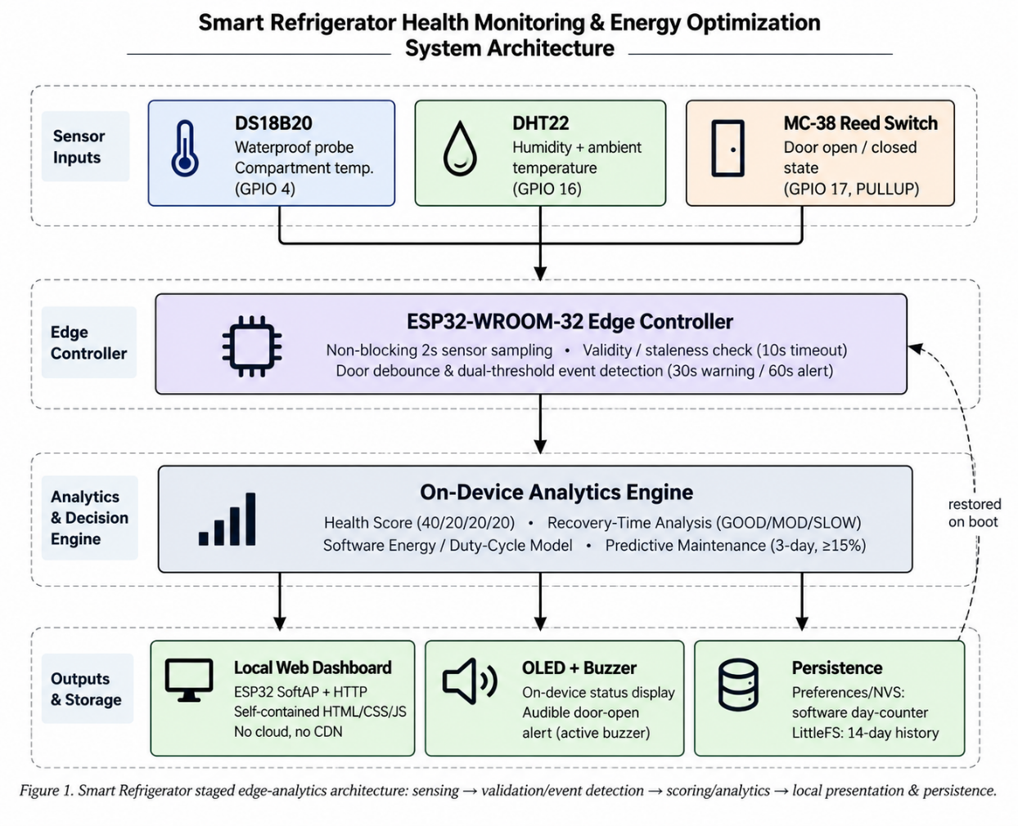
Figure 1. Smart Refrigerator staged edge-analytics architecture, including sensing → validation/event detection → scoring/analytics → local presentation and persistence.

7.2 Hardware components and pin mapping
The physical prototype employs only low-cost, swiftly available modules, with no mains-voltage switching and no connection to the compressor at any point:
Component | Function | Connection
ESP32-WROOM-32 | Edge controller; runs the WiFi Access Point and web server; runs all sensing, scoring, and persistence logic | —
DS18B20 (waterproof) | Primary compartment-temperature probe, placed inside the cold chamber | GPIO 4, 4.7 kΩ pull-up to 3V3
DHT22 / AM2302 | Humidity and secondary ambient-temperature reading, mounted outside the chamber | GPIO 16
MC-38 magnetic reed switch | Door open/closed detection | GPIO 17, INPUT_PULLUP
0.96" SSD1306 OLED (I²C) | On-device status display, namely live readings, health score, estimated kWh/day, day count | SDA = GPIO 21, SCL = GPIO 22
Active buzzer module | Audible door-open warning | GPIO 25
Breadboard and jumper wires | Prototype interconnection | Common GND
The DS18B20 is the only sensor placed inside the cold chamber, because it's the only component in the design rated for a condensing, waterproof environment; the controller, humidity sensor, buzzer, and display are all mounted outside the chamber, avoiding condensation risk with no added enclosure cost, on the whole.
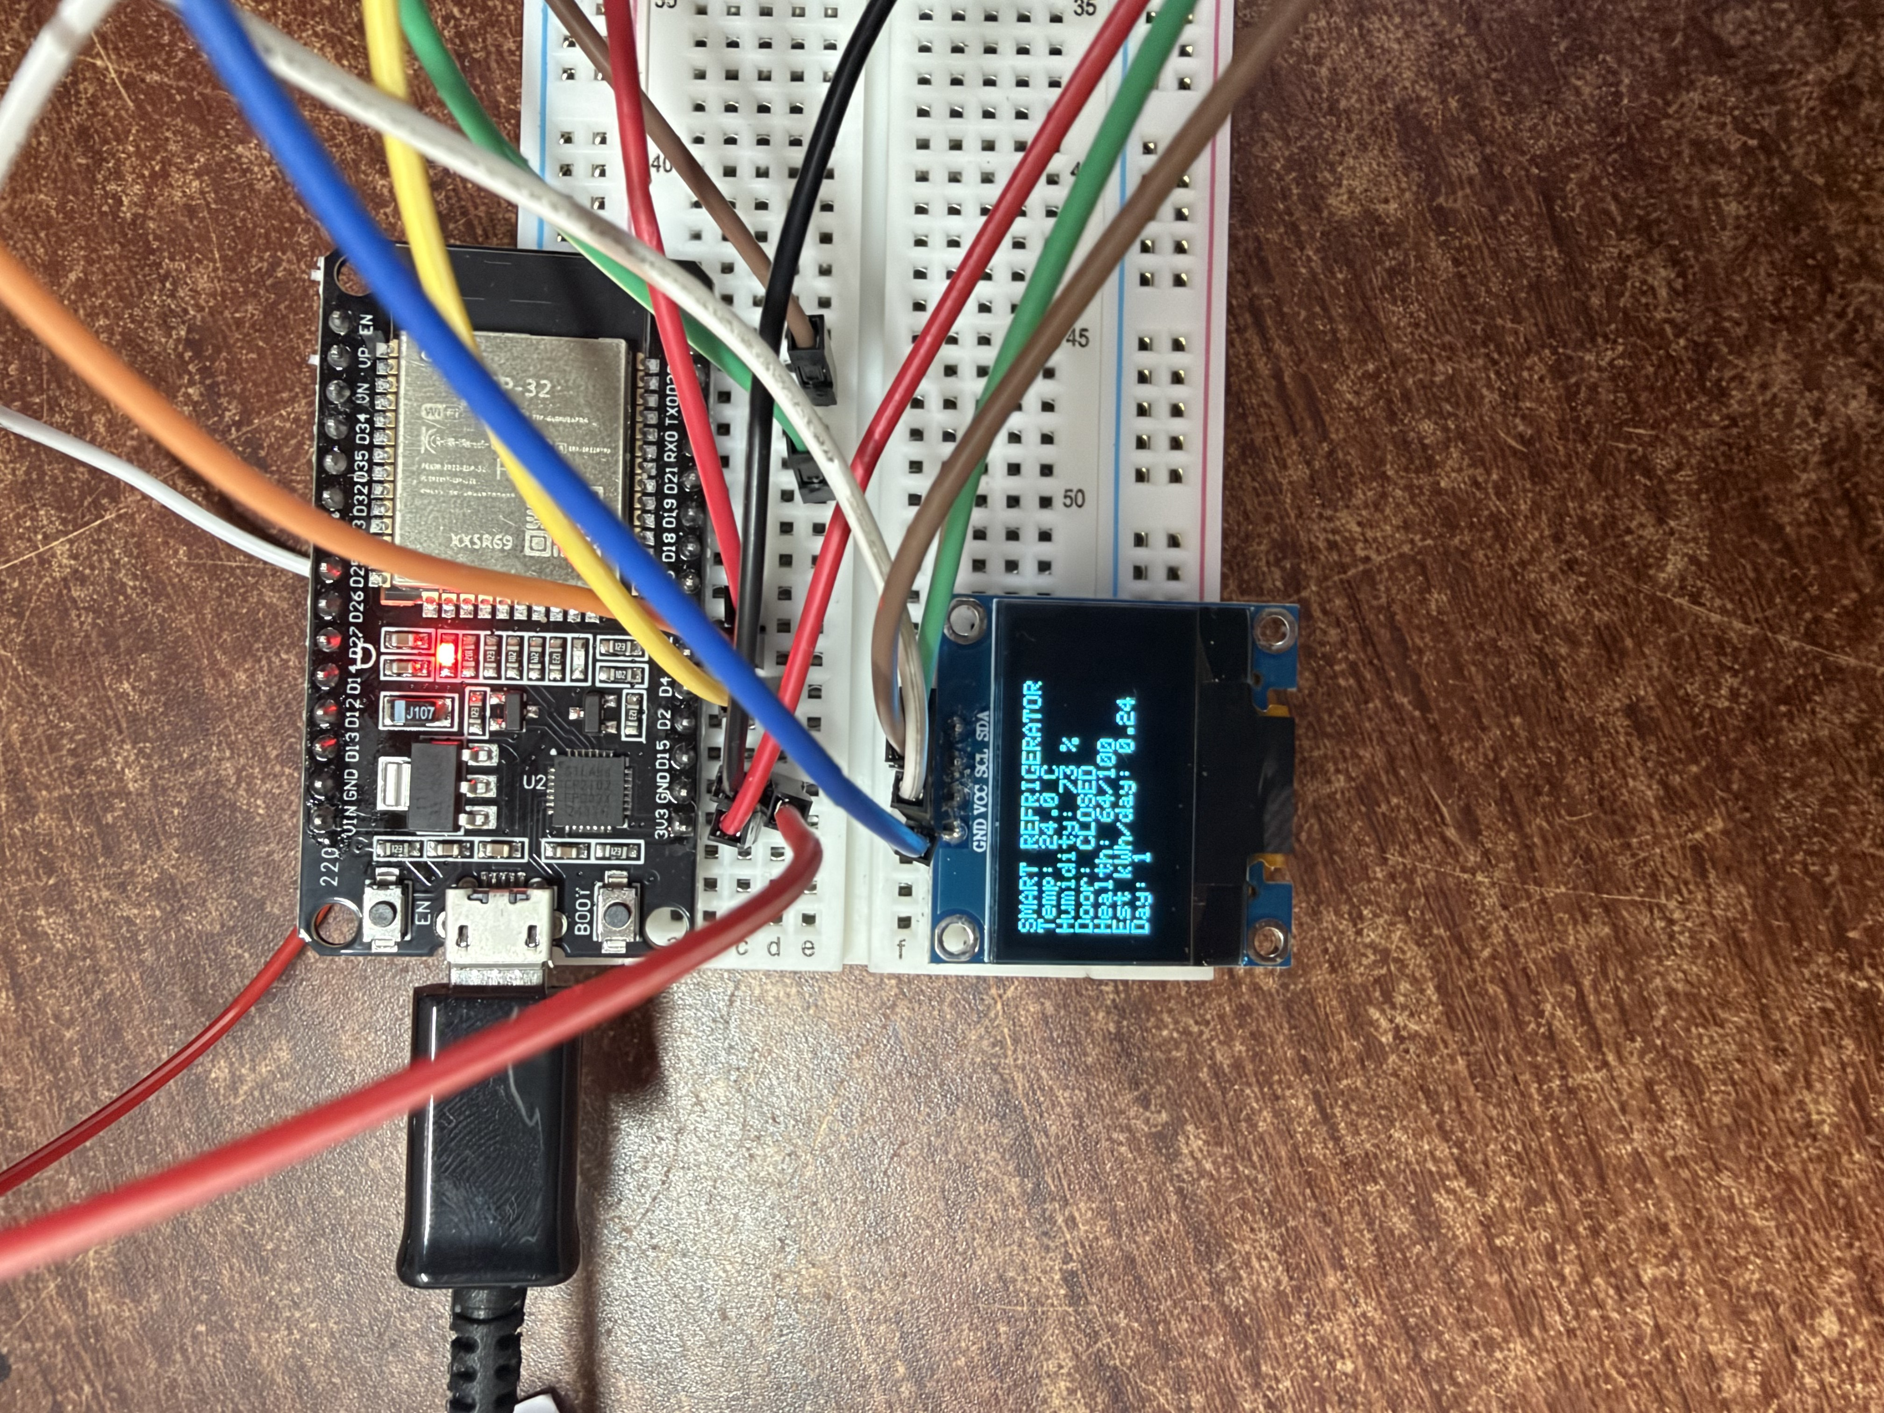
Figure 2. Complete ESP32-based prototype assembly on breadboard, showing the controller, OLED display, and sensor wiring, all things considered.
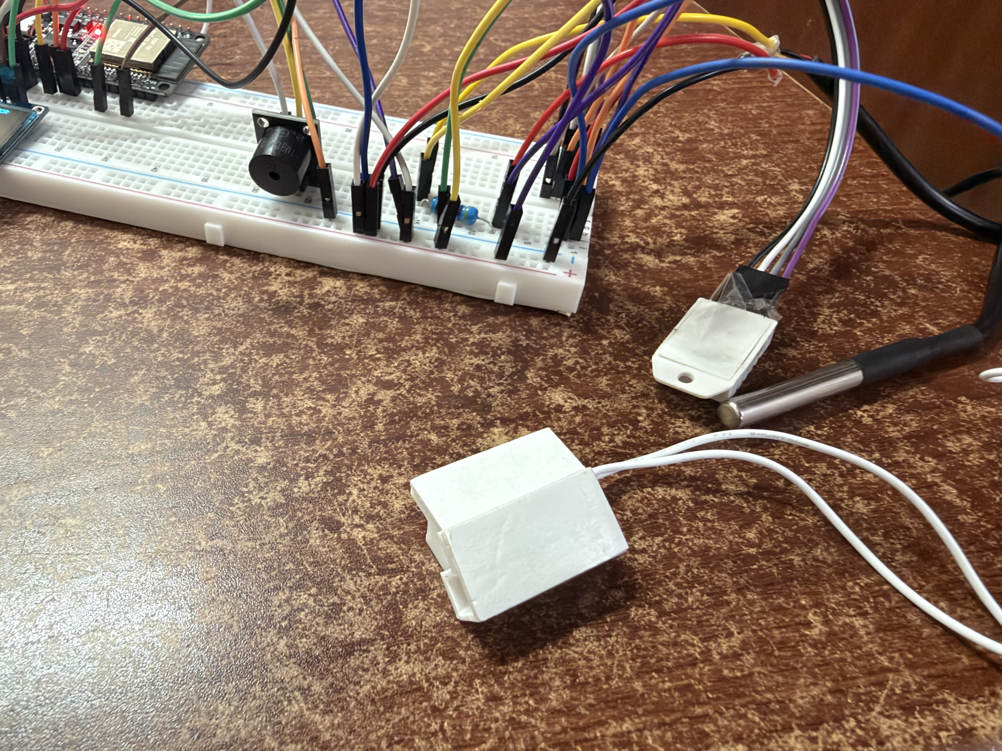
Figure 3. DS18B20 waterproof temperature probe (right) and MC-38 magnetic door reed switch (foreground), wired to the prototype, at least in principle.
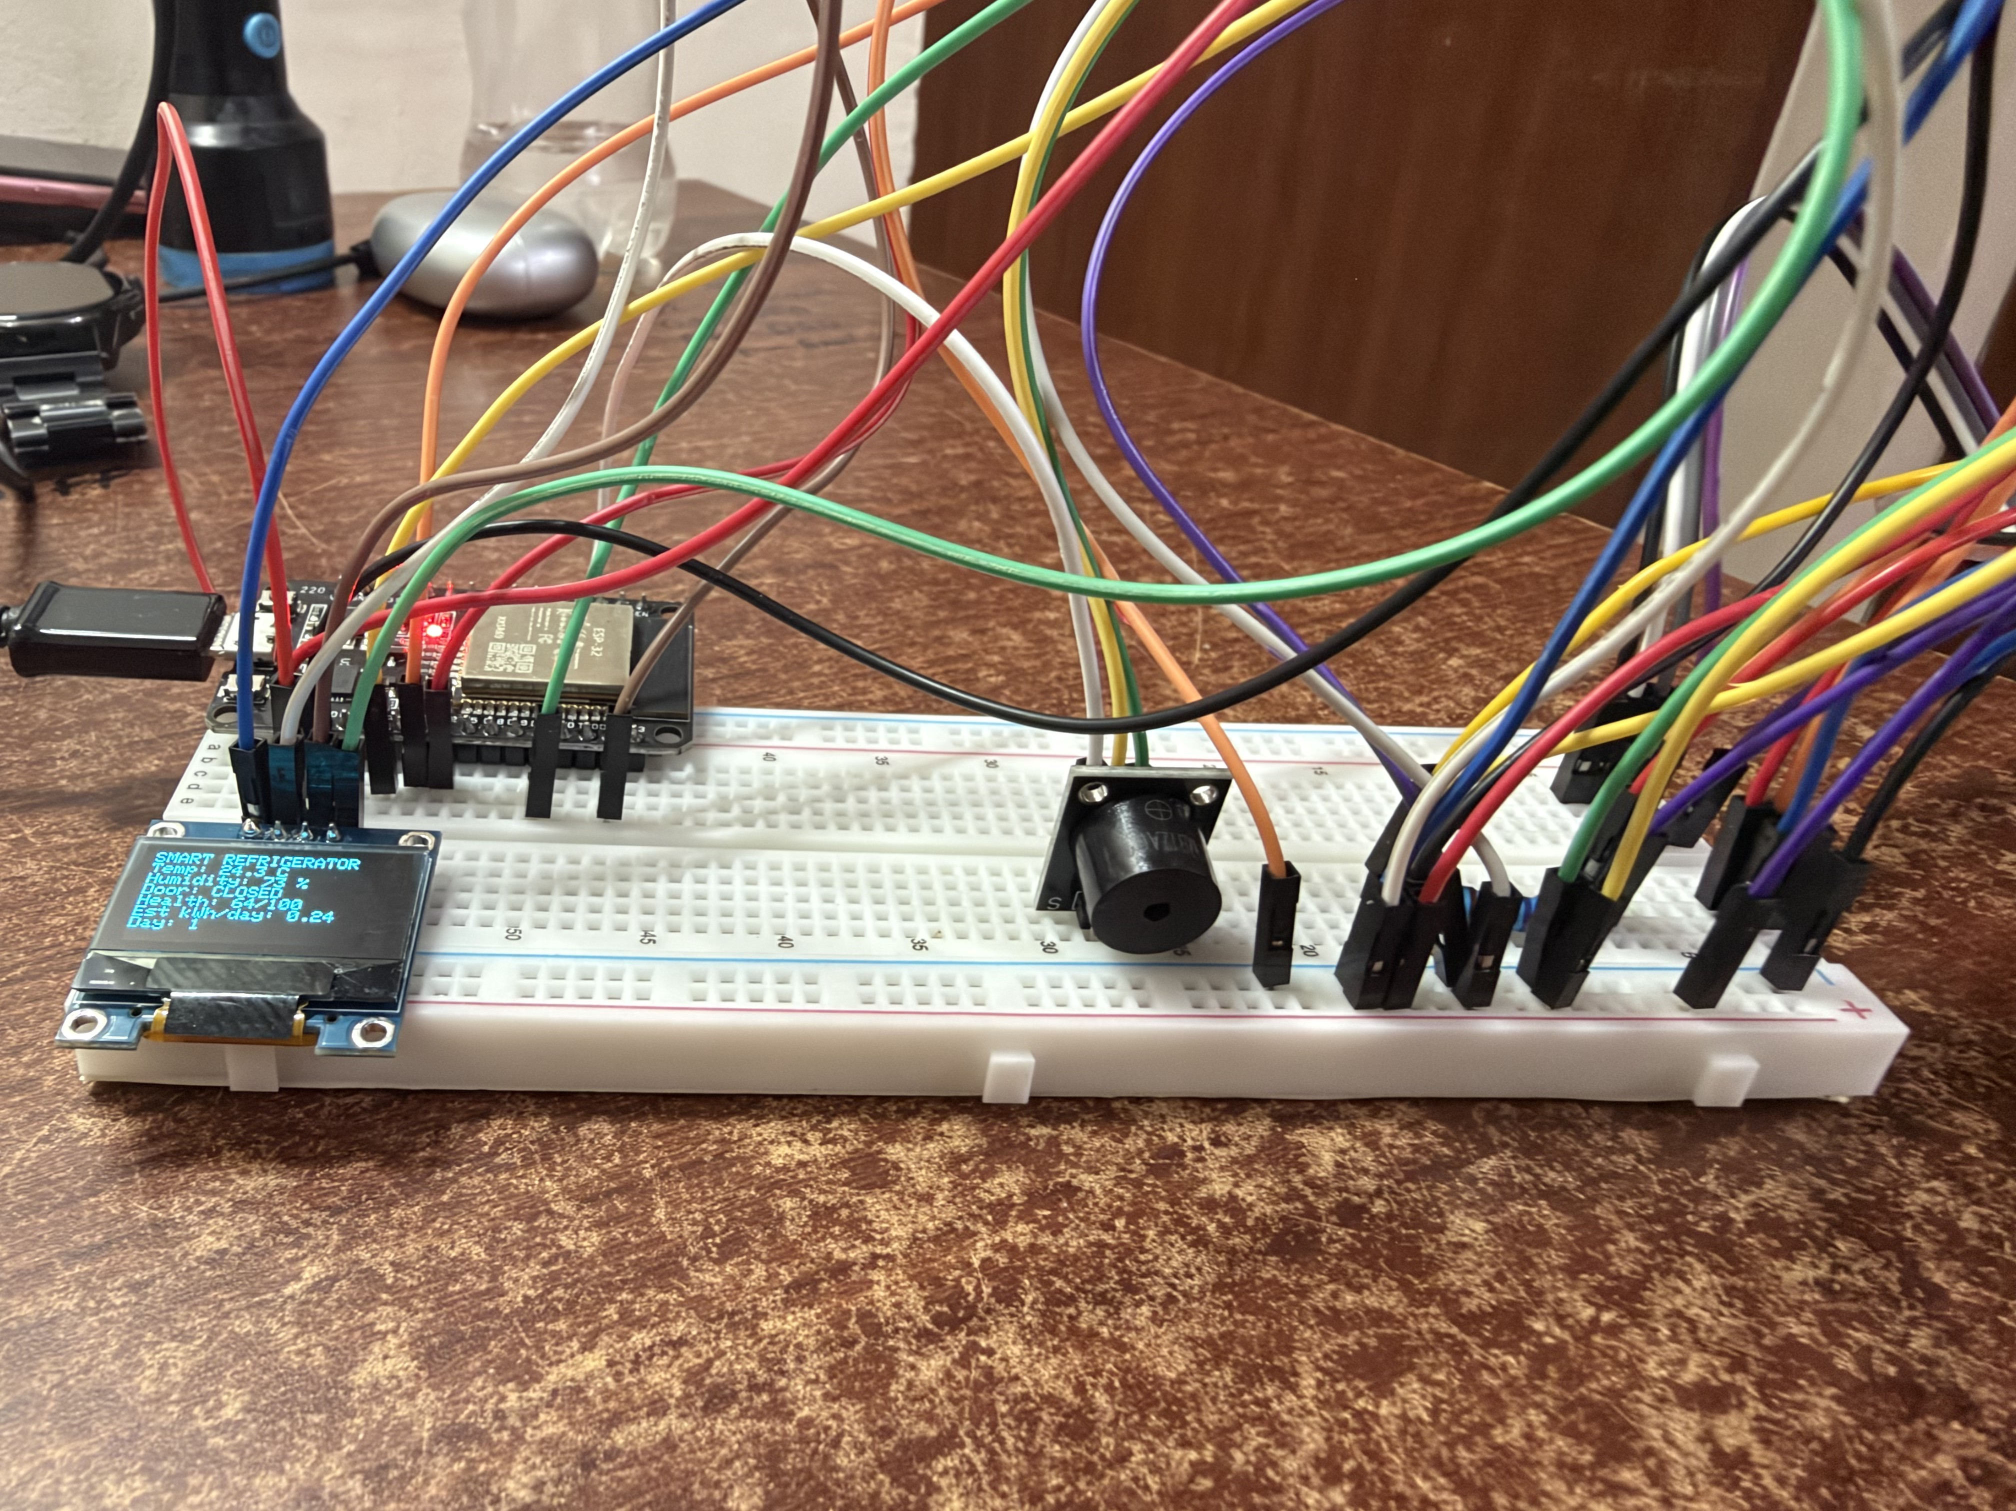
Figure 4. Active buzzer alert module combined into the prototype circuit, alongside the ESP32 and OLED, in real-world scenarios.

7.3 Sensor acquisition and validity management
The DS18B20 and DHT22 are normally sampled on a fixed, non-blocking interval. Rather than issuing a conversion request and waiting on it synchronously, which would, more precisely, stall the web server for the conversion duration probably, the controller requests a conversion and reads back the finding on the following cycle, so the control loop and the web server are currently never blocked by a sensor read, in actual application.
Each sensor reading carries an autonomous validity flag, cleared the moment a fresh value arrives and forced false if no fresh value arrives, within a fixed staleness window, on the whole. Both the OLED display and the web dashboard check this flag directly: a disconnected or failing sensor is shown as a visible warning state, not as a frozen last-good value presented as if it were current, a difference that matters, because a silently frozen reading is, in practice, indistinguishable from a healthy one until the user happens to catch the appliance's real behaviour has diverged from the display.

7.4 Door intelligence and dual-threshold alerting
Every door open-to-close-to-open transition increments a same-day opening count; so, what's more, the duration of each individual opening is timed. Two autonomous duration thresholds are employed to that timer:
- The audible buzzer is being activated by a first threshold (30 seconds) and marks the opening as "long" for the day's tally, in the main.
- A second, longer threshold (60 seconds) escalates the dashboard's door status from a warning state to an alert state, also triggering a slide-down alert banner on the dashboard, in actual application.
Door-opening events are also tallied against the hour of day in which they're arising, from which the individual busiest hour of the day is usually obtained, a secondary behavioural indicator surfaced on the dashboard without any extra hardware, in actual application.

7.5 Cooling-recovery analysis
When the door closes while the compartment temperature remains above a defined recovery threshold, a recovery timer starts; it stops the instant the temperature falls back to or below that threshold. The elapsed time is mainly graded:
Recovery time ≤ 120 s → GOOD
120 s < Recovery time ≤ 240 s → MODERATE
Recovery time > 240 s → SLOW
Every completed recovery updates the day's recovery count and cumulative recovery-time total, from which the day's average recovery time is typically obtained; this average recovery time is, as a matter of fact, the magnitude that's driving both the recovery component of the health score (Section 7.8) and the predictive-maintenance trend rule (Section 7.7), in real-world scenarios.

7.6 Software energy / duty-cycle estimation model
No current or power sensor is employed in this design; daily energy consumption is estimated from a disclosed software model, and is presented to the user clearly labelled as an estimate rather than a measurement. In plain words, three 0-100 impact scores are first computed from the day's behaviour:
TempImpact: ≤5.0°C → 0; ≤6.0°C → 15; ≤7.0°C → 30; >7.0°C → 50
DoorImpact = % of today's openings classed "long" (capped at 50)
RecoveryImpact: ≤120 s → 0; ≤240 s → 15; ≤360 s → 30; >360 s → 50
These three impacts are generally combined into an energy-waste score and inverted into an efficiency score:
EnergyWasteScore = 0.40 × TempImpact + 0.30 × DoorImpact + 0.30 × RecoveryImpact
EnergyEfficiencyScore = 100 − EnergyWasteScore
The same impacts also adjust a baseline compressor duty cycle, from which an estimated daily kWh figure is currently obtained employing a fixed reference wattage:
DutyCycle = 0.45 + adjustments for temperature band, door impact, and recovery impact (capped at 1.0)
EstimatedKWh = (ReferenceWattage × HoursElapsedToday × DutyCycle) / 1000

7.7 Predictive-maintenance trend rule
A day's average recovery time is recorded into a rolling three-slot history only on a day that actually created at least one recovery event. A day with none is skipped rather than recorded as zero, since a zero would misrepresent an absence of data as an boosting trend. Once three such valid days are available, the rule is checked:
IF recoveryDay1 < recoveryDay2 < recoveryDay3 (strictly increasing)
AND (recoveryDay3 − recoveryDay1) / recoveryDay1 ≥ 15%
And then flag “MAINTENANCE ADVISED”
This is a fixed, disclosed, deterministic rule rather than a statistical or machine-learned threshold, so the exact reason any flag is often raised is always inspectable from the three stored values alone, at least in principle.

7.8 Composite health-score calculation
The four same-day component scores, temperature stability, door behaviour, cooling recovery, and energy efficiency, are combined with a fixed, disclosed weighting into a single 0-100 health score:
HealthScore = 0.40 × TempScore + 0.20 × DoorScore + 0.20 × RecoveryScore + 0.20 × EnergyScore
All four components are computed strictly from that same day's data, never from a lifetime-cumulative total, broadly speaking, and yet, the score consistently answers one question, how did the refrigerator perform today, regardless of how long the device has been running, at least in principle.

7.9 Persistence and day-tracking without a real-time clock
Seeing as the device operates as a standalone WiFi Access Point with no internet uplink, neither a hardware real-time clock nor network time synchronisation is available or essential, in the main. In their place, the controller is sustaining a software day-counter advanced purely from elapsed on-device runtime, like once that elapsed time is reaching 24 hours' worth, a day boundary is declared, daily tallies reset, a summary record is appended to on-device flash history, and the day count advances, in the main. Completed daily summaries are separately appended, capped at a fixed number of most-recent data, to an on-device flash history file that powers the dashboard's multi-day history view; indeed, the day count, elapsed-time counter, and the three-slot recovery-time history employed for predictive maintenance are all written to flash-backed persistent storage. Plainly the same, a power loss or reset does not lose the day count or the maintenance-trend history, only short-lived in-memory buffers (the live temperature trend and activity feed) are reset, which is acceptable since those are meant to show only recent activity.

7.10 Local self-hosted dashboard
The device hosts its own WiFi Access Point; a phone or laptop connects to it directly and loads a dashboard served by the device itself at a fixed local address, with no router, internet connection, cloud account, or mobile application involved at any point, in actual application. Seeing that a WiFi Access Point client has no internet uplink, the dashboard can't and doesn't load any externally hosted script, font, or stylesheet, every visual element, covering the animated health-score indicator and the live temperature trend chart, is self-contained in the page the device serves, guaranteeing the dashboard loads over the local network with nothing to fetch from anywhere else, in many respects. And more, the connected browser polls small endpoints on a fixed interval and redraws only the changed values, without a full page reload, at least in practice.
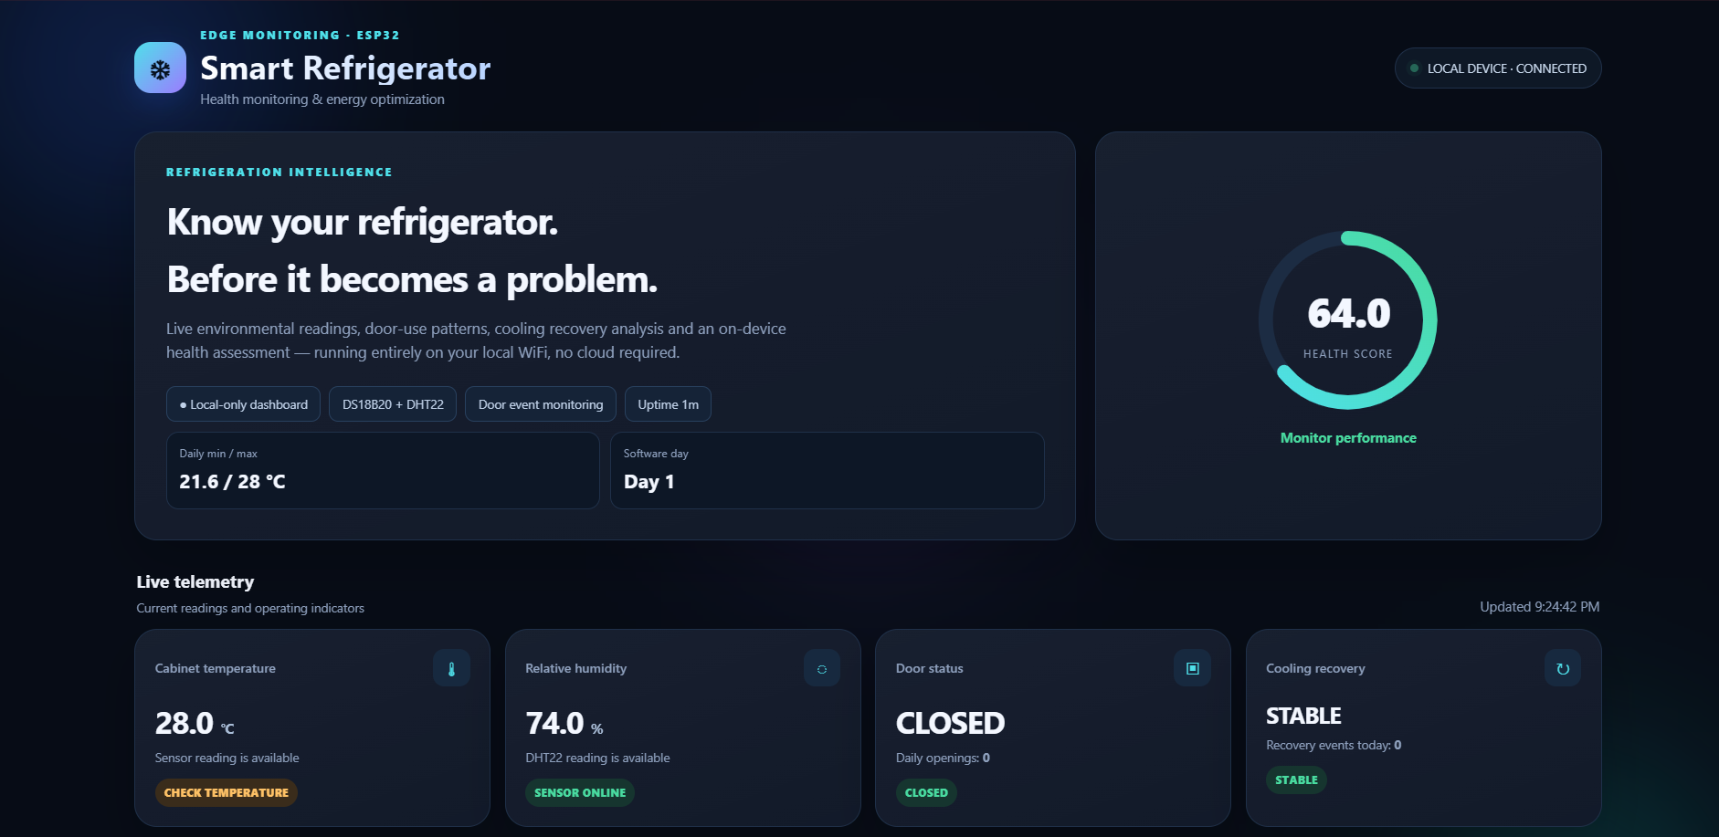
Figure 5. Live dashboard view, health-score indicator, current compartment temperature and humidity, door status, and cooling-recovery status, served directly by the device over its own WiFi Access Point, to a significant degree.
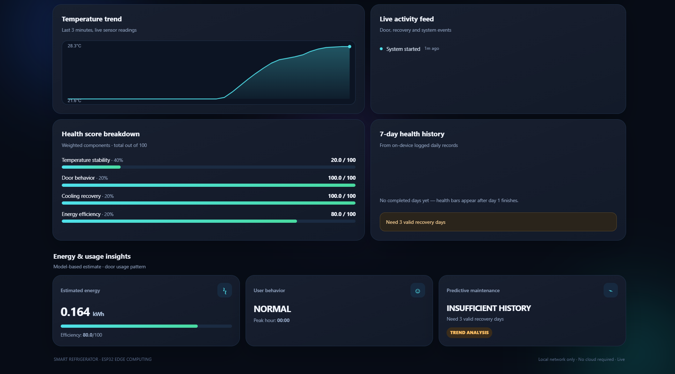
Figure 6. Live temperature trend, activity feed, health-score component breakdown, multi-day history, and energy/predictive-maintenance panels on the same self-hosted dashboard, at least in practice.

7.11 Diagnostic and alerting decision logic
The device's three output surfaces, dashboard, OLED/buzzer, and flash history, all act on the same underlying diagnostic state, summarised below:
Condition | Internal explanation | User-facing finding
Door open < 30 s | Normal | No alert; dashboard shows OPEN
Door open ≥ 30 s | Buzzer sounds; opening marked "long" | Dashboard shows WARNING
Door open ≥ 60 s | Buzzer continues | Dashboard escalates to ALERT; alert banner shown
Recovery time ≤ 120 s | Healthy recovery | Recovery status GOOD
Recovery time 120-240 s | Degraded recovery | Recovery status MODERATE
Recovery time > 240 s | Poor recovery | Recovery status SLOW
3 valid days, strictly increasing, ≥15% total rise | Trending compressor/seal degradation suspected | “MAINTENANCE ADVISED” flag; alert banner shown; activity-feed entry logged
Sensor stale > 10 s | Reading no longer trustworthy | OLED and dashboard show a sensor-warning state alternatively of the last value

7.12 Distinguishing technical mechanism
The central technical mechanism is the pairing of a deterministic, fully-disclosed scoring and trend-detection method with a hardware configuration — single microcontroller, no current sensor, no real-time clock, no cloud — that has no external dependency of any kind, at least in principle; and thus, sensed behaviour (temperature, door events, recovery time) is normally converted into the same-day composite health score, to a significant degree. And, independently, into a multi-day recovery-time trend employed purely for predictive maintenance; both computations are running on the device that sensed the data, and both are served back to the user by that same device, with no data leaving it unless the user chooses to.

8. Experimental validation results:

8.1 Firmware build validation
The complete firmware, sensing, validity/staleness handling, door and recovery intelligence, the energy model, the composite health score, the predictive-maintenance rule, flash persistence, and the self-hosted dashboard, was compiled for the ESP32 Dev Module target in the Arduino IDE and built without error.
Build parameter | Result
Target board | ESP32 Dev Module (ESP32-WROOM-32)
Compilation result | Build succeeded, zero errors
Program storage employed | 978,860 bytes (74% of available flash)
Dynamic memory employed | 47,504 bytes (14% of available RAM)

8.2 Physical hardware bench validation
The compiled firmware was flashed to a physical ESP32-WROOM-32 and run on the bench-assembled prototype shown in Figures 2-4, with the DS18B20 probe, DHT22, MC-38 reed switch, OLED and buzzer all wired and live, at least for now. Because the bench test was conducted at open-air ambient conditions rather than inside an actual refrigerator compartment, the probe read ordinary room temperature rather than a cold-chamber temperature, this is anticipated, and is exactly the kind of out-of-target reading the temperature-stability scoring (Section 7.8) is designed to score low, which the findings below verify it did correctly, at least in practice.
Within the same short interval, two autonomous user-facing surfaces, the on-device OLED and the browser-based dashboard, were read to corroborate they agree, since both are currently computed from the same underlying firmware state but rendered through the wholly separate code paths (direct frame-buffer drawing versus a served JSON endpoint and client-side JavaScript):
Parameter | OLED reading (Figure 7) | Dashboard reading
Compartment temperature | 24.4 °C | 28.0 °C (captured moments later, trending upward)
Humidity | 73 % | 74.0 %
Door status | CLOSED | CLOSED
Health score | 64 / 100 | 64.0 / 100
Estimated energy | 0.24 kWh/day | 0.164 kWh/day (captured at an earlier elapsed-time point in the same run)
Software day count | Day 1 | Day 1
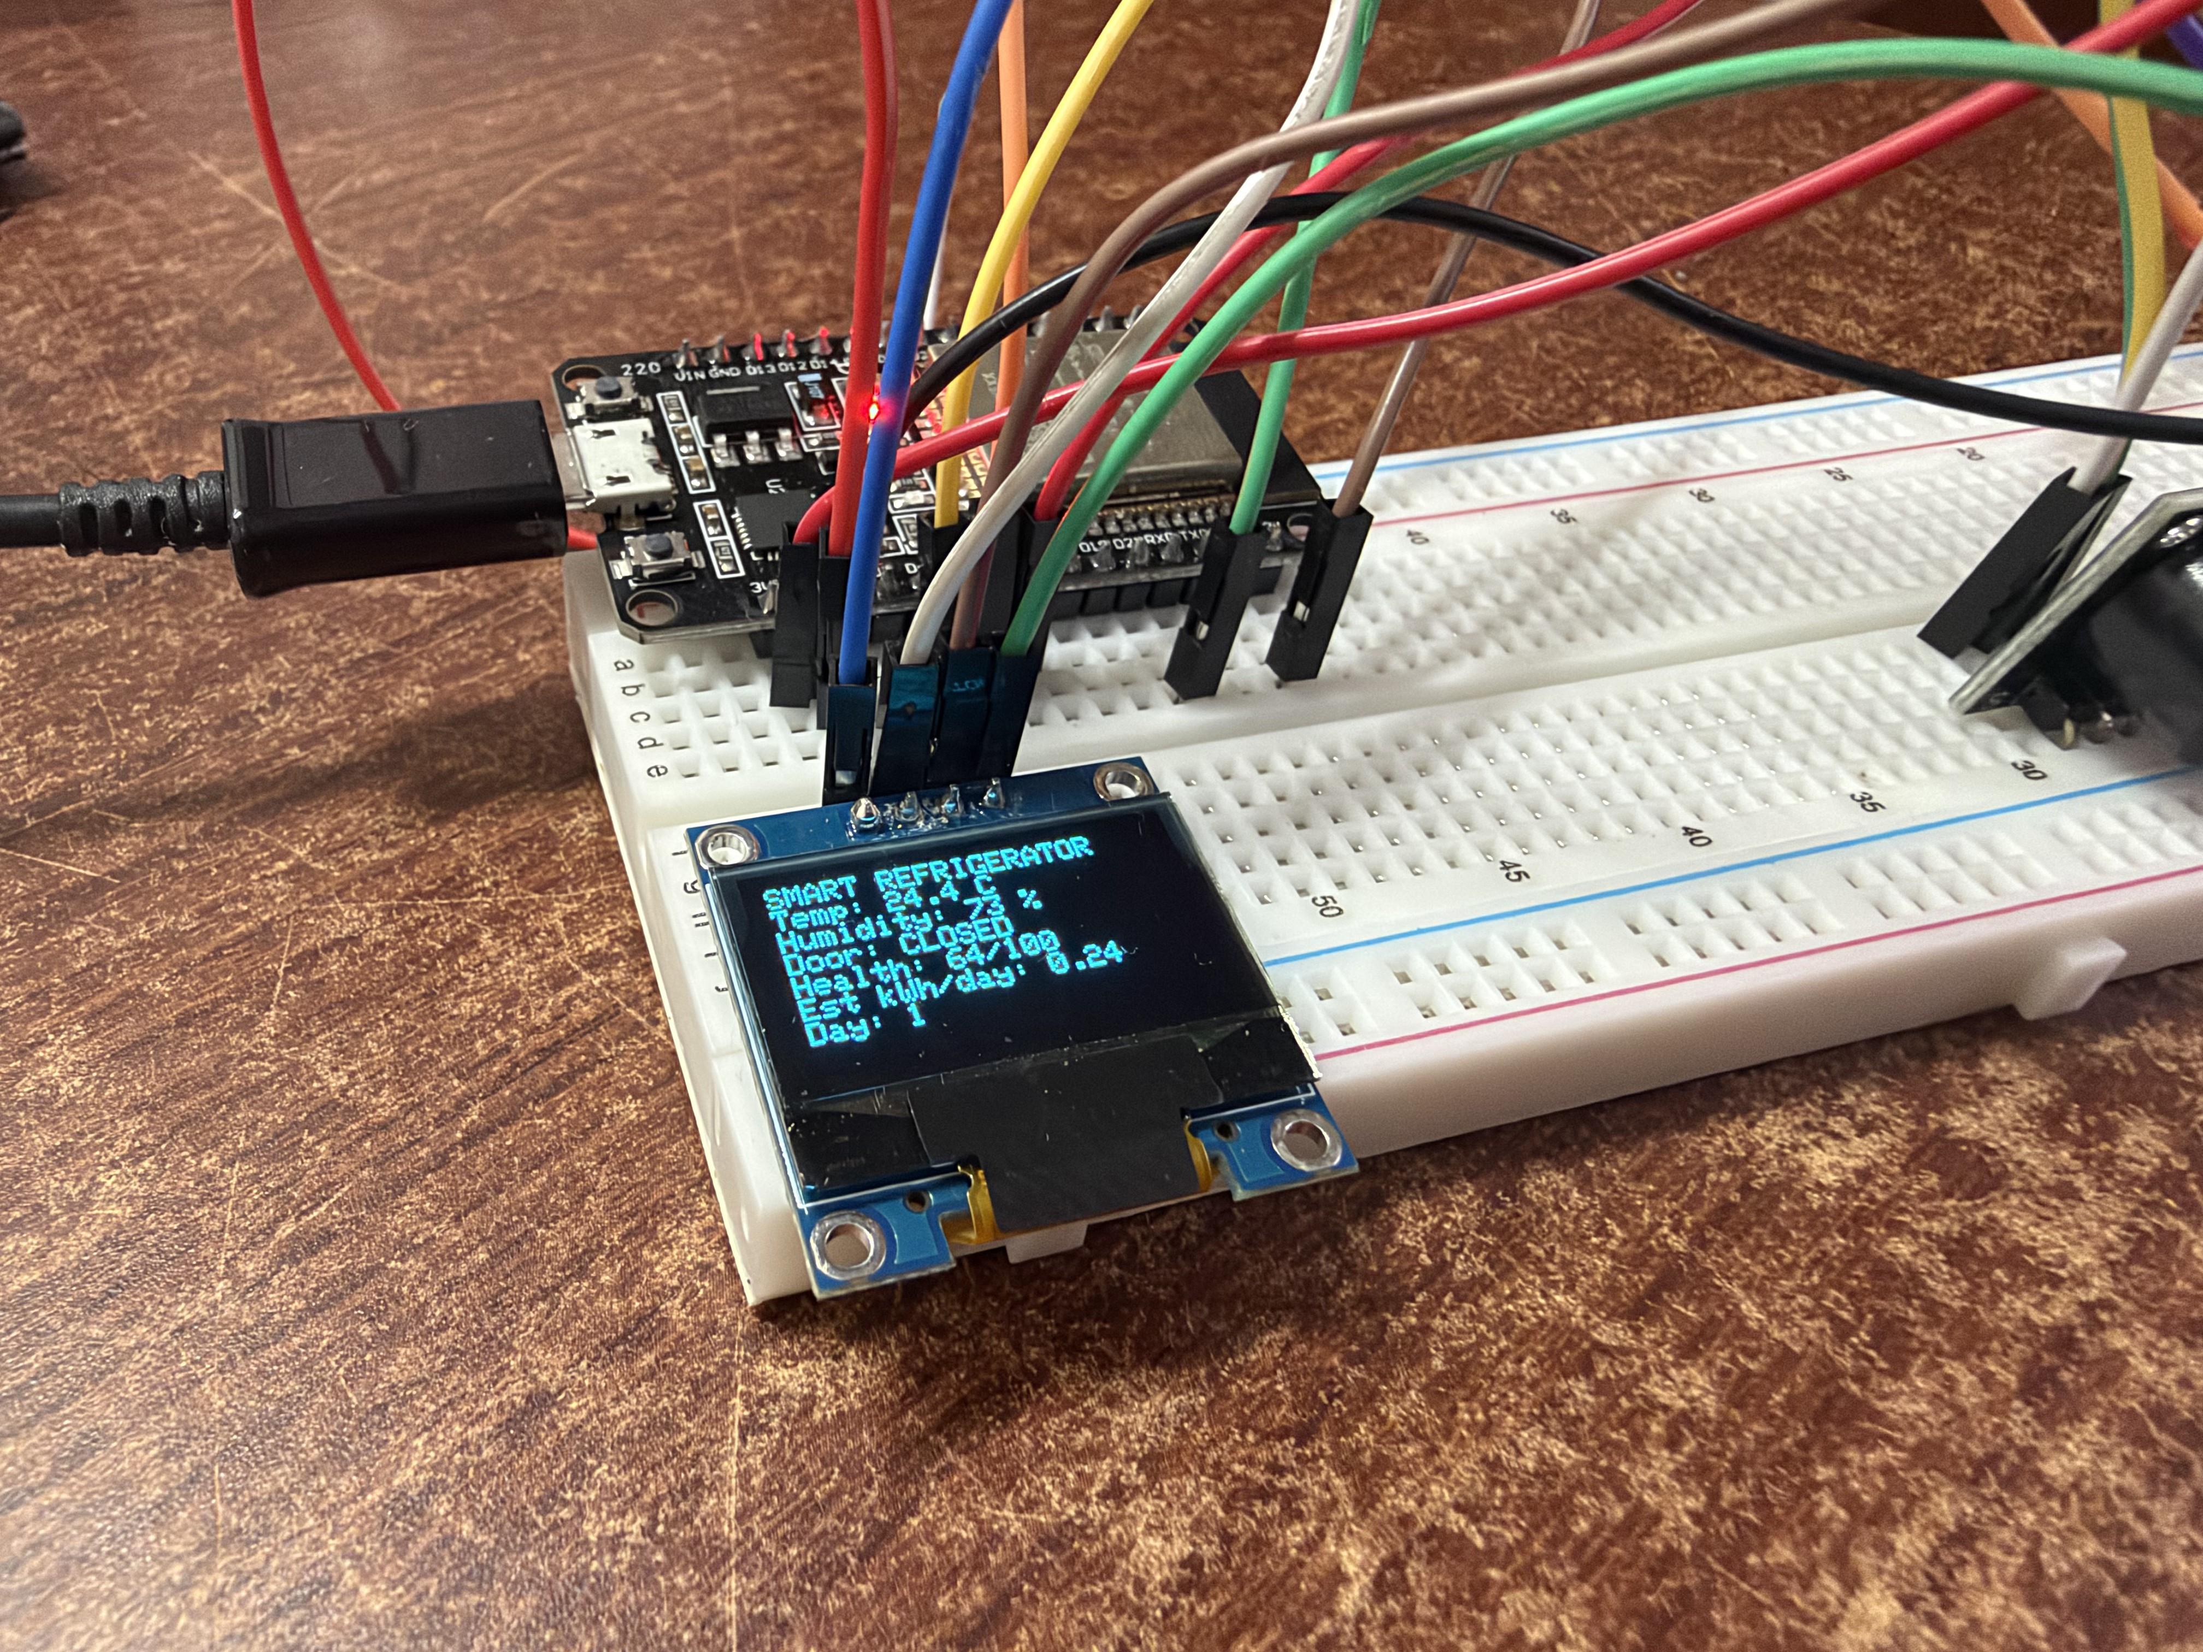
Figure 7. Close-up of the on-device OLED display during the bench trial, independently checking the live health score and estimated energy figure also shown on the dashboard, in real-world scenarios.
The health score of 64 shown by both surfaces is independently verifiable against the disclosed formula (Section 7.8) employing the dashboard's own component breakdown captured in the same session, temperature-stability 20.0/100, door-behaviour 100.0/100, cooling-recovery 100.0/100, energy-efficiency 80.0/100:
0.40 × 20.0 + 0.20 × 100.0 + 0.20 × 100.0 + 0.20 × 80.0 = 8.0 + 20.0 + 20.0 + 16.0 = 64.0
This is verifying the composite health-score calculation carrying out on the physical device matches its disclosed formula exactly, rather than only in separated software testing, in the main. The door-behaviour and cooling-recovery components both scored the maximum 100, uniform with zero door-opening events having yet arose during the short bench session; the predictive-maintenance panel correctly reported "insufficient history," since the rule in Section 7.7 is needing three valid days of recovery data and the session covered only day 1, the diagnostic logic withheld a maintenance judgement rather than guessing from insufficient data, in the main.

8.3 Combined validation conclusion
The combined evidence comprises a clean ESP32 compilation with healthy flash and RAM margin, in many respects, and a functioning physical prototype, sensors, door switch, OLED, buzzer and the self-hosted dashboard all live and in agreement, on real hardware, with the disclosed health-score formula independently verified against live device output, to a significant degree. What hasn't yet been exercised is multi-day, in-refrigerator operation, such as the predictive-maintenance rule needs three valid recovery-time days to gauge; and thus, what's more, the energy model's duty-cycle behaviour is best checked against supported cold-chamber operation rather than a short open-air bench session. Keeping this in mind, the invention is classified in this disclosure as TRL 4, Technology checked in a lab.
9. What aspect(s) of the invention need(s) protection?
Protection is sought mostly for the staged diagnostic and scoring method and the specific combination of elements that removes every external dependency, rather than for any individual commodity sensor, in real-world scenarios.
- A refrigerator-monitoring method in which a composite 0-100 health score is typically computed, wholly on a single embedded controller, from four disclosed, fixed-weight, same-day behavioural factors, like temperature stability, door behaviour, cooling-recovery time, and a software-estimated energy-efficiency factor, in real-world scenarios.
- A software duty-cycle energy-estimation method that's deriving a daily kWh figure from door-opening and cooling-recovery behaviour, needing no current or power-measurement sensor, and explicitly distinguished from a measured value, at least in principle.
- A deterministic predictive-maintenance method that flags a formulating fault when the daily-average cooling-recovery time strictly increases across the three consecutive valid days by at least a fixed percentage, where a day without a recovery event is ruled out from the trend rather than recorded as zero, to a significant degree.
- A dual-threshold door-open duration method that independently is triggering an audible local alert at a first threshold and an escalated dashboard alert state at a second, longer threshold, all things considered.
- A persistent software day-counter, advanced from elapsed on-device runtime and stored in non-volatile flash memory, employed in place of a real-time clock or network time synchronisation to mark daily boundaries and preserve state, across restarts on a device with no internet uplink, in many respects.
- A self-hosted local dashboard architecture in which the embedded controller operates its own WiFi Access Point and serves a fully self-contained web interface, with no externally hosted script, font, or stylesheet, and no cloud server, router, or mobile application, to a directly connected client device, on the whole.
- The combination of the above elements operating together on a single low-cost microcontroller with no cloud, server, current sensor, or real-time clock of any kind, at least in principle.
Core protectable relationship, including sensing same-day door, temperature and cooling-recovery behaviour; converting that behaviour into a disclosed, fixed-weight composite health score and, independently, into a multi-day recovery-time trend found by a deterministic rule for predictive maintenance; and serving both, together with a software energy estimate, through a dashboard the sensing device hosts itself, with no cloud, server, current sensor, or real-time clock anywhere in the system, at least in principle.
10. What's Technology readiness level of your invention? (Tick the suitable TRL)
Research |  |  | Development |  |  | Deployment
TRL 1 | TRL 2 | TRL 3 | TRL 4 | TRL 5 | TRL 6 | TRL 7 | TRL 8 | TRL 9
Basic Principles observed | Technology concept formulated | Experimental proof of concept | Technology validated in a lab | Technology validated in a relevant environment | Technology demonstrated in a relevant environment | System prototype demonstration in an operational environment | System complete and qualified | Actual system proven in an operational environment
 |  |  | ✓
Picked TRL, such as TRL 4, Technology checked in a lab.
----------------------END OF THE DOCUMENT-----------------------------

