|  |
| --- |
| **Program2 :** For a given set of training data examples stored in a  .CSV file, implement and demonstrate the Candidate - elimination algorithm to output a description of the set of all  Hypotheses consistent with the training examples. |

**Algorithm:**

***G*  maximally general hypotheses in H S  maximally specific hypotheses in H For each training example d=<x,c(x)> Case 1 : If d is a positive example**

*Remove from G any hypothesis that is inconsistent with d For each hypothesis s in S that is not consistent with d*

* *Remove s from S.*
* *Add to S all minimal generalizations h of s such that*
  + *h consistent with d*
  + *Some member of G is more general than h*
* *Remove from S any hypothesis that is more general than another hypothesis in S*

**Case 2: If d is a negative example**

*Remove from S any hypothesis that is inconsistent with d For each hypothesis g in G that is not consistent with d*

* *Remove g from G.*
* *Add to G all minimal specializations h of g such that*
  + *h consistent with d*
  + *Some member of S is more specific than h*
* *Remove from G any hypothesis that is less general than another hypothesis in G*

**Illustration :**

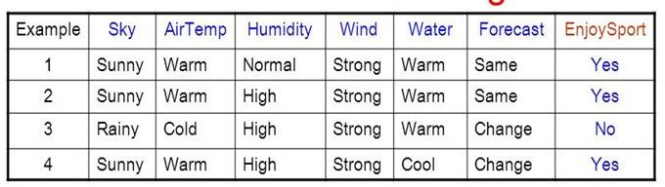

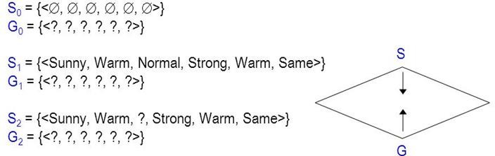

**Trace1 :**

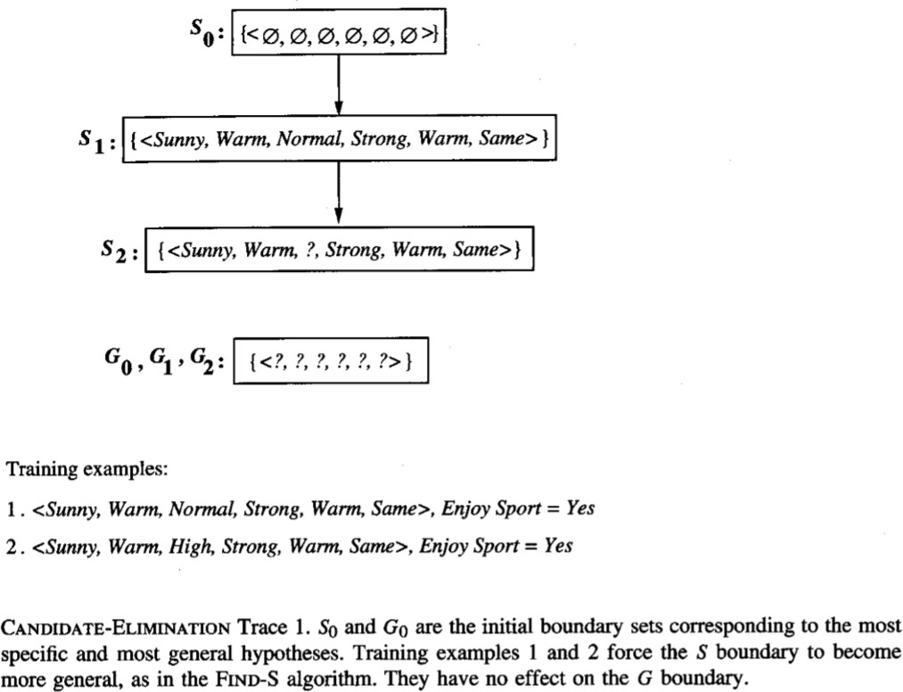

**Trace 2:**

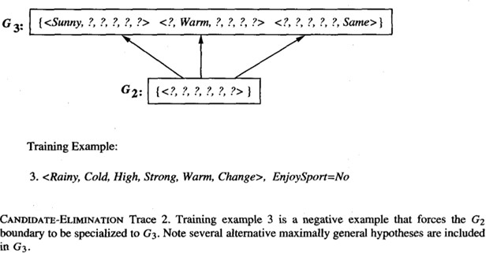

**Trace3 :**

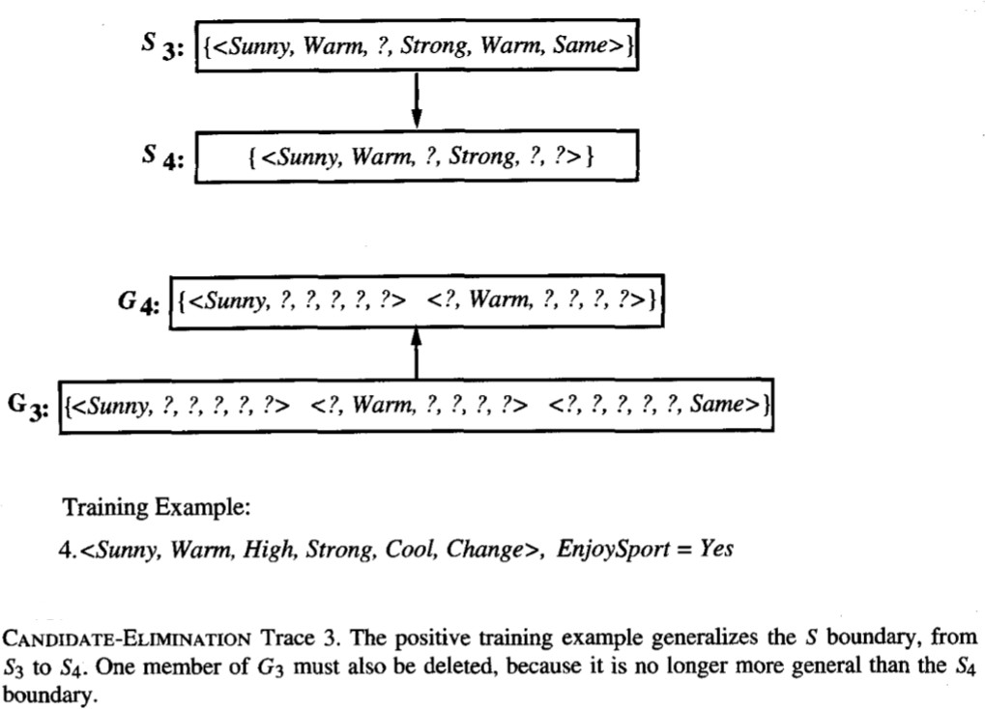

**Final Version Space:**

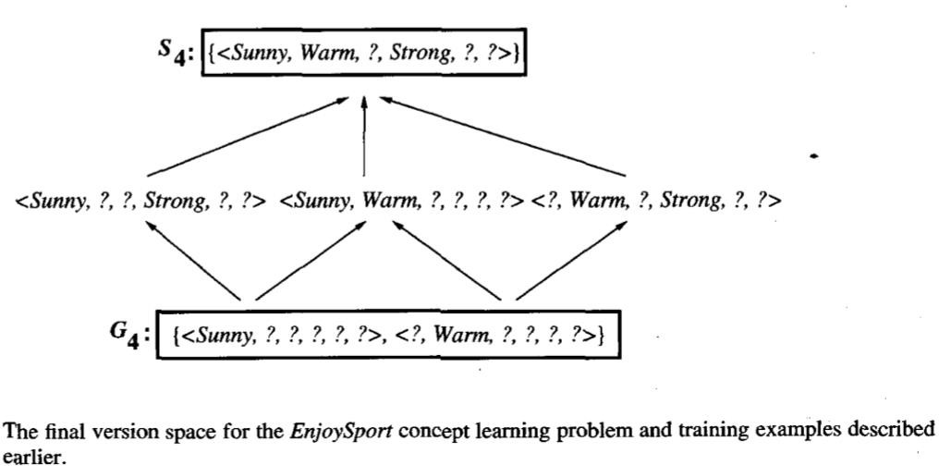

|  |
| --- |
| **Source Code :** |
| **import random import csv**  **def** g_0(n):  **return** ("?",)*n  **def** s_0(n):  **return** ('0',)*n |

|  |
| --- |
| **def** more_general(h1, h2): more_general_parts = [] **for** x, y **in** zip(h1, h2):  mg = x == "?" **or** (x != "0" **and** (x == y **or** y == "0")) more_general_parts.append(mg)  **return** all(more_general_parts)  l1 = [1, 2, 3]  l2 = [3, 4, 5] |

|  |
| --- |
| list(zip(l1, l2)) |

[(1, 3), (2, 4), (3, 5)]

|  |
| --- |
| *# min_generalizations*  **def** fulfills(example, hypothesis):  *### the implementation is the same as for hypotheses:*  **return** more_general(hypothesis, example)  **def** min_generalizations(h, x): h_new = list(h)  **for** i **in** range(len(h)):  **if not** fulfills(x[i:i+1], h[i:i+1]):  h_new[i] = '?' **if** h[i] != '0' **else** x[i]  **return** [tuple(h_new)]  min_generalizations(h=('0', '0' , 'sunny'),  x=('rainy', 'windy', 'cloudy')) |

[('rainy', 'windy', '?')]

|  |
| --- |
| **def** min_specializations(h, domains, x): results = []  **for** i **in** range(len(h)):  **if** h[i] == "?":  **for** val **in** domains[i]:  **if** x[i] != val:  h_new = h[:i] + (val,) + h[i+1:] results.append(h_new)  **elif** h[i] != "0":  h_new = h[:i] + ('0',) + h[i+1:] results.append(h_new)  **return** results |

|  |
| --- |
| min_specializations(h=('?', 'x',),  domains=[['a', 'b', 'c'], ['x', 'y']],  x=('b', 'x')) |

[('a', 'x'), ('c', 'x'), ('?', '0')]

|  |
| --- |
| **with** open('C:**\\**Desktop**\\**Data**\\**c1.csv') **as** csvFile: examples = [tuple(line) **for** line **in** csv.reader(csvFile)]  *#examples = [('sunny', 'warm', 'normal', 'strong', 'warm', 'same',True),*  *# ('sunny', 'warm', 'high', 'strong', 'warm', 'same',True),*  *# ('rainy', 'cold', 'high', 'strong', 'warm', 'change',False),*  *# ('sunny', 'warm', 'high', 'strong', 'cool', 'change',True)]* |

|  |
| --- |
| examples |

[('Sunny', 'Warm', 'Normal', 'Strong', 'Warm', 'Same', 'Y'),

('Sunny', 'Warm', 'High', 'Strong', 'Warm', 'Same', 'Y'),

('Rainy', 'Cold', 'High', 'Strong', 'Warm', 'Change', 'N'),

('Sunny', 'Warm', 'High', 'Strong', 'Cool', 'Change', 'Y')]

|  |
| --- |
| **def** get_domains(examples):  d = [set() **for** i **in** examples[0]]  **for** x **in** examples:  **for** i, xi **in** enumerate(x): d[i].add(xi)  **return** [list(sorted(x)) **for** x **in** d]  get_domains(examples) |

[['Rainy', 'Sunny'],

['Cold', 'Warm'],

['High', 'Normal'], ['Strong'], ['Cool', 'Warm'],

['Change', 'Same'],

['N', 'Y']]

|  |
| --- |
| **def** candidate_elimination(examples): domains = get_domains(examples)[:-1]  G = set([g_0(len(domains))])  S = set([s_0(len(domains))]) i=0  print("**\n** G[**{0}**]:".format(i),G)  print("**\n** S[**{0}**]:".format(i),S)  **for** xcx **in** examples: i=i+1  x, cx = xcx[:-1], xcx[-1] *# Splitting data into attributes and de*  *cisions*  **if** cx=='Y': *# x is positive example*  G = {g **for** g **in** G **if** fulfills(x, g)} S = generalize_S(x, G, S)  **else**: *# x is negative example*  S = {s **for** s **in** S **if not** fulfills(x, s)} G = specialize_G(x, domains, G, S)  print("**\n** G[**{0}**]:".format(i),G)  print("**\n** S[**{0}**]:".format(i),S)  **return** |

|  |
| --- |
| **def** generalize_S(x, G, S): S_prev = list(S)  **for** s **in** S_prev:  **if** s **not in** S:  **continue**  **if not** fulfills(x, s): S.remove(s)  Splus = min_generalizations(s, x)  *## keep only generalizations that have a counterpart in G*  S.update([h **for** h **in** Splus **if** any([more_general(g,h)  **for** g **in** G])])  *## remove hypotheses less specific than any other in S*  S.difference_update([h **for** h **in** S **if**  any([more_general(h, h1)  **for** h1 **in** S **if** h != h1])])  **return** S |

|  |
| --- |
| **def** specialize_G(x, domains, G, S): G_prev = list(G)  **for** g **in** G_prev:  **if** g **not in** G:  **continue**  **if** fulfills(x, g): G.remove(g)  Gminus = min_specializations(g, domains, x)  *## keep only specializations that have a conuterpart in S*  G.update([h **for** h **in** Gminus **if** any([more_general(h, s)  **for** s **in** S])]) *## remove hypotheses less general than any other in G* G.difference_update([h **for** h **in** G **if**  any([more_general(g1, h)  **for** g1 **in** G **if** h != g1])])  **return** G |

candidate_elimination(examples)