|  |
| --- |
| **Program3:** Write a program to demonstrate the working of the decision tree based ID3 algorithm. Use an appropriate data set for building the decision tree and apply this knowledge to classify  a new sample. |

**Algorithm :**

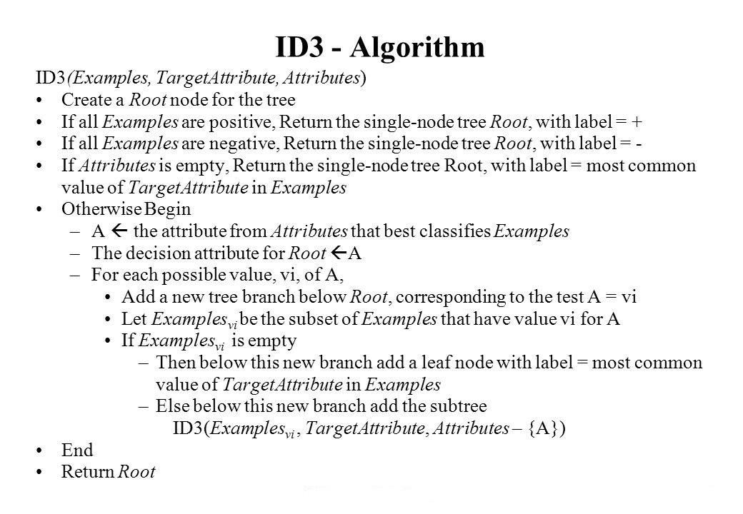

**Illustration:**

**To illustrate the operation of ID3, let’s consider the learning task represented by the below examples**

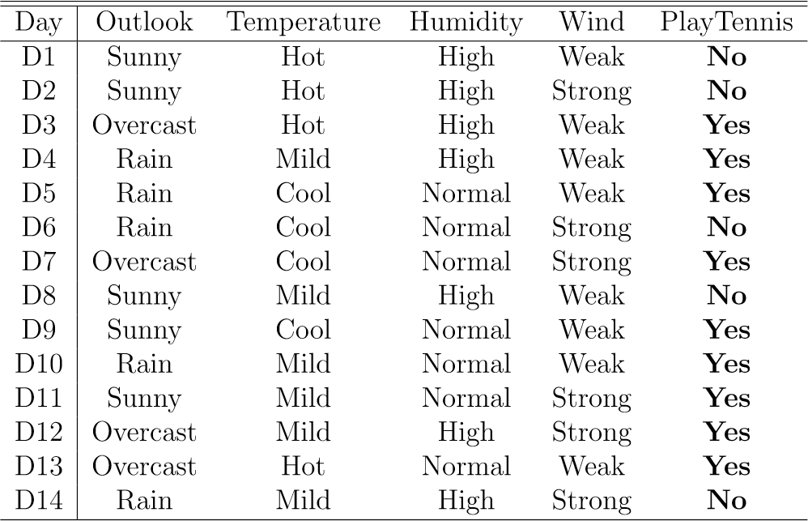

**Compute the Gain and identify which attribute is the best as illustrated below**

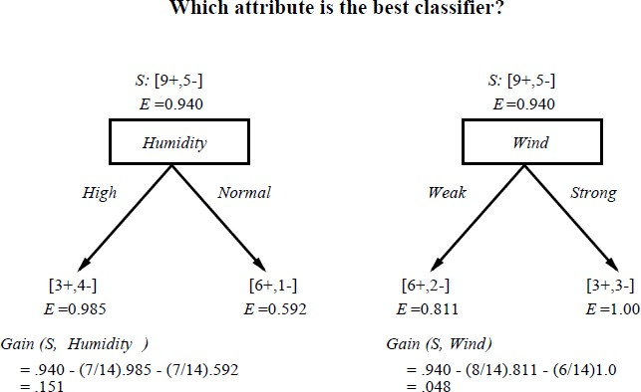

**Which attribute to test at the root?**

* **Which attribute should be tested at the root?**
  + ***Gain*(*S*, *Outlook*) = 0.246**
  + ***Gain*(*S*, *Humidity*) = 0.151**
  + ***Gain*(*S*, *Wind*) = 0.048**
  + ***Gain*(*S*, *Temperature*) = 0.029**
* ***Outlook* provides the best prediction for the target**
* **Lets grow the tree:**
  + **add to the tree a successor for each possible value of *Outlook***
  + **partition the training samples according to the value of *Outlook***

**After first step**

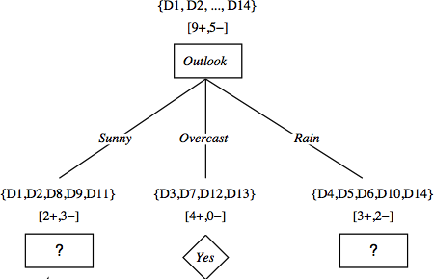

**Second step**

* **Working on *Outlook=Sunny* node:**

***Gain*(*SSunny*, *Humidity*) = 0.970  3/5  0.0  2/5  0.0 = 0.970 *Gain*(*SSunny*, *Wind*) = 0.970  2/5  1.0  3.5  0.918 = 0 .019 *Gain*(*SSunny*, *Temp.*) = 0.970  2/5  0.0  2/5  1.0  1/5  0.0 = 0.570**

* ***Humidity* provides the best prediction for the target**
* **Lets grow the tree:**
  + **add to the tree a successor for each possible value of *Humidity***
  + **partition the training samples according to the value of *Humidity***

**Second and third steps**

