Lake Darling Resort App

Senior Project

By

Kevin Justice – 108269

In partial fulfillment of the requirement for the award of BS in Mathematics Degree

Advisor: Anne Dow

June 2019 CS425 @ MUM

Table of Contents

Lake Darling Resort App………………………………………………………………………………………………………….-1-

1. Product Description………………………………………………………………………………………………………………..-3-

Vision……………………………………………………………………………………………………………………………….-3-

1. Introduction…………………………………………………………………………………………………………-3-
2. Position……………………………………………………………………………………………………………….-3-

2.1 Problem Statement…………………………………………………………………………………-3-

2.2 Product Position Statement……………………………………………………………………..-3-

3. Stakeholder Description………………………………………………………………………………………-4-

3.1 Stakeholder Summary………………………………………………………………………………-4-

3.2 User Environment…………………………………………………………………………………….-4-

4. Product Overview…………………………………………………………………………………………………-4-

4.1 Product Perspective………………………………………………………………………………….-4-

4.2 Assumptions and Dependencies……………………………………………………………….-4-

4.3 Needs and Features………………………………………………………………………………….-4-

5. Other Product Requirements…………………………………………………………………………………..-4-

B. Use Case Specification……………………………………………………………………………………………………………………….-5-

Customer/Villa/Owner CRUD…………………………………………………………………………………………………..-5-

Customer Views Available Villas……………………………………………………………………………………………….-6-

Customer Books Villa..……………………………………………………………………………………………………………..-6-

C. Class Diagram…………………………………………………………………………………………………………………………………..-7-

D. View Available Villas Sequence Diagram………………………………………………………………………………………….-8-

E. Book A Villa Sequence Diagram………………………………………………………………………………………………………..-9-

F. Architecture Analysis……………………………………………………………………………………………………………………….-10-

G. Glossary………………………………………………………………………………………………………………………………………….-11-

**Vision Document for “Lake Darling Resort”**

**Team members:**

*Kevin Justice #108269*

**1. Introduction – problem statement**

The Lake Darling Resort in Alexandria Minnesota is currently using excel spreadsheets for all record keeping, and their website has people call to make reservations. They are looking to upgrade to a database. Currently they are producing reports by hand using the excel data and word documents. They also want to upgrade the website to be able to have reservations be scheduled online and have the availability of villas online as well. Each villa sleeps either 8, 10, or 12 people and is available to rent for a minimum of 1 night. Each villa has an independent owner. The resort is managed by a property management company that handles all of the reservations.

**2. Positioning**

**2.1 Problem Statement**

|  |  |
| --- | --- |
| The problem of | *Managing the Lake Darling Resort and allowing customers to book a reservation for a villa.* |
| Affects | Villa Owners, Resort Managers, Customers |
| the impact of which is | *scheduling is complex, must be manually maintained, and requires a lot of human effort* |
| a successful solution would be | *one tool which handles reservations and integrates the*  *business rules for each villa’s availability. This tool will provide a Database and a user interface that is easy to use for resort managers and customers.* |

**2.2 Product Position Statement – possible to remove**

|  |  |
| --- | --- |
| For | Lake Darling Resort Management |
| Who | Needs an application to allow customers to rent rooms online |
| The (product name) | Web application |
| That | Is an upgrade from using excel spreadsheets with file based storage |
| Unlike | The Current Squarespace website |
| Our product | Is a custom web application with a database |

**3. Stakeholder Descriptions**

**3.1 Stakeholder Summary**

|  |  |  |
| --- | --- | --- |
| **Name** | **Description** | **Responsibilities** |
| **Admin** | **Adds new villas, owners, customers.** | **Admins are responsible for setting up system, input initial data and managing system** |
| **Owners** | **Villa owners can see when their villa is rented out** | **Villa owners can pick when they would like to stay in their villa** |
| **Customers** | **Customers can rent a villa for specific dates** | **Customers can view available villas, and view dates that are available for rental as well as the price per night. Customers can rent villas** |
|  |  |  |
| **Dev** | **Application develop will develop the Web app and the database** | **Application developer will produce a new web application with persistence in a database with reporting capabilities. Also will develop the reports so they can be generated quickly.** |
| **Tester** | **Tester will test the app and database for bugs/flaws** | **Tester will make sure the app is ready to be launched before launch.** |

**3.2 User Environment**

The user is going to be using a computer to view the website and rent villas.

**4. Product Overview**

**4.1 Product Perspective**

The product is totally independent.

**4.2 Assumptions and Dependencies**

**They have computers, people to operate them. They will have a hosted website and database.**

**4.3 Needs and Features**

|  |  |  |  |
| --- | --- | --- | --- |
| No | Problem | Need | Features |
| 1 | The resort has many customers | Customer information must be stored | Customer information will be stored in a database |
| 2 | The resort has villa for rent | A website for taking reservations | Web application listing available villas and dates/prices for each night. |
| 3. | Customers may pay online in advance of stay | Following business rules the bill needs to be generate and payment needs be accepted online | There will be a checkout on the website for scheduling and paying for a stay. |

**5. Other Product Requirements – hosted on the web**

Lake Darling Resort Use Case Description

|  |  |  |
| --- | --- | --- |
| Use Case Number: 1 | | |
| Name: Customer Profile CRUD – note this will be used for villas/owners as well | | |
| Brief Description : This use case allows admin to enter villa/owners/customers into system Customer can enter their own information | | |
| Actors | | |
| Admin – logged in  Customer – anonymous | | |
| Preconditions | | |
| The Admin must be logged in | | |
| Flow of Events | | |
| 1. Basic Flow | | |
| 1.1.0 Create Customer Profile | | |
|  | | |
| Step | User Actions | System Actions |
| 1. | The User Clicks Sign Up | The system displays a form with name, address, email, ect. |
| 2. | The User fills out the form and requests the system to save details | The system verifies that there are no other customer profiles with the same email address and generates a new customer number, then saves the Customer and returns the success message on success or a fail message in case of failure. |
| Postconditions | | |
| The Customer Profile is persisted in the system | | |
| Business Rules | | |
| No duplicate Customer profiles. A unique profile is identified by customer number or email address. | | |
|  | | |
| 1.1.1 Read/View Customer Profile | | |
| Step | User Actions | System Actions |
| 1. | The admin selects to view a list of customers | The system returns a list of all customers. |
|  | | |
| 1.1.2 Update Customer Profile – Note: Not Implemented Yet | | |
| Step | User Action | System Action |
| 1. | The admin selects to view a list of Customers | The system returns a list of all customers |
| 2. | The admin selects a customer from the list and selects update a profile | The system displays a form for updating a customer’s information with prefilled fields with the particular customers information. |
| 3. | The Admin edits fields and selects save profile | The system updates the record and returns the success message or a fail message on exception. |
| Use Case Number: 2 | | |
| Name: Customer Views Villa Availability | | |
| Brief Description : Customer uses Website to Rent Room | | |
| Actors | | |
| Customer | | |
| Preconditions | | |
| None | | |
| Flow of Events | | |
| 1. Basic Flow | | |
| 1.1.0 Customer rents room | | |
|  | | |
| Step | User Actions | System Actions |
| 1. | Customer selects view available villas | The system displays a form with a date picker for start date and end date |
| 2. | Customer selects dates to rent and clicks check availability | The system displays a list of villas available for tent on those dates |
| Postconditions | | |
| The Rental information, customer information, payment are persisted in the database | | |
| Business Rules | | |
| No villa can be rented twice in the same day. | | |
|  | | |
|  | | |
| Use Case Number: 3 | | |
| Name: Customer Rents Room | | |
| Brief Description : Customer Uses Website To Rent A Room | | |
| Actors | | |
| Admin | | |
| Preconditions | | |
| Customer Is Logged In | | |
| Flow of Events | | |
| 1. Basic Flow | | |
| 1.1.0 Customer Rents Room | | |
| Step | User Actions | System Actions |
| 1. | Customer Clicks Book Now | System returns a form with date pickers and a selector for number of beds |
| 2. | Customer selects dates and number of beds, then clicks check availability and checkout | The system displays a form with the dates, total price, and field for credit card info. |
| 3. | Customer clicks checkout | System displays success page |
| Post Condition: Reservation information is persisted in database | | |
| Business Rules: No Villa can be rented twice on the same day by different customers | | |

Class Diagram

View Available Villas Sequence Diagram

Book A Villa Sequence Diagram

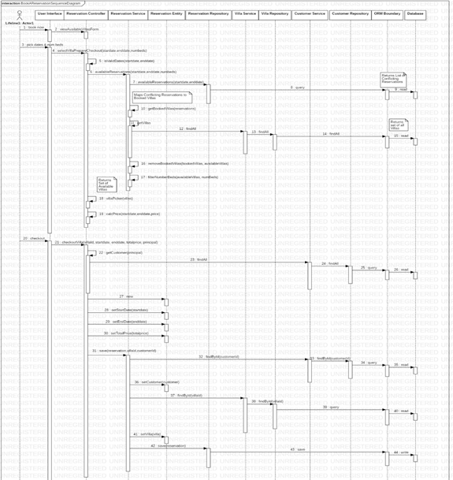

Architecture Analysis

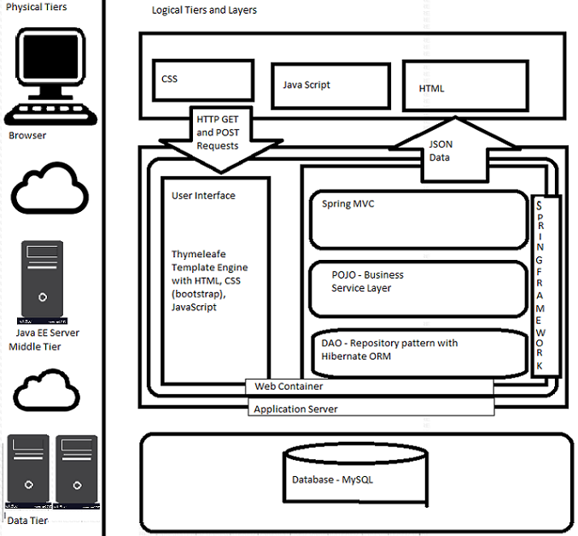

Glossary of Terms

Customer – The User of the system to rent rooms, Customers can also be admins.

Villa – The building for rent by the resort.

Reservation – Record of a Customer Staying at a Villa for at least 1 day.