Lab 6 Introduction to PCB Design
This laboratory assignment accompanies the book, Embedded Systems: Real-Time Interfacing to ARM Cortex M Microcontrollers, ISBN-13: 978-1463590154, by Jonathan W. Valvano, copyright © 2017.

Goals • PCB Layout,
• Systems level approach to embedded system design,
- Mechanical considerations,
- Available of parts (second source),
- Cost considerations,
- Power considerations,
• Design for Test.

Review • Data sheets for the TM4C123GH6PM microcontroller (review layout for 64 pin LQFP),
• http://users.ece.utexas.edu/~valvano/EE345L/Labs/Fall2011/PCBArtistLibraryTutorial.pdf,
• Design Process in Section 1.3 of the book, see https://youtu.be/wn426eLLYbk
Starter files at http://users.ece.utexas.edu/~valvano/arm/lectures2.html
PCBArtistLibrary.zip, Lab7_TM4C123Starter.sch, Lab7_TM4C123Starter.pcb, and Lab8BOM.xls

Note: do not use any starter files with 2016 or earlier dates.

Boxes http://users.ece.utexas.edu/~valvano/HowToDesignEnclosureMakerspace.htm
The starter file Lab7_TM4C123Starter.pcb will fit nicely into Lab9Box.pcb, WoodBox.pcb and WoodBox2.pcb

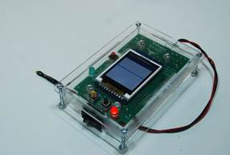
Figure 6.1. PCB inside Lab9Box.pcb

Background
The objective of this lab is to perform a PCB layout for an embedded system. In particular, you are asked to create a PCB layout for: Lab 3 Alarm Clock or Lab 5 Music Player. Regardless of which lab you choose, include the ST7735 LCD, and create a plan that places the PCB and LCD into the same box without a cable. In Labs 8, 9 and 11, you will design, build, and test a real PCB, but in this lab, you will just create the design with a cardboard mockup without actually buying or soldering the PCB. Considering the design cycle presented in Section 1.3 of the book, one starts by analyzing a problem, and then one generates a requirements document describing what the system must do. The output of the analysis phase is a list of specifications and constraints. Labs 3 and 5 involved requirements documents. The Preparation and Procedure sections of lab assignments address the design and implementation phases of the project (e.g., data flow graphs and call graphs are design steps). The lab assignment and your solution to it, which includes the initial design, an implementation on a breadboard system, and hardware/software testing, represents one pass through the design cycle in Figure 6.2.

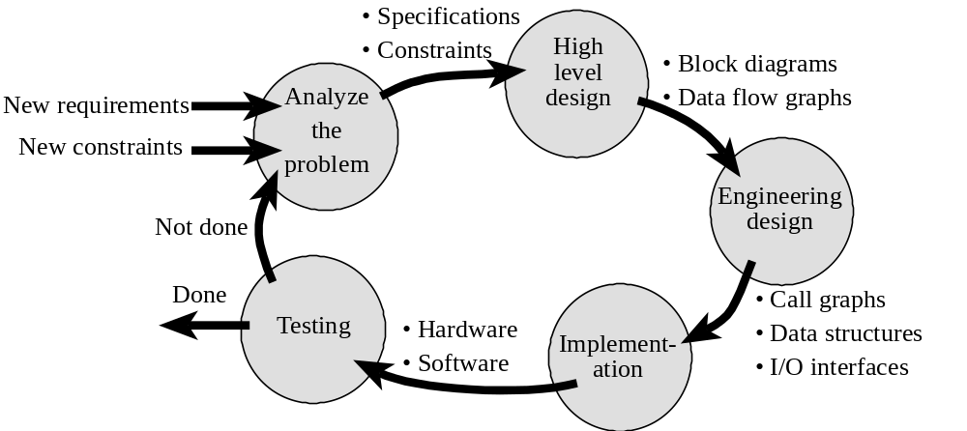
Figure 6.2. Product development cycle.

This lab does not have a separate requirements document. Rather, using a requirements document generated as part of Lab 3 or 5 (one lab, not both), you will begin to implement a PCB version of the system. As you know, commercial products are not manufactured using solder-less breadboards like the ones we use in EE319K and EE445L. Furthermore, commercial products do not include microcontroller boards like the TM4C123 LaunchPad. Implementing the embedded system on a PCB, which includes both the microcontroller and the external circuitry, will improve maintainability, testability and reliability. It will also reduce the size, weight and cost of the system. In this lab, we will also consider power. The following requirements are added to the design

The system will be controlled by the 64-pin LQFP TM4C123GH6PM
All electronic components must be soldered to a single PCB board (switches may be off board).
You must hand place and hand route the PCB (you cannot use Autoplace or Autoroute features)
The system must fit neatly into a box (your choice of the box)
The system will be battery powered, run for 24 hours, and the battery must also be in the box.

There are no specific desires in this lab to minimize size, weight, cost, or power. On the other hand, you will be asked to estimate these parameters in your system. There are three considerations when designing a power efficient system. First, we need to make a Power Budget. This means we determine the maximum amount of power that can be supported by the power source. Second, we need to identify and analyze required system tasks. This means we determine the tasks that need to be performed by the system and estimate the power required to perform these tasks. It is important to consider timing of the tasks and synchronization to I/O events. For example, executing about once a second (e.g., smoke detector checking for fires) will require less power than executing exactly once a second (digital watch). One way the TI MSP430 family achieves very low power is it can run with no crystal oscillator, and the rate at which the microcontroller runs can only be approximately set. For example, the 40-pin MSP430F2274 running at 1 MHz requires only 400 μA of supply current, whereas a Cortex M requires 10 to 100 times more current. The third consideration is to develop a power strategy. Having a strategy for power helps the power needed to perform the required system tasks to fit within the power budget. A Power Budget is a first order calculation that gives you a ballpark figure of the “total average current” supported by your power source. From the system specifications we are given how long the system must operate without replacing batteries, tlife in hours (tlife is 24 hours in this lab). From the battery datasheet we determine the storage capacity of the battery, E in mA-hours. Be aware, however, that for many batteries the storage capacity depends also on current, time and temperature. The power budget is

Average Current must be less than E/tlife

The system has functionality to handle the crystal, reset, power, logic analyzer test header, and JTAG interface. Both Lab 3 and Lab 5 (clock, motor and audio player) could run off a 4.8V NiMH battery plus 3.3 V regulator. Lab 3 could also run off a 3.7V Li-Ion battery with 3.3V regulator. We expect most EE445L students to power their system with one battery and a 3.3V regulator, but you are free to design the system at any voltage that works. You can use the LP2950 if your current is less than 100 mA and use the LM2937 if the current is between 100 and 500 mA.

Preparation (do this before your lab period)
1. Choose Lab 3 or Lab 5 to design your PCB. You are free to use any microcontroller you want, however we expect most EE445L students will choose the TM4C123GH6PM in a 64-pin LQFP package. If you want to choose a different microcontroller than this, please get approval from your TA. You will find the TM4C123GH6PM chip in the EE345L library for PCB Artist. The specific part number most students will use is the TM4C123GH6PM. As an option for Labs 8, 9 and 11, we have TM4C123GH6PM parts to solder onto your PCB. You will begin by downloading the Lab7_TM4C123Starter.sch and Lab7_TM4C123Starter.pcb files, changing the file names, changing it to Lab6, and adding your names, e.g., Lab6_Valvano_Bard. The SCH and PCB files are connected, so they need the same name, but different extensions. Next, open the Lab 3/Lab5 solution and select all the external circuits, and paste them into your Lab 6 SCH file. At this point there are two TM4C123s (LaunchPad and the 64-pin LQFP package). Next you connect all I/O pins to the 64-pin LQFP package from the Lab 6/7 starter file. You must connect the I/O pins to reestablish the functionality of the lab. Then, you delete the LaunchPad TM4C123 component and clean it up so it is pretty. Pay careful attention that all the +3.3V connections are one net, and all the ground connections are one net. You may add other hardware beyond what was needed for the lab if you choose, but it is not necessary to add more I/O functionality. Remember Labs 6, 7, 8, and 11 are not built with the LaunchPad, so you will have to add switches and LEDs as needed for input and output. For switches on the PCB, use part B4F-1050 or KSC353JLFG. For off board switches, use the part OffBoardSwitch. There are three low current LEDs that can be interfaced to the microcontroller with just one resistor, part LEDT1.75. Watch this 12 minute movie; it will demonstrate how to do the Lab 6 preparation
https://youtu.be/wn426eLLYbk
In the video, I should have added 10uF tantalum caps from +7.4V to ground and from 3.3V to ground at the regulator. I could have also added switches to PF4 and PF0 to allow user to adjust the motor set-point.

2. As part of Labs 3 and 5, you measured the supply current required to run your system. Choose a battery that will power your system for a reasonable amount of time. For example, if your system draws 50 mA, then a 1200 mAh battery will operate 24 hours between charges. The 24-hour is not a hard requirement. Go to a battery manufacturer (like http://www.tenergybattery.com/) and select a Li-ion or Li-poly battery pack to run your system. You will need to know its dimensions, weight, cost, and energy storage capacity. To get the price, you can search a retailer (like http://www.batteryspace.com http://www.batteryjunction.com) or a search engine like Google. It is not necessary, but just for fun, look at Figure 1 of the data sheet for the MAX1873; it shows a charging circuit that would allow you to charge your Li-ion battery. If you were to place this circuit on your PCB, then you could simply plug your system into a charging station without needing to disconnect the battery from the box. Lab 6 does not require an on-board charging circuit. You are allowed to power your system with a 5V cell-phone battery charging system like
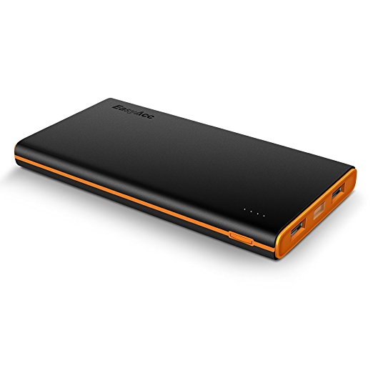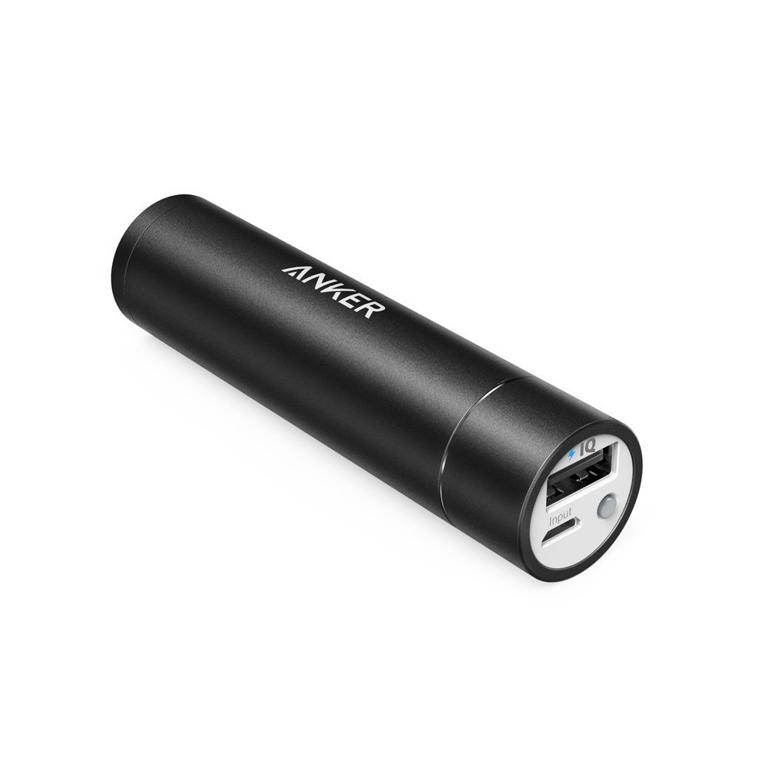

3. Decide on the PCB size you need to hold all the components, see Figure 6.3. Choose a box in which to enclose the system. Go to a box manufacturer (like http://www.pactecenclosures.com/ or http://www.serpac.com/) and select a box for your system. There are lots of Pactec and Serpac boxes in the lab if you want to see what they look like. You will need to know the box dimensions and cost. The starter files are configured for Lab9Box.pcb see
http://users.ece.utexas.edu/~valvano/HowToDesignEnclosureMakerspace.htm

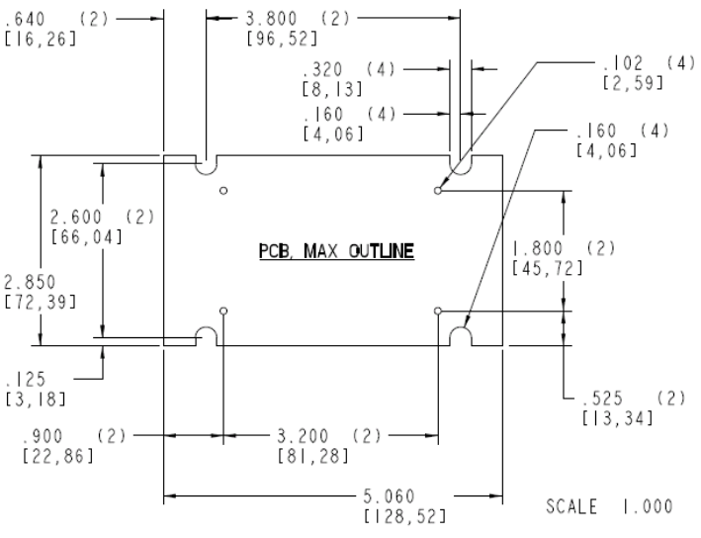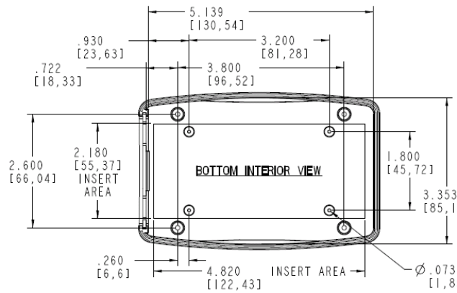
Figure 6.3a. Mechanical drawings for the Pactec XP enclosure.
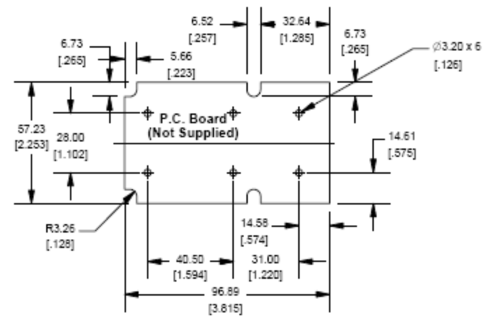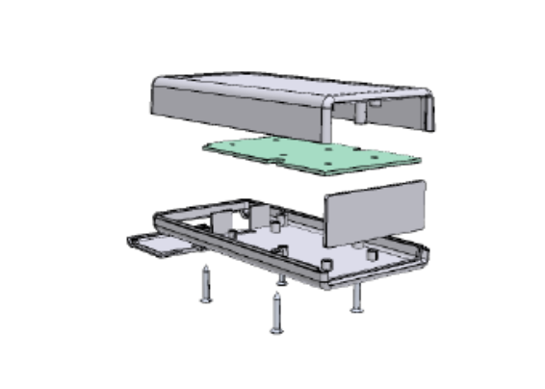
Figure 6.3b. Mechanical drawings for the Hammond 1593Y enclosure.

You may want to choose a bigger or prettier box. There is no specific requirement in this lab to minimize cost or size. A bigger box will handle a bigger PCB, making layout simpler. To get the price, you can search a parts distributor (like www.jameco.com www.mouse.com www.newark.com or http://www.digikey.com/) or a parts search engine like http://octopart.com/. In particular, you will need layout dimensions for placing a PCB board into the box, like Figure 6.3. Remember to leave room for the battery. All systems have operator buttons, which can be placed either on the box with cables onto the PCB (for $2 each), or soldered directly on the PCB (for no additional cost), but positioned so the buttons protrude outside the box. Lab 6 must include the LCD, the LCD needs to protrude out the top of the box and be plugged into a 10-pin header (ST7735) on the PCB without needing a cable (using the Samtec BCS-110-L-S-TE header, which is 0.29in tall). You can place a small 32-Ω speaker in the box. If you are building the Lab 5 music player, then a stereo jack (HeadphoneJack) is soldered directly on the PCB, but positioned so the jack protrudes outside the box. You were given a headphone jack in EE319K. The data sheets for the Hammond 1591E can be found at

7.5" by 4.3" by 2.2" http://users.ece.utexas.edu/~valvano/EE345L/Labs/Fall2011/Hammond1591E.pdf

4. Order a free sample from the internet or select a part from Enovation Controls. The last page of the course syllabus lists four web sites that give free samples. We strongly suggest you pick a part that you could use in Labs 7,8,11. It will be OK if the part is surface mount. However, please select a part that is available for immediate shipping so you can use it this semester. For example, if your project will have sound, I suggest you order a speaker amplifier (class AB). We will NOT be giving MC34119 parts out for Labs 7, 8, 11. On Texas Instruments website, click Audio, click Speaker amplifier (dynamic speaker), and then choose a part (like TPA731 or TPA751). The 8-pin SOIC package will not be horrible to solder. Pin 1 on the TPA751 should be high to enable. Pin 1 on the TP731 should be low to enable. Otherwise the TPA731 and TPA751 have the same pinout. Avoid packages with pins under the chip, like the very cool 3-axis accelerometers.

Procedure (do this during your lab period)
1. If you were asked to make 1000 copies of the system, think about how you would test each system during manufacturing. The JTAG pod allows you to download and run software on the microcontroller, but add test points to allow electrical testing of each system built. In particular, you must have a 16-pin logic analyzer connector on your system. Attach eight digital signals to the connector (the other 8 pins are ground). The logic analyzer connector will attach directly to the logic analyzers we have in lab. You will specify a test procedure for your system. Be as specific as possible, but limit this test procedure to one page. For high-volume production, the test procedure is automated and performed robotically, but for this part you can have steps like “connect a scope to test point V1” or “connect an 8-channel logic analyzer to 16-pin header J3”. You do not have to write actual software, but you should describe what the software does. E.g., “Run TM4C123 software that generates a 1 kHz sine wave on the DAC”.

2. Make a list of components required for the system. To get started, you can create a Bill of Materials for the PCB itself by executing Output-> Component List. Copy/paste this list into the Lab8BOM.xls starter file and add other components like the battery, box, LCD, speaker, motor etc. Add a column called estimated current. Collect pdf files of the data sheets for all components except resistors, capacitors, connectors, motor, speaker, and crystal (do not print the data sheets, just collect the pdf files). For each component, specify quantity, package type, and cost in the spreadsheet. To get the price, you can search a parts distributor (like www.jameco.com www.mouse.com www.newark.com or http://www.digikey.com/) or a parts search engine like http://octopart.com/. It doesn’t matter whether you use quantity 1 pricing or quantity 1000 prices, as long as you document what you did. Make a note of any device that has a single source (for example, Texas Instruments is the only manufacturer to produce the TM4C123GH6PM). Compare the total estimated current of the individual components with the actual measured current from lab. For every cable/connector your system needs, add $2 to the cost. Estimate the total cost of the system. For resistors, specify wattage (1/4 or 1/6 watt) and tolerance (5% carbon or 1% metal film). For capacitors, specify type as 5% C0G ceramic, 10% X7R ceramic, 20% Z5U ceramic, or 10% tantalum. For more information on resistors and capacitors, see
http://users.ece.utexas.edu/~valvano/Datasheets/CarbonFilmResistors.pdf
http://users.ece.utexas.edu/~valvano/Datasheets/CarbonFilmresistors2.pdf
http://users.ece.utexas.edu/~valvano/Datasheets/CapacitorC0G.pdf
and http://users.ece.utexas.edu/~valvano/Datasheets/TantalumCap.pdf

3. Make a PCB library component for the free part you sampled from TI or from the Enovation Controls part list. You may have to create a schematic symbol, a PCB symbol, and a component for it. If your part has not yet arrived, ask your TA/professor if there is a part with the same foot print. Please make a printout of the component in the Schematic Symbols editor, PCB Symbols editor and the Components editor for your report. You should create a new library into which to place your new part(s), so the information is not lost if EE345L or PCBArtist updates their libraries. Your system does not need to utilize the part in Lab 6, but you will have to demonstrate your footprint is accurate. If you use Enovation Controls, please update the google sheet with your name indicating which part you selected and describe its usefulness.

4. Within the SCH editor, execute Output->Unconnected Pins Report. Many of the TM4C123GH6PM pins will be not connected, but go through this list to spot any forgotten connections.

5. A net describes the interconnection pattern on the PCB. You need to label all your nets with descriptive names. I.e., there shall be no net names that begin with N0. Within the SCH editor, select the GoTo tab on the Interaction Bar and view the Net list. For each net, give it a descriptive name, and for each important net activate Display Net Name. Then one by one click on the Net name in the GoTo window on the Interaction Bar and verify the proper connections as highlighted in the schematic window. A common mistake people make is to inadvertently merge two nets, or split one net into two separate nets. Another common mistake people make is to place two lines close to each other so they look like they are connected on the computer screen, but they are not.

6. Have your SCH file checked by your TA or instructor before you start the PCB layout. There is no particular need to minimize size, cost or weight. So, except for the TM4C123GH6PM, it is ok to use the larger footprint through-hole parts. Within PCBArtist, execute Tools->SchematicPCB and select ForwardDesignChanges. Place the fixed objects first (e.g., drill holes for mounting in the box, headphone jack, LCD, and switches soldered to the PCB.) The next step is to place all remaining components inside the PCB area. Give careful thought when placing component to minimize trace lengths. Put parts next to each other that connect to each other. If possible, position polarized parts (i.e. diodes, and electrolytic caps) with the positive leads all having the same orientation. Many of the components use a square pad to mark the positive leads of these components. Doing a good job here will make laying the traces much easier. You cannot use AutoPlace or AutoRoute for this lab. You will save a lot of time by leaving generous space between ICs for traces. Frequently the beginner runs out of room when routing traces. Leave 0.350" to 0.500" between ICs, for large ICs allow even more. Once all components are placed, print out the PCB top layers. Using a ruler make sure the large components (LCD, switches, and connectors) will fit in the box.

7. Once you are sure everything fits, you will route the nets. Execute Tools->SchematicPCB and select Consistency Check. Execute update components if necessary. I like to route power and ground first. Avoid loops in the signals, because loops can pickup EM field noise. As you get more experience (after your 4th PCB design) you can use ground planes. However in this class, place ground and power paths in the shape of a capital E. Most of the signals in this class can be 7 to 10 mils wide. For the motor, use 20 to 30 mil wide signals for power, ground and signals carrying motor current. Whenever possible increase the power and ground paths as will fit. For this introductory class I recommend that you do NOT cover the unused area with a ground plane or a power plane, as shown in Figure 6.4. This means DO NOT execute a copper pour. Although ground planes are great for low noise or high frequency circuits, they do make it very hard to see what is connected to what. Later on in Lab 11, ground planes will also complicate the soldering process because of the thermal load of the plane (it will be hard to get it hot enough to melt solder). Here are some guidelines.

Make sure the Snap to Grid mode is active (experiment with different settings of the snap)
Add Top Silk labels for your initials, your TA’s initials, the date, and the purpose of the board,
Place all though-hole components on the top side (surface mount components can go on either side),
If possible align all chips in the same direction,
Configure the board so that all though-hole soldering occurs on the bottom side,
Add Top Silk labeling to assist in construction and debugging, add bottom silk to add more information
Add test points at strategic points to assist in debugging,
Either by placing two holes 0.1 in apart then soldering a U wire into it,
or adding a testpoint, which is a 0.090 in pad with 0.043 in hole
Each IC should have a bypass capacitor, placed as close to the chip as possible,
All components need labels (e.g., U1 R1 C1 J1 etc.), shown both on the board and the circuit diagram,
Avoid 90-degree turns, convert them to two 45 degree turns,
One way to make it all fit is to go left-right on one side and up-down on the other side

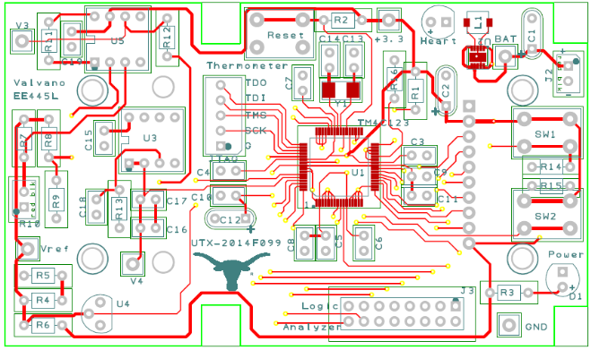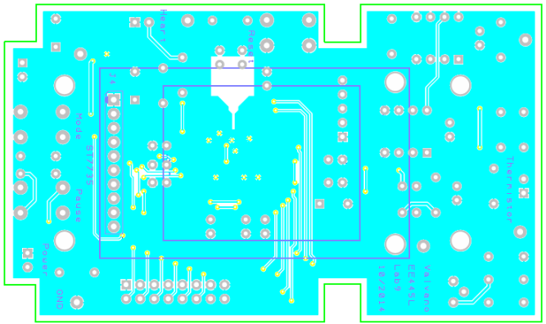
Figure 6.4. Top and bottom of PCB layout for a TM4C123 system (the ST7735 is on the bottom).

Traces that carry significant current should be wider than signal traces. In order to determine trace width, one needs to know the maximum current, the length of the trace, the thickness (1 oz/ft²), ambient temperature, and the maximum allowable temperature rise in the trace. For traces much longer than they are wide, and currents less than 35 amps, you can use the following calculators based on the IPC-2221 standard (formerly IPC-D-275). The second link can be used to calculate sizes of vias.
http://www.circuitcalculator.com/wordpress/2006/01/31/pcb-trace-width-calculator/
http://circuitcalculator.com/wordpress/2006/03/12/pcb-via-calculator/

Table 6.1 gives rough guidelines of how wide to make a trace for a given amount of current that trace will carry.

Length | Temperature Rise | Current | Thickness | Resistance | Trace Width
5" | 1 C | 100 mA | 1 oz/ft² | 1 Ω | 2 mil
5" | 1 C | 200 mA | 1 oz/ft² | 0.47 Ω | 5 mil
5" | 1 C | 500 mA | 1 oz/ft² | 0.13 Ω | 20 mil
5" | 1 C | 1 A | 1 oz/ft² | 0.05 Ω | 50 mil
5" | 1 C | 2 A | 1 oz/ft² | 0.02 Ω | 120 mil
Table 6.1. Minimum trace width for various current levels

8. When you think you are done, execute from the Output menu Design Status Report and a Net Completion Report. Fix any errors. Execute a Tools->DesignRuleCheck. Lastly, you should be able to go through the process of ordering the board described at http://users.ece.utexas.edu/~valvano/EE345L/Labs/Fall2011/PCBOrderProcess.pdf
up to the point where Advanced Circuits asks for a credit card. Please do not give them a credit card or order any boards. Make five printouts
1) A PCB showing the part you created in the library (put your actual chip on the paper to see if it fits)
2) Just top copper to be judged for layout style
3) Just bottom copper to be judged for layout style
4) Top copper and top silk, glue to top of cardboard, print at 100%
5) Bottom copper and bottom silk, glue to bottom of cardboard (print mirrored), print at 100%.

Cut out a piece of cardboard or wood about the thickness of a PCB board and glue the last two printouts to it, similar to the left side of Figure 6.5. Your mockup should fit nicely in the box.

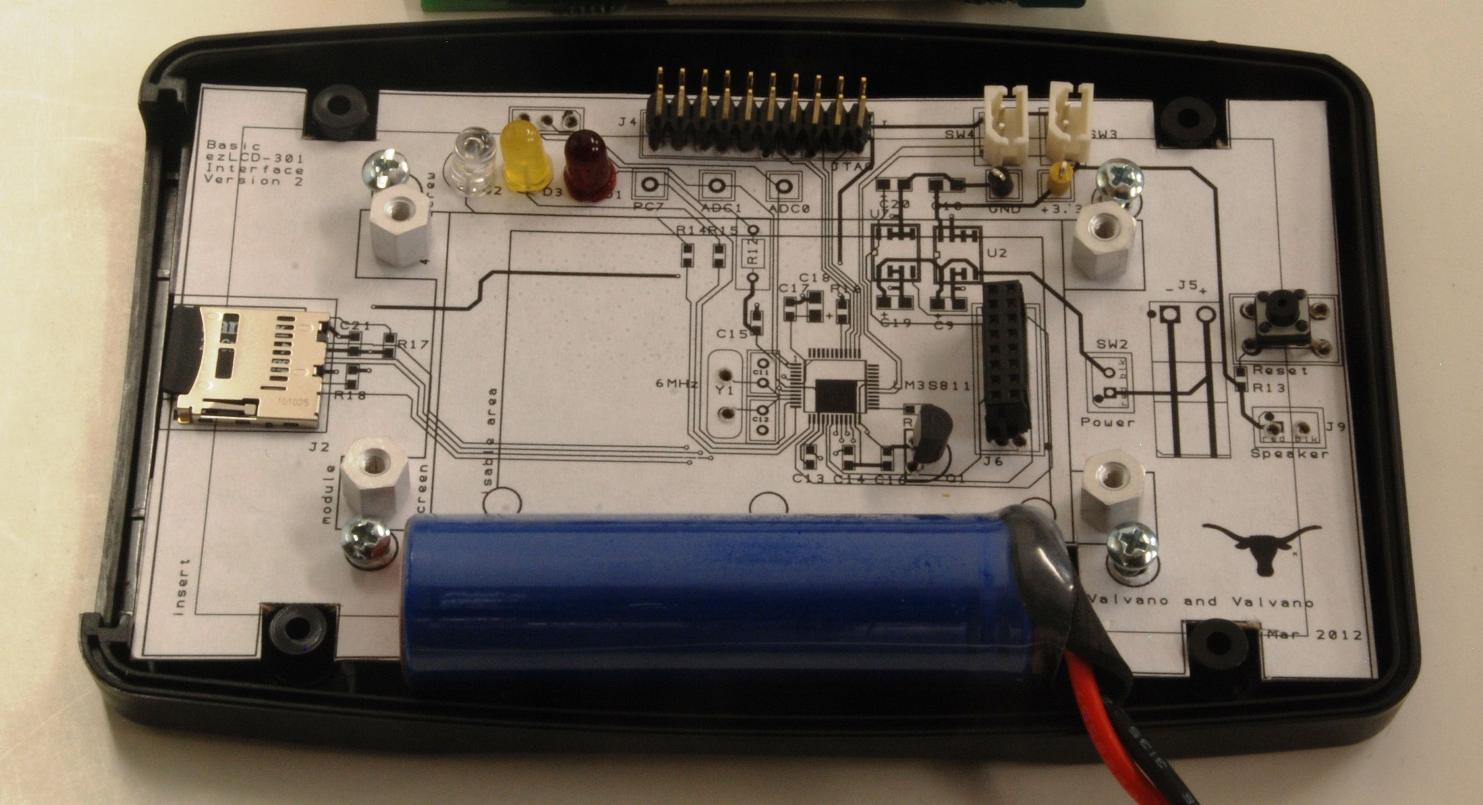
Figure 6.5. Mockup for an LM3S811 system using a PacTec enclosure.

9. Make two mechanical drawings of your system. Please include both top and side views. Your drawings can be hand-drawn. They must be drawn to scale, and please include the scale. For this type of system a 1-1 scale makes sense, but you can have other scales if you want. Explain the physical configuration of your major components, including the box, switches, jacks, speaker, connectors, PCB, and battery (as appropriate for your system).

Deliverables (exact components of the lab report)
A) Objectives (Requirements document from the Lab for which you selected to layout the PCB)
B) Hardware Design
One page description of the battery (printout from the web) (Preparation 2)
One page description of the box (like Figure 6.2, Preparation 3)
Three pages showing the new component you created and its usefulness (Procedure 3), and an example PCB using it
Two mechanical drawings (Procedure 9)
Final circuit diagram of the embedded system, SCH file
Cardboard mockup of the PCB layout (with top copper/silk on top and bottom copper/silk on bottom)
C) Software Design none
D) Measurement Data
Bill of Materials (quantity, package type, cost, and supply current) (Procedure 2)
Explain how you chose the battery (Preparation 2)
E) Analysis and Discussion (1/2 page maximum)
Explain the testing procedure you would suggest for the system (Procedure 1)

Checkout (show this to the TA)
You execute the commands listed in Procedures 4, 5, 6, 7, and 8 to verify project completion. You will be given a part number and asked to search for its data sheet and find the cheapest place to buy one (www.octopart.com). You should be prepared to discuss alternative approaches and be able to justify your solution. Show the directory of pdf files for your system.

A software and report files must be uploaded as instructed by your TA.
Your SCH and PCB files
Lab report
Bill of Materials of all your parts

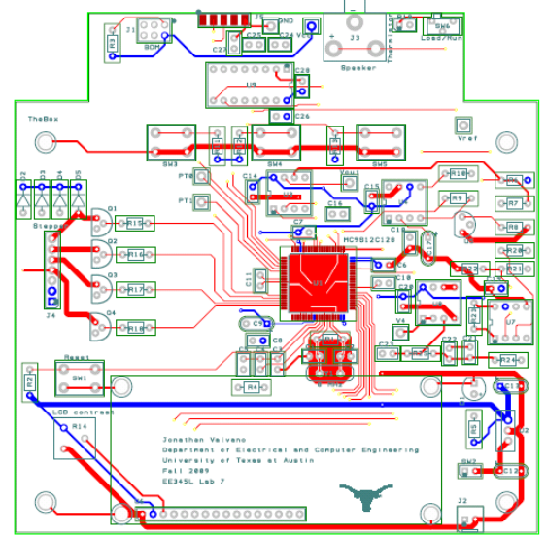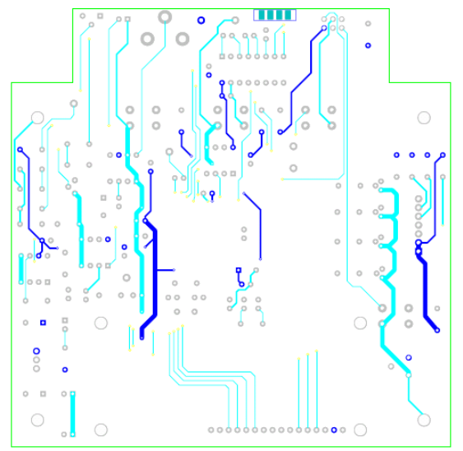
Figure 6.6. Notice the left-right traces are on top, and the up-down traces are on bottom.

