WEB DESIGN PROJECT REPORT

Student Name: Kevin Kiely (solo project)
Student ID: 18186866



WEBSITE DESIGN for KK CERAMICS pottery crafts business

Introduction

This project will entail the design and implementation of a website for a small ceramics/pottery business named KK Ceramics. The key goal of this project is to enable the business to have a modern, well designed online presence which will complement the current business model and showcase the business products to a wider audience.

Reason for choosing this project

For the last number of years I have been taking pottery/ceramics classes and have built up a collection of pieces which I would like to showcase to a larger group of prospective customers. I have previously designed the logo for this business, as can be seen at the beginning of this report, however no other work was done towards a website or marketing. I feel a well designed modern and responsive website is vital for this small fledgling business to be noticed in an increasingly competitive online world.

Personally having a background in Art & Design, I am confident that this will assist the design of this website from an aesthetic point of view, ensuring that while the art pieces are the main focus of attention, there will also be a focus on the website structure being of the required standards with respect to layouts, navigation and viewable correctly across different devices such as phones and tablets.

CONCEPT DEVELOPMENT

Research Ideas & Brainstorming

Having chosen my subject for the project, I began researching other similar websites to see how they approached a similar problem domain. The idea was to get a feel of how they presented their main business idea, the general layouts and designs of their websites, and elements such as colour schemes and fonts chosen. The following are a number of screenshots of these websites:

1 – Ballymorris Pottery

http://ballymorrispottery.ie/

The most striking aspect is how immediately noticeable the pottery products are by placing a large banner image at the top of the homepage. A plain white colour scheme with simple dark text, but logo is clearly visible in the traditional top left position. Vertical navigation bar is well spaced out and visible on all devices.

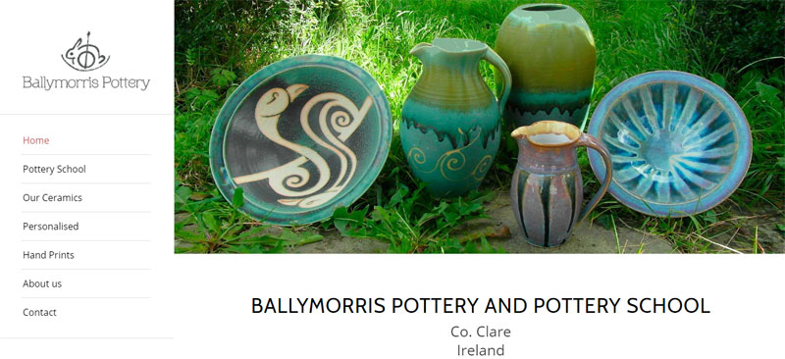

2 – Vivian O'Malley Ceramics

https://www.vivienomalleyceramics.com

A much darker colour scheme on this occasion, but very effective again in showcasing the works. A horizontal navigation bar on this example works very well at the top of the screen, with the logo and site title floated to the top left hand corner. Again the visual representation of the products are viewable instantly with an even wider banner image gallery than the previous example. On scrolling downwards, the most important site elements are clickable links as large images in a square grid format, again very clear as how to navigate the site.

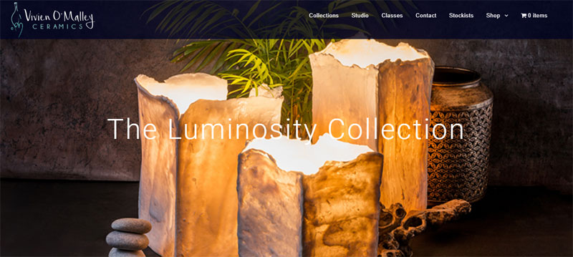

3 – Busy Bee Ceramics

https://www.busybeeceramics.ie/

Another well designed site with similar elements to the previous examples, one key difference on this design is the logo placed at the centre of the navigation bar which I find quite interesting. The most important aspect of this choice is how the menu and logo will render on smaller screen devices, it looks fine on mobile however it may need some adjustment on a mid size device such as an ipad. It is worth taking note of this should I decide to structure the navigation bar and logo in this way.

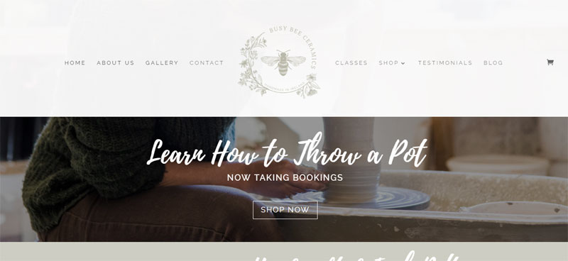
First Sketch on general Website Layout

The following sketch depicts my intended layout for the website pages, which would remain consistent across all pages of the site with only the “Main Content” area changing to reflect which page the user is on:

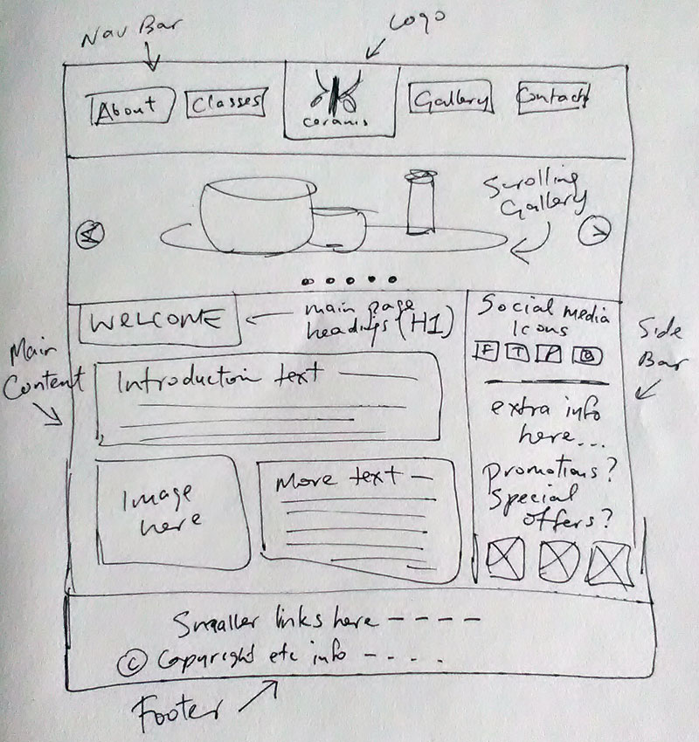
As shown in the image, the main template elements will be a header section with a navigation bar, and logo placed at the centre; A right hand sidebar with optional info; A scrolling slide-show banner below the header; A main page content area; and a footer section below with some more information regarding the business.

Site Navigation Plans

The following diagrams shows the intended pages of the website and how they will link together. It is intended that the gallery page will be broken down into 2 or 3 categories of the pottery products (such as tableware, and sculptural pieces) and the gallery will be a type of pop-up window to be used for scrolling between images in that category.

All sections will be reachable from the main navigation bar on the homepage, which will also be present on the other 4 pages, but the pop up gallery category section will only be reachable from the main gallery page.

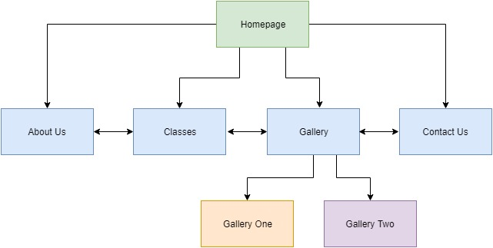

Theme of Website/Colours

I feel that a colour scheme from the previously designed logo will fit this website very well, the 3 shades of brown will reflect the idea of working with clay to create pottery products, giving an “earthy” feeling to the website and successfully portraying the ethos of the business.

However I will not be completely limited to these colours and plan to experiment with the addition of one or 2 complimentary colours as the design progresses. The 3 websites which I researched previously have varying colour approaches and all work quite well in the overall design of the websites.

I also need to approach the mobile responsive versions of the website to ensure they stick to the desktop design and colour schemes as much as is possible, without losing too much of the overall approach to colour schemes and layouts.

Conclusion

In conclusion, the following is a list of key deliverables that need to be met for the intended website to function efficiently and meet the goals of the project:

1 – 5 Related and connected HTML5 web pages.

2 – A linked CSS3 file with valid code to efficiently lay out the website and also enable the website to be responsive across all devices

3 – A JavaScript image gallery which is easy to navigate and again responsive on many devices, with the JavaScript files being referenced externally.

4 – A fully working contact form on the “Contact Us” page

5 – Consistent and related design patterns and navigation systems across the website.

The following is a list of project milestones that I intend to adhere to during the project:

1 – Completion of research into the topic of the website

2 – Persona submitted to show target audience of the website

3 – Wireframe of the design to help with the completion of a prototype design

4 – Prototype website to give a rough outline of the site without any in depth design details, to give the test user an opportunity to give feedback on the user experience.

5 – Testing the prototype mock-up to remedy any negative user experience issues or errors found thus far.

6 – Final Prototype: completed website free of any errors and ready for presentation as a final product.

