1. 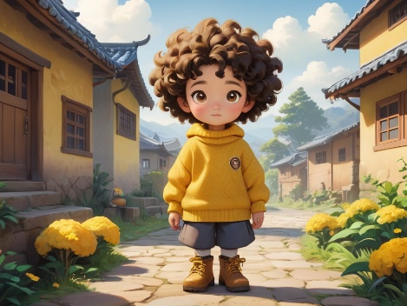A young girl named little Mantou , dressed in a yellow sweater and boots, with curly hair, a thoughtful expression, and a quiet but determined personality. Little Mantou lives in a warm little village. She is a happy girl who plays with her friends every day.
2. 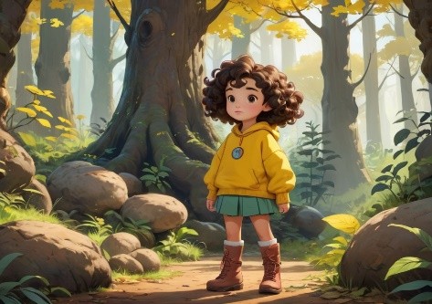Little Mantou decides that today she will go on an adventure in the forest. She tells her mom, "Mom, I'm going to find treasure!"
3. 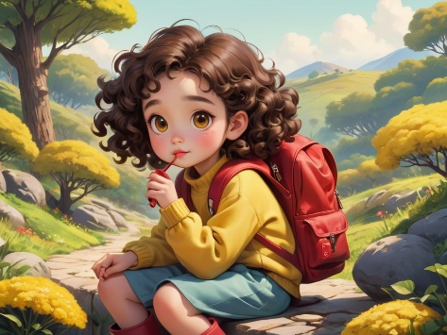Little Mantou puts on her red backpack, grabs her magnifying glass, and happily sets off.
4. 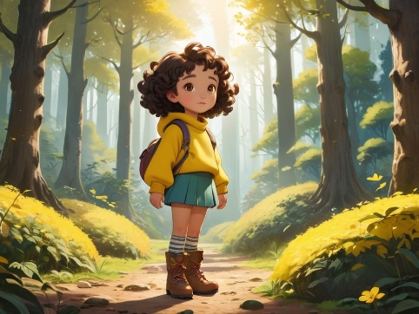Little Mantou arrives at a large forest. The trees are tall, and sunlight filters through the leaves. Everything feels magical.
5. 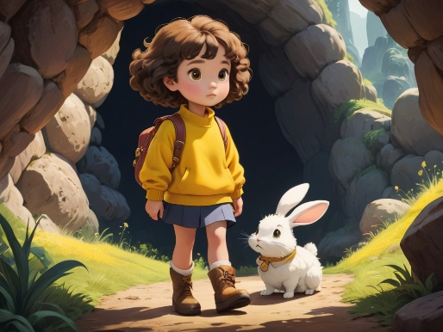As she walks, Little Mantou meets a little rabbit. The rabbit tells her, "There’s a mysterious cave ahead. Maybe there's treasure inside!"
6. 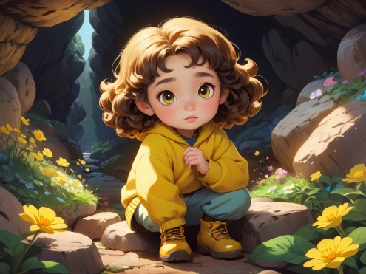Little Mantou carefully enters the cave and finds shiny stones and beautiful flowers inside.
7. 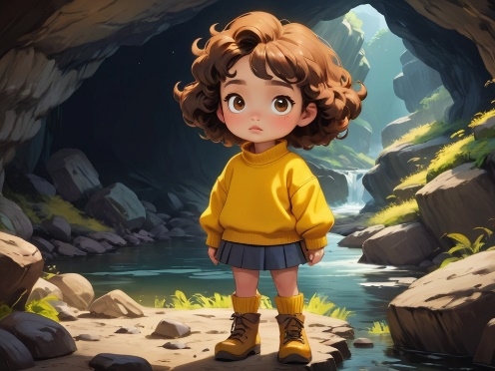Deeper into the cave, there is a small river with a fast current. Little Mantou is too scared to cross and begins to feel worried.
8. 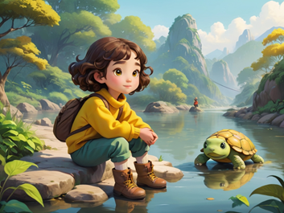Little Mantou meets an old turtle, who offers to help her cross the river on his back. Little Mantou happily agrees.
9. 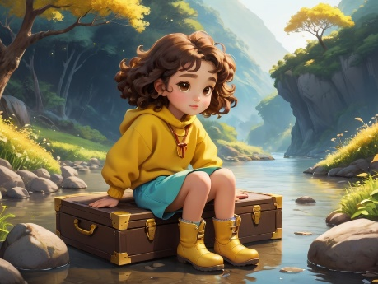On the other side of the river, Little Mantou discovers a sparkling treasure chest. When she opens it, she finds not gold or jewels, but memories of friendship and happiness.
10. 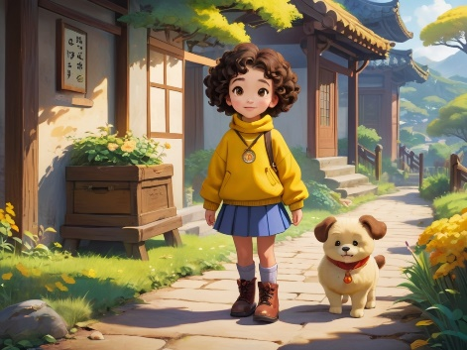Little Mantou heads back home with her treasure. Her mom greets her, and Little Mantou says with a smile, "This was my best adventure! The best treasure is friends and happiness!"