CO2R Autoanalyzer
This code will take the GC .ASC files, NMR data, and EC data from the echem experiment and automatically analyze the data and generate the relevant graph. This code was not meant to be used as a black-box. The user should understand the gist of the code and modify as needed. If the data output does not look 'normal' ask yourself first, where in the code could've the processing not worked?
Setting up the Analysis 1
Establishing Experimental time 2
Auto SRIGC run analysis 2
NMR Analysis section 4
Converting to ratio and FE 6
EC Data analysis 6
ECdata filtering for 1 ECdata set 7
Filtering Current 7
If multiple part load data: 7
Final Analysis: Ratio, FE, and Partial Current Density 9

Setting up the Analysis
All initial parameters need to be inputted in this section manually.
- Electrode name
- Experimental parameters
- GCstartdelay: when the GC runs were started
- GCrunrest: the total time for the GC run and rest in between
- Leftend: the GC run # which you want to start evaluating from
- Rightend: the GC run # which you want to end the evaluation
- Prodnum: number of products to analyze
clear;
clc; close all;
electrode_name = ['CuFoil168'];
exp_parameters = ['-1650-200mVps50ms'];
GCstartdelay = 8; %min
GCrunrest = 26; %18 min run time and 10 min rest time
Leftend = 1;
Rightend = 8;
Area = 0.2; %probably need to change
Prodnum = 6; %H2, CO, CH4, C2H4, formic, EtOH

Establishing Experimental time
Based on inputs above, this section establishes the experimentally evaluated time. CompiledData: is a blank matrix, which is setup depending on how many products are expected.
CompiledData = zeros((Rightend-Leftend),Prodnum); %H2, CO, CH4, C2H4, formic, EtOH
if Leftend == 1
ExpTime = GCstartdelay:GCrunrest:((Rightend-1)*GCrunrest+GCstartdelay);
else %when you don't start at FID01
ExpTime = (GCstartdelay+(Leftend-1)*GCrunrest):GCrunrest:((Rightend-1)*GCrunrest+GCstartdelay);
end
Len = length(ExpTime);

Auto SRIGC run analysis
User must:
- Make sure the Calibration data is up-to-date, file path is correct calibration .m file should be run if the calibration file has not been generated.
GCAutoAnalyzerCALIBRATIONS.m
- products: All product names (string) should be listed
- product_colors: For each product listed, choose a desired color scheme
- n: number of electrons used to produce this product.
- flowrate: units in sccm. If 7% flow rate, then 1.4 sccm
- CatholyteVol: the volume of the catholyte used
- In the For loop the user must change the GCFID and GCTCD file paths up to '...FID' or '...TCD' the value after will automatically change depending on the loop number to sample all GC files desired.
This section may take the longest depending on the number of GC runs being analyzed. If you would like to run this whole code multiple times without having to reanalyze the GC data each time, uncomment the save .mat line, run the code, then comment the for-loop and save .mat lines. Finally uncomment the load line. Loading a .mat file will be much faster.
save('CompiledData.mat','CompiledData')
load('CompiledData.mat');
%user inputs
Calibration = importdata(['C:\Users\Kevin\Documents\Graduate_Work_MAIN\Electrochemistry\Data\GCData_analyzer\Autogenerated_Calibration.csv']); %
products = ["H_2","CO","CH_4","C_2H_4","HCOOH","EtOH"];
product_colors = [1 0 0; 1 0.6 0; 0 0.498 0; 0.4 0.6 1; 0.4 0.2 1; 0.64 0.08 0.18];
n = [2 2 8 12 2 12];
flowrate = 1.4; %sccm
CatholyteVol = 15; %mL
%Constants
SampVol = 10; %mL
SampMol = 101.325*10/(100*8.314*300);
F = 96485; %faraday's constant
Pressure = 14.7; %psi
v = F*Pressure*6.8976/(8.314*300*60*1000);
molarflow = flowrate*Pressure*6.8976/(8.314*300*1000);
count = 1;
for i = Leftend:Rightend
%Work in progress to automate the SRI GC
run_num = i; %choose the desired run #
if run_num < 10
runstr = [num2str(0),num2str(run_num)];
else
runstr = num2str(run_num);
end
%import the .ASC file (user must specify path)
GCFID = importdata(['C:\Users\Kevin\Documents\Graduate_Work_MAIN\Electrochemistry\Data\Cufoil Data\Constant and Pulsed Long tests\190822_CuFoil168 -1650 -200 ps50ms\GC Data\190822 CuFoil168 -1650 -200 ps50ms 100mM KHCO3 FID',runstr,'.ASC']); %
GCTCD = importdata(['C:\Users\Kevin\Documents\Graduate_Work_MAIN\Electrochemistry\Data\Cufoil Data\Constant and Pulsed Long tests\190822_CuFoil168 -1650 -200 ps50ms\GC Data\190822 CuFoil168 -1650 -200 ps50ms 100mM KHCO3 TCD',runstr,'.ASC']); %
GCtime = 0.2/60:0.2/60:16; %last value is the total minutes, 5Hz intervals
H2peak1 = 0.8067; %first H2 peak location
CH4peak1 = 2.6; %first CH4 peak location
COpeak1 = 4.3; %first CO peak location
CH4peak2 = 8.283; %second CH4 peak location
C2H4peak1 = 10.8; %C2H4 peak location
H2peak1Area = H2peak1AreaFinder(H2peak1, GCtime, GCTCD.data);
CH4peak1Area = CH4peak1AreaFinder(CH4peak1, GCtime, GCFID.data);
COpeak1Area = COpeak1AreaFinder(COpeak1, GCtime, GCFID.data);
CH4peak2Area = CH4peak2AreaFinder(CH4peak2, GCtime, GCFID.data, 55, 25, 20, 55);
C2H4peak1Area = C2H4peak1AreaFinder(C2H4peak1, GCtime, GCFID.data, 200, 80, 60, 120);
H2ppm = H2peak1Area*Calibration(1);
CH4peak1ppm = CH4peak1Area*Calibration(2);
COppm = COpeak1Area*Calibration(3);
CH4peak2ppm = CH4peak2Area*Calibration(4);
C2H4ppm = C2H4peak1Area*Calibration(5);
CompiledData(count,:) = [H2ppm COppm (CH4peak2ppm+CH4peak1ppm)/2 C2H4ppm zeros(1,Prodnum-4)];
count = count +1;
end
% save('CompiledData.mat','CompiledData')
% load('CompiledData.mat');
CompiledData = CompiledData/1000000; %convert all ppm to x_i
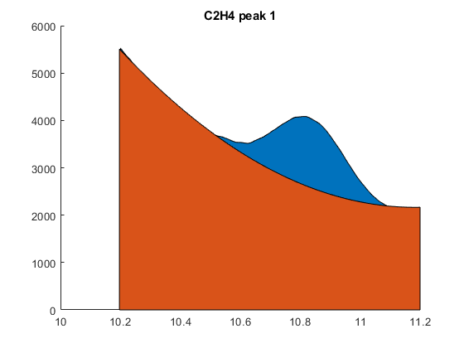

NMR Analysis section
This portion takes the NMR data in a column format .xlsx advised User much specify the path location and modify the P1 and P2 fit values if multiple NMR points were taken over a long test.
NMR = importdata(['C:\Users\Kevin\Documents\Graduate_Work_MAIN\Electrochemistry\Data\Cufoil Data\Constant and Pulsed Long tests\190822_CuFoil168 -1650 -200 ps50ms\CuFoil168NMRdata.xlsx']); %
NMR.time(:,1) = NMR.data(:,1)*60;
% NMR.Acetate = 50*(500/400)*(NMR.data(:,4)/3)./(NMR.data(:,3)/6)*CatholyteVol/(1000000*1000);
Analysis for Formic Acid
NMR.formic = 50*(500/400)*(NMR.data(:,2)/1)./(NMR.data(:,3)/6)*CatholyteVol/(1000000*1000); %for formic acid NMR
if length(NMR.data(:,1)) == 1 %only one NMR for the experiment
CompiledData(:,5) = (NMR.formic/(NMR.time(1,1))) / molarflow;
else
P1 = 3e-9; %linear portion user modified
P2 = 1.6e-11; %log portion user modified
Formicfit = P1*(ExpTime')+P2*log(ExpTime');
figure
plot(NMR.time, NMR.formic,'o',ExpTime, Formicfit)
title('Formic Fit')
for i = 1:length(Formicfit)-1 %finding the local slope
CompiledData(i,5) = ((Formicfit(i+1)-Formicfit(i)) / (ExpTime(i+1)-ExpTime(i))) / molarflow;
end
CompiledData(length(Formicfit),5) = CompiledData(length(Formicfit)-1,5);
end
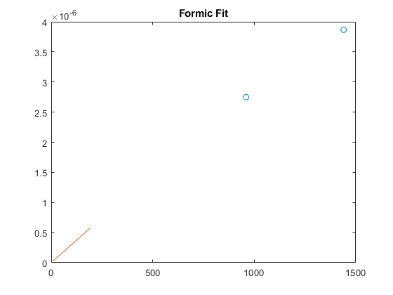
Analysis for EtOH
if length(NMR.data(1,:)) >= 4 && Prodnum >= 6
NMR.EtOH = 50*(500/400)*(NMR.data(:,4)/3)./(NMR.data(:,3)/6)*CatholyteVol/(1000000*1000); %for EtOH NMR
if length(NMR.data(:,1)) == 1 %only one NMR for the experiment
CompiledData(:,6) = (NMR.EtOH/(NMR.time(1,1))) / molarflow;
else
P1 = 2.5e-10; %linear portion user modified
P2 = 2.5e-11; %log portion user modified
EtOHfit = P1*(ExpTime')+P2*log(ExpTime');
figure
plot(NMR.time, NMR.EtOH,'o',ExpTime, EtOHfit)
title('EtOH Fit')
for i = 1:length(Formicfit)-1 %finding the local slope
CompiledData(i,6) = ((EtOHfit(i+1)-EtOHfit(i)) / (ExpTime(i+1)-ExpTime(i))) / molarflow;
end
CompiledData(length(EtOHfit),6) = CompiledData(length(EtOHfit)-1,6);
end
else
end
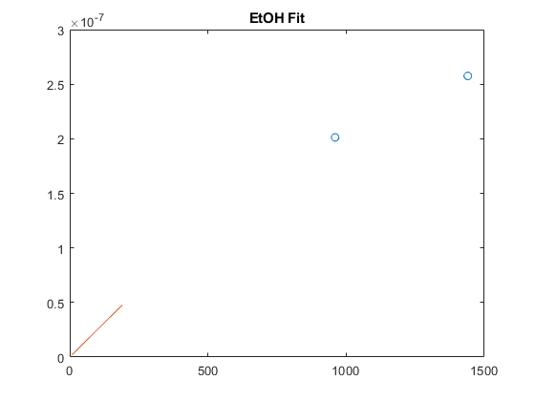

Converting to ratio and FE
convert all x_i to i to ratio
CompiledData_xin= (CompiledData'.*n')'; %number of electrons used per product
CompiledData_i = CompiledData_xin * F * v;
CompiledData_itotal(:,1) = sum(CompiledData_i,2); %setting total in col6
CompiledData_ratio(:,1:Prodnum) = CompiledData_i(:,1:Prodnum)./CompiledData_itotal(:,1); %convert to ratios *psuedo FE*

EC Data analysis
User must specify the file pathway for the EC data. This section will take EC data and average the currents based on each GC run section specified in the previous sections. Averaged current can be visualized in the plotted data.
If ECdata file is very large, you may want to same the ECdata in a .mat file and then load it each time the code is run.

ECdata filtering for 1 ECdata set
comment out if processed in separate script
ECdata = importdata(['C:\Users\Kevin\Documents\Graduate_Work_MAIN\Electrochemistry\Data\Cufoil Data\Constant and Pulsed Long tests\190822_CuFoil168 -1650 -200 ps50ms\ECdataCuFoil168pt1.xlsx']);
save('ECdata.mat','ECdata');
len = length(ECdata.data);

Filtering Current
filtered = zeros(round(len/20),2); %% rounds up, divides length by number of GC samples taken during part, makes a matrix of zeros with two columns
ct = 1; % initializing the counter
for i = 1:len
% finding faradaic current
if ECdata.data(i,2) < -0.5 && ECdata.data(i,2) > -1.7 %% taking current data that is negative but not huge negative charging spikes. this value will change based on case
filtered(ct,:) = ECdata.data(i,:); % adding cathodic Faradaic current data to new matrix
ct = ct +1;
else
end
end
AllECdata = filtered;

If multiple part load data:
comment out this section if only one ECdata set.
% load('CuFoil168TotalECdata.mat');
% AllECdata = data;
AllECdata(:,1) = AllECdata(:,1) - AllECdata(1,1); % scaling the time to start at 0
AllECdata(:,1) = AllECdata(:,1)/60; %converting to minutes
AllECdata(:,2) = AllECdata(:,2)/(2); %half the current (equal pulse), density (mA/cm^2)
GC1strun_starttime = 10; %minutes
GCrunrest_time = 24; %min
figure
hold all;
plot(AllECdata(:,1),AllECdata(:,2))
GCtotrun = floor((AllECdata(end,1) - GCstartdelay)./(GCrunrest)); %calc how many GC runs are in the EC dataset
count = 0; %keep track of which GC count to average
tempaverage = 0; %need to temporarily store all current values
AvgIdiscretized = zeros(GCtotrun,3); %1st col count, 2nd col is sample time, 3rd col is avg current
for i = 1:GCtotrun
AvgIdiscretized(i,1) = i;
if i == 1
[val,endidx]=min(abs(AllECdata(:,1)-GCstartdelay)); %first GC run is avg I from t=0 to GCstartdelay
AvgIdiscretized(i,2) = AllECdata(endidx,1); %document sample time point
AvgIdiscretized(i,3) = mean(AllECdata(1:endidx,2)); %calculating the avg current
else
[val,startidx]=min(abs(AllECdata(:,1)-(GCstartdelay+GCrunrest*(i-2)))); %start time and index
[val,endidx]=min(abs(AllECdata(:,1)-(GCstartdelay+GCrunrest*(i-1)))); %end time (sample point) and index
AvgIdiscretized(i,2) = AllECdata(endidx,1); %document sample time point
AvgIdiscretized(i,3) = mean(AllECdata(startidx:endidx,2)); %calculating the Avg current
end
end
if Len > length(AvgIdiscretized)
for x = 1:(Len-length(AvgIdiscretized))
AvgIdiscretized(i+x,1) = AvgIdiscretized(i,1)+1*x;
AvgIdiscretized(i+x,2) = AvgIdiscretized(i,2)+GCrunrest*x;
AvgIdiscretized(i+x,3) = AvgIdiscretized(i,3);
end
elseif Len < length(AvgIdiscretized)
AvgIdiscretized = AvgIdiscretized(1:Len,:);
else
end
plot(AvgIdiscretized(:,2),AvgIdiscretized(:,3),'o')
filtCurrent = AvgIdiscretized(:,3);
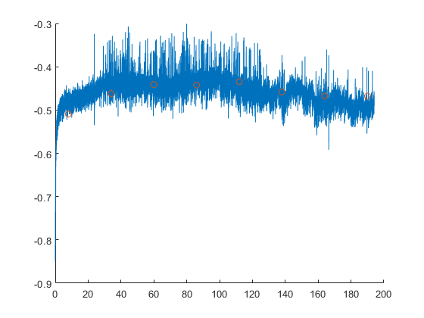

Final Analysis: Ratio, FE, and Partial Current Density
This section will take all of the GC, NMR, and EC data to calculate the FE and partial current densities, plotted
fitvol = TotalFE_fitvol(115, flowrate, Len, AvgIdiscretized, CompiledData_xin, SampMol);
sampleTime = fitvol/(flowrate/60);
variedsampleTime = ones(Len,1) * sampleTime;
variedsampleTime(1) = 50/(flowrate/60); %initial adjustments
% variedsampleTime(2) = 150/(flowrate/60);
% variedsampleTime(3) = 148/(flowrate/60); %delayed FID06
% variedsampleTime(7) = 128/(flowrate/60);
e_in = abs(AvgIdiscretized(:,3)).*variedsampleTime/(96485*1000); %converting to e in
CompiledData_FE = 100*CompiledData_xin * SampMol ./ e_in; %calculating FE
CompiledData_totalFE = sum(CompiledData_FE,2); %total FE
%plotting the moving average
AvgFitTime = (ExpTime(1):ExpTime(end))';
toAvgFitFE = CompiledData_FE;
InterpedtoAvgFitFE = zeros(length(AvgFitTime) , length(CompiledData_FE(1,:))); %defining, modified below
AvgFitFE = InterpedtoAvgFitFE; %defining, modified below
for ct = 1:5
InterpedtoAvgFitFE(:,ct) = interp1(ExpTime',CompiledData_FE(:,ct),AvgFitTime);
if ct == 1
AvgFitFE(:,ct) = smooth(InterpedtoAvgFitFE(:,ct),0.6,'loess'); %change the value to choose level of moving average
else
AvgFitFE(:,ct) = smooth(InterpedtoAvgFitFE(:,ct),0.6,'loess');
end
end
Plotting ratios
figure
hold all
for ct = 1:Prodnum
plot(ExpTime, CompiledData_ratio(:,ct),'Linewidth',2,'Color',product_colors(ct,:))
end
% plot(ExpTime, CompiledData_totalFE(:,1),'Linewidth',2)
title([electrode_name, ' ', exp_parameters, ' Ratio'])
ylim([0 1])
xlabel('Time (min)')
ylabel('Product ratio')
box('on')
legend(products)
savefig([electrode_name, '_', exp_parameters, '_ratios.fig']) %save the figure ratio
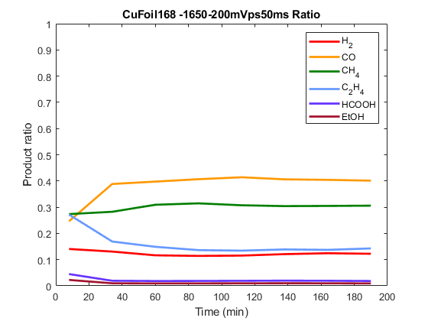
Plotting FEs and saving both FE values and moving averages
figure
hold all
for ct = 1:Prodnum
plot(ExpTime, toAvgFitFE(:,ct),'.','MarkerSize',50,'Color',product_colors(ct,:))
plot(AvgFitTime, AvgFitFE(:,ct),'Linewidth',2,'Color',product_colors(ct,:))
end
% plot(ExpTime, AvgFitFE(:,1),'Linewidth',2)
toAvgFitFE_totalFE = sum(toAvgFitFE,2); %total FE
plot(ExpTime, toAvgFitFE_totalFE(:,1),'Linewidth',2,'Color',[0 0 0])
title([electrode_name, ' ', exp_parameters, ' FE'])
ylim([0 115])
doubleproducts = [products products];
for n = 1:2:length(products)*2
doubleproducts(n:n+1) = [products((n+1)/2)];
end
legend(doubleproducts,'total FE')
xlabel('Time (min)')
ylabel('Faradaic efficiency (%)')
box('on')
csvwrite([electrode_name, '_', exp_parameters, '_FEprocessed.csv'],[ExpTime' toAvgFitFE toAvgFitFE_totalFE])
csvwrite([electrode_name, '_', exp_parameters, '_FE_movingAvg_processed.csv'],[AvgFitTime AvgFitFE])
savefig([electrode_name, '_', exp_parameters, '_FE.fig'])
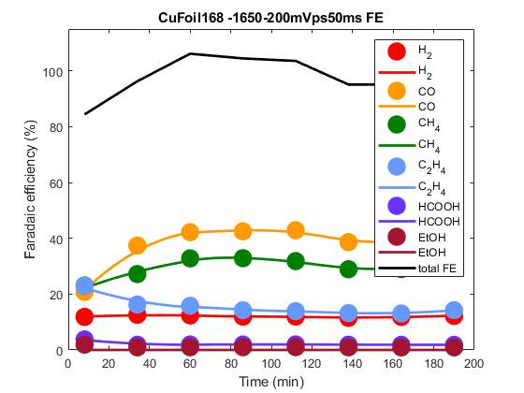
Plotting current densities and saving current densities
figure
hold all
CurrentDensities = [ExpTime' toAvgFitFE filtCurrent/Area]; %defining to modify, not averaged smoothed
for ct = 1:Prodnum
plot(ExpTime', filtCurrent.*(toAvgFitFE(:,ct)/100)/Area,'Linewidth',2,'Color',product_colors(ct,:))
CurrentDensities(:,ct+1) = filtCurrent.*(toAvgFitFE(:,ct)/100)/Area;
end
plot(ExpTime', filtCurrent/Area,'Linewidth',2,'Color',[0 0 0])
title([electrode_name, ' ', exp_parameters, ' partial Current Density'])
xlabel('Time (min)')
ylabel('j_i (mA/cm^2)')
box('on')
legend(products)
csvwrite([electrode_name, '_', exp_parameters, '_PartialCurrentprocessed.csv'],abs(CurrentDensities))
savefig([electrode_name, '_', exp_parameters, '_CurrentDensities.fig'])
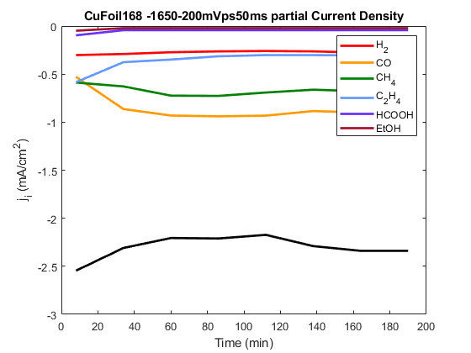
function Area = H2peak1AreaFinder(H2peak1location, time, GCdata)
[val,idx]=min(abs(time-H2peak1location)); %finding the index for Peak position
%make all data of interest positive
if min(GCdata((idx-30):(idx+50))) < 0
shiftup = abs(min(GCdata((idx-30):(idx+50))));
else
shiftup = 0;
end
if GCdata(idx) < 8000
Rightin = 20;
Rightout = 50;
else
Rightin = 30;
Rightout = 50;
end
tpseudo = [time((idx-30):(idx-18)),time((idx+Rightin):(idx+Rightout))];
datapseudo = [GCdata((idx-30):(idx-18)),GCdata((idx+Rightin):(idx+Rightout))];
timeH2 = time((idx-30):(idx+Rightout)); %all time
P = polyfit(tpseudo,datapseudo,4); %3rd order polyfit
yfit = P(1)*timeH2.^4+P(2)*timeH2.^3+P(3)*timeH2.^2+P(4)*timeH2+P(5);
BaselineArea = trapz(timeH2, yfit+shiftup);
H2peak1Area = trapz(time((idx-30):(idx+Rightout)), shiftup+GCdata((idx-30):(idx+Rightout)));
Area = H2peak1Area - BaselineArea;
figure
hold all
area(time((idx-30):(idx+Rightout)), shiftup+GCdata((idx-30):(idx+Rightout)))
area(timeH2, yfit+shiftup)
title(['H2 peak 1 Rightin',num2str(Rightin)])
end
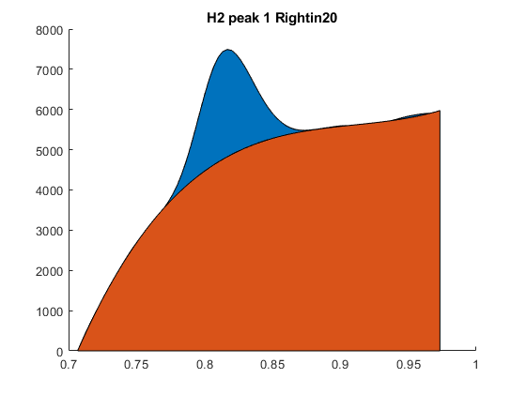
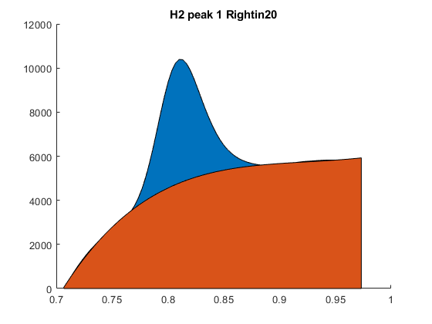
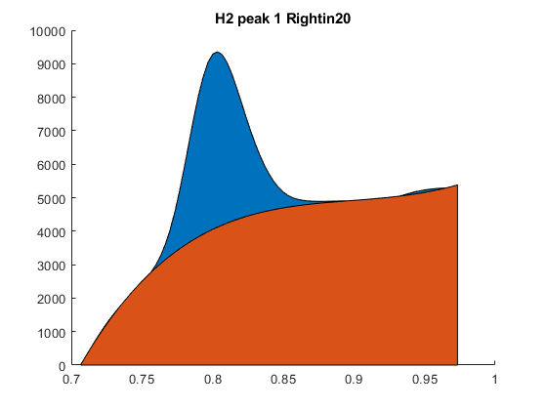
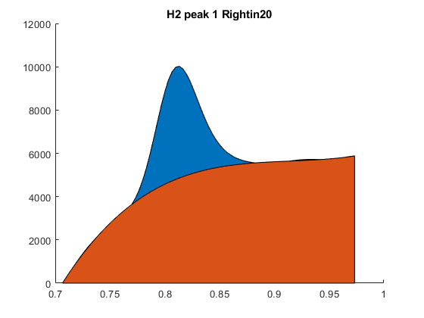
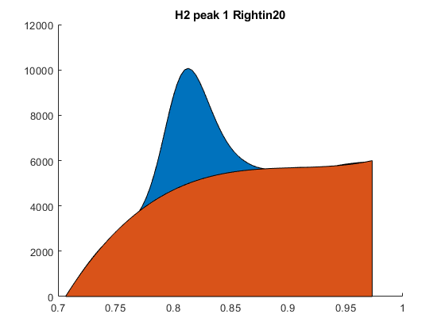
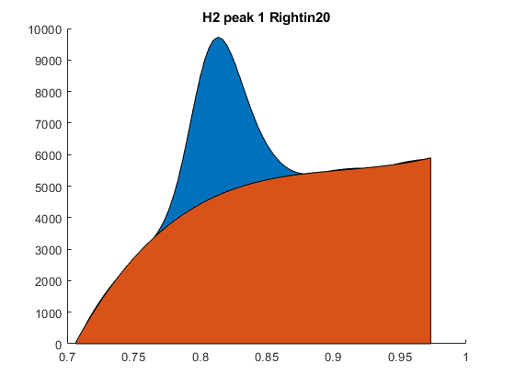
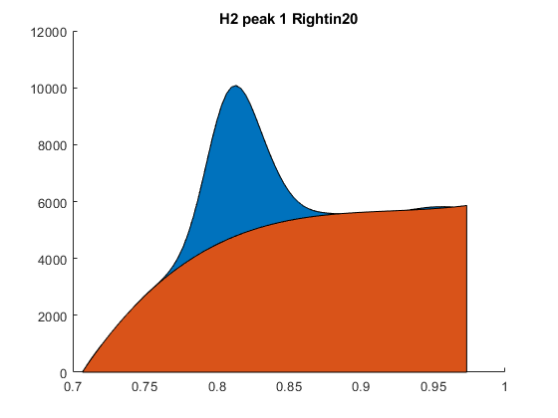
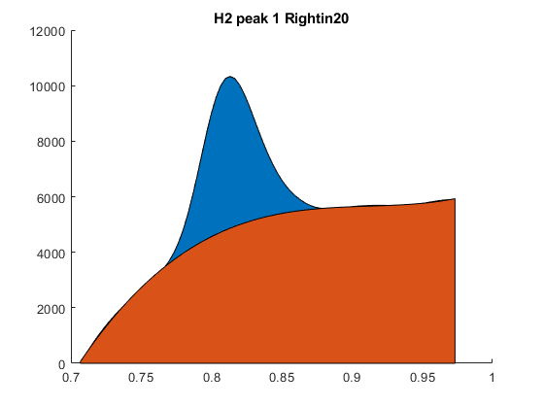
function Area = CH4peak1AreaFinder(CH4peak1location, time, GCdata)
[val,idx] = min(abs(time-CH4peak1location)); %finding the index for Peak position
%make all data of interest positive
if min(GCdata((idx-200):(idx+180))) < 0
shiftup = abs(min(GCdata((idx-200):(idx+180)))); %take absolute value
else
shiftup = 0;
end
if GCdata(idx) < 8000
Rightin = 80;
Rightout = 150;
else
Rightin = 150;
Rightout = 200;
end
tpseudo = [time((idx-200):(idx-150)),time((idx+Rightin):(idx+Rightout))];
datapseudo = [GCdata((idx-200):(idx-150)),GCdata((idx+Rightin):(idx+Rightout))];
P = polyfit(tpseudo,datapseudo,1);
yfit = P(1)*tpseudo+P(2);
BaselineArea = trapz(tpseudo, yfit+shiftup);
CH4peak1Area = trapz(time((idx-200):(idx+Rightout)), GCdata((idx-200):(idx+Rightout))+shiftup);
Area = CH4peak1Area - BaselineArea;
if Area < 5 %empirically found, below threshold of actual peak
Area = 0;
else
figure %graphing to check fit
hold all
area(time((idx-200):(idx+Rightout)), GCdata((idx-200):(idx+Rightout))+shiftup)
area(tpseudo, yfit+shiftup)
title(['CH4 peak 1',num2str(Rightin)])
end
end
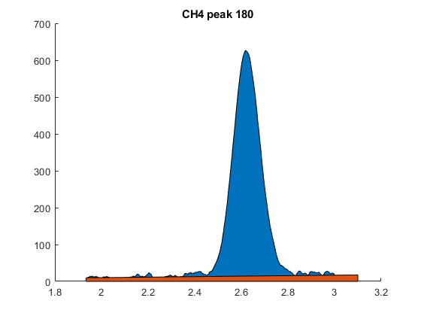
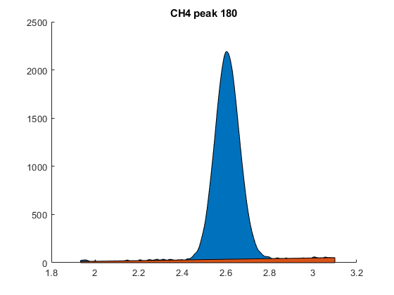
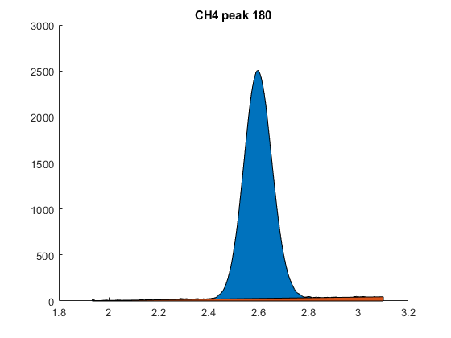
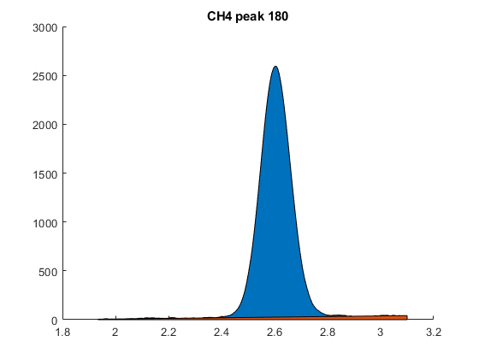
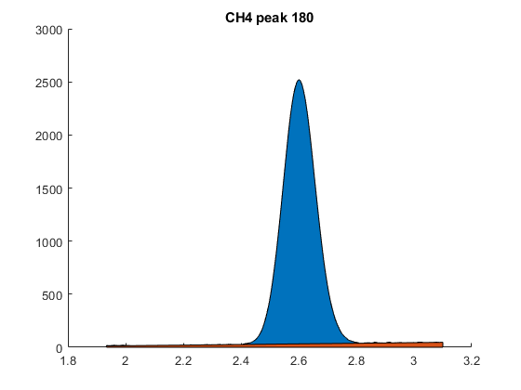
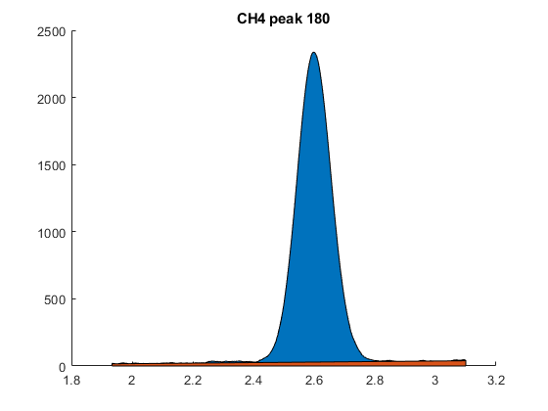
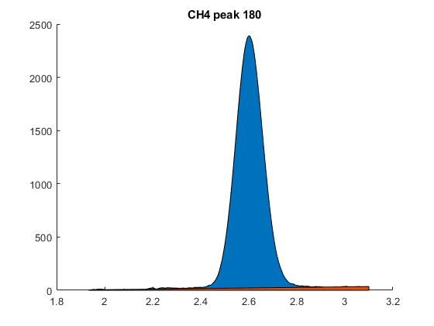
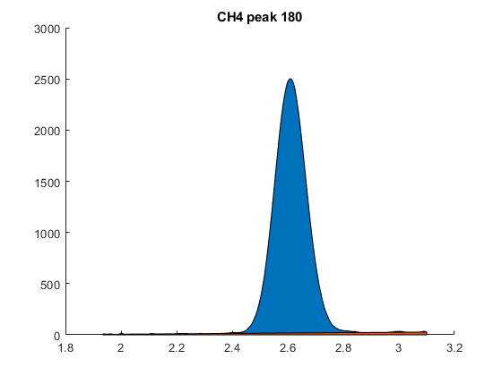
function Area = COpeak1AreaFinder(COpeak1location, time, GCdata)
[val,idx]=min(abs(time-COpeak1location)); %finding the index for Peak position
%make all data of interest positive
if min(GCdata((idx-200):(idx+200))) < 0
shiftup = abs(min(GCdata((idx-200):(idx+200)))); %take absolute value
else
shiftup = 0;
end
tpseudo = [time((idx-200):(idx-150)),time((idx+150):(idx+200))];
datapseudo = [GCdata((idx-200):(idx-150)),GCdata((idx+150):(idx+200))];
P = polyfit(tpseudo,datapseudo,2);
yfit = P(1)*tpseudo.^2+P(2)*tpseudo+P(3);
BaselineArea = trapz(tpseudo, yfit+shiftup);
COpeak1Area = trapz(time((idx-200):(idx+200)), GCdata((idx-200):(idx+200))+shiftup);
Area = COpeak1Area - BaselineArea;
figure %graphing to double check fit
hold all
area(time((idx-150):(idx+150)), GCdata((idx-150):(idx+150))+shiftup)
area(tpseudo, yfit+shiftup)
title('CO peak 1')
end
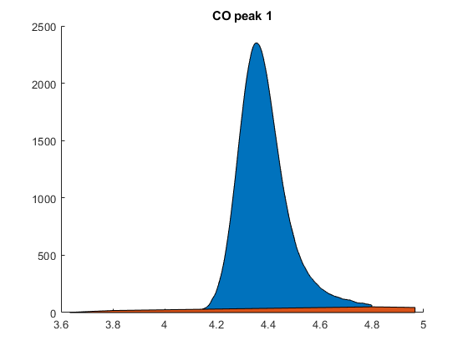
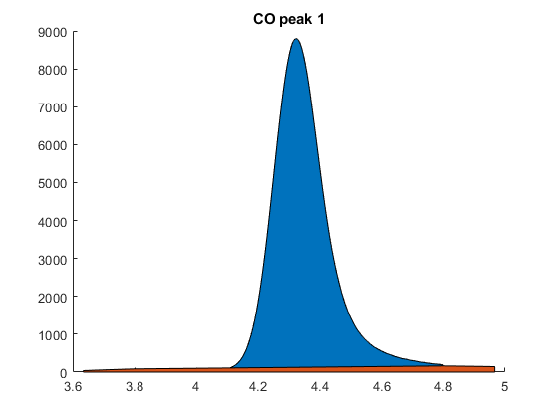
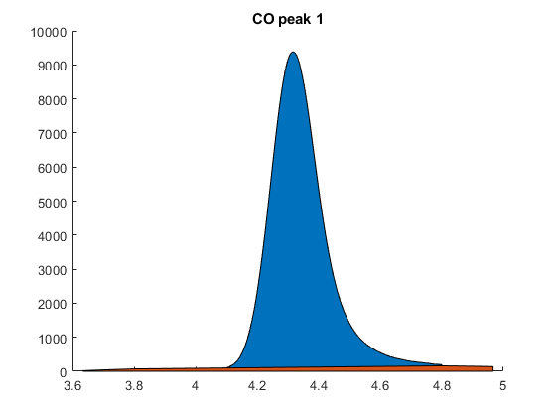
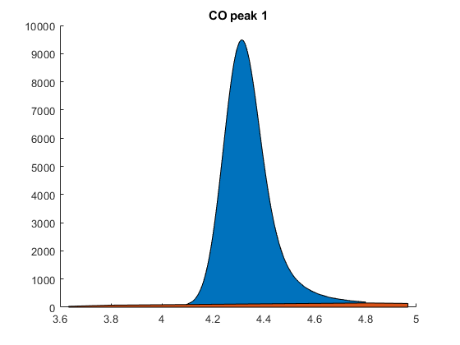
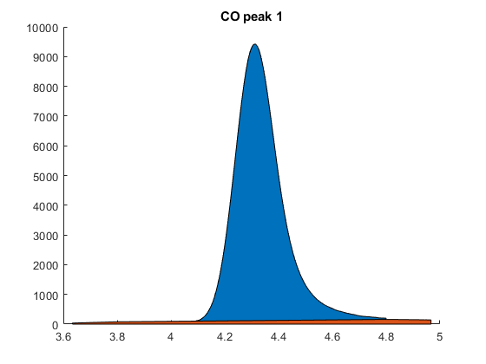
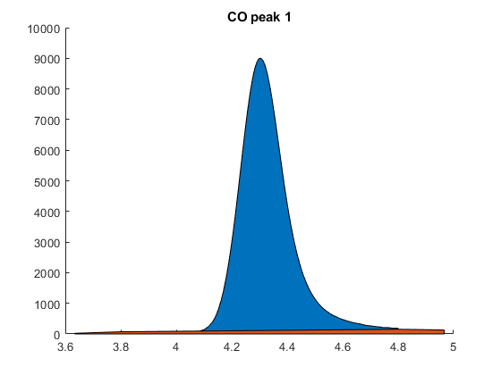
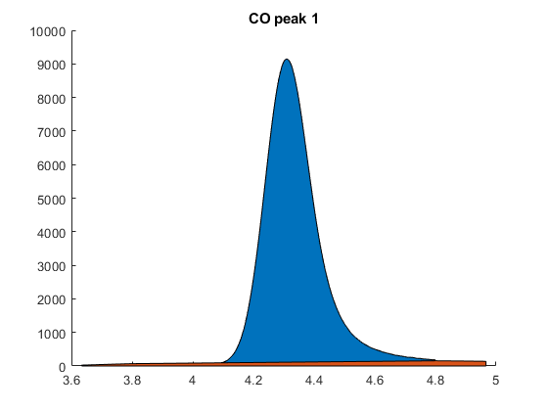
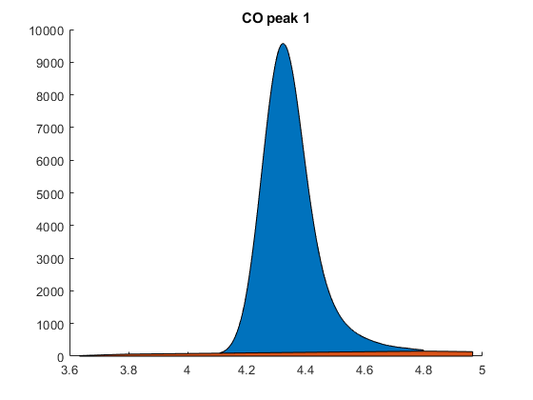
function Area = CH4peak2AreaFinder(CH4peak2location, time, GCdata, OutLeft, InLeft, InRight, OutRight)
[val,idx]=min(abs(time-CH4peak2location)); %finding the index for Peak position
%make all data of interest positive
if min(GCdata((idx-OutLeft):(idx+OutRight))) < 0
shiftup = abs(min(GCdata((idx-OutLeft):(idx+OutRight)))); %take absolute value
else
shiftup = 0;
end
tpseudo = [time((idx-OutLeft):(idx-InLeft)),time((idx+InRight):(idx+OutRight))]; %time span of interest for peak
datapseudo = [GCdata((idx-OutLeft):(idx-InLeft)),GCdata((idx+InRight):(idx+OutRight))]; %GCdata span of interest for peak
timeCH4 = time((idx-OutLeft):(idx+OutRight)); %all time
P = polyfit(tpseudo,datapseudo,2); % calculating quadratic fit
yfit = P(1)*timeCH4.^2+P(2)*timeCH4+P(3); %quadratic fit for baseline
BaselineArea = trapz(timeCH4, yfit+shiftup); %ares of baseline
CH4peak2Area = trapz(time((idx-OutLeft):(idx+OutRight)), GCdata((idx-OutLeft):(idx+OutRight))+shiftup);
Area = CH4peak2Area - BaselineArea;
if Area < 10 %empirically found, below threshold of actual peak
Area = 0;
else
figure
hold all
area(time((idx-OutLeft):(idx+OutRight)), GCdata((idx-OutLeft):(idx+OutRight))+shiftup)
area(timeCH4, yfit+shiftup)
title('CH4 peak 2')
end
end
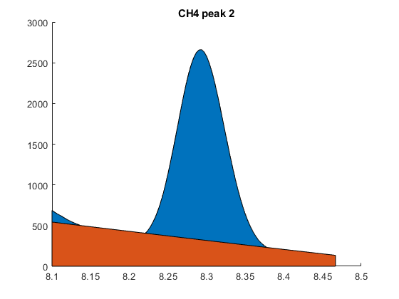
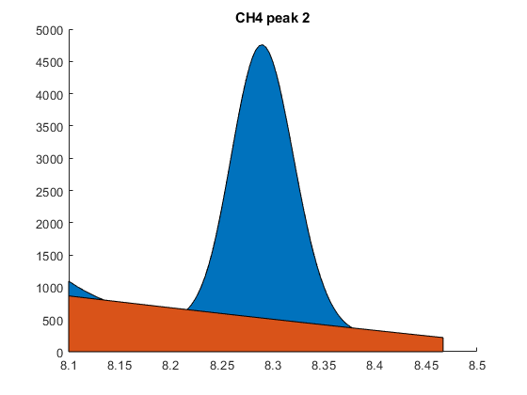
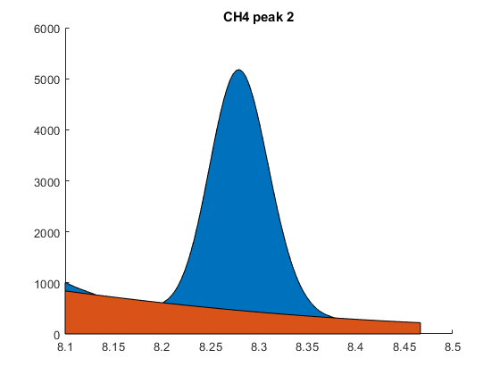
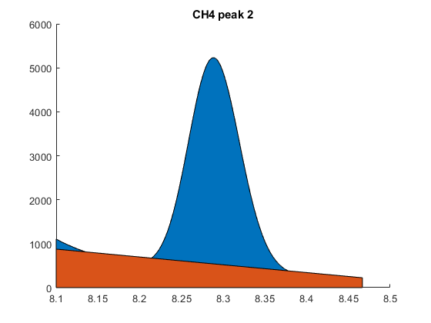
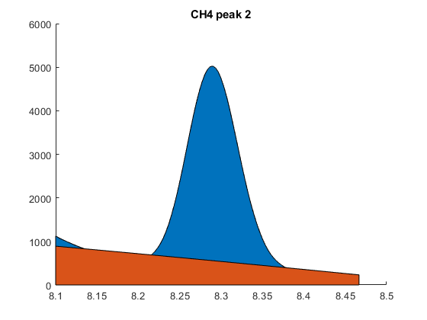
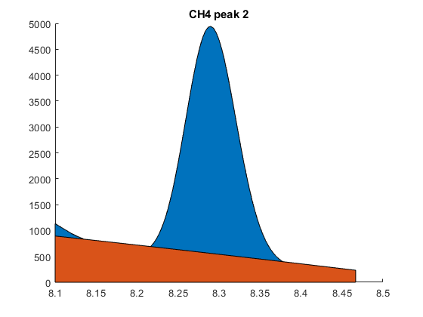
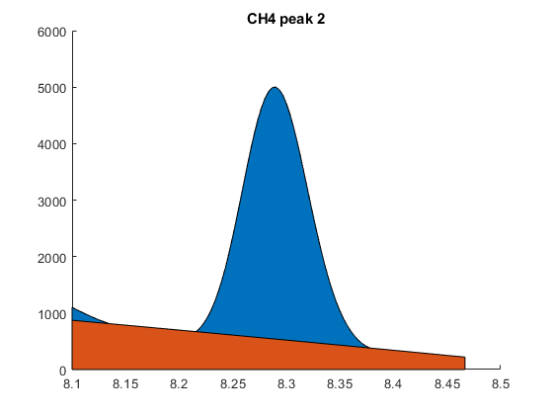
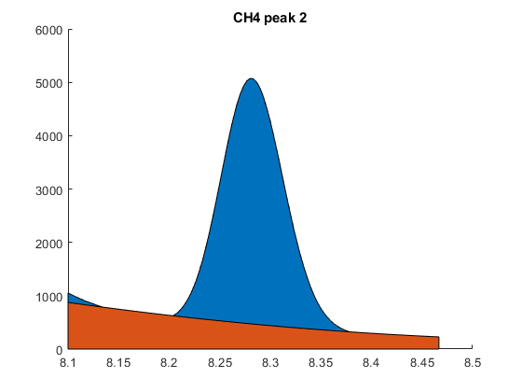
function Area = C2H4peak1AreaFinder(C2H4peak1location, time, GCdata,OutLeft, InLeft, InRight, OutRight)
[val,idx]=min(abs(time-C2H4peak1location)); %finding the index for Peak position
%make all data of interest positive
if min(GCdata((idx-OutLeft):(idx+OutRight))) < 0
shiftup = abs(min(GCdata((idx-OutLeft):(idx+OutRight)))); %take absolute value
else
shiftup = 0;
end
tpseudo = [time((idx-OutLeft):(idx-InLeft)),time((idx+InRight):(idx+OutRight))];
datapseudo = [GCdata((idx-OutLeft):(idx-InLeft)),GCdata((idx+InRight):(idx+OutRight))];
timeC2H4 = time((idx-OutLeft):(idx+OutRight));
% dataC2H4 = GCdata((idx-200):(idx+200));
P = polyfit(tpseudo,datapseudo,2);
yfit = P(1)*timeC2H4.^2+P(2)*timeC2H4+P(3);
BaselineArea = trapz(timeC2H4, yfit+shiftup); %ares of baseline
C2H4peak1Area = trapz(time((idx-OutLeft):(idx+OutRight)), GCdata((idx-OutLeft):(idx+OutRight))+shiftup);
Area = C2H4peak1Area - BaselineArea;
if Area < 120 %empirically found, below threshold of actual peak
Area = 0;
else
figure
hold all
area(time((idx-OutLeft+20):(idx+OutRight)), GCdata((idx-OutLeft+20):(idx+OutRight))+shiftup)
area(timeC2H4(20:end), yfit(20:end)+shiftup)
title('C2H4 peak 1')
end
end
function fitvol = TotalFE_fitvol(initialguess, flowrate, Len, AvgIdiscretized, CompiledData_xin, SampMol)
%id best sample time
fitvol = initialguess; %initial guess
sampleTime = fitvol/(flowrate/60);
variedsampleTime = ones(Len,1) * sampleTime;
e_in = abs(AvgIdiscretized(:,3)).*variedsampleTime/(96485*1000); %converting to e in
CompiledData_FE = 100*CompiledData_xin * SampMol ./ e_in; %calculating FE
CompiledData_totalFE = sum(CompiledData_FE,2); %total FE
baseline_diff = abs(100-CompiledData_totalFE(end));
for test = 1:100
newfitvol = 85 + 60*rand();
sampleTime = newfitvol/(flowrate/60);
variedsampleTime = ones(Len,1) * sampleTime;
e_in = abs(AvgIdiscretized(:,3)).*variedsampleTime/(96485*1000); %converting to e in
CompiledData_FE = 100*CompiledData_xin * SampMol ./ e_in; %calculating FE
CompiledData_totalFE = sum(CompiledData_FE,2); %total FE
if abs(100-CompiledData_totalFE(end)) < baseline_diff
fitvol = newfitvol;
baseline_diff = abs(100-CompiledData_totalFE(end));
else
end
end
end
Published with MATLAB® R2018a

