pritn test

## R Markdown

This is an R Markdown document. Markdown is a simple formatting syntax for authoring HTML, PDF, and MS Word documents. For more details on using R Markdown see <http://rmarkdown.rstudio.com>.

When you click the **Knit** button a document will be generated that includes both content as well as the output of any embedded R code chunks within the document. You can embed an R code chunk like this:

## -------------------------------------------------------------------------

## data.table + dplyr code now lives in dtplyr.  
## Please library(dtplyr)!

## -------------------------------------------------------------------------

##   
## Attaching package: 'dplyr'

## The following objects are masked from 'package:data.table':  
##   
## between, last

## The following objects are masked from 'package:stats':  
##   
## filter, lag

## The following objects are masked from 'package:base':  
##   
## intersect, setdiff, setequal, union

## Warning: package 'dummies' was built under R version 3.3.2

## dummies-1.5.6 provided by Decision Patterns

##   
Read 42.5% of 188318 rows  
Read 79.7% of 188318 rows  
Read 188318 rows and 132 (of 132) columns from 0.065 GB file in 00:00:04

##   
Read 87.6% of 125546 rows  
Read 125546 rows and 131 (of 131) columns from 0.043 GB file in 00:00:03

## Including Plots

You can also embed plots, for example:

## [1] "cat1"

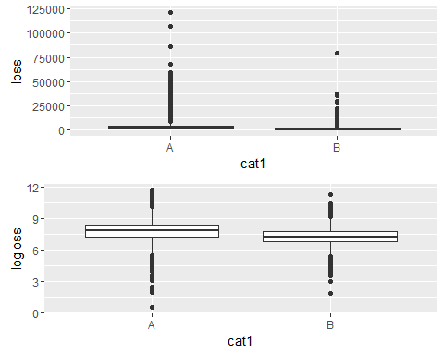

Note that the echo = FALSE parameter was added to the code chunk to prevent printing of the R code that generated the plot.