Hi kevin,

In Olx we need four type of properties

1) For sale Houses & apartments

2) For sale Lands & Plots

3) For sale Shops & Offices

4) Projects

You can select the first three types from the home page as screenshot below

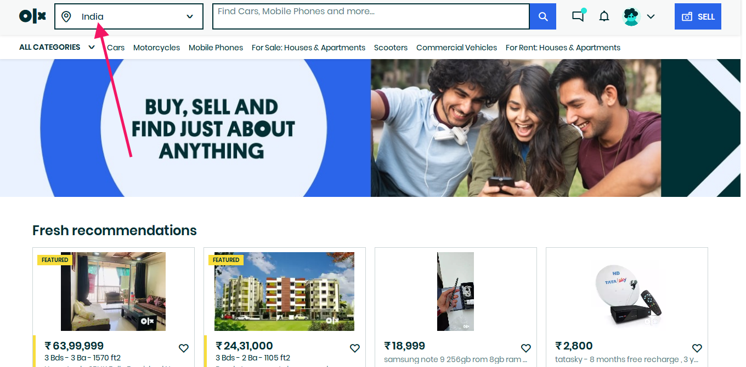

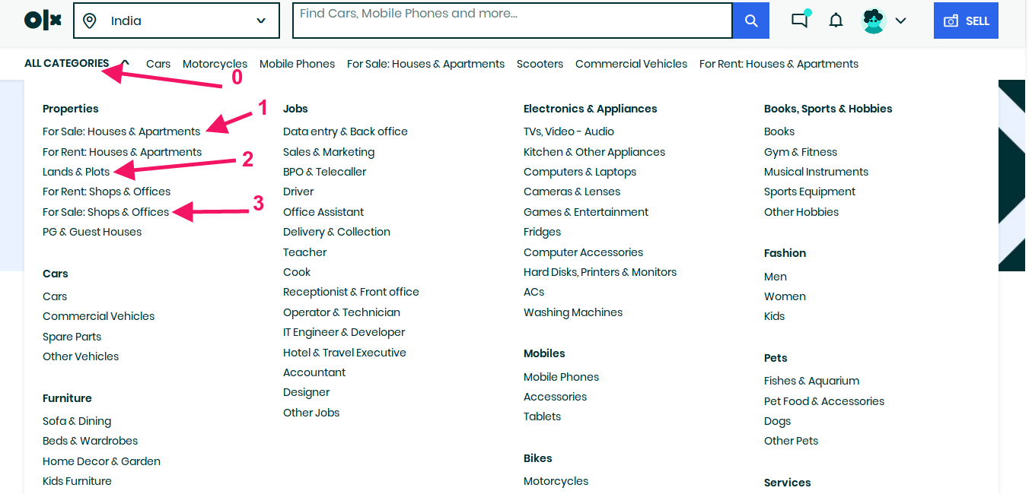

and the fourth one from here:

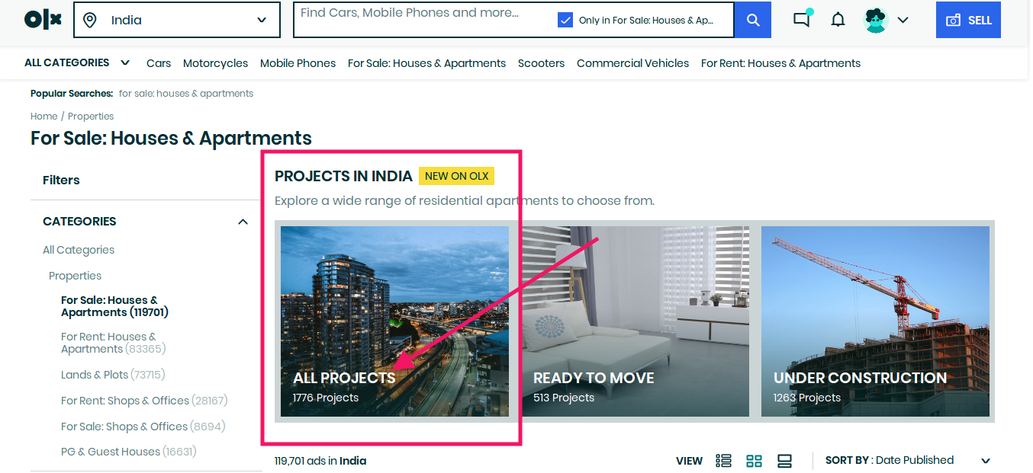

Sample data url for the type of Houses& Apartments : https://www.olx.in/item/available-for-sale-in-varthur-1-bhk-apartment-iid-1503240485

**Ps:** In the sample .xlsx I added “maintenance” as a field. This field “Maintenance (Monthly): ”in almost every listings but this field is not in the sample url

Data fields given in the attachment screenshot