Secure, Automated, Multi-Account Cloud Platform
Final Architecture & Executive Report — Capstone 9

1. Architecture Diagram
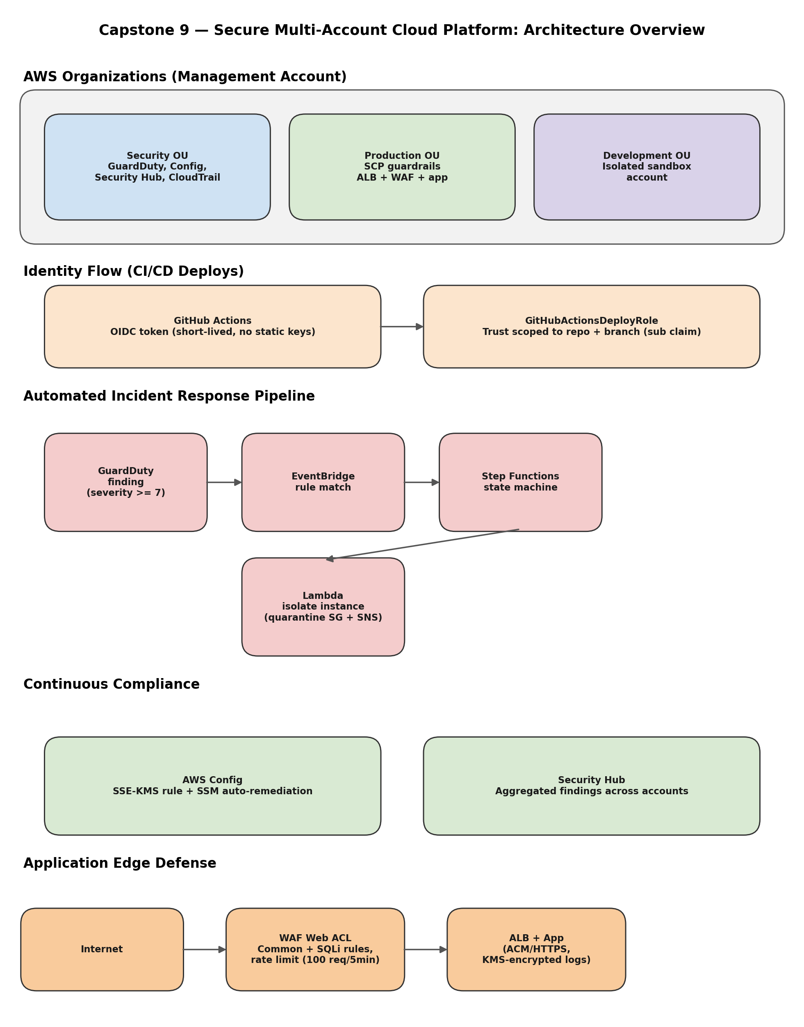
The platform spans a single AWS Organization with three organizational units — Security, Production, and Development — providing account-level isolation. Identity for automated deployment flows through GitHub's OIDC provider directly into a scoped IAM role, eliminating static credentials. Security telemetry (GuardDuty, Config, Security Hub, CloudTrail) is centralized in the Security OU, while the Production OU hosts the internet-facing application behind WAF and an Application Load Balancer. A fully automated detect-and-respond pipeline connects GuardDuty findings to isolation actions within seconds, and AWS Config continuously enforces encryption compliance across S3, CloudWatch Logs, and Secrets Manager.

2. Written Report

2.1 Architecture Explanation
The platform is built around a single AWS Organization acting as the management account, with three organizational units that separate concerns by function and blast radius. The Security OU centralizes account-wide visibility: GuardDuty for threat detection, AWS Config for continuous compliance, Security Hub for aggregated findings, and a multi-region CloudTrail trail for tamper-evident audit logging. The Production OU hosts the customer-facing workload — an Application Load Balancer fronted by a WAF Web ACL, running behind Service Control Policies that block destructive actions such as instance termination and disabling of CloudTrail, even for administrators. The Development OU is kept intentionally isolated so that experimentation cannot affect production data or credentials.
Identity is handled two ways. Human administrative access uses a dedicated IAM user assuming cross-account roles via OrganizationAccountAccessRole. Machine identity for CI/CD is handled entirely through OpenID Connect: GitHub Actions requests a short-lived token from GitHub's OIDC provider, which is exchanged for temporary AWS credentials via a role whose trust policy is scoped to a specific repository and branch. No long-lived AWS access keys exist in GitHub at any point.
The incident response pipeline is event-driven end to end. A GuardDuty finding above a defined severity threshold is matched by an EventBridge rule, which invokes a Step Functions state machine. The state machine coordinates a Lambda function that isolates the affected EC2 instance by swapping its security group to a quarantine group with no inbound or outbound rules, tags the instance for audit purposes, and sends a notification via SNS. This removes the dependency on a human being available at the moment of detection.
Compliance is enforced continuously rather than checked periodically. AWS Config rules evaluate S3 buckets for KMS-based encryption, and non-compliant resources are automatically remediated via SSM Automation documents that assume a dedicated remediation role. Encryption keys are managed through a customer-managed KMS key whose key policy explicitly grants the specific AWS services that need it (CloudWatch Logs, CloudTrail), rather than relying on default AWS-managed keys.

2.2 Why These Specific Services Were Chosen
- AWS Organizations + SCPs: chosen over a single-account model because SCPs enforce guardrails that apply even to account administrators, which IAM policies alone cannot guarantee (IAM policies can be modified by an admin; SCPs require organization-level access to change).
- OIDC over IAM access keys: eliminates a class of risk entirely — there are no long-lived credentials to leak, rotate, or accidentally commit to a repository.
- EventBridge + Step Functions over direct Lambda triggers: Step Functions provides visible, auditable state transitions and built-in retry/error handling, which a bare Lambda invoked directly from EventBridge would not give the same operational visibility into.
- AWS Config with SSM Automation over manual remediation: encodes the fix as code, so remediation is consistent and immediate rather than dependent on someone reading an alert and acting on it.
- WAF at the ALB over relying on application-level input validation alone: stops common attack patterns (SQLi, XSS, volumetric abuse) before they reach application code, which is a cheaper and more consistent control point than defending in every code path.
- Customer-managed KMS keys over AWS-managed keys: allows explicit, auditable control over exactly which principals and services can use the key, supporting the principle of least privilege at the encryption layer.

2.3 Threat Model and Controls
The design assumes three broad threat categories relevant to a fintech-style workload: (1) compromised or over-permissioned identities, (2) misconfigured resources drifting out of compliance over time, and (3) network-level attacks against the public-facing application.
- Compromised identity: mitigated by OIDC (no long-lived keys to steal), permission boundaries (caps what even a compromised or over-privileged role can do), and SCPs (guardrails that survive even if IAM is misconfigured).
- Configuration drift: mitigated by AWS Config continuously evaluating resource state against defined rules, with automatic remediation closing the gap between detection and fix.
- Network-level attack: mitigated by WAF rules for common exploits and SQL injection, plus rate limiting to blunt volumetric abuse, sitting in front of the load balancer before traffic reaches the application.
A notable finding during build-out was that automated remediation can itself introduce new risk if permissions are not fully modeled: when the Config remediation flipped a bucket's encryption to a customer-managed key, CloudTrail's own delivery to that bucket briefly risked failure because the KMS key policy did not yet grant the CloudTrail service principal access. This was caught and fixed by verifying trail delivery status immediately after the remediation ran, illustrating why automated response systems need to be tested for second-order effects, not just their primary action.

2.4 How Automation Reduces Risk
Manual security operations depend on a human noticing an alert, correctly interpreting it, and taking the right action — a chain with several points of delay and error. Automating detection-to-response collapses that chain to seconds and removes variability: the same finding always triggers the same isolation steps, tagged and logged the same way every time, regardless of time of day or who is on call. Automated compliance remediation similarly ensures that a non-compliant resource is fixed within minutes of Config detecting it, rather than sitting exposed until the next manual audit. The trade-off is that automation must be built defensively — as seen in the KMS/CloudTrail interaction above, an automated fix can have unintended side effects on adjacent services, so automation needs its own monitoring and graceful failure handling (for example, the Lambda isolation function was hardened to handle the case where a targeted instance no longer exists, rather than failing the whole pipeline).

2.5 Alignment with DevOps and AWS Best Practices
- Infrastructure and remediation logic are defined as code (Config rules, remediation configurations, Lambda functions, IAM policies) and version-controlled in the project repository, supporting repeatability and peer review.
- CI/CD deployment uses short-lived, narrowly-scoped credentials (OIDC), aligning with the AWS Well-Architected Framework's security pillar guidance to avoid long-lived credentials.
- Least privilege is applied at multiple layers: SCPs at the organization level, permission boundaries at the IAM role level, and explicit KMS key policy grants at the resource level — defense in depth rather than a single control.
- Detective controls (GuardDuty, Config, Security Hub, CloudTrail) are centralized and paired with automated corrective controls, matching the AWS Security Reference Architecture pattern of detect-and-respond rather than detect-and-wait.
- The system was validated with real attack simulations rather than only reviewed on paper — sample GuardDuty findings, deliberate SQLi payloads, and an unauthorized branch push were used to prove each control actually fires, not just that it is configured.

3. Five Exam-Style Answers
1. How do SCPs and Permission Boundaries differ?
A Service Control Policy is an organization-level guardrail applied to an OU or account; it defines the maximum permissions available to every principal in that account, including the account's own administrators, and it cannot be overridden by any IAM policy inside the account. A Permission Boundary is attached to a specific IAM user or role and caps what that identity can do, regardless of what its own IAM policies allow, but it operates entirely within the account — it has no effect on other identities and cannot restrict an SCP. In short: SCPs constrain an entire account from the outside; permission boundaries constrain a single identity from the outside. In this project, the SCP blocks ec2:TerminateInstances and cloudtrail:StopLogging organization-wide in Production, while the permission boundary on the DevOpsEngineer role blocks destructive S3 actions for that one role specifically, even though its attached policy (PowerUserAccess) would otherwise allow them.
2. Why is OIDC preferred over long-lived credentials?
Long-lived IAM access keys are a static secret that must be stored somewhere (a repository secret, an environment variable) and remain valid indefinitely until manually rotated or revoked — if leaked, they grant an attacker standing access until someone notices. OIDC federation replaces this with a token exchange: GitHub Actions requests a signed identity token from GitHub's own OIDC provider at the moment a workflow runs, and AWS's IAM role trust policy verifies that token's claims (including the exact repository and branch) before issuing temporary credentials that expire automatically, typically within an hour. There is no secret to leak because no long-lived credential exists in the first place, and access is cryptographically tied to the specific CI context that requested it.
3. How does Step Functions ensure consistent incident remediation?
Step Functions defines the incident response as an explicit state machine rather than a loose chain of triggers, so every GuardDuty finding that matches the EventBridge rule is guaranteed to pass through the same sequence of states in the same order, with the same error handling, every single time. It provides built-in retry and catch behavior for each step, a durable execution history that records exactly what happened and when (useful for audit and post-incident review), and it decouples the orchestration logic from the Lambda function's business logic, so the response process itself can be updated without touching the isolation code, and vice versa.
4. Why should WAF be attached at the ALB rather than at CloudFront?
Both placements are valid depending on the architecture, but for an application load balancer serving as the direct entry point (rather than sitting behind a CDN), attaching WAF at the ALB inspects every request at the actual compute boundary, regardless of whether it arrived through a CDN, a direct IP, or another path. If WAF were only attached at CloudFront, any request that reached the ALB directly — bypassing the distribution — would receive no inspection at all. Attaching WAF at the ALB guarantees that the protection cannot be bypassed by skipping a layer in front of it; where CloudFront is used for global caching and edge termination, WAF is typically attached there in addition, not instead, for defense in depth against volumetric attacks before they reach the region.
5. Why is auto-remediation critical for compliance?
Manual compliance processes typically rely on periodic audits — weekly or monthly reviews that can leave a misconfigured resource exposed for days or weeks before anyone notices. Auto-remediation closes that gap to minutes: AWS Config detects the non-compliant state (for example, an S3 bucket missing the required KMS encryption) and immediately triggers an SSM Automation runbook to correct it, without waiting for a human to read a report. This matters especially for a regulated fintech context, where the compliance posture needs to be continuously true, not true-as-of-the-last-audit, and where the cost of a gap (a data breach, a failed audit) is disproportionate to the cost of building the automation.

Prepared for AWS Capstone 9 — Secure, Automated, Multi-Account Cloud Platform

