Already Download cuda

Cudnn not yet

Modify pyinn\utils for new torch version

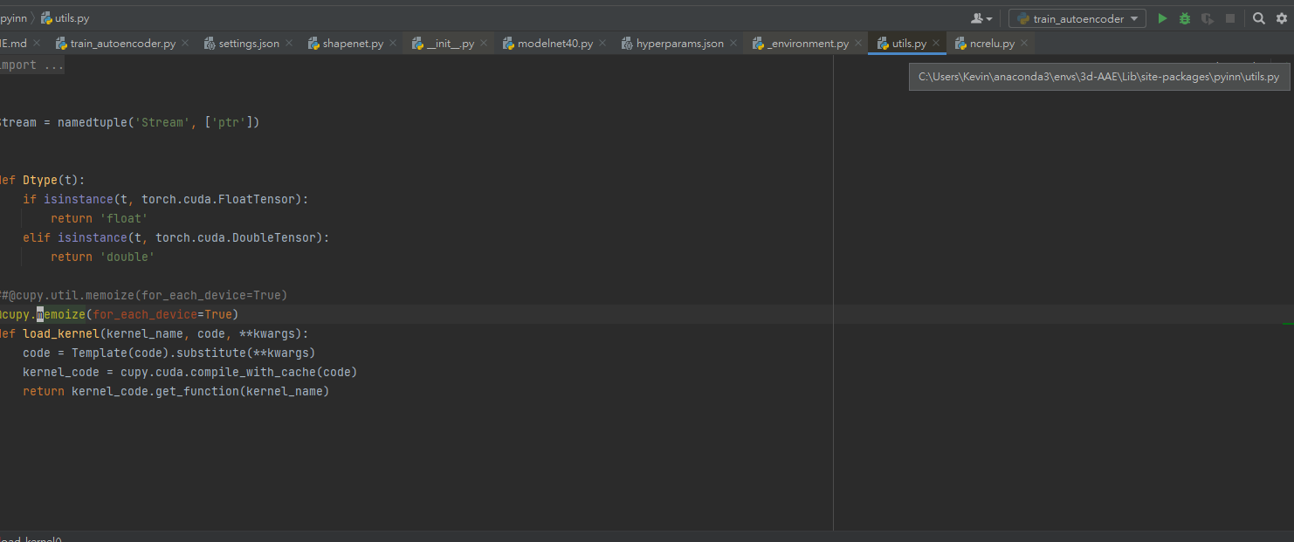

https://blog.csdn.net/weixin_40506067/article/details/109074236