Kevin Leary

Homework 4

**Problem 1**

# Copyright 2017, 2013, 2011 Pearson Education, Inc., W.F. Punch & R.J.Enbody

"""Predator-Prey Simulation

four classes are defined: animal, predator, prey, and island

where island is where the simulation is taking place,

i.e. where the predator and prey interact (live).

A list of predators and prey are instantiated, and

then their breeding, eating, and dying are simulted.

"""

import random

import time

import pylab

class Island (object):

"""Island

n X n grid where zero value indicates not occupied."""

def __init__(self, n, prey_count=0, predator_count=0, human_count=0):

'''Initialize grid to all 0's, then fill with animals

'''

# print(n,prey_count,predator_count)

self.grid_size = n

self.grid = []

for i in range(n):

row = [0]*n # row is a list of n zeros

self.grid.append(row)

self.init_animals(prey_count,predator_count, human_count)

def init_animals(self,prey_count, predator_count, human_count):

''' Put some initial animals on the island

'''

count = 0

# while loop continues until prey_count unoccupied positions are found

while count < prey_count:

x = random.randint(0,self.grid_size-1)

y = random.randint(0,self.grid_size-1)

if not self.animal(x,y):

new_prey=Prey(island=self,x=x,y=y)

count += 1

self.register(new_prey)

count = 0

# same while loop but for predator_count

while count < predator_count:

x = random.randint(0,self.grid_size-1)

y = random.randint(0,self.grid_size-1)

if not self.animal(x,y):

new_predator=Predator(island=self,x=x,y=y)

count += 1

self.register(new_predator)

count = 0

#loop for Humans

while count < human_count:

x = random.randint(0,self.grid_size-1)

y = random.randint(0,self.grid_size-1)

if not self.animal(x,y):

new_human=Human(island=self,x=x,y=y)

count += 1

self.register(new_human)

def clear_all_moved_flags(self):

''' Animals have a moved flag to indicated they moved this turn.

Clear that so we can do the next turn

'''

for x in range(self.grid_size):

for y in range(self.grid_size):

if self.grid[x][y]:

self.grid[x][y].clear_moved_flag()

def size(self):

'''Return size of the island: one dimension.

'''

return self.grid_size

def register(self,animal):

'''Register animal with island, i.e. put it at the

animal's coordinates

'''

x = animal.x

y = animal.y

self.grid[x][y] = animal

def remove(self,animal):

'''Remove animal from island.'''

x = animal.x

y = animal.y

self.grid[x][y] = 0

def animal(self,x,y):

'''Return animal at location (x,y)'''

if 0 <= x < self.grid_size and 0 <= y < self.grid_size:

return self.grid[x][y]

else:

return -1 # outside island boundary

def __str__(self):

'''String representation for printing.

(0,0) will be in the lower left corner.

'''

s = ""

for j in range(self.grid_size-1,-1,-1): # print row size-1 first

for i in range(self.grid_size): # each row starts at 0

if not self.grid[i][j]:

# print a '.' for an empty space

s+= "{:<2s}".format('.' + " ")

else:

s+= "{:<2s}".format((str(self.grid[i][j])) + " ")

s+="\n"

return s

def count_prey(self):

''' count all the prey on the island'''

count = 0

for x in range(self.grid_size):

for y in range(self.grid_size):

animal = self.animal(x,y)

if animal:

if isinstance(animal,Prey):

count+=1

return count

def count_predators(self):

''' count all the predators on the island'''

count = 0

for x in range(self.grid_size):

for y in range(self.grid_size):

animal = self.animal(x,y)

if animal:

if isinstance(animal,Predator):

count+=1

return count

def count_humans(self):

''' count all the humans on the island'''

count = 0

for x in range(self.grid_size):

for y in range(self.grid_size):

animal = self.animal(x,y)

if animal:

if isinstance(animal,Human):

count+=1

return count

class Animal(object):

def __init__(self, island, x=0, y=0, s="A"):

'''Initialize the animal's and their positions

'''

self.island = island

self.name = s

self.x = x

self.y = y

self.moved=False

def position(self):

'''Return coordinates of current position.

'''

return self.x, self.y

def __str__(self):

return self.name

def check_grid(self,type_looking_for=int):

''' Look in the 8 directions from the animal's location

and return the first location that presently has an object

of the specified type. Return 0 if no such location exists

'''

# neighbor offsets

offset = [(-1,1),(0,1),(1,1),(-1,0),(1,0),(-1,-1),(0,-1),(1,-1)]

result = 0

for i in range(len(offset)):

x = self.x + offset[i][0] # neighboring coordinates

y = self.y + offset[i][1]

if not 0 <= x < self.island.size() or \

not 0 <= y < self.island.size():

continue

if type(self.island.animal(x,y))==type_looking_for:

result=(x,y)

break

return result

def move(self):

'''Move to an open, neighboring position '''

if not self.moved:

location = self.check_grid(int)

if location:

# print('Move, {}, from {},{} to {},{}'.format( \

# type(self),self.x,self.y,location[0],location[1]))

self.island.remove(self) # remove from current spot

self.x = location[0] # new coordinates

self.y = location[1]

self.island.register(self) # register new coordinates

self.moved=True

def breed(self):

''' Breed a new Animal.If there is room in one of the 8 locations

place the new Prey there. Otherwise you have to wait.

'''

if self.breed_clock <= 0:

location = self.check_grid(int)

if location:

self.breed_clock = self.breed_time

# print('Breeding Prey {},{}'.format(self.x,self.y))

the_class = self.__class__

new_animal = the_class(self.island,x=location[0],y=location[1])

self.island.register(new_animal)

def clear_moved_flag(self):

self.moved=False

class Prey(Animal):

def __init__(self, island, x=0,y=0,s="O"):

Animal.__init__(self,island,x,y,s)

self.breed_clock = self.breed_time

# print('Init Prey {},{}, breed:{}'.format(self.x, self.y,self.breed_clock))

def clock_tick(self):

'''Prey only updates its local breed clock

'''

self.breed_clock -= 1

# print('Tick Prey {},{}, breed:{}'.format(self.x,self.y,self.breed_clock))

class Predator(Animal):

def __init__(self, island, x=0,y=0,s="X"):

Animal.__init__(self,island,x,y,s)

self.starve_clock = self.starve_time

self.breed_clock = self.breed_time

# print('Init Predator {},{}, starve:{}, breed:{}'.format( \

# self.x,self.y,self.starve_clock,self.breed_clock))

def clock_tick(self):

''' Predator updates both breeding and starving

'''

self.breed_clock -= 1

self.starve_clock -= 1

# print('Tick, Predator at {},{} starve:{}, breed:{}'.format( \

# self.x,self.y,self.starve_clock,self.breed_clock))

if self.starve_clock <= 0:

# print('Death, Predator at {},{}'.format(self.x,self.y))

self.island.remove(self)

def eat(self):

''' Predator looks for one of the 8 locations with Prey. If found

moves to that location, updates the starve clock, removes the Prey

'''

if not self.moved:

location = self.check_grid(Prey)

if location:

# print('Eating: pred at {},{}, prey at {},{}'.format( \

# self.x,self.y,location[0],location[1]))

self.island.remove(self.island.animal(location[0],location[1]))

self.island.remove(self)

self.x=location[0]

self.y=location[1]

self.island.register(self)

self.starve_clock=self.starve_time

self.moved=True

class Human(Predator):

def __init__(self, island, x=0, y=0, s="H"):

Predator.__init__(self,island,x,y,s)

self.hunt_clock = self.hunt_time

def clock_tick(self):

''' Human updates hunt cloak and both predator clocks

'''

self.hunt_clock -=1

Predator.clock_tick(self)

def hunt(self):

''' Human looks for Predators to hunt for fun. NOT TO EAT

'''

if not self.moved:

location = self.check_grid(Predator)

#print(location)

if location == (1,0) or location == (0,1) or location == (1,1):

self.island.remove(self.island.animal(location[0],location[1]))

self.island.remove(self)

self.x=location[0]

self.y=location[1]

self.island.register(self)

self.hunt_clock = self.hunt_time

self.moved=True

###########################################

def main(human_breed_time=10, human_starve_time=7, human_hunt_time=5, initial_humans=5,\

predator_breed_time=6, predator_starve_time=3, initial_predators=10, prey_breed_time=3, initial_prey=60, \

size=10, ticks=300):

''' main simulation. Sets defaults, runs event loop, plots at the end

'''

# initialization values

Predator.breed_time = predator_breed_time

Predator.starve_time = predator_starve_time

Prey.breed_time = prey_breed_time

#Human Initialization

Human.breed_time = human_breed_time

Human.starve_time = human_starve_time

Human.hunt_time = human_hunt_time

# for graphing

predator_list=[]

prey_list=[]

human_list=[]

# make an island

isle = Island(size,initial_prey, initial_predators, initial_humans)

print(isle)

# event loop.

# For all the ticks, for every x,y location.

# If there is an animal there, try eat, move, breed and clock_tick

for i in range(ticks):

# important to clear all the moved flags!

isle.clear_all_moved_flags()

for x in range(size):

for y in range(size):

animal = isle.animal(x,y)

if animal:

if isinstance(animal,Predator):

animal.eat()

if isinstance(animal,Human):

animal.eat()

animal.hunt()

animal.move()

animal.breed()

animal.clock_tick()

# record info for display, plotting

prey_count = isle.count_prey()

predator_count = isle.count_predators()

human_count = isle.count_humans()

if prey_count == 0:

print('Lost the Prey population. Quiting.')

break

#NOW only quit if prey population is gone

#if predator_count == 0:

#print('Lost the Predator population. Quitting.')

#break

prey_list.append(prey_count)

predator_list.append(predator_count)

human_list.append(human_count)

# print out every 10th cycle, see what's going on

if not i%10:

print(prey_count, predator_count, human_count)

# print the island, hold at the end of each cycle to get a look

# print('*'*20)

# print(isle)

# ans = input("Return to continue")

pylab.plot(predator_list)

pylab.plot(prey_list)

pylab.plot(human_list)

pylab.gca().legend(('Predators', 'Prey', 'Humans'))

pylab.show()

main()

Terminal output for the last graph

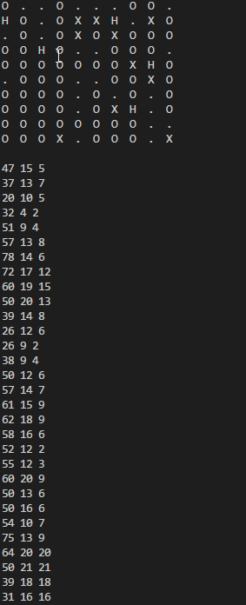

Screenshots of different outcomes

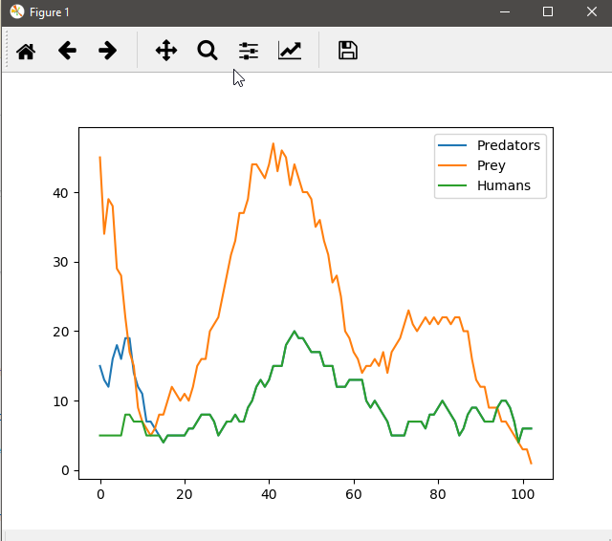

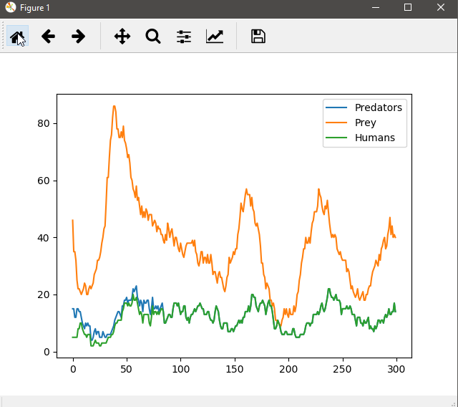

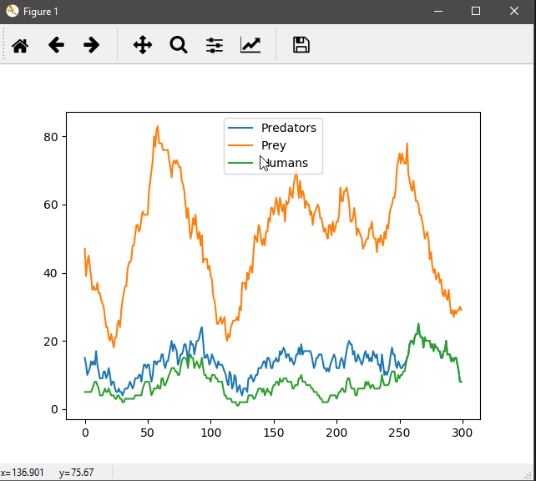

**Problem 2**

#Part B

def test_ed_append():

test_name = 'test_append'

test_fn = 'test.txt'

if os.path.isfile(test_fn):

os.remove(test_fn)

initial_text = 'ABCD'

with open(test_fn, 'w') as test_f:

test_f.write(initial_text)

try:

new_text = '01234'

ret = ed_append(test_fn, new_text)

expected_text = initial_text + new_text

current_text = open(test_fn, 'r').read()

cond = (ret == len(new_text)) and (current_text == expected_text)

return testif(cond, test_name)

except Exception as exc:

print('test {} failed due to exception: {}\n'.format(test_name, str(exc)))

return False

def testif(b, testname, msgOK= "" , msgFailed= "" ):

"""Function used for testing."""

if b:

print ( "Success: " + testname + "; " + msgOK)

else :

print ( "Failed: " + testname + "; " + msgFailed)

return b

#Part A

def ed_read(file, start, end):

"""Will Read the file starting from the give starting index and

ending at the given end index

"""

try:

str_read = ""

str_file = open(file, "r", encoding='utf8')

for start, c in str_file:

if start == end:

break

else:

str_read = str_read + c

except IOError:

print('{} is a bad file name'.format(file))

break

except FileNotFoundError:

print('file {}: cannot be found'.format(file))

break

except ValueError:

print('one or more variables exceed file length')

break

def ed_find(file, search_str):

"""This function will retun the first index a word is found and can return

multiple values. will return [] if nothing is found

"""

try:

temp = list() #for variables

str_file = open(file, "r", encoding='utf8')

for i, c in str_file: #start searching the file

if c == search_str[0]: #if the character in the file is equal to the first letter in the search string then...

temp.append(i) #append it to list then..

for j in search_str: #incrementing through the search word

if str_file[i+j] != search_str[j]: #if it doesnt match the part of the file then....

temp.remove(i) #Remove the value from the list and end the loop

break

return temp

except IOError:

print('{} is a bad file name'.format(file))

break

except FileNotFoundError:

print('file {}: cannot be found'.format(file))

break

def ed_replace(file, search_str, replace_with, occurence):

"""Similar to ed_find .. can probably call it...

This function takes a search string and a astring to replace with..

if occurence >= 0 it replaces the search string with the replace word only at that index

if occurence == -1 then it replaces all of them

"""

try:

str_file = open(file, "w", encoding='utf8')

if occurence == -1:

temp_ls = ed_find(file, search_str)

for i in temp_ls:

#temp_str = ""

#for j in search_str:

#temp_str = str_file[temp_ls + j]

str_file[i].replace(search_str, replace_with) #hoping that this works like a string

else:

str_file[occurence].replace(search_str, replace_with)

except IOError:

print('{} is a bad file name'.format(file))

break

except FileNotFoundError:

print('file {}: cannot be found'.format(file))

break

def ed_append(file, str_a):

"""Appends a string to the end of the file. If the file does not exist a new one is created

The function returns the number of characters written to the file

"""

try:

str_file = open(file, "a", encoding='utf8')

str_file.write(str_a)

return len(str_a)

except IOError:

print('{} is a bad file name'.format(file))

break

except FileNotFoundError:

print('file {}: cannot be found'.format(file))

break

def ed_write(file, pos_str_col):

"""pos_str_col is a list has (position, s)

"""

try:

str_file = open(file, "r+", encoding='utf8')

count = 0

for i in pos_str_col:

if i < 0 or i > len(str_file):

raise ValueError('position parameter is less than 0 or greater than the file length')

return count

except IOError:

print('{} is a bad file name'.format(file))

break

except FileNotFoundError:

print('file {}: cannot be found'.format(file))

break

def ed_insert(file, pos_str_col):

"""

"""

try:

str_file = open(file, "r+", encoding='utf8')

count = 0

for i in pos_str_col:

if i < 0 or i > len(str_file):

raise ValueError('position parameter is less than 0 or greater than the file length')

return count

except IOError:

print('{} is a bad file name'.format(file))

break

except FileNotFoundError:

print('file {}: cannot be found'.format(file))

break

#Part C

def main():

fn = "file1.txt" # assume this file does not exist yet.

ed_append(fn, "0123456789") # this will create a new file

ed_append(fn, "0123456789") # the file content is: 01234567890123456789

print(ed_read(fn, 3, 9)) # prints 345678. Notice that the interval excludes index to (9)

print(ed_read(fn, 3)) # prints from 3 to the end of the file: 34567890123456789

lst = ed_find(fn, "345")

print(lst) # prints [3, 13]

print(ed_find(fn, "356")) # prints []

ed_replace(fn, "345", "ABCDE", 1) # changes the file to 0123456789012ABCDE6789

# assume we reset the file content to 01234567890123456789 (not shown

ed_replace(fn, "345", "ABCDE") # changes the file to 012ABCDE6789012ABCDE6789

# assume we reset the file content to 01234567890123456789 (not shown)

# # this function overwrites original content:

ed_write(fn, ((2, "ABC"), (10, "DEFG"))) # changes file to: 01ABC56789DEFG456789# this should work with lists as well: [(2, "ABC"), (10, "DEFG")]

ed_write(fn, ((2, "ABC"), (30, "DEFG")))

ed_insert(fn, ((2, "ABC"), (10, "DEFG"))) # changed file to: 01ABC23456789DEFG0123456789

main()

I wasn’t able to finish so lots of errors on this bad boy

