Year 2023

整体预览

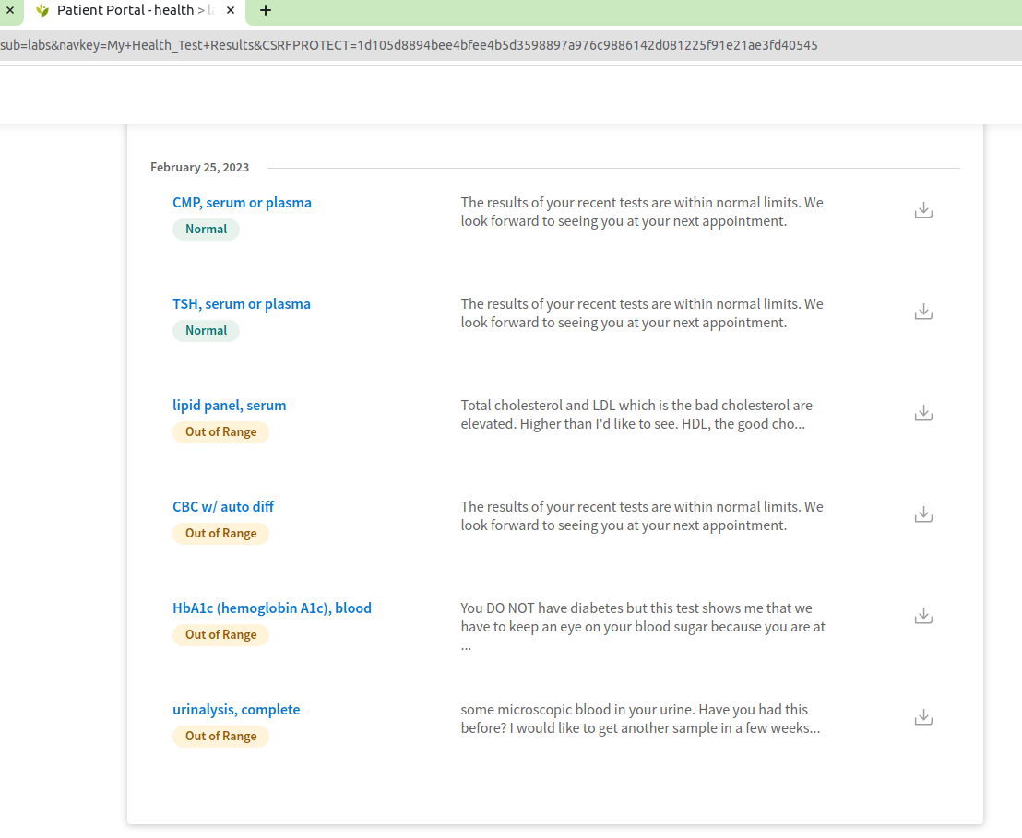
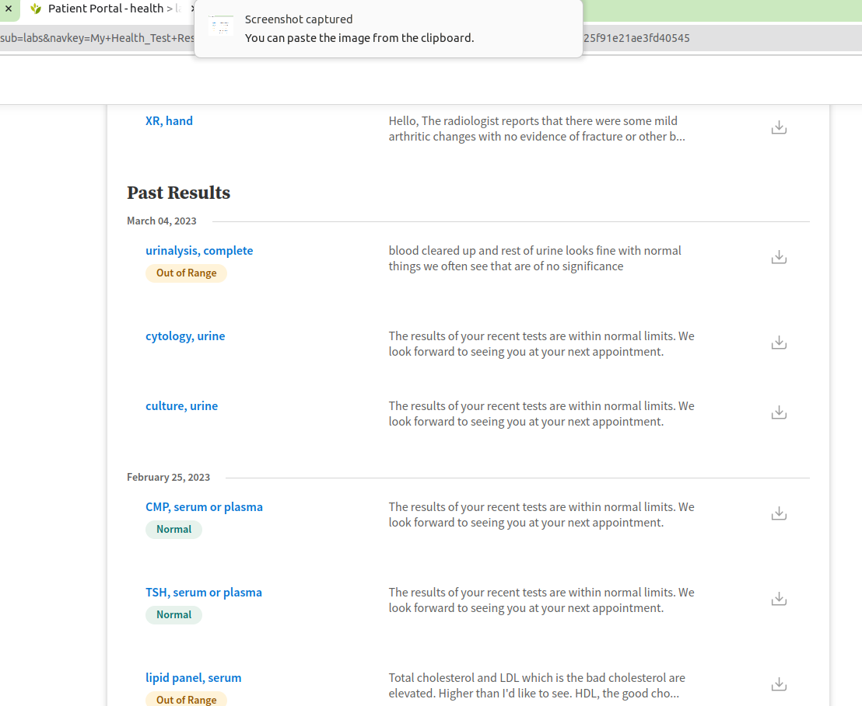

解释

上面有很多检查的项，每一条里面都有很多检查，只要1/10 有问题就会显示成黄色。黄色就是有问题的。
很多绿色的是OK的，但是因为是一个值域区间，所以过高和过低 都要值得重视。
Out of Ranges （超过标准值域的指标）

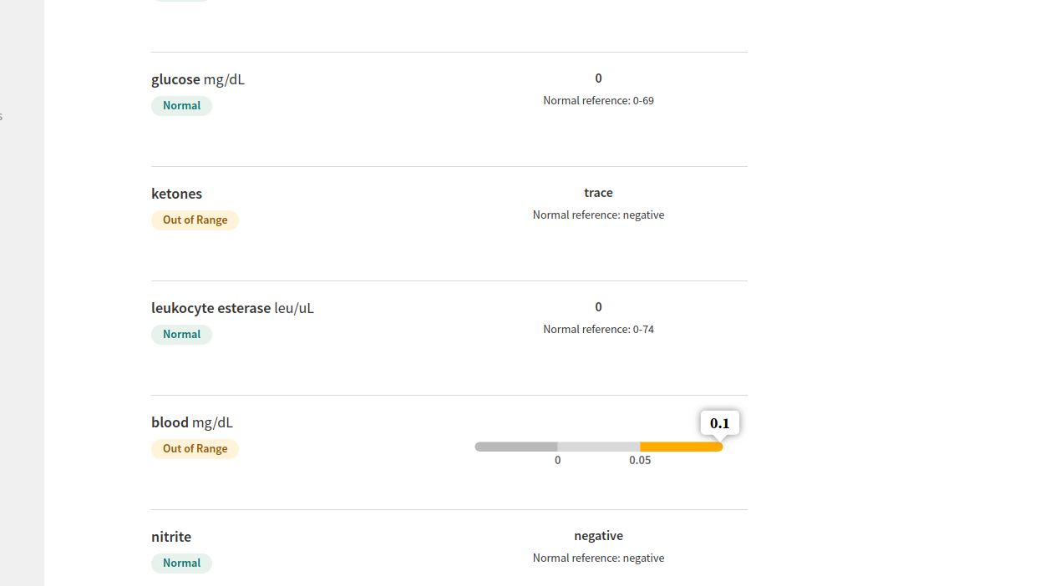

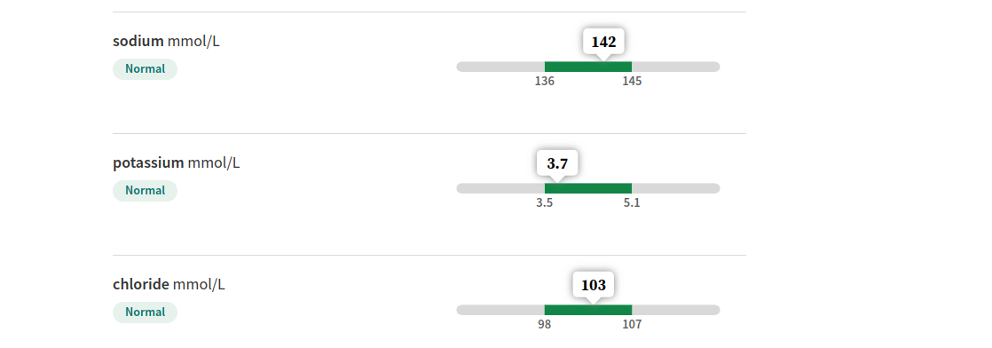

需要注意的：

氯： 正常
钠离子： 偏高，可能是盐过多
钾离子： 偏低，多吃香蕉和维生素

Ketones in your blood or urine indicate that your body is burning fats instead of glucose for energy. Having ketones means your body is using its backup energy source — fats. If you have Type 1 diabetes, high ketones can be dangerous. Levels that are too high can put you at risk of a potentially fatal complication called diabetes-related ketoacidosis (DKA).

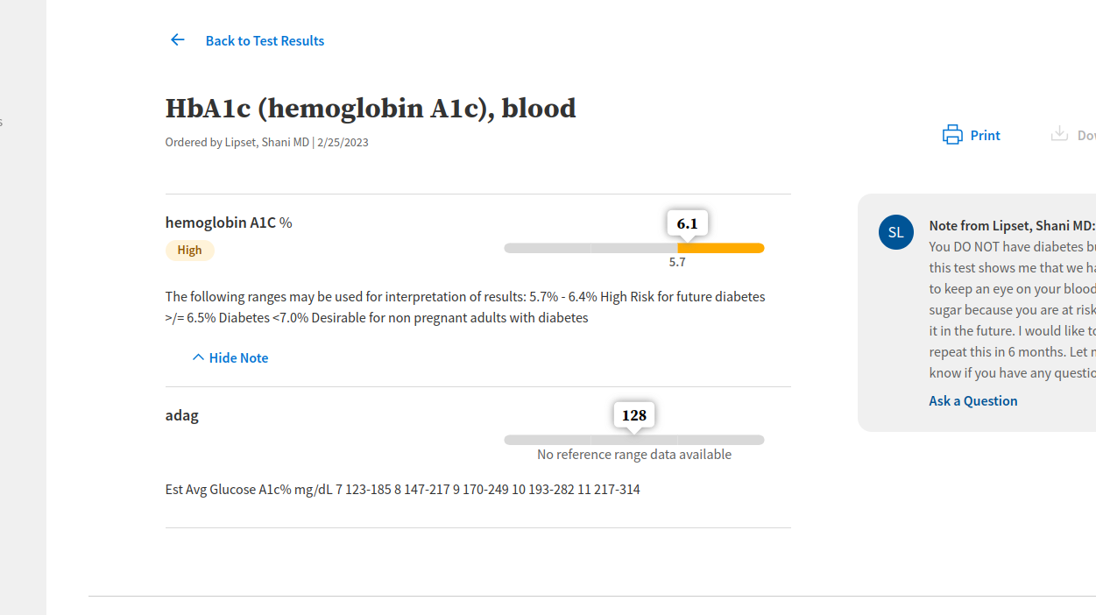

糖血红蛋白： 高. 不运动，不生肌肉，所以代谢的慢，需要增加肌肉训练和换血。

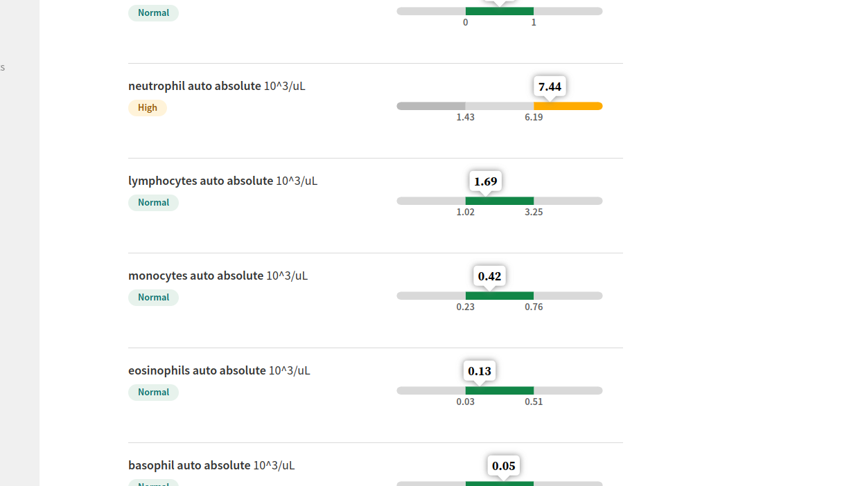
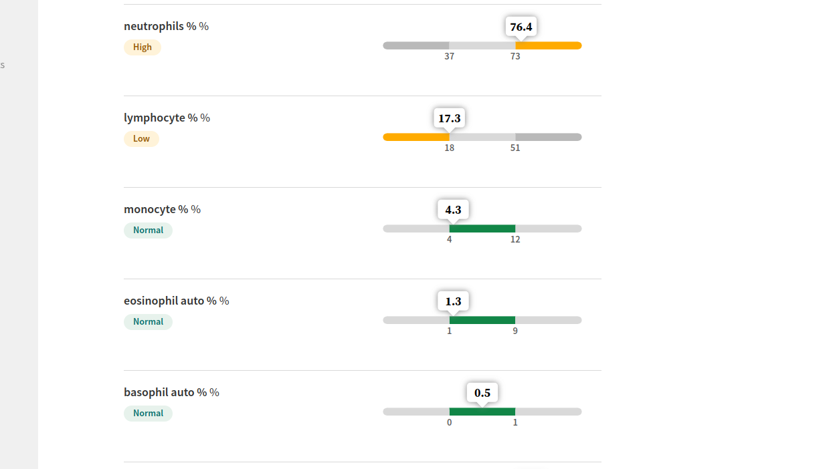

Neutropohils: 中性白细胞
lymphocyte: 淋巴细胞
eosinophil: white cell

- Reactions to certain drugs, such as corticosteroids(皮质激素类), beta-2-agonists(2受体激动剂), and epinephrine (肾上腺素)
- Physical or emotional stress

These spikes are generally short-term. In many cases, it's normal for your body to produce more neutrophils to help you heal, especially in the case of a bone fracture or severe burn. However, if the number of neutrophils doesn't decrease to normal levels after repairing an injury, it can pose a health risk.
Symptoms of a high neutrophil count include:
- Fevers
- Recurring infections
- Fast heart rate
- Swollen lymph nodes
- Unexplained weight loss
- Night sweats
- Fatigue
- Body aches

A low eosinophil count, also known as eosinopenia, is usually not a major health concern because other immune system cells compensate. However, long-term eosinopenia can be dangerous and requires immediate treatment from a healthcare provider.

Low eosinophil numbers may indicate excessive stress, alcohol misuse, or the presence of an underlying condition. Eosinophils play a role in the immune system by helping to fight bacterial and viral infections and can also play a role in the inflammatory response to an allergen.
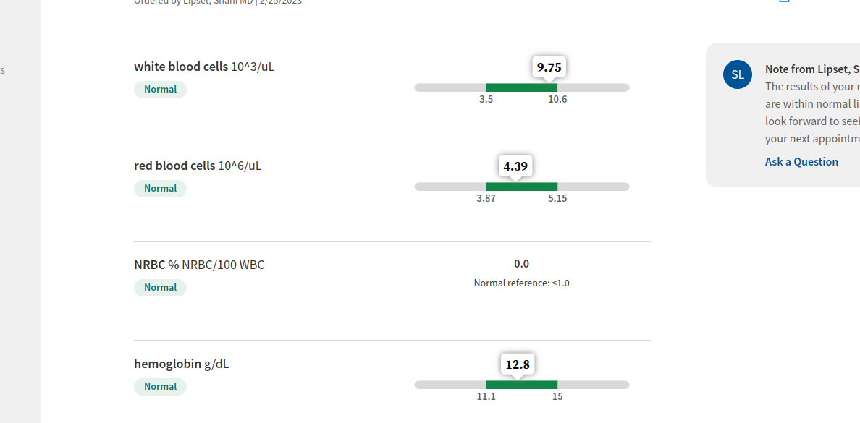

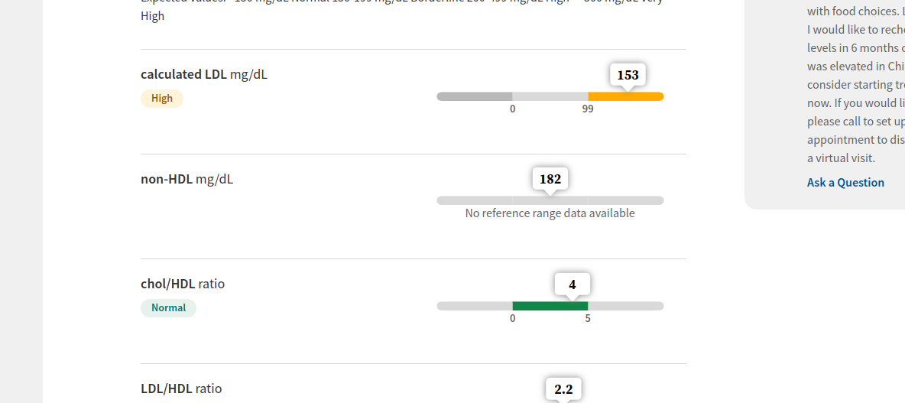
LDL: high. 低密度胆固醇高，容易导致中风。需要运动减少。

尿检


以上是尿液里面有絮状物质，第二项是有不规则的晶体。通常无害，问题存在于吃的东西含有大量的糖和盐。

整体解释：

1/ 尿有絮状物，晶体颗粒可能是酸性物质的结晶，和饮食多盐有关。
2/ KETONES 过高，keytones是酸性的酸，身体分泌它是因为身体在消耗你的脂肪而不是摄入的葡萄糖，说明你摄入的葡萄糖不够，消耗脂肪。过高的ketones会导致血液太酸和中毒。
3/ Ketones 中文是酮。产生过高的原因是碳水化合物摄入不够。

解决方案：

1/ 少盐
2/ 肌肉训练和献血，减少糖化血红蛋白和LDL
3/ 吃维生素，补充金属钾
4/ 吃碳水化合物和优质脂肪，让Ketones下降一些。

参考资料

What do ketones do in your body?
Ketones fuel your brain and body in the absence of glucose, your body’s primary energy source. Think of ketones as your backup energy reserve when the main source is depleted, low or unusable.
Typically, your body breaks down food into glucose. A hormone called insulin helps your cells use glucose as an energy source or store it for when you need it later.
Your body will switch to ketosis if you’re not getting enough carbohydrates. During ketosis, your body breaks down fats for energy, releasing ketones. The ketones energize cells and tissue so your body can keep working. Ketosis is a normal process. For example, your body can go into ketosis (and make more ketones) when:
You’re asleep.
- You’re fasting.
- You’re exercising.
- You’re on the keto diet.
People on the keto diet purposely cut back on carbs and eat more fatty foods so their bodies will burn more fat. Inducing ketosis with the keto diet may provide benefits depending on your health. But you should always speak with a healthcare provider before trying this diet. It causes major changes to your body and isn’t for everyone. Also, the keto diet is very restrictive, so it can be difficult to stick to for extended periods of time.

Where are ketones located?
Ketosis occurs in your liver. Your liver releases the ketones into your bloodstream, where they travel throughout your body, providing energy. Once they’ve done their job, you pee them out.

Conditions and Disorders

What are the common conditions and disorders associated with ketones?
Understanding what ketones do and keeping track of ketone levels is especially important if you have diabetes — Type 1 diabetes, in particular. Type 1 diabetes is a condition that prevents your body from making insulin. Insulin is the hormone that helps your body use glucose for energy.
Problems with insulin cause your blood sugar levels to rise (hyperglycemia) and can cause too many ketones to build up in your blood. This can lead to diabetes-related ketoacidosis (DKA). DKA is more common in people with Type 1 diabetes but can happen with Type 2 diabetes, too.
People with alcohol use disorder are at risk of alcoholic ketoacidosis. People with a history of heavy drinking may develop dangerously high levels of ketones. This usually happens after binge drinking and vomiting, which prevents you from getting enough nutrition. Like DKA, alcohol-related ketoacidosis is a medical emergency that requires immediate treatment.

What are the symptoms of high ketones?
Call your provider immediately or visit the ER if you have diabetes and notice symptoms of high ketones.
Early symptoms are similar to the symptoms of high blood sugar and include:
- Having to pee more than usual (frequent urination).
- Feeling extremely thirsty.
- Dry mouth and dehydration.
- Dry skin.
- Headache.
Without treatment, DKA can progress fast (within 24 hours or even less). Symptoms include:
- Nausea and vomiting.
- Fatigue (feeling tired and weak even with rest).
- Stomach pain.
- Shortness of breath.
- Confusion.
- Fruity-smelling breath (sometimes called “keto breath”).

