Terminology

HbA1c (hemoglobin A1c)

Appendix Report of Oct 2023

CBC w/ auto diff
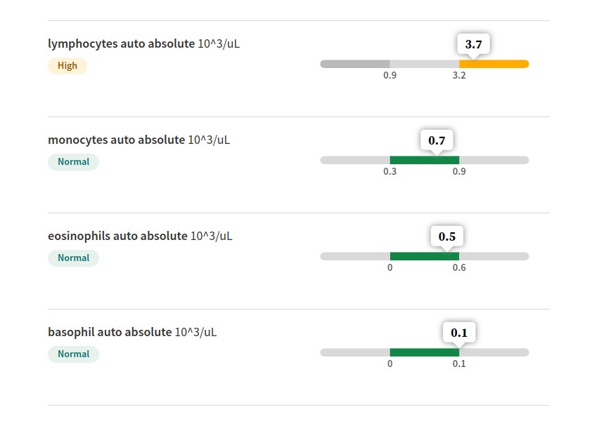

CMP, serum or plasma
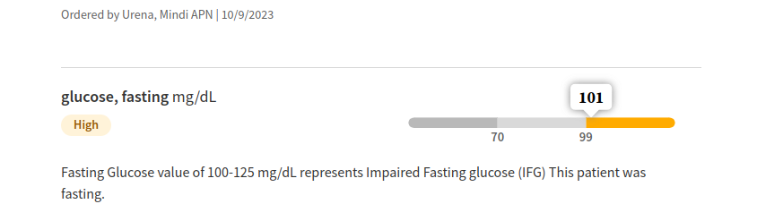
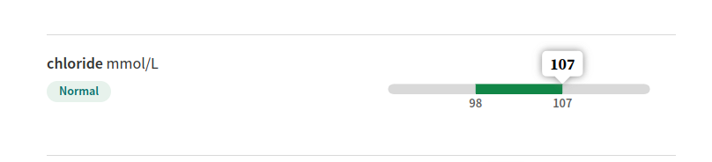

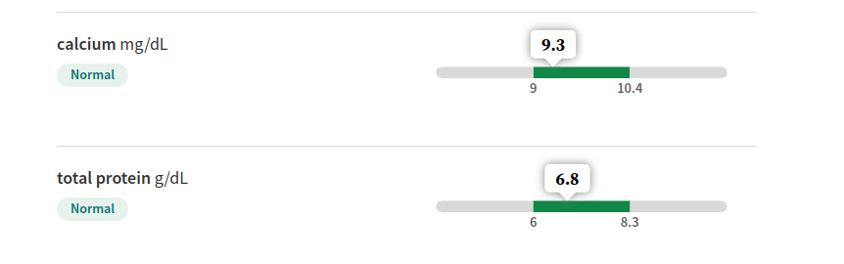

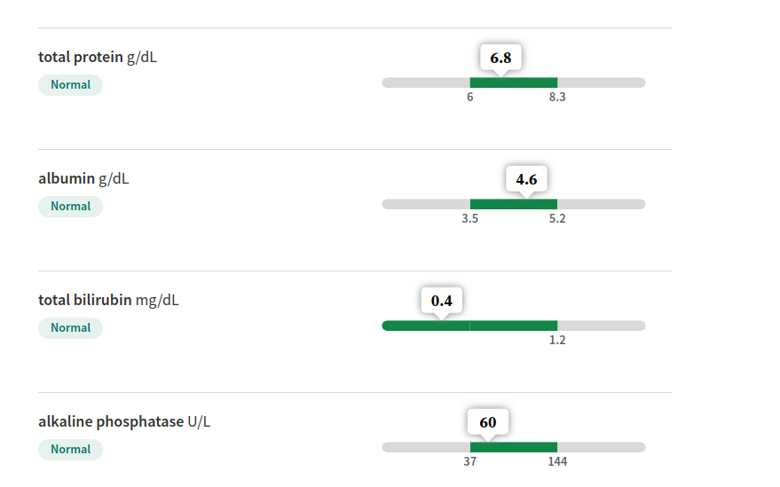

lipid panel, serum

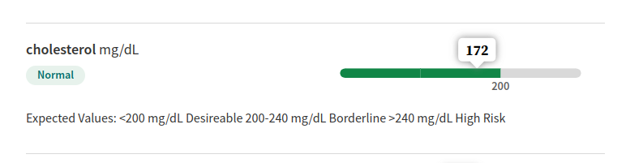

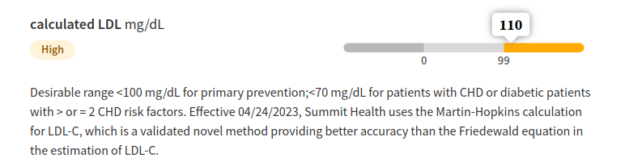

HbA1c (hemoglobin A1c), blood

