Advanced Data Management Study Guide

Video Recording

https://kevinli-webbertech.github.io/blog/html/courses_list.html

Video Recordings in the past semesters, but it was divided into small pieces and it was better than a 3-hr recording but I also recorded this session for today.

The previous transcripts or videos of zoom, I will look for it during our lab time and I will ping you late in the announcement.

Go to the section called "Advanced Database Courses"

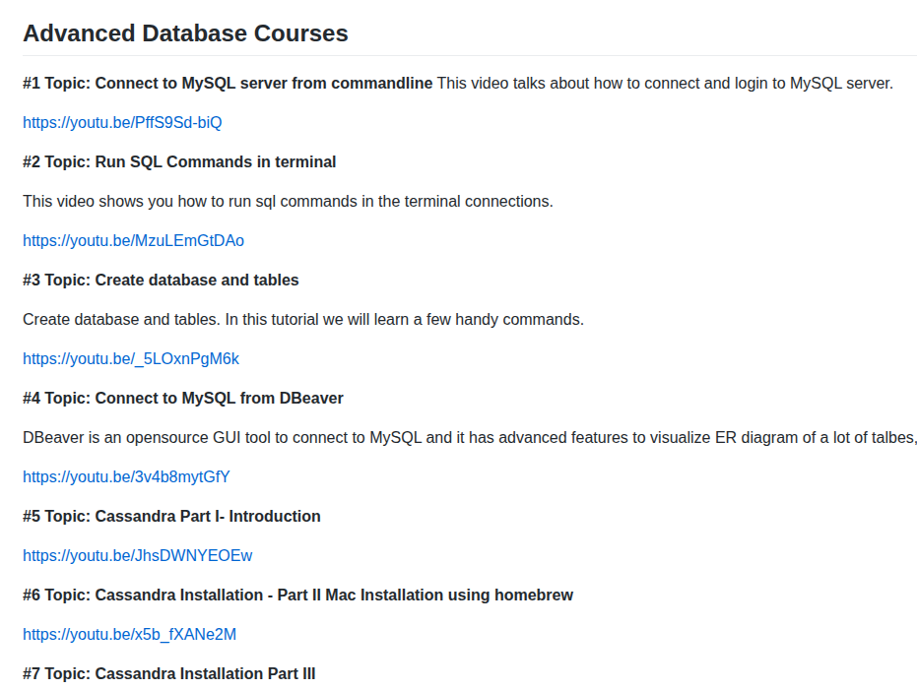

Midterm Quiz (45 mins)

It is all multiple(single-choice) choices questions. Only one answer. It is all about SQL Syntax.

For studying for the quiz, you can refer to the following websites,

* https://www.tutorialspoint.com/sql/index.htm

* https://www.w3schools.com/sql/

For mocking quiz for midterm, please go to,

https://www.w3schools.com/sql/sql_quiz.asp

Ways to contact and Q&A Time

Contact me by email in NJCU Blackboard.

Click on “New Message”,
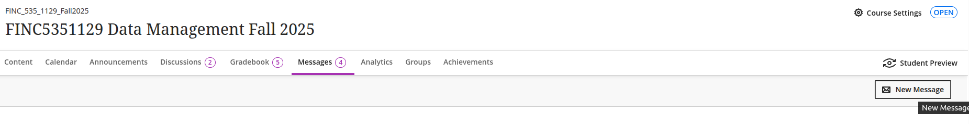
Type xli7 and see “Xiaofeng Li” and this will send a copy to my school email as well,
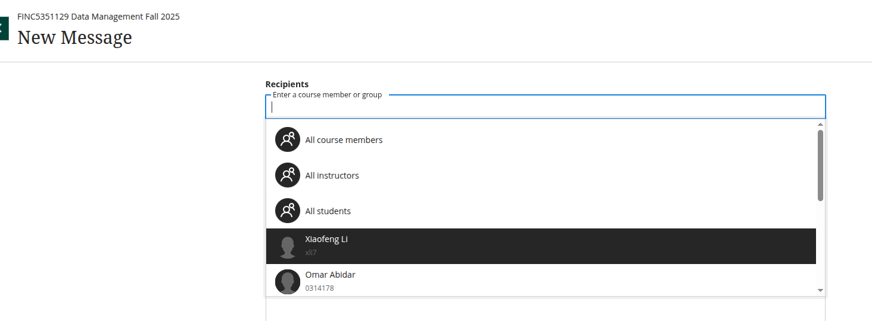

Dockerized DB

https://kevinli-webbertech.github.io/blog/html/courses/dev_ops/docker/labs/docker_database.html

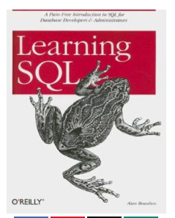
Books

Learning SQL
By Alan Beaulieu

you can find free copy online.

