Git Lab – Get familiar with basic git commands

Step 1 Checkout your git repo we created earlier when we built the Jenkin Pipeline job with Jenkinfile.

bash-3.2$ git clone https://github.com/kevinli-webbertech/gs-spring-boot.git

Step 2 Check your branches in your local. Because you clone the image site of the whole repo from the git server to your local.

bash-3.2$ git branch
- main

Step 3 you create a local branch, or your development branch

bash-3.2$ git checkout -b my_branch
Switched to a new branch 'my_branch'
bash-3.2$ git branch
main
* my_branch

Step 4 Let us create a new file called Readme.md

bash-3.2$ git status
On branch my_branch
nothing to commit, working tree clean

bash-3.2$ touch Readme.md

Step 5 Edit the Readme.md
Assume this is a documentation or source code we need to commit

bash-3.2$ git status
On branch my_branch
Untracked files:
(use "git add <file>..." to include in what will be committed)
Readme.md

nothing added to commit but untracked files present (use "git add" to track)

bash-3.2$ vi Readme.md
bash-3.2$ git status
On branch my_branch
Untracked files:
(use "git add <file>..." to include in what will be committed)

Readme.md

nothing added to commit but untracked files present (use "git add" to track)
bash-3.2$ git add Readme.md
bash-3.2$ git status
On branch my_branch
Changes to be committed:
(use "git reset HEAD <file>..." to unstage)

new file: Readme.md

bash-3.2$ git commit -m "add a readme file"
[my_branch 864e332] add a readme file
1 file changed, 9 insertions(+)
create mode 100644 Readme.md

Now `git status` does not tell you anything beyond this point when you committed all the new files successfully but it will tell anything that is not committed, so called “not tracked”.

bash-3.2$ git status
On branch my_branch
nothing to commit, working tree clean

Step 6 Git PUSH

Now I try to push the new branch with my new changes to the remote server.

If I do that, I see the following,

bash-3.2$ git push
fatal: The current branch my_branch has no upstream branch.
To push the current branch and set the remote as upstream, use
git push --set-upstream origin my_branch

Copy the following command from the above message prompt and then execute it, then you will see the new branch created in your local is pushed to the remote server, now the server has it.

bash-3.2$ git push --set-upstream origin my_branch
Enumerating objects: 4, done.
Counting objects: 100% (4/4), done.
Delta compression using up to 12 threads
Compressing objects: 100% (3/3), done.
Writing objects: 100% (3/3), 366 bytes | 366.00 KiB/s, done.
Total 3 (delta 1), reused 0 (delta 0)
remote: Resolving deltas: 100% (1/1), completed with 1 local object.
remote:
remote: Create a pull request for 'my_branch' on GitHub by visiting:
remote: https://github.com/kevinli-webbertech/gs-spring-boot/pull/new/my_branch
remote:
To https://github.com/kevinli-webbertech/gs-spring-boot.git
* [new branch] my_branch -> my_branch
Branch 'my_branch' set up to track remote branch 'my_branch' from 'origin'.

Step 7. Check the new branch in both remote git server and in local.

There are two ways you can check if your branch was successfully pushed to the remote git server.

- You can go to the web page of git and check the new branch there.
- You run a command in your local command line and you do not have to waste to open a browser tab and check the info by clicking a few times.
- Now if I type the following commands,

bash-3.2$ git branch
main
- my_branch

It just showed my local branches, not the remote branches,

If somehow I removed some local branches, that will not affect the git server repo branches, unless I delete the remote branches as well.

So now let us delete the local branch after we pushed it.

bash-3.2$ git branch
main
- my_branch

bash-3.2$ git branch -d my_branch
error: Cannot delete branch 'my_branch' checked out at '/Users/xiaofengli/code/gs-spring-boot'

As we notice that above, I am currently on the `my_branch`, so I can not delete it. But if I really want to delete it, I have to switch to another branch.

bash-3.2$ git checkout main
Switched to branch 'main'
Your branch is up to date with 'origin/main'.

Now we are able to delete the previous branch.

bash-3.2$ git branch -d my_branch
warning: deleting branch 'my_branch' that has been merged to
'refs/remotes/origin/my_branch', but not yet merged to HEAD.
Deleted branch my_branch (was 864e332).

Now we check the local branch, and it is not there anymore.

bash-3.2$ git branch
- main

- Solution 2

How do we check what remote branches we have in the remote git server repo using command?

bash-3.2$ git branch -r
origin/HEAD -> origin/main
origin/main
origin/my_branch

Now what we can see from the above is that we can see `origin/my_branch` in there.
That is our remote branch that we just pushed.

Now since we do not have a local branch in our own computer, sometimes at work, I mistakenly got rid of my own personal branch and I really want to get it back. We can checkout remote branch to local as well.

For instance, now I want to checkout my_branch back to my local from remote server.

bash-3.2$ git checkout my_branch
Branch 'my_branch' set up to track remote branch 'my_branch' from 'origin'.
Switched to a new branch 'my_branch'

Now I check my local branches and I can see my branch came back.

bash-3.2$ git branch
main
- my_branch
bash-3.2$ git branch -h
usage: git branch [<options>] [-r | -a] [--merged | --no-merged]
or: git branch [<options>] [-l] [-f] <branch-name> [<start-point>]
or: git branch [<options>] [-r] (-d | -D) <branch-name>...
or: git branch [<options>] (-m | -M) [<old-branch>] <new-branch>
or: git branch [<options>] (-c | -C) [<old-branch>] <new-branch>
or: git branch [<options>] [-r | -a] [--points-at]
or: git branch [<options>] [-r | -a] [--format]

Generic options
-v, --verbose show hash and subject, give twice for upstream branch
-q, --quiet suppress informational messages
-t, --track set up tracking mode (see git-pull(1))
-u, --set-upstream-to <upstream>
change the upstream info
--unset-upstream Unset the upstream info
--color[=<when>] use colored output
-r, --remotes act on remote-tracking branches
--contains <commit> print only branches that contain the commit
--no-contains <commit>
print only branches that don't contain the commit
--abbrev[=<n>] use <n> digits to display SHA-1s

Specific git-branch actions:
-a, --all list both remote-tracking and local branches
-d, --delete delete fully merged branch
-D delete branch (even if not merged)
-m, --move move/rename a branch and its reflog
-M move/rename a branch, even if target exists
-c, --copy copy a branch and its reflog
-C copy a branch, even if target exists
-l, --list list branch names
--create-reflog create the branch's reflog
--edit-description edit the description for the branch
-f, --force force creation, move/rename, deletion
--merged <commit> print only branches that are merged
--no-merged <commit> print only branches that are not merged
--column[=<style>] list branches in columns
--sort <key> field name to sort on
--points-at <object> print only branches of the object
-i, --ignore-case sorting and filtering are case insensitive
--format <format> format to use for the output

In linux/Unix, the -h will help you, and single dash with one letter is similar to double dash with a full words.

For example, `-r` means `--remotes`

bash-3.2$ git branch --remote
origin/HEAD -> origin/main
origin/main
origin/my_branch

bash-3.2$ git branch --remotes
origin/HEAD -> origin/main
origin/main
origin/my_branch

- Solution 2

Let us check the branch on the web UI.

Please see the yellow banner below,
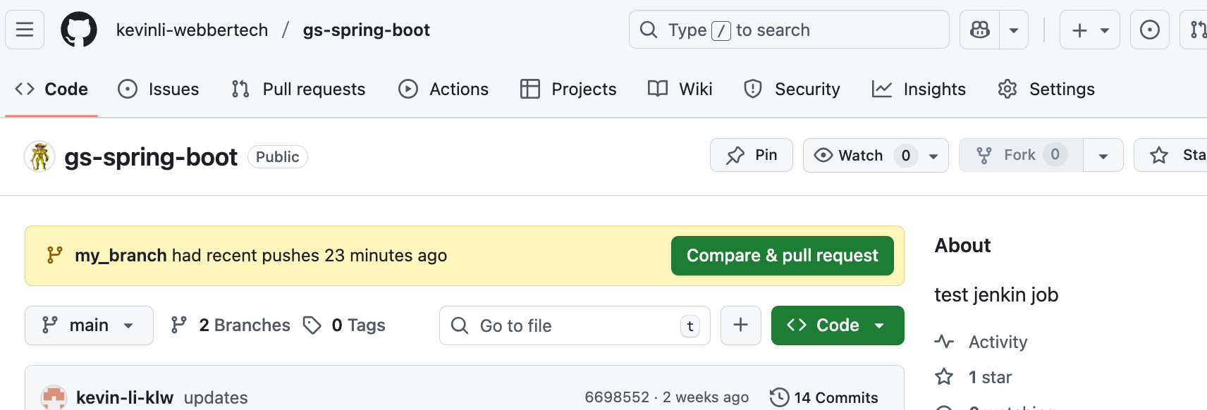
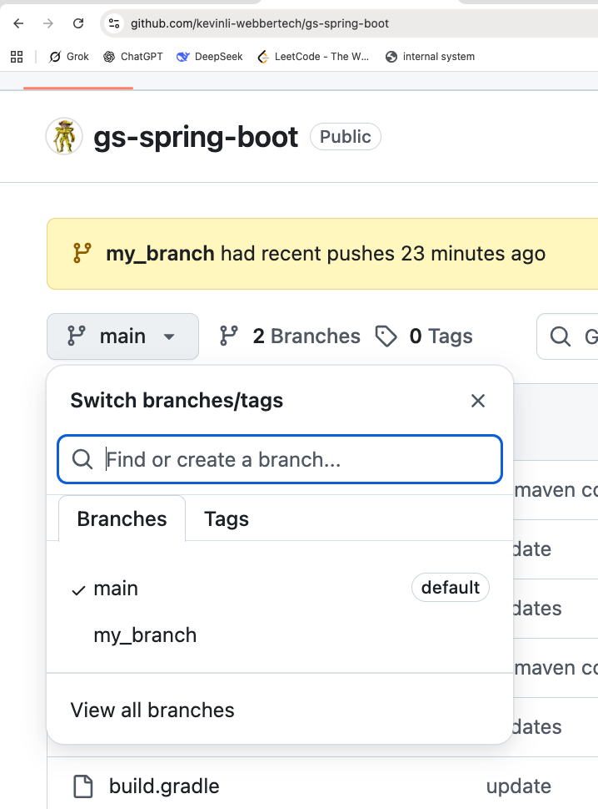
Check the drop-down menu,
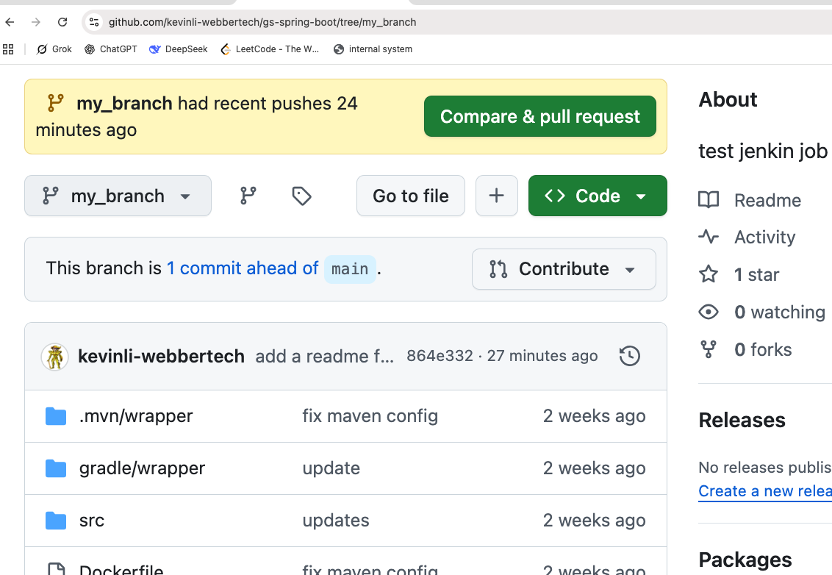
Now let us check the new file we added,
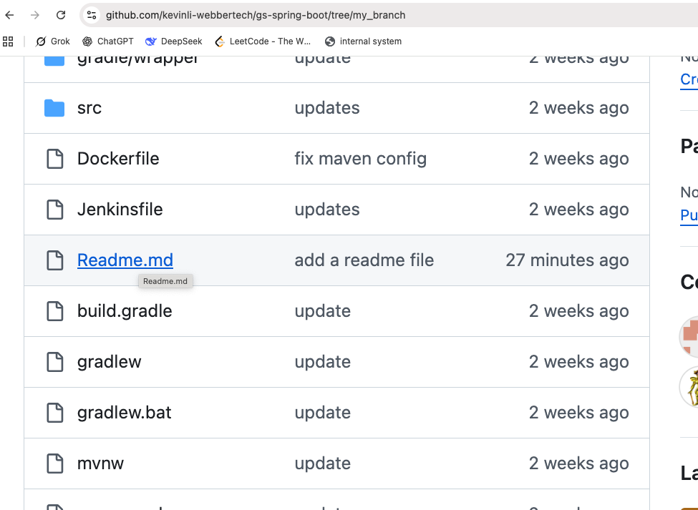

Click on the Readme.md, which is a markdown file.

**Markdown** is actually similar to **Markup** Language which is a HTML.

I use markdown in css in my course site so it will convert into html without writing a whole bunch of code and writing markdown is just like a word document but we have a lot of annotations to render and support the writing without html tagging libs.

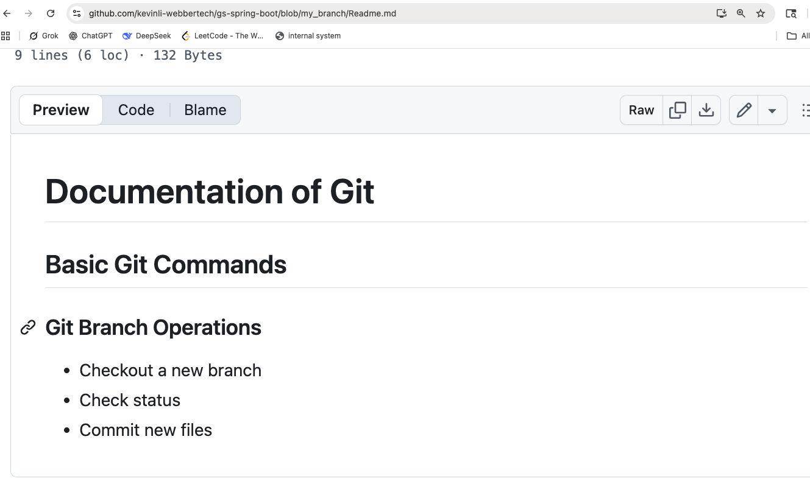
Click on “edit” button,

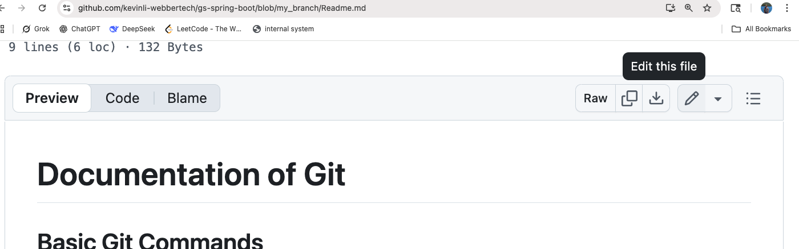

Keep Editing and adding new stuff,

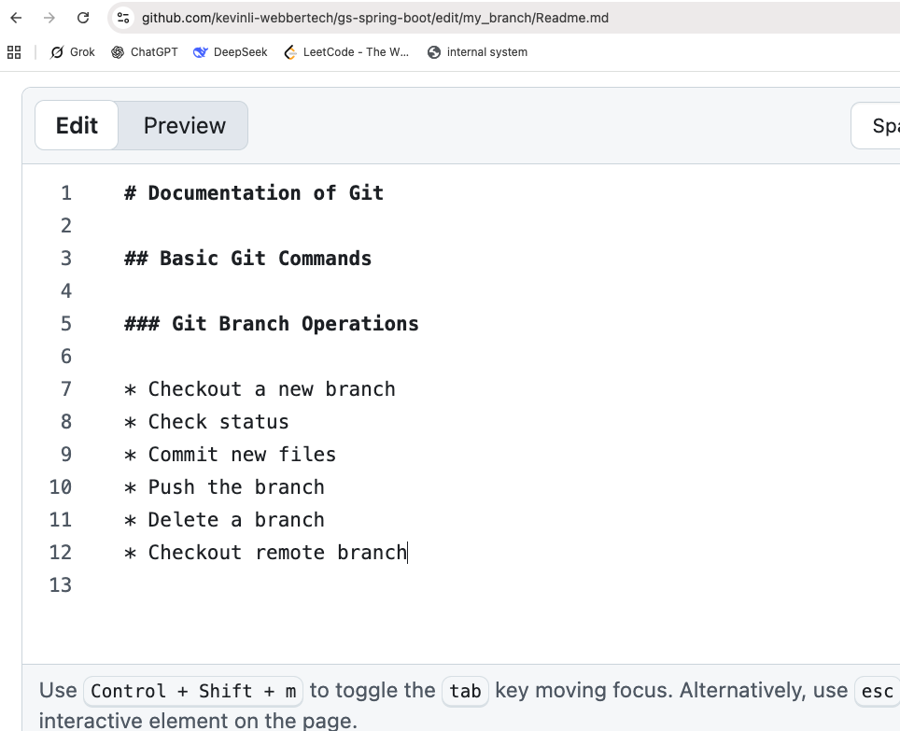
Once you are done, do a ctrl/cmd + s to save the file.

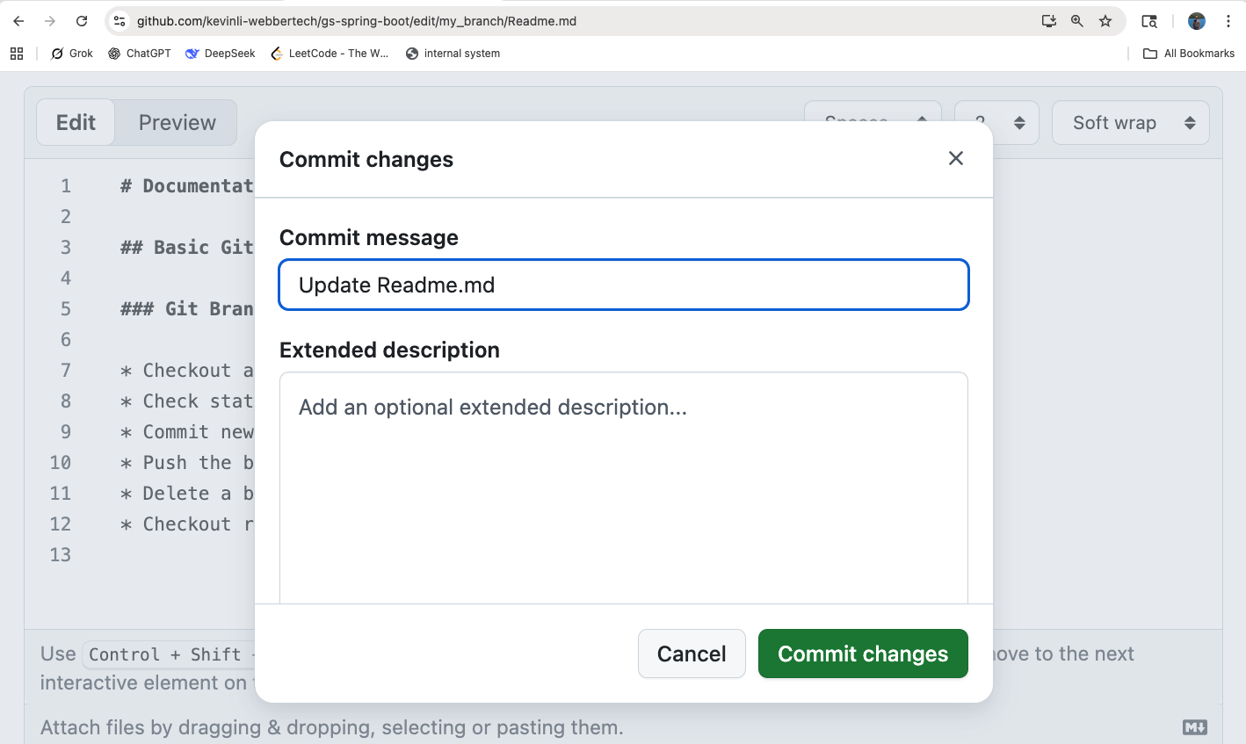
And you will see this,

Hit the green button above.

After you save it, please check the following,
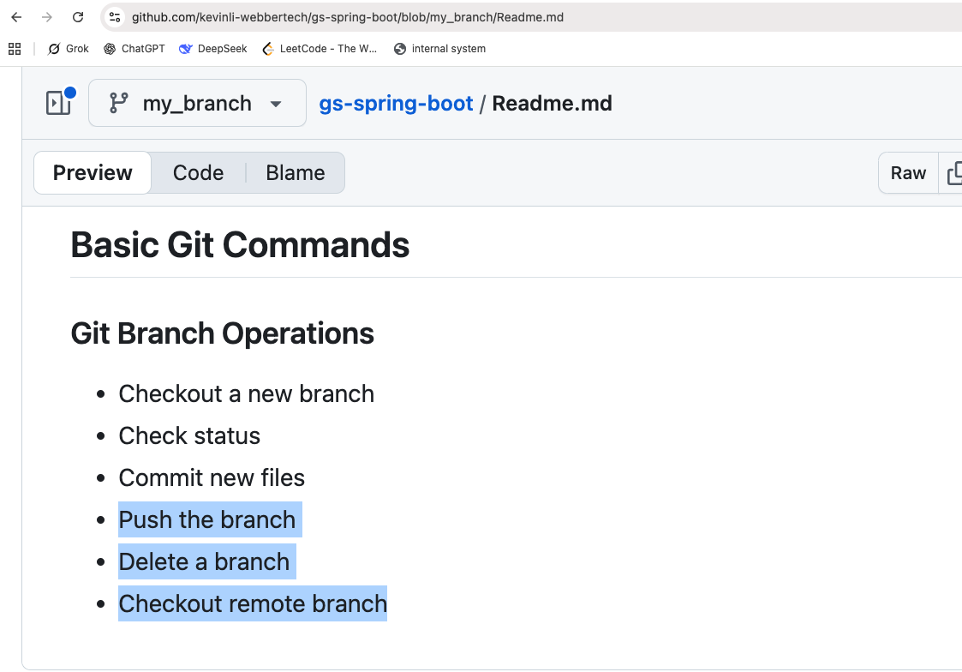
Next, let us check all the commits we did,
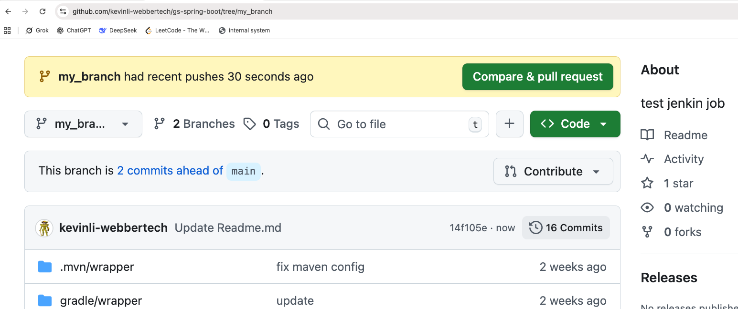

In the above image, let us click on “16 commits”,
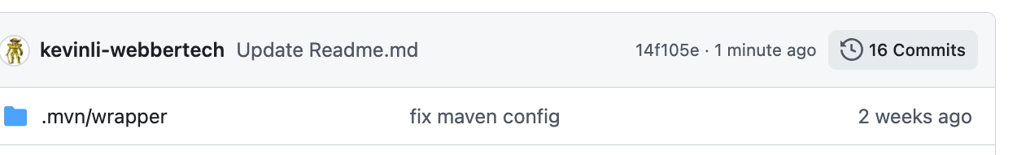

Now we can see the following hashes,

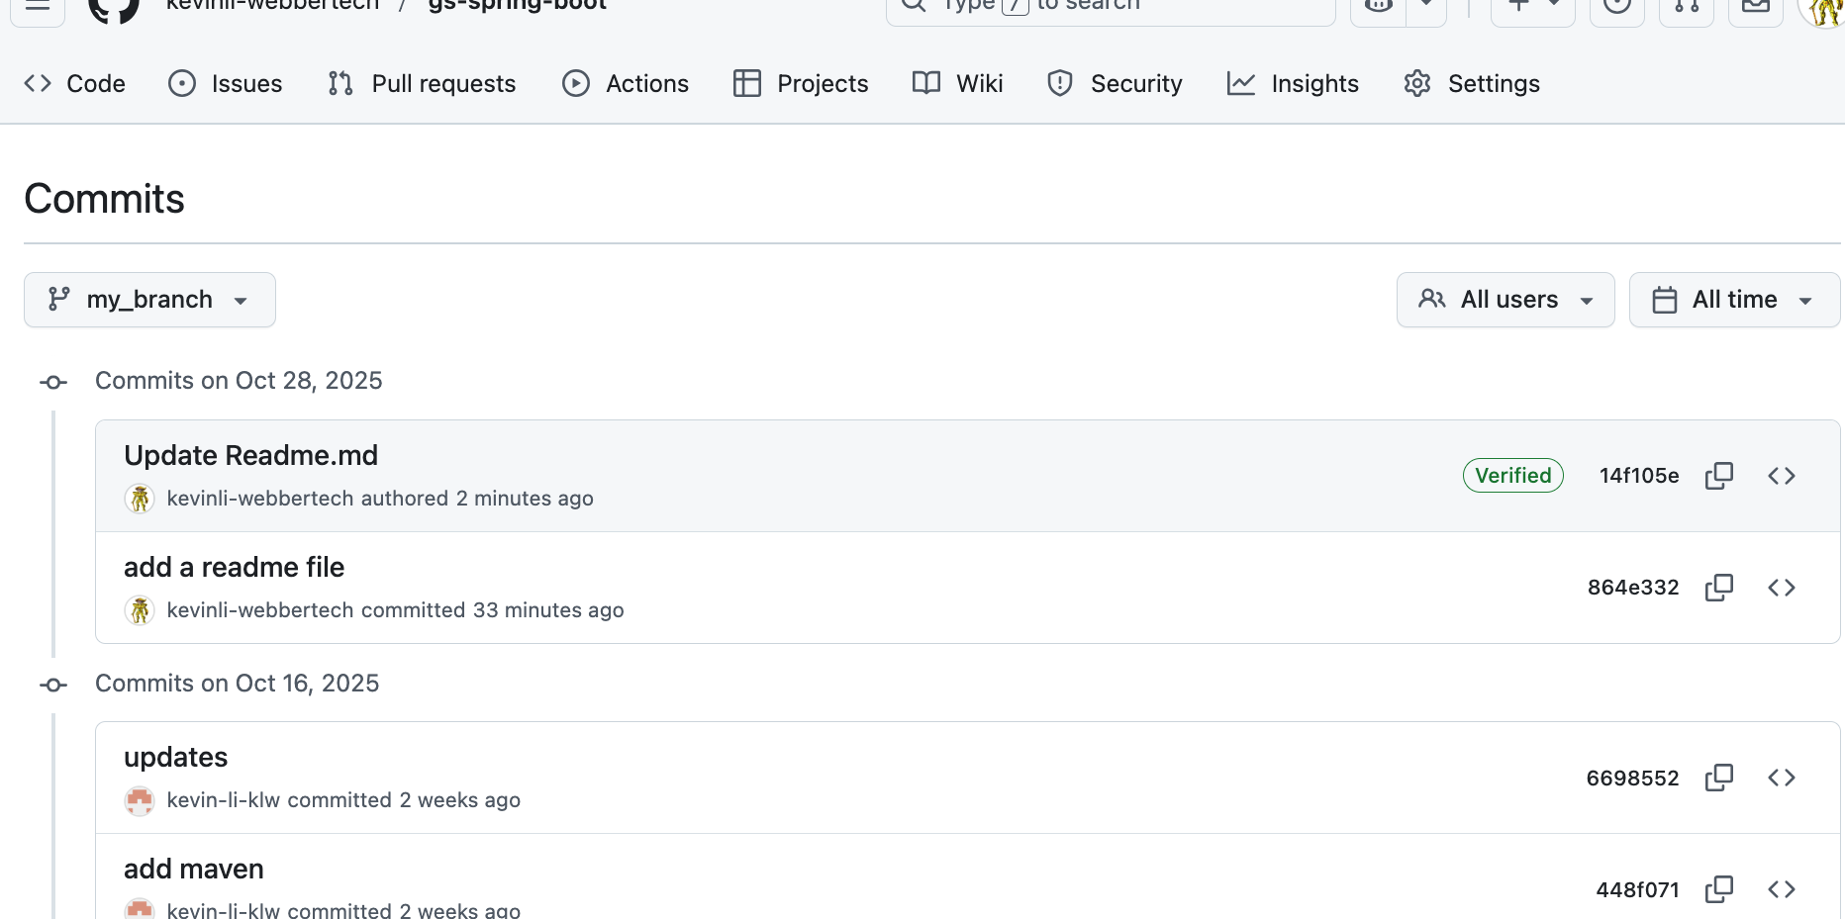

For instance, click on the hash below,
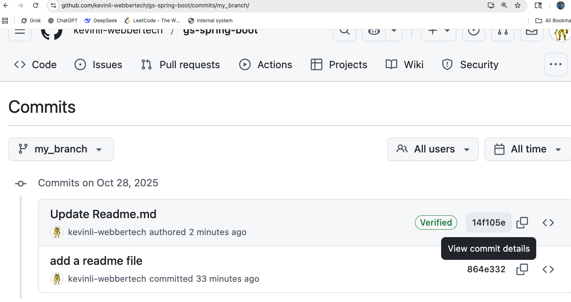
Then you click on the hash,
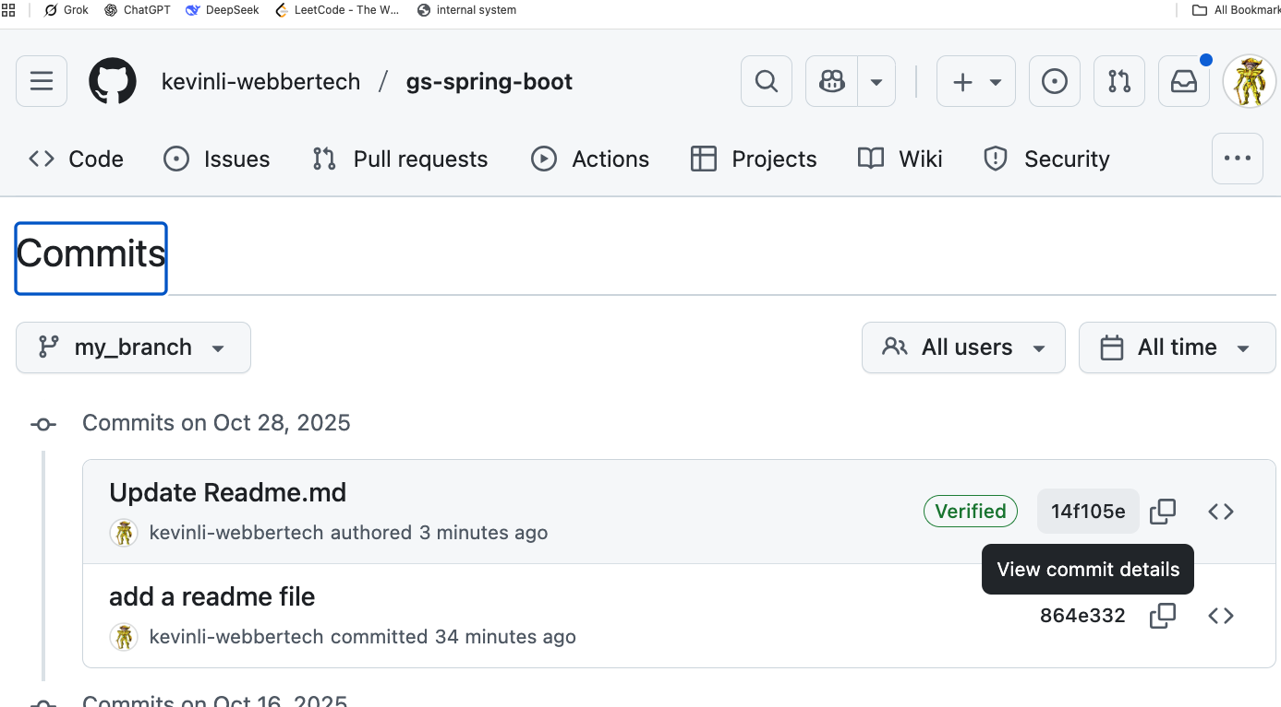

In the next view, you can see a diff of previous edits vs the latest edits.
