A Mongo DB docker guide

Step 1 Download a docker image

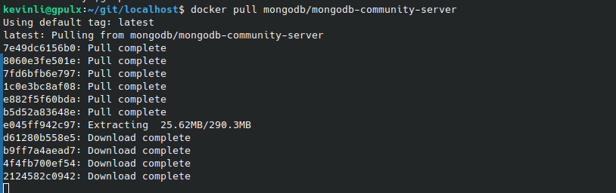
docker pull mongodb/mongodb-community-server

Step 2 Running this mongodb docker image

docker run --name mongodb -p 27017:27017 -d mongodb/mongodb-community-server:latest

See the container/linux os is running inside,

kevinli@gpulx:~/git/localhost$ docker container ls
CONTAINER ID IMAGE COMMAND CREATED ST
ATUS PORTS NAMES
5bcd3b37f082 mongodb/mongodb-community-server:latest "python3 /usr/local/…" 52 seconds ago Up
50 seconds 0.0.0.0:27017->27017/tcp, [::]:27017->27017/tcp mongodb
Step 3 Connect to mongdo db

In order to use `mongosh` it seems that I need to install the full build of mongodb in my Ubuntu 24, which I would like to avoid it as I do not want to install anything.

Once you had this mongosh installed, you can connect to your mongo server inside of you linux docker container via the following commands,
kevinli@gpulx:~/git/localhost$ mongosh --host localhost --port 27017
mongosh: command not found
>Note: Please make sure you take the above port correctly so that you can connect to it. You do not need an IPv4, you just need a `localhost`.
Remember when run the container,

kevinli@gpulx:~/git/localhost$ docker run --name mongodb -p 27017:27017 -d mongodb/mongodb-community-
server:latest
5bcd3b37f082bb4806e01995a1ec4b8a954b96fb3de2b42abe0fd8a0746ef12c

The hash is the container id,

5bcd3b37f082bb4806e01995a1ec4b8a954b96fb3de2b42abe0fd8a0746ef12c

And I use the following command to enter this container,

kevinli@gpulx:~/git/localhost$ docker exec -it 5bcd3b37f082bb4806e01995a1ec4b8a954b96fb3de2b42abe0fd8
a0746ef12c /bin/bash
mongodb@5bcd3b37f082:/$
When I say enter the container, it is like ssh to the container,

mongodb@5bcd3b37f082:/$ ps axuw|grep mongo
mongodb 1 0.0 0.0 19556 14888 ? Ss 18:31 0:00 python3 /usr/local/bin/docker-entr
ypoint.py mongod
mongodb 8 1.1 0.3 3769224 214804 ? Sl 18:31 0:18 mongod --bind_ip_all
mongodb 61 0.0 0.0 4628 3816 pts/0 Ss 18:46 0:00 /bin/bash
mongodb 69 0.0 0.0 7064 3116 pts/0 R+ 18:57 0:00 ps axuw
mongodb 70 0.0 0.0 3472 1896 pts/0 S+ 18:57 0:00 grep mongo
The mongod is the daemon process (a process/server process running in the backgroup, and normally they have higher OS job priorities).

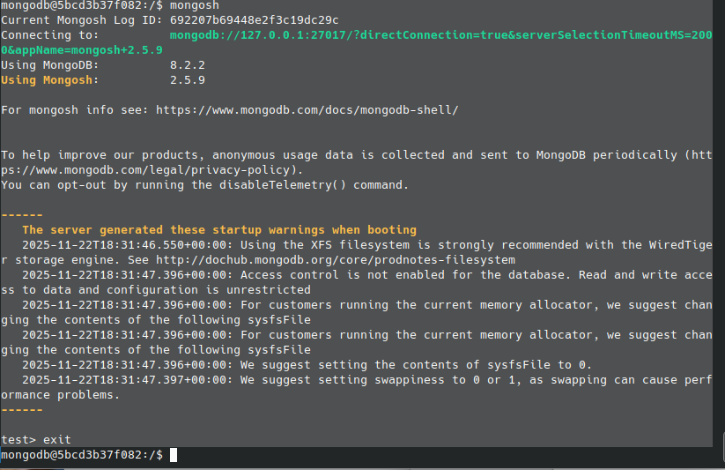
Step 4 Import to db (skips)

mongodb@5bcd3b37f082:/$ which mongosh
/usr/bin/mongosh

From here you can google for documentation to import csv or json file using the mongosh and you can go from there.
## Ref

For more linux and Mac terminal tutorials,

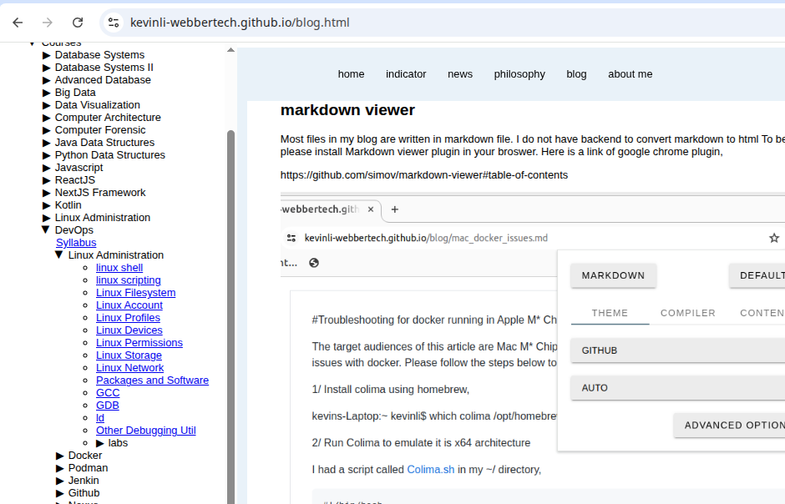

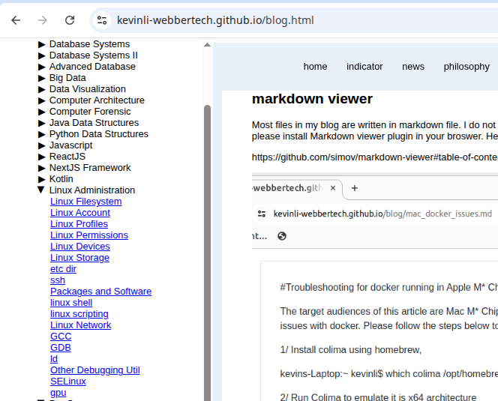
Or there is a more detailed linux administration course.

Also under the References section, I have another linux ref,

