Nov 15 Class Notes

AWS Summit

https://aws.amazon.com/events/summits/new-york/

MongoDB was one of the biggest sponsors.

Note: Meetup of companies, business ideas and interesting people and investors. Job and opportunities..

Sequoia
URL : sequoiacap.com
MongoDB
https://sequoiacap.com/companies/mongodb/
https://sequoiacap.com/our-companies/?_spotlight=1#all-panel

Note:

* Please pay attention to the companies they invested in.
* Please reads more on what is private equity and venture capitals.
* Please check more other larget AUM venture capital companies similar to sequoia.

Windows Troubleshooting

Note: Majorities are using Windows 11. Here are some notes we took from the class to help you better understand how to use Windows and troubleshoot and resolve problems.

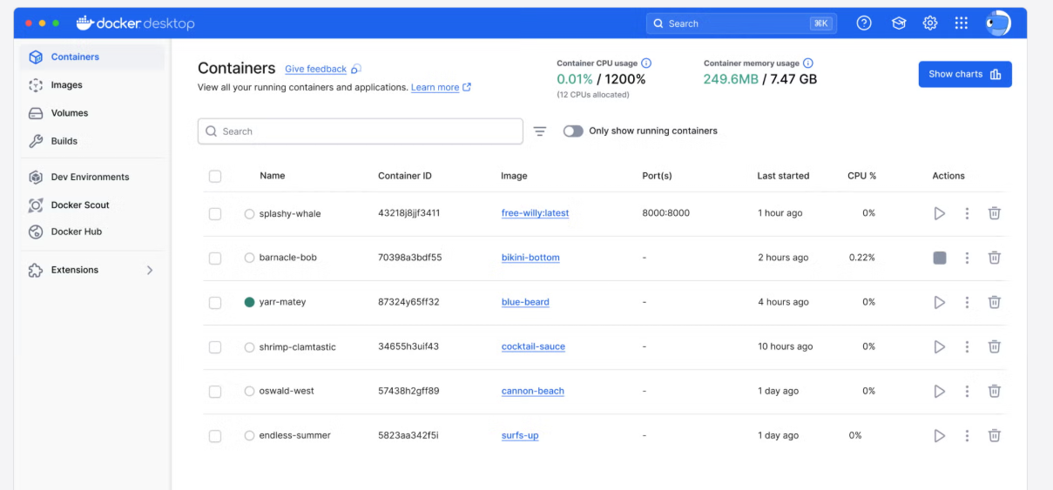
Initially we want to start a docker image of MySQL, and we face an error of port 3306 was occupied. And then we did some troubleshooting and we figured out that the problem was caused by the issue of that there is another instance MySQL running.

In the installation folder of MySQL, which is C:\program files\MySQL 8.0\MySQL 8.0 Server\bin,

* bin: stands for binary
* normally there is a mysql.exe and mysqld.exe.
* mysql.exe: is the terminal parser and interpreter of the client side program which is to understand the sql syntax and pass it via TCP socket to the mysqld.exe which is the server program.
* mysqld.exe: is the server side software and that might have to work with a whole bunch of other programs.
* program/process: is the mininum/atmic unit of runnable/executable running in any operating system such windows, linux or Mac/Unix.
* serverside program: For instance, programs such as mysqld.exe, sshd.exe or httpd.exe, or there could be more,

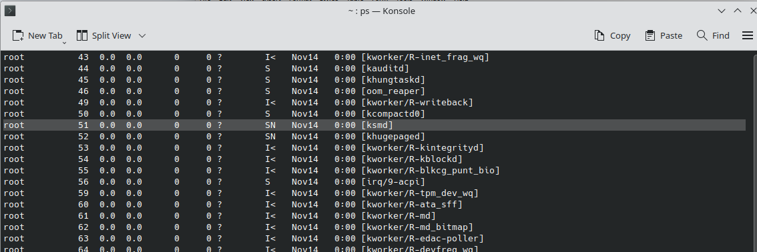
anything with a “d” in the end of the name, which does not resemble a proper English name of program, it is a Daemon program, a service running in the backgroud.

Ref: https://en.wikipedia.org/wiki/Daemon_(computing)

Once we figured out the pid of the running mysql, terminate it and stop it from the startup of the msconfig and we will be fine.

Docker Session

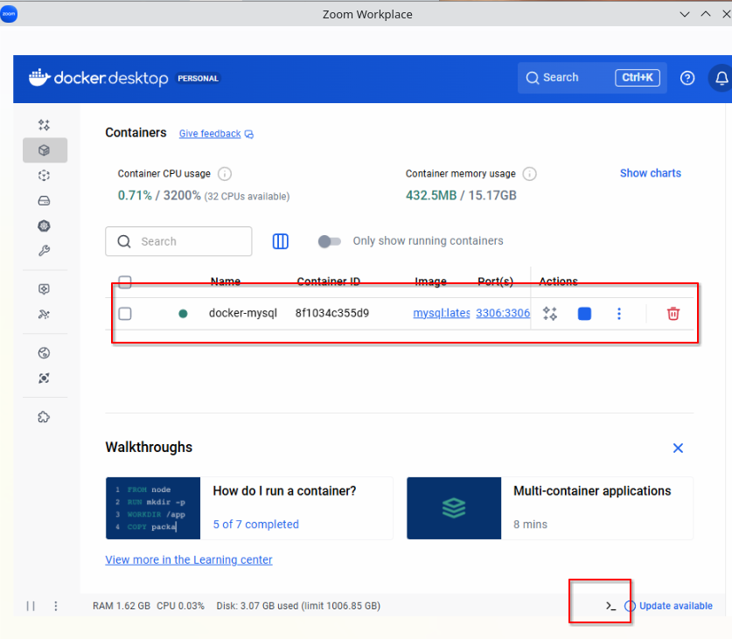
Normally windows does not have linux/unix like good terminal, so we wuold like to use docker desktop and pull or run an docker image.

Sometimes, a unix/linux like terminal would be nice to have, the red circle box in the above image would show us how to open the terminal and we can use it as a linux or mysql terminal in windows to do the connection from the terminal.

The windows-dos like terminal looks like the one in the following image. Next we will talk about how to find out that concerning pid of the running mysql to terminate it.

Today's session we did some troubleshooting of tcpIP port of how to find the computer program (the most atomic unit of runnable, we called Process in computer science, all the OS will assign an ID to each of the Process). We could detect the port by which PID or program is occupying it and terminate that from your windows 11 task manager (commasnd: taskmgr), and turn it off from autorunning during bootup of your computer with a command called "msconfig"

Troubleshoot: Port in use
Root problem: You had another copy of MySQL server running during boot up of windows, and it took the port 3306,

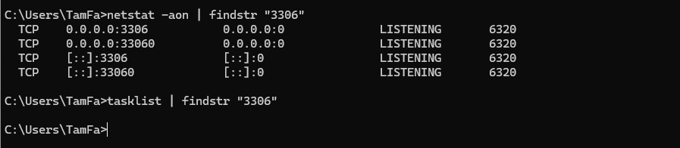
To confirm that you can use the following command,

Then you type or search in the box for “taskmgr”, or open it from the programs,

and terminate that pid shows “6320”,

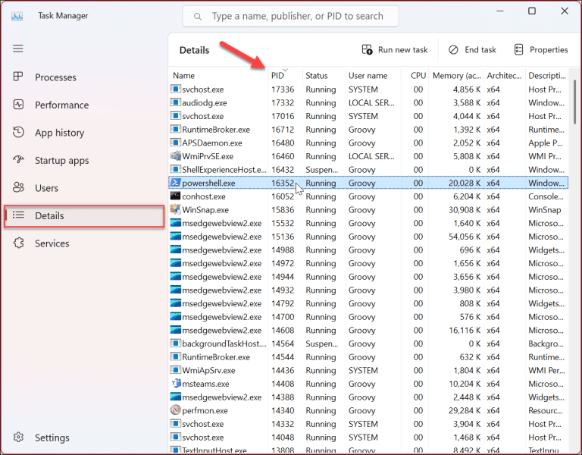

If we want to turn if off from the windows from bootup time, we can type “msconfig”,

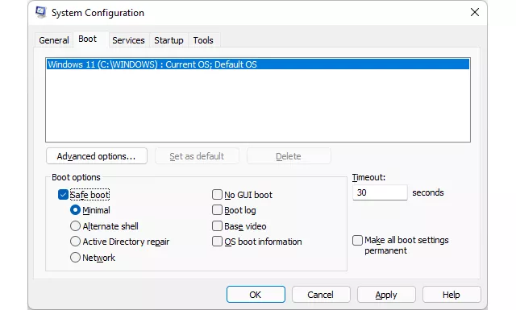

Then we need to go to the “Services” tab, there are hundreds of hidden windows internal services running, to hide them, and quickly find out what we are looking for, to be exact the MySQL service, we would like to do the following,

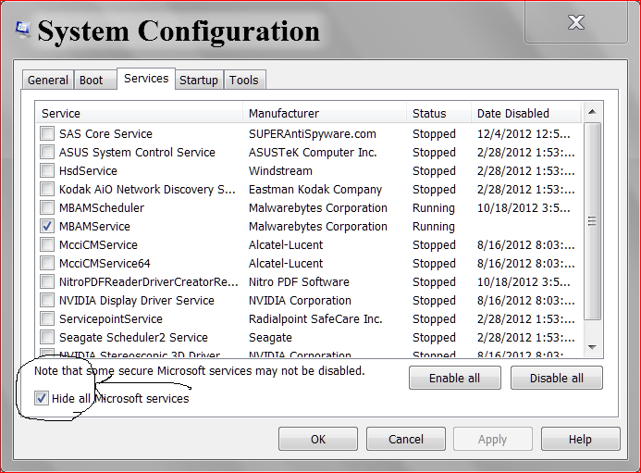
Click any name on the first column, and type “M”, the initial letter of Mysql and it will jump to the program sorted by M, and you scroll down and you will find out the MySQL.

Ref:

https://www.lifewire.com/how-to-start-windows-in-safe-mode-using-system-configuration-2626115
For docker supplement,

https://kevinli-webbertech.github.io/blog/html/courses/dev_ops/docker/labs/docker_database.html

All we need to spin up a docker container of mysql,

docker run --name docker-mysql -p 3306:3306 -e MYSQL_ROOT_PASSWORD=hello -d mysql:latest --character-set-server=utf8mb4 –collation-server=utf8mb4_unicode_ci

And connect it by doing the following,

mysql -hlocalhost --protocol=TCP -uroot -p

Then it will promp you to type your password, in above example it is “hello”.

>Note: if your system complains about the mysql not found, then you need to find out its installation and add it to the system variable called “Path”.

For example, in Windows 11/?, it is often in c:\program files\MySQL 8.0\MySQL 8.0 Server\bin,
please confirm the exact path of it and add to the system variable similar in the following window.

