Github Lab 2: Add SSH key to authenticate with Github Server

Takeaways and Goals:

- Understand public/private key. This is being used everywhere for authentication.
- Github server uses SSH authentication as well, we would need to operate on github server with admin role. Assuming you are a devOps engineer, you would be one of the admin type of person, so your github account would have the permission.
Remember that the Github server also have a similar account permission hierachy just like linux, windows operating systems, so it deals with account types (access permissions).
- Once we understand the public/private key we need to understand how to use the `ssh-keygen` tool to generate the public/private key pairs. You always keep the private key and you share the public key with someone. In our case, we add the public key to the github server.

Labs

Step 1 Validate our docker image is good

Once we work in the company, we are also preparing a good docker image, some engineer who works on upstream team would give you a docker image, but that does not mean that it will have everything you need.

In this lab, since it is a linux docker image of Jenkin, so we would need to at least need a couple of things,

- Java (JVM) – We need this to run Jenkin app itself, which is written in Java.
- Javac (Java compiler) – we need to build and compile maven project.
- ssh-keygen

First of all, we need to make sure our Jenkin docker image is pulled down (downloaded from docker.io) successfully. It might not be running, so we need to check with `ls -a` command.

bash-3.2$ docker container ls -a
CONTAINER ID IMAGE COMMAND CREATED STATUS PORTS NAMES
bf043ccd8869 jenkins/jenkins:lts "/usr/bin/tini -- /u…" 2 weeks ago Exited (255) 8 days ago 0.0.0.0:8080->8080/tcp, 0.0.0.0:50000->50000/tcp nervous_cori

We need to start the Jenkin container from the previous lab,

bash-3.2$ docker container start bf043ccd8869
bf043ccd8869

Now we check if our Jenkin container is running,

bash-3.2$ docker container ls
CONTAINER ID IMAGE COMMAND CREATED STATUS PORTS NAMES
bf043ccd8869 jenkins/jenkins:lts "/usr/bin/tini -- /u…" 2 weeks ago Up 48 seconds 0.0.0.0:8080->8080/tcp, 0.0.0.0:50000->50000/tcp nervous_cori

Next, we would `ssh` into the running docker container.

bash-3.2$ docker exec -it bf043ccd8869 /bin/bash
First we need to check we have enough binary tools in this docker image, here we would need to use the 'ssh-keygen', and we can check it by doing the following,

jenkins@bf043ccd8869:/$ which ssh-keygen
/usr/bin/ssh-keygen

Once you type the following, you see the following and it is ok.
Press “ctrol + c” to terminate it in your VM(ubuntu or Kali).

jenkins@bf043ccd8869:/$ ssh-keygen

Generating public/private rsa key pair.
Enter file in which to save the key (/var/jenkins_home/.ssh/id_rsa):

Now let us check Java and Javac,

jenkins@bf043ccd8869:/$ which java
/opt/java/openjdk/bin/java

jenkins@bf043ccd8869:/$ which javac
/opt/java/openjdk/bin/javac

jenkins@bf043ccd8869:/$ javac --version
javac 21.0.8

Now everything looks good.

Next step, let us verify that our login account is not root. It is better to use a dedicated account that runs Jenkin.

jenkins@bf043ccd8869:/$ whoami
jenkins

jenkins@bf043ccd8869:/$ ps axuw|grep java
jenkins 7 3.2 24.0 5222292 489560 ? Sl 20:00 0:48 java -Duser.home=/var/jenkins_home -Djenkins.model.Jenkins.slaveAgentPort=50000 -Dhudson.lifecycle=hudson.lifecycle.ExitLifecycle -jar /usr/share/jenkins/jenkins.war

Step 2 Generating SSH key pairs

Normally we would need to do the following to generate a key pairs, but in our case, we need to check if our repo already had it.

So please do not generate a new pair of keys just yet. Scroll down to pass the following section and see how we handle this.

jenkins@bf043ccd8869:/$ ssh-keygen -t rsa -b 4096 -C "xlics05@example.com"
Generating public/private rsa key pair.
Enter file in which to save the key (/var/jenkins_home/.ssh/id_rsa):
Created directory '/var/jenkins_home/.ssh'.
Enter passphrase (empty for no passphrase):
Enter same passphrase again:
Your identification has been saved in /var/jenkins_home/.ssh/id_rsa
Your public key has been saved in /var/jenkins_home/.ssh/id_rsa.pub
The key fingerprint is:
SHA256:r9ymp6BU6SyFn+X0NrB4dc0lpWwSJbRwlnONS3f5nrc xlics05@example.com
The key's randomart image is:
+---[RSA 4096]----+
| ..*o.oo|
| +o=+++|
| o+=o+|
| . . =.o.|
| . + S . . o..|
| * * * . .o|
| o B + = o|
| . o + +o. E |
| . ==. |
+----[SHA256]-----+

jenkins@bf043ccd8869:/$ cd ~
jenkins@bf043ccd8869:~$ ls
caches hudson.plugins.gradle.Gradle.xml jenkins.model.JenkinsLocationConfiguration.xml org.jenkinsci.plugins.gitclient.JGitApacheTool.xml secret.key.not-so-secret war
config.xml hudson.tasks.Ant.xml jenkins.mvn.GlobalMavenConfig.xml org.jenkinsci.plugins.gitclient.JGitTool.xml secrets workspace
copy_reference_file.log hudson.tasks.Maven.xml jenkins.telemetry.Correlator.xml org.jenkinsci.plugins.workflow.flow.FlowExecutionList.xml tools
fingerprints identity.key.enc jobs plugins updates
hudson.model.UpdateCenter.xml jenkins.install.InstallUtil.lastExecVersion logs queue.xml.bak userContent
hudson.plugins.git.GitTool.xml jenkins.install.UpgradeWizard.state nodeMonitors.xml secret.key users
jenkins@bf043ccd8869:~$ ls -al
total 168
drwxr-xr-x 20 jenkins jenkins 4096 Oct 29 20:36 .
drwxr-xr-x 1 root root 4096 Sep 17 10:04 ..
drwxr-xr-x 3 jenkins jenkins 4096 Oct 15 20:10 .cache
drwxr-xr-x 3 jenkins jenkins 4096 Oct 17 20:16 .config
drwxr-xr-x 3 jenkins jenkins 4096 Oct 15 20:13 .groovy
drwxr-xr-x 3 jenkins jenkins 4096 Oct 15 20:10 .java
-rw-r--r-- 1 jenkins jenkins 0 Oct 29 20:00 .lastStarted
drwxr-xr-x 3 jenkins jenkins 4096 Oct 17 20:19 .m2
-rw-r--r-- 1 jenkins jenkins 1 Oct 18 01:04 .owner
drwx------ 2 jenkins jenkins 4096 Oct 29 20:36 .ssh
drwxr-xr-x 4 jenkins jenkins 4096 Oct 17 20:19 caches
-rw-r--r-- 1 jenkins jenkins 1663 Oct 29 20:00 config.xml
-rw-r--r-- 1 jenkins jenkins 324 Oct 29 20:00 copy_reference_file.log
drwxr-xr-x 3 jenkins jenkins 4096 Oct 17 20:19 fingerprints
-rw-r--r-- 1 jenkins jenkins 156 Oct 29 20:00 hudson.model.UpdateCenter.xml
-rw-r--r-- 1 jenkins jenkins 370 Oct 17 20:18 hudson.plugins.git.GitTool.xml
-rw-r--r-- 1 jenkins jenkins 194 Oct 17 20:18 hudson.plugins.gradle.Gradle.xml
-rw-r--r-- 1 jenkins jenkins 161 Oct 17 20:18 hudson.tasks.Ant.xml
-rw-r--r-- 1 jenkins jenkins 571 Oct 17 20:18 hudson.tasks.Maven.xml
-rw------- 1 jenkins jenkins 1680 Oct 15 20:13 identity.key.enc
-rw-r--r-- 1 jenkins jenkins 7 Oct 29 20:00 jenkins.install.InstallUtil.lastExecVersion
-rw-r--r-- 1 jenkins jenkins 7 Oct 15 20:25 jenkins.install.UpgradeWizard.state
-rw-r--r-- 1 jenkins jenkins 179 Oct 15 20:24 jenkins.model.JenkinsLocationConfiguration.xml
-rw-r--r-- 1 jenkins jenkins 247 Oct 17 20:18 jenkins.mvn.GlobalMavenConfig.xml
-rw-r--r-- 1 jenkins jenkins 171 Oct 15 20:10 jenkins.telemetry.Correlator.xml
drwxr-xr-x 4 jenkins jenkins 4096 Oct 15 20:26 jobs
drwxr-xr-x 2 jenkins jenkins 4096 Oct 15 20:14 logs
-rw-r--r-- 1 jenkins jenkins 1037 Oct 29 20:00 nodeMonitors.xml
-rw-r--r-- 1 jenkins jenkins 255 Oct 17 20:18 org.jenkinsci.plugins.gitclient.JGitApacheTool.xml
-rw-r--r-- 1 jenkins jenkins 243 Oct 17 20:18 org.jenkinsci.plugins.gitclient.JGitTool.xml
-rw-r--r-- 1 jenkins jenkins 46 Oct 17 20:19 org.jenkinsci.plugins.workflow.flow.FlowExecutionList.xml
drwxr-xr-x 91 jenkins jenkins 12288 Oct 15 20:13 plugins
-rw-r--r-- 1 jenkins jenkins 258 Oct 17 20:20 queue.xml.bak
-rw-r--r-- 1 jenkins jenkins 64 Oct 15 20:10 secret.key
-rw-r--r-- 1 jenkins jenkins 0 Oct 15 20:10 secret.key.not-so-secret
drwx------ 2 jenkins jenkins 4096 Oct 17 20:16 secrets
drwxr-xr-x 3 jenkins jenkins 4096 Oct 17 20:19 tools
drwxr-xr-x 2 jenkins jenkins 4096 Oct 29 20:00 updates
drwxr-xr-x 2 jenkins jenkins 4096 Oct 15 20:10 userContent
drwxr-xr-x 3 jenkins jenkins 4096 Oct 15 20:10 users
drwxr-xr-x 10 jenkins jenkins 4096 Oct 15 20:10 war
drwxr-xr-x 5 jenkins jenkins 4096 Oct 17 20:19 workspace

Now we noticed we have a .ssh directory,

jenkins@bf043ccd8869:~/.ssh$ ls
id_rsa id_rsa.pub

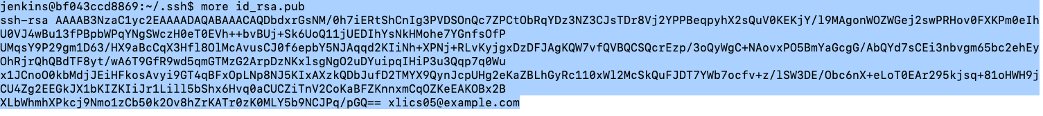

Add SSH Key to GITHUB remote server

Let us click on your Avatar and click on “Settings”,

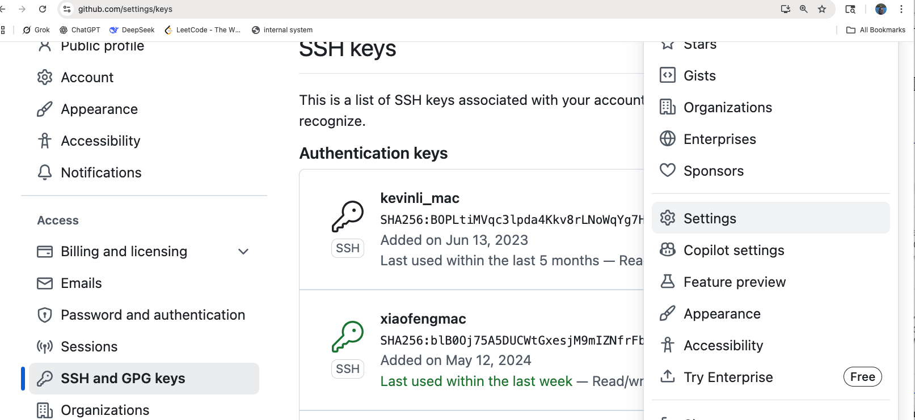
Confirm that the new key was added like the following,

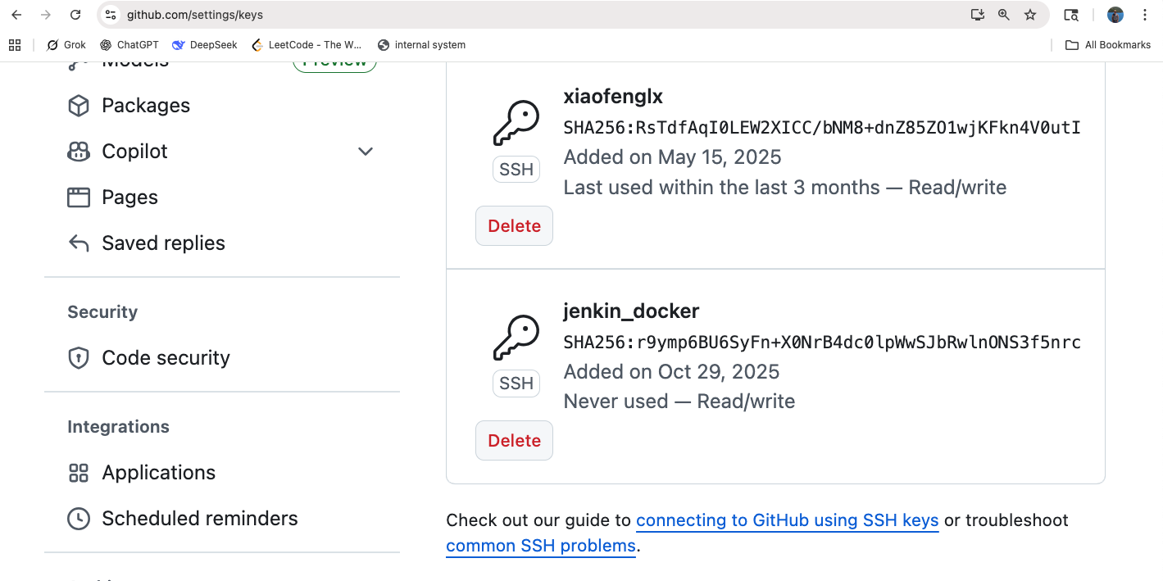
Now let us valid if this public/private key authentication can be established successfully.

For github, it actually provides the hash so it confirms with you after you added your public key in github server. The following is the link from github official documentation.

https://docs.github.com/en/authentication/keeping-your-account-and-data-secure/githubs-ssh-key-fingerprints

From our side, all you need to do is to run the following commands,

jenkins@bf043ccd8869:~/.ssh$ ssh -T git@github.com
The authenticity of host 'github.com (140.82.112.3)' can't be established.
ED25519 key fingerprint is SHA256:+DiY3wvvV6TuJJhbpZisF/zLDA0zPMSvHdkr4UvCOqU.
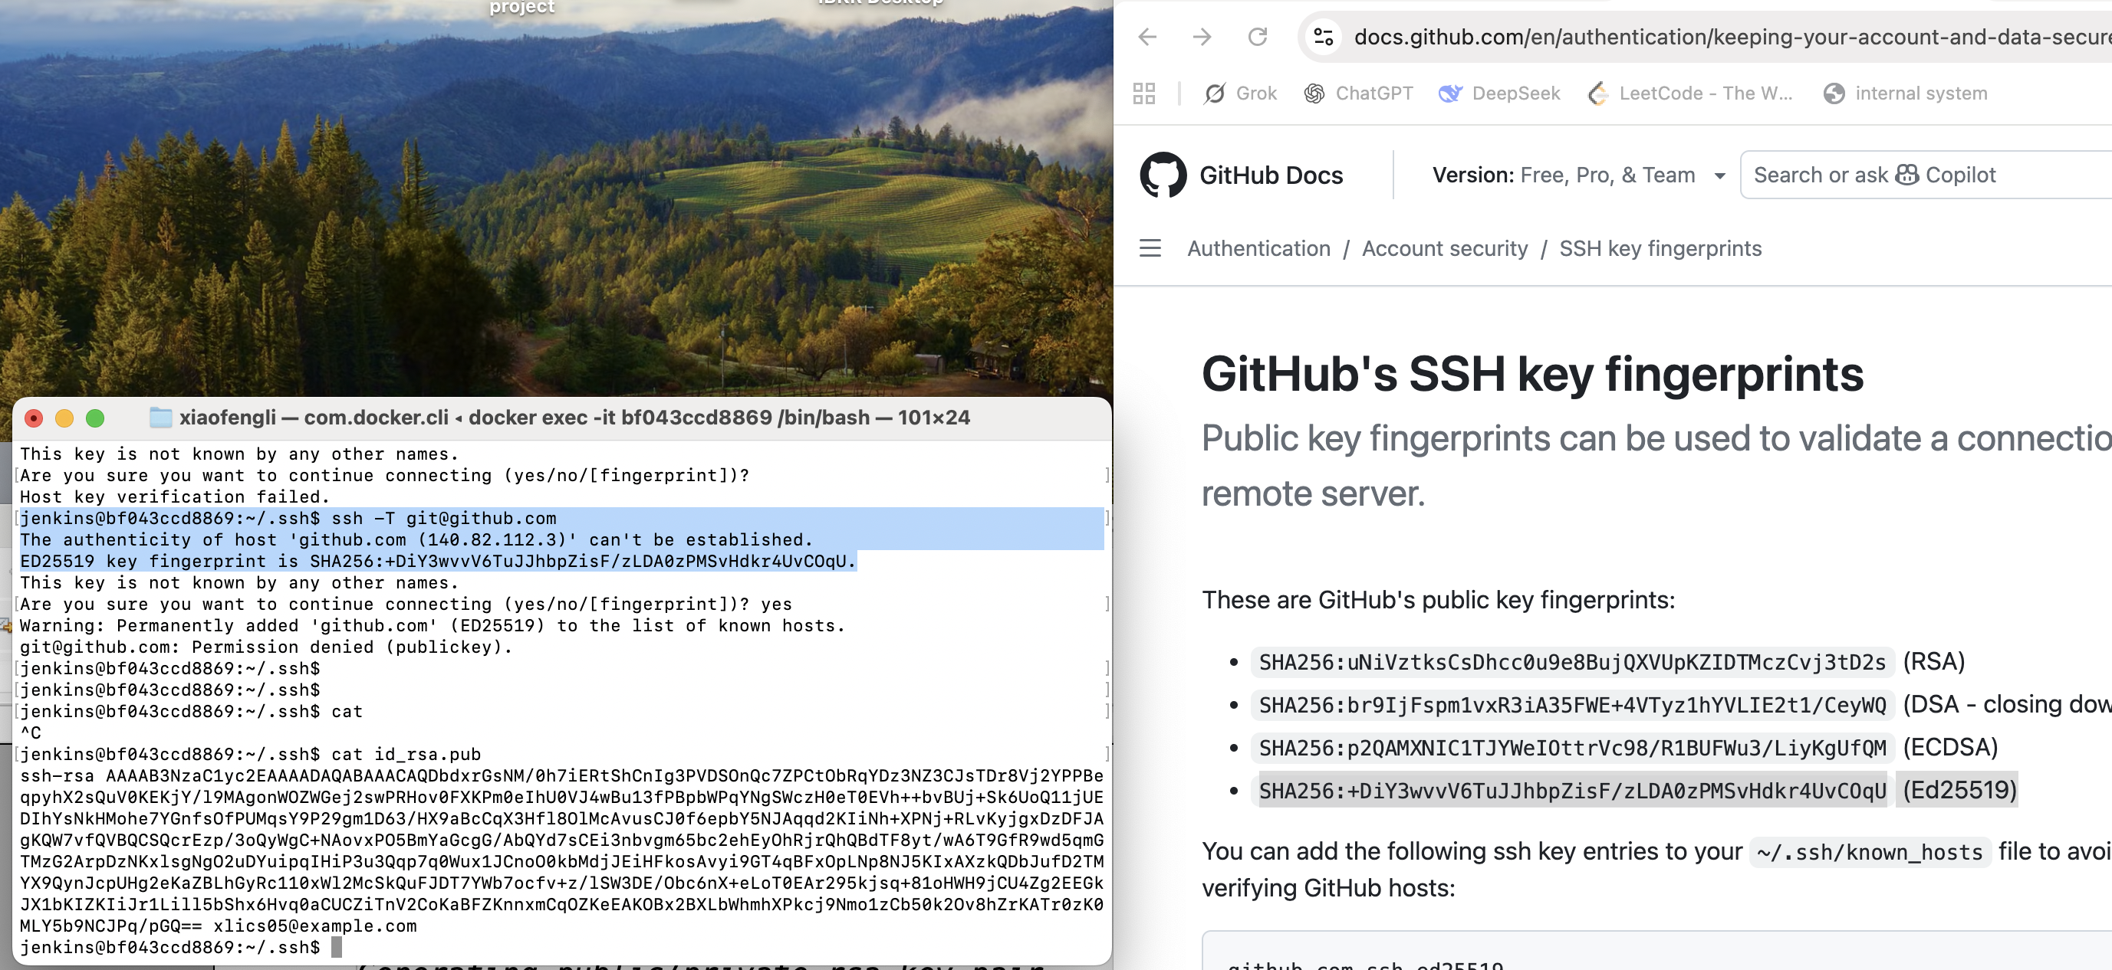

The line above

“ED25519 key fingerprint is SHA256:+DiY3wvvV6TuJJhbpZisF/zLDA0zPMSvHdkr4UvCOqU.”

# Step 3 change our spring-boot repo from public to private

First, we click our public repo we created before shown in the following image,

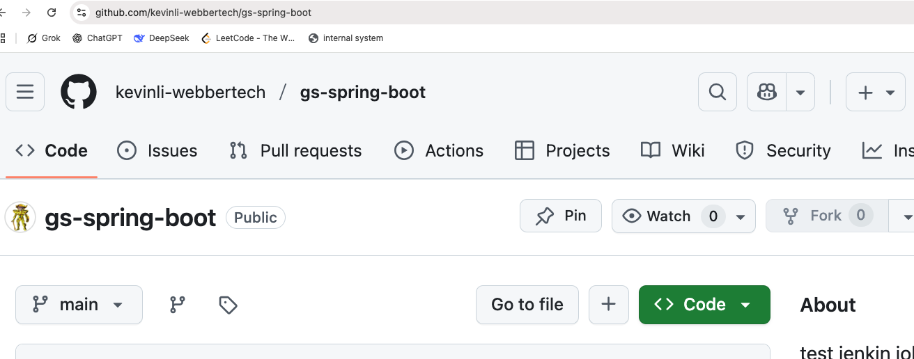
Next, we click on “Settings”,

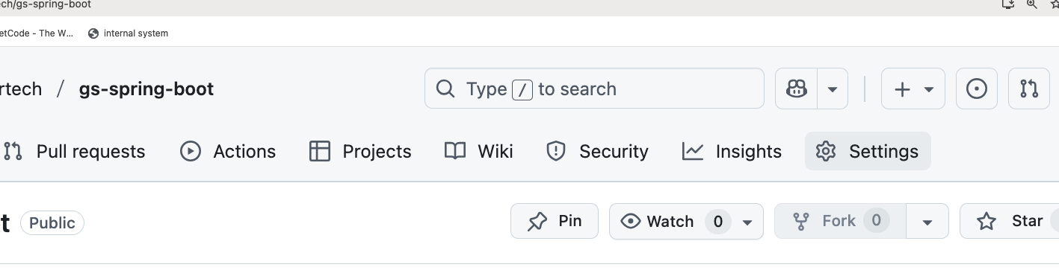

We scroll down to the bottom of this page,

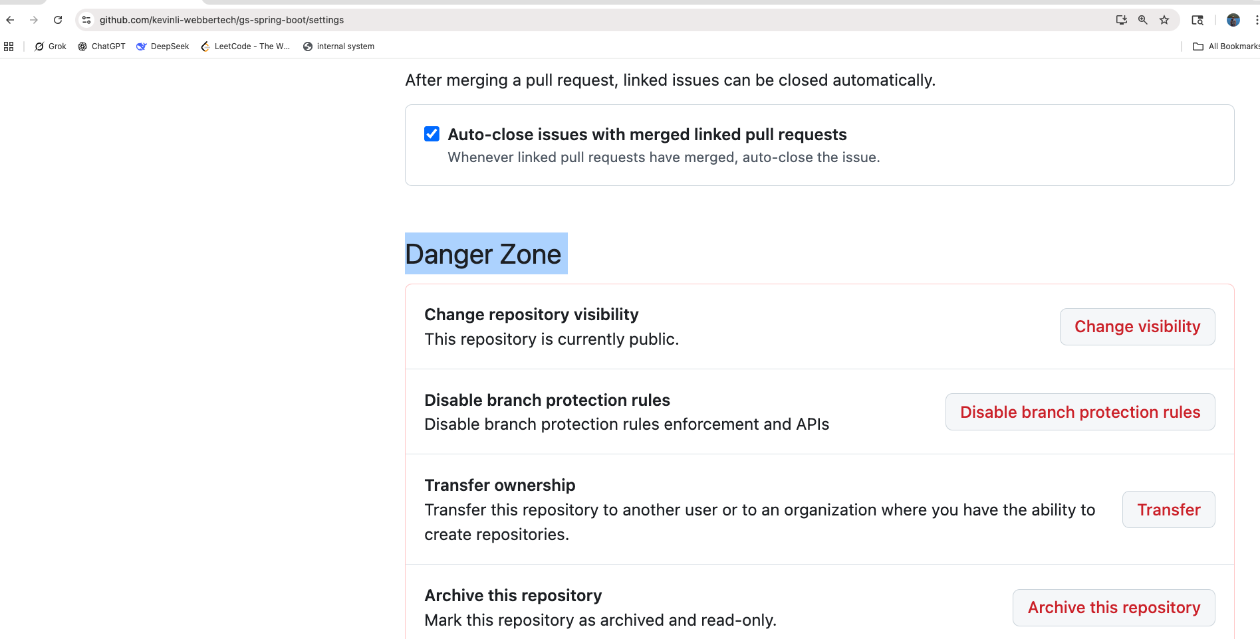
Now if you click on the “Change visibility”, and you will see the “Change to private”,

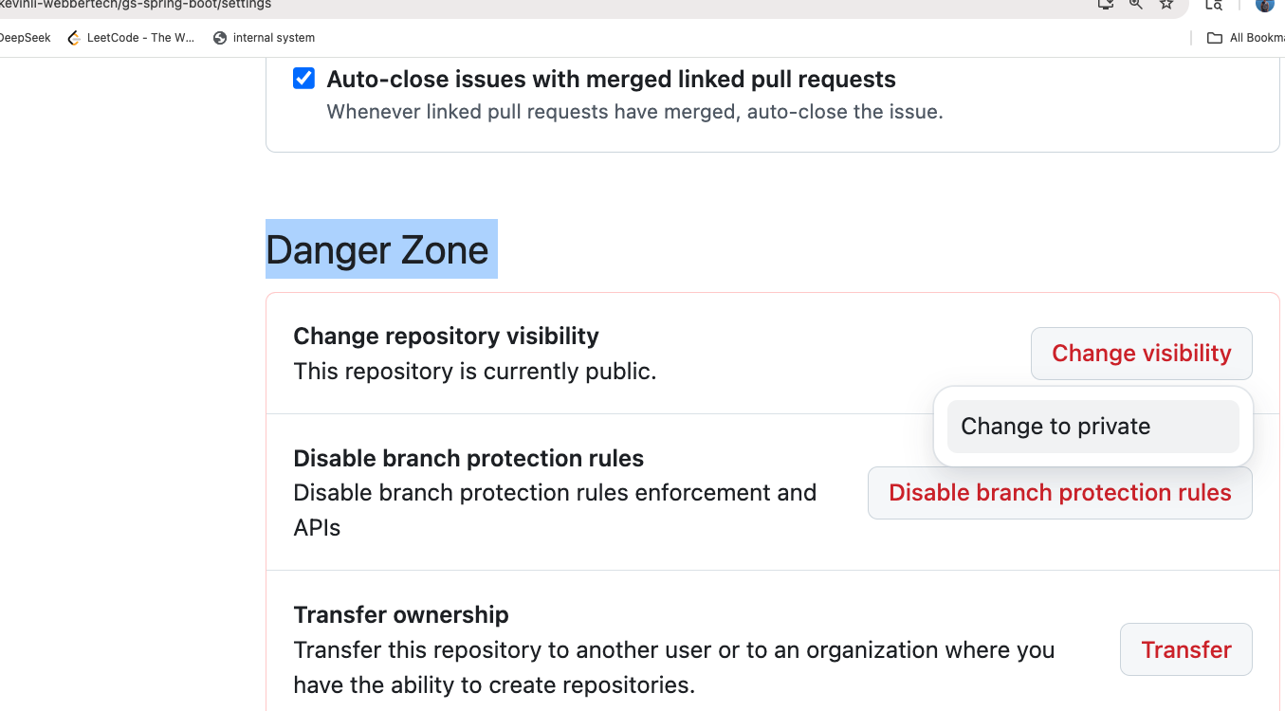
Click the grey button below,
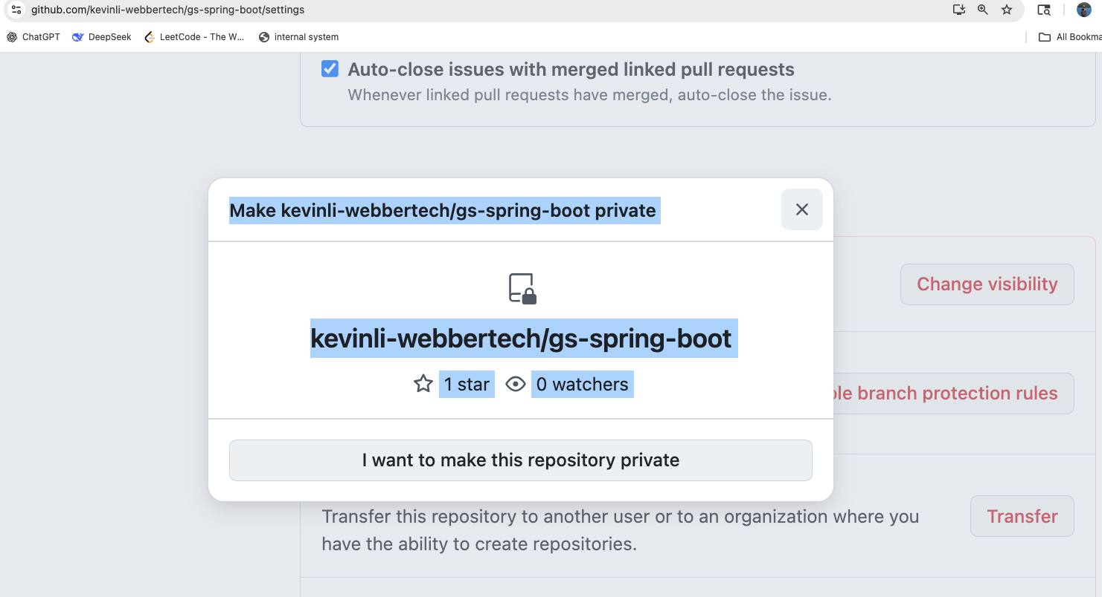
There is an agreement to click,
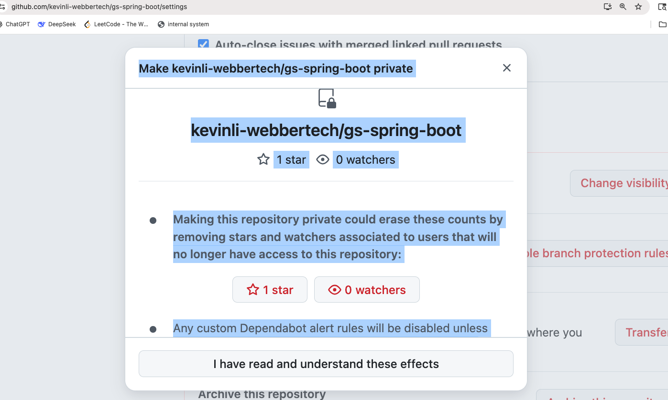

This is a confirmation box, because this can be a dangerous operation. Without confirmation, we could accidentally delete a repo or make the scope unavailable to the developers who were actively work on it,
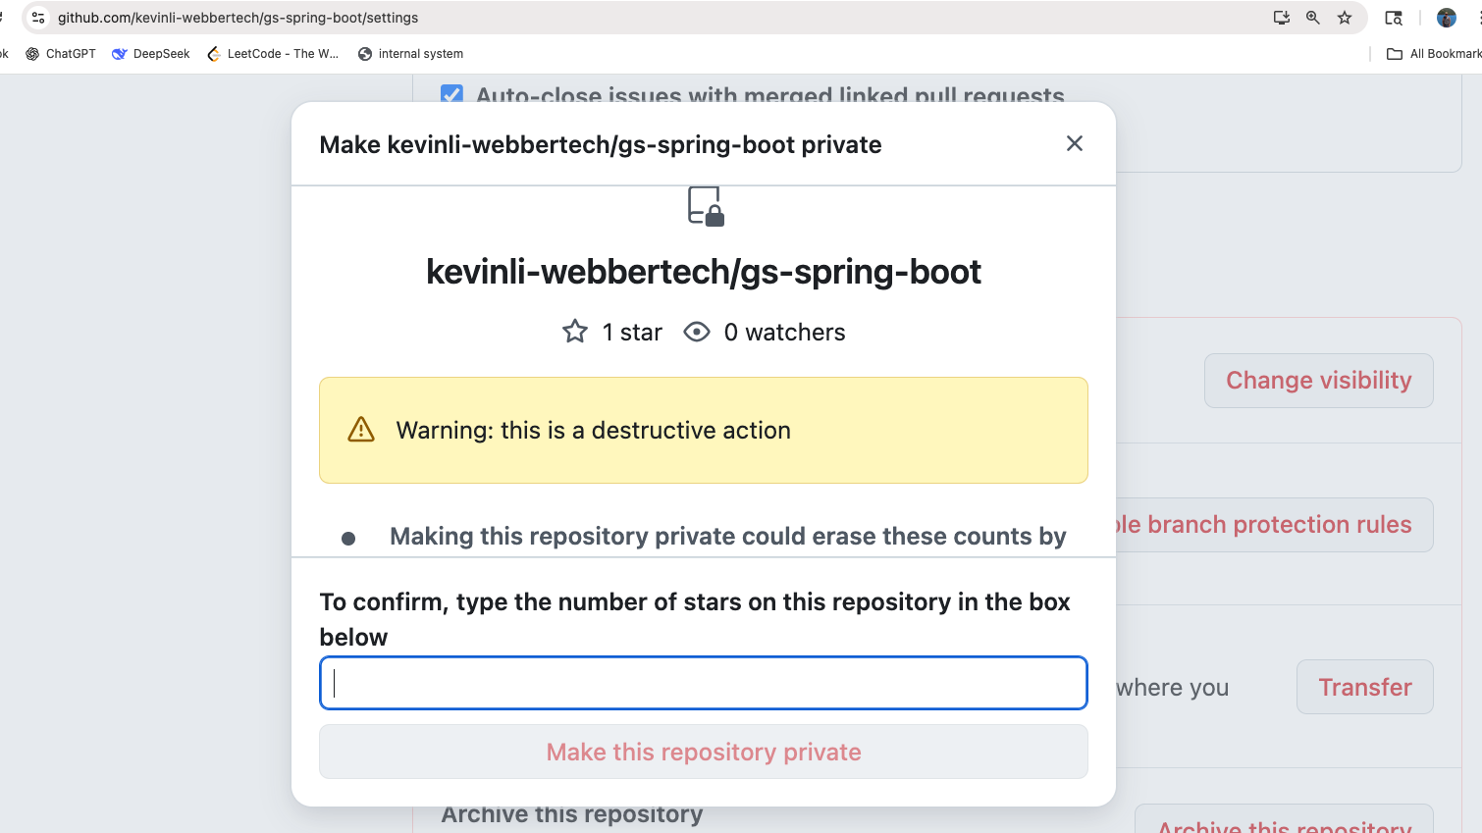
Now the button is not grey anymore, and we can click on it,
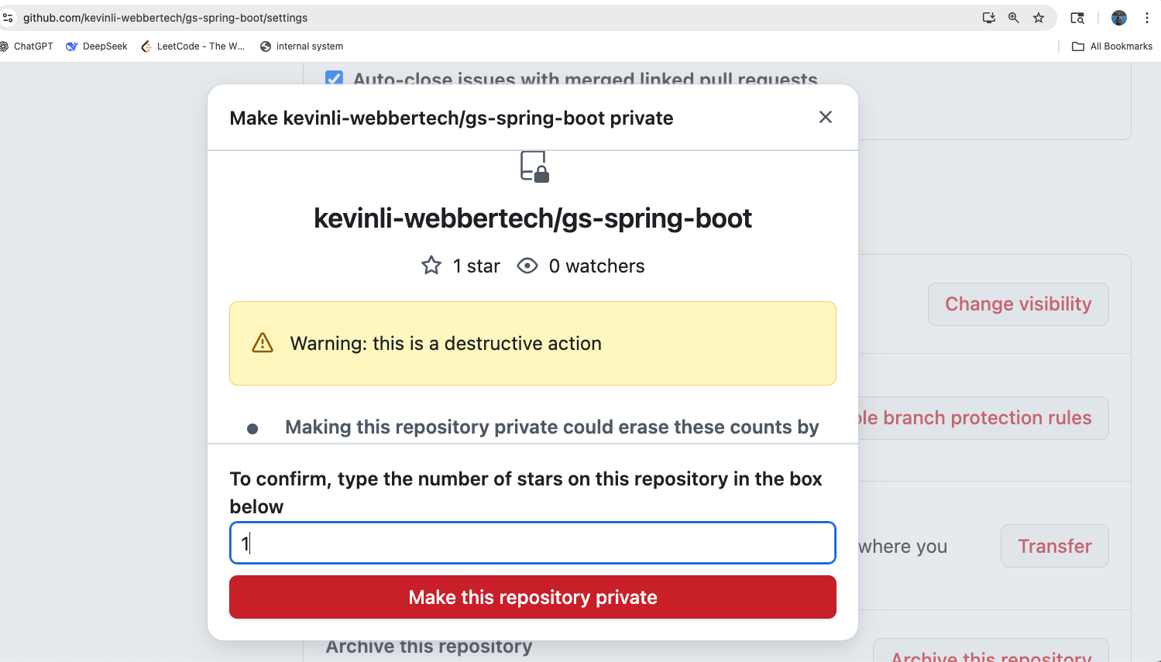
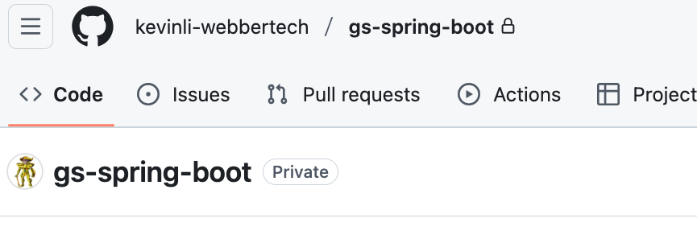
Now it shows “private”.
Now you are good to go. Please use this guide to prepare your container. Make sure once you set it up and you do not delete your container, since the .ssh directory would be there and just in case it changes every time so you don't need to update your ssh public key in the github server all the time.

## Ref

https://docs.github.com/en/authentication/connecting-to-github-with-ssh/testing-your-ssh-connection (github official guide – how to test your ssh key after you add it)

https://docs.github.com/en/authentication/connecting-to-github-with-ssh/adding-a-new-ssh-key-to-your-github-account (how to add ssh key to the github)

https://medium.com/@mai.vly/setup-jenkins-for-your-application-from-the-private-github-repo-with-docker-bac79335ff27 (how to configure and jenkin job with the ssh)

