Nexus Lab Nexus Installation and Usage
Date: Nov 6 2025
Written by: Kevin Li

Step 1 Run Nexus Docker Instance

1/ Create a folder called nexus-data in your current working directory,

Commands:

docker run -d -p 8081:8081 --name nexus \
-v nexus-data:/nexus-data \
sonatype/nexus3

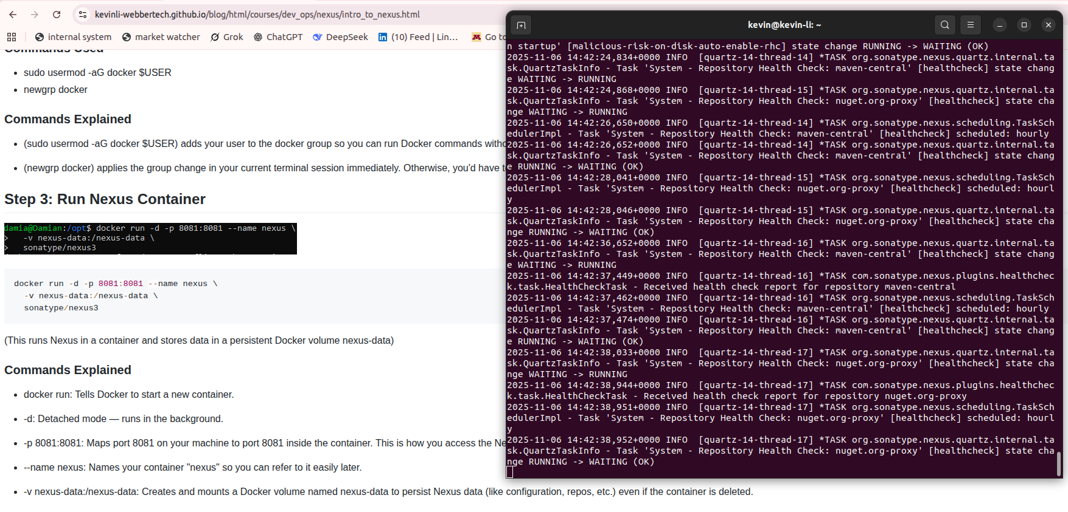
Commands:

docker logs -f 3cedcd8a1a28e153695bfd553cc37c4464f73b2912ea5af9218b8a59b91eba9c &

Explanation:

* The hash id 3cedcd8a1a28e153695bfd553cc37c4464f73b2912ea5af9218b8a59b91eba9c is your container, please replace it and do not use this.

* & in the end is to release the terminal back to you. As it was run as a background job.
* -f is to output the log in realtime mode.

You can see in the bottom, if you hit enter, you can get your terminal back. This terminal process would not be hung there since the ‘docker logs -f …’ process is running in the background.

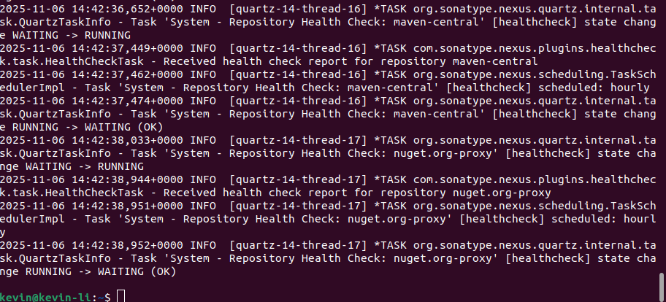
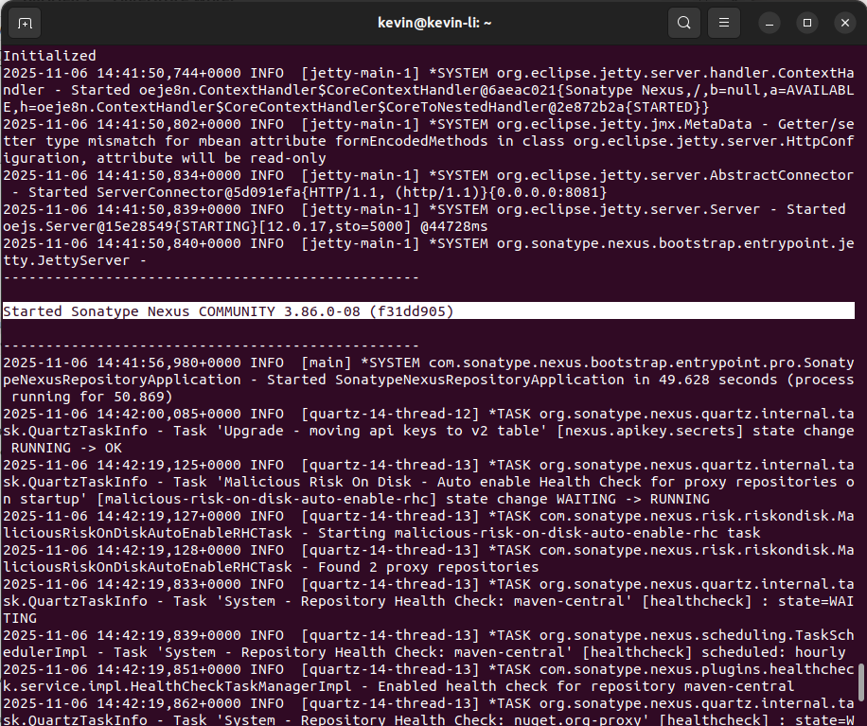
Now in the log window, please scroll up and you should see a line like the one below.
What it shows is the version and the nexus instance has been run successfully.

Step 2: Get password and Login

Next, let us get the password,

Commands:

docker exec -it nexus cat /nexus-data/admin.password

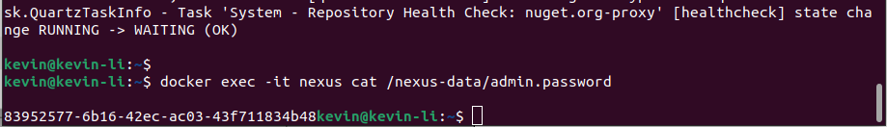
Go to your browser and open this url,

localhost:8081

For me the password is:
83952577-6b16-42ec-ac03-43f711834b48
Note: For you, the password might be different.

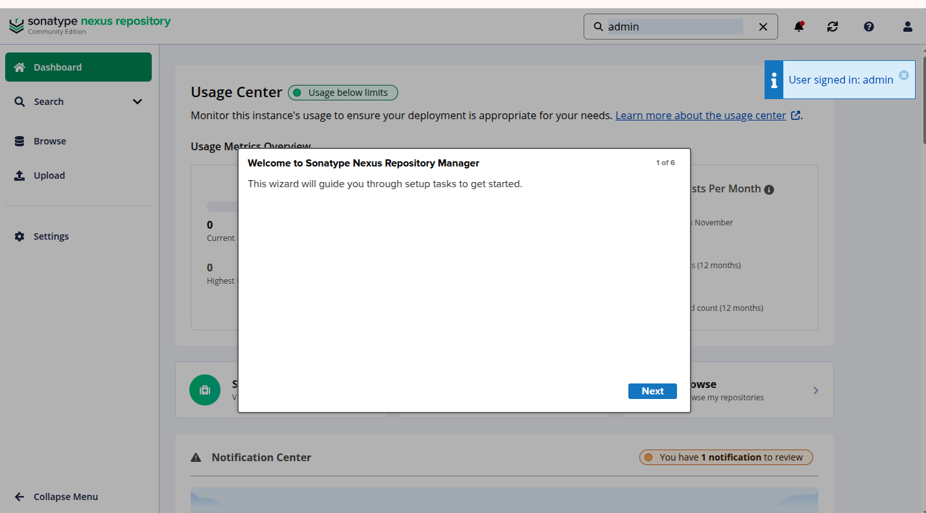

Change password for the first time.
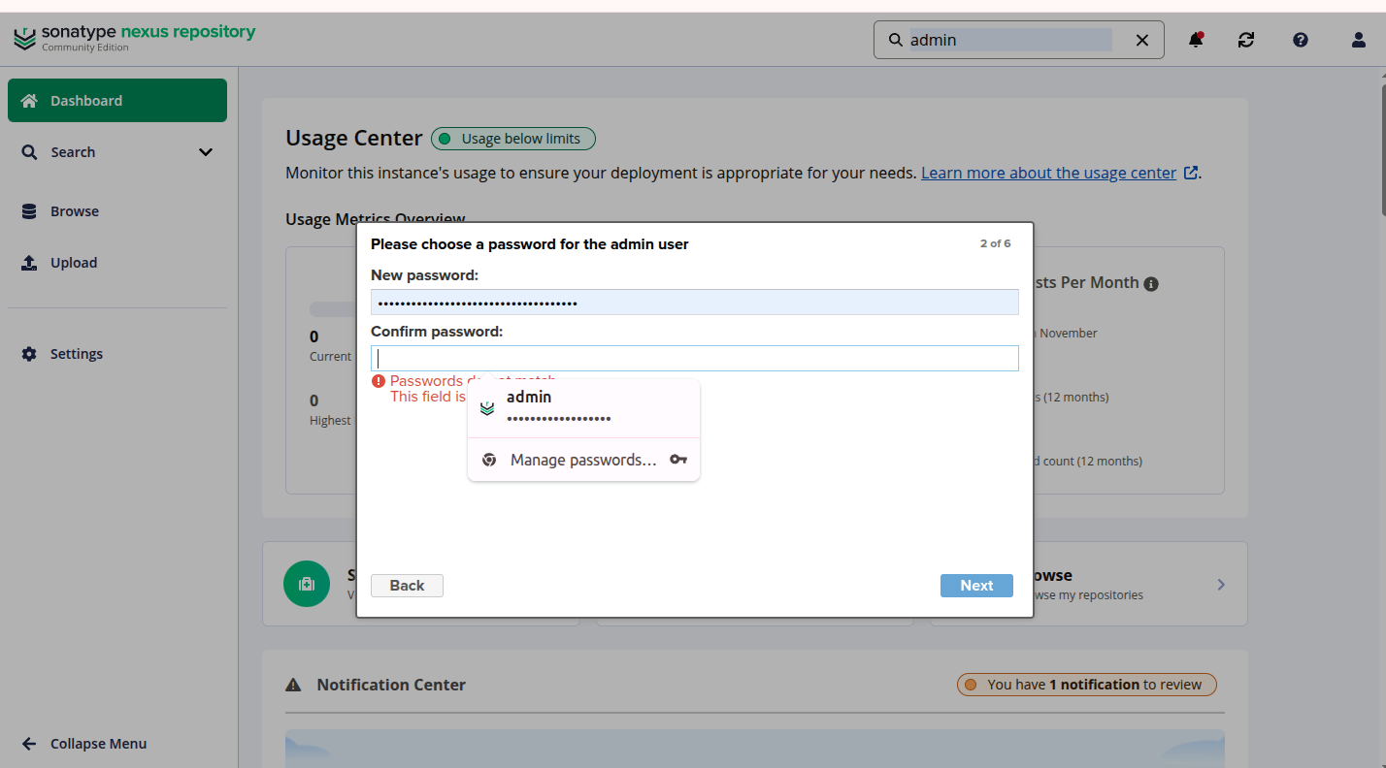

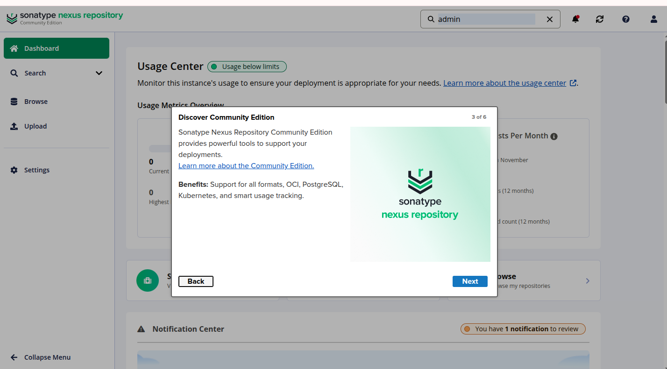
Next screen,
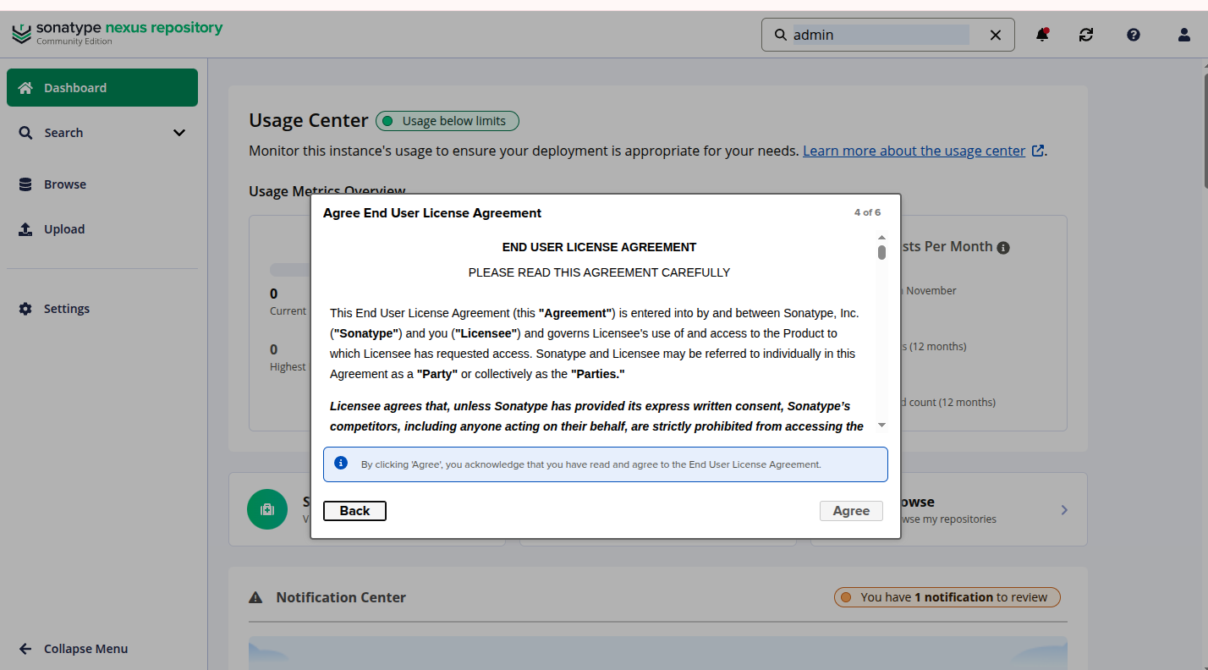
Select the first option,
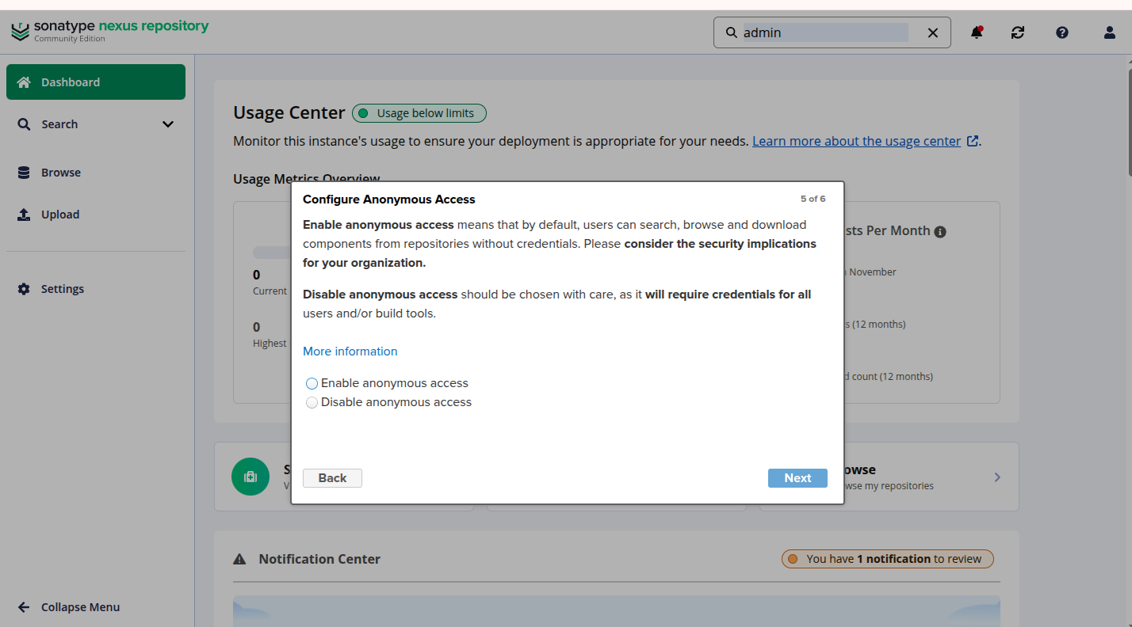
As of now, we would choose “Enable anonymous access”,
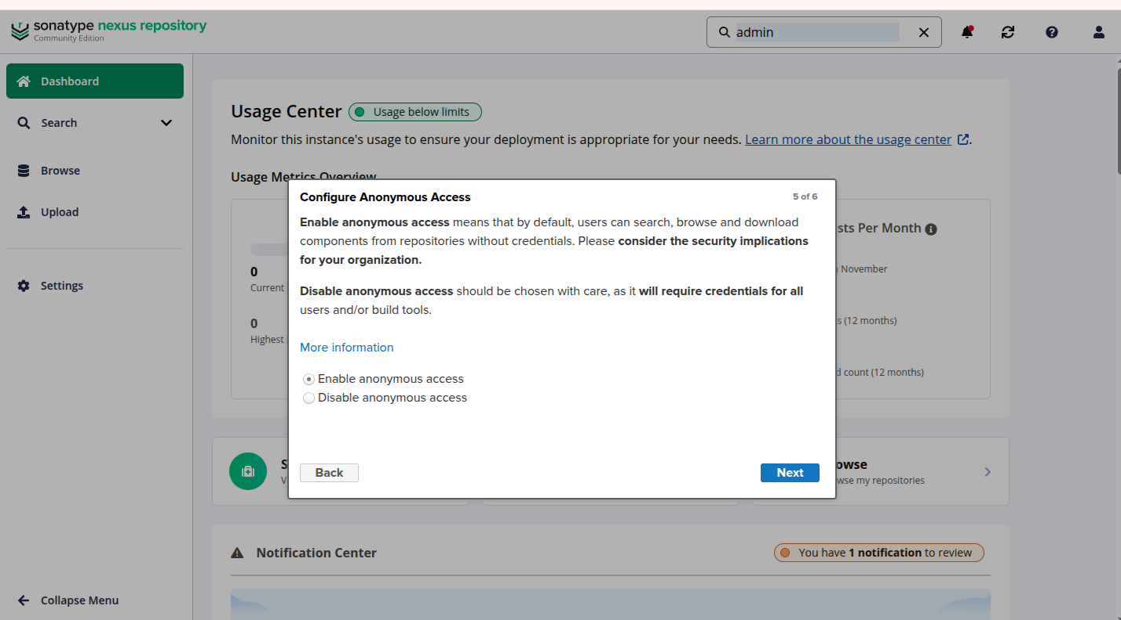
For our future lab we will just work with this option.
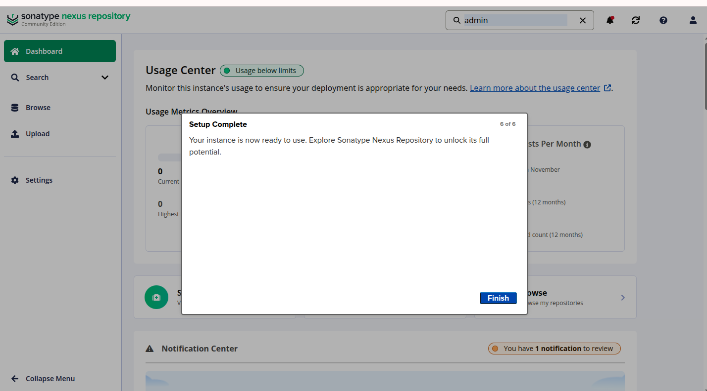
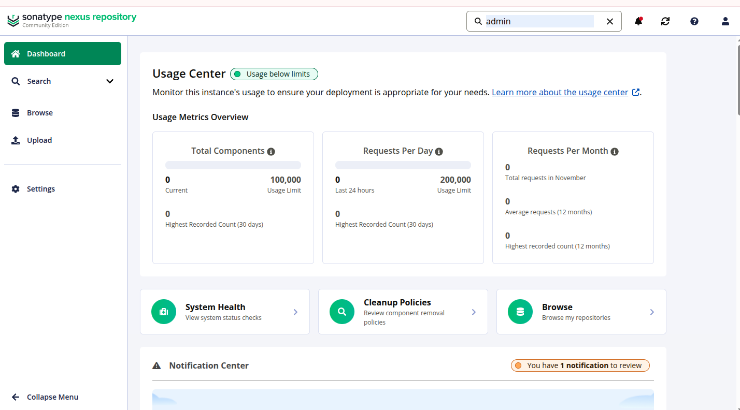
Step 3 Upload Artifact

First let us click on browse,

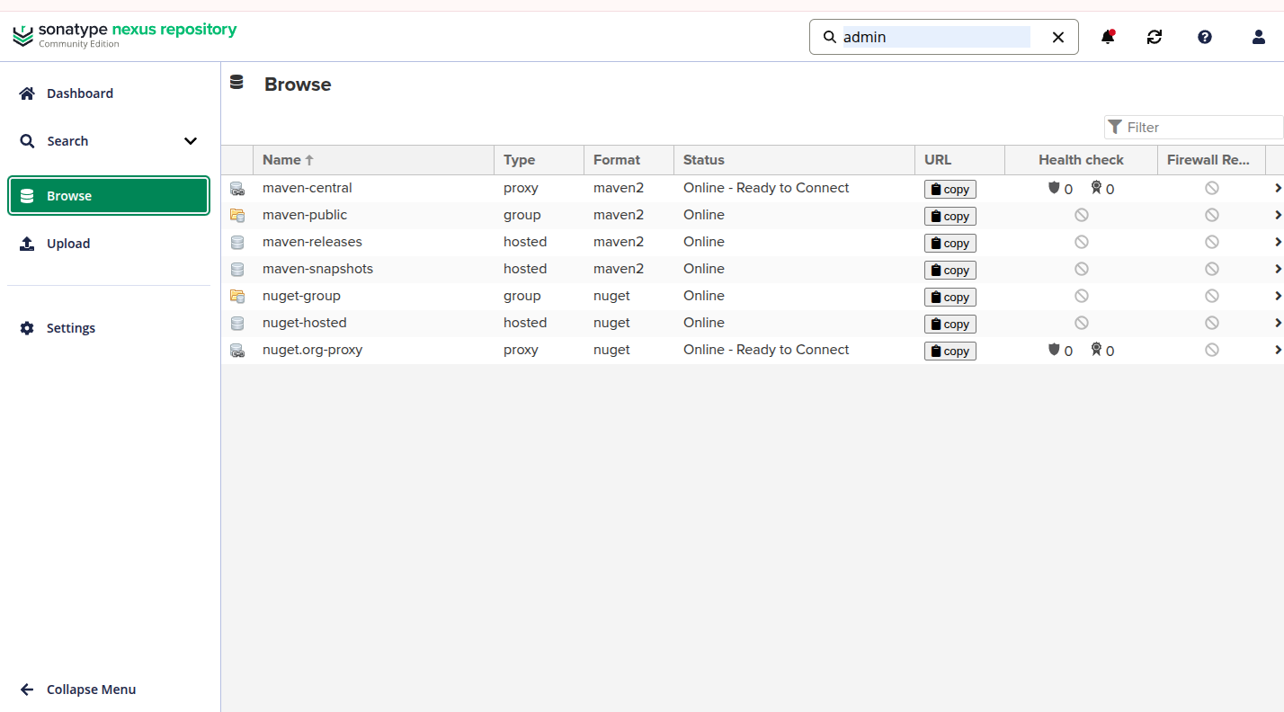
Then click on maven-central,

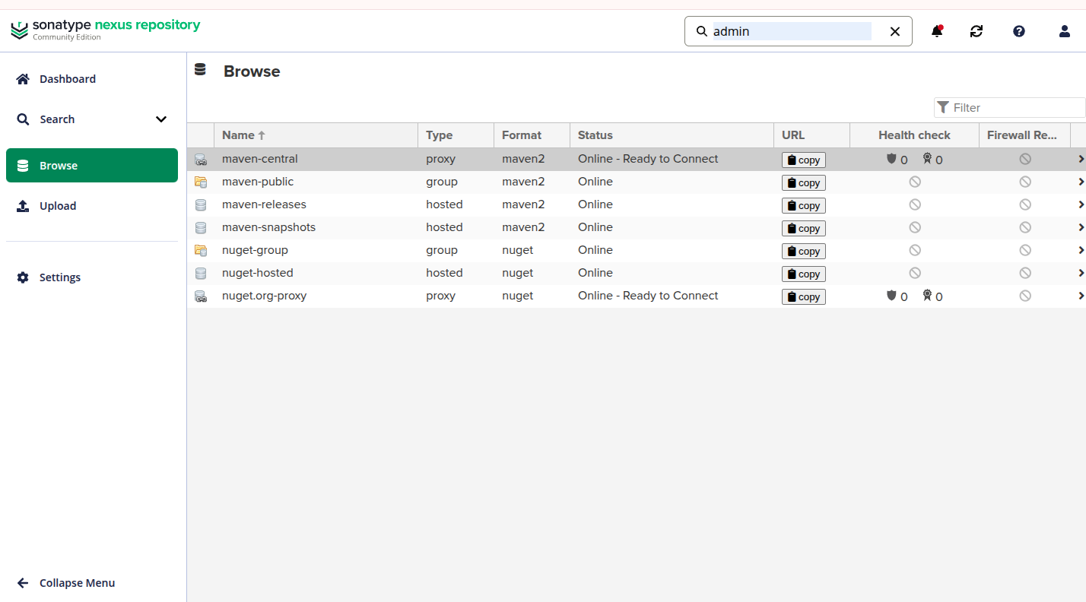

Remember the https://mvnrepository.com/. That is similar to this.

Then let us go to upload an artifact,

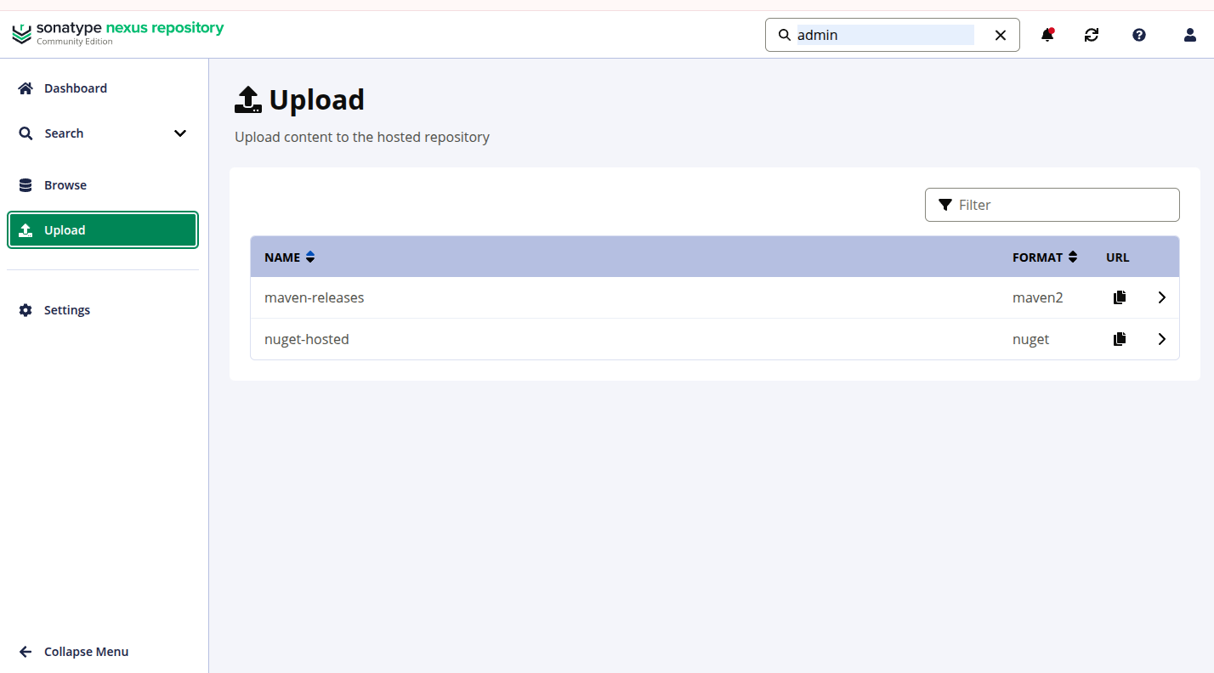

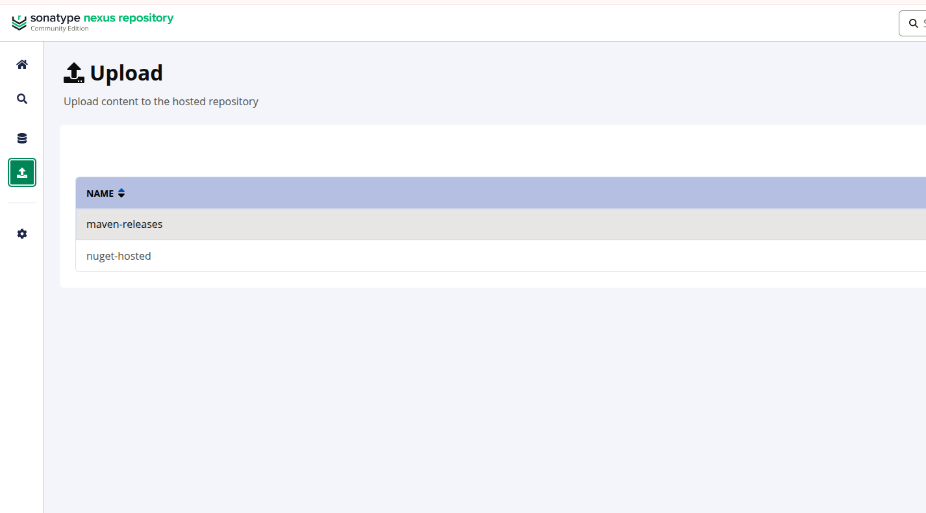

Let us click on maven-releases, and you will see the following screen,
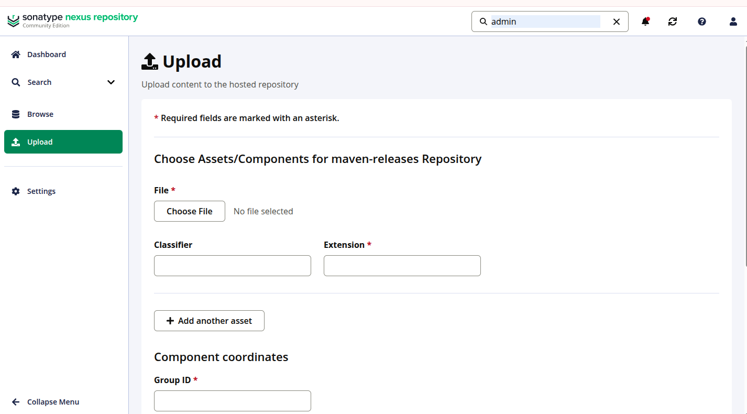
Pick a jar you built,

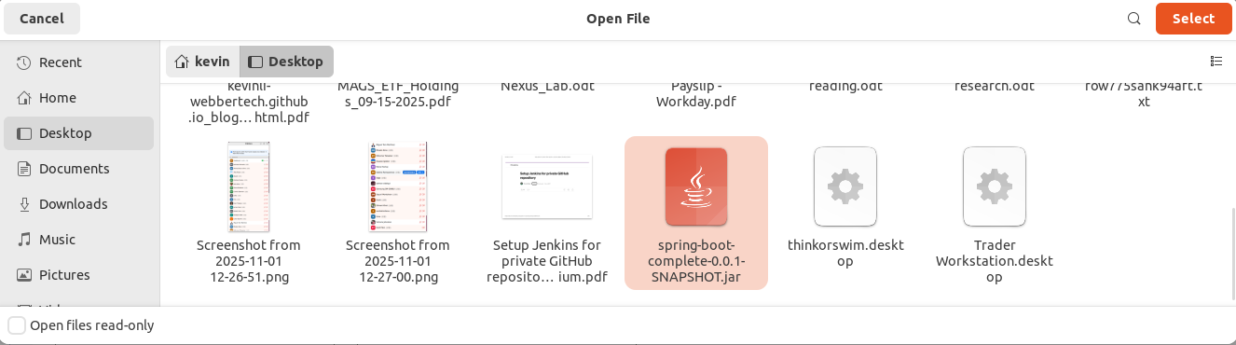

You will find out that the jar is uploaded and the Extension.
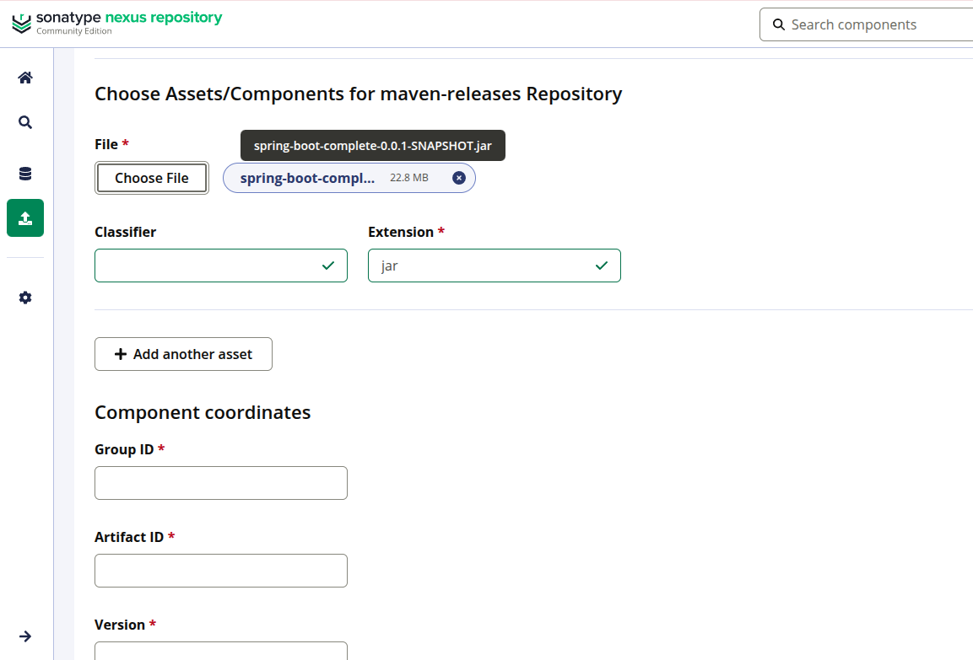

For the fields,

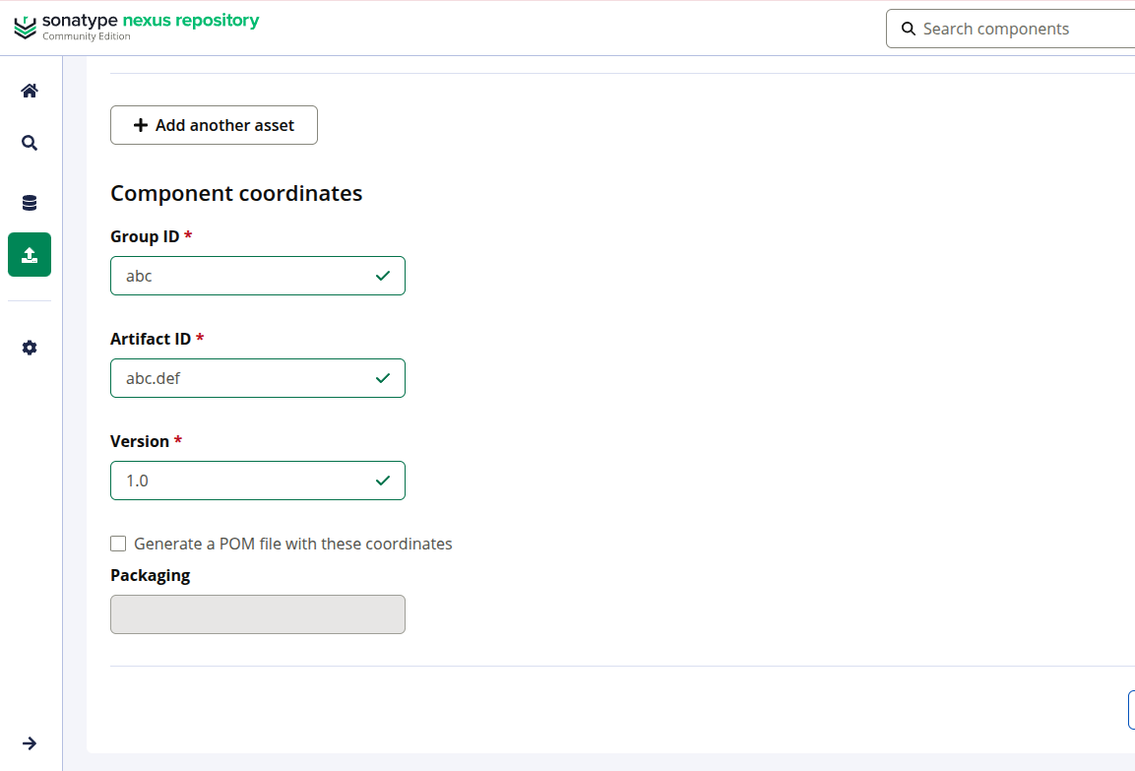

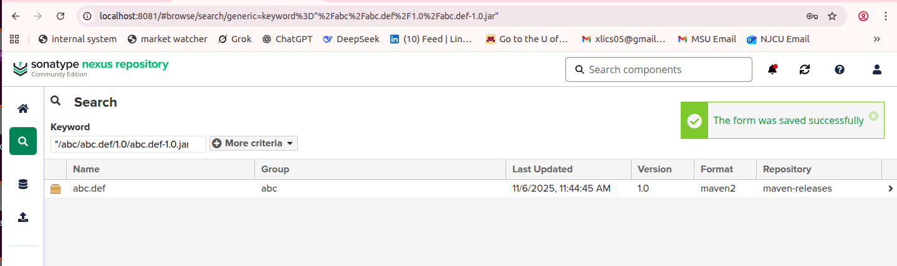
Click on the jar,

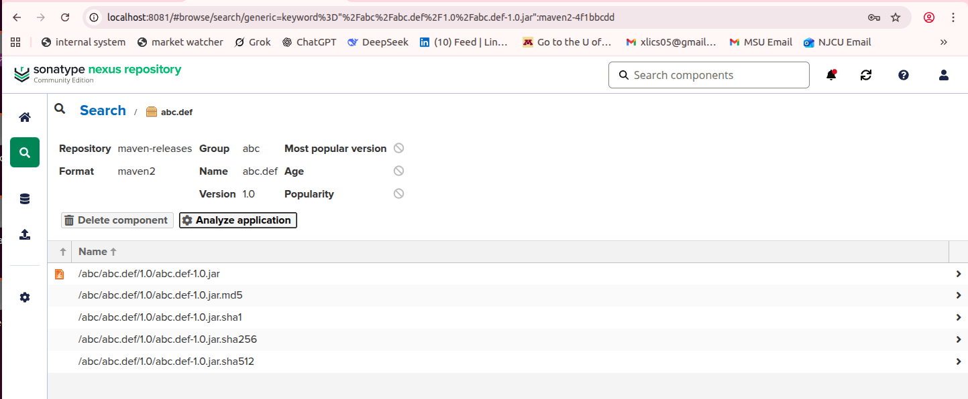
Click on the above jar,

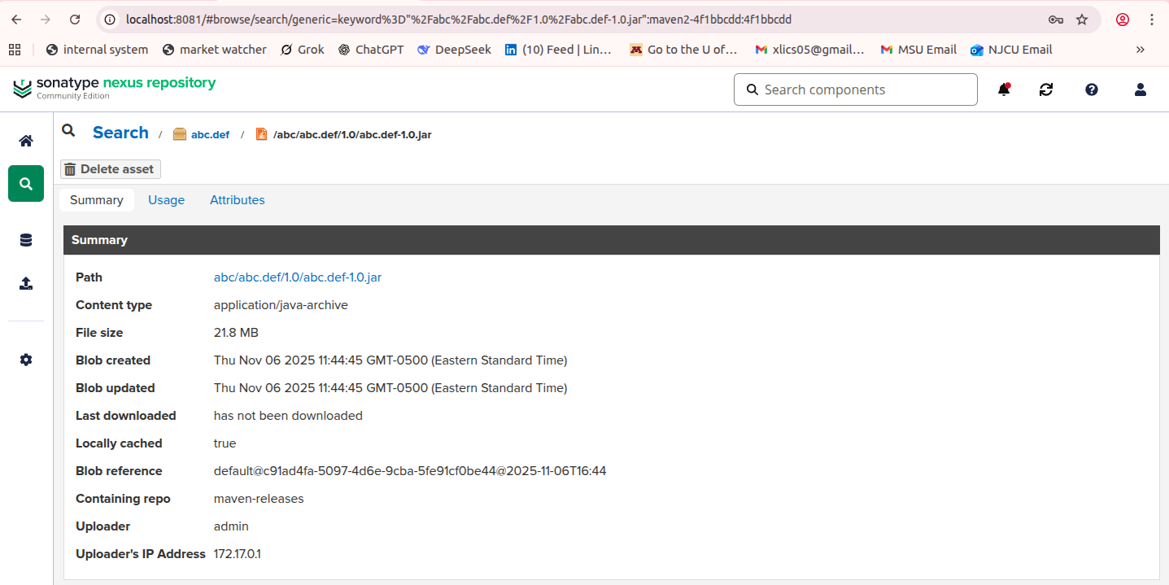

This is how it looks,
