Lab 1 - Javascript Introduction
– Codepilot Setup in Visual Studio Code

Step 1. Download and Install Visual Studio Code

Visual Studio code is a lightweight code editor that we can use to write HTML and Javascript.
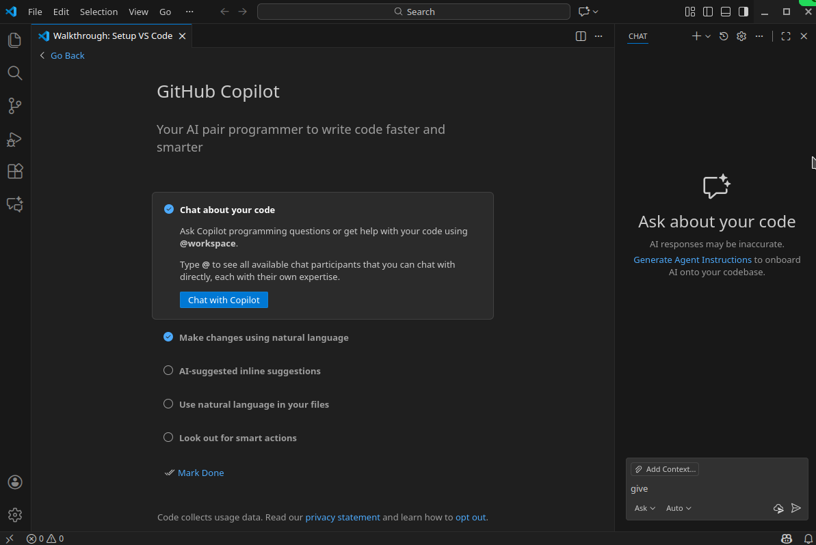
Once you open it, you will see the following tab window open. Click “Chat with Copilot”.

Step 2 Configure the ChatGPT or other AI Engine

Then next you will need to configure the chatGPT or some AI engine with an authentication method, such as gmail...etc.

Once that is done, you will see a chat box like the following,

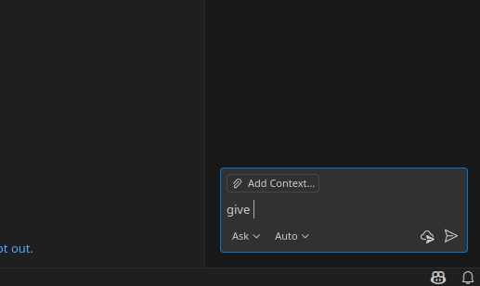

For our example, we could ask a question, and it will like the following,

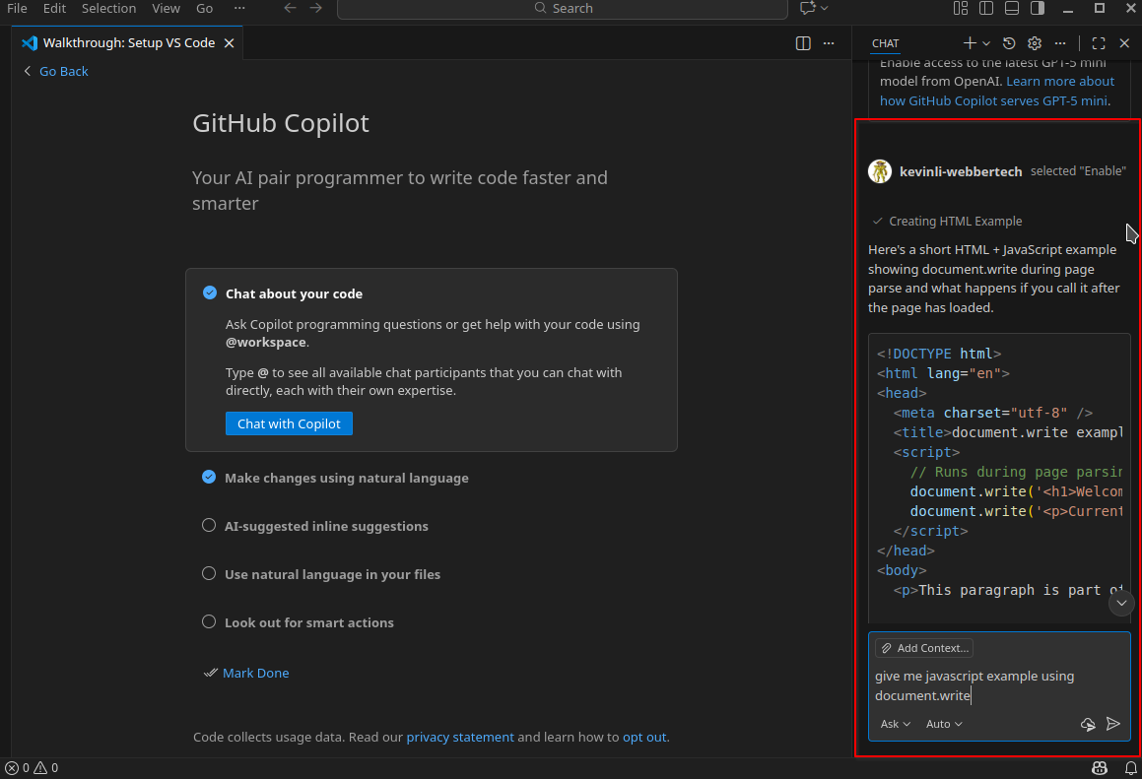
Click the auto dropdown menu in the following image, and you will see the menu shows you a few options,

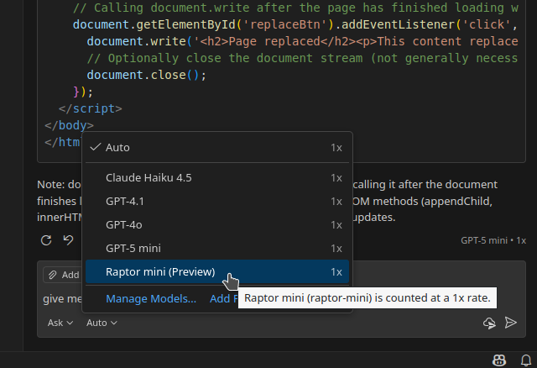

Check some other boxes in the following image, and click on “Mark Done”,

Walkthrouh setup

Please configure the color theme if you like,
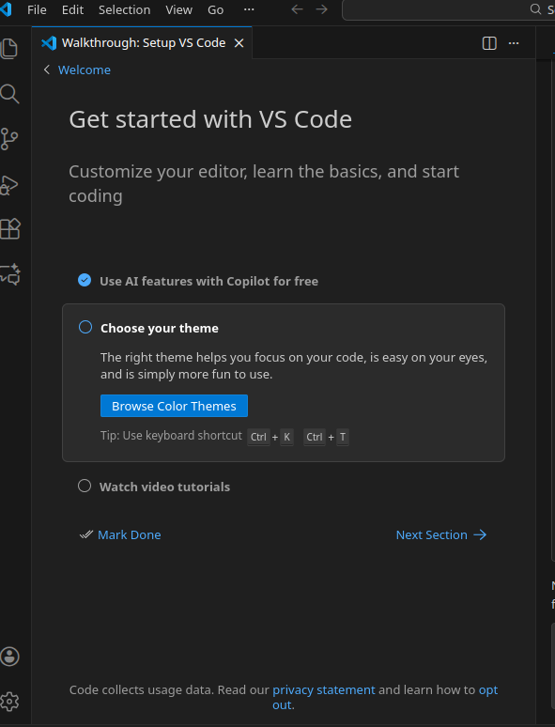

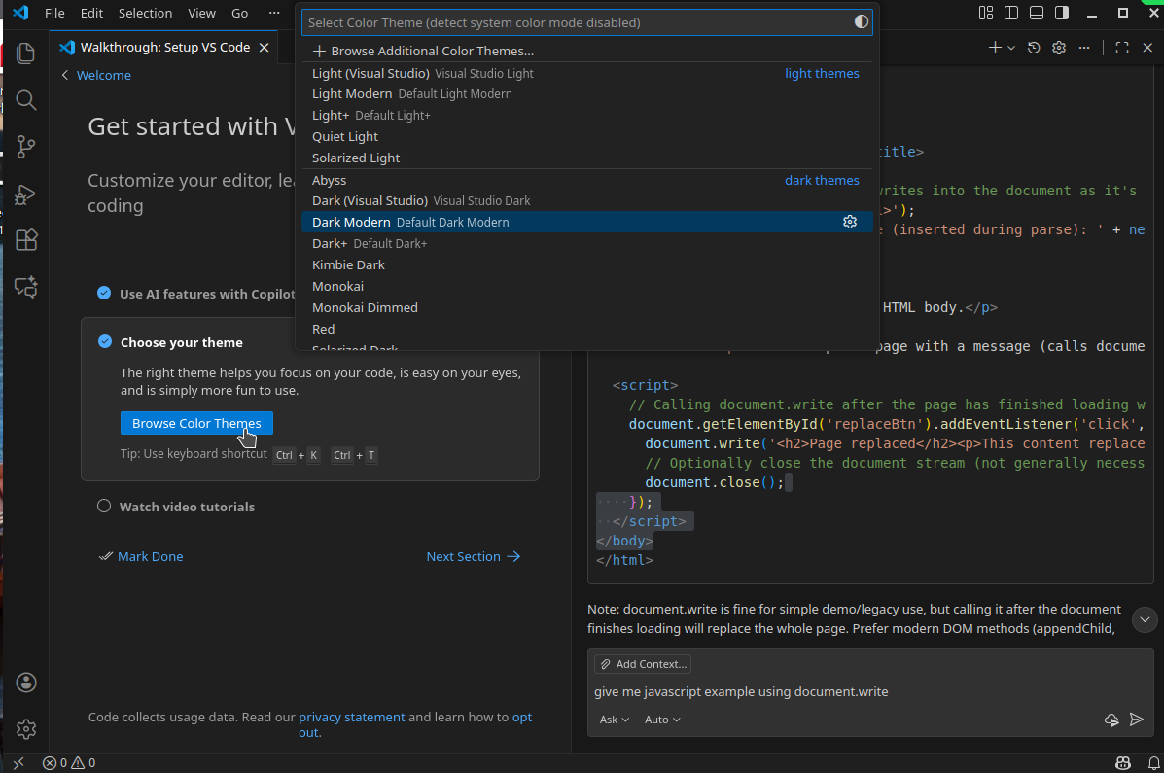
If you want to reconfigure the settings, such as the AI or the Theme, you can go to the “Setting”. It is a gear button in the bottom left.
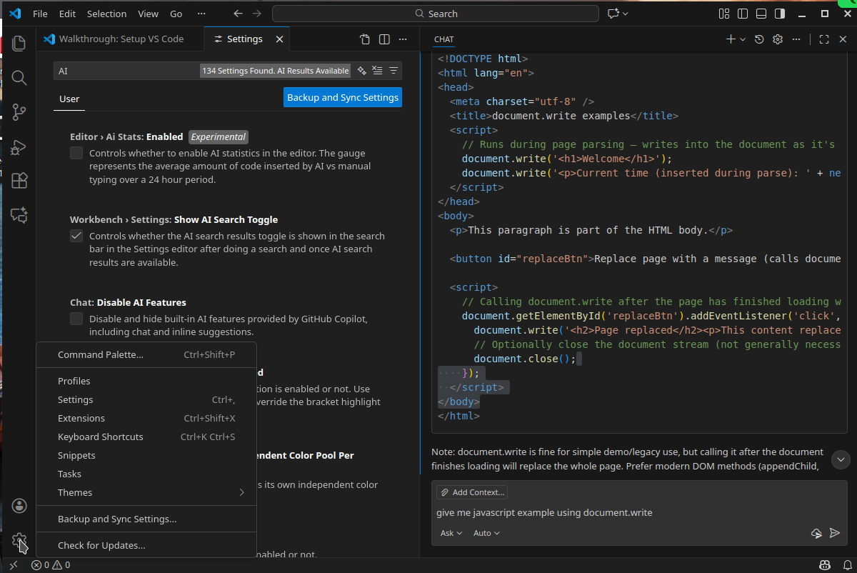

Click on the settings,

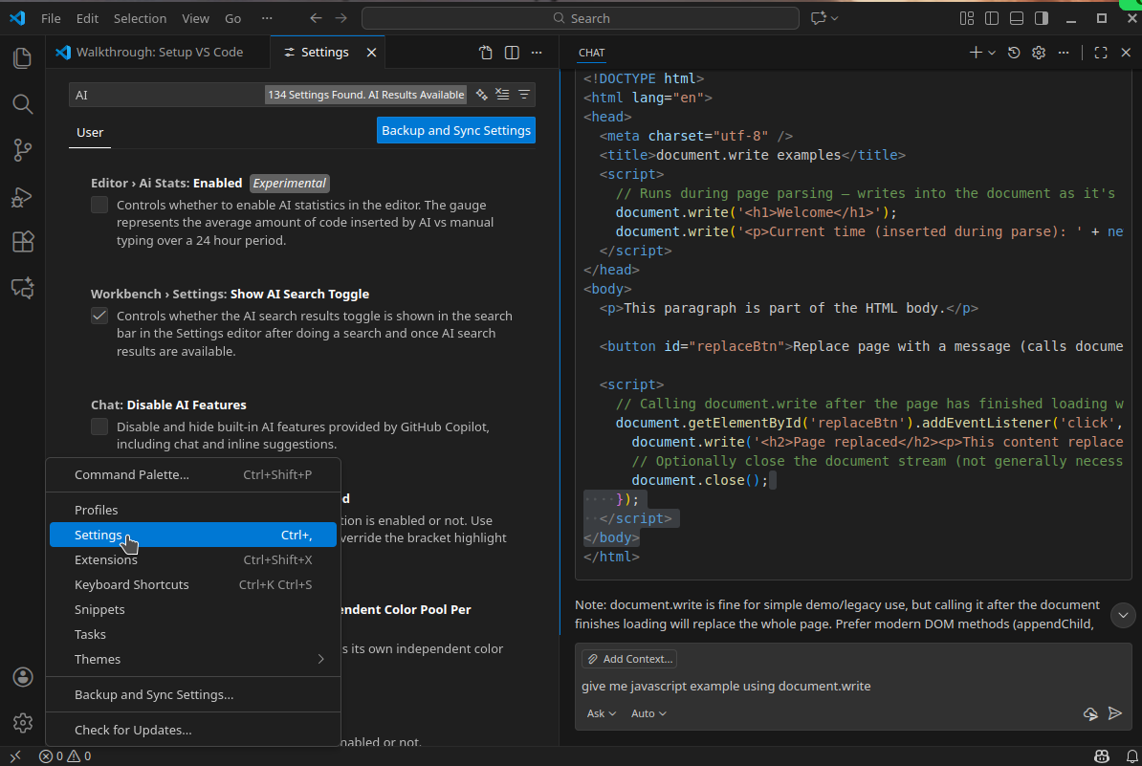
Step 3 Set up a directory for development

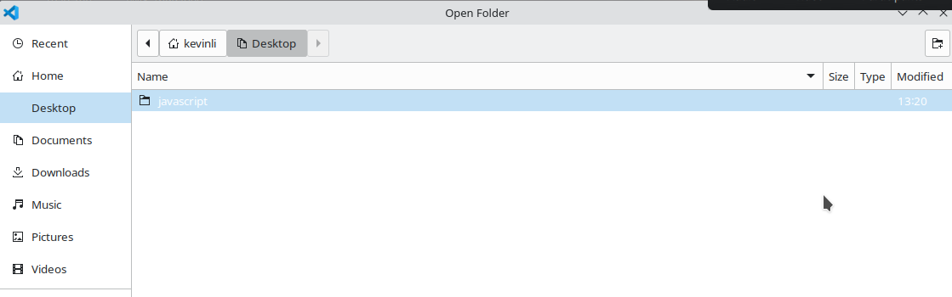
Next, create a directory in your home drive or desktop, in my case I call it “Javascript”, and go to “File” menu, and pick the Javascript directory you created, and you will see the following image.

Note that, I have changed my color scheme to light instead of dark.

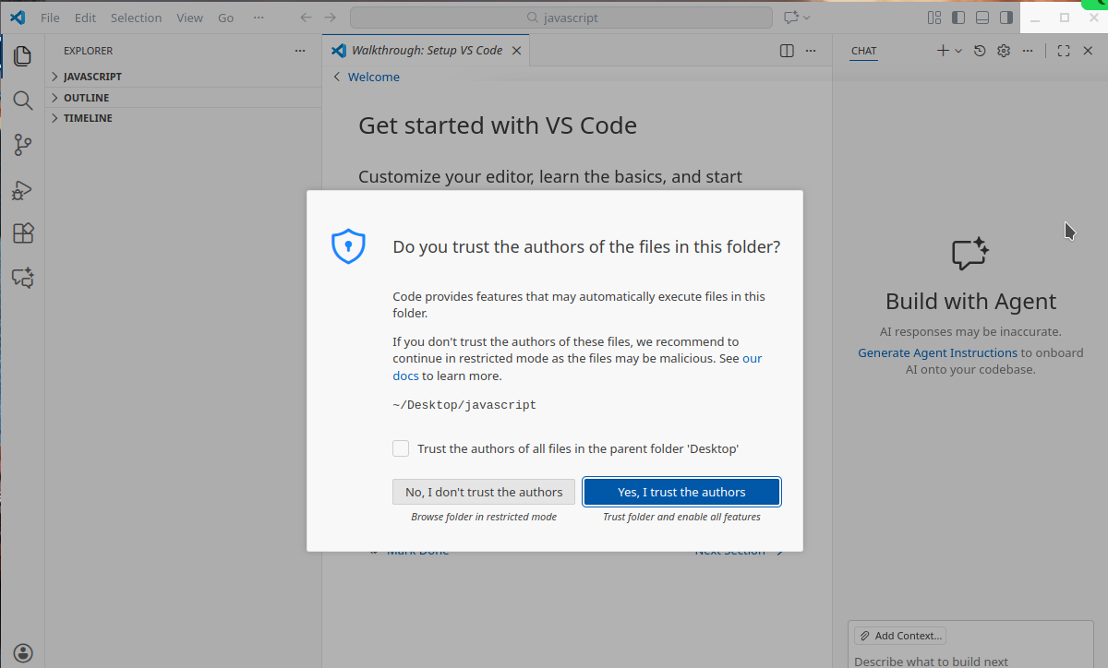

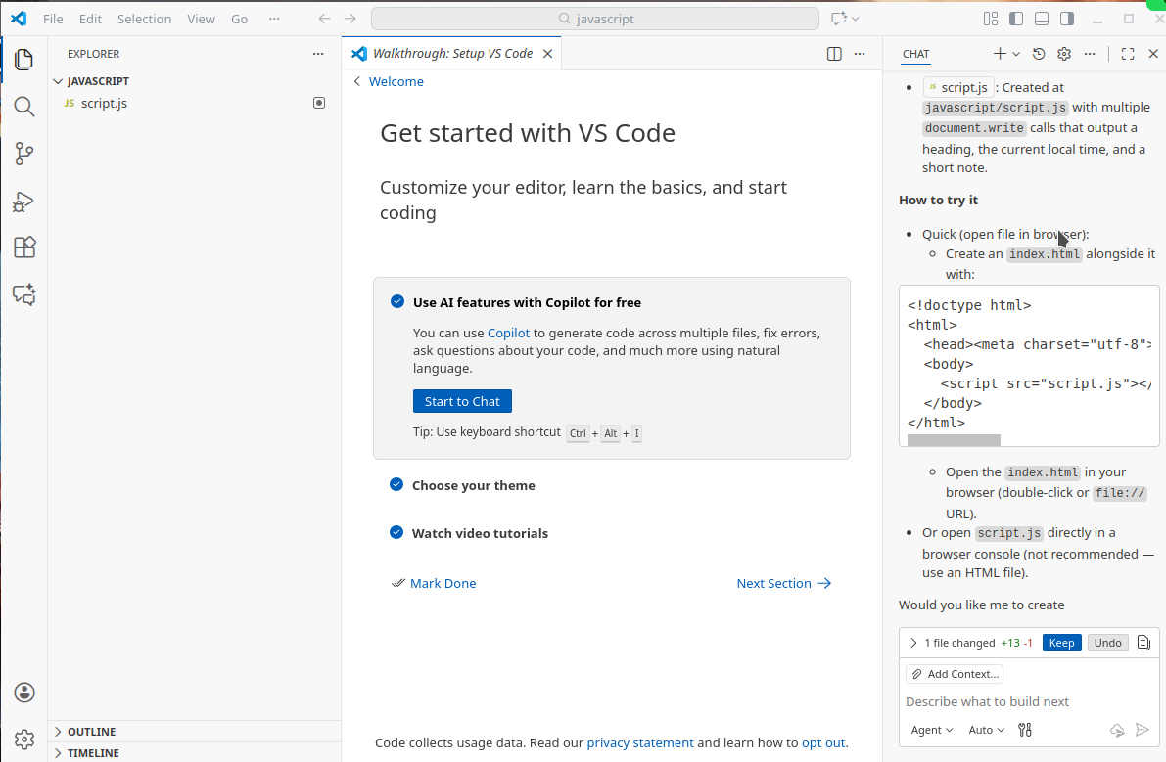
Next, in the chat box and ask questions to generate a Javascript file. We need not only to generate the

code but we also want to save it to my working directory, now in the above image, you can see script.js in the workspace in the left pane.

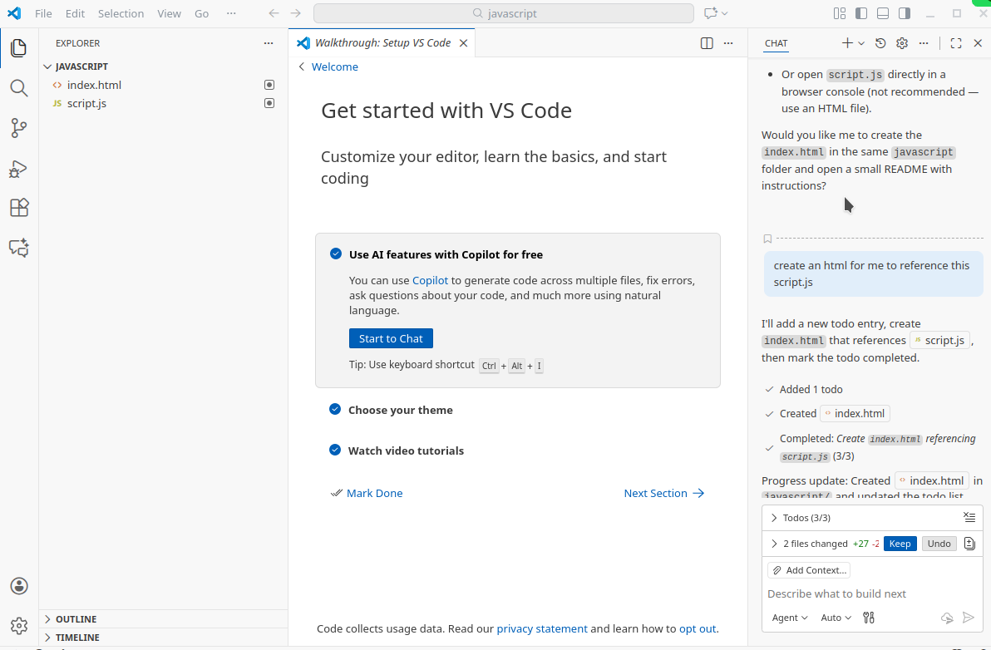
Now, I ask for another HTML to call/reference this script.js file. Now you can see two files on the left of the image blow,

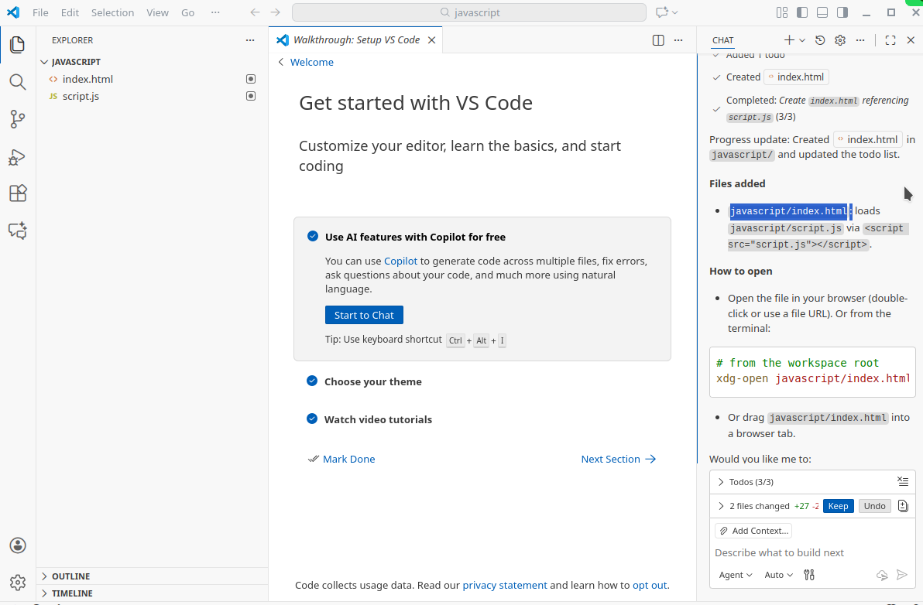
On the right hand side where I highlighted, it also explains how to use it.

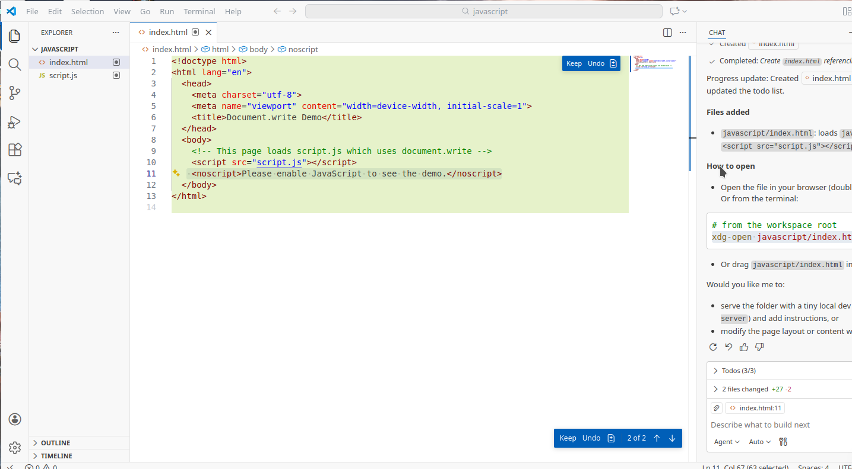
Now let us open the HTML file and take a look at how it writes the code. Now, this is a good way of learning and what is more, it saves your time, copy and paste from the web version. ChatGPT.

Now the following is the Javascript file,

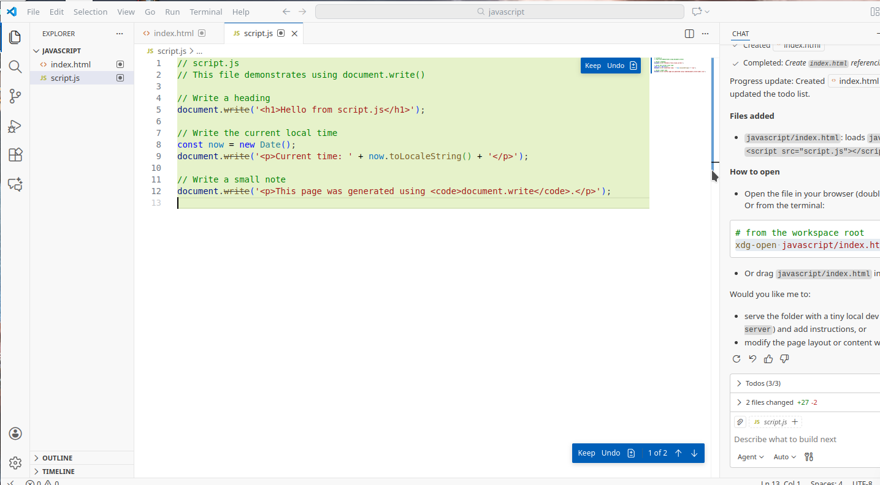
Step 4 Test the Javascript file

From the left of the workspace in the image above, open it in its containing folder, and we will see two files here, shown in the following image.

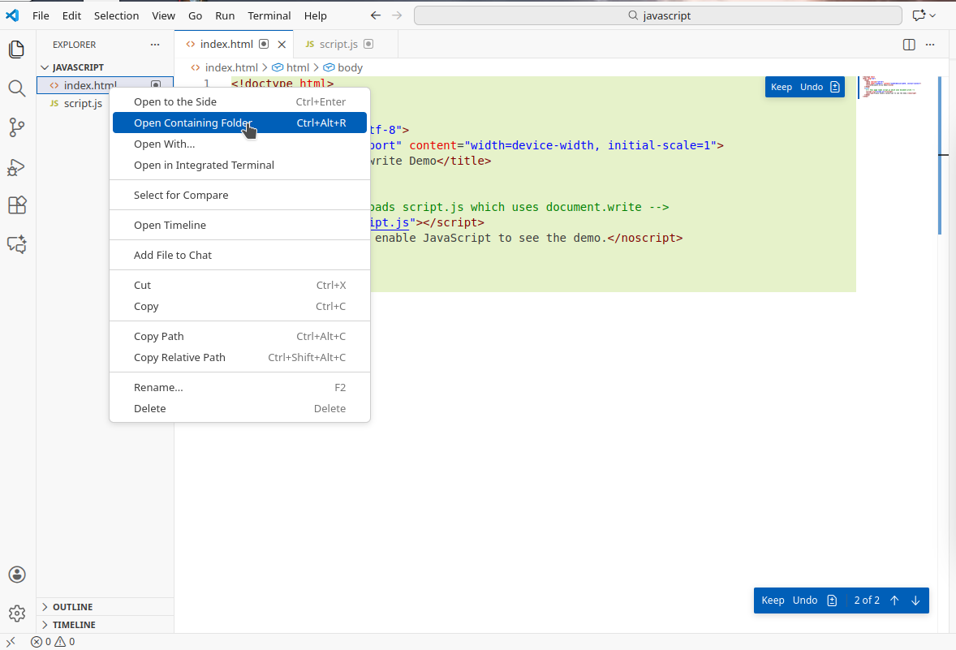
Then you will see the files show in the following images,
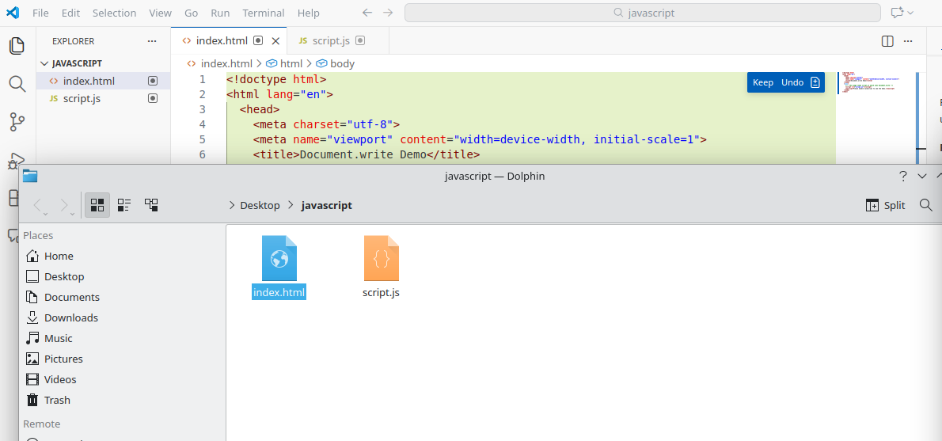
Note that, you can only test the HTML file in the browser, and your Javascript file is being called and referenced in the html file.

So let us double click it or drag and drop it to a web browser, and you will see the html file open. In the following image, I put them side-by-side.

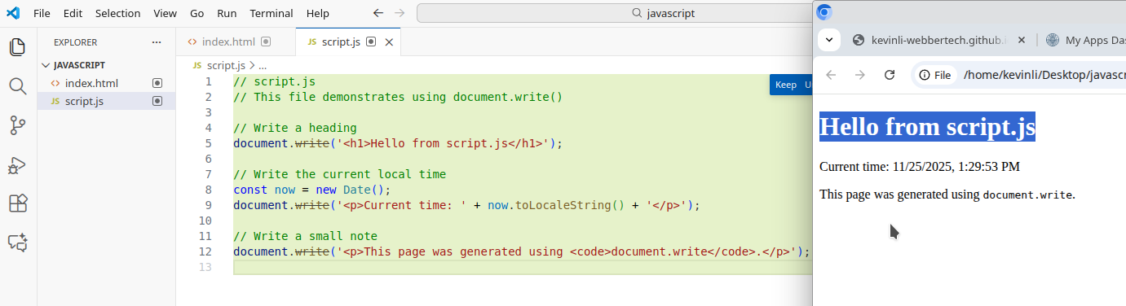
Now I ask another question to add another feature “add console.log example” to the javascript file.

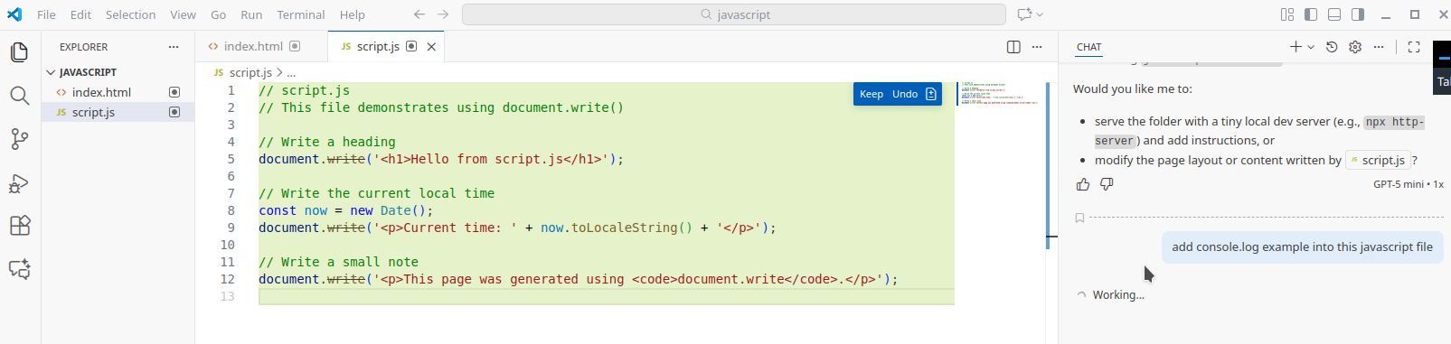
Then the code was automatically generated on the left, shown in the following image,

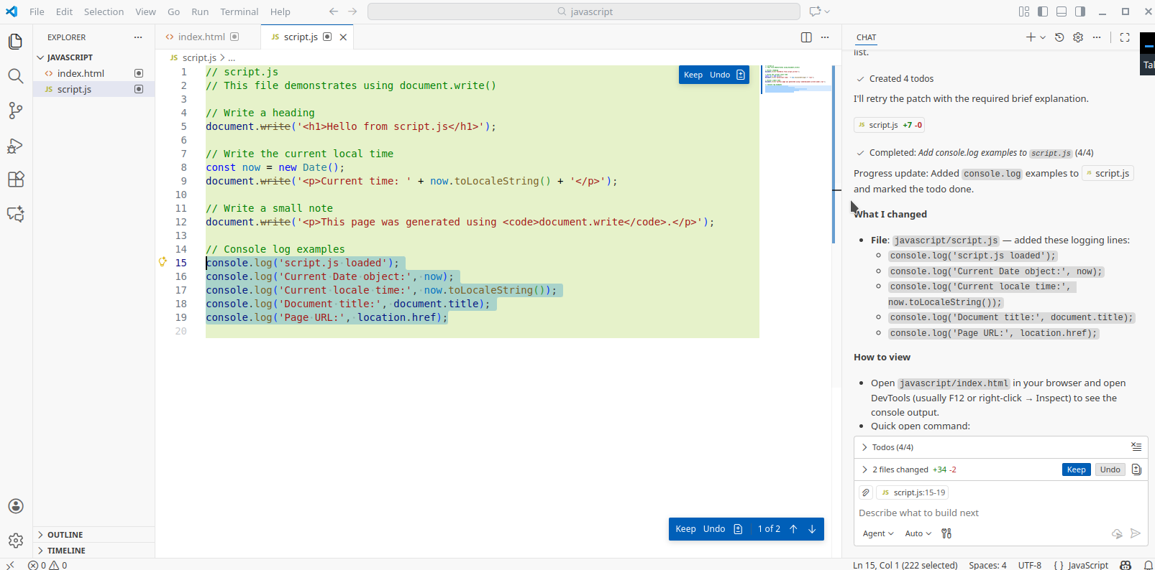

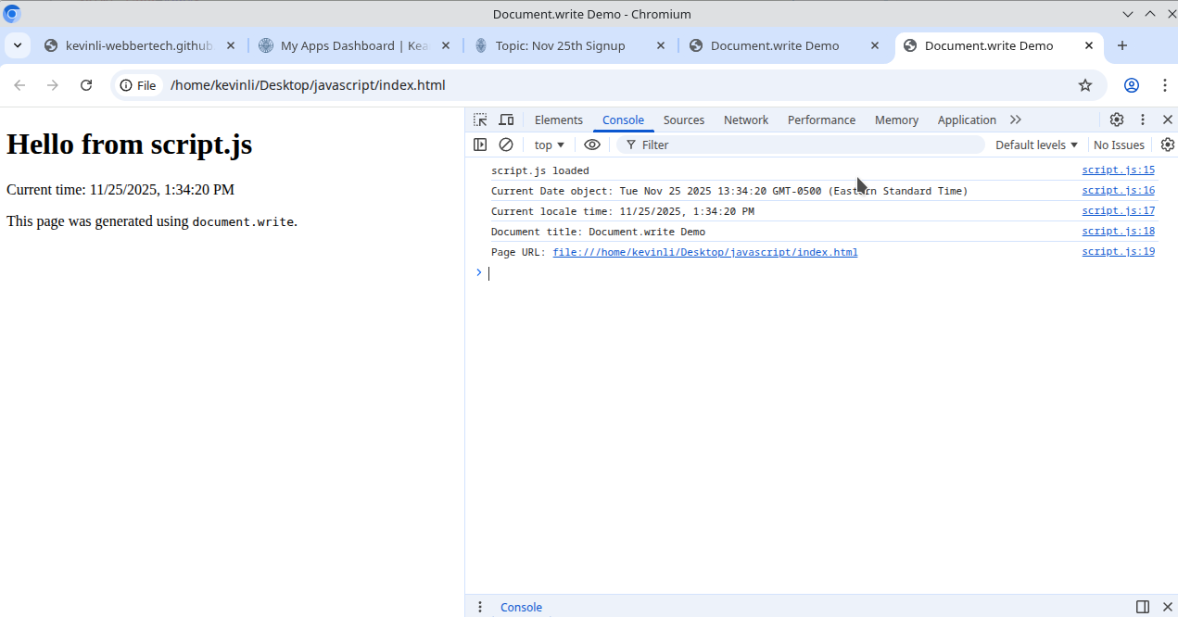
Open the web page in browser (all the browser supports the debugging), right click
in the white area, and in the contextual menu, and click on the “Inspect” button,

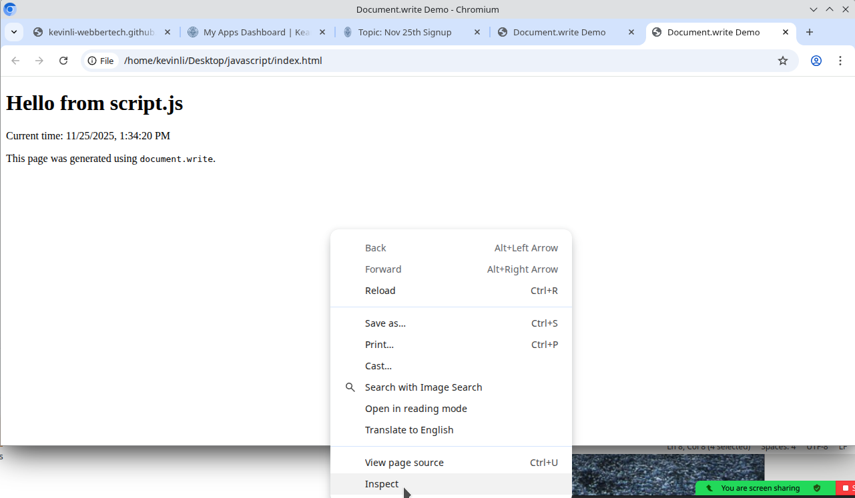
Let us open the console tab on the right hand side of the following image,
