HW2 Solution

Solution 1 Temporary mounting

In this temporary mounting it is only working in this user session. If you reboot your client machine, the mounting will be gone.

On the client computer or vm, you run the following command,

sudo mkdir /mnt/share
`mount -t cifs -o vers=3.0,username=xiaofeng '\\192.168.1.153\shared' /mnt/share`

we show `mount`, and in the output we can see the following,

//192.168.1.153/shared on /mnt/share type cifs (rw,relatime,vers=3.0,cache=strict,username=xiaofeng,uid=0,noforceuid,gid=0,noforcegid,addr=192.168.1.153,file_mode=0755,dir_mode=0755,soft,nounix,serverino,mapposix,rsize=4194304,wsize=4194304,bsize=1048576,retrans=1,echo_interval=60,actimeo=1,closetimeo=1)

You can also see them in the following screen,
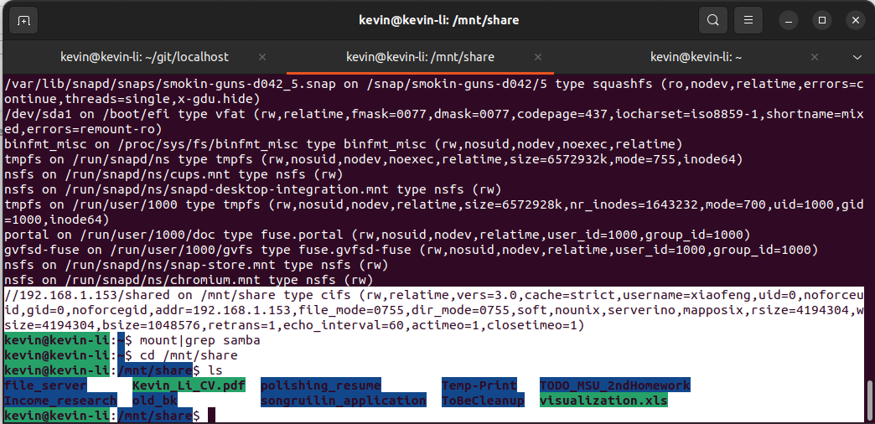

Then you check if the mounted drive is successful by doing the following commands,

`cd /mnt/share`
`ls`

And you can also see the NTFS hard drive and partition was mounted successfully and we can see the files in the above image as well.

Solution 2 Permanent mounting

First use the `id` command to find out your user id and group id,

kevin@kevin-li:~$ id
uid=1000(kevin) gid=1000(kevin) groups=1000(kevin),4(adm),24(cdrom),27(sudo),30(dip),46(plugdev),122(lpadmin),135(lxd),136(sambashare),137(docker)

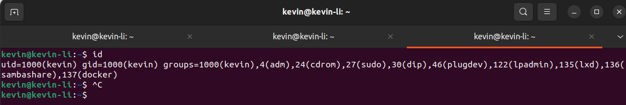

Create a file

sudo nano /etc/samba/credentials

Give permission

sudo chmod 600 /etc/samba/credentials

and put the following in there,

username=your_username
password=your_password

Reboot your machine and check the /mnt/share and see if it works.

